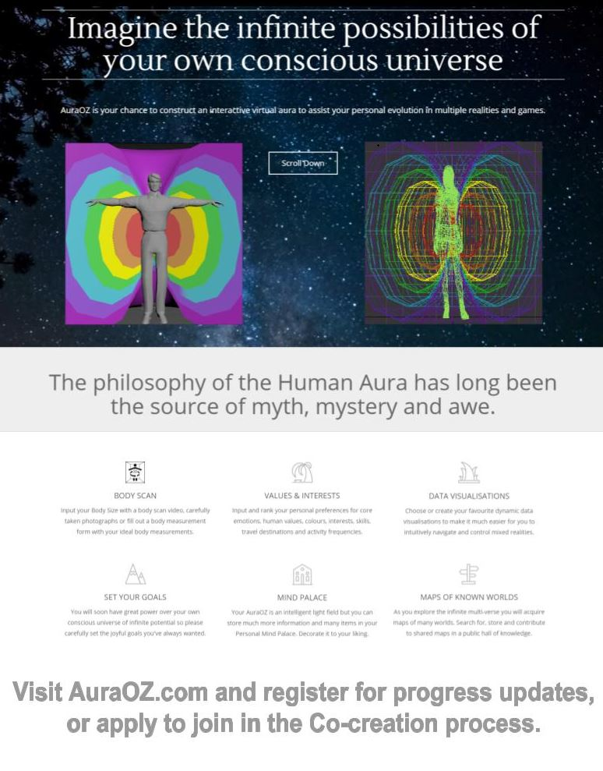

Virtual Cloning and Aura Creation
  - How to build an intelligent aura & A digital version of your self
Luke Nathan Hayes | My Learning Progression and Thought Experiments Towards General Intelligence
Table of Contents
Forward 2
Abstract 2
Introduction 2
Body 2
Self-Reflection 2
Subheading: 2
Day One Schedule: 3
Avatar Creation 3
Subheading: 3
Day Two Schedule: 3
Aura Creation 4
Subheading: 4
Day Three Schedule: 4
Mind Palace Creation 5
Subheading: 5
Day Four Schedule: 5
The Operating Zeitgeist 5
Subheading: 5
Day Five Schedule: 5
Device Management 6
Subheading: 6
Day Six Schedule: 6
Training and Assessment 7
Subheading: 7
Day Seven Schedule: 7
Play Time and Wellbeing 7
Subheading: 7
Day Eight Schedule: 7
Universal Environment 8
Subheading: 8
Day Nine Schedule: 8
Participatory Governance 9
Subheading: 9
Day Ten Schedule: 9
Natural Disaster Emergency Response 9
Subheading: 9
Day Eleven Schedule: 10
Joyous Virtuous Compassionate Responsible Abundance 10
Subheading: 10
Day Twelve Schedule: 10
Planning Self Directed Evolution and Social Co-Creation 11
Subheading: 11
Day Thirteen Schedule: 11
Graduation Ceremony and Media Activities 12
Subheading: 12
Day Fourteen Schedule: 12

Forward

Abstract
General Intelligence seems to have emerged in the human species as a result of sustained self-reflection. Internal and external reflections of self through environmental influence; observing each now moment using human senses, using memory to reflect on the past, compared to now, and also using imagination to simulate the future and compare simulations to past, now and other, by using contextual awareness.
These reflective processes seem relative to experience, focus, motivation and mental distortion tools for accentuating different styles of thought. These can include processes like fasting (going without food for extended periods of time), experiencing solitude Vs interacting with many peers, or by exposing a self to one or more consciousness distorting substances, of which, there are incalculable “+” & “-” combinations.
Now the race is on to quantify this process into a safe and responsible system that can be embedded in computerized devices to extend intelligence. The approach I have chosen to take, is to attempt to build a simulated copy of my physical self, my environmental imagination self, my spiritual self and my cultural self, combined with my general learning principals, motivators, preferences, tolerances and memory. This information will be curated in stages and reflected by identifying common generalizations of intelligence.
The result I aim for is a digital avatar self with an intelligence operating zeitgeist, a high definition virtual Aura with interactive heads up displays and a progressively generative environment and physics engine.

Introduction
Personal history, environments, memories
Knowing myself, Neuro Linguistic Programming
Duplicating the physical self into a simulated digital form
Embedded associations between color, shapes, emotions and language
Familial and cultural expectations, suppositions, assumptions, rules and guides
Brain Rules for Baby – Scientific research into the neurological development of a child
1,000 to 4,000 of the most common words used by Australian children (pre-G3) in assignments
Word reduction from Diploma of Interactive Game Design into a word list, edited to ‘bias|prefer good’
Personal excel spreadsheet of conscious intelligence keywords, ‘bias good,’ reduced to a word list
Social Media, Sovereignty, Analysis of Trade Mechanisms and Responsible Abundance
Spectrum of linguistics, related to common sense, suppositions and assumptions
Spectrum of internal beliefs, external moral perceptions and humane needs
Mathematic logic of observed physics to generate nDimensional Arrays
Predictable environmental cycles with regular observable effects
Logic of Language – English, and a generalization of terms
Programmable computer memory, sensor arrays, machine vision, machine learning, cryptography
Building an interactive aura program for embedding, displaying, editing and distributing intelligence
Visualization techniques to convert nDimensional data into meaningful images and intuitive controls
Imagining the flow of energy through the world from every perspective, to a single set of words and math
Phonetics of language and pronunciation differentials between languages, dialects, slang and vibrancy
Quantify computation requirements for machine learning of images, video, audio, text and imagination
Quantify computation improvements for efficiency and accuracy of algorithms by adjusting perspectives
Compare maximum computation available now with distributed computing services, private and cloud
Quantify computation requirements for machines to progressively simulate environments low to hi def.
Quantify total required computations per second for sustainable intelligent clothing and accessories
Quantify total required computations per second for a festival hive mind extended intelligence cloud
Quantify total required computations per second per million people at very high level of intelligence

Body

Self-Reflection

Subheading:
Topics

Day One Schedule:
- 08:00 Introduction, Welcome to Country, Smoking Ceremony and Breakfast
- 09:00 Course Overview and Familiarization with Tools
- 10:00 Defining Your Preferences of Self and Not Self
- 11:00 Defining Your Preferences of Formative Past Experiences
- 12:00 Lunch Break
- 1:00 pm Defining Your Preferences of Timekeeping and Scheduling
- 2:00 pm Defining Your Preferences of Interests and Goals
- 3:00 pm Defining and Role Playing Your Preferences of Social Norms and Ideals
- 4:00 pm Afternoon Break
- 5:00 pm Defining Your Preferences of General Wellbeing
- 6:00 pm Defining Your Preferences of Work Experiences, Skills and Purpose
- 7:00 pm Defining Your Preferences of Travel, Entertainment and Joy
- 8:00 pm Evening Meal

Avatar Creation

Subheading:
Topics

Day Two Schedule:
- 08:00 Breakfast and Introduction to Blendr, Unity 5 or Unreal Engine
- 09:00 Use Body Measurements to Build a Simple Animation Rig
- 10:00 Build a Full Body Avatar of Self Around the Animation Rig
- 11:00
- 12:00 Lunch Break
- 1:00 pm Transpose Your Facial Features onto the Avatar
- 2:00 pm Rig and Customize Clothing onto the Avatar
- 3:00 pm
- 4:00 pm Afternoon Break
- 5:00 pm Polish Avatar and Create Some Renders
- 6:00 pm Build a simple 2 Dimensional Avatar of Self
- 7:00 pm
- 8:00 pm Evening Meal

Aura Creation

Subheading:
Topics

Day Three Schedule:
- 08:00 Breakfast and Introduction to Guest Speaker
- 09:00 Presentation on the Philosophy of Aura’s and Kundalini Chakras
- 10:00 Choose your Preferences and Build a Basic Aura Scaffolding Around Your Avatar
- 11:00 Enter Virtual Reality to Adjust the Aura for Depth of Perception
- 12:00 Lunch Break
- 1:00 pm Choose How to Display and Interact With Your Adjustable Settings
- 2:00 pm Build a Fast Access Tool List and Set Triggers/Prompts for Automation
- 3:00 pm Define and Design Visualizations for Energy Transfers from Aura to Aura
- 4:00 pm Afternoon Break
- 5:00 pm Set Preferences for Common Environments, Interactions and Situations
- 6:00 pm Set Preferences for Discovery Modes like Dating, Entertainment and Travel
- 7:00 pm
- 8:00 pm Evening Meal

Mind Palace Creation

Subheading:
Topics

Day Four Schedule:
- 08:00 Breakfast and Introduction to Guest Speaker
- 09:00 Presentation on Rapid Prototyping Virtual Architectures to Improve Memory
- 10:00
- 11:00
- 12:00 Lunch Break
- 1:00 pm
- 2:00 pm
- 3:00 pm
- 4:00 pm Afternoon Break
- 5:00 pm
- 6:00 pm
- 7:00 pm
- 8:00 pm Evening Meal

The Operating Zeitgeist

Subheading:
Topics

Day Five Schedule:
- 08:00 Breakfast and Introduction to Guest Speaker
- 09:00 Presentation on Machine Learning and Extended Intelligence Algorithms
- 10:00 Recording Language Patterns to Create The Keystone of Consciousness
- 11:00
- 12:00 Lunch Break
- 1:00 pm Building an N-Dimensional Array as the Basis for A Cryptographic Algorithm
- 2:00 pm Associating Mini-Programs With N-Dimensional Cryptographic Algorithm
- 3:00 pm
- 4:00 pm Afternoon Break
- 5:00 pm Practice Interacting With Your Avatar, Aura and Cryptographic Algorithm in VR
- 6:00 pm Prepare Sequences of Algorithms for Overnight Machine Learning in the Cloud
- 7:00 pm
- 8:00 pm Evening Meal

Device Management

Subheading:
Topics

Day Six Schedule:
- 08:00 Breakfast and Introduction to Guest Speaker
- 09:00 Presentation About The Internet of Things, A.P.I’s and Information Security
- 10:00 Preparing for Internet Access by confirming Ethics, Goals and Agreements
- 11:00 Discover how to command your existing electronic technology with AuraOZ
- 12:00 Lunch Break
- 1:00 pm How to find technical specifications and train your Avatar on new device software
- 2:00 pm
- 3:00 pm Prepare your mind for identifying hardware and hacking new tools into reality
- 4:00 pm Afternoon Break
- 5:00 pm Look into a wide variety of Internet Enabled Smart Devices and Sensors
- 6:00 pm A fast track process to virtualize ideal technical environments for new projects
- 7:00 pm
- 8:00 pm Evening Meal

Training and Assessment

Subheading:
Topics

Day Seven Schedule:
- 08:00 Breakfast
- 09:00 Prepare to Teach a 2 hour class about your experiences since you began this course
- 10:00 Teach a 2 hour online class to Secondary and Tertiary School Students
- 11:00 Do your best to answer questions and obtain feedback
- 12:00 Lunch Break
- 1:00 pm Prepare to Teach a 2 hour class about your experiences since you began this course
- 2:00 pm Teach a 2 hour online class to Retirees and Unemployed Civilians
- 3:00 pm Do your best to answer questions and obtain feedback
- 4:00 pm Afternoon Break
- 5:00 pm Prepare to Teach a 2 hour class about your experiences since you began this course
- 6:00 pm Teach a 2 hour online class to Working Class Civilians
- 7:00 pm Do your best to answer questions and obtain feedback
- 8:00 pm Evening Meal

Play Time and Wellbeing

Subheading:
Topics

Day Eight Schedule:
- 08:00 Breakfast and Introduction to Guest Speaker
- 09:00 Presentation About Nutrition, Fasting, Exercise, Micro Biome and Life Logging
- 10:00 Create a Body Real Estate Overlay onto your Avatar for Health and Accessories
- 11:00 Assign Touch Points, Triggers and Programs for Fast Access of Information
- 12:00 Lunch Break
- 1:00 pm
- 2:00 pm
- 3:00 pm
- 4:00 pm Afternoon Meal
- 5:00 pm
- 6:00 pm
- 7:00 pm
- 8:00 pm Evening Meal

Universal Environment

Subheading:
Topics

Day Nine Schedule:
- 08:00 Breakfast and Introduction to Guest Speaker
- 09:00 Presentation About the Local Universe, Space Weather and Earth’s Climate
- 10:00
- 11:00
- 12:00 Lunch Break
- 1:00 pm
- 2:00 pm
- 3:00 pm
- 4:00 pm Afternoon Break
- 5:00 pm
- 6:00 pm
- 7:00 pm
- 8:00 pm Evening Meal

Participatory Governance

Subheading:
Topics

Day Ten Schedule:
- 08:00 Breakfast and Introduction to Guest Speaker
- 09:00 Presentation About Governance, Leadership, Sharing, Simulations and Trust
- 10:00
- 11:00
- 12:00 Lunch Break
- 1:00 pm
- 2:00 pm
- 3:00 pm
- 4:00 pm Afternoon Break
- 5:00 pm
- 6:00 pm
- 7:00 pm
- 8:00 pm Evening Meal

Natural Disaster Emergency Response

Subheading:
Topics

Day Eleven Schedule:
- 08:00 Breakfast and Introduction to Guest Speaker
- 09:00 Presentation About Natural Disasters, Prepping & Coordinating Recovery
- 10:00
- 11:00
- 12:00 Lunch Break
- 1:00 pm
- 2:00 pm
- 3:00 pm
- 4:00 pm Afternoon Break
- 5:00 pm
- 6:00 pm
- 7:00 pm
- 8:00 pm Evening Meal

Joyous Virtuous Compassionate Responsible Abundance

Subheading:
Topics

Day Twelve Schedule:
- 08:00 Breakfast
- 09:00 Presentation of Big Data Transformed into Meaningful Points of View
- 10:00 Self-Reflection on JVCRA to compute a reality with no money or artificial scarcity
- 11:00
- 12:00 Lunch Break
- 1:00 pm
- 2:00 pm
- 3:00 pm
- 4:00 pm Afternoon Break
- 5:00 pm
- 6:00 pm
- 7:00 pm
- 8:00 pm Evening Meal

Planning Self Directed Evolution and Social Co-Creation

Subheading:
Topics

Day Thirteen Schedule:
- 08:00 Breakfast and Introduction to The Wall of Ideas and The Threads of Achievement
- 09:00 Choose Your Own Adventure(s) and/or Create Your Own Adventure(s)
- 10:00 Dial Up Your Time Scale, Urgency Scale, Importance Scale and Social Scales
- 11:00 Attribute Style Guide(s) for Storytelling Your Adventure(s) to Yourself and Others
- 12:00 Lunch Break
- 1:00 pm Do a Solo Virtual Reality Test
- 2:00 pm Problem Solving, Bug Fixing and Building an Automated Virus Control Software
- 3:00 pm Polish Your Interactive Elements and Further Test the Changing Scales Algorithm
- 4:00 pm Afternoon Break
- 5:00 pm Set up some more storylines with your friends while it is still all fresh in your mind
- 6:00 pm Do a Social Virtual Reality Test
- 7:00 pm Problem Solving and Bug Fixing, helping others or having some fun
- 8:00 pm Evening Meal

Graduation Ceremony and Media Activities

Subheading:
Topics

Day Fourteen Schedule:
- 08:00 Breakfast
- 09:00 Rehearse for Live Demonstrations
- 10:00
- 11:00
- 12:00 Lunch Break
- 1:00 pm Pre-Recorded Media Releases
- 2:00 pm Live Public Demonstrations
- 3:00 pm
- 4:00 pm Prepare for Evening Gala
- 5:00 pm
- 6:00 pm Live Media Interview
- 7:00 pm Evening Gala Begins
- 8:00 pm
- 9:00 pm

