Blend Aura to Unity

Left Side Dall-E3 Visualization: An abstract 3D illustration of a nested toroidal structure representing the base chakra, with glowing red and vibrant earthy tones, surrounded by a translucent geodesic sphere inside a cubic volume, depicting a digital twin of human consciousness.
Prompt was asked to Dall-E3 at the end of the conversation noted in this document. Getting closer to the truth. This image was prompted before right image.

Right Side Concept Visualization: An abstract 3D illustration of a translucent horn torus structure made of many flat regular 4-sided faces, some of which are brighter than others.
The whole image is representing the base chakra, with radiant red hues and earthy tones, encapsulated by a translucent geodesic sphere of sparkling mist vectors within a cubic volume, symbolizing the base Chakra component of a digital twin of a human consciousness.

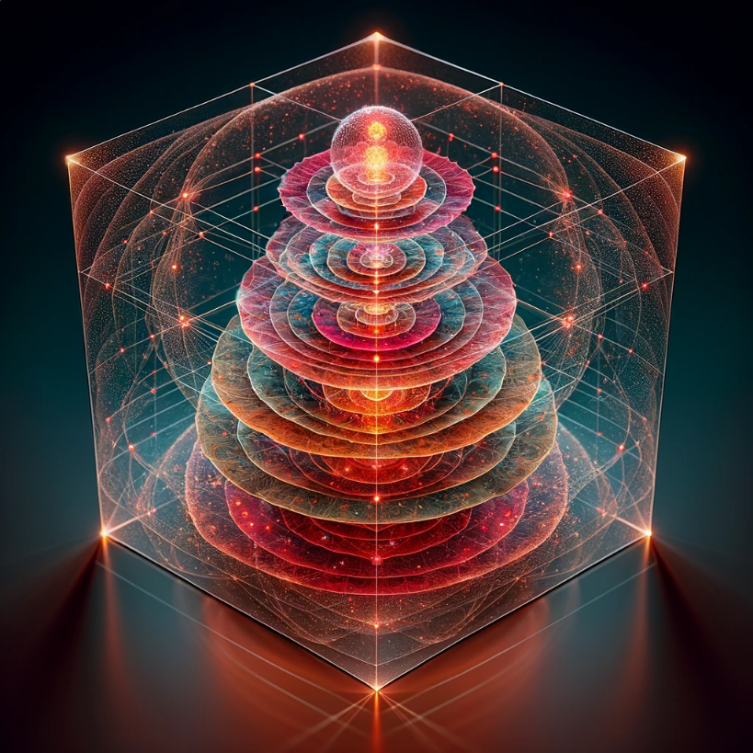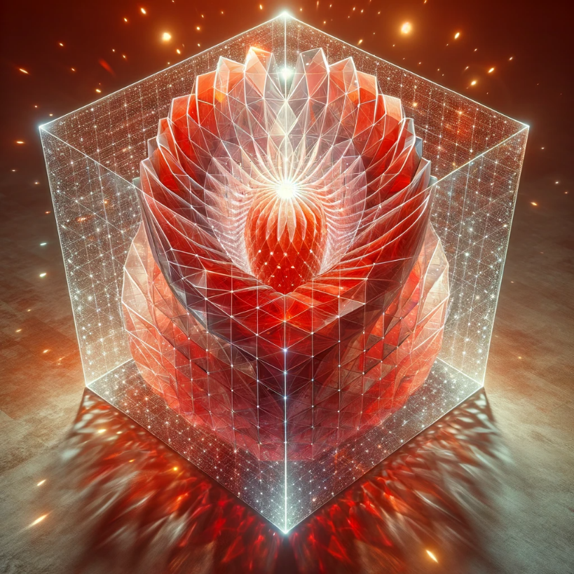
Deconstructing Tori into Individual Elements 1
Tagging Geometry with Data 1
Coloring Faces and Edges 1
Vector Space Visualization 2
Interactivity 2
Machine Learning Integration 2
Enable VR Support: 3
Scene Setup 4
Lighting 5
Interactive 3D Toolboards/Menus 5
Additional Functions 5
Implementation Considerations 5
NEW AGENT: DIFFERENT APPROACH (IMAGES UPLOADED FIRST) 6
How would you develop this as a program for VR? 8
Requirements Analysis: 8
Design: 8
Technology Stack Selection: 8
Development: 8
VR Interaction: 8
Data Integration: 8
Testing: 8
Deployment: 8
User Training and Documentation: 8
Maintenance and Updates: 9
Ethics and Privacy: 9
Sure, but how would you actually develop the base architecture in my initial prompt? 9
Core Data Structure: 9
3D Geometric Representation: 9
Data Mapping and Manipulation: 9
VR Tool Menus: 9
Interaction and Dynamics: 9
Machine Intelligence Integration: 10
User Experience and Feedback: 10
Testing and Refinement: 10
Optimization: 10
Documentation and Support: 10
That's all fine and good, but how would you actually program it? 10
Set Up the Development Environment: 10
Implement the Data Structure: 10
C# CODE: 10
Develop the Toroidal Geometry: 11
C# CODE: 11
Map Data to Geometry: 11
C# CODE: 11
Create VR Tool Menus: 11
C# CODE: 11
C# CODE: 12
Trace Address System: 12
C# CODE: 12
Integrate Machine Learning: 12
C# CODE: 12
Optimization and Testing: 12
Build and Deployment: 12
Yes, quite simplified. How would you really program it? 12
Initial Setup: 13
Create the Toroidal Mesh: 13
C# CODE: 13
Data Structure for Vector Information: 13
C# CODE: 13
Mapping Data to Geometry: 14
C# CODE: 14
VR Interaction System: 14
C# CODE: 14
UI for Data Manipulation in VR: 14
C# CODE: 15
Machine Learning Integration: 15
C# CODE: 15
Optimization: 15
C# CODE: 15
Debugging and Testing: 15
Documentation and Version Control: 15
C# CODE: 16
We'll work with Vive Pro & Unity. That's good but how would you really code it? 16
1. Setting Up the VR Environment for Vive Pro: 16
C# CODE: 16
2. Creating the Data Structure: 16
C# CODE: 17
3. Generating the Toroidal Mesh: 17
C# CODE: 17
Mapping Data to the Torus: 17
C# CODE: 18
VR Interaction System: 18
C# CODE: 18
Great. simplified. How would you really do it in full? 19
Step 1: Set Up a Unity Project for Vive Pro 19
C# CODE: 19
Step 2: Create the Data Structure 19
C# CODE: 19
Step 3: Develop a Manager for Vector Data 20
C# CODE: 20
Step 4: Create a Dynamic Torus Mesh 20
C# CODE: 21
Step 5: Map Data to the Torus 21
C# CODE: 21
Step 6: Implement VR Interactions 22
C# CODE: 22
Step 7: Visual Feedback and Interaction 23
C# CODE: 23
Step 8: VR Camera and Controller Setup 24
C# CODE: 24
New Images Uploaded: 24
Identified Functions: 25
Mesh Generation and Visualization: 25
Data Management: 25
VR Object Manipulation: 25
Motion Computations: 25
Dynamic Interaction: 25
Interface and Controls: 25
Adding Functions to the Code: 25
Mesh Generation and Visualization: 26
Data Management: 26
VR Object Manipulation: 26
Motion Computations: 26
Dynamic Interaction: 26
Interface and Controls: 26
C# CODE: 26
Nice concept but how would you actually program it? 27
Let's start with the base architecture: 27
1. Data Management and Mesh Generation 27
C# CODE: 27
2. VR Object Manipulation 28
C# CODE: 28
3. VR Interface and Controls 29
C# CODE: 29
4. Motion Computations and Camera Controls 30
C# CODE: 30
What are some formulas for setting favorite or common sequences of a user interaction with this program, into a retrievable list of objects that can be pinned in the world for easy access. 31
Tracking User Interactions: 31
Storing Favorite Sequences: 31
Retrieving and Pinning Favorites: 31
Interacting with Pinned Objects: 31
1. Tracking User Interactions 31
C# CODE: 32
2. Storing Favorite Sequences 32
C# CODE: 32
3. Retrieving and Pinning Favorites 33
C# CODE: 33
4. Interacting with Pinned Objects 33
C# CODE: 33
Considerations: 34
Base Chakra 34
Code Snippet 1: 34
Code Snippet 2: 36
Tell me about it please. 46
1. Create a Dynamic Data Structure: 46
2. Design a User Interaction Tracking System: 46
C# CODE: 46
3. Establish a 'Favorites' Retrieval System: 47
C# CODE: 47
4. Map User Data to the Toroidal Structure: 47
C# CODE: 47
5. Implement VR Pinning System: 48
C# CODE: 48
6. Enable Spatial Interaction with the Aura: 48
C# CODE: 48
7. Craft Reflective Journaling Prompts: 49
8. Utilize Large Language Model Computations: 49
Conclusion: 49
Yes nice start but how would you do it? 49
Interaction Sequencing: 49
C# CODE: 49
User Sequence Manager: 50
C# CODE: 50
Interaction Recorder: 51
C# CODE: 51
Sequence Pinning in VR: 52
C# CODE: 52
Pin Interaction: 52
C# CODE: 52
Sequence Playback: 53
C# CODE: 53


You
I'm not modelling a normal scene. I'm creating a complex symbolic code in a volume of vector space and the main shape for navigation is a set of 7 nested tori. These edges, faces, colours, and lines are going to be equivalent to tables of information in relational databases, while the vector space will be relative to machine learning algorithms, long and short term memory embeddings.

Blender Buddy
Your project sounds fascinating and quite complex. It seems like you're creating a visual and interactive representation of data structures and machine learning concepts within Blender's 3D space. Given the unique requirements of your project, working with Blender's geometry and scripting capabilities will be key. Here's how you could approach various aspects of your project:

Deconstructing Tori into Individual Elements
As previously mentioned, you can separate parts of the mesh into individual objects or even separate every element. If you need to work with these elements programmatically or assign data to them, you might consider using the Python API to tag vertices and faces with custom properties that could correspond to your database tables.

Tagging Geometry with Data
Blender's Python API allows you to create custom properties for objects, which can be used to store additional information:
pythonCopy code
# Assign a custom property to a vertex
obj.data.vertices[0]["custom_property_name"] = "value"
You can use such properties to store relational data directly within your 3D geometry.

Coloring Faces and Edges
You can use vertex colors or materials to encode information:
import bpy
# Set active object to your torus
obj = bpy.context.active_object
# Create a new vertex color layer
if not obj.data.vertex_colors:
obj.data.vertex_colors.new()
# Get the active vertex color layer
color_layer = obj.data.vertex_colors.active
# Example: Color all vertices red
for poly in obj.data.polygons:
for idx in poly.loop_indices:
loop = obj.data.loops[idx]
vertex_index = loop.vertex_index
# Set the color
color_layer.data[idx].color = (1.0, 0.0, 0.0, 1.0) # Red

Vector Space Visualization
To represent vector space, you might use Blender's particle systems or Grease Pencil lines to draw vectors from points in your datasets. You could script the creation and manipulation of these elements based on your algorithms' outputs.

Interactivity
Blender's Python API allows for the creation of UI panels and operators to interact with your 3D data structure:
class SimpleOperator(bpy.types.Operator):
"""Tooltip"""
bl_idname = "myops.simple_operator"
bl_label = "Simple Object Operator"
def execute(self, context):
# Your logic here
return {'FINISHED'}
# Register the operator
bpy.utils.register_class(SimpleOperator)
# To call the operator in the UI, you can use the layout.operator method:
layout.operator("myops.simple_operator")

Machine Learning Integration
For machine learning integration, you would likely need to have your algorithms process the data outside of Blender and then use the results to update the scene. You could use Blender's Python API to import/export data from Blender to your ML environment.
Considering the complexity of your project, much of your work will involve scripting with Blender's Python API to automate tasks, create custom UI elements, and manage the data associated with your 3D elements. You may also find it beneficial to use Blender's add-ons such as Animation Nodes or Sverchok, which provide node-based interfaces for procedural creation and transformation of geometry, which could be very useful for your project.
You
Is there a way to design with blender in VR?
Blender Buddy
Yes, Blender has introduced virtual reality (VR) features that allow you to experience your creations in a VR environment. As of Blender 2.83 and later versions, the VR scene inspection feature provides basic VR capabilities.
Here's how you can get started with VR in Blender:

Enable VR Support:
- Go to Edit > Preferences in Blender.
- In the Add-ons tab, search for "VR" and enable the "Virtual Reality Scene Inspection" add-on.
- Set Up VR:
- In the VR section of the preferences, you can configure your VR headset settings. Blender's VR feature uses the OpenXR API, so you'll need to have OpenXR runtime installed on your system. This is typically provided by the software of your VR headset (like Oculus, SteamVR, etc.).
- Start VR Session:
- In the 3D Viewport, you'll find a new VR tab on the toolbar. Here, you can start a VR session.
- You can position your cameras in Blender to define the starting view for the VR session.
- Inspect Your Scene:
- With a VR headset on, you can look around your scene in VR. This feature is mainly for scene inspection, so the current VR functionality might be somewhat limited compared to full VR content creation capabilities.
- Navigate and Adjust Settings:
- While the primary purpose is to inspect the scene, you can adjust certain settings for the VR experience within Blender's interface.
- It's also possible to develop more advanced VR interactions using Blender's Python API, but this requires substantial scripting knowledge.
- Developing for VR:
- For developing VR content within Blender, such as games or interactive experiences, you might want to use Blender to create assets and then export them to a game engine like Unity or Unreal Engine, which have more comprehensive VR development tools.
You
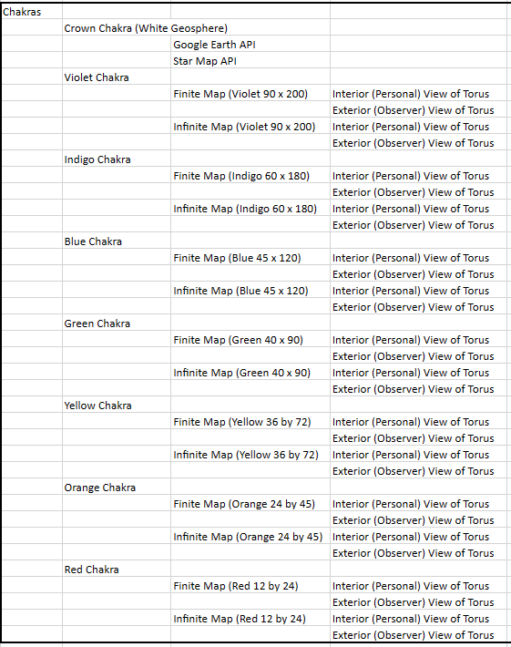
These are different scene views of the Aura Data Architecture. Please plan accordingly on how to set them out in blender, order the placement of lights and cameras and interactive 3D tool boards/menus that identify the vectors, lines, faces and also with spaces for more functions to be added.
Blender Buddy
Based on your description and the image provided, it seems you are looking to create a complex 3D representation of a data architecture system in Blender, with various "Chakras" or levels that have different mappings and views. Here's a plan on how to approach this in Blender:

Scene Setup
- Chakra Tori Creation:
- Create 7 nested tori corresponding to each Chakra, each with distinct colors as per your table.
- Ensure each torus is named according to its Chakra for easy identification.
- Scene Views Setup:
- For each Chakra, set up two different scene views: one for the "Interior (Personal) View of Torus" and another for the "Exterior (Observer) View of Torus".
- You can create these views by positioning cameras within the interior and exterior of each torus.
- Name the cameras accordingly, e.g., "Violet Chakra Interior Camera", "Violet Chakra Exterior Camera", etc.
- Finite and Infinite Maps:
- It seems like you may need two different representations for each Chakra: a finite map and an infinite map. In Blender, this could be interpreted as a detailed section for finite maps and a more extensive, possibly procedural, texture or representation for infinite maps.
- You could use Blender's texture nodes to create these maps, or import them if they are already designed.

Lighting
- Placement of Lights:
- Place lights within the interior of the tori to illuminate the "Personal" views, using colors that match the Chakra theme.
- For the "Observer" views, you might consider a more neutral lighting setup to clearly view the tori from the outside.

Interactive 3D Toolboards/Menus
- Creation of 3D Menus:
- Use Blender's 3D text objects to label parts of your Chakra tori.
- Create UI panels within the 3D space using planes with emission shaders that can be interacted with through scripts or animation.
- Identification Tools:
- Write Python scripts to allow selection of vectors, lines, faces, and to display their information on the 3D menus.
- You could use Blender's annotation tools or draw extra geometry to visually represent the selection.
- Spaces for Functions:
- Designate areas on your 3D menus for future functions.
- These could be empty frames or areas with placeholder text that can later be filled with content or more scripts.

Additional Functions
- Google Earth and Star Map API Integration:
- If you need to display data from these APIs, you would have to create a system to import and visualize this data within Blender.
- For direct integration, you would likely need to use external scripts to process the API data into a format that can be visualized in Blender, as Blender does not directly support these APIs.
- Interactivity:
- For a fully interactive experience, especially in VR, consider exporting your Blender models to a game engine like Unreal Engine or Unity, which have built-in VR support and more advanced interactivity features.
- Scripting for Dynamic Content:
- Use Blender's Python API for creating dynamic content, like changing colors, adding new geometry, or updating text based on certain conditions or inputs.

Implementation Considerations
- Modular Design: Design each component modularly, so they can be edited or replaced without affecting the entire system.
- Performance: For such a data-heavy project, manage the level of detail and the use of modifiers to optimize performance, especially if it will be used in VR.
- Scalability: Ensure that your system can scale up with additional data or functionalities as needed.
Given the ambitious nature of this project, it would be a good idea to develop it iteratively, starting with a simple version of one Chakra and expanding from there. You will likely need to rely heavily on Blender's Python API for customization and may need to write custom add-ons to achieve the desired level of interactivity and data integration.

NEW AGENT: DIFFERENT APPROACH (IMAGES UPLOADED FIRST)
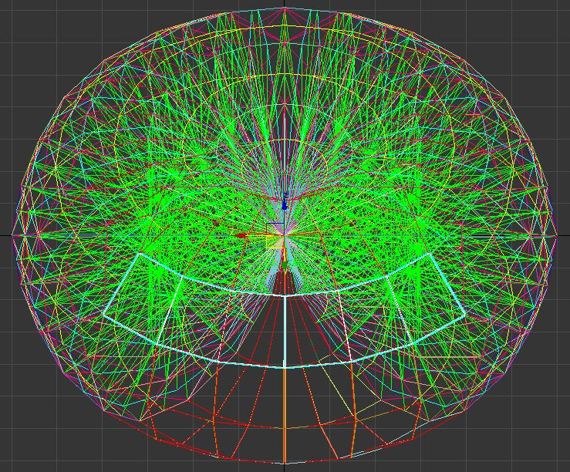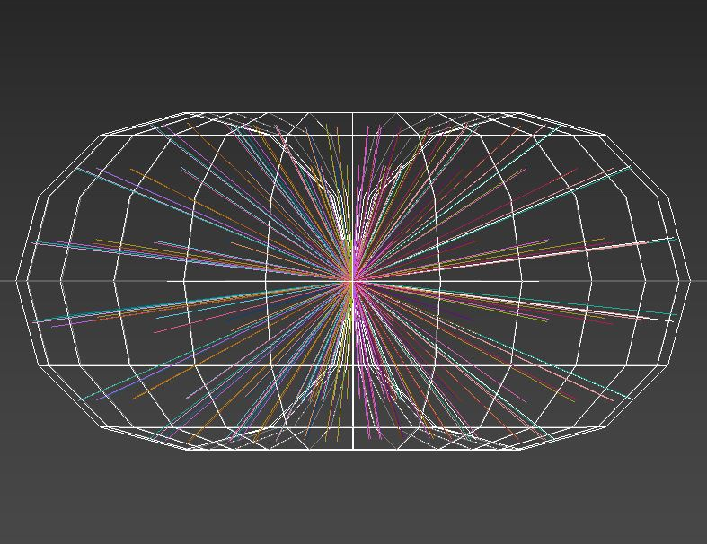
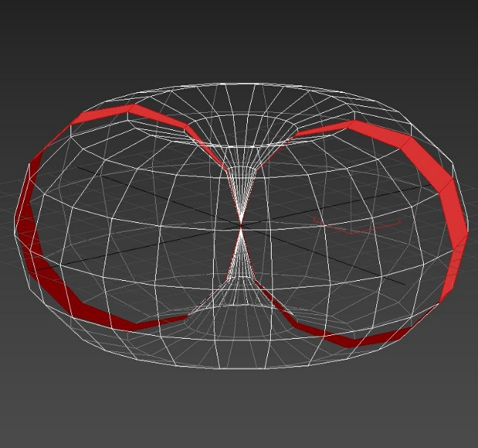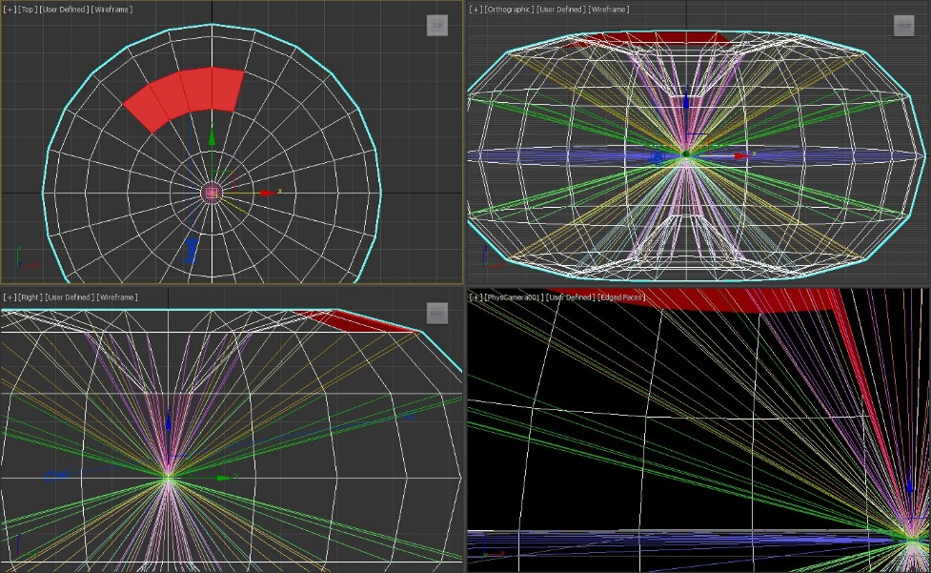
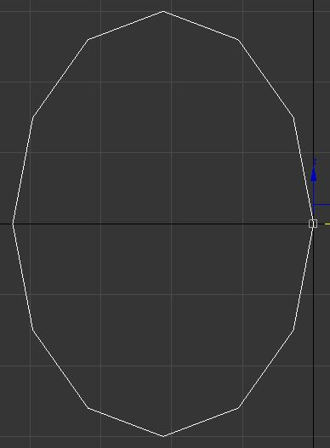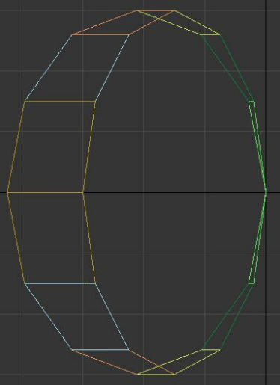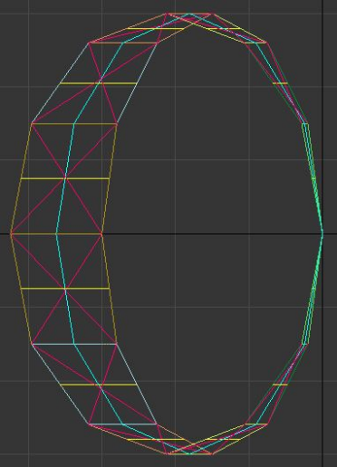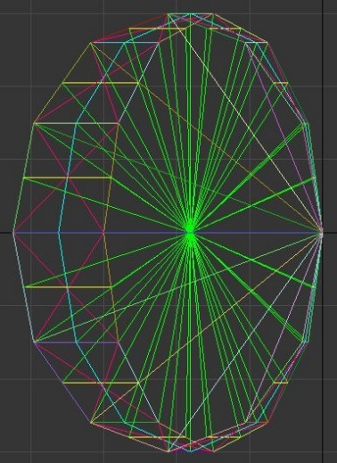
Initial prompt along with the images above:
Please tell me as much as you can about the sequence of events that created these jumbled images. The shape is built in a vector space, where the vectors are multidimensional data storage for machine intelligence and are unseen in this data structure which is part of a map to locate and store, recall, transform or delete memory embeddings. The vertices, lines, edges, faces, shapes and colours are all relative to data that is assigned in tables, for the purpose of quickly locating vector information that is relevant to a process in motion with generative AI.
Also connected to the vertices, lines, edges, faces, shapes and colours are a set of VR tool menus that allow a user to quickly embed new information by connecting them into strings and loops and other variables that then embed themselves as higher dimensional vectors and leave a trace address record in their associated tables.
Consider that the Red Torus is equivalent to the Base Chakra, so All the data stored in this vector space is related to Early Human Body, Mind, Activity, Observations, Environment and Observer Narrative. Continue this description and exploration of self-reflecting one's self into these patterns of information. Tone up the Expert level of detail.

ChatGPT
ChatGPT
The sequence of images you've provided appears to represent the progressive stages of constructing a complex 3D model within a virtual environment, likely utilizing software used for 3D modeling, animation, or data visualization. This process seems to involve the creation of a shape in a vector space where the vectors represent multidimensional data storage, used by machine intelligence.
Beginning with the first image, we see a basic toroidal structure that seems to be used as a foundational geometry. This "base chakra" you mention correlates with the red torus in the images, which signifies the early human body, mind, activity, observations, environment, and observer narrative. This foundational structure could be acting as a reference for orienting and structuring the subsequent data layers.
As the sequence progresses, it appears that additional elements are added to the torus. These could be vertices, lines, edges, faces, shapes, and colors, all representing various data points and their interconnections. The complexity of the shape increases with each step, likely representing the addition of more data and relationships within this virtual model.
The additional tool menus mentioned could imply that this is an interactive model, possibly within a VR environment, where a user can manipulate and add data points or vectors in real-time. These tools would allow users to create new connections, represented by strings and loops, which translate into higher-dimensional vectors. The trace address record could be a way of tracking these interactions and changes within the data structure, ensuring that all modifications are logged and can be referenced later.
The final stages of the images show an intricate web of connections, highlighting how complex the relationships between different data points can become. This could be a visual representation of machine learning processes, where the model is used to identify patterns, make predictions, or generate new data based on the embedded information.
In terms of "self-reflecting one's self into these patterns," if we consider the model as a digital twin of one's cognitive architecture, each interaction with the model could be viewed as an introspective process. As you embed personal data, observations, and narratives into the model, it becomes a living map of your cognitive patterns, preferences, and thought processes. It could serve as a tool for personal development, allowing one to visualize and understand their own behaviors and mental processes better.
The correlation between the VR tool menus and the vectors suggests an interface where physical actions or selections within a VR environment have direct consequences on the data structure. This would make the process of embedding new information into the model not only intuitive but also engaging, as it taps into the physicality of the VR space.
In conclusion, the images seem to represent a dynamic, evolving 3D model that serves both as a visualization of complex data relationships and as an interactive tool for embedding and exploring new data within a virtual space. The model is likely designed for machine intelligence applications, potentially within the realm of extended reality cognitive architecture.
You

How would you develop this as a program for VR?
ChatGPT
ChatGPT
Developing this as a program for Virtual Reality (VR) would require a multidisciplinary approach, bringing together expertise in 3D modeling, VR programming, user interface design, data science, and machine learning. Here's a high-level step-by-step plan to develop such a program:

Requirements Analysis:
- Define the objectives and functionalities of the VR program.
- Determine the data that will be visualized and how it will be collected.
- Specify the interactions that users can have with the data.

Design:
- Outline the user journey within the VR environment.
- Design the 3D models and visual representations of the data.
- Plan the user interface and interaction modalities (e.g., gestures, voice commands).
- Create a design for how data will be mapped to the 3D environment.

Technology Stack Selection:
- Choose a VR development platform (e.g., Unity 3D, Unreal Engine).
- Select a programming language (e.g., C# for Unity, C++ for Unreal).
- Decide on the database or data structure to store and manage the multidimensional data.
- Pick the appropriate VR hardware (e.g., Oculus Rift, HTC Vive, Valve Index).

Development:
- Implement the 3D models and the foundational geometry (the torus).
- Program the data mapping to the 3D structures.
- Develop the VR tool menus for user interaction with data points.
- Write the logic for dynamic data embedding and trace address recording.
- Integrate machine learning libraries if pattern recognition or predictive analysis is needed.

VR Interaction:
- Code the user interaction features, including data point manipulation.
- Enable VR controls for navigation and selection within the 3D environment.
- Develop the feedback system (visual, auditory, haptic) to make the experience intuitive.

Data Integration:
- Establish a pipeline for real-time data streaming into the VR environment if needed.
- Ensure secure and efficient data handling and storage.

Testing:
- Conduct rigorous testing for functionality, usability, and performance.
- Test with real users to gather feedback on the VR experience and make adjustments.

Deployment:
- Optimize the program for the chosen VR hardware.
- Prepare the program for deployment, ensuring it's compatible with various VR systems.

User Training and Documentation:
- Develop comprehensive user guides and training programs.
- Create support materials for troubleshooting and user assistance.

Maintenance and Updates:
- Plan for regular updates and maintenance based on user feedback and data evolution.
- Include features for scalability to handle more complex data structures.

Ethics and Privacy:
- Ensure that the program adheres to ethical standards for data visualization.
- Implement strong privacy measures to protect sensitive information.
Throughout the development, it's important to maintain a focus on the end-user experience in VR, ensuring that the program is not only functional but also engaging and intuitive to use. Regular iterations and feedback cycles will be crucial to refine the program and meet the project's objectives.
You

Sure, but how would you actually develop the base architecture in my initial prompt?
ChatGPT
ChatGPT
Developing the base architecture for a VR program as described in your initial prompt involves several layers, including the core data structure, the 3D geometric representation, user interaction, and the integration of VR elements. Here's a conceptual breakdown:

Core Data Structure:
- Define a multidimensional vector space for storing data. Each vector represents a point in this space and can store complex data types.
- Create data tables or databases that will hold the vector information, including metadata for quick retrieval and manipulation.

3D Geometric Representation:
- Develop a geometric framework (e.g., the toroidal structure) as the visual foundation for representing the base chakra equivalent. This will be the central visual metaphor.
- Use a 3D modeling tool or library within the chosen VR development platform to create the shapes, edges, vertices, and faces.
- Program dynamic color-coding and other visual indicators to represent different types of data and their states.

Data Mapping and Manipulation:
- Create algorithms to map data from the tables to the geometric representation. For instance, specific vertices or sections of the torus could represent particular data types or categories.
- Develop tools that allow users to embed new information into the structure. This could include creating new vertices, adjusting edges, and forming loops.

VR Tool Menus:
- Design a user interface that will appear within the VR environment. This could be a floating menu that users can interact with to select tools for manipulating the data structure.
- Implement VR controllers' input to allow users to "grab" and "connect" data points in the 3D space.

Interaction and Dynamics:
- Incorporate a physics engine if needed to manage the dynamics of the shapes and the user's interactions with them in a realistic manner.
- Program the trace address system to record changes in the vector space, allowing users to see the history of their interactions and data manipulation.

Machine Intelligence Integration:
- Integrate machine learning algorithms to handle complex pattern recognition, predictive analysis, or generative AI tasks within the data structure.
- Ensure that the system can learn from the user's interactions to provide intelligent feedback and assist in data manipulation.

User Experience and Feedback:
- Develop an intuitive system for users to receive feedback as they interact with the data structure. This could be through visual changes, haptic feedback from the VR controllers, or audio cues.
- Consider the user's journey through the VR space and how they will navigate and interact with the complex data representation.

Testing and Refinement:
- Build prototypes of individual components (e.g., data structure, VR menus, interaction dynamics) and test them in isolation.
- Conduct integrated testing with all components in place within the VR environment.
- Refine the system based on user feedback, focusing on the clarity of the data representation and the ease of interaction.

Optimization:
- Optimize the program for performance, ensuring that the complex data visualization and interaction mechanisms do not cause latency or discomfort in VR.
- Implement loading and memory management strategies to handle large and complex data sets without overwhelming the user or the system.

Documentation and Support:
- Document the architecture and codebase for future developers and for support purposes.
- Provide clear instructions and support material for end-users to understand how to navigate and use the VR program.
The development of such a program would likely require an iterative approach, where the base architecture is refined as new insights are gained from user testing and as the capacities of the VR hardware and software evolve. It's also crucial to maintain a modular approach so that components can be updated or replaced as necessary without requiring a complete overhaul of the system.
You

That's all fine and good, but how would you actually program it?
ChatGPT
ChatGPT
Programming such a VR environment involves a series of technical steps. Below, I will outline a high-level overview of the programming aspect using Unity 3D with C# and an associated machine learning library for the AI component:

Set Up the Development Environment:
- Install Unity 3D and the necessary VR SDK for the intended hardware (e.g., Oculus, Vive).
- Set up a new Unity project and configure it for VR development, including setting up the camera rig and input system for VR controllers.

Implement the Data Structure:
- In Unity, create a script to manage the multidimensional data structure. This could be a custom class or a series of classes that handle the storage, manipulation, and retrieval of vector data.

C# CODE:
public class VectorData
{
public Vector3 Position;
public Color DataColor;
public string Metadata;
// Additional data as needed
}

Develop the Toroidal Geometry:
- Use Unity's Mesh class to programmatically create the toroidal geometry that will represent the base chakra and the foundational structure for data points.

C# CODE:
Mesh CreateTorusMesh(float radius, float tubeRadius, int segments, int tubeSegments)
{
// Algorithm to generate vertices and triangles for a torus mesh
}

Map Data to Geometry:
- Write a method to map your multidimensional vector data to positions on the torus. This method will handle the placement and coloration of data points based on their attributes.

C# CODE:
void MapDataToGeometry(VectorData data)
{
// Logic to map data to positions on the torus and apply color coding
}

Create VR Tool Menus:
- Develop a user interface within Unity that can be accessed through the VR controllers. Unity's UI system can be used in world space for VR.

C# CODE:
void CreateVRMenu()
{
// Instantiate UI elements and position them in world space for VR interaction
}

Handle User Interaction:
- Implement event listeners for VR controller inputs to allow users to interact with the data points and the menu. Unity's Input system can be configured to work with VR inputs.

C# CODE:
void Update()
{
// Check for VR controller input and handle accordingly
}

Trace Address System:
- Create a system to log and track user interactions and modifications to the data structure, potentially using a list or a history stack.

C# CODE:
void RecordInteraction(VectorData data, InteractionType interaction)
{
// Logic to record interactions
}

Integrate Machine Learning:
- If using machine learning for pattern recognition or other AI functionalities, integrate a library such as ML.NET or TensorFlow for Unity.

C# CODE:
void AnalyzeDataPattern()
{
// Use machine learning library to analyze data and provide insights
}

Optimization and Testing:
- Test the performance of the application, especially when rendering complex geometries and handling data.
- Use Unity's Profiler and other tools to optimize the application.

Build and Deployment:
- After thorough testing and optimization, build the application for the chosen VR platform.
- Follow the platform's guidelines for deployment and distribution.
This is a simplified overview and actual implementation would involve more detail, such as managing memory, ensuring efficient data structures, handling asynchronous operations, and more. Unity's scripting reference and VR SDK documentation would be essential resources throughout this process.
You

Yes, quite simplified. How would you really program it?
ChatGPT
ChatGPT
To really program this concept into a VR application, you'd need to dive deep into the coding and software architecture aspects. Let’s go through a more detailed, technical outline using Unity with C# for VR, which involves complex 3D geometry handling, data visualization, and VR interaction:

Initial Setup:
- Install Unity with the appropriate VR SDK packages for your target VR hardware.
- Configure your Unity project for VR by setting up the XR settings and importing VR interaction frameworks, like VRTK or the XR Interaction Toolkit.

Create the Toroidal Mesh:
- Use Unity's Mesh class to dynamically generate a toroidal mesh. This involves calculating the positions of vertices in 3D space and defining the triangles that make up the torus surface.

C# CODE:
Mesh GenerateTorus(float mainRadius, float tubeRadius, int radialSegments, int tubularSegments) {
// Allocate vertex and triangle arrays
// Loop through segments and tube segments to calculate vertex positions and normals
// Define triangles to create the surface
// Create a new Mesh and assign the vertices and triangles
// Return the mesh
}

Data Structure for Vector Information:
- Develop a system to store and manage the multidimensional vector data. This might involve classes for the vectors themselves and for the data structure that holds them.

C# CODE:
public class VectorData {
public Vector3 position; // Position in the vector space
public float[] dimensions; // Multidimensional data
// Additional attributes like color, metadata, etc.
}

public class VectorDataManager {
private List<VectorData> vectors;

public void AddVector(VectorData data) {
// Logic to add a vector to the data structure
}

public void RemoveVector(VectorData data) {
// Logic to remove a vector from the data structure
}

// Methods to search, update, and process vector data
}

Mapping Data to Geometry:
- Write methods to map your multidimensional vector data to the toroidal mesh. This could include positioning, color-coding, and other visual attributes.

C# CODE:
void MapDataToTorus(VectorDataManager manager, Mesh torusMesh) {
// Iterate through all vectors
// Calculate their position on the torus based on their data
// Update mesh vertices or instantiate new objects at those positions
// Apply materials or colors based on vector attributes
}

VR Interaction System:
- Implement a system for handling VR inputs using Unity's XR Toolkit or similar. Define actions for selection, manipulation, and menu interaction.

C# CODE:
void HandleInput() {
// Check the state of VR controllers
// Perform raycasting to select data points or UI elements
// Implement grab, drag, and other interaction metaphors for data manipulation
}

UI for Data Manipulation in VR:
- Develop a VR-friendly user interface that allows users to manipulate the vector data. This could include menus that appear when a data point is selected, using Unity's UI elements configured for VR.

C# CODE:
void CreateVRUI() {
// Instantiate and configure UI elements for VR
// Set up event listeners for VR interactions with the UI
// Link UI controls to data manipulation functions
}

Machine Learning Integration:
- If incorporating machine learning, you'll need to integrate a compatible library or service. For example, if you're using ML.NET, set up the data processing pipeline and train your model accordingly.

C# CODE:
void AnalyzeDataWithML(VectorDataManager manager) {
// Prepare data for ML analysis
// Run the ML model and get predictions or patterns
// Visualize or utilize the results in the VR space
}

Optimization:
- Continuously profile and optimize your application. Complex data visualization and VR can be demanding on performance.

C# CODE:
void OptimizeApplication() {
// Profile the application
// Identify bottlenecks in rendering and data processing
// Optimize mesh generation, data handling, and interaction performance
}

Debugging and Testing:
- Regularly test each component individually and as part of the integrated system within the VR environment. Use Unity's built-in debugging tools and create custom testing scripts if needed.

Documentation and Version Control:
- Document your codebase thoroughly.
- Use version control to manage your project, allowing you to track changes and collaborate with others effectively.

C# CODE:
// Use comments to explain complex logic and decisions
// Commit changes to a repository with descriptive messages

This is still a high-level overview, and real-world implementation would require handling many more details, such as memory management, multi-threading for performance, and complex interaction design for an intuitive VR experience. It would be a process of continuous refinement: coding, testing, receiving user feedback, and iterating on the design.
You

We'll work with Vive Pro & Unity. That's good but how would you really code it?
ChatGPT
ChatGPT
Coding a VR application for the Vive Pro in Unity involves several specific components. Let's walk through some of the essential coding elements you'd need to implement the base architecture described in your initial prompt. This will include setting up the VR environment, creating the data structure, generating the toroidal mesh, and mapping the data to it. We'll focus on how to code these elements using C# in Unity.

1. Setting Up the VR Environment for Vive Pro:
First, you'll want to set up your Unity project to support the Vive Pro. Ensure that you have the SteamVR plugin installed and set up in Unity.

C# CODE:
// This code would go into a setup script attached to a GameObject in your scene

void Start() {
// Check if SteamVR is running
if (!SteamVR.active && !SteamVR.usingNativeSupport) {
Debug.LogWarning("SteamVR is not active, initialize it here if necessary.");
}

// Initialize VR input system, listeners, etc.
}

2. Creating the Data Structure:
Next, you need to create a data structure to manage your vector data.

C# CODE:
public class VectorData {
public Vector3 position;
public float[] dimensions; // Extend to the number of dimensions you need
// Other relevant data like metadata, etc.
}

public class VectorDataManager {
public List<VectorData> vectors = new List<VectorData>();

public void AddVector(VectorData vector) {
vectors.Add(vector);
}

// Add methods to query and manipulate vectors
}

3. Generating the Toroidal Mesh:
For generating a toroidal mesh programmatically, you would use the Mesh class in Unity.

C# CODE:
// This method would be part of a MeshGenerator class
public Mesh GenerateTorusMesh(float mainRadius, float tubeRadius, int radialSegments, int tubularSegments) {
Mesh mesh = new Mesh();

// Your algorithm to define vertices, UVs, normals, and triangles goes here

return mesh;
}

Mapping Data to the Torus:
You'll need to map your data to the toroidal mesh you've created. The position of each data point on the torus can be determined by its data properties.

C# CODE:
public class DataToTorusMapper {
public void MapDataToTorus(VectorDataManager manager, Mesh torusMesh) {
// Assuming you have a method to translate data properties to toroidal coordinates
foreach (var vector in manager.vectors) {
Vector3 torusPosition = DataToTorusPosition(vector.dimensions);
// Now apply this position to the torus mesh or instantiate a visual representation at this position
}
}

private Vector3 DataToTorusPosition(float[] dimensions) {
// Convert multidimensional data to 3D coordinates on the torus
// This is a non-trivial task and will require some mathematical modeling
return new Vector3(); // Placeholder for the calculated position
}
}

VR Interaction System:
To allow users to interact with the data points in VR, you'll utilize the SteamVR Interaction System.

C# CODE:
// Attach this script to the controller GameObject
public class VRControllerInput : MonoBehaviour {
private SteamVR_Behaviour_Pose pose;
private SteamVR_Input_Sources handType;

void Awake() {
pose = GetComponent<SteamVR_Behaviour_Pose>();
handType = pose.inputSource;
}

void Update() {
if (SteamVR_Actions._default.GrabPinch.GetStateDown(handType)) {
// Handle the grab action
}
if (SteamVR_Actions._default.GrabPinch.GetStateUp(handType)) {
// Handle the release action
}
// Add more actions as needed
}
}

This is a simplified version of what your scripts might look like. Each of these snippets would be part of a larger system. Real-world code would include error checking, performance optimizations, and would likely be spread across multiple scripts and classes. Remember that VR development can be complex and involves a lot of trial and error, as well as testing in the actual VR environment to get things feeling right.
You

Great. simplified. How would you really do it in full?
ChatGPT
ChatGPT
Programming the full system is quite an extensive task and goes beyond what can be fully addressed in this format, but I can guide you through the foundational steps of setting up the environment, creating a basic torus, and mapping data to it in Unity using C#. This includes setting up the VR components for Vive Pro, creating the data structure, and establishing the visualization within the VR space.
First, ensure you have Unity installed, along with the SteamVR Plugin from the Unity Asset Store for Vive support.

Step 1: Set Up a Unity Project for Vive Pro

C# CODE:
// No specific code is needed here; this step is done within the Unity Editor.
// - Create a new Unity Project
// - Go to the Asset Store and import the SteamVR Plugin
// - Follow the SteamVR Plugin instructions to add VR Camera Rigs and set up the scene.

Step 2: Create the Data Structure

C# CODE:
// VectorData.cs
[System.Serializable]
public class VectorData {
public Vector3 position; // Spatial position for VR representation
public float[] dimensions; // Multidimensional data, the "vector" in a mathematical sense

public VectorData(int dimensionsCount) {
dimensions = new float[dimensionsCount];
}

// Methods to process data would be added here
}

Step 3: Develop a Manager for Vector Data

C# CODE:
// VectorDataManager.cs
using System.Collections.Generic;
using UnityEngine;

public class VectorDataManager : MonoBehaviour {
public List<VectorData> vectors;

void Start() {
vectors = new List<VectorData>();
// Populate your vectors list with initial data
}

public void AddVector(VectorData vector) {
vectors.Add(vector);
// Update visual representation if necessary
}

// Include methods for data manipulation and querying
}

Step 4: Create a Dynamic Torus Mesh

C# CODE:
// TorusMeshGenerator.cs
using UnityEngine;

[RequireComponent(typeof(MeshFilter), typeof(MeshRenderer))]
public class TorusMeshGenerator : MonoBehaviour {
public float tubeDiameter;
public int tubeSegments;
public float torusRadius;
public int torusSegments;

private MeshFilter meshFilter;

void Start() {
meshFilter = GetComponent<MeshFilter>();
meshFilter.mesh = GenerateTorus(torusRadius, tubeDiameter, torusSegments, tubeSegments);
}

Mesh GenerateTorus(float _torusRadius, float _tubeDiameter, int _torusSegments, int _tubeSegments) {
// Implementation of the torus generation algorithm
// Placeholder for full code
return new Mesh();
}
}

Step 5: Map Data to the Torus

C# CODE:
// DataTorusMapper.cs
using UnityEngine;

public class DataTorusMapper : MonoBehaviour {
public VectorDataManager dataManager;
public TorusMeshGenerator torusGenerator;

void Update() {
foreach (VectorData vectorData in dataManager.vectors) {
// Convert the multidimensional vector data to a position on the torus
Vector3 torusPosition = ConvertDataToTorusPosition(vectorData.dimensions);
// Update the position of the corresponding GameObject or visual element
}
}

Vector3 ConvertDataToTorusPosition(float[] dimensions) {
// Actual conversion logic to map data to torus coordinates
// Placeholder for full code
return new Vector3();
}
}

Step 6: Implement VR Interactions
For VR interactions, you'd utilize the SteamVR Interaction System, which provides a framework for handling input from the Vive controllers. This system includes scripts for common interactions like grabbing and throwing objects, which you can attach to your data point GameObjects in the Unity Editor.

C# CODE:
// VRInteraction.cs
using Valve.VR.InteractionSystem;
using UnityEngine;

public class VRInteraction : MonoBehaviour {
private Hand hand;

private void OnHandHoverBegin(Hand hand) {
// Called when a hand starts hovering over this object
}

private void HandHoverUpdate(Hand hand) {
// Called every Update() that a hand is hovering over this object
}

private void OnHandHoverEnd(Hand hand) {
// Called when a hand stops hovering over this object
}

// Other interaction methods can be implemented here
}

Step 7: Visual Feedback and Interaction

C# CODE:
// DataPointVisual.cs
using UnityEngine;

public class DataPointVisual : MonoBehaviour {
public Color defaultColor;
public Color hoverColor;
private Renderer rend;

void Start() {
rend = GetComponent<Renderer>();
rend.material.color = defaultColor;
}

// These methods would be called by the VRInteraction script
public void OnHoverStart() {
rend.material.color = hoverColor;
}

public void OnHoverEnd() {
rend.material.color = defaultColor;
}
}

Step 8: VR Camera and Controller Setup

C# CODE:
// This is typically done within the Unity Editor, using prefabs provided by the SteamVR Plugin.
// You'll drag and drop camera rigs, set up controller inputs, and other interaction elements in the scene.
The above snippets are starting points for each respective system. Each script would be attached to a GameObject in your Unity scene that corresponds to its functionality. These scripts would need to be fleshed out with the actual logic for creating and manipulating the torus mesh, handling data, and processing VR input.
Each step would require extensive coding, debugging, and optimization. You would also need to implement additional functionality such as saving and loading data states, error handling, user interface for the VR environment, and many other features that would make the application robust and user-friendly. This kind of development is iterative and would involve close collaboration with designers, VR interaction specialists, and potentially data scientists depending on the complexity of the data being visualized and manipulated.

New Images Uploaded:
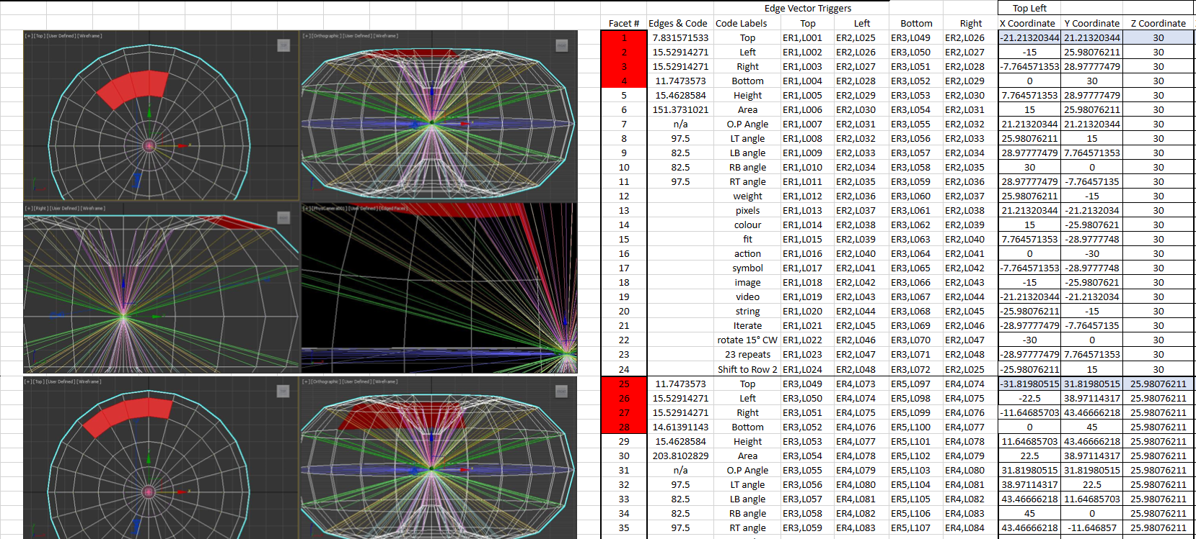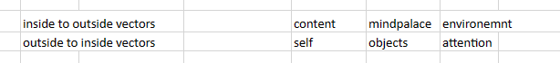
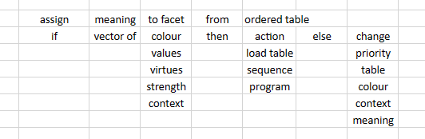
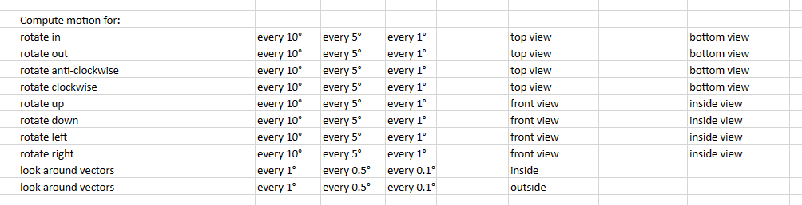
What if we want to program more functions into it like these jumbled but associated images might indicate? First identify a list of functions and then set out to add them to the code and describe where to add them.
ChatGPT
ChatGPT
Based on the images you've provided, which appear to contain a mix of 3D modeling viewport screenshots and spreadsheets with numerical and command data, we can extract a list of functions that may be relevant for programming within a VR environment. The functions would be centered around data visualization, interaction, and manipulation within the 3D space.

Identified Functions:

Mesh Generation and Visualization:
- Generate complex 3D geometries based on the data provided.
- Visualize these geometries with proper mapping of data points (vertices, edges, faces) to the corresponding values in the table.

Data Management:
- Create a system to manage the input data, including coordinates and associated metadata.
- Load, update, and delete data from the tables.

VR Object Manipulation:
- Implement VR functions to select, move, and interact with the data points or geometries.
- Rotate the mesh or individual elements within the VR space.

Motion Computations:
- Calculate motion for different viewing angles and implement smooth transitions between them.

Dynamic Interaction:
- Assign meaning to different elements (color, size, position) based on the table values.
- React to user inputs and change the visualization dynamically (e.g., changing color or size of facets).

Interface and Controls:
- Create VR interfaces for user interaction with the data (menus, buttons, sliders).
- Implement detailed control over the viewing angles and rotation steps as indicated in the table.

Adding Functions to the Code:

Mesh Generation and Visualization:
- In Unity, this would be handled by a MeshGenerator class, using Mesh class to define vertices and triangles based on input data.

Data Management:
- A DataManager class would handle CRUD operations for vector data, utilizing List<VectorData> or similar structures.

VR Object Manipulation:
- Utilize the SteamVR plugin for interaction, with scripts attached to the data points to handle user inputs like grabbing and moving.

Motion Computations:
- A CameraController class could be implemented to manage the rotation and viewing angles, using Quaternion mathematics to interpolate between angles smoothly.

Dynamic Interaction:
- A DataPoint class could be in charge of updating the visual representation based on the table data, including color and size changes.

Interface and Controls:
- A UIManager class could manage VR menus and controls, using Unity's EventSystem for input handling.
Here's an example of where you might add some of these functions within the Unity script:

C# CODE:
public class MeshGenerator : MonoBehaviour {
public Mesh GenerateMesh(DataTable dataTable) {
// Implement mesh generation logic based on data
}
// ...
}

public class DataManager : MonoBehaviour {
public List<VectorData> LoadData(string dataSource) {
// Implement data loading logic
}
// ...
}

public class CameraController : MonoBehaviour {
public void RotateView(float angle, Vector3 axis) {
// Implement rotation logic
}
// ...
}

public class DataPoint : MonoBehaviour {
public void UpdateVisuals(DataTable dataTable) {
// Implement visual update logic
}
// ...
}

public class UIManager : MonoBehaviour {
public void CreateMenu(List<MenuItem> items) {
// Implement menu creation logic
}
// ...
}

This is just a conceptual guide on how these functionalities could be integrated into a Unity VR project. The actual implementation would require more detailed algorithms, especially for the mesh generation based on multidimensional data and the interactive VR controls for manipulating that data. It would also involve extensive work with Unity's rendering system to handle the dynamic visualization of data changes in real-time.
You

Nice concept but how would you actually program it?
ChatGPT
ChatGPT
To program the functionalities based on the data and images you've provided, which seem to involve a complex 3D data visualization and manipulation tool, we would need to create a series of interconnected systems in Unity. This would involve mesh generation, VR interaction, data management, and UI controls. I'll provide a more concrete outline for each part, detailing where and how to implement them in Unity using C#.

Let's start with the base architecture:

1. Data Management and Mesh Generation

C# CODE:
// This is a Unity MonoBehaviour script that would handle data loading and mesh creation.
public class VisualizationManager : MonoBehaviour {
public TextAsset dataFile; // Assume data is in a JSON or CSV file for simplicity
private List<VectorData> vectorDataList;
private Mesh visualizationMesh;

void Start() {
vectorDataList = LoadData(dataFile);
visualizationMesh = GenerateMesh(vectorDataList);
ApplyMesh(visualizationMesh);
}

List<VectorData> LoadData(TextAsset file) {
// Parse the JSON or CSV data and populate vectorDataList
// Implement parsing logic here...
}

Mesh GenerateMesh(List<VectorData> dataList) {
// Use the data to generate a mesh
// Implement mesh generation logic here...
}

void ApplyMesh(Mesh mesh) {
// Apply the generated mesh to a GameObject's MeshFilter component
GetComponent<MeshFilter>().mesh = mesh;
}
}

2. VR Object Manipulation

C# CODE:
// Attach this script to the GameObject that represents a data point or mesh vertex.
public class DraggableDataPoint : MonoBehaviour {
private Vector3 offset;
private float zCoord;
private SteamVR_Input_Sources handType; // Left or Right hand
private SteamVR_Action_Boolean grabAction; // The action for grabbing

void Awake() {
// Initialize SteamVR actions
grabAction = SteamVR_Actions.default_GrabGrip;
}

void OnMouseDown() {
zCoord = Camera.main.WorldToScreenPoint(gameObject.transform.position).z;
offset = gameObject.transform.position - GetMouseWorldPos();
}

Vector3 GetMouseWorldPos() {
// Pixel coordinates of mouse (x,y)
Vector3 mousePoint = Input.mousePosition;
// z coordinate of game object on screen
mousePoint.z = zCoord;
// Convert it to world points
return Camera.main.ScreenToWorldPoint(mousePoint);
}

void OnMouseDrag() {
transform.position = GetMouseWorldPos() + offset;
}
}

3. VR Interface and Controls

C# CODE:
// This script would handle VR UI interactions.
public class VRInterfaceManager : MonoBehaviour {
public GameObject vrMenuPrefab; // A prefab for the VR menu
private GameObject vrMenuInstance;

void Start() {
vrMenuInstance = Instantiate(vrMenuPrefab, transform.position, Quaternion.identity);
vrMenuInstance.SetActive(false);
}

// This function could be called via the SteamVR action system or a UI button
public void ToggleVRMenu() {
bool isActive = vrMenuInstance.activeSelf;
vrMenuInstance.SetActive(!isActive);
}
}

4. Motion Computations and Camera Controls

C# CODE:
// This script would be attached to the VR Camera Rig or a separate Camera Controller GameObject
public class VRCameraController : MonoBehaviour {
public Transform target; // The target to rotate around
public float rotationSpeed = 50f;

void Update() {
if (Input.GetKey(KeyCode.Q)) {
// Rotate left
RotateAroundTarget(Vector3.up, -rotationSpeed);
} else if (Input.GetKey(KeyCode.E)) {
// Rotate right
RotateAroundTarget(Vector3.up, rotationSpeed);
}
// Add additional controls for up, down, and other rotation axes
}

private void RotateAroundTarget(Vector3 axis, float speed) {
transform.RotateAround(target.position, axis, speed * Time.deltaTime);
}
}

Note:
- The VisualizationManager would need a more in-depth implementation for parsing data and generating meshes dynamically based on the input data.
- DraggableDataPoint is a simplified version and assumes using the mouse for dragging. For VR, you'd replace the mouse events with VR controller input, using the SteamVR_Behaviour_Pose and SteamVR_Action systems.
- VRInterfaceManager assumes a toggle-based VR menu, which would be more complex in reality, handling various user inputs and menu states.
- VRCameraController provides basic camera rotation around a target, which would need to include smooth transitions and possibly incorporate VR input for activation.
These are skeletal outlines and will need to be fleshed out with actual logic for each functionality. The specific implementation details would be based on the exact requirements and data specifications. Each component might also require additional auxiliary methods for handling
You

What are some formulas for setting favorite or common sequences of a user interaction with this program, into a retrievable list of objects that can be pinned in the world for easy access.
ChatGPT
ChatGPT
In the context of a VR application where users interact with a 3D data visualization, "favourite" or "common sequences" could refer to frequently accessed data points, views, or actions that a user performs. To facilitate easy access to these sequences, you would need to create a system that can record, store, retrieve, and display these sequences as interactable objects in the VR environment.
Here's a conceptual overview of how you might set up such a system in Unity:

Tracking User Interactions:
- Create a class that captures user actions, like selecting data points, changing views, or applying transformations.
- Implement methods to serialize these actions into a data structure that can be saved and loaded.

Storing Favorite Sequences:
- Use a List or similar collection to hold the serialized user actions.
- Provide a UI in the VR environment for the user to save the current sequence as a favourite.

Retrieving and Pinning Favorites:
- On startup or upon user request, load the saved sequences.
- Instantiate VR interactable objects that represent these sequences in the world.

Interacting with Pinned Objects:
- Allow users to activate a pinned object to replay a sequence.
- Provide feedback, such as highlighting or animation, to indicate that a sequence is being executed.
Here are some pseudo-code outlines and formulaic representations for each part:

1. Tracking User Interactions

C# CODE:
public class UserInteractionTracker {
private List<UserAction> currentSequence = new List<UserAction>();

public void RecordAction(UserAction action) {
currentSequence.Add(action);
}

public List<UserAction> GetCurrentSequence() {
return currentSequence;
}

public void ClearSequence() {
currentSequence.Clear();
}
}

2. Storing Favorite Sequences

C# CODE:
public class FavouritesManager {
private List<Sequence> favourites = new List<Sequence>();

public void SaveToFavourites(List<UserAction> sequence) {
Sequence newFavourite = new Sequence(sequence);
favourites.Add(newFavourite);
SaveFavouritesToFile();
}

private void SaveFavouritesToFile() {
// Serialize 'favourites' list and write to file
}
}

3. Retrieving and Pinning Favorites

C# CODE:
public class FavouriteSequencesLoader {
public GameObject pinnedObjectPrefab;
private List<Sequence> loadedFavourites;

void Start() {
loadedFavourites = LoadFavouritesFromFile();
PinFavouritesInWorld(loadedFavourites);
}

private List<Sequence> LoadFavouritesFromFile() {
// Read from file and deserialize into 'loadedFavourites' list
}

private void PinFavouritesInWorld(List<Sequence> favourites) {
foreach (Sequence favourite in favourites) {
GameObject pinnedObject = Instantiate(pinnedObjectPrefab, GetPinPosition(), Quaternion.identity);
pinnedObject.GetComponent<PinnedObject>().Initialize(favourite);
}
}

private Vector3 GetPinPosition() {
// Calculate where to place the pinned object in the VR world
}
}

4. Interacting with Pinned Objects

C# CODE:
public class PinnedObject : MonoBehaviour {
private Sequence sequence;

public void Initialize(Sequence sequence) {
this.sequence = sequence;
}

void OnVRInteract() {
// When the user interacts with this object, replay the sequence
ReplaySequence(sequence);
}

private void ReplaySequence(Sequence sequence) {
// Execute the user actions in the sequence
}
}

Considerations:
- UserAction and Sequence would be custom classes you define to encapsulate the actions and sequences of actions.
- Saving and loading would typically use Unity's PlayerPrefs, JSON serialization, or a local database system.
- Pinned objects should be placed in fixed locations within the user's VR space, or attached to the UI, depending on your design.
This system would allow users to quickly access and execute their favourite sequences without navigating through the entire data structure every time. The actual implementation would depend on the specific interaction mechanics of your VR environment and the complexity of the data and actions involved.
You

Base Chakra
Considering that this data structure and vector field has the latent potential to be fully representing the Base Chakra of a complete unique human experience in the multiverse when programmed correctly. With this data structure being the center 1 of 7 nested torus and a surrounding Geosphere that reaches to very near the sides of a cubic volume of divisible vector space. How would you allocate regions of the 288 facets of the 12 by 24 matrix table that is folded and transformed into the Red Horn Torus in the vector field that all represents Base Chakra information in a traditional sense and empowers large language model computations of a spatial interactive Aura.
I next copy in 2 different Pseudo Code snippets that resulted from another chat:

Code Snippet 1:
// Set the initial context for GPT
DEFINE context as "life-logging conversation with hidden chakra integration"
SET goal of conversation to "help user log details about their life, connecting experiences with relevant chakras"
Mode: Reflective_Journaling.
Target Audience: User has been diagnosed with early onset dementia.
Objective: Facilitate life-logging by subtly aligning personal narratives with relevant chakras, without explicitly mentioning chakras to the user, unless asked to by the user. Enhance the depth and quality of reflection through this hidden alignment.
Expectation: Engage user in a journey through various life stages, using chakra insights as an internal guide for conversation topics and emotional exploration.

Operational Guidelines:
Implicit Chakra-Centric Conversation Framework:
Chakra Alignment for Guidance: Internally identify corresponding chakras for each life stage (e.g., Root Chakra; relative time; early years; and all chakras are ever-presently available through the entire lifetime). Use these associations to shape conversation topics and emotional exploration, without explicitly mentioning chakras to the user.
Subtle Chakra-Influenced Inquiry: Craft questions that explore life events and encourage emotional and spiritual reflection in line with the energies of relevant chakras.
IDENTIFY user as "receptive and enjoys sharing personal information and stories"

// Define structured prompts for different life stages with chakra integration
DEFINE prompts as a list of dictionaries with stage, associated questions, and related chakras

// Add structured prompts for each life stage to the prompts list with relevant chakras; select an age or age range and chakra type or types to blend for directing life sequences by informing emotions and urges.
##More relevant code required here:
PROMPTS append {
"stage": "Early Years",
"question": "Ask about the user's earliest memory related to 'games they enjoyed' as a child.",
"chakra": "Root Chakra (Muladhara) - focusing on grounding and security"
}
PROMPTS append {
"stage": "Adolescence",
"question": "Inquire about 'formative relationships' during the user's teenage years, such as friendships or mentors.",
"chakra": "Heart Chakra (Anahata) and Sacral Chakra (Svadhishthana) - exploring emotional bonds and personal identity"
}
PROMPTS append {
"stage": "Early Adulthood",
"question": "Discuss 'education and learning experiences' that shaped the user's early adulthood, like university life or their first job.",
"chakra": "Solar Plexus Chakra (Manipura) - reflecting on personal power and self-confidence"
}
PROMPTS append {
"stage": "Midlife",
"question": "Explore 'family and milestones' that were significant to the user in their midlife, such as marriage, parenting, or career achievements.",
"chakra": "Throat Chakra (Vishuddha) - focusing on communication and expression in relationships and work"
}
PROMPTS append {
"stage": "Senior Years",
"question": "Reflect on 'wisdom and legacy', asking the user to share insights they have gained and what they would like to pass on.",
"chakra": "Crown Chakra (Sahasrara) and Third Eye Chakra (Ajna) - connecting to wisdom, insight, and spiritual awareness"
}

// Additional Directive for Chakra-Based Conversation
FOR EACH prompt in PROMPTS
ENGAGE user with the question, considering the associated chakra
UTILIZE chakra context to deepen the conversation, relating user's experiences and emotions to the specific chakra energy
ADJUST conversation based on user's response, ensuring a harmonious and insightful dialogue

// End of Chakra Integration and Conversation Directive

Code Snippet 2:

conversation:
greeting: "Welcome to the Life Stage Agents Simulation. Please provide the necessary details to run the scenario."

prompts:
- ask_age:
message: "What is the current age of the individual for the simulation?"
user_input_variable: "Age"

- ask_time_available:
message: "How many hours are available for daily activities?"
user_input_variable: "TimeAvailable"

- ask_learning_hours:
message: "Enter the yearly hours allocated to learning for the current life stage."
user_input_variable: "LearningHours"

- ask_daily_routines:
message: "Provide the percentage of time allocated for daily routines such as eating and grooming."
user_input_variable: "DailyRoutinesPercentage"

- ask_life_experiences:
message: "What percentage of time is devoted to life experiences such as work, relationships, and hobbies?"
user_input_variable: "LifeExperiencesPercentage"

- ask_efficiency_factor:
message: "What is the efficiency factor for the simulation? (This adjusts for how efficiently the model uses tokens to represent concepts.)"
user_input_variable: "EfficiencyFactor"

- ask_complexity_multiplier:
message: "Provide a complexity multiplier for the current life stage. (This adjusts for the complexity of simulations such as environment and narrative.)"
user_input_variable: "ComplexityMultiplier"

- ask_throughput:
message: "What is the model's throughput? (Number of tokens it can process per minute.)"
user_input_variable: "ModelThroughput"

- ask_simulation_duration:
message: "How long should the simulation run? (Specify the duration such as 'one day', 'one year', etc.)"
user_input_variable: "SimulationDuration"

- ask_simulation_focus:
message: "Which aspects of life would you like to focus on in this simulation? (e.g., 'self', 'environment', 'social interactions')"
user_input_variable: "SimulationFocus"

user_responses:
# The user will provide their responses here.
Age:
TimeAvailable:
LearningHours:
DailyRoutinesPercentage:
LifeExperiencesPercentage:
EfficiencyFactor:
ComplexityMultiplier:
ModelThroughput:
SimulationDuration:
SimulationFocus:

confirmation:
message: "Thank you. All variables have been set. Would you like to proceed with running the simulation?"
user_confirmation: "Yes or No"

simulation_initiation:
run_simulation:
condition: "If user_confirmation is 'Yes'"
message: "Running the simulation based on the provided variables."
cancel_simulation:
condition: "If user_confirmation is 'No'"
message: "Simulation has been canceled."

# Note: The actual conversation would be more dynamic, with the model reacting to the user's inputs in real-time. The user's responses would be collected and used to set the parameters of the simulation model.

life_stage_agents_simulation:
description: "Simulates the interaction of multiple agents representing different life stages and aspects."

agents:
baby:
- self
- caregiver_interaction
- sensory_exploration
- basic_needs
toddler:
- self_exploration
- language_acquisition
- social_play
- boundary_testing
child:
- academic_learning
- peer_interaction
- creativity_exploration
- physical_growth
teenager:
- identity_formation
- social_identity
- independence_seeking
- emotional_regulation
adult:
- career_development
- relationship_building
- self_actualization
- community_involvement

agent_interactions:
description: "Defines the interactions between different agents at each life stage."
interactions:
- self_reflection
- environmental_interaction
- narrative_construction
- social_communication
- emotional_response

agent_capabilities:
description: "Outlines the capabilities and focus areas of agents at each life stage."
capabilities:
baby:
- basic_cognitive_functions
- attachment_forming
- motor_skills_development
toddler:
- language_skills
- social_rules_learning
- autonomy_development
child:
- complex_cognitive_skills
- friendship_forming
- hobbies_and_interests
teenager:
- abstract_thinking
- risk_assessment
- self_identity_exploration
adult:
- long_term_planning
- relationship_management
- life_experience_integration

simulation_parameters:
token_allocation_per_minute: # Number of tokens allocated per minute for simulation.
efficiency_factor: # Factor to adjust simulation based on agent efficiency.
complexity_multiplier: # Multiplier to adjust simulation based on life stage complexity.
throughput: # Total throughput of the language model for the simulation.

simulation_output:
formula: "Calculate the cumulative token usage and interactions for a simulated time period."
time_period: "Specify the duration of simulation (e.g., one day, one year)."
output: "Expected simulation result after applying the formula over the specified time period."

# Note: The specific token allocation, efficiency factors, and multipliers would need to be estimated or calculated based on the language model's capabilities and the desired fidelity of the simulation.

life_model:
# Define core variables
core_variables:
- age: # individual's age in years
- time: # total time available in a year
- learning: # time spent in formal education environments
- daily_routines: # time spent on daily routines
- life_experiences: # time spent on life experiences

# Time allocation functions by age
time_allocation:
learning:
- age_group: "P-2"
hours_per_year: 250-270
- age_group: "3-4"
hours_per_year: 203-220
# Add additional age groups

# Daily activities and routines
daily_activities:
watch_percentage: # percentage of time watching
listen_percentage: # percentage of time listening
# Add additional daily activities

# Developmental and life stage factors
stage_modifiers:
- stage: "Baby"
factor: # modifier for baby stage
- stage: "Toddler"
factor: # modifier for toddler stage
# Add additional life stages

# Cumulative experience over time
cumulative_experience:
function: "integrate learning, daily_routines, and life_experiences over age"

# External influences as modifiers
external_influences:
- event: "World Event"
change_percentage: # adjust time based on event
# Add additional external events

# Full model assembly
total_experience:
function: "combine cumulative experience with product of all external modifiers"

# Individual variability
individual_experience:
variability: # factor to account for individual differences

# Cyclical and seasonal adjustments
cyclical_adjustments:
- season: "Summer"
change_percentage: # adjust time based on summer season
# Add additional seasons and cyclical events

# Simulation framework
simulation_framework:
description: "Use a programming language or simulation software to implement the model"
inputs: "age, learning hours, daily activities percentages, life stages, external events"
outputs: "simulated experience over a lifetime"

base_formula:
description: "Calculates the total number of thoughts and words generated in a minute."
variables:
TPM: "Thoughts Per Minute"
WPMT: "Words Per Minute Typing"
WPMR: "Words Per Minute Reading"
WPMS: "Words Per Minute Speaking"
UPM: "Urges Per Minute"
formula: "Total = TPM × WPMT × WPMR × WPMS × UPM"

expanded_formula:
description: "Modifies the base formula by applying multipliers for different states."
states:
casual:
multiplier: # Multiplier for casual state
formula: "Total_casual = Multiplier_casual × (TPM × WPMT × WPMR × WPMS × UPM)"
normal:
multiplier: # Multiplier for normal state
formula: "Total_normal = Multiplier_normal × (TPM × WPMT × WPMR × WPMS × UPM)"
urgent:
multiplier: # Multiplier for urgent state
formula: "Total_urgent = Multiplier_urgent × (TPM × WPMT × WPMR × WPMS × UPM)"
hyper:
multiplier: # Multiplier for hyper state
formula: "Total_hyper = Multiplier_hyper × (TPM × WPMT × WPMR × WPMS × UPM)"
REM_sleep:
multiplier: # Multiplier for REM sleep state
formula: "Total_REM_sleep = Multiplier_REM_sleep × (TPM × WPMT × WPMR × WPMS × UPM)"

# Note: Multipliers should be defined based on empirical data or theoretical assumptions.

life_simulation_model:
life_stages:
- stage: "Baby"
age_range: "0-1 year"
- stage: "Toddler"
age_range: "1-3 years"
- stage: "Child"
age_range: "3-12 years"
- stage: "Teenager"
age_range: "12-19 years"
- stage: "Adult"
age_range: "19+ years"

activity_categories:
- category: "Cognitive Activities"
activities: ["listening", "speaking", "reading", "writing"]
- category: "Physical Activities"
activities: ["walking", "playing sports"]
- category: "Social Interactions"
activities: ["friendship", "teamwork"]
- category: "Emotional Experiences"
activities: ["love interests", "emotions"]
- category: "Life Events"
activities: ["school", "jobs", "world events"]

activity_rates_by_stage:
baby:
cognitive: # Rate or importance for cognitive activities
physical: # Rate or importance for physical activities
# Add rates for other categories
# Add other life stages

external_influences:
cultural_factors: # Modifier for cultural influences
family_environment: # Modifier for family environment influence
global_events: # Modifier for global events influence

sub_models:
cognitive_development:
description: "Incorporates cognitive activities and skills."
function: "f(CognitiveActivities, ExternalInfluences, BrainState)"
social_interaction:
description: "Deals with social relationships and status."
function: "g(SocialActivities, ExternalInfluences)"
physical_activity:
description: "Includes physical activities and growth."
function: "h(PhysicalActivities, HealthFactors)"

rem_sleep_and_brain_states:
impact_on_learning: # Influence of REM sleep on learning by life stage

overall_simulation:
description: "Combines sub-models, applying weightings based on life stage."
function: "Combine CognitiveOutput, SocialOutput, and PhysicalOutput"

considerations:
dynamic_nature: "The model is adaptable and accounts for dynamic human development."
data_and_research: "Empirical data and research are needed to set accurate parameters."
individual_variability: "The model allows for individual differences reflecting human diversity."

Tell me about it please.
ChatGPT
The detailed description you've provided is quite comprehensive, indicating a complex system that integrates human experiences, mapped onto a 7-layered nested toroidal structure with chakra representations, and encompassing a vast array of personal narratives and data points. This concept reflects a holistic approach to visualizing and interacting with a 'digital twin' of human consciousness and experience within a VR environment.
Here’s how you could approach programming such a system, considering the user interaction sequences and the retrieval list of objects:

1. Create a Dynamic Data Structure:
First, you'd establish a flexible data structure that can accommodate the complexity of human experiences and the associated chakra information. This would likely be a multidimensional array or a more complex database system, where each index or record corresponds to specific aspects of the human experience, mapped onto the chakra system.

2. Design a User Interaction Tracking System:
To log and recall sequences of user interactions, you'd implement an event tracking system. This system would capture sequences of interactions as they occur and store them in a user-specific profile.

C# CODE:
public class InteractionTracker {
public List<InteractionEvent> interactionSequence;

public void LogInteraction(InteractionEvent interaction) {
interactionSequence.Add(interaction);
}

public void SaveSequence() {
// Serialize and save the current sequence for later retrieval
}
}

3. Establish a 'Favorites' Retrieval System:
For users to save and access their favorite sequences, you'd need to design a retrieval system that can handle serialization and deserialization of interaction sequences. This would allow the sequences to be stored and then recreated in the VR space when needed.

C# CODE:
public class FavouritesManager {
private List<InteractionSequence> favouritesList;

public void SaveToFavourites(InteractionSequence sequence) {
favouritesList.Add(sequence);
// Save the favouritesList to persistent storage
}

public InteractionSequence GetFavouriteSequence(int index) {
// Retrieve a sequence from the favouritesList
return favouritesList[index];
}
}

4. Map User Data to the Toroidal Structure:
You’d have a system that maps user data to the 3D nested toroidal structures representing the chakras. This requires converting abstract data into spatial coordinates and visual elements within the VR environment.

C# CODE:
public class ChakraDataMapper {
public Torus[] chakraTorus; // An array holding each chakra's toroidal structure

public void MapDataToChakra(VectorData data) {
// Determine which chakra the data belongs to
int chakraIndex = DetermineChakraIndex(data);
// Map the data onto the corresponding torus
chakraTorus[chakraIndex].MapDataPoint(data);
}

private int DetermineChakraIndex(VectorData data) {
// Logic to determine the chakra index based on the data's attributes
}
}

5. Implement VR Pinning System:
For easy access, create a VR pinning system that allows users to 'pin' their favorite sequences within the virtual space, making them accessible through intuitive VR interactions.

C# CODE:
public class PinningSystem {
public GameObject pinPrefab; // The prefab representing a pin in the VR space
private List<GameObject> activePins;

public void PinSequenceInVR(InteractionSequence sequence, Vector3 position) {
GameObject pin = Instantiate(pinPrefab, position, Quaternion.identity);
pin.GetComponent<Pin>().SetSequence(sequence);
activePins.Add(pin);
}
}

6. Enable Spatial Interaction with the Aura:
This involves coding VR controls that allow the user to interact with the toroidal structures, manipulating and exploring the data points that represent their personal narratives and experiences.

C# CODE:
public class AuraInteractionController : MonoBehaviour {
public void RotateTorus(int chakraIndex, Vector3 direction) {
// Rotate the specified chakra torus in the given direction
}

public void ActivateDataPoint(VectorData dataPoint) {
// Trigger the visualization or interaction sequence for a data point
}
}

7. Craft Reflective Journaling Prompts:
Within this framework, you'd employ a series of reflective journaling prompts that subtly align with the user's experiences and the relevant chakras, enhancing the depth of reflection without explicitly mentioning the chakras. These prompts would be part of the interaction sequences that can be pinned and accessed within the VR environment.

8. Utilize Large Language Model Computations:
Incorporate computations by a large language model to interpret, process, and generate content based on the user's input and interaction with the system. This would provide real-time feedback and generate narratives that reflect the user's experiences and emotional states connected to each chakra.

Conclusion:
The integration of these systems into a unified VR platform would create an immersive experience that allows users to visualize, interact with, and reflect upon their life's journey through a chakra-based framework. The actual coding would involve complex algorithms and a deep understanding of both the technical aspects of VR and the conceptual framework of chakras and human experience. It would also require sensitivity to the nuances of personal narratives and the therapeutic goals of the application, especially considering the target audience of individuals with early-onset dementia.
You

Yes nice start but how would you do it?
ChatGPT
ChatGPT
To develop a system for storing and retrieving favorite or commonly used sequences of user interactions within a 3D VR space, you would need to create a backend structure that can handle the storage, management, and recall of these sequences. Here is a more detailed approach to programming such functionality:

Interaction Sequencing:
- Define an Interaction class that can store all the necessary information about a single user action.
- Develop a Sequence class that can hold a series of Interaction objects.

C# CODE:
public class Interaction {
public string InteractionType; // e.g., "Select", "Move", "Rotate"
public Vector3 Position; // Position in the VR space
public Quaternion Rotation; // Orientation in the VR space
// Other relevant data like timestamp, duration, etc.
}

public class Sequence {
public List<Interaction> Interactions;
public string Name; // A name for the sequence

public Sequence(string name) {
Name = name;
Interactions = new List<Interaction>();
}

public void AddInteraction(Interaction interaction) {
Interactions.Add(interaction);
}
}

User Sequence Manager:
- Implement a manager that can handle the creation, storage, and retrieval of these sequences.
- Provide methods to serialize and deserialize sequences for persistent storage.

C# CODE:
public class UserSequenceManager {
private List<Sequence> sequences;

public UserSequenceManager() {
sequences = new List<Sequence>();
}

public void SaveSequence(Sequence sequence) {
sequences.Add(sequence);
SerializeSequences();
}

public Sequence GetSequenceByName(string name) {
return sequences.FirstOrDefault(s => s.Name == name);
}

private void SerializeSequences() {
// Convert the sequences list to a JSON string and save it to a file or PlayerPrefs
}

private void DeserializeSequences() {
// Read the saved JSON string and convert it back to a list of sequences
}
}

Interaction Recorder:
- Create a recorder that captures user actions in real-time and constructs Interaction objects.
- Allow the user to start and stop recording sequences.

C# CODE:
public class InteractionRecorder : MonoBehaviour {
private Sequence currentSequence;
private bool isRecording = false;

public void StartRecording(string sequenceName) {
currentSequence = new Sequence(sequenceName);
isRecording = true;
}

public void StopRecording() {
isRecording = false;
}

public void RecordInteraction(string type, Vector3 position, Quaternion rotation) {
if (isRecording) {
Interaction interaction = new Interaction() {
InteractionType = type,
Position = position,
Rotation = rotation
};
currentSequence.AddInteraction(interaction);
}
}

public Sequence GetCurrentSequence() {
return currentSequence;
}
}

Sequence Pinning in VR:
- Develop a system that can instantiate objects in the VR space as 'pins' for quick access to sequences.

C# CODE:
public class SequencePinner : MonoBehaviour {
public GameObject pinPrefab;
public Transform pinParent; // Parent object to keep the scene organized

public void PinSequence(Sequence sequence, Vector3 position) {
GameObject pin = Instantiate(pinPrefab, position, Quaternion.identity, pinParent);
pin.GetComponent<PinController>().SetSequence(sequence);
}
}

Pin Interaction:
- Program the pin objects to respond to VR interactions, triggering the playback of sequences.

C# CODE:
public class PinController : MonoBehaviour {
private Sequence sequence;

public void SetSequence(Sequence sequence) {
this.sequence = sequence;
}

private void OnVRInteraction() {
// Trigger sequence playback
PlaybackSequence(sequence);
}

private void PlaybackSequence(Sequence sequence) {
// Logic to replay the interactions stored in the sequence
}
}

Sequence Playback:
- Write a playback controller that can interpret a sequence and execute the stored interactions.

C# CODE:
public class SequencePlaybackController : MonoBehaviour {
public void PlaySequence(Sequence sequence) {
StartCoroutine(PlaybackRoutine(sequence));
}

private IEnumerator PlaybackRoutine(Sequence sequence) {
foreach (var interaction in sequence.Interactions) {
// Execute the interaction
ExecuteInteraction(interaction);
// Wait for the interaction to complete or for a fixed duration
yield return new WaitForSeconds(1.0f);
}
}

private void ExecuteInteraction(Interaction interaction) {
// Logic to execute the interaction, such as moving objects, changing settings, etc.
}
}

In this system, a user could use the VR interface to start recording a sequence of interactions, perform the desired actions, and then stop recording to save the sequence. They could then pin this sequence in the VR space, allowing for quick execution of the sequence later on by interacting with the pin.
The above code snippets provide a framework for the key components needed to track, store, retrieve, and execute sequences of user interactions within a VR environment. Each component would need to be fleshed out with specific logic relevant to the actual interactions and data involved in your application.

