**COMM644  
Assignment 8, Part 2**

**A jQuery Image Selection Slideshow (10 points)**

In this part of the assignment you will create an image selection slideshow using jQuery. The image below outlines what the final result should look like. To receive maximum points on this part of the assignment, be sure to take the following into account:

1. The slideshow must have a minimum of 5 images.
2. Add a numeric paging widget underneath the images. Make sure to stylize them using jQuery so that the selected image is clearly differentiated from the non-selected images.
3. Only one image will fade into view at a time. Depending on the number selected in the paging widget, the image that represents that number should fade into view. Make sure to take advantage of jQuery effects for this fade into view.  
     
   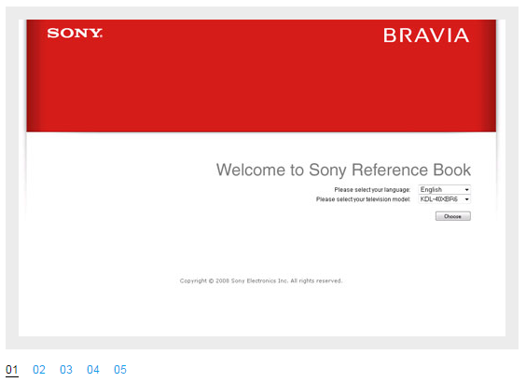

**A jQuery Tabbed Menu Bar (10 points)**

In this part of the assignment you will create a tabbed menu and associated panels using jQuery. The image below outlines what the final result should look similar to. To receive maximum points on this part of the assignment, be sure to take the following into account:

1. The tabbed menu must have a minimum of 3 tabs with 3 associated panels.
2. Each tab should show its respective panel when clicked. Add CSS styling to your tab menu, tabs, and panels so that it’s aesthetically pleasing.  
     
   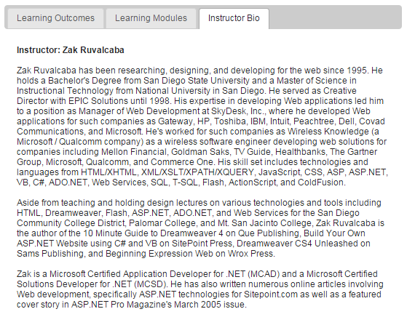

**A jQuery Accordion (10 points)**

In this part of the assignment you will create an accordion using jQuery. The image below outlines what the final result should look similar to. To receive maximum points on this part of the assignment, be sure to take the following into account:

1. The accordion must have a minimum of 3 headings and associated panels for each heading.
2. Next to the text for each heading should be a plus icon. You can use an actual icon image or just use text if you prefer. When an accordion panel is open, the icon should change just as it does in the image below. The heading style should also change including shape and color as it does in the image below.
3. The panels should animate into view when their respective headings are clicked.   
     
   