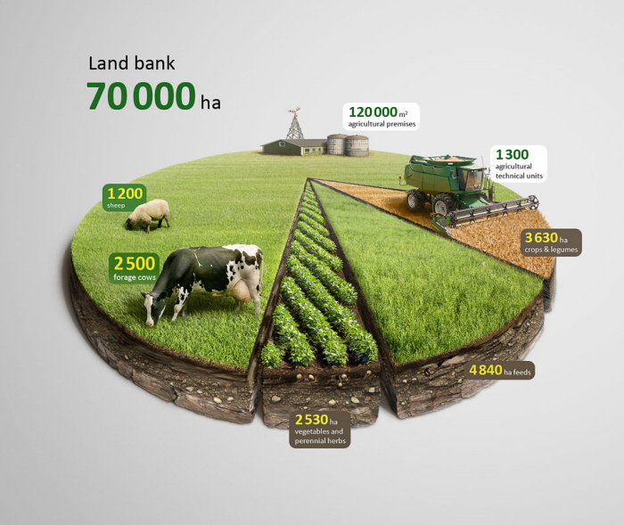**Visual variables 🡪 component :**

* Angle 2D : quantitative (infini) 🡪 area
* Color texture: qualitative (4) 🡪 type/us
* Size (shape) ? 🡪 ?
* Color (labels) : qualitative (3) 🡪 unit type

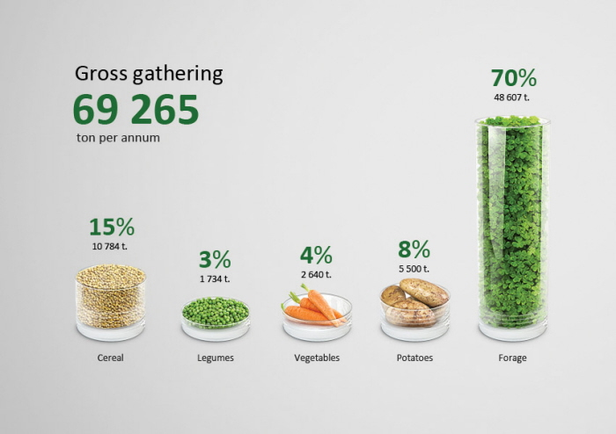Bar chart: not easy to see the top of the bar