Aurélien Pacaud ZZ3 F2

Julien Pal

# Application Mock-Ups

Year : 2012 - 2013

# Document's goal

This document contains all the UI mockups of our application.

All the UI mockup have been created with the Balsamiq software.

The real design can be seen on the application wiki : <https://github.com/aurelien-pacaud/free-your-mind/wiki>

# UI Mock-ups

## Home page

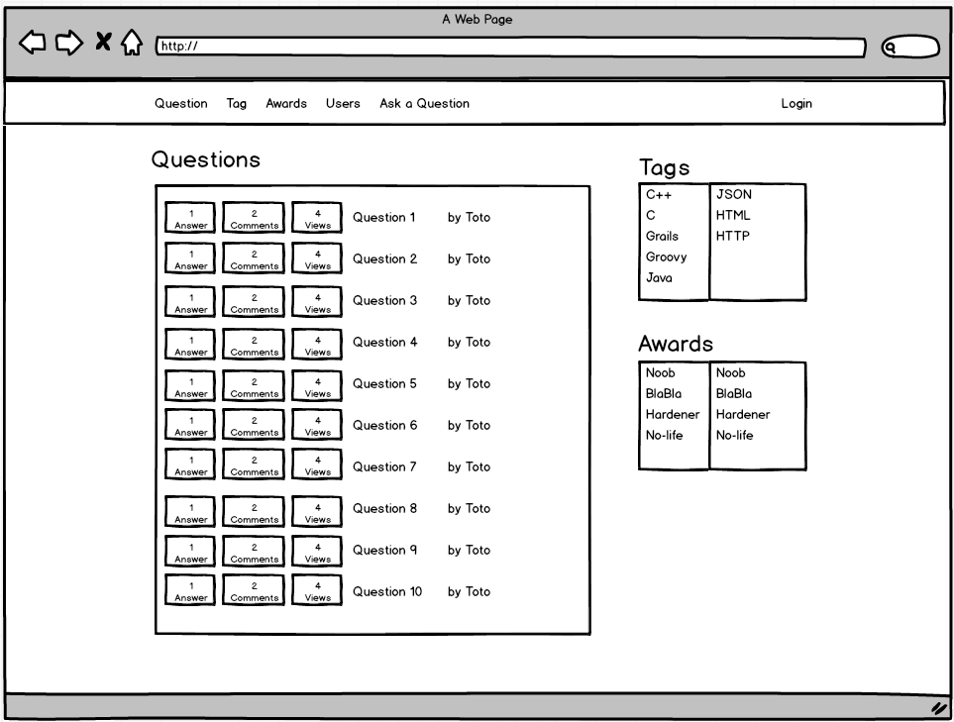

## Questions

### Question list

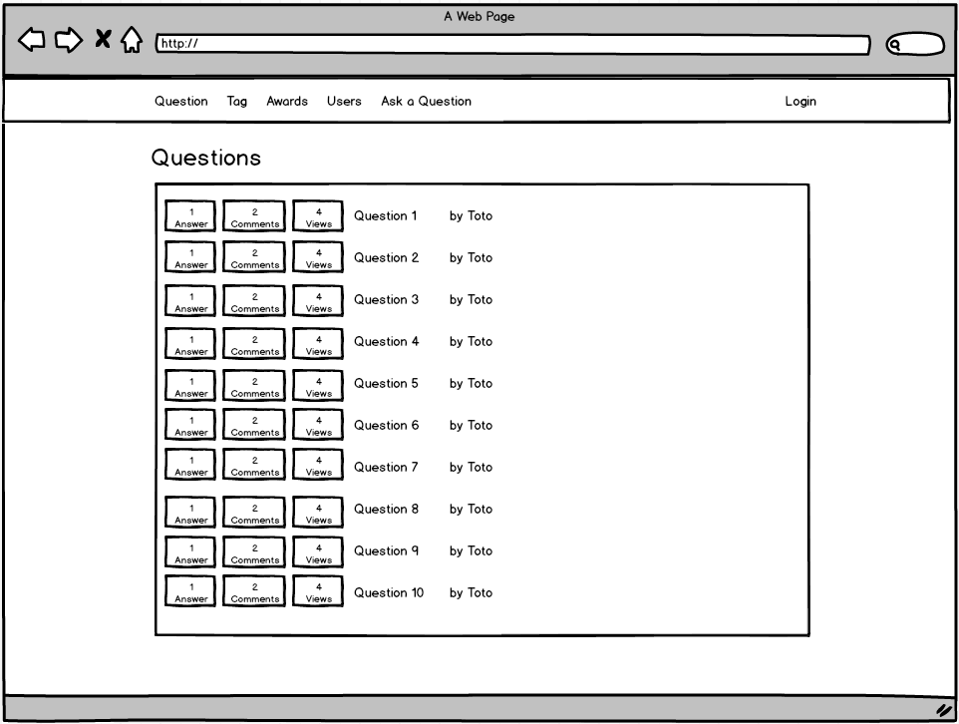

### Question Detail

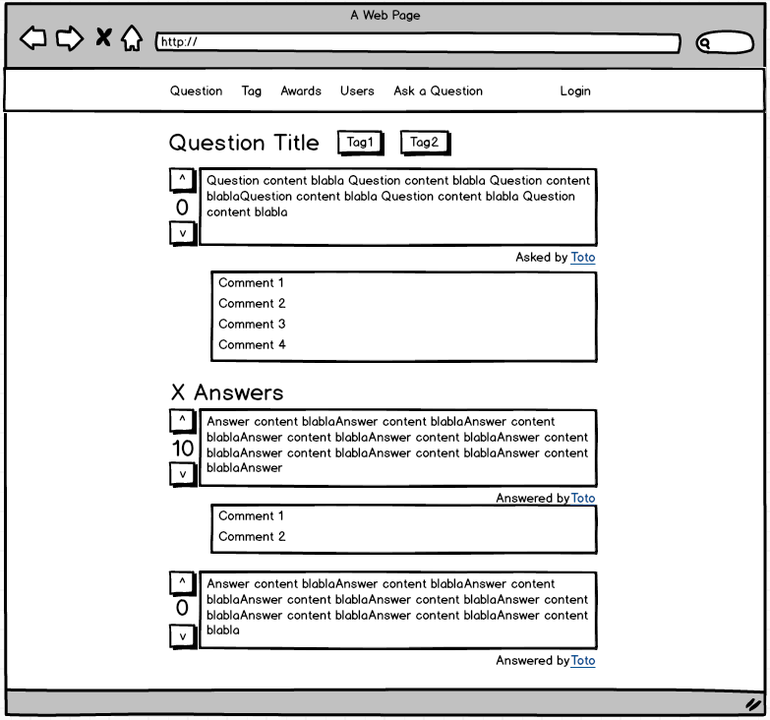

## Tags

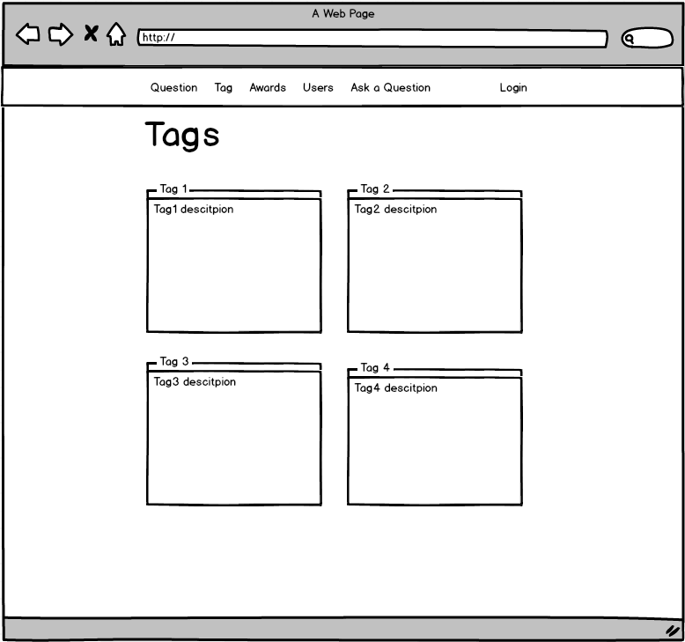

### Awards

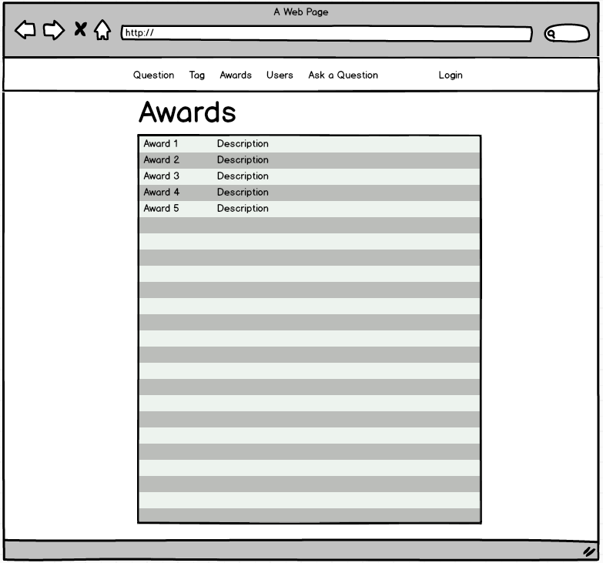

## Users

### User List

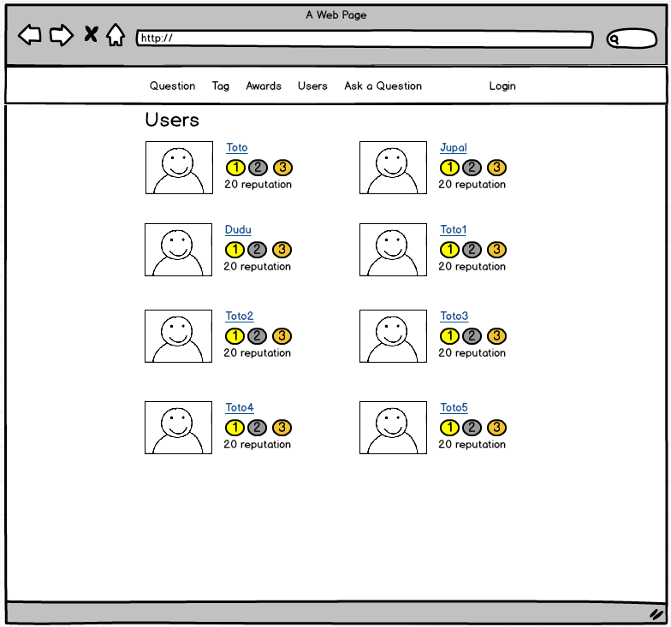

### User detail

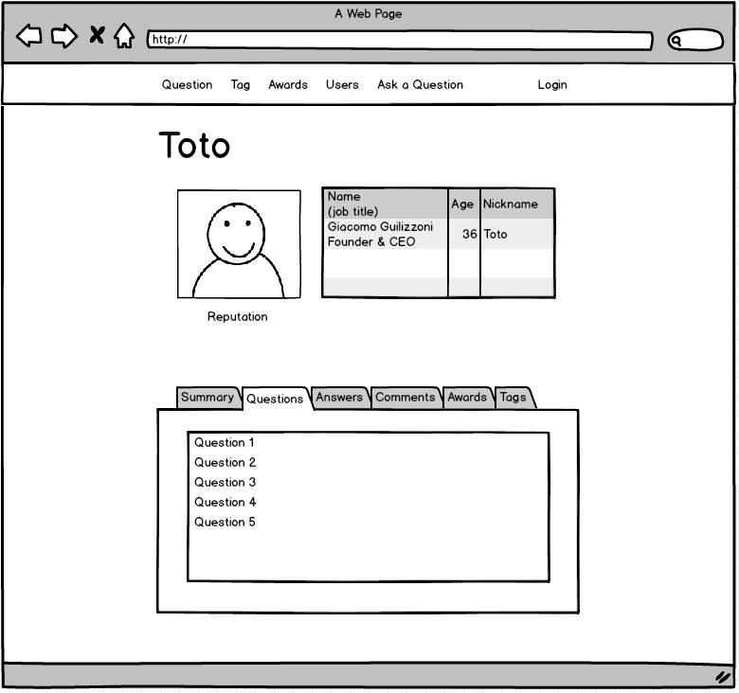

### User connection

