BibAnt
Installer User Guide & Manual Installation Procedure

Windows Installer – GUI Mode

For Windows operating systems, an installer is provided to take care of the entire installation procedure of BibAnt on the client computer. When executed, the installer starts by default in GUI mode, i.e. a user interface will be displayed to guide the user through the software installation process.

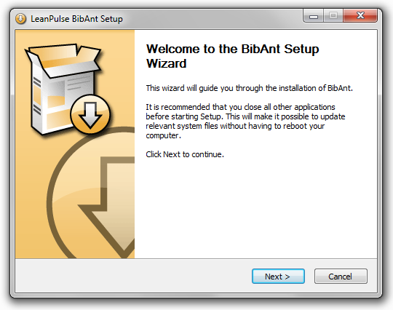
BibAnt Installation Wizard

The installer will let the user choose between three types of install: Full, Minimal or Custom. When the type Full is selected (this is the default), the following steps will be performed by the installer:

- Check and Install Prerequisites
    - Check if compatible versions of Java and PDFCreator are installed on the local computer,
    - If not, automatically download the missing third-party software from the LeanPulse website and install it.

- Copy BibAnt Core Files (required)
    - Copy the BibAnt core files to the installation directory.

- Create Start Menu Shortcuts
    - Create start menu shortcuts to directly open the BibAnt manual, run the program on the default script (the one provided with the installation) or uninstall the software.

- Update the System PATH
    - Add the BibAnt installation directory to the PATH environment variable to make the command “BibAnt” available from any directory.

If the Minimal install type is selected, only the second step will be performed. The Custom type well let the user select all optional steps individually (first, third and last).
Windows Installer – Silent Mode

The BibAnt installer can also be executed silently, i.e. it will fully install the software without displaying any interface or ask for any user interaction. As this mode is intended to be used by system administrators to remotely install the application on a client computer, no access to the Internet will be required in this mode and therefore the check for prerequisites and automatic download will be disabled. Except this particular point, a full installation will be performed (program files copy, shortcuts creation and system PATH update).

To execute the installer in silent mode, the /S command-line option must be added:
> BibAnt_1.x_xxx.exe /S

By default, BibAnt will be installed in a directory named BibAnt in the default Program Files system directory. This can be overridden by using the /D command-line option. It must be the last parameter used in the command line and must not contain any quotes, even if the path contains spaces. Only absolute paths are supported:
> BibAnt_1.x_xxx.exe /S /D=C:\Program Files\BibAnt_Install

Those commands will return immediately, even if the installer is still running in the background. To wait for the installer to finish, the following command-line can be used:
> start “BibAnt_1.x_xxx” /wait “BibAnt_1.x_xxx.exe” /S

At the end of the installation, an uninstaller is automatically created in the BibAnt installation directory. This uninstaller can also be executed in silent mode to uninstall the software without any user interaction required. The same /S command-line option must then be used:
> uninstall.exe /S

Manual Installation Procedure

When delivered as a portable package, BibAnt will require to be manually installed on the local computer. The installation is nevertheless basic: just uncompress the provided archive to the location of your choice and you're pretty much done.

If you fancy an extra step, the directory where you previously extracted the BibAnt files can be added to the system PATH and you will then be able to run BibAnt from anywhere in the command shell.

