Getting Started
LeanPulse System Document Generator (SyD)

First Run

The LeanPulse System Document (SyD) is fully integrated in your Matlab/Simulink environment: it directly adds actions to the model editor menus as shown below.

File Menu  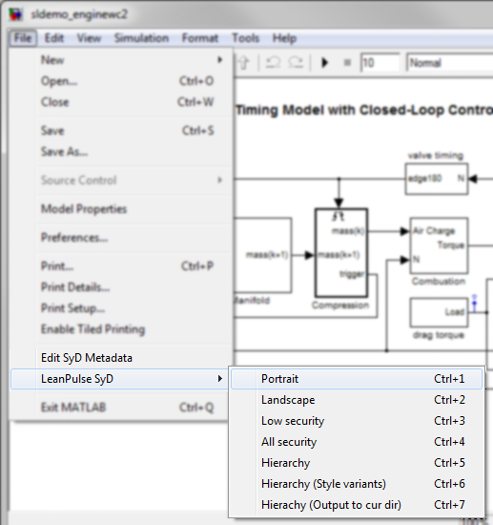 | Edit Menu  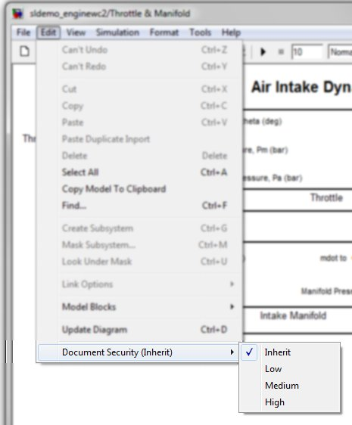 | Context Menu  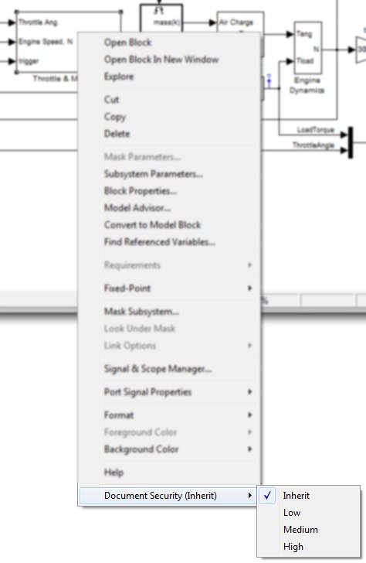

To generate a first document with SyD, just open a Simulink model and select in the editor menu:

File >> LeanPulse SyD >> “ProfileName”
Where “ProfileName” in the name of the profile you want to execute (for instance “Portrait” in the picture above)
This depends on your custom profiles configuration

Most profiles generate the document in the same folder as the model so you may have to first ensure you've got write access to this folder.

Notes:
First-time latency: the first time SyD is executed, it will index all the fonts installed on the system in order to be able to use them in your documents. This can be a long-running process and the generation will appear to be hanging on the “rendering” step.
Please be patient, this occurs only once and the next generations will then be very fast!

Installation troubleshoot:
If you can't see the menu items displayed above, that means an error occurred during the software installation. Please refer to the troubleshoot section of this document to solve your problem.

Understanding Profiles

SyD enables you to generate several documents with different layouts, styles and even contents from a single model. Therefore, the concept of “profile” has been defined.

For the end-user, each menu items in the “Generate Document” group of the “File” menu is a profile.
In detail, each profile defines in particular:
- Where the document file will be automatically saved and with which name,
- The security level of the generated document (to hide secured content from the model),
- The layout and style of the document (with the help of a style-sheet),
- The above parameters repeated several times to generate several documents with a single profile.

Edit Document Meta-data

You can add documentation specific meta-data to your model and edit them with a user-friendly interface.
To open the document meta-data editor, select in the Simulink window menu:
File >> Edit SyD Metadata

The picture below shows the interface.

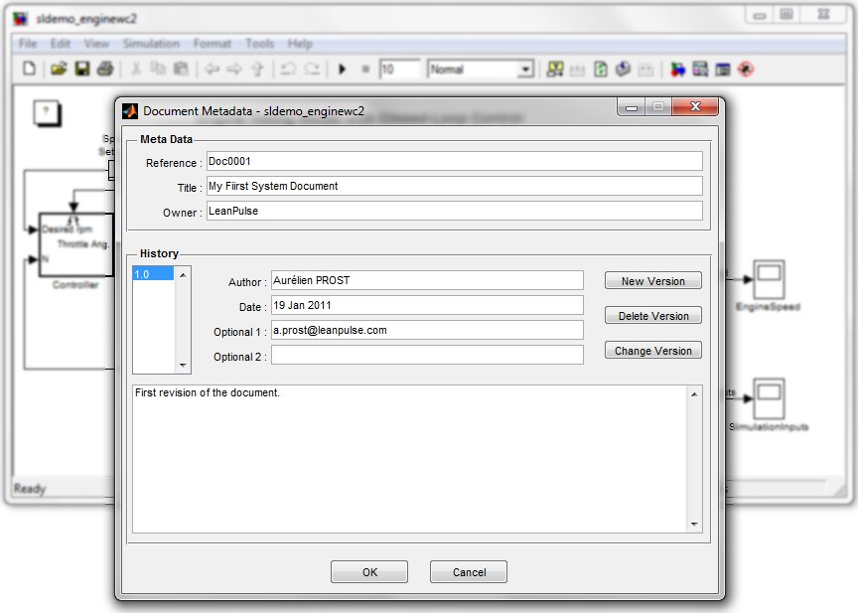
Fill in the fields and the information entered will be used to define parts of the generated document

Notes:
which meta-data is used and where they are are copied in the final document depends on the style-sheet applied.
Most style-sheets provide default values if meta-data aren’t defined.

Add Comments

SyD supports three types of comments directly embedded in the Simulink model:
- Description parameter of SubSystems: the user can edit the description by right-clicking on the SubSystem, select “Block Properties”, and enter some text in the “Description” field of the “General' tab,
- Text DocBlocks: to add a Text DocBlock, drag&drop in the desired SubSystem the block called “DocBlock” from the “Simulink/Model-Wide Utilities” library. To edit it, just double-click on the block.
- RTF DocBlocks: same as above plus change the mask parameter “Document type” to “RTF”.

The last type of comment is the more powerful and easy to use as the edition is directly performed in MS Word (if available), enabling the addition of lists, tables, pictures, etc. in your comments.

Notes:
Most style-sheets use the DocBlock block name to define the paragraph title in the generated document, so it's recommended to display and edit their names in the model,
MS Word 2003 or later is required by SyD to support RTF DocBlocks.

Define Security Levels

Security levels can be defined for SubSystems and DocBlocks. They enable to control the output of the corresponding element in the generated document. For instance, the content of a given SubSystem with a security level set to high will only be displayed when a high security document is generated.

Security levels of SubSystems and DocBlocks are defined by using dedicated menu items available in the Simulink editor menus as shown below.

Edit Menu  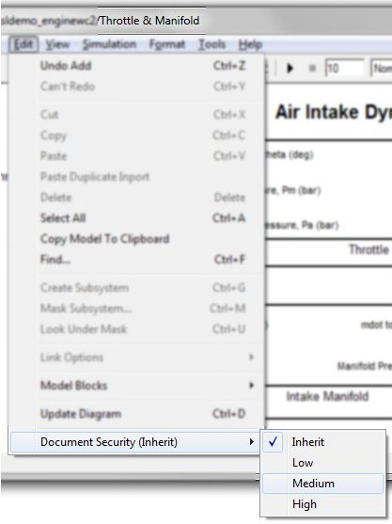  Security level applied on the current SubSystem  (example above, on SubSystem “Throttle & Manifold”) | Context Menu  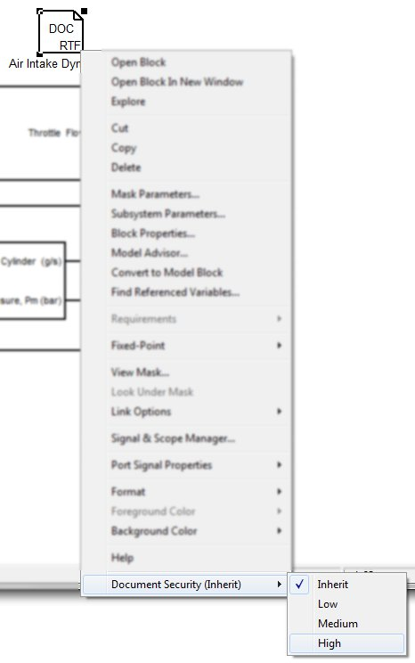  Security level applied on the selected block  (example above, on DocBlock “Air Intake Dy...”)
Manage Data Dictionary

SyD relies on the Model Workspace to get the data definitions of signals and parameters used in the model. They have to be defined as Simulink.Signal and Simulink.Parameters to be detected.

For data defined in the dictionary, SyD will automatically add links to their definition on each reference found in the block-diagram snapshots.

Troubleshoot

SyD menu items not available after installation:
The SyD installer should automatically set your Matlab path to include the directory where the tool has been installed. But failures may occur during the process or the operation might be performed on the wrong Matlab installation (in the case you've got several on the same computer).
To correct this, please check the Matlab path by clicking on “Set Path...” in the “File” menu of the Matlab window. Ensure a reference to the SyD installation directory is included and add it if not. Then restart Matlab.

Other issues
Please contact us.

Other Useful Information

Check SyD Version:
Type in the Matlab Command Window: >> ver
And look for the line starting with “System Document Generator (SyD)”

Compatibility Notes:
Operating System: MS Windows XP or later, x86 and x64 platforms.
Matlab: R2007b or later.
Java: 1.6 or later.
Optional: MS Word 2003 or later (to enable RTF DocBlock support)

