CS 436 Networking
T, Th. 17:30 – 20:15
Name___________________________

MIDTERM

Spring 2011

- Depict or explain how the Internet layering model maps to the ISO/OSI layering model. (5 pts)

Internet Layering Model | ISO/OSI layering model
Application | Application  Presentation  Session
Transport | Transport
Internet | Network
Network Interface | Data Link
Physical | Physical

- What are the advantages of fiber optics over copper as a transmission medium? Are there any downsides of using fiber over copper wire? (4 pts)

Advantages: Immune to electrical noise, higher bandwidth, does not lose as much energy when traveling long distance.

Disadvantages: Copper is cheaper, more specialization needed, easily broken, ends need to be polished.

3. Suppose the message 1001 1100 1010 0011 is transmitted using the Internet Checksum (4-bit word). What is the value of the checksum? (4 pts)

1001 0010
1100 0010
------ ------
10101 0100
1010 1011 = 11 (this is the integer)
------
11111
0011
------
100010

4. Give the typical sequence of socket calls used by a typical client and a typical server. (12 pts)

Client | Server
Socket | Socket
Connect | Bind
Send | Listen
Receive | Accept
Back to send or to close | Receive
 | Send / back to receive
 | Close / back to accept

- What is the main purpose of the Domain Name Service? (3 pts)

Maps readable symbolic names to computer addresses.

- If the frequency range is 0 to 8000 Hz at what rate must the analog signal be sampled when converting it to a digital signal using an 8-bit sample? (4 pts)

Sampling rate = 2 * max frequency
= 2 * 8000
= 16000 times/sec

- Television channels are 6MHz wide. How many bits/sec can be sent if 4-level digital signals are used? Assume a noiseless channel? (3pts)

D = 2 B log₂ K , B is bandwidth K is channels
D = 2 (6 *10^6) * log₂ 4
D = 7.2247 * 10^6

- Given the following bit streams determine the single parity bit for even and odd parity:
(10 pts)

Original Data | Even Parity | Odd Parity
0001 0000 | 1 | 0
0101 1001 | 0 | 1
0100 1001 | 1 | 0
1111 1111 | 0 | 1
0100 1011 | 0 | 1

- Generate a RAC parity matrix for a (20, 12) coding of the dataword 1000 11001 1111. (5 pts)

1 0 0 0  1 1 0 0  1 1 1 1 | 1  0  0
1 0 1 1 1

- Describe the difference between serial and parallel transmission. (4 pts)

Serial transfers one byte of a time. Serial cheaper to extend over a distance. No need to convert data in serial. No need to check timing issues.

Parallel transfers data quicker. Need to coordinate timing. Matches the internal circuitry of the hardware.

- Given the following bit stream 0101 1101 draw the square wave for a Manchester encoded signal.
(8 pts)

0

- Using Statistical Time Division Multiplexing show how the following data blocks would be multiplexed over the channel. (8 pts)

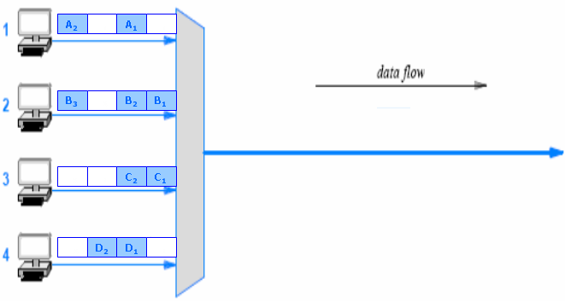

B3 A2 D2 D1 C2 B2 A1 C1 B1

