Leaf nutrients are driven by chemical attributes under eutric soils in *Prosopis pallida* dryland forest

Pablo C. Salazar1, 2*, Rafael M. Navarro-Cerrillo3, Nora Grados1, Gastón Cruz1, Vidal Barrón4 and Rafael Villar2

1 *Facultad de ingeniería, Universidad de Piura. Av. Ramón Mujica 131, Piura, Perú*

*2Área de Ecología, Universidad de Córdoba, Edificio Celestino Mutis, Campus de Rabanales, 14071 Córdoba, Spain*

*3Departamento. Ingeniería Forestal, Laboratorio de Selvicultura, Dendrocronología y Cambio climático. DendrodatLab- ERSAF. Universidad de Córdoba. Campus de Rabanales, 14071 Córdoba, Spain*

*4 Departamento de Agronomía, Universidad de Córdoba, Edificio Celestino Mutis, Campus de Rabanales, 14071 Córdoba, Spain*

Corresponding author: Pablo Salazar (ORCID: 0000-0003-4520-9003)

e-mail: pcsalazarz@gmail.com

**Key-words:** leaf nutrients; Mn; Peru, pH; soil texture, salinity, variance partitioning

Key Message: Soil pH, EC, and salinity explain the leaf nutrient concentration despite of the high amount of soil nutrients near *Prosopis pallida* tree.

**Abstract**

Dryland forests are constantly facing extreme abiotic conditions, and this is affecting plant growth and nutrition. We determine the effect of soil chemical attributes and soil nutrients on the leaf nutrient concentration of eight *Prosopis pallida* populations located along a climatic gradient in the North-Peruvian dryland forests. We analyzed the leaf chemical composition (N, P, K, Ca, Mg, Fe, Mn, Cu, and Zn), and soil chemical attributes [texture, pH, salinity (electrical conductivity; EC) and sodium adsorption ratio (SAR)] and soil nutrient concentrations (the same elements as in the leaves) at 2 m from the base of each tree. Soil and leaf nutrient concentrations were not associated with the climatic gradient and were highly variable within populations. Despite the dry conditions, soil nutrients were not a limited resource (eutric conditions), and thus soil chemical attributes were the main driver of variation in leaf nutrients. Interestingly, leaf Mn correlated with soil and leaf nutrients, as well as with soil chemical attributes. Therefore, suggesting it can be used as an early indicator of plant nutrition.

**Introduction**

Dryland ecosystems are characterized by limited annual rainfall and high evapotranspiration, coupled with low soil nutrients, that affect plant nutrition (Maestre et al. 2012). These climatic conditions generally produce long drought seasons, which affect nutrient recycling, soil microbial activity, and, ultimately, plant productivity (Abril et al. 2009; Lozano et al. 2014). Thus, soil nutrient concentrations are influenced by the macro-environment factor (e.g., soil properties, precipitation, and temperature), as well as local conditions (soil water content, microbial activity, leaf litter production, and root proliferation), leading to complex interactions that determine plant-soil nutrient relationships (Cross and Schlesinger 1999; Ruiz et al. 2008).

The driven factors of leaf nutrients depend on the variability at different ecological scales (Albert 2015; Lajoie and Vellend 2015). Differences at a large scale (km) would be the result of climatic and edaphic variability that affect entire populations in a large area, while differences at the small scale (m) would be the result of local microclimatic conditions that affect individual trees in different ways (Le Bagousse-Pinguet et al. 2015). At the small scale, the leaf nutrients are related to the tree functional traits and symbiotic relationships between roots and microorganisms (Abril et al. 2009; Salazar et al. 2019). This effect has been evaluated as the *tree footprint* which shows a positive feedback between soil and tree, leading to higher nutrient concentrations in leaves and in the soil near the tree (Gómez-Aparicio and Canham 2008; Uriarte et al. 2015), particularly in dry ecosystems (Waring et al. 2015). Therefore, unravelling the leaf nutrient variability at different ecological scales, will provide an insight into the role of climatic factors (regional scale) and the tree footprint (local scale) in this matter.

Regardless of the source of variation, soil chemical attributes [pH, EC (electrical conductivity), and SAR (sodium adsorption ratio)] may determine the availability of nutrients. For instance, in alkaline soils of dryland forests in Asia and South America, Na accumulates in the leaf (He et al. 2017). This creates a disruption in the leaf osmotic balance that decreases plant growth, leaf P, and increase Zn concentration (Cline et al. 1986; Guevara et al. 2010). Moreover, heavy elements such as arsenic, copper, or cadmium, which are commonly found in dryland ecosystems, can increase its availability under high soil pH (Alban et al. 2002; Senthilkumar et al. 2005; Mokgalaka-Matlala et al. 2009). Similarly, soil EC is related to the concentrations of all cations and anions in the solution, and thus provides information on the overall soil fertility (Officer et al. 2004).

Plant-soil interactions can affect soil chemical attributes, reducing pH, and increasing EC and the soil moisture content (Ruiz et al. 2008; White et al. 2009; Alameda et al. 2012). The way plants respond to nutrient availability also depends on the type of species. For instance, species with fast-growing root systems show a rapid exploration of the soil, with the roots exhibiting morphological and physiological changes to increase nutrient availability (Vance et al. 2003). A physiological change to increase nutrient availability was suggested by Lambers et al. (2015): under low soil nutrient concentration, roots exude organic acids to decrease soil pH and increase soil nutrient availability, especially for P but also for other elements like Mn and Fe (White et al. 2013). In the process of leaf senescence, leaf N and P can be translocated to new tissues. However, leaf Mn, which is stored in the cell vacuole, is relatively immobile in the phloem and can provide a proxy of nutrient assimilation (White 2012). Thus, the leaf Mn concentration could be used as an indicator of the plant nutrient uptake strategy and as a functional trait to predict soil nutrient availability (Lambers et al. 2015; Faucon et al. 2017). The potential use of leaf Mn is related to the species capability to adsorb nutrients, as well as the local soil chemical attributes. This would provide fast and cheap monitoring tools for forestry programs in dryland ecosystems, which are heavily needed. Therefore, experimental studies need to be carried out to prove leaf Mn as an indicator of soil and leaf nutrients.

*Prosopis pallida* (Willd.) Kunth (algarrobo) is a native leguminous tree found in the dryland forests of the South American Pacific Coast (Pasiecznik et al. 2001). In the North-Peruvian dryland forests, *P. pallida* represents more than 60 % of total plant cover (Bravo et al. 2003), and its growth and establishment have been shown to be strongly related to climatic factors, particularly the El Niño Southern Oscillation (ENSO) event (Squeo et al. 2007; Salazar et al. 2018a). However, it has been suggested that soil parameters can be more important than precipitation with regard to vegetation structure and composition (Muenchow et al. 2013).

The aim of this study was to understand the leaf nutrient differences between ecological scales in the *P. pallida* dryland forests, the relationships of soil and leaf nutrient concentrations, and the potential of the leaf Mn concentration as an indicator of soil nutrient concentrations along an aridity gradient in Northern Peru. This leads to three questions and hypotheses: i) Is leaf nutrients variability higher at local scale (tree, plots) or at large scale along a climatic gradient? We expect that leaf nutrients will be highly variable at local scale due to the effect of tree traits, and with a limited variability at population scale. ii) Are leaf nutrients more likely driven by soil chemical attributes (pH, EC and SAR) than soil nutrients in eutric conditions? Our hypothesis is that chemical attributes would play a key role in leaf nutrients. iii) Can the leaf Mn concentration be used as an indicator of soil and leaf nutrients in *P. pallida* dryland forests? We expect that leaf Mn concentration will correlate to both soil and leaf nutrients.

**Material and methods**

The *P. pallida* dryland forests studied are located between 4º5′ – 6º22′ S and 79º00′ – 81º7′ W in the Piura Province (North-Western Peru, South America; Fig. 1). The geology is characterized by the presence of eolian and alluvial deposition and the topography is characterized by a semi-desertic plain (Bravo et al. 2003). The soil texture comprises more than 98% sand, except near the mountain foothills, where silt and clay reach 20% and 10%, respectively. The altitude varies between 15 and 232 m a.s.l. Even though this zone is located in a tropical area, the Humboldt Current flowing close to the Pacific coast of Peru reduces the annual precipitation and temperature. The climate is characterized by hot summers and mild, dry winters, with an annual average temperature between 23.4 and 24.8 ºC (Hijmans et al. 2005). Annual precipitation averages between 48 (73 m a.s.l.) and 354 mm (232 m a.s.l.) and occurs in summer (January to March), resulting in a long winter drought of 8-9 months (from April to December) (Bravo et al. 2003). The variation in altitude, temperature, and precipitation indicates the presence of a climatic gradient related to the altitude, which increases from the coast to the foothills (Fig. 1 and Table 1), while the proximity to the Pacific Ocean also provides a gradient of evapotranspiration, which decreases as one moves further inland. The climatic variability in this area is highly affected by the ENSO, which creates a dry phase of 5-10 years (with the climatic conditions described before) and a wet phase of 1-2 years (with an increase in air temperature of 1-2 °C and an increase in annual precipitation of up to 2000 mm) (Erdmann et al. 2008). These extreme precipitation events are major drivers of alluvial depositions and, alongside wind dispersal, control the soil surface nutrient composition in the North-Peruvian coastal areas (Wells 1990; Li et al. 2008). Soil and leaf samples were taken in summer 2014, during the dry phase of the ENSO cycle. During this phase, highly stable climatic conditions are found and the monthly temperature variability fits a sine wave with a phase length of one year (Rollenbeck et al. 2015). The last significant ENSO event prior to the sampling date occurred in 1998.

*Sampling design and data collection*

The sampling process was carried out in summer 2014 during one month period. Seven *P. pallida* populations were selected to cover the variation in soil properties and nutrient concentrations, as well as in altitude, temperature, and precipitation along a climatic gradient (Table 1; Fig. 1). This study is part of large experimental project, and the variability between sites in terms of plant functional traits have been address before (Salazar et al. 2018b; Salazar Zarzosa et al. 2019). Therefore, we expected a similar pattern in the soil and leaf nutrients. Since one of them (Ñapique) presented high site variability related to its proximity to a lake, this location was considered as two different populations (Ñapique Wet and Ñapique Dry, the former being closer to the lake). Therefore, we considered a total of eight populations. Thus, the populations ordered according to mean annual precipitation were Piura (PI), Rinconada (RI), Quebrada Soledad (QS), Ñapique dry (ND), Ñapique wet (NW), Locuto (LO), Ignacio Tavara (IT), Rio Seco (RS). The population proximity to bodies of water (rivers) were also recorded. However, the river flow was relatively low (50-100 m3 s-1) and it is mainly use for agriculture and human consumption. These locations represent most of the North-Peruvian dryland forests, where the plant cover is mainly dominated by *P. pallida* trees. To cover the spatial and microclimatic variability within each site, three plots (of ca. 1 ha each) per population were established. The average distance between plots was 1265 m, to avoid pseudo-replication. Within each plot, a random sampling inventory was developed and five adult trees of *P. pallida*, with a basal stem diameter exceeding 10 cm at breast height, were selected, giving a total of 120 trees (experimental units) across all populations, with a 20 m average distance between them. Individual tree locations were recorded with a real-time differential global positioning system (GPSMAP 76CSx - Garmin USA International, Inc; estimated position error <1 m).

In each tree, a fully-expanded, sun-exposed branch was selected and mature leaves with no signs of damage were collected and transported to the laboratory in hermetic bags, to measure leaf nutrient concentrations. Two meters from each tree, soil samples (8 cm in diameter) were collected using a steel core sampler, at a depth of 0-25 cm from the topsoil surface, and stored in hermetic bags until they were processed in the laboratory. All soil samples were air-dried, and coarse soil particles were removed with a stainless steel sieve (mesh size 2 mm) before elemental analysis.

*Soil and leaf analysis*

We measured the concentrations of macronutrients (N, P, K, Ca, and Mg) and micronutrients (Fe, Mn, Cu, and Zn) in the soil and leaves. The total N in the soil samples was determined by dry combustion, after grinding, using an elemental analyzer (Eurovector EA3000; EuroVector SpA, Milan, Italy) (Wang and Anderson 1998). Available P (Olsen et al. 1982) was determined according to the molybdate blue method (Murphy and Riley 1962). The K, Ca, and Mg were determined by atomic absorption spectrophotometry, after extraction with 1 M NH4OAc at pH 7. The Fe, Mn, Cu, and Zn were determined by atomic absorption spectrophotometry after extraction with a solution containing 0.1 M triethanolamine (TEA), 0.005 M diethylenetriaminepentaacetic acid (DTPA), and 0.01 M CaCl2 (Norvell and Lindsay 1972). Soil texture was measured in 50 g of soil using the Bouyoucos hydrometer method (Bouyoucos 1962). Soil pH was determined in a 1:2 (w/v) soil/water extract, using a pH meter (Crison GLP 21, Hach Lange, Spain), and EC in a 1:5 extract, using an electrical conductivity meter (Crison model basic 30, Hach Lange, Spain). The soil Na in the latter extract was determined by atomic absorption spectrophotometry, and it was used to obtain the soil sodium adsorption ratio (SAR) according to:

Leaves were dried at 70 °C for 24 h before grinding with a stainless steel grinder. Then, the leaf N concentrations were measured using an elemental analyzer (Eurovector EA3000), and the other elements were determined after digestion with a nitric-perchloric acid mixture (Zasoski and Burau 1977), using the same methods described for the soils.

*Statistical analysis*

First, we used leaf stoichiometry (the ratio between nutrients and C concentration) instead of leaf nutrient concentration to study the elemental composition (Urbina et al. 2015). However, leaf stoichiometry and leaf nutrient concentration showed nearly the same results, so we used the latter for the sake of simplicity. We examined the fit of all variables to the assumptions of normality and homogeneity of variance, using the Shapiro-Wilk and Levene test, respectively. All variables were normalized by log10 transformations. To know the importance of the three sources of variability (tree, plot, and population level) in the soil and leaf nutrient concentrations, we used the restricted maximum likelihood (REML) method in the lme function of the "nlme" package of R. We fitted a general linear model to the variance across the three scales, nesting one into another in this increasing order: tree, plot, population. The amount of variance explained at each level and the coefficient of variation (CV) of each nutrient determine the nutrient variability in the leaf. CV was calculated as the standard deviation divided by the mean (× 100).

To know the relationships among soil nutrients we used a Principal Component Analysis (PCA) for all the soil nutrients. An ANOVA and a Tukey HSD post-hoc analysis were performed using the individual scores of the two main axes of the PCA, to determine the significant differences between populations. A similar approach was taken for the leaf nutrient concentrations, and nutrient score values from each PCA axes was recorded (Online Resource 1). We explored the relationships between the soil chemical attributes, and the soil and leaf nutrient concentrations, as well as between the main soil and leaf axes of the PCAs, using Pearson's correlations. Due to the high amount of variability in these variables, we chose not to apply a Bonferroni correction in the p-values, to avoid the deletion of correlations with biological causes but a low correlation coefficient. Finally, to explain the causal relationship of soil chemical attributes and soil and leaf nutrients, we built a structural equation model (SEM) with the “lavaan” package, using untransformed data. The structure of the hypothesized causal relationships between selected variables was set based in our hypotheses and the Pearson correlation results and later slightly modified as a function of the highest statistical support according to the significance of chi-squared (*P* > 0.05), indicating that the covariance pattern predicted by the model is indistinguishable from the observed (Alameda et al. 2012). In the SEM, we used the PCA axes to reduce the amount of variables to a linear combination of smaller components instead of creating composite variables. The “lavaan” package have compiling issues to create composite variables (especially if there is more than one) and some authors (Grace and Bollen 2008) have suggested to calculate the estimates manually. To avoid this (and make a reproducible work) we decided to use the PCA axes instead. A prior model based on the expected effect of soil fertility on leaf nutrients is included in the Online Resource 2. All statistical analyses were carried out using R software (R Core Team 2017), using all the trees and soil samples (n = 120).

**Results**

*Variability of leaf nutrient concentrations at different scales*

The leaf nutrient variability showed high differences between ecological scales (Fig. 2A), where the percentage of variance explained at tree level was between 50 and 77%, the plot level explained was approximately 5%, and the population level explained between 17 and 47%. A high variability at local scale means individual samples are different from each other, and that could be related with a high coefficient of variance, however, this was not the case (Figs. 2B). As such, no correlation was found between the coefficient of variance and the variance explained at any scale.

*Soil and leaf nutrient relationship*

The PCA of the soil nutrient concentrations showed that most of the variance was loaded in the first main PCA axis (PCA1), which explained 63 % of the total variance, whereas the second main PCA axis (PCA2) only explained 13 % of the variance (Fig. 3A). The soil nutrient concentrations were highly correlated among themselves and with the soil PCA1, suggesting the presence of a fertility gradient (for example, there was a strong, positive relationship between N and P) (Fig. 4). The PCA2 axis was related to the soil Ca and Mg concentrations on the negative side and to the soil P, Mn, and Fe concentrations on the positive side (Fig. 3A and Online Resource 1). The ANOVA of the PCA1 loadings indicated that the sites of the *P. pallida* populations differed in their soil nutrient concentration, from QS, ND, and NW with the lowest soil nutrient concentrations (being the most-desert-like forests) to RI and RS with the highest soil nutrient concentrations (being the sites with the most-favorable climates) (Table 1). However, neither precipitation nor temperature correlated with either soil PCA axes (*P* > 0.05; Online Resource 3). Most importantly, even the lowest soil nutrient concentration forest had a non-limited conditions for agricultural standards.

Similarly, the PCA of the leaf nutrient concentrations showed that most of the variance was loaded in the first main PCA axis (PCA1), explaining 47 % of the total variance, whereas the second main PCA axis (PCA2) only explained 15 % of the variance (Fig. 3B). The macronutrients (N, P, and K), as well as Cu and Zn, showed strong, positive correlations among themselves (Fig. 4) and were positively related to the leaf PCA1. Other nutrients such as Mn, Mg, and Fe showed positive correlations among themselves, and were related positively to the PCA2 axis but negatively to the PCA1 axis. The leaf N, P, Mn, and Fe concentrations were positively correlated with the PCA2 axis (Online Resource 1). The ANOVA of the PCA loadings indicated that the leaf nutrient concentrations have low differences among populations. Population LO showed the highest macronutrient concentrations, which were significantly different from those of the other populations (Fig. 3B), and the highest Zn concentration (Table 2). No climatic variables correlated with either leaf PCA axes (*P* > 0.05; Online Resource 3).

The two main axes of the PCA considering the soil and leaf nutrient concentrations were associated with pH, EC, and SAR. The soil PCA1 correlated negatively with the soil pH, and positively with EC and clay percentage, whereas the leaf PCA1 correlated positively with EC and showed no correlation with soil SAR (Fig. 5 A, B, and C). However, soil PCA2 and leaf PCA2 showed a similar pattern, as both correlated negatively with soil pH, EC, and SAR (Fig. 5D, E, and F). Accordingly, the structural equation model (SEM) (χ2 = 7.2, *P* = 0.6) showed that the soil chemical attributes (pH, EC, and clay percentage) explained the soil main PCA axes, whereas EC and SAR explained a small but significant part of the leaf main PCA axes (Fig. 6). The leaf nutrient concentrations (leaf main PCA axes) were not explained by the soil nutrient concentrations (soil PCA axes), but they were explained by the soil chemical attributes.

*Leaf Mn relationship with soil and leaf nutrients*

Overall, we found little or no significant correlation between the soil and leaf nutrient concentrations (Fig. 4). As exceptions, leaf P was correlated positively with the soil N and Fe concentrations, leaf Ca negatively correlated with the soil N and Zn concentrations, and leaf Cu negatively correlated with soil P, Fe, Mn and Zn concentrations. The soil chemical attributes had a significant effect on the leaf nutrient concentrations: soil pH correlated positively with leaf Cu and negatively with leaf P, while soil EC correlated positively with leaf K and Cu, and negatively with leaf Fe and Mn (Fig. 4).

The leaf Mn concentration showed a peculiar pattern. For instance, it was negatively correlated with the soil N, Ca, Mg, Fe, Cu, and Zn concentrations (7 of the 10 soil elements studied). On the other hand, it correlated positively with the leaf Ca, Mg, and Fe concentrations, and negatively with the leaf N, P, K, and Cu concentrations (Fig. 4). Also, leaf Mn was correlated negatively with the soil and leaf PCA1 axes and positively with the soil and leaf PCA2 axes. Contrastingly, leaf Mn was not correlated with the soil Mn concentration.

**Discussion**

Our results indicate that the leaf nutrients showed higher variability at small scale (tree and plot levels) than at large scale (population level). Soil chemical attributes were the main driver of leaf nutrient in this eutric (nutrients were not a limited resource) area rather than soil nutrients. Lastly, leaf Mn showed significant correlations with both soil and leaf nutrients.

*Leaf nutrient variability explained at local scale*

The leaf nutrient variability was located mainly at the local scale - suggesting that it is affected by tree level factors like soil moisture content, soil pH, genetic variability, or leaf traits, instead of regional factors like climatic conditions (Salazar et al. 2018b). The patchy vegetation cover and high spatial variation of soil processes like respiration and leaf litter decomposition can increase local scale variability (Puigdefábregas 2005; Liu et al. 2016). In tropical dry forests, the tree effect on the ecosystem is referred as the *Prosopis* fertility island effect, increasing soil nutrients and changing soil chemical attributes (Abril et al. 2009; Salazar et al. 2019). Large scale environmental factors (like rainfall) in a dryland ecosystem should have played a more relevant role due to the lack of water availability. However, similar results in Central America have shown that environmental filtering have little effect when local scale variability is relative large (Messier et al. 2010). Additionally, it is possible that extreme precipitation events like the ENSO have contributed to increase local scale variability because long-lived species tend to have high ontogenetic variation and high intraspecific variability to face environmental hazards over their lifetimes (Siefert et al. 2015). Either way, this shows that local scale factor is is more important than large scale factor to determine leaf nutrient variability.

*Leaf nutrients are mainly affected by soil chemical attributes*

Our results showed the salinity and slightly alkaline conditions are playing a more important factor regardless of the soil nutrient concentration. In fact, based on our model, soil chemical attributes had significant effects on both the leaf and soil nutrient concentrations (main PCA axes). Similar results suggest that soil EC can be a driver of species distribution in dryland forests, and can be even more important than precipitation (Muenchow et al. 2013). For example, although phosphorus is an essential nutrient in plant growth and metabolism (Ågren 2008, Hawkesford et al. 2011), however, leaf P did not show any correlation with soil P. Instead leaf P was negatively correlated with soil pH, which increase its availability in acidic soils (White and Brown 2010). Our results are similar to those found in Brazilian tropical forest and agree with the idea that soil pH accounts for the differences in leaf nutrient concentration (Viani et al. 2014), which not always relate to soil nutrients (Geng et al. 2011). Similarly, we found a positive correlation between EC and leaf K, suggesting that soil chemical attributes can play a more important role in this ecosystem (Officer et al. 2004).

In general, we did not find strong correlation between the soil and leaf nutrients concentration. However, some key elements showed significant correlations and could be used to explain the limitations and properties of the soils in dryland forests. For instance, our results show a high soil P concentration (between 5 and 43 mg kg-1) which is higher than those found under *Prosopis caldenia* (0.3 mg kg-1), *P. juliflora* (0.56 mg kg-1), or *P. cineriana* (3.9 mg kg-1) in Southern Asia (Buschiazzo et al. 2001; Panwar et al. 2005; El-Keblawy and Abdelfatah 2014). This is also reflected in the leaf P concentration, which was found to be between 1.8 and 3.6 g kg-1 in our study, but lower (1.1 to 2.5 g kg-1) in similar ecosystems (Cline et al. 1986; Geesing et al. 2000; Deans et al. 2003). The same can be said about the soil K concentration, which had a high concentration because the low rainfall has minimized leaching in the last decade (Hagin and Tucker 2012). Cline et al. (1986) developed a minimum leaf nutrient diagnostic criterion to detect nutrient deficiency in *P. alba* and *P. glandulosa*; and based on that results, it indicate that the leaf nutrients in *P. pallida* were above this threshold, except for Mn and Cu. In fact, they were even above the sufficiency level for crop plants (White and Brown 2010). Therefore, it is possible that soil nutrients do not play a role as important as soil chemical attributes in *P. pallida* nutrition when soil nutrients are non-limited (eutric conditions).

*Leaf Mn as an indicator of plant nutrition and soil nutrient availability*

Our results showed that an increase of Mn in the leaf is associated with a decrease of soil nutrients, EC, SAR, and leaf N, P, and K. This suggest it can be used as an indicator for plant and soil nutrients under eutric conditions. The use of leaf Mn as a preventive indicator of plant and soil nutrients is tied with its role in plant physiology and stress response. Several biological processes require Mn, but its most important role is in photosynthesis (Schmidt et al. 2016). The activity of photosystem II is strongly depressed by Mn deficiency, which eventually decreases the chlorophyll concentration and negatively affects the thylakoids structure (Broadley et al. 2011). Additionally, Mn-containing enzymes protect tissues from the deleterious effects of oxygen radicals, and are often found in high concentrations at high temperatures (Burnell 1988; Fernando et al. 2016). In our case, we found a positive correlation between leaf Mn and mean annual temperature across the climatic gradient (r = 0.77, *P*= 0.03); also based on the gas exchange results, leaf Mn was positively correlated with instantaneous water use efficiency (r = 0.82, *P* = 0.01) (Salazar et al. 2018b). Therefore, leaf Mn is sensitive to environmental factors and it is involved in gas exchange regulation. Our results add up to the clearly long list of potential uses for leaf Mn, and as such should be taken into account when monitoring soil nutrients. Additionally, the increase in leaf Mn under physiological stress suggests that Mn is not limited, and confirms our results that *P. pallida* nutrition is not limited by soil nutrients. Continuous Mn leaf data would allow us to monitor changes in soil properties before it have a negative effect on plant nutrition.

It is necessary to consider the implication of these results in future climate scenarios and forest management. Current IPCC scenarios expect an increase in temperature of 1.5-2°C as well as changes in precipitation patterns globally (Masson-Delmotte et al. 2018). Locally, the ENSO already have a similar seasonal (5-7 years) effect, increasing the South American Pacific Ocean temperature by 2 ºC, and changing the temperature and precipitation pattern (Tapley and Waylen 1990). Based on the amount of large scale variability found in our results, and the expected plasticity of this species to extreme events (Salazar et al. 2018a), it is clear that environmental drivers are not the main source of variation of leaf nutrients. On the other hand, land management activities like pruning and logging have a local scale impact and may play a more important role in plant nutrition. Currently, excessive logging, is one the most threating problems in dryland ecosystems and it motivates permanent changes in land use (Ektvedt et al. 2012). This leads to large bare soil areas with poor quality chemical attributes that utterly reduce plant growth, and may threaten dryland forest more than we originally expected. This highlights the role of local forest management practices (like soil amendment to reduce pH) as important drivers of dryland sustainability in comparison to extreme events and for coming changes in climatic conditions due to global warming. Most of the environmental science community is moving toward remote sensing to extrapolate and predict changes in large areas, however, local scale studies should be analyzed more carefully to weight its relevance in large/global scale studies.

**Conclusions**

The leaf nutrient concentrations showed a high variability in the North-Peruvian *P. pallida* forests, particularly at local (small) scales, but did not follow any climatic or geographic gradient. Additionally, leaf nutrients are more likely driven by the soil chemical attributes (pH, EC, and SAR) than soil nutrients under non-limited conditions. Finally, our study provide evidence that leaf Mn can be used as a nutrient indicator as we found that the leaf Mn concentration correlated with nine of the 10 leaf nutrients studied, seven of the 10 soil nutrients studied, and with soil EC. The relatively low, but significant, correlations found between leaf Mn and soil and leaf nutrients suggest that leaf Mn is not the ultimate indicator of the current state of the forest; however, it provides a view of soil nutrients based on the plant response and should be taken into account in dryland ecosystems.

**Author contribution statement:** PSZ, RV, and RMNC conceived and designed the experiment. PSZ and VB collected and analyzed the data. PSZ, RMNC, VB, and RV wrote the manuscript. GC and NG supervised the research.

**Acknowledgments**

This research was funded by the Programa Nacional de Innovación para la Competitividad y Productividad, also known as INNOVATE Peru (grant number: 146-FINCyT-IB-2013); Fondecyt (grant number: 163-2018-Fondecyt-BM-IADT-SE); Spanish MEC projects DIVERBOS (CGL2011-30285-C02-02), ECO-MEDIT (CGL2014-53236-R), ESPECTRAMED (CGL2017-86161-R) and SUNAME (AGL 2017-87074-C2-2-R); the project *Ecología funcional de los bosques andaluces y predicciones sobre sus cambios futuros* (For-Change) (UCO-27943) by Junta de Andalucía (Spain) and European FEDER funds. Additionally, we thank the biologist Luis Urbina, for his help during field data acquisition, Beatriz Rodriguez (@beart_heart), for the graphical design in Figure 6, and the Servicio Central de Apoyo a la Investigación (SCAI) of the University of Córdoba, for technical support in the chemical analyses.

**Conflict of interest:** The authors declare they have no conflict of interest.

**References**

Abril A, Villagra P, Noe L (2009) Spatiotemporal heterogeneity of soil fertility in the Central Monte desert (Argentina). J Arid Environ 73:901–906. doi: 10.1016/j.jaridenv.2009.04.019

Ågren GI (2008) Stoichiometry and nutrition of plant growth in natural communities. Annu Rev Ecol Evol Syst 39:153–170. doi: 10.1146/annurev.ecolsys.39.110707.173515

Alameda D, Villar R, Iriondo JM (2012) Forest Ecology and Management Spatial pattern of soil compaction: Trees ’ footprint on soil physical properties. For Ecol Manage 283:128–137. doi: 10.1016/j.foreco.2012.07.018

Alban L, Matorel M, Romero J, et al (2002) Cloning of elite, multipurpose trees of the Prosopis juliflora/pallida complex in Piura, Peru. Agrofor Syst 54:173–182. doi: 10.1023/A:1016093106338

Albert CH (2015) Intraspecific trait variability matters. J Veg Sci 26:7–8. doi: 10.1111/jvs.12240

Bouyoucos GJ (1962) Hydrometer Method Improved for Making Particle Size Analyses of Soils. Agron J 54:464. doi: 10.2134/agronj1962.00021962005400050028x

Bravo M, Rodriguez M, De los Heros M (2003) Mapa de bosques secos del departamento de Piura. Memoria Descriptiva. Piura

Broadley M, Brown P, Cakmak I, et al (2011) Function of Nutrients: Micronutrients.

Burnell JN (1988) The Biochemistry of Manganese in Plants. In: Manganese in Soils and Plants. Springer Netherlands, Dordrecht, pp 125–137

Buschiazzo DE, Hevia GG, Hepper EN, et al (2001) Organic C, N and P in size fractions of virgin and cultivated soils of the semi-arid pampa of Argentina. J Arid Environ 48:501–508. doi: 10.1006/jare.2000.0775

Cline G, Rhodes D, Felker P (1986) Micronutrient , Phosphorus and pH Influences on Growth and Leaf Tissue Nutrient Levels of Prosopis alba and Prosopis glandulosa. For Ecol Manage 16:81–93.

Cross AF, Schlesinger WH (1999) Plant regulation of soil nutrient distribution in the northern Chihuahuan Desert. Plant Ecol 145:11–25. doi: 10.1023/A:1009865020145

Deans JD, Diagne O, Nizinski J, Lindley DK (2003) Comparative growth, biomass production, nutrient use and soil amelioration by nitrogen-fixing tree species in semi-arid Senegal. For Ecol Manage 176:253–264.

Ektvedt TM, Vetaas OR, Lundberg A (2012) Land-cover changes during the past 50 years in the semi-arid tropical forest region of northern peru. Erdkunde 66:57–75. doi: 10.3112/erdkunde.2012.01.05

El-Keblawy A, Abdelfatah MA (2014) Impacts of native and invasive exotic Prosopis congeners on soil properties and associated flora in the arid United Arab Emirates. J Arid Environ 100–101:1–8. doi: 10.1016/j.jaridenv.2013.10.001

Erdmann W, Schulz N, Richter M, Rodríguez Rodríguez EF (2008) Efectos del fenómeno del Niño 1997-1998 en la vegetación del desierto de Sechura, Región Paita hasta el año 2008. Arnaldoa 15:63–86. doi: 10.1017/CBO9781107415324.004

Faucon M-PP, Houben D, Lambers H (2017) Plant Functional Traits: Soil and Ecosystem Services. Trends Plant Sci 22:385–394. doi: 10.1016/j.tplants.2017.01.005

Fernando DR, Moroni SJ, Scott BJ, et al (2016) Temperature and light drive manganese accumulation and stress in crops across three major plant families. Environ Exp Bot 132:66–79. doi: 10.1016/j.envexpbot.2016.08.008

Geesing D, Felker P, Bingham RL (2000) Influence of mesquite (Prosopis glandulosa) on soil nitrogen and carbon development: Implications for global carbon sequestration. J Arid Environ 46:157–180. doi: 10.1006/jare.2000.0661

Geng Y, Wu Y, He J, others (2011) Relationship between leaf phosphorus concentration and soil phosphorus availability across Inner Mongolia grassland. Chinese J Plant Ecol 35:1–8.

Gómez-Aparicio L, Canham C (2008) Neighborhood Models of the Effects of Invasive. Ecol Monogr 78:69–86.

Grace JB, Bollen KA (2008) Representing general theoretical concepts in structural equation models: The role of composite variables. Environ Ecol Stat 15:191–213. doi: 10.1007/s10651-007-0047-7

Guevara A, Giordano CV, Aranibar J, et al (2010) Phenotypic plasticity of the coarse root system of Prosopis flexuosa, a phreatophyte tree, in the Monte Desert (Argentina). Plant Soil 330:447–464. doi: 10.1007/s11104-009-0218-4

Hagin J, Tucker B (2012) Fertilization of Dryland and irrigated soils.

He H, Peng Q, Wang X, Fan C (2017) Growth, morphological and physiological responses of alfalfa (Medicago sativa) to phosphorus supply in two alkaline soils. Plant Soil 416:565–584. doi: 10.1007/s11104-017-3242-9

Hijmans RJ, Cameron SE, Parra JL, et al (2005) Very high resolution interpolated climate surfaces for global land areas. Int J Climatol 25:1965–1978. doi: 10.1002/joc.1276

Lajoie G, Vellend M (2015) Understanding context dependence in the contribution of intraspecific variation to community trait-environment matching. Ecology 96:2912–2922. doi: 10.1890/15-0156.1.sm

Lambers H, Hayes PE, Laliberté E, et al (2015) Leaf manganese accumulation and phosphorus-acquisition efficiency. Trends Plant Sci 20:83–90. doi: 10.1016/j.tplants.2014.10.007

Le Bagousse-Pinguet Y, Börger L, Quero JL, et al (2015) Traits of neighbouring plants and space limitation determine intraspecific trait variability in semi-arid shrublands. J Ecol 103:1647–1657. doi: 10.1111/1365-2745.12480

Li J, Okin GS, Alvarez L, Epstein H (2008) Effects of wind erosion on the spatial heterogeneity of soil nutrients in two desert grassland communities. Biogeochemistry 88:73–88. doi: 10.1007/s10533-008-9195-6

Liu G, Sonobe R, Wang Q (2016) Spatial Variations of Soil Respiration in Arid Ecosystems. Open J Ecol 6:192–205.

Lozano YM, Hortal S, Armas C, Pugnaire FI (2014) Interactions among soil, plants, and microorganisms drive secondary succession in a dry environment. Soil Biol Biochem 78:298–306. doi: 10.1016/j.soilbio.2014.08.007

Maestre FT, Salguero-Gómez R, Quero JL (2012) It is getting hotter in here: determining and projecting the impacts of global environmental change on drylands. Philos Trans R Soc Lond B Biol Sci 367:3062–75. doi: 10.1098/rstb.2011.0323

Masson-Delmotte V, Zhai P, Pörtner HO, et al (2018) IPCC, 2018. Global Warming of 1.5° C. Viena

Messier J, McGill BJ, Lechowicz MJ (2010) How do traits vary across ecological scales? A case for trait-based ecology. Ecol Lett 13:838–848. doi: 10.1111/j.1461-0248.2010.01476.x

Mokgalaka-Matlala NS, Flores-Tavizón E, Castillo-Michel H, et al (2009) Arsenic tolerance in mesquite (Prosopis sp.): Low molecular weight thiols synthesis and glutathione activity in response to arsenic. Plant Physiol Biochem 47:822–826. doi: 10.1016/j.plaphy.2009.05.007

Muenchow J, von Wehrden H, Rodríguez EF, et al (2013) Woody vegetation of a Peruvian tropical dry forest along a climatic gradient depends more on soil than annual precipitation. Erdkunde 67:241–248. doi: 10.3112/erdkunde.2013.03.03

Murphy J, Riley J (1962) A modified single solution method for the determrnation of phosphate in natural waters. Anal Chem ACTA 27:31–36. doi: 10.1016/S0003-2670(00)88444-5

Norvell WA, Lindsay WL (1972) Reactions of DTPA chelates of iron, zinc, copper, and manganese with soils. Soil Sci Soc Am J 36:778–783.

Officer SJ, Kravchenko A, Bollero GA, et al (2004) Relationships between soil bulk electrical conductivity and the principal component analysis of topography and soil fertility values. Plant Soil 258:269–280.

Olsen SR, Sommers LE, Page AL (1982) Methods of soil analysis. Part 2. Chem Microbiol Prop Phosphorus ASA Monogr 403–430.

Panwar J, Saini VK, Tarafdar JCÃ, et al (2005) Changes in labile P status under different cropping systems in an arid environment. J Arid Environ 61:137–145. doi: 10.1016/j.jaridenv.2004.08.005

Pasiecznik N, Felker P, Harris PJC, et al (2001) The Prosopis juliflora - Prosopis pallida complex: A Monograph. HDRA, Coventry, UK

Puigdefábregas J (2005) The role of vegetation patterns in structuring runoff and sediment fluxes in drylands. Earth Surf Process Landforms 30:133–147. doi: 10.1002/esp.1181

R Core Team (2017) R: A Language and Environment for Statistical Computing.

Rollenbeck R, Bayer F, Münchow J, et al (2015) Climatic Cycles and Gradients of the El Niño Core Region in North Peru. Adv Meteorol 2015:1–10. doi: 10.1155/2015/750181

Ruiz TG, Zaragoza SR, Cerrato RF (2008) Fertility islands around Prosopis laevigata and Pachycereus hollianus in the drylands of Zapotitlán Salinas, México. J Arid Environ 72:1202–1212. doi: 10.1016/j.jaridenv.2007.12.008

Salazar PC, Navarro-Cerrillo RM, Ancajima E, et al (2018a) Effect of climate and ENSO events on Prosopis pallida forests along a climatic gradient. For An Int J For Res 91:552–562. doi: 10.1093/forestry/cpy014

Salazar PC, Navarro-Cerrillo RM, Cruz G, Villar R (2018b) Intraspecific leaf functional trait variability of eight Prosopis pallida tree populations along a climatic gradient of the dry forests of northern Peru. J Arid Environ 152:12–20. doi: 10.1016/j.jaridenv.2018.01.010

Salazar PC, Navarro-Cerrillo RM, Grados N, et al (2019) Tree size and leaf traits determine the fertility island effect in Prosopis pallida dryland forest in Northern Peru. Plant Soil 437:117–135. doi: 10.1007/s11104-019-03965-7

Salazar Zarzosa P, Palacios Mc Cubbin E, Curiel Yuste J, et al (2019) Tree influence exacerbates the El Niño effects over soil CO2 emissions and its microclimatic controls. Appl Soil Ecol 147:103379. doi: 10.1016/j.apsoil.2019.103379

Schmidt SB, Jensen PE, Husted S (2016) Manganese deficiency in plants: The impact on photosystem II. Trends Plant Sci 21:622–633.

Senthilkumar P, Prince WSPM, Sivakumar S, Subbhuraam C V (2005) Prosopis juliflora - A green solution to decontaminate heavy metal (Cu and Cd) contaminated soils. Chemosphere 60:1493–6. doi: 10.1016/j.chemosphere.2005.02.022

Siefert A, Violle C, Chalmandrier LL, et al (2015) A global meta-analysis of the relative extent of intraspecific trait variation in plant communities. Ecol Lett 18:1406–1419. doi: 10.1111/ele.12508

Squeo FA, Holmgren M, Jimenez M, et al (2007) Tree establishment along an ENSO experimental gradient in the Atacama desert. J Veg Sci 18:195–202. doi: 10.1111/j.1654-1103.2007.tb02530.x

Tapley TD, Waylen PR (1990) Spatial variability of annual precipitation and ENSO events in western Peru. Hydrol Sci J 35:429–446. doi: 10.1080/02626669009492444

Urbina I, Sardans J, Beierkuhnlein C, et al (2015) Shifts in the elemental composition of plants during a very severe drought. Environ Exp Bot 111:63–73. doi: 10.1016/j.envexpbot.2014.10.005

Uriarte M, Turner BL, Thompson J, Zimmerman JK (2015) Linking spatial patterns of leaf litterfall and soil nutrients in a tropical forest: a neighborhood approach. Ecol Appl 25:2022–2034.

Vance CP, Uhde-Stone C, Allan DL (2003) Phosphorus acquisition and use: Critical adaptations by plants for securing a nonrenewable resource. New Phytol 157:423–447. doi: 10.1046/j.1469-8137.2003.00695.x

Viani RAG, Rodrigues RR, Dawson TE, et al (2014) Soil pH accounts for differences in species distribution and leaf nutrient concentrations of Brazilian woodland savannah and seasonally dry forest species. Perspect Plant Ecol Evol Syst 16:64–74. doi: 10.1016/j.ppees.2014.02.001

Wang D, Anderson DW (1998) Direct measurement of organic carbon content in soils by the Leco CR-12 carbon analyzer. Commun Soil Sci Plant Anal 29:15–21.

Waring BG, Álvarez-Cansino L, Barry KE, et al (2015) Pervasive and strong effects of plants on soil chemistry: a meta-analysis of individual plant ‘Zinke’ effects. Proc R Soc B Biol Sci 282:20151001. doi: 10.1098/rspb.2015.1001

Wells LE (1990) Holocene History of the El Niño Phenomenon as recorded in flood sediments of Northern Coastal Peru. In: Sixth Annaul Pacific Climate (PACLIM) Workshop. California Department of Water Resources. Technical Report 23, pp 5–8

White D a., Welty-Bernard A, Rasmussen C, Schwartz E (2009) Vegetation controls on soil organic carbon dynamics in an arid, hyperthermic ecosystem. Geoderma 150:214–223. doi: 10.1016/j.geoderma.2009.02.011

White PJ (2012) Chapter 3 - Long-distance Transport in the Xylem and Phloem. In: Marschner P (ed) Marschner’s Mineral Nutrition of Higher Plants (Third Edition), Third Edit. Academic Press, San Diego, pp 49–70

White PJ, Brown PH (2010) Plant nutrition for sustainable development and global health. Ann Bot 105:1073–1080. doi: 10.1093/aob/mcq085

White PJ, George TS, Gregory PJ, et al (2013) Matching roots to their environment. Ann Bot 112:207–222. doi: 10.1093/aob/mct123

Zasoski RJ, Burau RG (1977) A rapid nitric-perchloric acid digestion method for multi-element tissue analysis. Commun Soil Sci Plant Anal 8:425–436.

**Table 1.** Mean values (±SE) of soil nutrient concentrations, soil characteristics [pH, EC (electrical conductivity), SAR (sodium absorption ratio) and percentage of clay and sand], and climatic characteristics of the studied zones (MAT, mean annual temperature; MAP, mean annual precipitation, from the WorldClim data [1950-2000]) (Hijmans et al. 2005). PI = Piura, RI = Rinconada, QS = Quebrada Soledad, ND = Ñapique dry, NW = Ñapique wet, LO = Locuto, IT = Ignacio Tavara, RS = Rio Seco. The populations are ordered according to increasing mean annual precipitation (n = 120).

|  |  |  |  |  |  |  |  |  |
| --- | --- | --- | --- | --- | --- | --- | --- | --- |
|  | **PI** | **RI** | **QS** | **ND** | **NW** | **LO** | **IT** | **RS** |
| N (g kg-1) | 1.19±0.24 | 1.71±0.3 | 0.33±0.08 | 0.42±0.07 | 0.48±0.05 | 0.71±0.12 | 0.96±0.11 | 1.49±0.11 |
| P (mg kg-1) | 23.27±2.8 | 43.58±7.5 | 8.72±2.5 | 5.32±1.1 | 5.51±0.9 | 16.30±1.9 | 25.40±1.2 | 34.33±3.7 |
| K (mg kg-1) | 449±39 | 731±85 | 206±34 | 202±33 | 186±29 | 303±28 | 429±54 | 506±81 |
| Ca (mg kg-1) | 3202±294 | 1865±269 | 1380±136 | 2361±386 | 1786±151 | 1313±208 | 1357±45 | 2199±289 |
| Mg (mg kg-1) | 176±19 | 396±68 | 136±20 | 168±21 | 202±30 | 158±25 | 146±6 | 458±62 |
| Fe (mg kg-1) | 4.43±0.5 | 12.61±2.3 | 2.44±0.2 | 8.73±2 | 13.90±1.7 | 11.69±2.2 | 13.44±1.1 | 36.76±4.9 |
| Mn (mg kg-1) | 8.74±1 | 12.95±2 | 7.21±0.7 | 3.86±0.3 | 4.82±0.5 | 12.19±1.5 | 15.09±0.9 | 28.95±2.7 |
| Cu (mg kg-1) | 0.47±0.04 | 0.42±0.07 | 0.20±0.02 | 0.19±0.02 | 0.21±0.01 | 0.41±0.12 | 0.22±0.01 | 1.79±0.23 |
| Zn (mg kg-1) | 2.45±0.42 | 1.31±0.28 | 0.16±0.05 | 0.16±0.04 | 0.16±0.03 | 0.47±0.09 | 0.95±0.11 | 1.65±0.2 |
| pH | 7.7±0.1 | 7.5±0.1 | 7.8±0.1 | 7.8±0.1 | 7.9±0.1 | 7.1±0.1 | 6.9±0.1 | 7.1±0.1 |
| EC (µS cm-1) | 451±56 | 703±123 | 201±17 | 582±128 | 644±108 | 150±17 | 172±10 | 350±78 |
| SAR | 0.9±0.11 | 0.5±0.07 | 0.25±0.05 | 1.24±0.26 | 1.81±0.25 | 0.15±0.02 | 0.1±0.001 | 0.6±0.07 |
| Clay (%) | 1.95±1.5 | 1.1±0.4 | 2.01±0.3 | 2.28±0.7 | 1.77±0.4 | 1.74±0.7 | 1.59±0.4 | 7.61±1.4 |
| Sand (%) | 95.6±0.6 | 97.3±0.7 | 96.8±0.4 | 96.7±0.9 | 97.4±0.4 | 96.1±0.5 | 95.0±0.8 | 62.9±6.3 |
| MAT (ºC) | 23.9 | 23.4 | 23.9 | 23.7 | 23.7 | 24.3 | 24.8 | 23.2 |
| MAP (mm) | 48 | 52 | 73 | 81 | 81 | 157 | 208 | 354 |
| Distance to a body of water (m) | 1970 | 800 | 1330 | 1520 | 80 | 1550 | 5730 | 2240 |

**Table 2.** Mean leaf nutrient concentrations (±SE) per population (n = 120). See Table 1 for population acronyms. As reference values, the last two columns show the minimum leaf nutrient criterion suggested by Cline et al. (1986) for *Prosopis alba* (*P. alba*) and *Prosopis glandulosa* (*P. gland*).

|  |  |  |  |  |  |  |  |  |  |  |
| --- | --- | --- | --- | --- | --- | --- | --- | --- | --- | --- |
|  | **PI** | **RI** | **QS** | **ND** | **NW** | **LO** | **IT** | **RS** | ***P. alba*** | ***P. gland*** |
| N (%) | 3.7±0.2 | 3.8±0.2 | 3.4±0.1 | 3.5±0.1 | 3.2±0.1 | 4.2±0.1 | 3.2±0.1 | 3.7±0.2 | 3 | 4 |
| P (g kg-1) | 2.4±0.1 | 3.1±0.3 | 1.8±0.1 | 2.4±0.2 | 2.2±0.1 | 3.6±0.3 | 2.2±0.1 | 2.6±0.2 | 1.6 | 2.3 |
| K (g kg-1) | 18±0.1 | 19.5±0.2 | 15.7±0.1 | 16.0±0.1 | 17.2±0.1 | 18.1±0.1 | 11.9±0.1 | 15.3±0.2 | 12 | 14 |
| Ca (g kg-1) | 7.8±0.2 | 9±0.2 | 16.4±0.1 | 8.9±0.1 | 10.4±0.1 | 5.8±0.1 | 15.6±0.1 | 9.3±0.2 | 12 | 4.6 |
| Mg (g kg-1) | 2.7±0.2 | 3.7±0.2 | 3.6±0.1 | 2.9±0.1 | 3.2±0.1 | 2.7±0.1 | 3.7±0.1 | 3.2±0.2 | 2.3 | 1.3 |
| Fe (mg kg-1) | 474±41 | 502±65 | 473±70 | 521±80 | 490±82 | 417±76 | 1039±134 | 518±49 | 130 | 200 |
| Mn (mg kg-1) | 28.6±3 | 31.6±2 | 68.5±9 | 31.2±5 | 24.3±3 | 32.1±2 | 73.2±7 | 27.8±2 | 70 | 113 |
| Cu (mg kg-1) | 14.1±0.8 | 12.8±1.2 | 15.5±1.2 | 13.8±1.4 | 14.5±1 | 9.8±0.8 | 3.9±0.3 | 9.8±0.8 | 17 | 31 |
| Zn (mg kg-1) | 43.2±2.1 | 42±2.5 | 41.4±2.3 | 38.5±2.8 | 35±2.3 | 47.9±1.7 | 31.3±1.4 | 40.4±2.9 | 27 | 20 |

**Figure 1.** Geographic location of the eight *Prosopis pallida* populations included in this study. Average rainfall values during no-ENSO years, across the climatic gradient, are shown (adapted from Erdmann et al. 2008).

**Figure 2.** (A) Leaf nutrient variability at different ecological scales (tree, plot, and population) and (B) Coefficient of variance for leaf nutrients.

**Figure 3.** Principal component analysis (PCA) of soil (A) and leaf (B) nutrient concentrations among all populations. The population scores in each axis are shown. Black lines below the population code indicate significant differences between populations (*P*<0.05), based on the Tukey HSD result. Colored circles indicate grouped population results. Black lines under the PCA axes indicate the main nutrients driving the greatest variability within each axis. See Table 1 for population codes.

**Figure 4.** Bivariate correlation matrix among soil properties, soil and leaf nutrient concentrations, and soil and leaf PCA 1 and 2 axes, as S1 and S2 and L1 and L2, respectively. Left and right ellipse inclinations indicate negative and positive significant correlations, respectively. Blue and red colors indicate positive and negative significant correlations, respectively. High correlation coefficients are indicated with thin ellipses. Upper and lower dark frames classify soil and leaf nutrients, respectively. The middle frame classifies soil properties and soil and leaf PCA 1 and 2 axes. n = 118.

**Figure 5.** Bivariatecorrelations between soil pH and soil and leaf PCA1 axes (A) and PCA2 axes (D), correlations between soil electrical conductivity (EC) and soil and leaf PCA1 axes (B) and PCA2 axes (E), and correlations between soil sodium adsorption ratio (SAR) and soil and leaf PCA1 axes (C) and PCA2 axes (F). * *P* <0.05 and *** *P* <0.001

**Figure 6.** Structural equation modeling the relationships among soil properties (Clay %, pH, EC, and SAR) and the soil and leaf PCA1 and PCA2 axes. The arrow widths are proportional to the path coefficient. Short arrows indicate the variances of the independent variables. Blue and red colors indicate positive and negative significant effects, respectively. n = 120

**Figure 1**

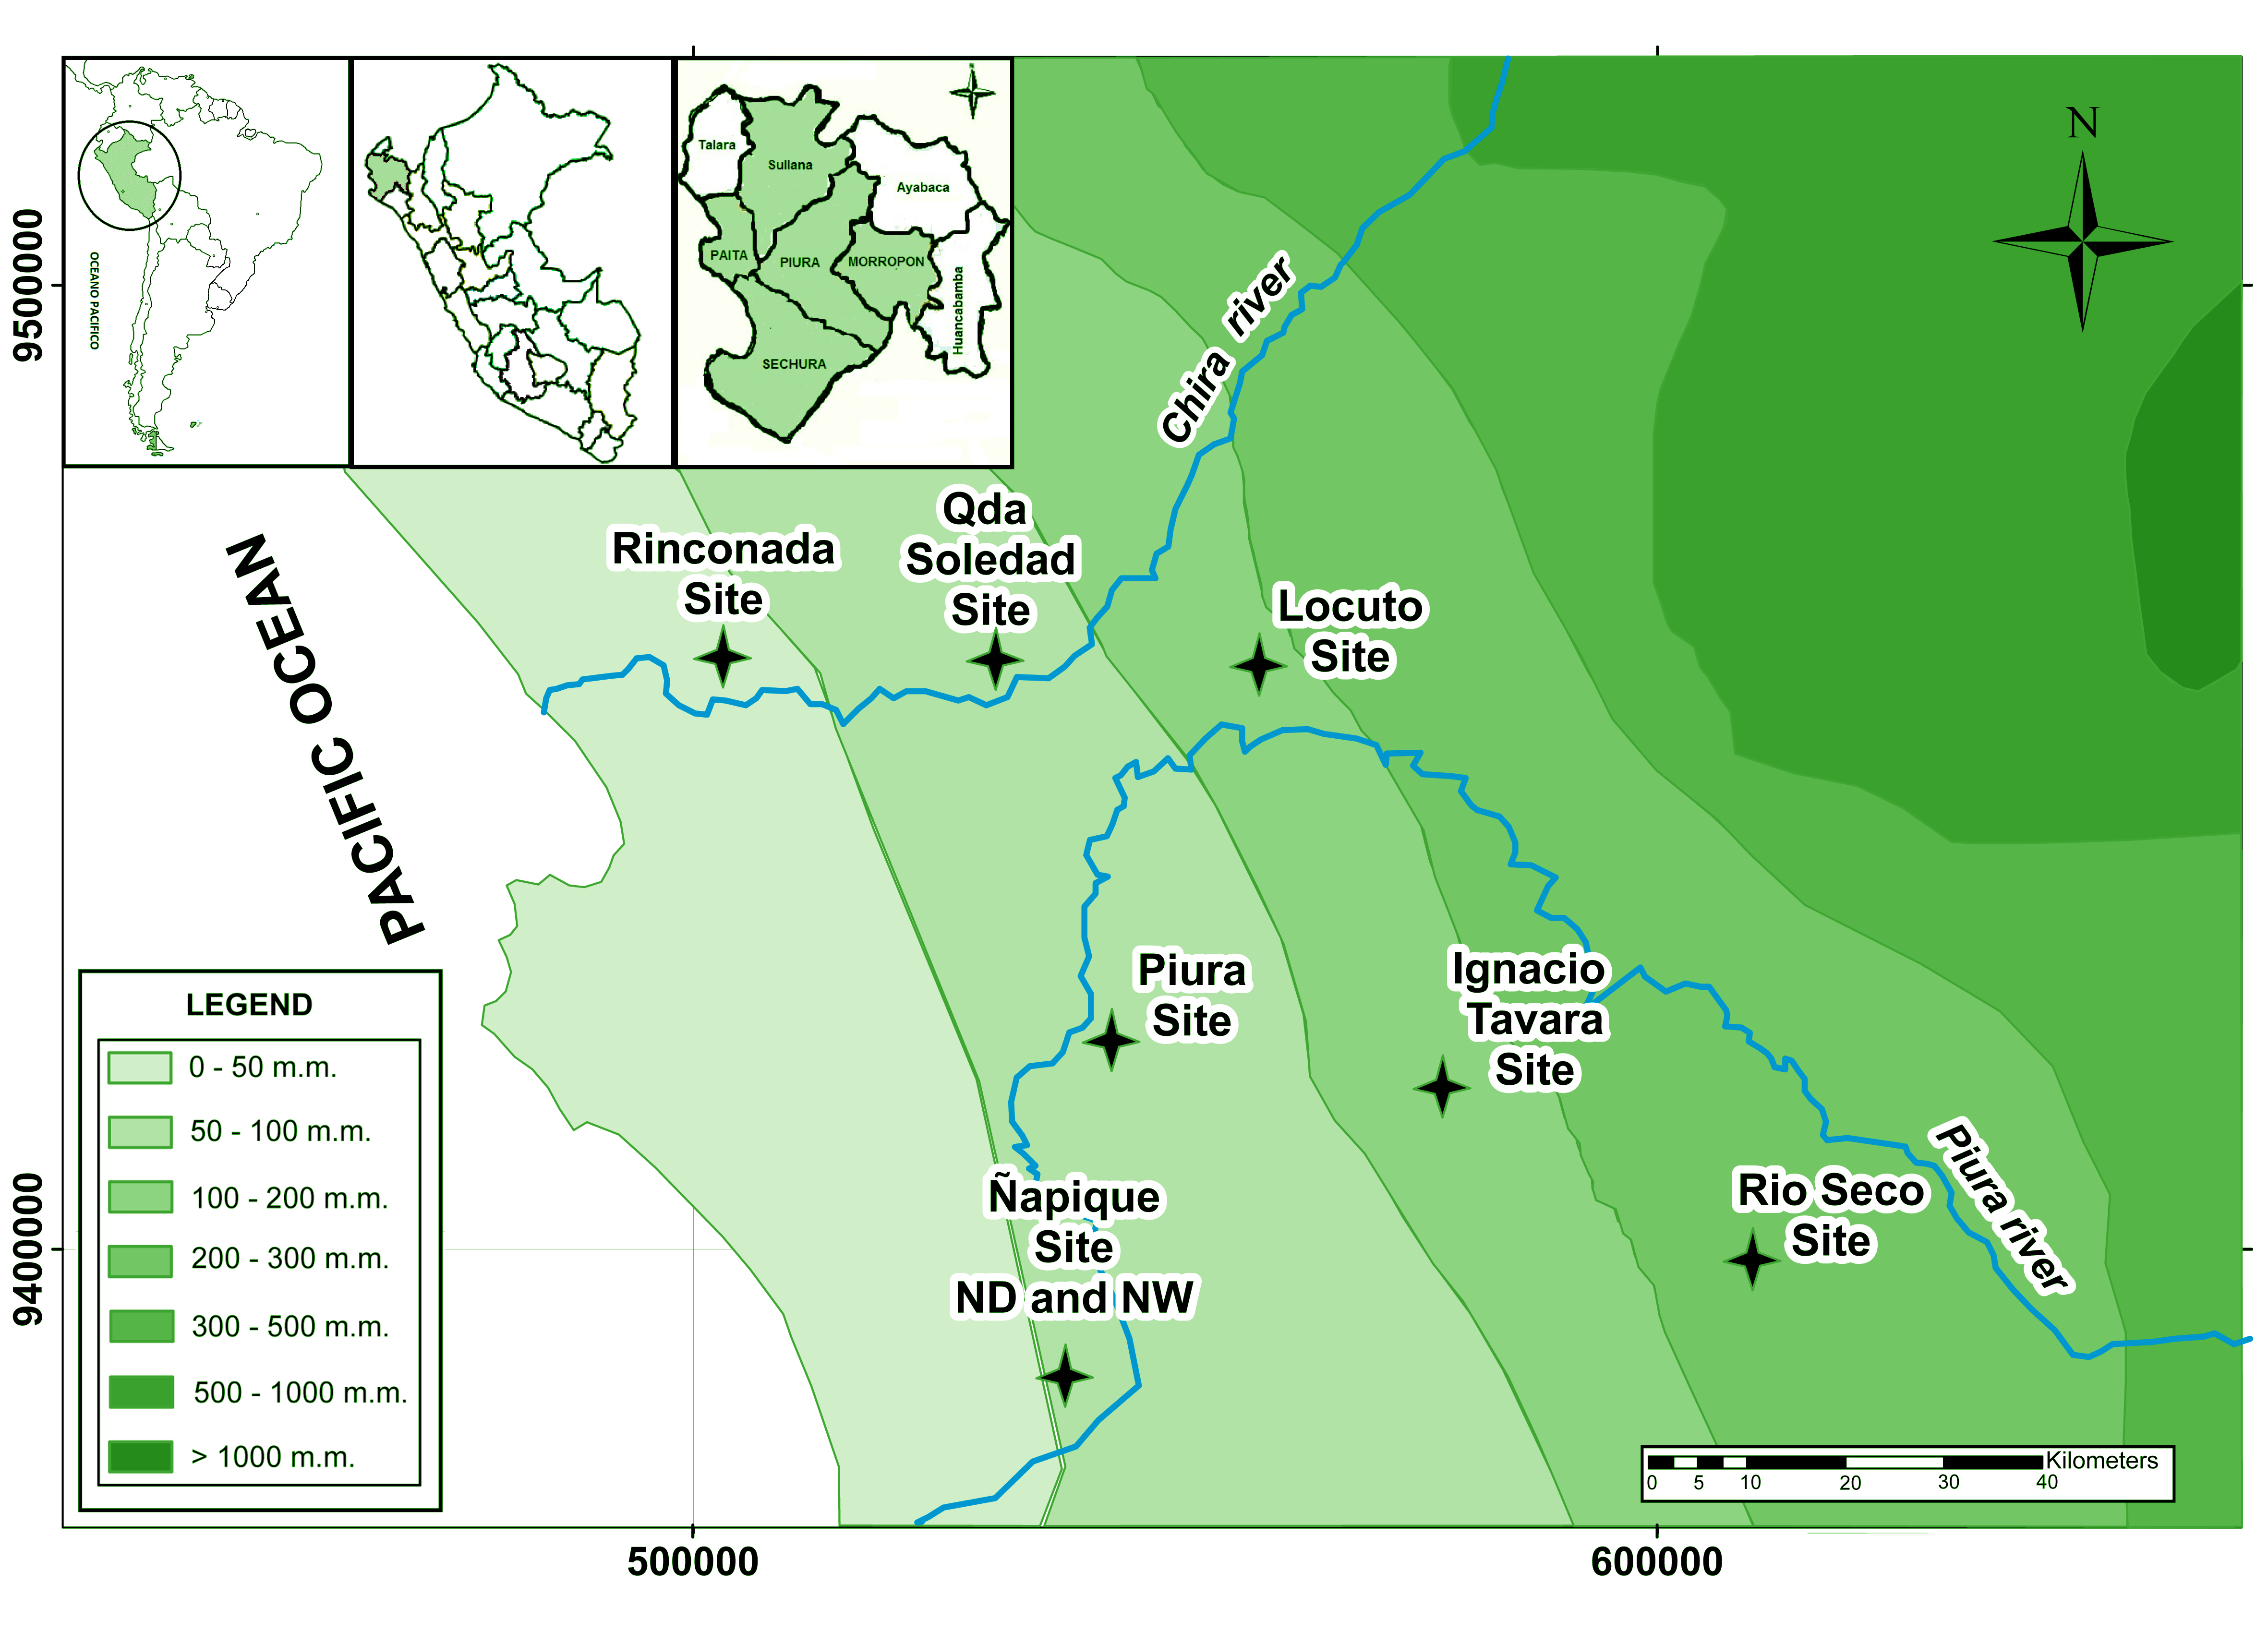

**Figure 2**

**E:\Dropbox\Fincyt\Estequiometria\Plant and soil\PlantSoil 2\Figuras 2\Fig2b.tiff**

**Figure 3**

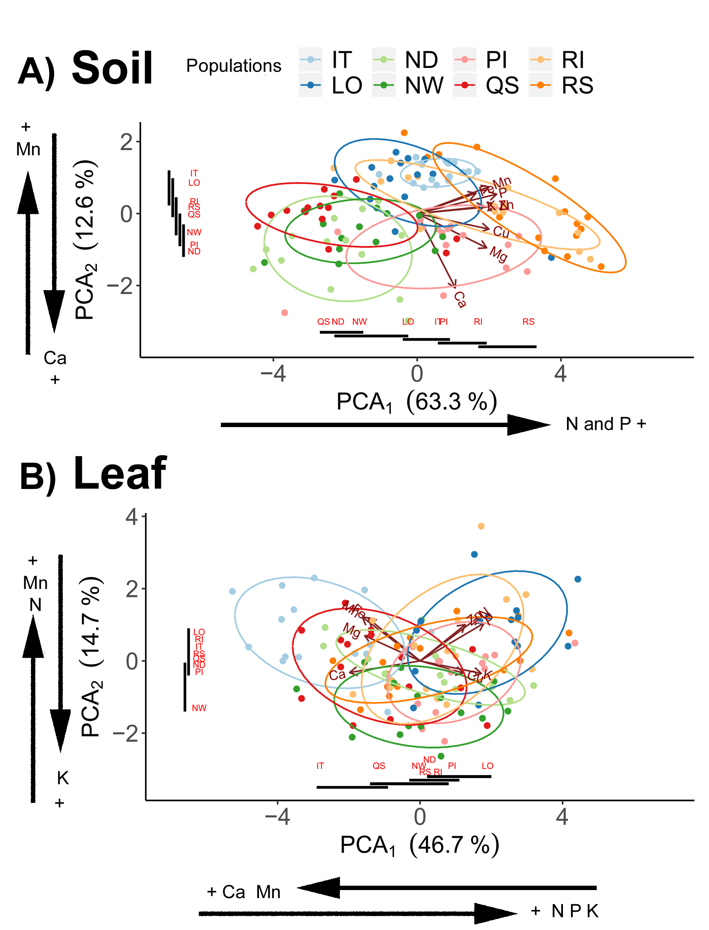

**Figure 4**

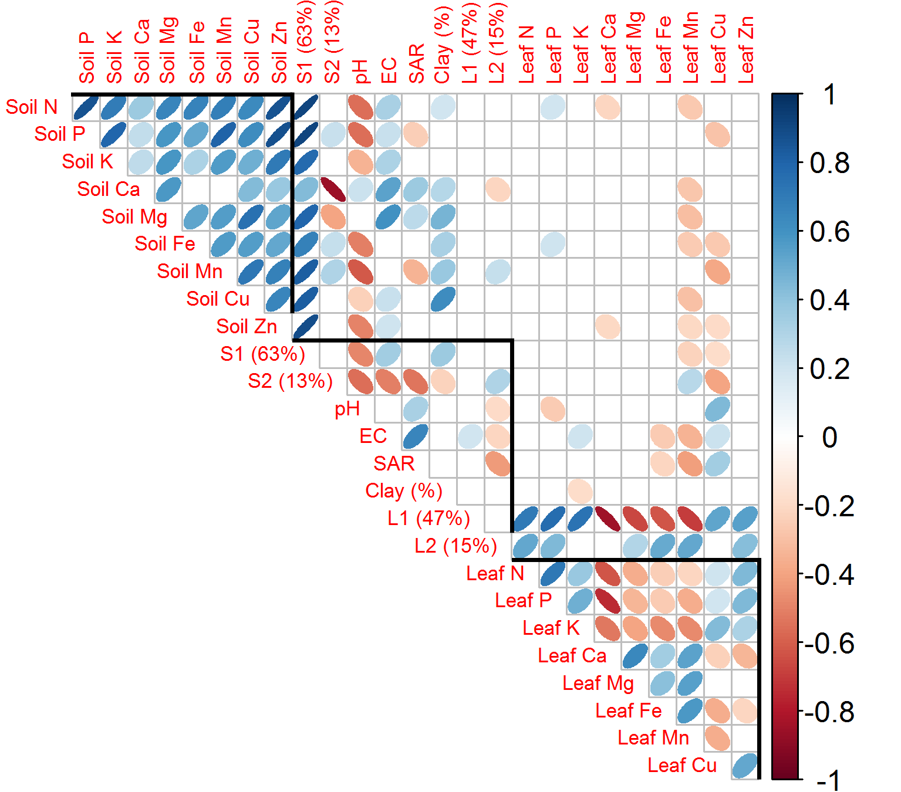

**Figure 5**

**E:\Dropbox\Fincyt\Estequiometria\Analisis\Plot5c.tiff**

**Figure 6**

**E:\Dropbox\Fincyt\Estequiometria\Plant and soil\PlantSoil 2\Figuras 2\Figure6N.tif**