Digestiones hojas encina

Aurelio_Diaz

21/05/2020

#Lectura de datos del archivo .csv

setwd(dir="C:/Users/Aurelio Diaz/Documents/5_DOUTORADO/Bosques Ibéricos/Digestiones")  
  
datdig <- read.table("190520_Resultados_analisis.csv", sep = ";", header = T, dec = ",")  
str(datdig)

## 'data.frame': 148 obs. of 13 variables:  
## $ Parcela : int 490299 490299 490299 490299 490299 490813 490813 490813 490813 490813 ...  
## $ Provincia: Factor w/ 7 levels "Cadiz","Cordoba",..: 7 7 7 7 7 7 7 7 7 7 ...  
## $ ID : int 1 2 3 4 5 6 7 8 9 10 ...  
## $ Individuo: int 1 3 5 2 4 6 7 5 8 10 ...  
## $ P : num 116 138.6 166 99.6 111.2 ...  
## $ K : num 4877 4591 4156 5866 3037 ...  
## $ Na : num 81.1 50.8 61.5 130.3 85.3 ...  
## $ Mg : num 525 650 985 569 1436 ...  
## $ Ca : num 2425 1650 3636 3020 3119 ...  
## $ Cu : num 5.5 2 2.53 2.48 1.98 1.98 2 1.95 1.98 1.96 ...  
## $ Zn : num 20 13 24.2 17.8 11.9 ...  
## $ Mn : num 2080 3420 4101 2614 2891 ...  
## $ Fe : num 77 28 77.8 84.2 70.3 ...

head(datdig)

## Parcela Provincia ID Individuo P K Na Mg Ca Cu  
## 1 490299 Zamora 1 1 115.97 4876.85 81.11 525.00 2425.00 5.50  
## 2 490299 Zamora 2 3 138.57 4591.11 50.81 650.00 1650.00 2.00  
## 3 490299 Zamora 3 5 166.03 4156.44 61.53 984.85 3636.36 2.53  
## 4 490299 Zamora 4 2 99.62 5865.91 130.29 569.31 3019.80 2.48  
## 5 490299 Zamora 5 4 111.19 3036.79 85.30 1435.64 3118.81 1.98  
## 6 490813 Zamora 6 6 170.58 4168.44 95.30 717.82 4133.66 1.98  
## Zn Mn Fe  
## 1 20.00 2080.00 77.00  
## 2 13.00 3420.00 28.00  
## 3 24.24 4101.01 77.78  
## 4 17.82 2613.86 84.16  
## 5 11.88 2891.09 70.30  
## 6 14.85 1148.51 66.34

#para poder juntar varias columnas he de transformar los vectores factores en caracter para despues juntarlos  
  
datdig$Provincia<-as.character(datdig$Provincia)  
datdig$Parcela<-as.character(datdig$Parcela)  
str(datdig)

## 'data.frame': 148 obs. of 13 variables:  
## $ Parcela : chr "490299" "490299" "490299" "490299" ...  
## $ Provincia: chr "Zamora" "Zamora" "Zamora" "Zamora" ...  
## $ ID : int 1 2 3 4 5 6 7 8 9 10 ...  
## $ Individuo: int 1 3 5 2 4 6 7 5 8 10 ...  
## $ P : num 116 138.6 166 99.6 111.2 ...  
## $ K : num 4877 4591 4156 5866 3037 ...  
## $ Na : num 81.1 50.8 61.5 130.3 85.3 ...  
## $ Mg : num 525 650 985 569 1436 ...  
## $ Ca : num 2425 1650 3636 3020 3119 ...  
## $ Cu : num 5.5 2 2.53 2.48 1.98 1.98 2 1.95 1.98 1.96 ...  
## $ Zn : num 20 13 24.2 17.8 11.9 ...  
## $ Mn : num 2080 3420 4101 2614 2891 ...  
## $ Fe : num 77 28 77.8 84.2 70.3 ...

#para crear una columna con las parcelas y provincias, le he metido el orden de las muestras   
#para que no me de problemas despues en el nombre de las filas  
  
library(tidyverse)

## -- Attaching packages ---------------------------- tidyverse 1.3.0 --

## v ggplot2 3.3.0 v purrr 0.3.3  
## v tibble 2.1.3 v dplyr 0.8.4  
## v tidyr 1.0.0 v stringr 1.4.0  
## v readr 1.3.1 v forcats 0.4.0

## Warning: package 'ggplot2' was built under R version 3.6.3

## Warning: package 'purrr' was built under R version 3.6.3

## -- Conflicts ------------------------------- tidyverse_conflicts() --  
## x dplyr::filter() masks stats::filter()  
## x dplyr::lag() masks stats::lag()

datdig1<-unite(datdig, Local, c(1:3), sep = " ", remove = TRUE)  
head(datdig1)

## Local Individuo P K Na Mg Ca Cu Zn  
## 1 490299 Zamora 1 1 115.97 4876.85 81.11 525.00 2425.00 5.50 20.00  
## 2 490299 Zamora 2 3 138.57 4591.11 50.81 650.00 1650.00 2.00 13.00  
## 3 490299 Zamora 3 5 166.03 4156.44 61.53 984.85 3636.36 2.53 24.24  
## 4 490299 Zamora 4 2 99.62 5865.91 130.29 569.31 3019.80 2.48 17.82  
## 5 490299 Zamora 5 4 111.19 3036.79 85.30 1435.64 3118.81 1.98 11.88  
## 6 490813 Zamora 6 6 170.58 4168.44 95.30 717.82 4133.66 1.98 14.85  
## Mn Fe  
## 1 2080.00 77.00  
## 2 3420.00 28.00  
## 3 4101.01 77.78  
## 4 2613.86 84.16  
## 5 2891.09 70.30  
## 6 1148.51 66.34

str(datdig1)

## 'data.frame': 148 obs. of 11 variables:  
## $ Local : chr "490299 Zamora 1" "490299 Zamora 2" "490299 Zamora 3" "490299 Zamora 4" ...  
## $ Individuo: int 1 3 5 2 4 6 7 5 8 10 ...  
## $ P : num 116 138.6 166 99.6 111.2 ...  
## $ K : num 4877 4591 4156 5866 3037 ...  
## $ Na : num 81.1 50.8 61.5 130.3 85.3 ...  
## $ Mg : num 525 650 985 569 1436 ...  
## $ Ca : num 2425 1650 3636 3020 3119 ...  
## $ Cu : num 5.5 2 2.53 2.48 1.98 1.98 2 1.95 1.98 1.96 ...  
## $ Zn : num 20 13 24.2 17.8 11.9 ...  
## $ Mn : num 2080 3420 4101 2614 2891 ...  
## $ Fe : num 77 28 77.8 84.2 70.3 ...

summary(datdig1)

## Local Individuo P K   
## Length:148 Min. : 1.000 Min. : 97.27 Min. :2353   
## Class :character 1st Qu.: 2.000 1st Qu.: 202.07 1st Qu.:3706   
## Mode :character Median : 4.000 Median : 533.25 Median :4496   
## Mean : 3.959 Mean : 503.26 Mean :4573   
## 3rd Qu.: 5.000 3rd Qu.: 700.29 3rd Qu.:5315   
## Max. :10.000 Max. :1322.81 Max. :8170   
## Na Mg Ca Cu   
## Min. : 30.93 Min. : 525 Min. : 1141 Min. :1.440   
## 1st Qu.: 90.82 1st Qu.:1200 1st Qu.: 3587 1st Qu.:2.487   
## Median :114.12 Median :1506 Median : 4851 Median :3.850   
## Mean :132.86 Mean :1607 Mean : 5232 Mean :3.756   
## 3rd Qu.:147.37 3rd Qu.:1891 3rd Qu.: 6559 3rd Qu.:4.500   
## Max. :677.27 Max. :3383 Max. :12956 Max. :8.370   
## Zn Mn Fe   
## Min. :10.95 Min. : 69.65 Min. : 18.0   
## 1st Qu.:18.00 1st Qu.: 730.54 1st Qu.: 103.5   
## Median :22.88 Median :1185.24 Median : 166.7   
## Mean :23.81 Mean :1324.34 Mean : 247.7   
## 3rd Qu.:28.04 3rd Qu.:1757.43 3rd Qu.: 317.6   
## Max. :48.34 Max. :4238.81 Max. :1432.8

#cambiamos el nombre de las filas por la columa local previamente montada,   
#no puede haber valores repetidos lo cual me ha complicado la vida.  
  
rownames(datdig1)=datdig1$Local  
  
datdig1<-datdig1[,-(1:2)]  
head(datdig1)

## P K Na Mg Ca Cu Zn Mn Fe  
## 490299 Zamora 1 115.97 4876.85 81.11 525.00 2425.00 5.50 20.00 2080.00 77.00  
## 490299 Zamora 2 138.57 4591.11 50.81 650.00 1650.00 2.00 13.00 3420.00 28.00  
## 490299 Zamora 3 166.03 4156.44 61.53 984.85 3636.36 2.53 24.24 4101.01 77.78  
## 490299 Zamora 4 99.62 5865.91 130.29 569.31 3019.80 2.48 17.82 2613.86 84.16  
## 490299 Zamora 5 111.19 3036.79 85.30 1435.64 3118.81 1.98 11.88 2891.09 70.30  
## 490813 Zamora 6 170.58 4168.44 95.30 717.82 4133.66 1.98 14.85 1148.51 66.34

#realizamos una transformacion en los parámetros de mayores valores absolutos  
# asi al máximo del K, Ca y Mn se le retira el valor de cada muestra  
datdig1$K<-max(datdig1$K) -datdig1$K  
datdig1$Mg<-max(datdig1$Mg) -datdig1$Mg  
datdig1$Ca<-max(datdig1$Ca) -datdig1$Ca  
datdig1$Mn<-max(datdig1$Mn) -datdig1$Mn  
head(datdig1)

## P K Na Mg Ca Cu Zn Mn Fe  
## 490299 Zamora 1 115.97 3292.81 81.11 2858.08 10530.67 5.50 20.00 2158.81 77.00  
## 490299 Zamora 2 138.57 3578.55 50.81 2733.08 11305.67 2.00 13.00 818.81 28.00  
## 490299 Zamora 3 166.03 4013.22 61.53 2398.23 9319.31 2.53 24.24 137.80 77.78  
## 490299 Zamora 4 99.62 2303.75 130.29 2813.77 9935.87 2.48 17.82 1624.95 84.16  
## 490299 Zamora 5 111.19 5132.87 85.30 1947.44 9836.86 1.98 11.88 1347.72 70.30  
## 490813 Zamora 6 170.58 4001.22 95.30 2665.26 8822.01 1.98 14.85 3090.30 66.34

library(TeachingDemos)   
  
faces2(datdig1, nrows=7)

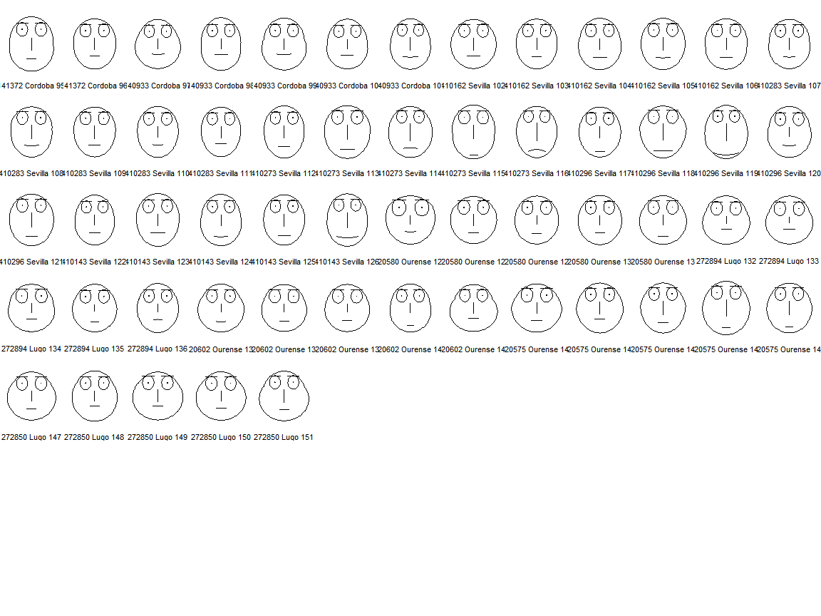

#Representacion gráfica de las posibles correlaciones entre variables  
panel.hist <- function(x, ...)   
{   
 usr <- par("usr"); on.exit(par(usr))   
 par(usr = c(usr[1:2], 0, 1.5) )   
 h <- hist(x, plot = FALSE)   
 breaks <- h$breaks; nB <- length(breaks)   
 y <- h$counts; y <- y/max(y)   
 rect(breaks[-nB], 0, breaks[-1], y, col="blue", ...)   
}   
pairs(datdig1,diag.panel=panel.hist)

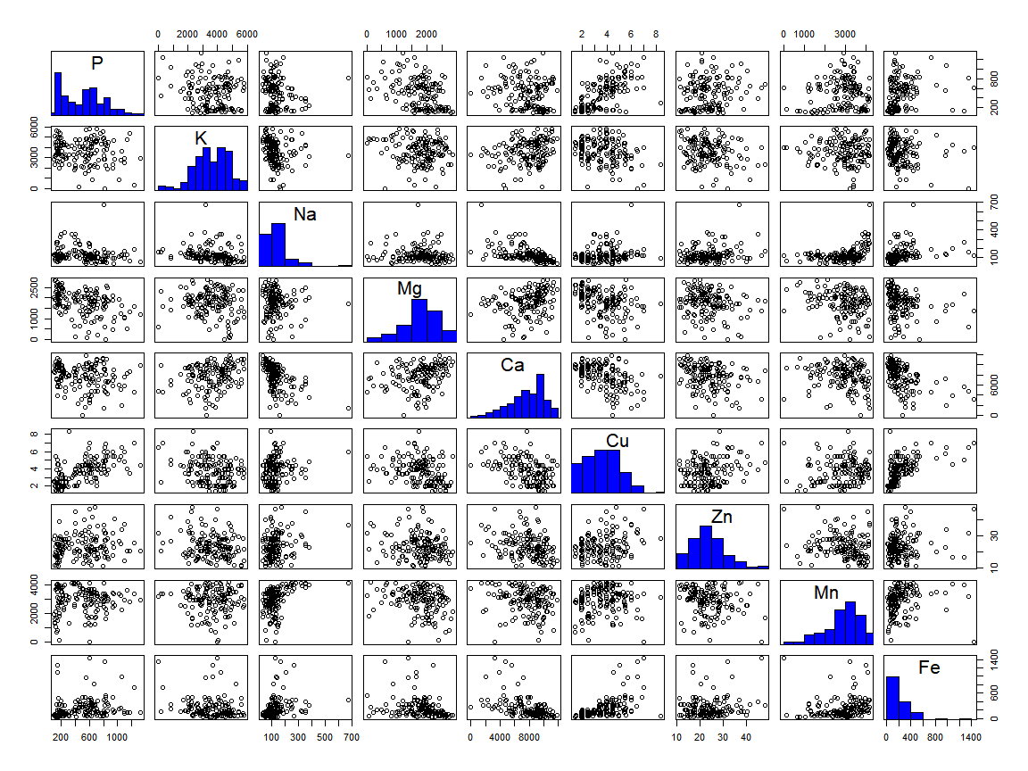

library(PerformanceAnalytics)

## Loading required package: xts

## Loading required package: zoo

##   
## Attaching package: 'zoo'

## The following objects are masked from 'package:base':  
##   
## as.Date, as.Date.numeric

## Registered S3 method overwritten by 'xts':  
## method from  
## as.zoo.xts zoo

##   
## Attaching package: 'xts'

## The following objects are masked from 'package:dplyr':  
##   
## first, last

##   
## Attaching package: 'PerformanceAnalytics'

## The following object is masked from 'package:graphics':  
##   
## legend

chart.Correlation(datdig1)

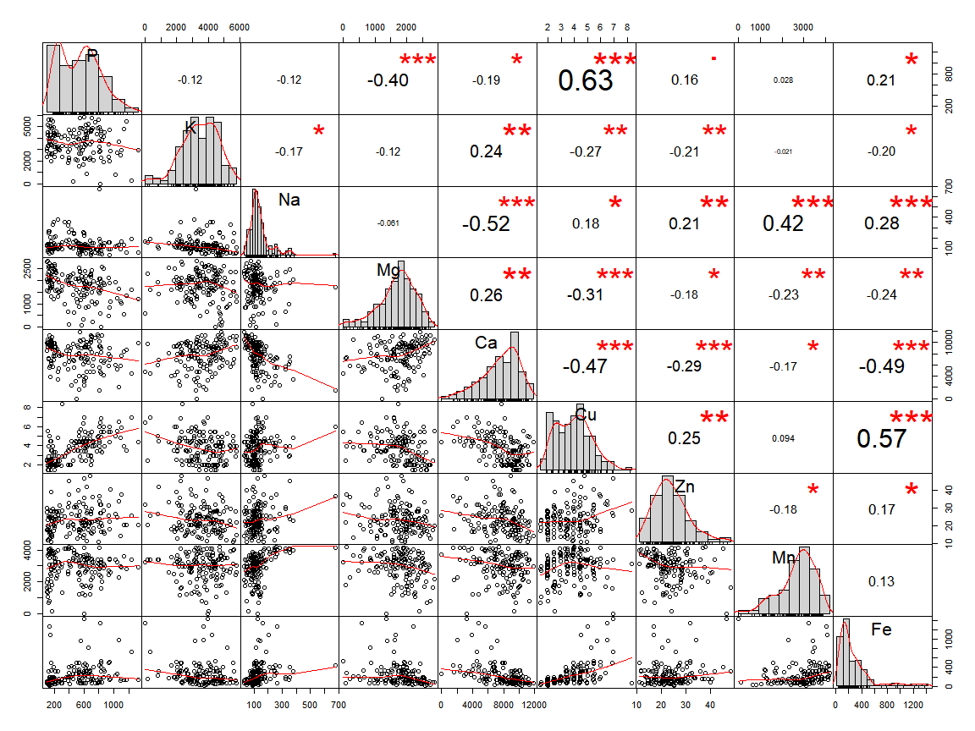

rs.cor <- (cor(x=datdig1, method="pearson",use="complete.obs"))  
rs.cor

## P K Na Mg Ca Cu  
## P 1.0000000 -0.11812833 -0.12103725 -0.40066056 -0.1916307 0.62819847  
## K -0.1181283 1.00000000 -0.17202789 -0.11534659 0.2400848 -0.26769231  
## Na -0.1210372 -0.17202789 1.00000000 -0.06098485 -0.5198639 0.18437878  
## Mg -0.4006606 -0.11534659 -0.06098485 1.00000000 0.2628899 -0.31106720  
## Ca -0.1916307 0.24008479 -0.51986391 0.26288990 1.0000000 -0.46760568  
## Cu 0.6281985 -0.26769231 0.18437878 -0.31106720 -0.4676057 1.00000000  
## Zn 0.1588944 -0.21396795 0.21403847 -0.17701649 -0.2850085 0.24615943  
## Mn 0.0277838 -0.02149406 0.42156066 -0.22829084 -0.1719943 0.09424482  
## Fe 0.2104936 -0.19677542 0.27842734 -0.23618554 -0.4903553 0.57193693  
## Zn Mn Fe  
## P 0.1588944 0.02778380 0.2104936  
## K -0.2139679 -0.02149406 -0.1967754  
## Na 0.2140385 0.42156066 0.2784273  
## Mg -0.1770165 -0.22829084 -0.2361855  
## Ca -0.2850085 -0.17199431 -0.4903553  
## Cu 0.2461594 0.09424482 0.5719369  
## Zn 1.0000000 -0.17680921 0.1652023  
## Mn -0.1768092 1.00000000 0.1323512  
## Fe 0.1652023 0.13235121 1.0000000

dig.pc<-princomp(datdig1,cor=TRUE)   
summary(dig.pc,loadings=TRUE)

## Importance of components:  
## Comp.1 Comp.2 Comp.3 Comp.4 Comp.5  
## Standard deviation 1.7193757 1.2288604 1.1356258 0.9697199 0.87728649  
## Proportion of Variance 0.3284725 0.1677886 0.1432940 0.1044841 0.08551462  
## Cumulative Proportion 0.3284725 0.4962612 0.6395552 0.7440393 0.82955388  
## Comp.6 Comp.7 Comp.8 Comp.9  
## Standard deviation 0.72855352 0.68912703 0.54987595 0.47535797  
## Proportion of Variance 0.05897669 0.05276623 0.03359595 0.02510724  
## Cumulative Proportion 0.88853058 0.94129680 0.97489276 1.00000000  
##   
## Loadings:  
## Comp.1 Comp.2 Comp.3 Comp.4 Comp.5 Comp.6 Comp.7 Comp.8 Comp.9  
## P 0.316 0.527 0.168 0.184 0.263 0.411 0.566  
## K -0.218 0.513 -0.480 -0.486 0.416 -0.178   
## Na 0.294 -0.592 -0.173 0.331 0.625 0.166  
## Mg -0.288 -0.232 -0.473 0.391 -0.189 0.539 -0.258 -0.288 0.106  
## Ca -0.443 0.219 0.134 0.220 -0.137 -0.652 0.488   
## Cu 0.472 0.256 0.245 -0.116 0.272 -0.173 0.143 -0.717  
## Zn 0.251 -0.441 -0.636 0.284 -0.426 -0.258   
## Mn 0.171 -0.430 0.531 0.210 0.388 -0.337 -0.438   
## Fe 0.414 0.164 -0.601 -0.405 -0.388 0.352

S = cor(datdig1)   
eigen(S)

## eigen() decomposition  
## $values  
## [1] 2.9562529 1.5100978 1.2896459 0.9403567 0.7696316 0.5307902 0.4748961  
## [8] 0.3023636 0.2259652  
##   
## $vectors  
## [,1] [,2] [,3] [,4] [,5] [,6]  
## [1,] 0.3163487 0.52725092 -0.167885916 0.1842441 -0.26343465 0.411433283  
## [2,] -0.2179171 0.08961290 -0.512824343 -0.4797447 0.48640520 0.415606580  
## [3,] 0.2940424 -0.59228003 0.015436172 -0.1731948 -0.06723838 0.331397864  
## [4,] -0.2883618 -0.23169960 0.473258153 0.3906221 0.18855360 0.539254072  
## [5,] -0.4429032 0.21866998 -0.087568999 0.1338586 -0.22030738 -0.137148724  
## [6,] 0.4718349 0.25622478 0.007320219 0.2453663 0.11593031 0.271508212  
## [7,] 0.2512406 0.09751524 0.440692747 -0.6356531 -0.28408427 0.008751445  
## [8,] 0.1709011 -0.43037471 -0.531005720 0.2102058 -0.38796417 -0.027981324  
## [9,] 0.4143691 -0.03600484 0.026737047 0.1641739 0.60061923 -0.404954692  
## [,7] [,8] [,9]  
## [1,] -0.03157843 0.01013384 0.5657060310  
## [2,] 0.17785595 -0.09958625 -0.0216531344  
## [3,] 0.01556891 0.62481362 0.1659178620  
## [4,] 0.25775153 -0.28752955 0.1055812069  
## [5,] 0.65186188 0.48802040 -0.0009123642  
## [6,] 0.17335996 0.14315337 -0.7167701028  
## [7,] 0.42648805 -0.25771496 -0.0038041007  
## [8,] 0.33676077 -0.43792168 -0.0541712446  
## [9,] 0.38783291 -0.00808656 0.3523102220

dig.pc$scores[,1:3]

## Comp.1 Comp.2 Comp.3  
## 490299 Zamora 1 -1.56820123 0.173252064 -1.324058e+00  
## 490299 Zamora 2 -3.56277163 0.509247618 -1.430734e+00  
## 490299 Zamora 3 -2.53178515 1.035906183 -2.125444e+00  
## 490299 Zamora 4 -2.28229952 -0.649004984 -1.945145e+00  
## 490299 Zamora 5 -2.97188851 0.212864751 1.847638e-01  
## 490813 Zamora 6 -2.38327775 -1.036545442 -4.223727e-05  
## 490813 Zamora 7 -1.61356362 -1.250222175 -1.175308e+00  
## 490813 Zamora 8 -1.90818275 -0.908004243 -4.380190e-01  
## 490813 Zamora 9 -1.54044092 0.003951360 -2.008934e-01  
## 490813 Zamora 10 -2.52047961 -0.279715367 -4.953411e-01  
## 490125 Zamora 11 -0.86269922 -0.117392132 -2.585578e+00  
## 490125 Zamora 12 -2.39200451 -0.698454127 -3.583408e-01  
## 490125 Zamora 13 -1.49983945 -0.277683732 -1.223557e+00  
## 490125 Zamora 14 -1.31239610 -0.385025041 -5.829217e-01  
## 490125 Zamora 15 -2.35829569 -0.766551047 -5.897780e-01  
## 490300 Zamora 16 -1.72195763 -0.382892101 -3.920566e-01  
## 490300 Zamora 17 -2.32036998 -0.832208091 -5.534280e-01  
## 490300 Zamora 18 -1.75024258 -0.326586760 -8.085165e-01  
## 490300 Zamora 19 -2.57470612 -0.736496415 7.667506e-02  
## 490300 Zamora 20 -1.84387301 0.197063745 -1.078516e-01  
## 490525 Zamora 21 -1.38297592 -0.457995733 -1.546191e+00  
## 490525 Zamora 22 -1.18468595 0.065351782 -1.530449e+00  
## 490525 Zamora 23 -3.02827407 -0.159782723 -1.629678e+00  
## 490525 Zamora 24 -2.58646819 -0.219520989 -1.223056e+00  
## 490525 Zamora 25 -2.07697845 -0.256454937 -1.680539e+00  
## 450176 Toledo 26 -1.46308786 -0.476742190 -6.570555e-01  
## 450176 Toledo 27 -1.06704474 -0.533228597 1.668554e-01  
## 450176 Toledo 28 0.46833651 -0.764191013 -1.104212e+00  
## 450176 Toledo 29 -1.58144828 -0.645812965 2.399301e-02  
## 450176 Toledo 30 1.35145321 0.691460511 -7.821424e-01  
## 450101 Toledo 31 -1.54757016 -0.809859261 -2.635313e-01  
## 450101 Toledo 32 -2.07653956 -0.862669221 8.608284e-01  
## 450101 Toledo 33 -2.09178861 -0.809910794 9.725322e-01  
## 450101 Toledo 34 -0.81502956 -0.943605364 -2.066619e-01  
## 450101 Toledo 35 -1.20427135 -0.877755047 -2.765198e-01  
## 450265 Toledo 36 -1.30691055 -0.850692941 2.565717e-01  
## 450265 Toledo 37 -1.54744891 -0.350173597 1.724137e-01  
## 450265 Toledo 38 -1.17183758 -0.063160486 -1.486632e+00  
## 450265 Toledo 39 -0.62952843 -0.177381860 -9.751842e-01  
## 450265 Toledo 40 -0.57985496 -1.046525139 -1.383801e+00  
## 451383 Toledo 41 -1.51284362 -0.866179859 9.372498e-01  
## 451383 Toledo 42 -0.37797374 -1.035835649 9.473042e-01  
## 451383 Toledo 43 -0.77761851 -0.815697280 -2.001239e-02  
## 451383 Toledo 44 -1.49321859 -1.134491485 2.964766e-01  
## 451383 Toledo 45 -1.56113846 -1.000540511 1.013765e+00  
## 450203 Toledo 46 -0.04543864 -0.284830648 -6.506862e-01  
## 450203 Toledo 47 -0.10601605 -0.619844934 3.885823e-02  
## 450203 Toledo 48 -0.47964452 -0.337315508 -5.850338e-01  
## 450203 Toledo 50 -1.12685275 -0.422760590 7.615200e-01  
## 110397 Cadiz 51 -0.65335383 -2.559859908 -3.941362e-02  
## 110397 Cadiz 52 -0.39692519 -1.990379501 -3.048862e-01  
## 110397 Cadiz 53 2.04046989 -3.133258345 -9.002249e-02  
## 110397 Cadiz 54 0.42784419 -2.643783224 3.125049e-01  
## 110397 Cadiz 55 -0.14604494 -2.995801521 7.237554e-02  
## 110085 Cadiz 56 2.22069784 -2.052310700 1.041706e+00  
## 110085 Cadiz 57 2.42260462 -2.532384996 3.341969e-01  
## 110085 Cadiz 58 0.01346453 -1.505642038 1.868834e+00  
## 110085 Cadiz 59 -0.11009168 -2.006915050 2.189233e+00  
## 110085 Cadiz 60 0.23662386 -1.462560203 1.722129e+00  
## 110158 Cadiz 62 5.34204566 -4.053171490 -3.378906e-01  
## 110158 Cadiz 63 1.71287628 -1.741714915 3.199923e-01  
## 110158 Cadiz 64 1.19778046 -1.243597296 2.268824e+00  
## 110158 Cadiz 65 1.82777411 -0.785493457 1.646590e+00  
## 110160 Cadiz 66 2.34975868 -0.982393492 3.951443e-01  
## 110160 Cadiz 67 1.36260617 -1.207033244 3.833459e-02  
## 110160 Cadiz 68 2.11257124 -1.482002268 -8.817753e-02  
## 110160 Cadiz 69 1.73576995 -0.930435212 -1.289127e+00  
## 110160 Cadiz 70 2.67667631 -0.921012210 -1.175899e+00  
## 110094 Cadiz 71 2.37170719 -2.323608201 -1.411299e+00  
## 110094 Cadiz 72 2.34662992 -2.234753489 1.102361e-01  
## 110094 Cadiz 73 1.00764068 -2.365540811 1.352213e+00  
## 110094 Cadiz 74 1.78244017 -1.891466181 1.153264e+00  
## 110094 Cadiz 75 -0.55190858 -1.373663382 9.466095e-01  
## 140897 Cordoba 76 0.86362858 1.409018409 2.497544e+00  
## 140897 Cordoba 77 -0.83362712 0.140754235 1.513369e+00  
## 140897 Cordoba 78 1.97291192 0.641489370 1.982948e+00  
## 140897 Cordoba 79 2.98757364 1.383422657 1.530271e+00  
## 140897 Cordoba 80 0.37258674 0.366965764 1.055366e+00  
## 141364 Cordoba 81 -0.33931392 0.004565755 3.079550e-01  
## 141364 Cordoba 82 0.32208915 0.494128549 1.057126e-01  
## 141364 Cordoba 84 0.09153007 0.684372204 2.578276e-01  
## 141364 Cordoba 85 1.28025763 1.121406923 -1.360740e+00  
## 141364 Cordoba 86 0.40372438 -0.052566445 -2.275567e+00  
## 141353 Cordoba 87 2.05266237 0.399740689 1.085701e-02  
## 141353 Cordoba 88 4.35568454 0.748774734 -9.190904e-01  
## 141353 Cordoba 89 1.83640809 0.664301033 -1.014413e+00  
## 141353 Cordoba 90 2.14730874 1.134445211 3.921859e-01  
## 141353 Cordoba 91 1.42112193 0.237312443 -7.252082e-01  
## 141372 Cordoba 92 -0.16481287 1.107640531 -1.425523e+00  
## 141372 Cordoba 93 1.10778198 0.627177257 2.441133e-01  
## 141372 Cordoba 94 1.34630603 1.764681044 7.081122e-01  
## 141372 Cordoba 95 0.38240916 0.420985568 -1.033733e-01  
## 141372 Cordoba 96 0.17443247 0.471987369 9.159845e-03  
## 140933 Cordoba 97 -0.35889327 0.975825099 2.902850e+00  
## 140933 Cordoba 98 0.21470456 -0.367900012 1.050519e+00  
## 140933 Cordoba 99 -0.45686504 -0.106884502 1.485512e+00  
## 140933 Cordoba 100 -0.25675308 0.331128727 1.003814e+00  
## 140933 Cordoba 101 1.09394205 0.507469809 1.155323e+00  
## 410162 Sevilla 102 0.09370088 1.064676308 1.410726e+00  
## 410162 Sevilla 103 -0.33567394 1.180643997 -1.251809e+00  
## 410162 Sevilla 104 -0.14871745 0.876651757 -3.559918e-01  
## 410162 Sevilla 105 0.76932972 0.985574629 3.269458e-03  
## 410162 Sevilla 106 0.18549387 0.603592689 -4.237143e-01  
## 410283 Sevilla 107 -0.33512937 0.501669981 -9.038665e-02  
## 410283 Sevilla 108 0.71943273 0.455847675 -5.411384e-01  
## 410283 Sevilla 109 0.57675122 1.206087363 -1.310951e+00  
## 410283 Sevilla 110 0.86060008 -0.121464776 1.723848e-01  
## 410283 Sevilla 111 0.85029543 0.237057767 -3.823980e-01  
## 410273 Sevilla 112 1.25756662 0.647655457 -1.516634e+00  
## 410273 Sevilla 113 1.78242738 1.014746932 -1.353608e+00  
## 410273 Sevilla 114 1.87399899 1.927590179 -1.290587e+00  
## 410273 Sevilla 115 1.36354120 1.110565124 -2.722730e+00  
## 410273 Sevilla 116 4.36490438 2.177740241 -2.905719e+00  
## 410296 Sevilla 117 1.93350688 0.485324487 -1.649645e+00  
## 410296 Sevilla 118 4.14411382 1.358894975 -8.376363e-01  
## 410296 Sevilla 119 5.35830905 0.533731917 -1.012707e+00  
## 410296 Sevilla 120 -0.48656820 0.162391437 3.245641e-01  
## 410296 Sevilla 121 1.32513381 0.934550376 -3.498548e-02  
## 410143 Sevilla 122 0.12276232 -0.026598509 1.007742e+00  
## 410143 Sevilla 123 1.41043879 -0.318243292 -1.150203e-01  
## 410143 Sevilla 124 0.79980356 -0.129312698 4.180252e-01  
## 410143 Sevilla 125 1.41553059 0.181221537 3.868508e-01  
## 410143 Sevilla 126 2.40635090 0.094665892 4.005594e-01  
## 320580 Ourense 127 -0.28265219 2.075107476 1.699747e+00  
## 320580 Ourense 128 0.21839050 1.935523982 1.896346e+00  
## 320580 Ourense 129 -0.38168774 1.113415258 -4.766934e-01  
## 320580 Ourense 130 -0.06096910 1.131209751 1.118399e+00  
## 320580 Ourense 131 -0.27664424 1.892515193 2.242663e-01  
## 272894 Lugo 132 -2.11450891 0.426270134 1.046392e+00  
## 272894 Lugo 133 -2.06933766 0.504302903 1.084502e+00  
## 272894 Lugo 134 -1.78031412 1.654333230 -5.378734e-01  
## 272894 Lugo 135 -0.92158907 1.501729158 1.078214e+00  
## 272894 Lugo 136 -0.46865225 1.560634941 1.375914e+00  
## 320602 Ourense 137 -1.85194081 1.004560779 8.913388e-02  
## 320602 Ourense 138 -1.59356313 1.511728146 -5.111683e-01  
## 320602 Ourense 139 -1.65264739 1.675230941 -4.676568e-01  
## 320602 Ourense 140 -0.62343339 1.046566944 -1.198557e+00  
## 320602 Ourense 141 -2.01651644 1.037154272 8.266016e-01  
## 320575 Ourense 142 0.55002626 2.486043079 9.176517e-01  
## 320575 Ourense 143 1.20168230 1.435845413 9.353063e-01  
## 320575 Ourense 144 1.84508812 1.796899611 9.297456e-01  
## 320575 Ourense 145 2.32355254 1.625344270 -1.651692e-01  
## 320575 Ourense 146 1.76810783 2.018981513 -7.013603e-01  
## 272850 Lugo 147 -0.84357243 1.937363299 1.543301e+00  
## 272850 Lugo 148 -1.15443310 0.674921849 2.064878e+00  
## 272850 Lugo 149 -1.14063498 1.621809168 2.286828e+00  
## 272850 Lugo 150 -1.11091361 1.827505439 1.677065e+00  
## 272850 Lugo 151 -0.69522330 1.248923485 1.139324e+00

par(pty="s")   
plot(dig.pc$scores[,1],dig.pc$scores[,2],   
 ylim=range(dig.pc$scores[,1]),   
 xlab="PC1",ylab="PC2",type="n",lwd=2)   
text(dig.pc$scores[,1],dig.pc$scores[,2],   
 labels=abbreviate(row.names(datdig1)),cex=0.5,lwd=2)

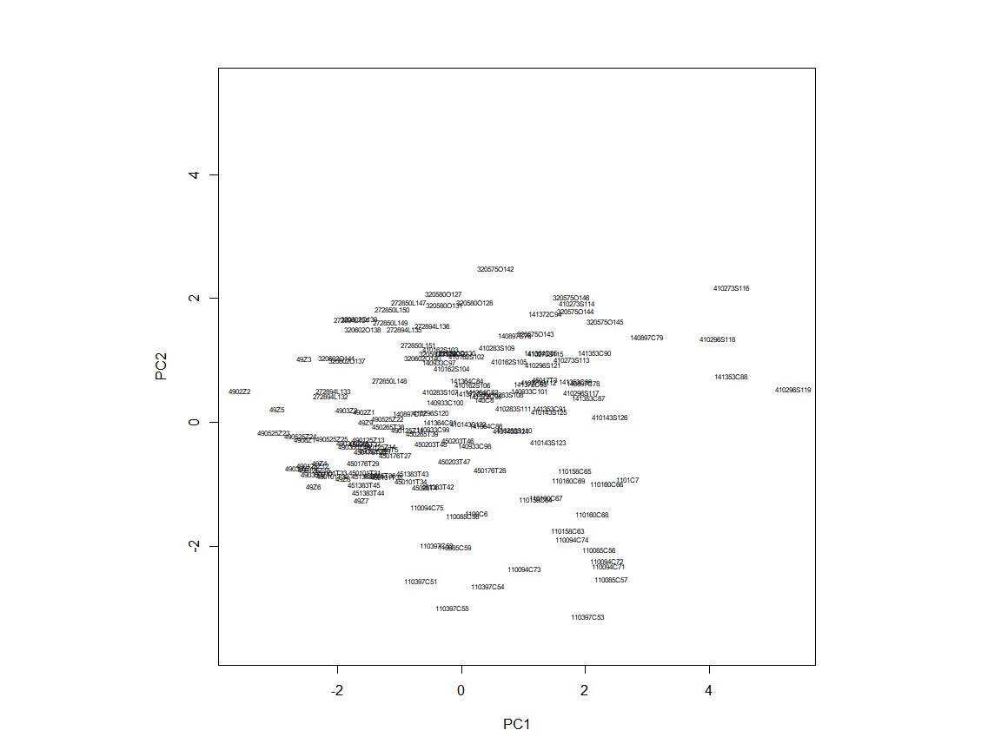

plot(dig.pc$scores[,1],dig.pc$scores[,3],   
 ylim=range(dig.pc$scores[,1]),   
 xlab="PC1",ylab="PC3",type="n",lwd=4)   
text(dig.pc$scores[,1],dig.pc$scores[,3],   
 labels=abbreviate(row.names(datdig1)),cex=0.5,lwd=4)

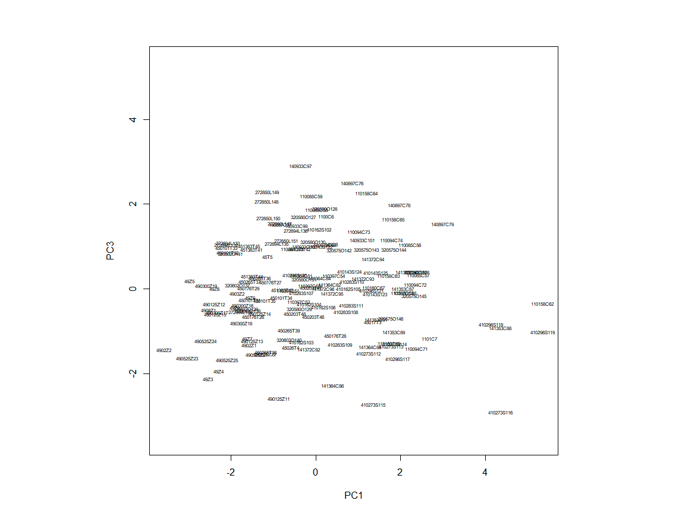

plot(dig.pc$scores[,2],dig.pc$scores[,3],   
 ylim=range(dig.pc$scores[,2]),   
 xlab="PC2",ylab="PC3",type="n",lwd=2)   
text(dig.pc$scores[,2],dig.pc$scores[,3],   
 labels=abbreviate(row.names(datdig1)),cex=0.5,lwd=2)

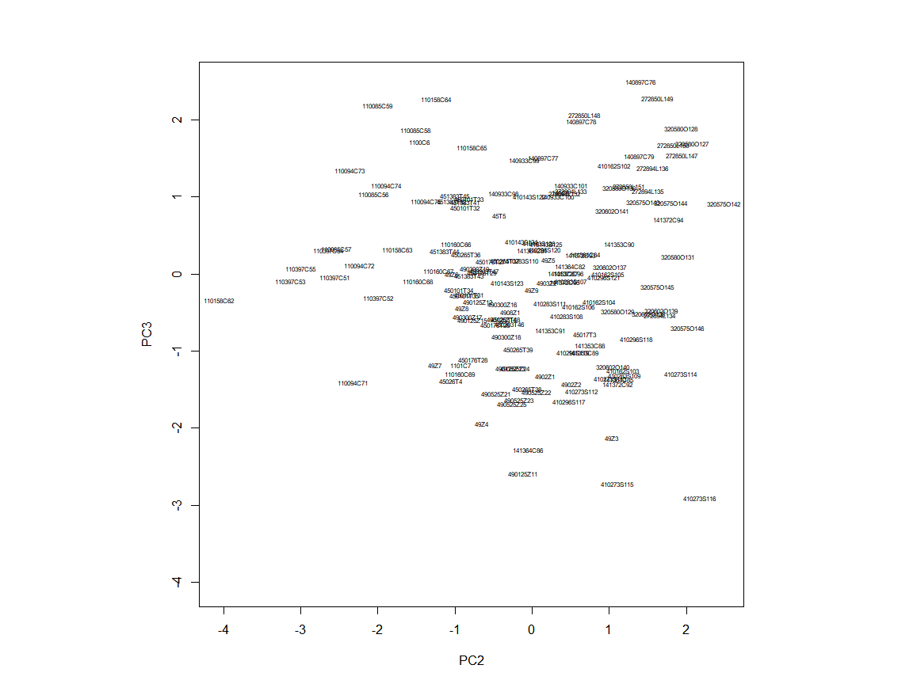

par(mfrow=c(1,3))   
plot(dig.pc$scores[,1], datdig$P, xlab="PC1")   
plot(dig.pc$scores[,2], datdig$P, xlab="PC2")   
plot(dig.pc$scores[,3], datdig$P, xlab="PC3")

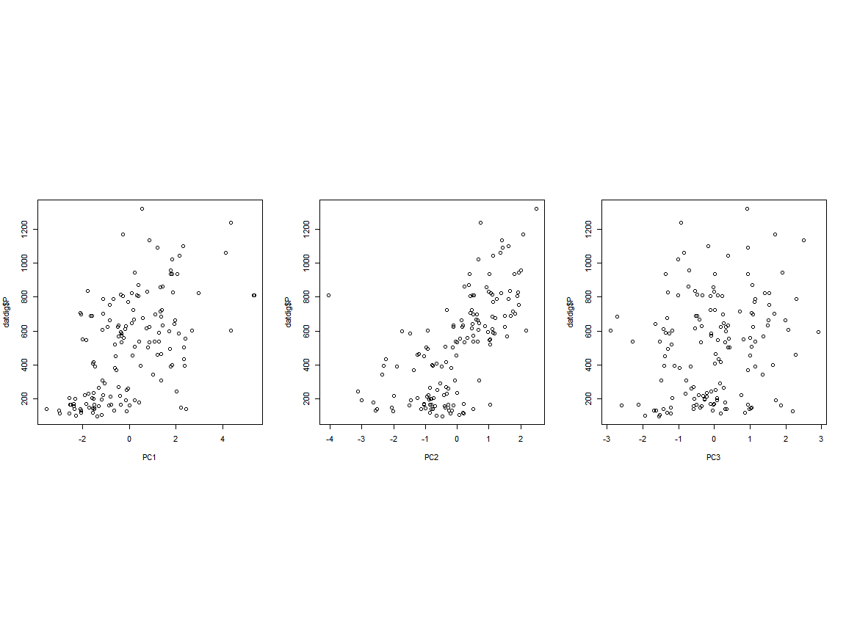

plot(dig.pc$scores[,1], datdig$Ca, xlab="PC1")   
plot(dig.pc$scores[,2], datdig$Ca, xlab="PC2")   
plot(dig.pc$scores[,3], datdig$Ca, xlab="PC3")

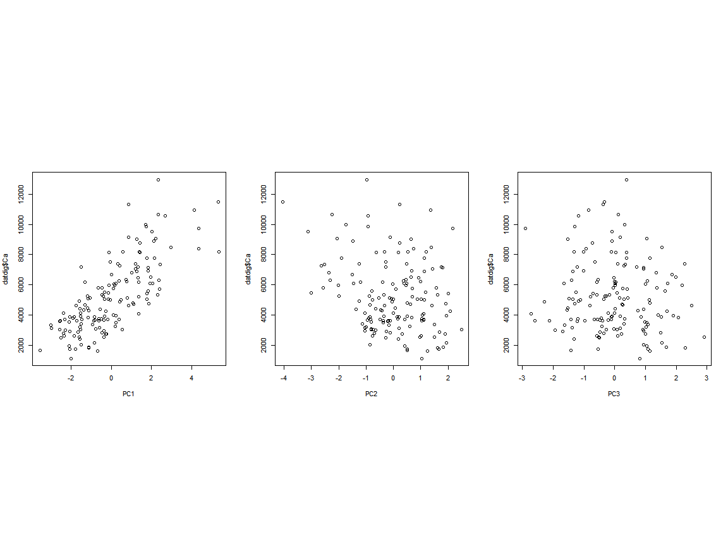

summary(lm(datdig$P~dig.pc$scores[,1]+dig.pc$scores[,2]+dig.pc$scores[,3]))

##   
## Call:  
## lm(formula = datdig$P ~ dig.pc$scores[, 1] + dig.pc$scores[,   
## 2] + dig.pc$scores[, 3])  
##   
## Residuals:  
## Min 1Q Median 3Q Max   
## -504.68 -105.09 5.98 98.40 455.92   
##   
## Coefficients:  
## Estimate Std. Error t value Pr(>|t|)   
## (Intercept) 503.258 12.319 40.851 < 2e-16 ***  
## dig.pc$scores[, 1] 93.909 7.165 13.107 < 2e-16 ***  
## dig.pc$scores[, 2] 156.515 10.025 15.613 < 2e-16 ***  
## dig.pc$scores[, 3] 49.837 10.848 4.594 9.41e-06 ***  
## ---  
## Signif. codes: 0 '***' 0.001 '**' 0.01 '*' 0.05 '.' 0.1 ' ' 1  
##   
## Residual standard error: 149.9 on 144 degrees of freedom  
## Multiple R-squared: 0.752, Adjusted R-squared: 0.7468   
## F-statistic: 145.5 on 3 and 144 DF, p-value: < 2.2e-16

summary(lm(datdig$Ca~dig.pc$scores[,1]+dig.pc$scores[,2]+dig.pc$scores[,3]))

##   
## Call:  
## lm(formula = datdig$Ca ~ dig.pc$scores[, 1] + dig.pc$scores[,   
## 2] + dig.pc$scores[, 3])  
##   
## Residuals:  
## Min 1Q Median 3Q Max   
## -2924.7 -1086.2 -15.2 759.4 5241.8   
##   
## Coefficients:  
## Estimate Std. Error t value Pr(>|t|)   
## (Intercept) 5231.62 115.16 45.428 < 2e-16 ***  
## dig.pc$scores[, 1] 1052.80 66.98 15.718 < 2e-16 ***  
## dig.pc$scores[, 2] -519.79 93.72 -5.546 1.35e-07 ***  
## dig.pc$scores[, 3] -208.16 101.41 -2.053 0.0419 *   
## ---  
## Signif. codes: 0 '***' 0.001 '**' 0.01 '*' 0.05 '.' 0.1 ' ' 1  
##   
## Residual standard error: 1401 on 144 degrees of freedom  
## Multiple R-squared: 0.662, Adjusted R-squared: 0.655   
## F-statistic: 94.01 on 3 and 144 DF, p-value: < 2.2e-16

plot(dig.pc$scores[,2],datdig$P,xlab="PC1",ylab="P")

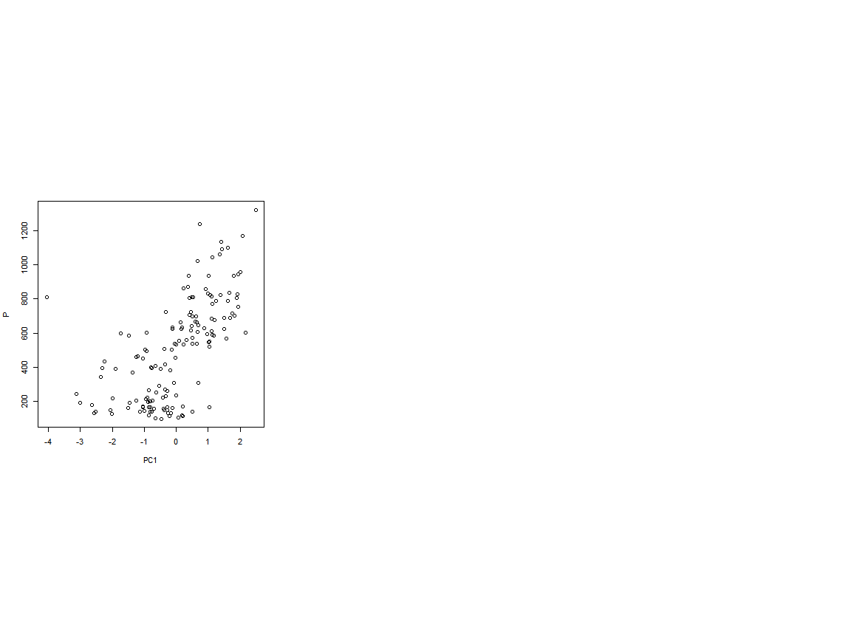

#tambien siguiendo otro camino

pca <- prcomp(datdig1, scale = TRUE)  
names(pca)

## [1] "sdev" "rotation" "center" "scale" "x"

pca$center

## P K Na Mg Ca Cu   
## 503.257838 3596.266892 132.856892 1775.614459 7724.050676 3.755946   
## Zn Mn Fe   
## 23.813243 2914.471014 247.741284

pca$rotation

## PC1 PC2 PC3 PC4 PC5 PC6  
## P 0.3163487 -0.52725092 0.167885916 -0.1842441 0.26343465 -0.411433283  
## K -0.2179171 -0.08961290 0.512824343 0.4797447 -0.48640520 -0.415606580  
## Na 0.2940424 0.59228003 -0.015436172 0.1731948 0.06723838 -0.331397864  
## Mg -0.2883618 0.23169960 -0.473258153 -0.3906221 -0.18855360 -0.539254072  
## Ca -0.4429032 -0.21866998 0.087568999 -0.1338586 0.22030738 0.137148724  
## Cu 0.4718349 -0.25622478 -0.007320219 -0.2453663 -0.11593031 -0.271508212  
## Zn 0.2512406 -0.09751524 -0.440692747 0.6356531 0.28408427 -0.008751445  
## Mn 0.1709011 0.43037471 0.531005720 -0.2102058 0.38796417 0.027981324  
## Fe 0.4143691 0.03600484 -0.026737047 -0.1641739 -0.60061923 0.404954692  
## PC7 PC8 PC9  
## P 0.03157843 0.01013384 -0.5657060310  
## K -0.17785595 -0.09958625 0.0216531344  
## Na -0.01556891 0.62481362 -0.1659178620  
## Mg -0.25775153 -0.28752955 -0.1055812069  
## Ca -0.65186188 0.48802040 0.0009123642  
## Cu -0.17335996 0.14315337 0.7167701028  
## Zn -0.42648805 -0.25771496 0.0038041007  
## Mn -0.33676077 -0.43792168 0.0541712446  
## Fe -0.38783291 -0.00808656 -0.3523102220

head(pca$x)

## PC1 PC2 PC3 PC4 PC5  
## 490299 Zamora 1 -1.562894 -0.1726658 -1.319577e+00 -1.1939904 -0.5451803  
## 490299 Zamora 2 -3.550715 -0.5075243 -1.425893e+00 -0.7434044 -1.0086845  
## 490299 Zamora 3 -2.523217 -1.0324006 -2.118251e+00 0.7677010 -1.2749374  
## 490299 Zamora 4 -2.274576 0.6468087 -1.938563e+00 -0.9536162 -0.2368467  
## 490299 Zamora 5 -2.961831 -0.2121444 1.841386e-01 0.3307329 -1.4483419  
## 490813 Zamora 6 -2.375212 1.0330377 -4.209433e-05 -0.7237250 -0.3398876  
## PC6 PC7 PC8 PC9  
## 490299 Zamora 1 -0.606368802 -0.6525524 0.3663561 1.73989529  
## 490299 Zamora 2 0.105855137 0.5857528 0.8871736 -0.02742825  
## 490299 Zamora 3 0.002895834 0.6812526 0.6930957 0.12851504  
## 490299 Zamora 4 0.158351295 0.3628963 0.7590477 0.06432015  
## 490299 Zamora 5 0.169219837 0.8753681 0.8651238 0.08200075  
## 490813 Zamora 6 -0.211938706 0.1830611 -0.4903013 -0.08372358

biplot(x = pca, scale = 0, cex = 0.4, col = c("blue4", "brown3"))

