# Fun with fantamorph

1. Select the two faces you want to morph. Image 1 should be the neutral face, and image 2 should be the emotional face.
   1. An ideal face has a little teeth as possible showing in the “happy” emotion. If there are too much teeth, they end up looking like they need dental work when morphed. **Look for a face in which the lips cover most of the teeth when smiling.**

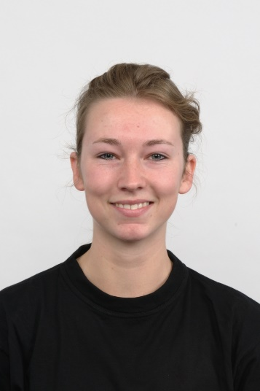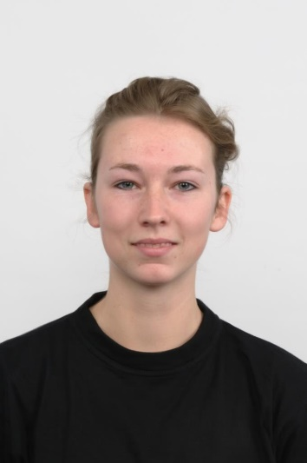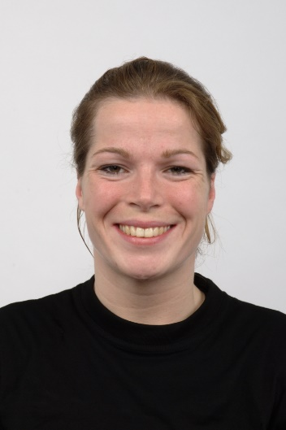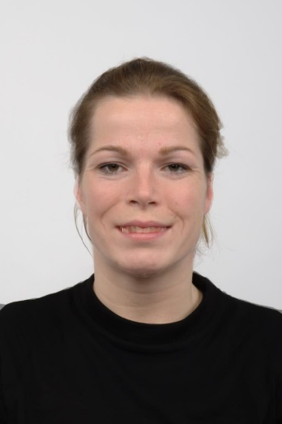

Ideal on the left, not ideal on the right. Notice how unnatural the teeth look in comparison.

1. Set the number of frames to 50.
2. Double check – when you first start the morph, do the mouth first! You want to outline the upper and lower lips and advance the morph to make sure it looks good.

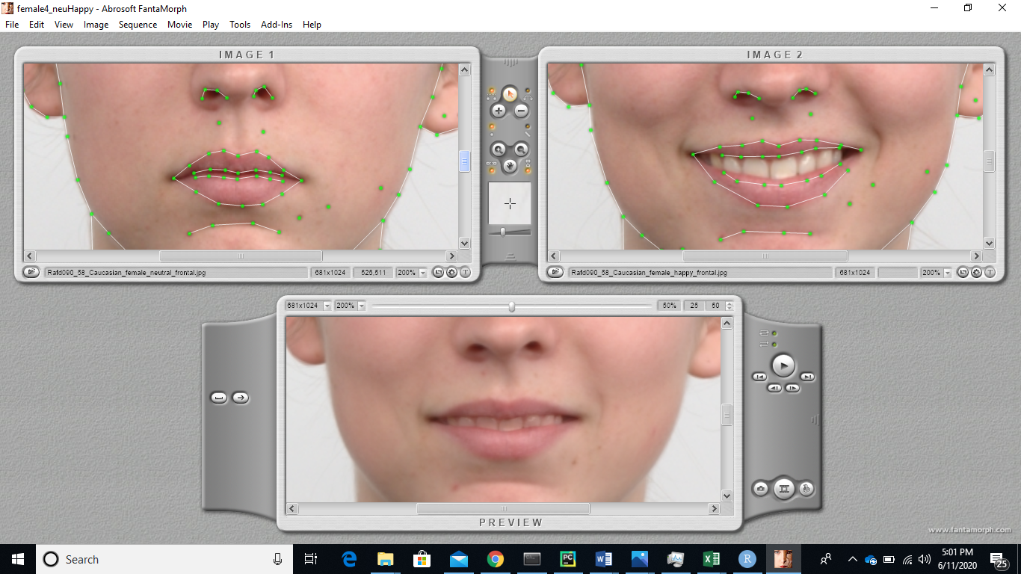

1. Begin placing the rest of the tracking dots. You want to track the outline of the head, the hairline, the jawline, and the shirt. Then track the detailed features, such as the eyes, the nose, brows, and any moles/ scars/ other lines to help make the morph look realistic. For the edge of the shirt, it is helpful to track it off the picture in order to reduce any potential distortion. See the red circles below.

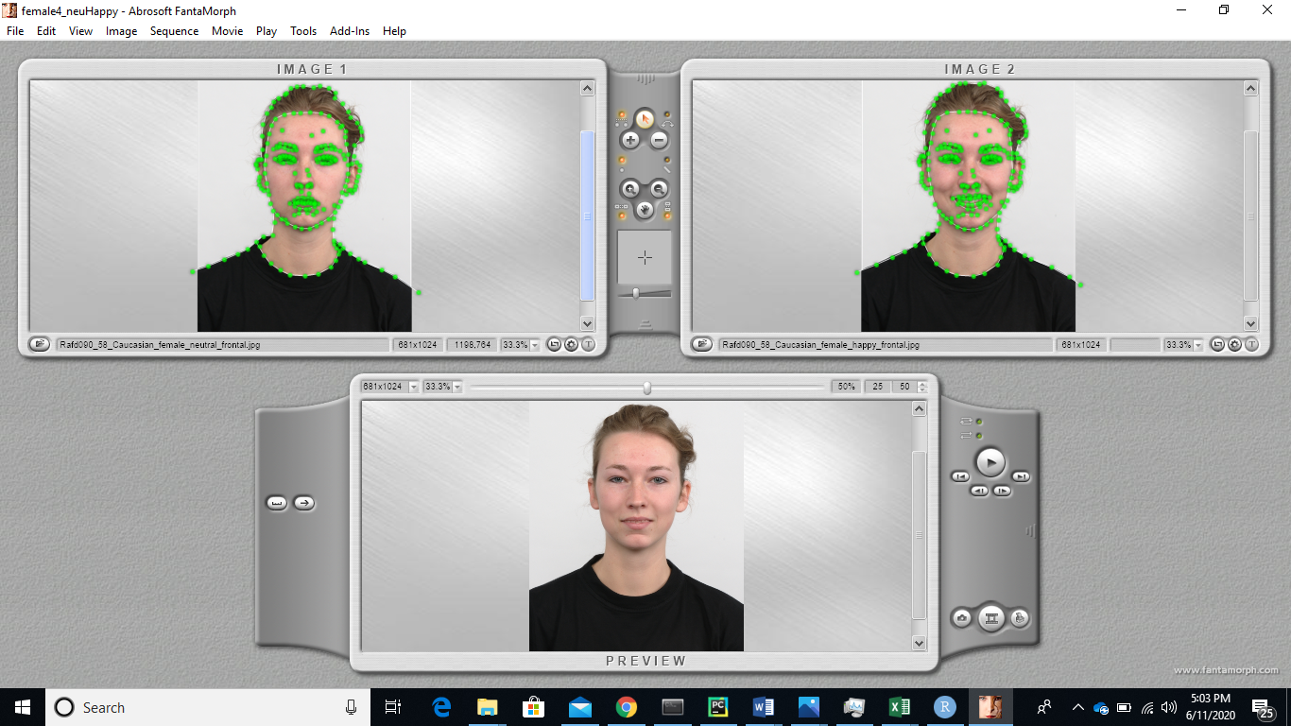

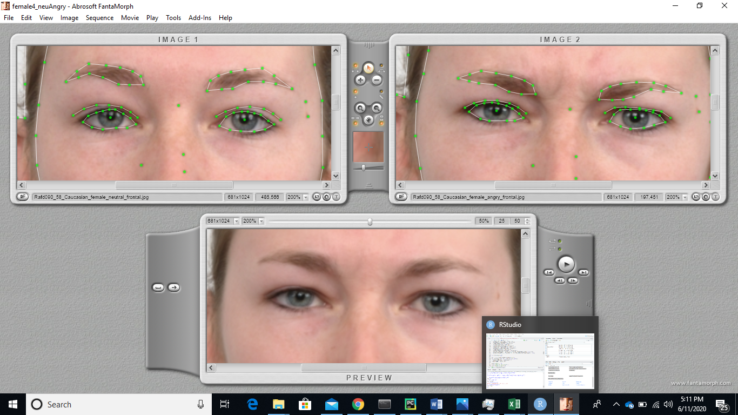

Close-up of eye morphs

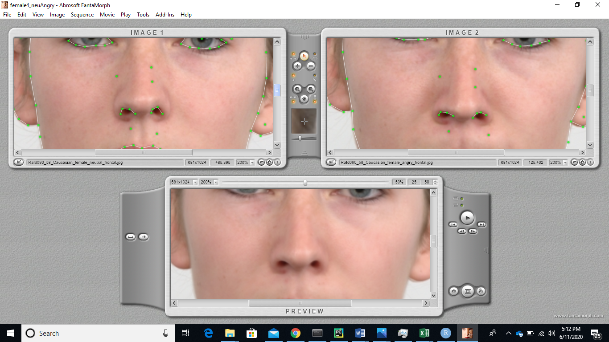

Close-up of nose morph. Sometimes it is necessary to outline the nose bridge and other features; use your judgment to see what looks the most natural.

1. When doing an angry face, only one line for the intersection between the lips is necessary (not two as in the happy face).

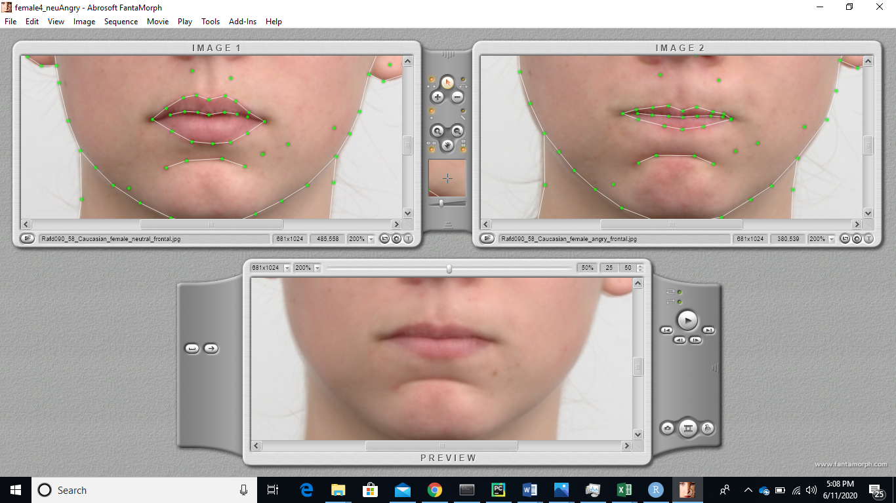

1. Export the morph and make sure that you are only exporting 50 frames (not 100).
   1. Set the quality to 100%!

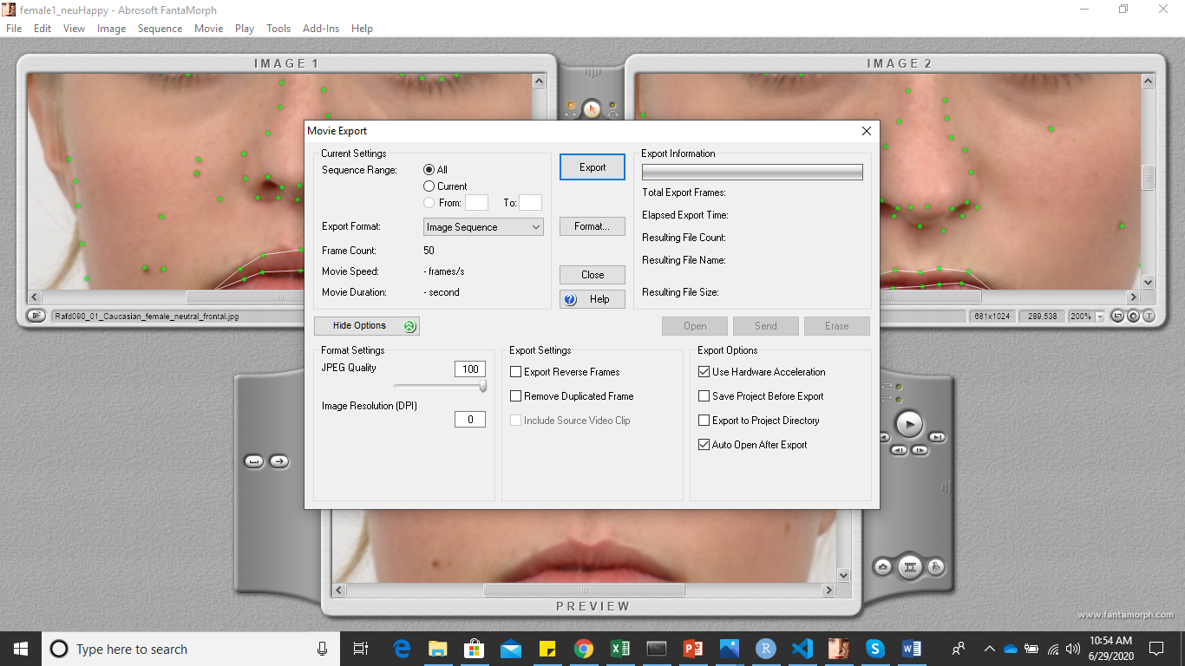

* 1. Happy: Export name should be the letter of the person (A, B, C, etc). Fantamorph will automatically number them for you as A01, A02, etc.
  2. Angry: Export name should be the letter of the person and the number 1 (A1, B1, C1). Fantamorph will automatically number them for you as A101, A102, etc.

You’re done! Now go forth and merge.