Admin/usercontroller
namespace App\Http\Controllers\Admin;

use App\Http\Controllers\Controller;
use App\Models\User;
use Illuminate\Http\Request;
use Illuminate\Support\Facades\Hash;

class UserController extends Controller
{
public function index()
{
$users = User::all();
return view('admin.user.index', compact('users'));
}

public function create()
{
return view('admin.user.create');
}

public function store(Request $request)
{
$request->validate([
'name' => 'required|string|max:255',
'email' => 'required|string|email|max:255|unique:users',
'password' => 'required|string|min:6',
'role' => 'required|in:admin,user',
]);

User::create([
'name' => $request->name,
'email' => $request->email,
'password' => Hash::make($request->password),
'role' => $request->role,
]);

return redirect()->route('admin.user.index')->with('success', 'Data anggota berhasil ditambahkan.');
}

public function edit(User $user)
{
return view('admin.user.edit', compact('user'));
}

public function update(Request $request, User $user)
{
$request->validate([
'name' => 'required|string|max:255',
'email' => 'required|string|email|max:255|unique:users,email,' . $user->id,
'role' => 'required|in:admin,user',
]);

$data = [
'name' => $request->name,
'email' => $request->email,
'role' => $request->role,
];

// Jika password diisi, maka update passwordnya
if ($request->filled('password')) {
$request->validate(['password' => 'string|min:6']);
$data['password'] = Hash::make($request->password);
}

$user->update($data);

return redirect()->route('admin.user.index')->with('success', 'Data anggota berhasil diperbarui.');
}

public function destroy(User $user)
{
// Mencegah admin menghapus akunnya sendiri yang sedang aktif
if ($user->id === auth()->id()) {
return redirect()->route('admin.user.index')->with('error', 'Anda tidak dapat menghapus akun sendiri yang sedang digunakan.');
}

$user->delete();
return redirect()->route('admin.user.index')->with('success', 'Data anggota berhasil dihapus.');
}
}

CEK ROUTES/WEB.PHP

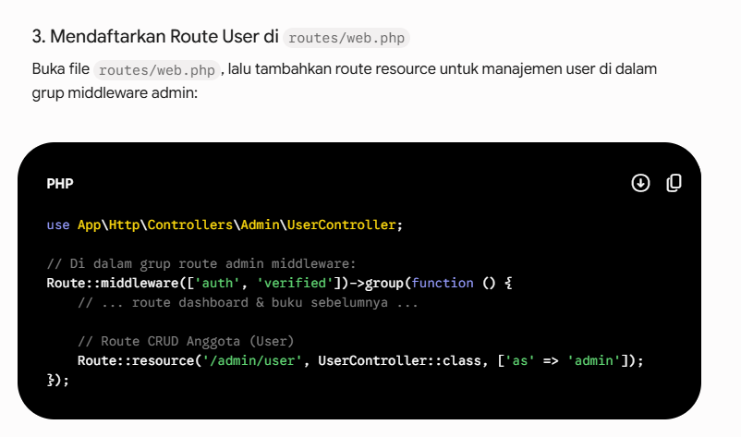
TAMBAHKAN APABILA BELUM

Buat folder USER dalam Resouces/views/admin/user
Buat file index.blade.php

<x-app-layout>
<x-slot name="header">
<h2 class="font-semibold text-xl text-gray-800 leading-tight">
{{ __('Kelola Data Anggota (User & Admin)') }}
</h2>
</x-slot>

<div class="py-12">
<div class="max-w-7xl mx-auto sm:px-6 lg:px-8">
<div class="bg-white overflow-hidden shadow-sm sm:rounded-lg p-6">
<a href="{{ route('admin.user.create') }}" class="bg-emerald-600 hover:bg-emerald-700 text-white font-semibold px-4 py-2 rounded-md mb-4 inline-block shadow">+ Tambah Anggota</a>

@if(session('success'))
<div class="bg-green-100 text-green-700 p-3 rounded mb-4">{{ session('success') }}</div>
@endif
@if(session('error'))
<div class="bg-red-100 text-red-700 p-3 rounded mb-4">{{ session('error') }}</div>
@endif

<table class="w-full border-collapse border border-gray-300 mt-4">
<thead>
<tr class="bg-gray-200 text-gray-700">
<th class="border border-gray-300 p-2">No</th>
<th class="border border-gray-300 p-2">Nama</th>
<th class="border border-gray-300 p-2">Email</th>
<th class="border border-gray-300 p-2">Role</th>
<th class="border border-gray-300 p-2">Aksi</th>
</tr>
</thead>
<tbody>
@foreach($users as $index => $usr)
<tr class="hover:bg-gray-50">
<td class="border border-gray-300 p-2 text-center">{{ $index + 1 }}</td>
<td class="border border-gray-300 p-2">{{ $usr->name }}</td>
<td class="border border-gray-300 p-2">{{ $usr->email }}</td>
<td class="border border-gray-300 p-2 text-center">
<span class="px-2 py-1 rounded text-xs font-semibold {{ $usr->role === 'admin' ? 'bg-purple-100 text-purple-700' : 'bg-blue-100 text-blue-700' }}">
{{ ucfirst($usr->role) }}
</span>
</td>
<td class="border border-gray-300 p-2 text-center">
<a href="{{ route('admin.user.edit', $usr->id) }}" class="bg-amber-500 hover:bg-amber-600 text-white font-medium px-3 py-1 rounded text-sm shadow inline-block">Edit</a>
<form action="{{ route('admin.user.destroy', $usr->id) }}" method="POST" class="inline-block" onsubmit="return confirm('Yakin hapus anggota ini?')">
@csrf
@method('DELETE')
<button type="submit" class="bg-rose-600 hover:bg-rose-700 text-white font-medium px-3 py-1 rounded text-sm shadow">Hapus</button>
</form>
</td>
</tr>
@endforeach
</tbody>
</table>
</div>
</div>
</div>
</x-app-layout>

BUAT CREATE.BLADE.PHP

<x-app-layout>
<x-slot name="header">
<h2 class="font-semibold text-xl text-gray-800 leading-tight">{{ __('Tambah Anggota Baru') }}</h2>
</x-slot>

<div class="py-12">
<div class="max-w-7xl mx-auto sm:px-6 lg:px-8">
<div class="bg-white overflow-hidden shadow-sm sm:rounded-lg p-6">
<form action="{{ route('admin.user.store') }}" method="POST">
@csrf
<div class="mb-4">
<label class="block font-medium text-sm text-gray-700">Nama Lengkap</label>
<input type="text" name="name" class="border-gray-300 rounded-md shadow-sm w-full" required>
</div>
<div class="mb-4">
<label class="block font-medium text-sm text-gray-700">Email</label>
<input type="email" name="email" class="border-gray-300 rounded-md shadow-sm w-full" required>
</div>
<div class="mb-4">
<label class="block font-medium text-sm text-gray-700">Password</label>
<input type="password" name="password" class="border-gray-300 rounded-md shadow-sm w-full" required>
</div>
<div class="mb-4">
<label class="block font-medium text-sm text-gray-700">Role / Hak Akses</label>
<select name="role" class="border-gray-300 rounded-md shadow-sm w-full" required>
<option value="user">User / Siswa</option>
<option value="admin">Admin</option>
</select>
</div>
<button type="submit" class="bg-blue-500 hover:bg-blue-600 text-white px-4 py-2 rounded-md">Simpan</button>
<a href="{{ route('admin.user.index') }}" class="ml-2 text-gray-600">Batal</a>
</form>
</div>
</div>
</div>
</x-app-layout>

BUAT EDIT.BLADE.PHP

<x-app-layout>
<x-slot name="header">
<h2 class="font-semibold text-xl text-gray-800 leading-tight">{{ __('Edit Data Anggota') }}</h2>
</x-slot>

<div class="py-12">
<div class="max-w-7xl mx-auto sm:px-6 lg:px-8">
<div class="bg-white overflow-hidden shadow-sm sm:rounded-lg p-6">
<form action="{{ route('admin.user.update', $user->id) }}" method="POST">
@csrf
@method('PUT')
<div class="mb-4">
<label class="block font-medium text-sm text-gray-700">Nama Lengkap</label>
<input type="text" name="name" value="{{ $user->name }}" class="border-gray-300 rounded-md shadow-sm w-full" required>
</div>
<div class="mb-4">
<label class="block font-medium text-sm text-gray-700">Email</label>
<input type="email" name="email" value="{{ $user->email }}" class="border-gray-300 rounded-md shadow-sm w-full" required>
</div>
<div class="mb-4">
<label class="block font-medium text-sm text-gray-700">Password Baru <span class="text-xs text-gray-500">(Kosongkan jika tidak ingin mengubah password)</span></label>
<input type="password" name="password" class="border-gray-300 rounded-md shadow-sm w-full">
</div>
<div class="mb-4">
<label class="block font-medium text-sm text-gray-700">Role / Hak Akses</label>
<select name="role" class="border-gray-300 rounded-md shadow-sm w-full" required>
<option value="user" {{ $user->role === 'user' ? 'selected' : '' }}>User / Siswa</option>
<option value="admin' ? 'selected' : '' }}" {{ $user->role === 'admin' ? 'selected' : '' }}>Admin</option>
</select>
</div>
<button type="submit" class="bg-blue-500 hover:bg-blue-600 text-white px-4 py-2 rounded-md">Update</button>
<a href="{{ route('admin.user.index') }}" class="ml-2 text-gray-600">Batal</a>
</form>
</div>
</div>
</div>
</x-app-layout>

