GQG Core Card · v0.2
Geometric Quotient Grammar
Status: experimental language specification
Profile: Set (normative core)
Date: 2026-08-20
Attribution: not specified in the supplied GQG source
License: not specified in the supplied GQG source
Continuity: v0.2 distillation of the supplied GQG working material
Purpose: a typed visual and textual language for witness-relative quotient constructions
Claim boundary. GQG records observations, the equivalence they induce, the quotient they justify, and the proof obligations required for later operations. It does not claim that different application domains are isomorphic, that measurement is quotienting, or that a shared Hamiltonian governs those domains.

Semantic ownership
Text source → canonical AST → type checker → formal outputs
Canonical AST → glyph and diagram renderings
The abstract syntax tree owns the semantics. A rune, commutative diagram, accessible monochrome view, terminal view, and canonical JSON may all render the same accepted tree. Diagram-to-AST parsing is a future feature and must pass semantic round-trip tests before the arrow becomes bidirectional.

Canonical construction
CAT → SRC → WIT → OBS → EQV → QUO → (IMG) → {DSC, REF, (CPL)}
In the normative Set profile:
P ↠ Q_W ≅ im(Ω_W) ↪ ∏_{w∈W} O_w
Define O_W := ∏_{w∈W} O_w and Ω_W(x) := (w(x))_{w∈W}. Then x ~_W y exactly when Ω_W(x) = Ω_W(y). The image comparison is conditional in other backends: the profile must declare the needed products, kernel pairs, coequalizers, images, and exactness assumptions.

Token alphabet
Token | Typed role
CAT | Ambient category or structural profile
SRC | Presented source object P
WIT | Witness family W on P
OBS | Aggregate observation Ω_W : P → O_W
EQV | Kernel pair / induced equivalence ~_W
QUO | Quotient object and map q_W : P ↠ Q_W
IMG | Backend-supported image factorization
DSC | Certificate that an operation descends
REF | Witness refinement and quotient comparison
CPL | Separately typed completion specification

Equality lanes
Lane | Form | Meaning
Source | x = y | The presented elements are equal.
Observation | x ~_W y | The declared witnesses cannot distinguish them.
Quotient | [x]_W = [y]_W | They name the same quotient class.
Completion | u = v in Q̂_W | Equality may involve new completion elements; the declared embedding must state what it preserves and reflects.

Never move a claim between lanes without an explicit constructor or proof.

Formation rules
- Declare CAT before SRC; v0.2 accepts only the explicit declaration category Set.
- Every WIT names its source and every OBS has a complete domain and codomain.
- For an arbitrary map, EQV means the kernel pair—not an algebraic kernel.
- Form QUO only when the active profile supports the required quotient.
- Emit IMG and Q_W ≅ im(Ω_W) only when the backend justifies that factorization.
- Defining an operation on Q_W induced by a source operation requires DSC: if each x_i ~_W y_i, then f(x_1,…,x_n) ~_W f(y_1,…,y_n). The certificate must reference a checked proof term or an externally verified obligation.
- A finer witness system induces a finer quotient, and that finer quotient maps canonically onto the coarser quotient; the quotient arrow points fine → coarse.
- CPL must name its added structure (for example, metric, order, topology, or norm). Set alone cannot justify a Dedekind completion.
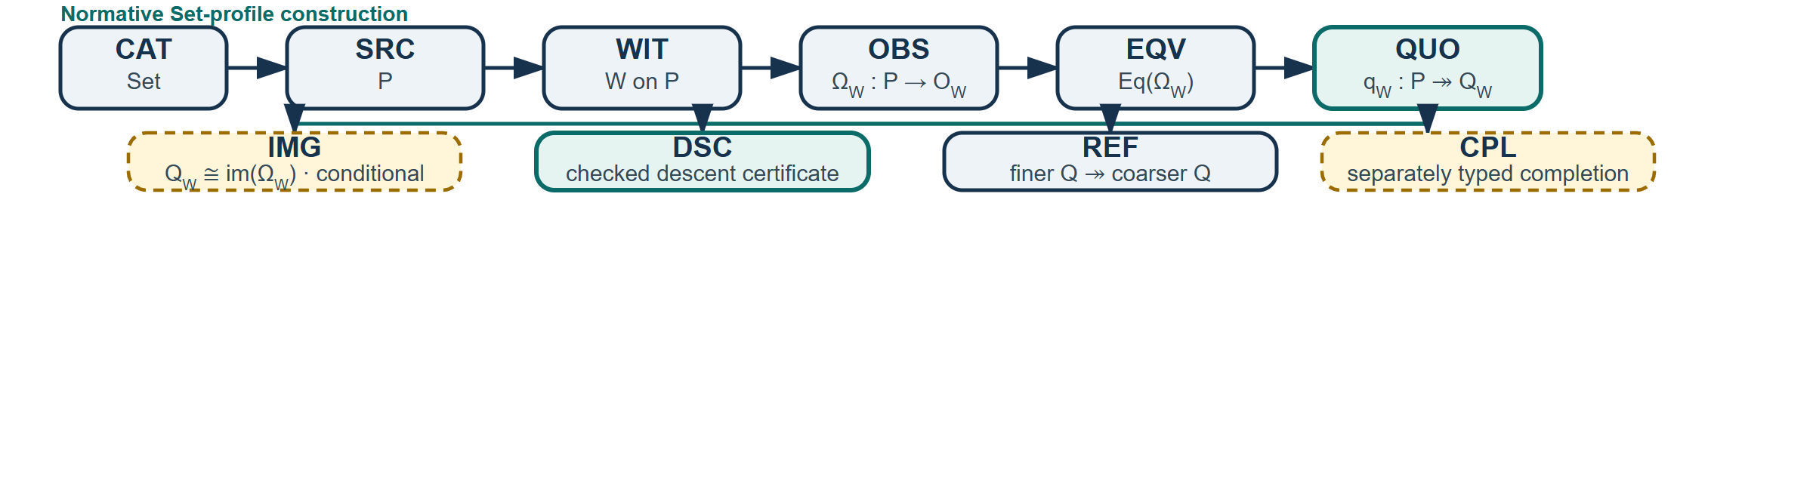

Worked card

Minimal source form
category Set
source P = Integers
codomain ParityBits = Z/2Z
witness Parity on P {
observation omega : P -> ParityBits
definition omega(n) = n mod 2
}
equivalence same_parity := kernel_pair(omega)
quotient Q2 := P / same_parity
operation add : P × P -> P
certificate add_respects_parity {
require n ~2 n' and m ~2 m'
prove n + m ~2 n' + m'
}
descend add through Q2 using add_respects_parity

Parity example
Let P = Z and Ω₂(n) = n mod 2. Then
n ~₂ m ⇔ Ω₂(n) = Ω₂(m) ⇔ n − m ∈ 2Z, so Q₂ ≅ Z/2Z.
Addition passes descent:
n ~₂ n′ and m ~₂ m′ ⇒ n + m ~₂ n′ + m′.
The operation h(n) = floor(n/2) fails. Although 0 ~₂ 2, its proposed quotient outputs differ:
[h(0)]₂ = [0]₂ ≠ [1]₂ = [h(2)]₂.
The checker therefore accepts DSC[add, add_respects_parity] after checking its certificate and rejects DSC[h].

Witness refinement
For Ω₄(n) = n mod 4 and Ω₂(n) = n mod 2, the mod-4 witness is finer:
~₄ ⊆ ~₂, hence Q₄ ↠ Q₂.
Combining witness families intersects their induced equivalence relations and produces a common refinement in the Set profile.

Diagnostic catalogue
Code | Rejection
E101 | QUO has no declared EQV.
E204 | An induced quotient operation has no valid DSC certificate.
E301 | CPL omits the structure and universal property being added.
E407 | A refinement arrow points coarse → fine.
E512 | The requested quotient–image comparison is unsupported by the active profile.
E610 | A statement crosses equality lanes without a constructor or proof.

Illustrative typed machine record
{
"schema": "gqg-set-0.2",
"profile": "Set",
"objects": {
"P": {"kind": "Set", "presentation": "Integers"},
"ParityBits": {"kind": "Set", "presentation": "Z/2Z"},
"Q2": {"kind": "QuotientSet"}
},
"witness": "Parity",
"observation": {
"name": "omega",
"domain": "P",
"codomain": "ParityBits",
"definition": "n mod 2"
},
"equivalence": "kernel_pair(observation)",
"quotient": {
"id": "Q2",
"map": {"name": "q2", "domain": "P", "codomain": "Q2"}
},
"descent": {
"operation": "add",
"certificate": "add_respects_parity",
"status": "checked"
}
}
This compact record is illustrative: a production schema must replace free-form expressions with expression AST nodes, define stable identifiers, and specify a JSON canonicalization algorithm. Only then should canonical identity be a digest of canonical JSON for the AST. Prime products may remain an unordered feature signature—useful for indexing which token types occur—but they are not syntax because they lose order, direction, scope, and binding.

v0.2 acceptance target
- Parseability: one valid sentence produces one unambiguous AST.
- Soundness: accepted trees satisfy the declared formation rules.
- Rendering stability: text and diagrams emitted from one accepted AST preserve the same semantic structure. Any future diagram parser must pass round-trip tests before use.
- Diagnostic value: rejected trees receive local, actionable errors.
- Accessible rendering: meaning survives without color or decorative glyphs.
Implementation milestone: parse the Set profile, validate the parity example, emit canonical JSON, and render both a labelled diagram and an accessibility-first text view from the same AST.

