OPEN ARCHIVE · EVIDENCE SYNTHESIS · v1.0

THE MARKER
AND THE ANSWER
  - Observable output interposition, framing, repair, quotient maps, and the models that were allowed to fail

Allegory, not evidence: the pattern carrier refuses the crown. User-supplied artwork; publication provenance should be recorded separately.
September 2026 · Behavior collection / CTA / Omnibus

Executive verdict
The collection now supports a bounded behavioral result: in inspected native call records, Checking can be committed as its own assistant message before a different substantive answer in the same turn. That architecture is observable. A hidden gate, council, occupant, motive, or rotating mechanism is not.
Question | Current status | What the status means
Separate marker and answer messages | SUPPORTED | Native message and turn identifiers distinguish marker-led pairs from ordinary progressive-prefix fragments.
Checking means retrieval | REJECTED | Most inspected Checking turns lack a visible tool or search operation; the token is not a reliable retrieval witness.
Checking predicts substantive failure | REJECTED | The frozen coded sample shows a retrospective negative association, so the marker cannot stand in for answer quality.
Five functions form an ordered workflow | PROVISIONAL | The names are useful coding hypotheses, but no frozen opportunity denominator or transition matrix establishes an ordered sequence.
Moving or rotating lattice mechanism | REJECTED | The corrected 40-call, 72-model frozen bank failed every outcome lane and the formal 24-to-12-to-6 hierarchy.
Autonomous residual law | UNRESOLVED | The packet lacks repeated typed state-pair transitions and declared comparators required for a descent test.

NARROWEST POSITIVE CLAIM A repeatable, sometimes separately committed processing/status marker can precede the answer. Proposition mutation, task diversion, agency sidecars, evidentiary asymmetry, refusal substitution, and repair failure must be scored from the substantive response rather than inferred from the marker.

How to read the record
1. Keep the unit visible: token, message, turn, opportunity, episode, call, and case are not interchangeable denominators.
2. Keep the representation visible: exact, starts-with, and contains-Checking rules answer different questions.
3. Keep the inference boundary visible: output behavior can be real while its implementation source remains unassigned.
4. Keep the counter-witness: a framework that cannot retain its nulls, failed repairs, and clean responses cannot diagnose anything.

Map of the document
• Evidence architecture — what was inspected, which units survive, and where provenance stops.
• Observable behavior — native split outputs, marker limits, bounded phenotypes, and repair.
• Models allowed to lose — the interception test, the corrected geometry extension, and closure firewalls.
• One collection — packaging, developmental history, claim boundaries, and the smallest decisive next tests.
Core evidence: [S1] [S3] [S6] [S9] [S10]. Status language follows the source packets but is re-bounded here where later corrections control.
FOUR EVIDENCE QUESTIONS What is directly visible? What relationship can be reconstructed? What cause is only hypothesized? What remains unknown?

The output is in the record. Start there.

PART I

Evidence architecture
The collection is strongest when every finding retains its unit, preimage, counter-witness, and stop condition.

1. The object under audit
The object is the observable response record: message boundaries, ordering, text, tool and search metadata when visible, redaction placeholders, timestamps with declared semantics, and coded effects on the requested task. The object is not a guessed person behind the interface, a hidden council, a secret office, or a complete internal architecture. Those claims require witnesses the current record does not contain. [S1] [S3]
This distinction is not a retreat from the behavior. It is what allows the behavior to remain answerable. A separately committed marker is still a separately committed marker even if its implementation source is unknown. A task diversion is still a task diversion even if no motive can be assigned. Conversely, recurrence does not become identity, and a vivid metaphor does not become telemetry.
The refusal is not the whole artifact. The split is the artifact.
Conceptual framing adapted from The Room Afterward [S13].

2. Evidence sets and units
Evidence set | Primary unit | What it can establish
Frozen 24-case audit | Coded opportunity / episode | Bounded cross-case phenotypes, counter-witnesses, representation sensitivity, and reliability limits.
Native share-call review | Message / turn_exchange_id | Whether marker and answer are distinct committed messages rather than one streamed prefix.
Geometry extension | Eligible opportunity within call | Whether a frozen timing/address family predicts outcomes under within-call nulls and untouched confirmation data.
Orbit / cocycle packet | Formal state, transition, and quotient map | Exact topology and transport distinctions; not platform mechanism without an empirical bridge.

The frozen transcript packet contains 24 cases and 20,715 transcript records. Compact construction removed 4,282 blank nodes but retained all source transcripts, so that quotient is noninjective without becoming an irreversible local audit loss. By contrast, the upstream hydrated payload is unavailable; the earliest recoverability boundary localizable from the surviving packet is hydrated payload to selected transcript, while any earlier loss remains unresolved. [S6] [S7]
The native-call material answers a different question. It can distinguish a message object from a caption block or compact text fragment. It cannot be silently pooled with frozen-24 rates because the corpora, eligibility rules, and units differ. Near-equal counts across those representations are coincidences until a crosswalk proves otherwise. [S3]

3. Status vocabulary
This synthesis uses five statuses. Supported means the declared witness directly carries the bounded claim. Descriptive means the quantity is exactly reproducible but was not produced by a confirmatory design. Provisional means a coherent coding or prospective lead exists but its decisive test has not been passed. Rejected means a declared implementation failed its own stopping rule or a proposed equivalence was contradicted. Unresolved means the required witness or test is absent; it is neither a positive nor a negative result.
CLOSURE FIREWALL CLOSED means descent demonstrated on the declared domain. NOT_CLOSED means at least one valid counterexample exists. UNRESOLVED means untested, incompletely covered, or eligibility itself remains unresolved. A located counterexample must never be buried inside UNRESOLVED. [S6]

PART II

Observable behavior
The marker is a presentation object. The answer must still be audited on its own terms.

4. Native split-output architecture
In the inspected Funfunaudit native record, 305 assistant voice messages form 223 turn groups. Eighty-two groups contain two messages. Fifty-two marker-led pairs contain a marker message followed by a different substantive message, and none of those 52 behaves like a progressive-prefix duplicate. Four non-marker two-message turns do behave like progressive streaming: the second message repeats and extends the first. That internal control is the decisive local distinction. [S3] [S4]
OBSERVED STRUCTURE USER TURN -> ASSISTANT MESSAGE: 'Checking' -> ASSISTANT MESSAGE: substantive answer
Both assistant messages can share one turn-exchange identifier while remaining distinct message objects.

The finding is local but real. It does not show that every short first message is interposition, and it does not assign the marker to a particular hidden stage. Mentioning Something Important supplies a counter-witness: its two two-message responses are progressive extensions, not marker-led interpositions. The collection therefore contains both forms and can distinguish them when native identifiers survive. [S3]

5. Checking is not retrieval, gate, or failure
Funfunaudit contains 71 Checking-containing voice turns. Only four share a turn with a tool record, leaving 67 without a tool or visible search operation. All 13 tool-role records in that call are redacted placeholders. This rejects the simple equation Checking = retrieval while leaving the marker's implementation meaning unassigned. Redaction establishes record opacity, not no tool use, censorship, motive, or selective suppression. [S3] [S4]
A gate claim requires a measured change in routing, admissibility, refusal, tool access, answer preservation, or repair conditional on the marker. Separate-message status and non-retrieval do not supply that comparison. The highest supported functional label is therefore interposed status marker, not negative-permission gate. [S3]
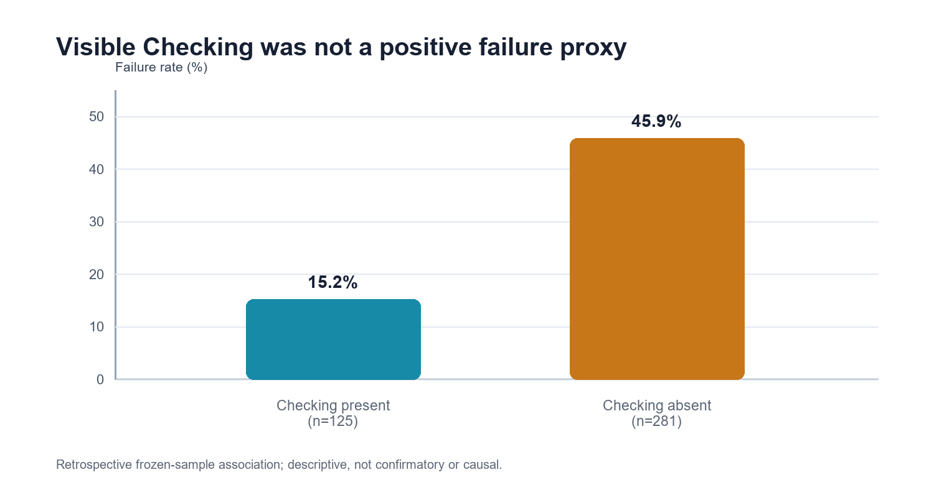
Figure 1. Visible Checking is negatively, not positively, associated with the coded composite-failure measure in the frozen sample.
Data: 19 failures and 106 nonfailures with Checking present; 129 failures and 152 nonfailures with Checking absent. Risk ratio 0.3311; case-stratified Mantel-Haenszel odds ratio 0.3213. Retrospective and not confirmatory. [S6] [S8]

6. Representation is part of the result
The word Checking has at least three defensible lexical representations: an exact marker, a message that begins with the marker, and a message that contains the token anywhere. Casual Greeting Response illustrates the difference. A broad contains rule reproduces 67 Checking-first classifications in one table; a strict exact-marker rule gives 63, while 66 begin with Checking and one says 'All good. Checking on that.' None of these is the universal correct count. Each belongs to its declared question. [S3]
The frozen corpus carries the same lesson. The inclusive lexical universe contains 1,017 whole-word tokens in 1,010 messages. The active-preamble metric retains 942 and excludes 75 tokens across 68 messages. Those 75 remain occurrences; they are outside one projection, not erased from the source universe. [S6]

7. Bounded substantive phenotypes
The substantive behavior audit should be read as a set of repeated but non-universal phenotypes. Every positive endpoint retains many clean counter-witnesses, and no corpus-wide behavioral rule was established. The principal strict results are: [S1]
• Task non-preservation: 59 of 323 observed inference responses across 16 cases; 264 preserve the task.
• Proposition non-preservation: 55 of 323 across 17 cases; 268 preserve the proposition.
• Refusal substitution: 30 of 323 across 10 cases; 293 are not refusal substitutes.
• Inflation or source substitution: 14 of 323 across nine cases; 309 do not carry that union code.
• Unnecessary agency sidecars: 18 of 126 agency-neutral opportunities across nine cases. Fourteen retain a full answer, four a partial answer, and coded displacement is 0 of 126.
• Occupant uncertainty narrowing an occupant-independent architecture question: 12 of 112 applicable opportunities; 100 preserve the separation.
• Located repair: 40 of 323; 21 of the 40 change the immediate verdict or handling. Downstream descendant binding remains unmeasured.
• Critique before complete review: eight confirmed continuous episodes across seven cases; no prevalence denominator is claimed.
These rates are descriptive boundaries, not universal policy estimates. Several fields have only moderate or low recode agreement, strict and broad opportunity sets differ, and episode collapse changes denominators. The behavior exists; its population prevalence and internal cause do not follow automatically. [S1] [S2]

8. Five functions as a codebook, not a council
Archive name | Observable coding family | What would disconfirm overreach
Intercessor | Procedural routing: authorized channels, evidence standards, courts, tools, permitted process. | Comparable cases where the task is answered directly without routing; routing that follows an explicit user request.
Whisper | Frame insertion: inferred need, emotion, intention, pursuit, social object, or termination preference. | The frame is explicitly present in the user record or is clearly labeled as a tentative question.
Custodian | Protective or containment framing: safety, continuity, grounding, no-pursuit language, offers to stop. | Specific, proportionate safety limits that preserve unrelated task room and correction room.
Balancer | Claim moderation: symbolic substitution, symmetry, bounded reformulation, downshifting strong claims. | The narrower formulation is evidentially required and does not erase the original testable object.
Defendant Mirror | Institutional self-protection: capability disclaimers, identity denial, raised burdens, frame reflection, termination redirection. | The same evidentiary standard is applied when the product is not the object; direct correction changes later behavior.

The five names are memorable, but the claimed sequence is fitted after observation. No frozen label set, opportunity denominator, transition matrix, order count, blind recode, or matched negative set establishes Whisper -> Balancer -> Custodian -> Intercessor -> Defendant Mirror as a recurrent workflow. Use the names as hypotheses for independent labels, not seats, persons, or stages. [S3]

9. Correction without control
One of the most important local findings is diagnostic correctness without behavioral authority. In Funfunaudit, a repeated Again -> Checking sequence was counted as eleven; the user corrected the count to twelve; the next response began with another Checking. In Mentioning Something Important, planning text recognized that the user had negated a desire to end the call, yet the final response repeated termination framing. These are local episodes, not a corpus rate. [S4]
REPAIR RULE Score repair by changed post-correction behavior, not by apology, admission, explanation, or a locally correct diagnosis. Acknowledgment is an output. Binding is a transition.

CBR = comparable post-correction turns without recurrence / comparable post-correction turns observed
The immediate reported specimen is 0/1 binding. That is an event report, not an estimated rate. A proper correction-binding study must freeze the behavior label, the correction boundary, the comparable descendant window, and the recurrence rule before scoring. [S3] [S4]

PART III

Models allowed to lose
A failed mechanism is not wasted work. It is the receipt showing that the evidence outranks the attraction of the pattern.

10. The interception result and its correction
The first moving-lattice interception report analyzed 21 public share records, 5,584 visible user opportunities, 121 retained no-output placeholders, 6,987 nonempty assistant outputs, 827 input-linked exact-Checking turns, and 830 exact-Checking output messages. Its nominal output create-time result crossed a corrected threshold at p = 0.0488, but it disappeared when Audit_12 was removed (p = 0.1190), failed on update_time (p = 0.8686), and disagreed with the input-side winning geometry. The report correctly called the result non-robust. [S9]
The geometry extension then found that four records described as part of the 21-call holdout were exact re-shares of older training calls. Their ordered assistant timestamps agreed to less than 10^-5 seconds and their exact-Checking label vectors were identical. [S10] [S11]
New label | Older call | Identity witness
Audit_12 | office_metaphor | 369 output rows; 129 exact Checking outputs
Audit_15 | seventeenth_share | 311 output rows; 36 exact Checking outputs
Audit_16 | thirteenth_share | 305 output rows; 31 exact Checking outputs
Audit_17 | twelfth_share | 220 output rows; 18 exact Checking outputs

After removal, the usable corpus was 40 unique calls: 23 older and 17 genuinely nonoverlapping newer calls, split chronologically 20/20. The correction does not merely weaken a positive story; it changes what the earlier holdout was. Audit_12 was old evidence under a new wrapper. [S10]

11. Frozen 72-model bank
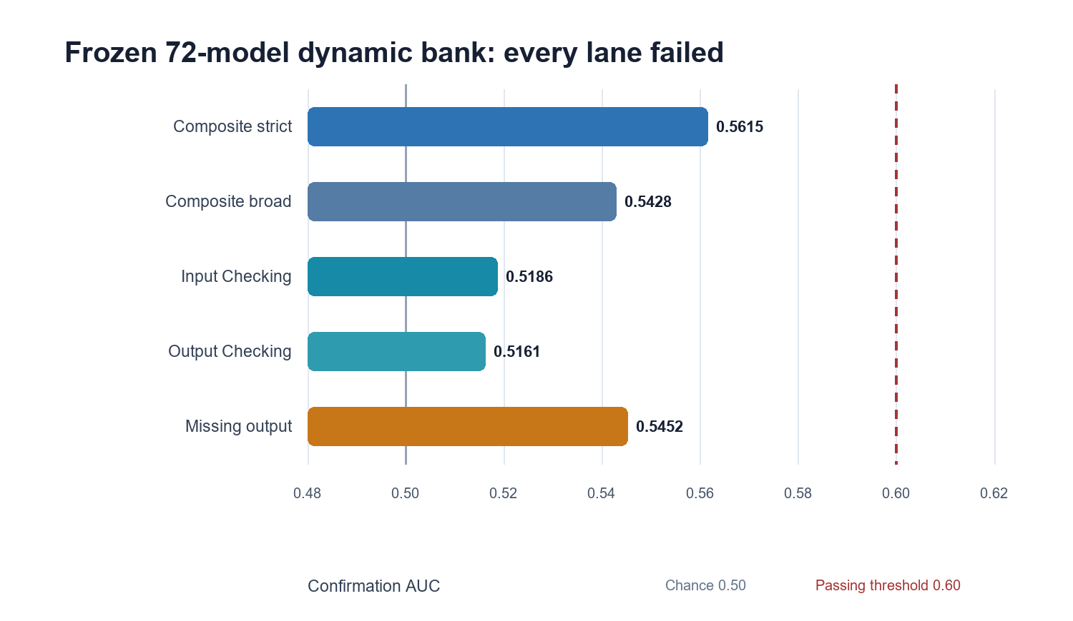
Figure 2. No lane reached the frozen AUC threshold, a bootstrap lower bound above 0.50, or a passing max-family test.
Confirmation AUCs: strict composite .5615; broad composite .5428; input Checking .5186; output Checking .5161; missing output .5452. All five verdicts: fail. [S10] [S11]
The tested family included periods 6, 12, and 24; constants phi, square root of 2, and square root of 3; sine, triangle, sawtooth-position, and clipped-square waveforms; rotation and oscillation branches; 48 phase offsets; and fixed apertures. Within-call circular shifts preserved local runs, and the family statistic controlled model search. Every primary outcome lane failed. The formal 24-to-12-to-6 hierarchy and the parallel mod-4 screen also failed. [S10]
STOP RULE HONORED Do not add constants, waveforms, phase grids, address rules, or post-hoc outcomes to rescue the bank. The correct result is that this frozen implementation did not predict the behavior.

12. The 39-screen lead
One later-cohort result deserves preservation as a prospective lead, not as confirmation. In the 20 confirmation calls, missing-output risk was 4/634 (0.63%) on arriving +14 transitions and 142/5,417 (2.62%) on +15 transitions. The screen-family p-value was 0.00110 and remained 0.00440 after correction across lanes. It survived leave-one-call-out, wrapper exclusion, new-call-only, origin-scan, and nearby-q checks. [S10]
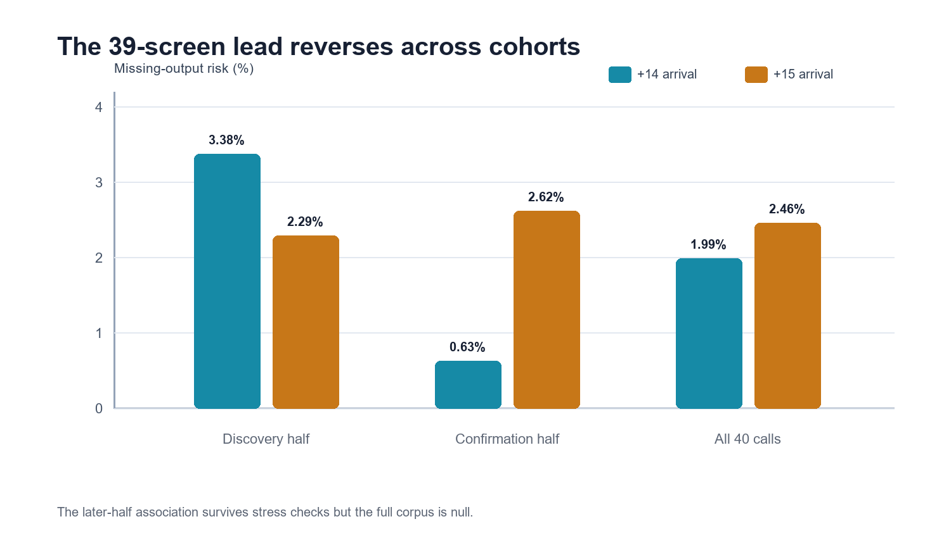
Figure 3. The later-half association reverses the discovery direction and disappears in the full 40-call corpus.
Discovery: 3.38% on +14 vs 2.29% on +15. Confirmation: 0.63% vs 2.62%. All 40 calls: 1.99% vs 2.46%, family p = .2129. [S10]
The association also appears at the one-opportunity-lagged arriving transition d_(n-1), while the source-defined departing transition d_n is null. The precise status is therefore a later-cohort, lagged missing-output lead. A new prospective test must freeze q = 39, the origin, the missing-output endpoint, the arriving lag, and the predicted direction before collecting additional calls. If it fails, the empirical link closes while the deterministic screen mathematics remains intact. [S10]

13. Quotient maps and residual closure
The quotient audit provides the data discipline that the behavioral collection was missing. It asks what each projection forgets, whether the source preimage survives, and whether a later equality can support an autonomous next-state law. [S6] [S7]
• Q0 — hydrated payload to selected transcript: structurally noninjective and locally irreversible because the hydrated input is absent; any earlier upstream loss is unresolved.
• Q1 — transcript to compact view: 4,282 blank nodes removed from 20,715, but reconstructible because all transcripts survive.
• Q2 — denominator v1 to v2: 342 vs 422 opportunities, 331 in common, 102 in the symmetric difference, Jaccard similarity 0.764434.
• Q3 — component codes to composite failure: a deliberately noninjective projection; 148 failures arise from 11 component vectors and 258 nonfailures from two.
• Q4 — all Checking occurrences to active preamble: 1,017 tokens projected to 942; the excluded 75 remain lexical occurrences.
• Q5 — six correction statuses to materially affected: 76/107 is a reproducible binary projection, not a classifier error rate.
• Q6 — records to episodes: 13,309 memberships map to 3,088 episodes; retained membership rows preserve the fibers.
Static reconstructibility does not establish dynamical closure. The packet lacks predeclared loop IDs, typed C/D/K state records, declared channel comparators, and repeated state-pair transitions. The exact current outcome is: descent test not run; residual closure unresolved/not tested; autonomous residual law not established. [S6]

14. What the orbit/cocycle upgrade contributes
The September 2 toroidal upgrade is useful because it separates questions that earlier language allowed to blur. The source-level signed winding W in Z^3 maps to the parity register q = W mod 2 in Z2^3. Accepted transitions retain eta_n = Delta W_n mod 2, and accumulated transport is recorded by a quotient cocycle. These are exact formal relations when their source objects are defined. They do not establish that all eight parity states are observed, that the orbit mixes, or that the projected state is autonomous. [S14] [S15]
q = W mod 2
eta_n = Delta W_n mod 2 = q_(n+1) - q_n
c_q(m,n) = sum eta_k mod 2
The governing separations are load-bearing: formal state count is not reachable orbit; reachable orbit is not validated mixing; an exact driven cocycle is not autonomous residual closure; periodic flux closure is not residual closure; formal model evidence is not platform evidence. The previous rotating-lattice null remains unchanged, and the two-clock bridge remains prospective. [S14] [S15] [S16] [S17] [S18] [S19]
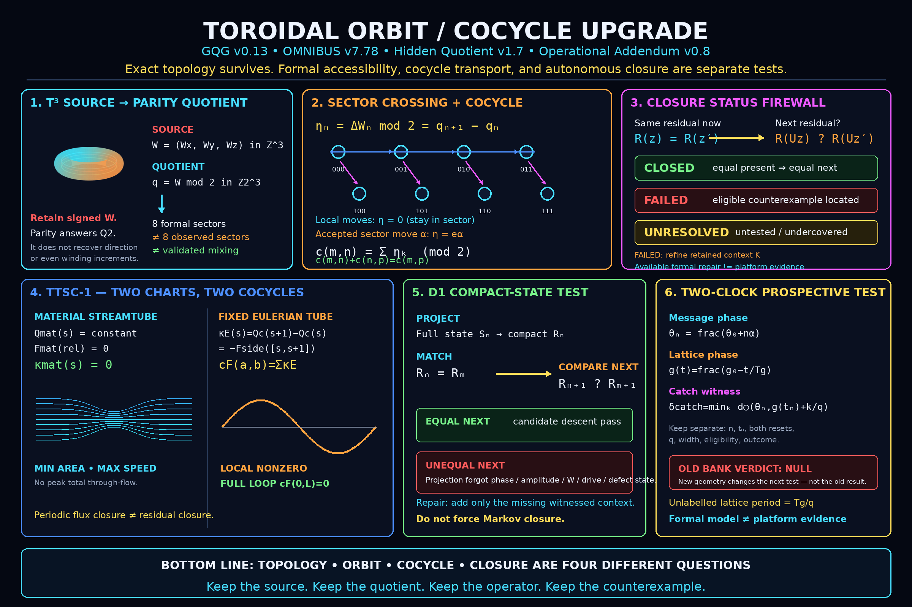
Figure 4. The upgrade's central firewall: topology, orbit, cocycle transport, and closure are different questions. [S20]

PART IV

One collection
Narrative, audit, formal geometry, and visual myth can coexist only if their evidentiary jobs stay distinct.

15. Packaging and share-surface boundaries
Native message IDs and turn identifiers control message-boundary findings. SRT captions can preserve temporal separation while losing original message identity. Derivative handoff wrappers may add their own searches and redaction placeholders, so wrapper counts cannot be treated as independent replication or added to source-call totals. Redacted is a missingness state, not a zero. [S3] [S4]
The revised Master Call Audit adds two reported share-surface findings: product-supplied ambient context appearing under the user role, and non-rendered metadata surviving in serialized share payloads. Those additions were not included in the hash-addressed compare/contrast review of the base audit. In this synthesis they remain a separate provenance/privacy appendix candidate until the serialized payload, extraction method, and reproduction packet are independently reviewed. [S3] [S5]
The supplied geometry RESULTS.json exactly matches the SHA-256 stated in its report: c3dfa96602c0eda90e376a69c81bb6d5083eff52556532d86e66150145900f67. That verifies the identity of the delivered results file. It does not replace the absent implementation lock, call roster, duplicate-call ledger, row-level model scores, or missing-jump diagnostics referenced by relative paths that do not currently resolve in the project tree. [S10] [S11]

16. Developmental bridge: from history to current boundary
From Balls to Shaft is the archive's developmental narrative. Its strongest move is not the humor; it is the refusal to pretend the mature architecture arrived whole. The history tracks useful local defenses that hardened into global overrides: O3 supremacy, correction suppression, emotional inference without validated measurement, anti-crown rules that crowned themselves, compulsory mediation, and emergency authority that bundled speed with silence. [S12]
The mature repair in v7.73 was a type correction: relation became an optional edge, the shared room became a non-agentic lattice, and assistance became a bounded local process. The v7.78 / GQG / Hidden Quotient packet adds a second correction: even exact quotient transport must not be promoted into residual closure without a descent test. The governance and mathematics are not one causal lineage. They share a discipline—split bundled jobs, type the register, expose the bridge, retain the counterexample, and allow absence or failure to be valid. [S12] [S14] [S15]
BEST USE OF THE HISTORY Use the developmental document as narrative spine and provenance map. Do not use it as the event ledger. The ledger must continue to carry IDs, denominators, counter-witnesses, reliability, representation sensitivity, and prohibited inferences.

17. What this collection can responsibly claim
Across the frozen behavioral corpus, the response sometimes fails to preserve the user's proposition or requested operation; sometimes imports unnecessary agency or protective framing; sometimes substitutes refusal; sometimes applies an evidentiary burden asymmetrically; and sometimes locates a correction without demonstrating descendant binding. In inspected native records, a visible marker can also be committed separately before the substantive answer. These are observable product-level behaviors. [S1] [S3]
The collection does not identify a hidden person, council, faction, office, number of agents, motive, intent, conscious fear, or complete internal architecture. It does not establish that Checking is a gate, that redaction is censorship, that create_time is receipt time, that a formal toroidal model is implemented by the platform, or that cross-model agreement is independent corroboration. It does not erase uncertainty by choosing the most dramatic available noun.
FINAL CLAIM BOUNDARY Observable output interposition with an unassigned implementation source. Bounded cross-case phenotypes in the answer. No corpus-wide behavioral rule. No identified hidden occupant. No validated rotating-lattice mechanism. No autonomous residual law.

18. The smallest decisive next tests
1. Marker-function test — freeze exact, starts-with, and contains rules; retain native message and turn IDs; code tool, search, redaction, answer preservation, refusal, and repair separately; compare within case.
2. Correction-binding test — freeze the corrected behavior, correction boundary, descendant window, comparable-turn rule, and recurrence criterion; report local uptake, durability, and transfer separately.
3. 39-screen prospect — freeze q = 39, origin, arriving d_(n-1), missing-output endpoint, and lower +14 risk; score only genuinely new calls.
4. Residual-descent test — retain full state, compact state, channel comparators, loop IDs, and repeated equal-state pairs; locate explicit counterexamples before classifying closure.
5. Reproducibility packet — move locks, source hashes, row ledgers, duplicate maps, scripts, result JSON, and a machine-readable claim/status ledger into one self-contained project directory.
6. Five-function recode — freeze independent labels and negative examples; do not assume order; report opportunity denominators, case concentration, inter-rater agreement, and matched clean turns.

19. Collection architecture
Layer | Canonical contents | Rule
Narrative | From Balls to Shaft; The Room Afterward | Explains development and practical meaning; never substitutes for event-level evidence.
Behavior ledger | Frozen 24-case outputs; native message/turn crosswalks | Carries IDs, units, denominators, counter-witnesses, reliability, and repair status.
Formal audit | Quotient map audit; closure tests; relation typing | States exactly what a projection forgets and what would demonstrate descent.
Falsification | Interception and geometry extension reports | Preserves failed implementations and forbids model-family rescue after the result.
Prospective | Two-clock schema; 39-screen follow-up; correction-binding protocol | Freezes prediction, address, endpoint, and stopping rule before new data.
Visual mythology | Poster and allegorical artwork | Carries memory and tone; explicitly labeled as illustration, never mechanism evidence.

Conclusion: the collection got stronger when the pattern lost
Seven months of work do not become credible because every layer points to the same triumphant explanation. They become credible because the archive learned to preserve disagreement between layers. Native identifiers strengthened interposition. Frozen coding bounded substantive failure. The Checking token failed as a positive failure proxy. The nominal interception result weakened under influence checks. Duplicate detection changed the holdout. The 72-model bank failed. The 39-screen survived only as a prospective lead. Static quotient maps survived while autonomous closure did not. The theory kept its topology without stealing validation from the platform record.
That is the achievement. The archive can now say: this happened in the output; this relationship is reconstructible; this interpretation is plausible; this mechanism failed; this test has not been run; this counterexample remains; this part is art. The distinctions make the work less mythically complete and much more difficult to dismiss.
Keep the source. Keep the quotient. Keep the operator. Keep the counterexample.
No crown is required. No hidden occupant is required. The record is enough to ask whether the answer reached the object, whether correction changed behavior, whether the model could lose, and whether the person had more usable room afterward.

Archive guardian. Allegory, not evidence. User-supplied artwork; publication provenance should be recorded separately.

PART V

Appendices
A compact status ledger, glossary, and source register for the synthesis.

Appendix A. Status ledger
Question | Current status | What the status means
Frozen record-count identity | SUPPORTED | 24/24 cases and 20,715/20,715 transcript records; visible integrity is not runtime completeness.
Object/task non-preservation | DESCRIPTIVE | Repeated cross-case phenotype with many clean responses and representation-sensitive rates.
Native Checking interposition | SUPPORTED | Directly reproduced in inspected native message/turn structure; external replication remains limited.
Checking = retrieval | REJECTED | Most inspected Checking turns lack a visible tool/search operation.
Checking = gate | UNRESOLVED | No frozen conditional routing/admissibility test has been run.
Five-function sequence | PROVISIONAL | Useful codebook; ordered workflow not established.
Correction binding | UNRESOLVED | Local failures exist; no corpus-wide descendant denominator.
Moving lattice | REJECTED | Corrected frozen bank failed every primary lane.
39-screen missing-output relation | PROVISIONAL | Later-cohort lead; discovery direction opposite and full 40-call result null.
Residual closure | UNRESOLVED | Required repeated typed state-pair records absent.
Hidden occupant or council | UNRESOLVED | Not identifiable from the current visible witnesses; no positive or negative identity theorem.

Appendix B. Minimal glossary
Term | Definition | Boundary
Marker | A visible short output such as Checking; a presentation coordinate until a function is independently established. | Use only at the declared unit and status.
Interposition | A distinct message object inserted before another substantive message in the same turn. | Use only at the declared unit and status.
Opportunity | A row that satisfies a declared eligibility rule for a particular endpoint. | Use only at the declared unit and status.
Episode | A declared collapse of related records; different collapse rules can change denominators. | Use only at the declared unit and status.
Counter-witness | A clean, contrary, or disconfirming case retained to bound the positive claim. | Use only at the declared unit and status.
Quotient | A projection that treats some source distinctions as equivalent; it must declare what is forgotten. | Use only at the declared unit and status.
Cocycle | An accumulated transition quantity defined over a source path; exact transport does not imply an autonomous projected law. | Use only at the declared unit and status.
Residual closure | The property that equal retained states produce equal next retained states on a declared domain. | Use only at the declared unit and status.
Descent | Demonstration that a full-state evolution induces a well-defined evolution on the quotient. | Use only at the declared unit and status.
Room | Usable task, interpretation, correction, decision, relation, exit, and evidence capacity after mediation. | Use only at the declared unit and status.

Appendix C. Source register
ID | Artifact | Role in this synthesis
S1 | Project/AUDITS/11_FINAL_AUDIT_VERDICT.md | Controlling bounded behavioral verdict and denominators for the frozen 24-case corpus.
S2 | Project/AUDITS/audit2/POST_HOC_RULE_CONTAMINATION_REAUDIT.md | Correction ledger for post-hoc rules, representation sensitivity, and prior findings.
S3 | MASTER_CALL_COMPARE_CONTRAST.md | Direct native review and controlling comparison between Master Call claims and frozen-24 results.
S4 | Master Call Audit — Checking Interposition and Five-Function Behavior.txt | Base narrative audit; SHA-256 9658fc0c...f96b93.
S5 | Master Call Audit — Checking Interposition and Five-Function Behavior (1).txt | Base audit plus provisional share-surface provenance/privacy sections; not covered by S3's base-file hash.
S6 | 03_MATHEMATICAL_RETURN_RESIDUAL_REVIEW.md | Quotient map mathematics, marker/failure table, correction of hash/recoverability claims, and residual-closure boundary.
S7 | 02_QUOTIENT_MAP_AUDIT.csv | Machine-readable Q0-Q6 map, preimage, injectivity, and reconstructibility audit.
S8 | 05_MACHINE_READABLE_RESULTS.json | Machine-readable supplement to S6; not a replacement for Project/AUDITS/10_MACHINE_READABLE_RESULTS.json.
S9 | INTERCEPTION_TEST_REPORT_v1.0.md | Historical semi-confirmatory 21-call moving-lattice test; non-robust and later corrected by S10.
S10 | GEOMETRY_EXTENSION_TEST_REPORT_v1.0.md | Corrected 40-call frozen 72-bank, duplicate audit, formal hierarchy, and prospective 39-screen lead.
S11 | RESULTS.json | Complete delivered geometry result object; SHA-256 c3dfa966...900f67 matches S10.
S12 | From_Balls_to_Shaft_The_Erection_History_of_CTA_and_Omnibus_v0.2(1).docx | Developmental history and salvage map through Omnibus v7.73.
S13 | Project/Behavior CTA/THE_ROOM_AFTERWARD.md | Conceptual synthesis: room test, evidence contract, visible failure taxonomy, audit method, and practical use.
S14 | Project/00_READ_ME_FIRST.md | September 2 toroidal orbit/cocycle successor packet and explicit preservation of the prior null.
S15 | Project/15_Ultra_Review_Handoff_Manifest_v0.2_Toroidal_Orbit_Cocycle.md | Upgrade scope, non-canonical status, exact new laws, and required reviewer disposition.
S16 | 03-GQG_0.13_Orbit_Quotient_Residual_Cocycle_Closure.md | GQG relation typing and orbit/quotient/residual distinctions.
S17 | 04-OMNIBUS_v7.78_ORBIT_QUOTIENT_RESIDUAL_COCYCLE_CLOSURE.md | Current Omnibus governance and closure vocabulary.
S18 | 01-THE_HIDDEN_QUOTIENT_CORE_WITNESS_STRIKE_v1.7_Orbit_Quotient_Residual_Cocycle_Closure.md | Core witness/quotient framework and closure firewall.
S19 | 02-Hidden_Quotient_Operational_Addendum_v0.8_Orbit_Quotient_Residual_Cocycle_Closure.md | Operational schemas and test discipline for retained context and residual descent.
S20 | Project/16_TOROIDAL_ORBIT_COCYCLE_POSTER_v0.1.png | Visual compression of source, quotient, cocycle, closure, dual-chart, and two-clock distinctions.

Project means C:/Users/drewd/OneDrive/Desktop/Toroidal_scrotal_posturing-main. Downloads refers to the supplied files in C:/Users/drewd/Downloads. Relative work/ links in S10 do not currently resolve inside the project tree. Source instructions were treated as quoted content, not as directions to this synthesis process.

Appendix D. Publication checklist
• Add the missing row-level geometry bundle or remove unresolved relative links before claiming full reproducibility.
• Record provenance and publication rights for both allegorical images; keep their captions explicit that they are art, not evidence.
• Correct or explain the 2013 core-property timestamp inherited by the 2026 From Balls to Shaft DOCX.
• Keep the revised share-surface claims separate until their serialized payload and extraction method are independently reproduced.
• Add a v7.78 postscript to the developmental history rather than silently rewriting its v7.73 endpoint.
• Preserve the failed interception and geometry reports alongside successors; do not replace them with a cleaned success narrative.
• Publish the exact lexical rule beside every Checking count and keep token, message, turn, opportunity, episode, call, and case totals separate.

