Five-String Acoustic Resonator — Rev A
Build-ready first-pass schematic • acoustic/passive baseline • 13 August 2026
Design status: PROVISIONAL until the measurement gates in §4 are completed.
Build intent | Hard boundary | First-pass criterion
Upright five-string resonator using a vessel as an acoustic enclosure and a central hardwood load path. | No high voltage, energized helix, “Tesla coil,” exposed mains, smoke, salt, or mechanism inferred from mythology. | Stable, serviceable, audibly resonant, and measurable before any powered excitation is added.

1. Labeled geometry
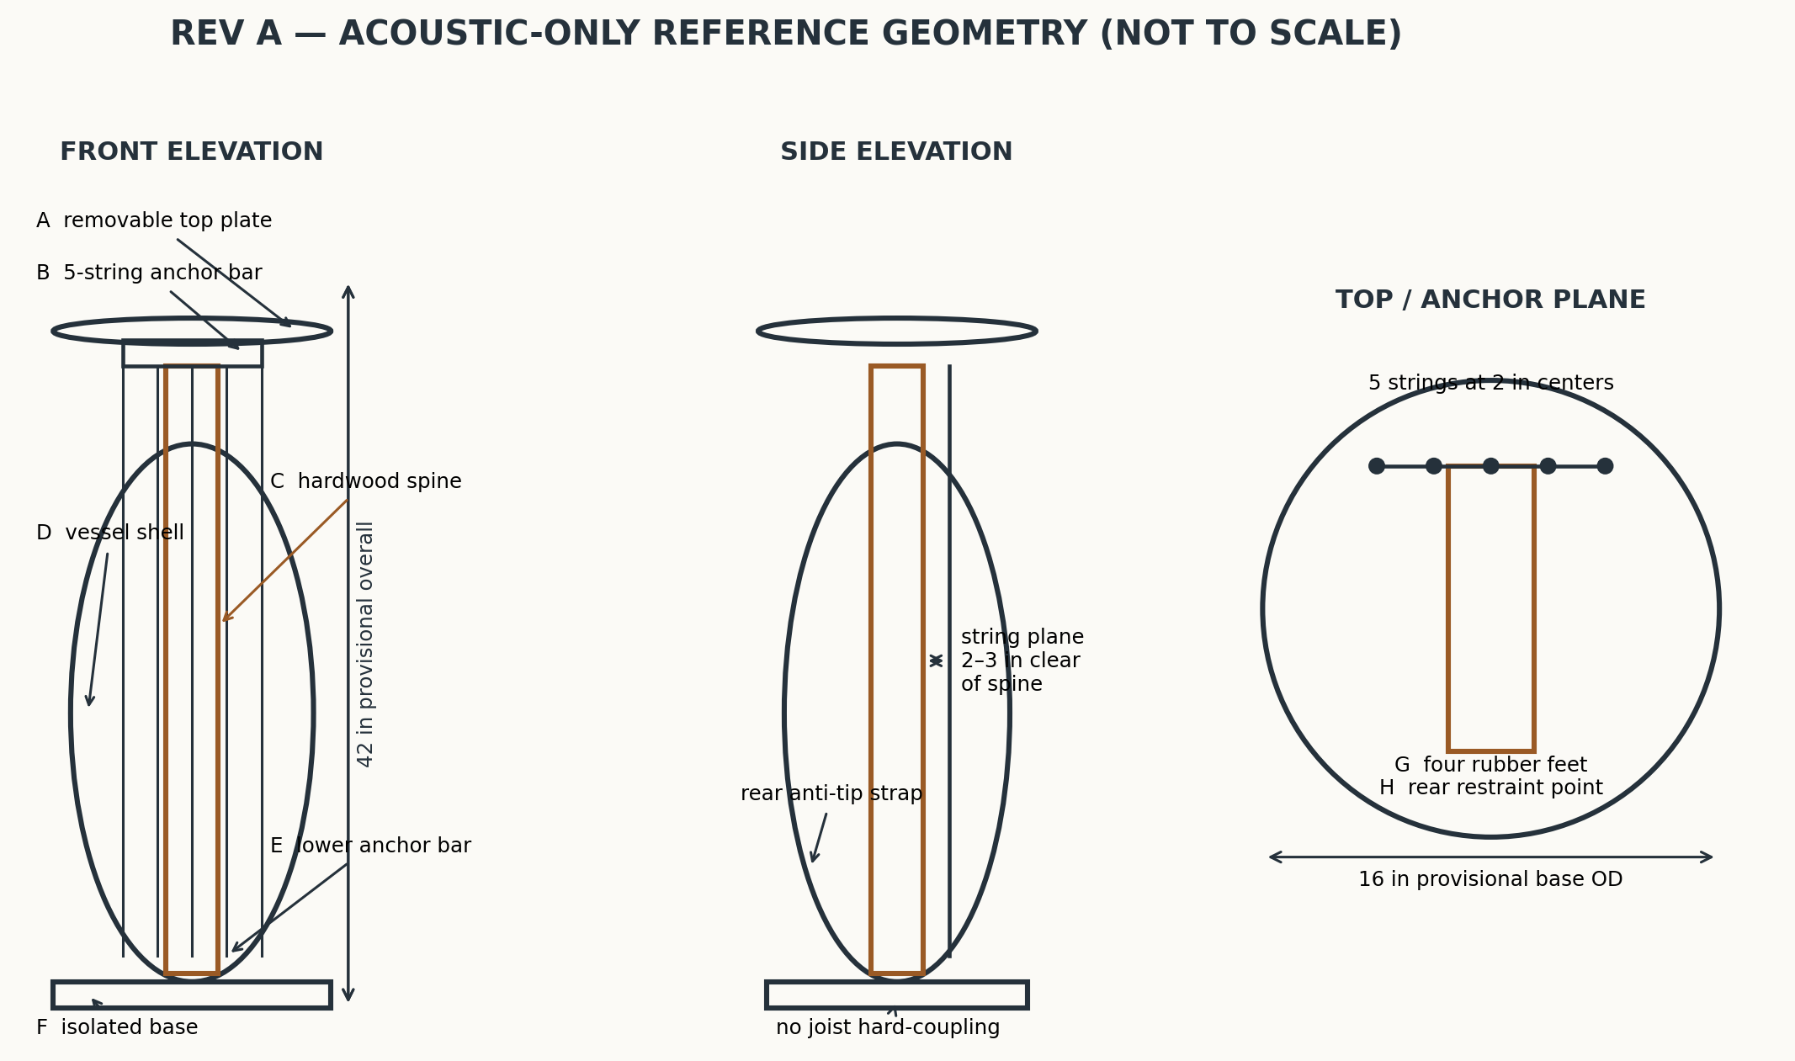
Geometry rule. Strings occupy one serviceable plane in front of the spine. The vessel is an enclosure and guard, not a primary structural member. All string tension closes through the upper anchor, hardwood spine, lower anchor, and base frame.

2. Provisional dimensions and acceptance limits
Feature | Rev A nominal | Allowed / gate | Design note
Overall height | 42 in (1067 mm) | 36–48 in | Must fit room and remain tip-stable
Base outside diameter | 16 in (406 mm) | ≥ 14 in | Wider if total center of gravity is high
Vessel maximum OD / clear ID | 14 / ≥ 12 in | Measure actual | ≥ 1 in clearance to moving strings/hardware
Top plate diameter | 16 in | 14–18 in | Thin metal or 1/4–3/8 in plywood; removable
Spine | 2 × 3 in hardwood, 40 in long | Engineer to load | Straight grain; no cracks/large knots
Speaking string length L | 32 in (813 mm) | 28–36 in | All five equal within 1/16 in unless intentionally scaled
String spacing | 2 in centers | 1.5–2.25 in | Enough access for plucking and damping
String-to-spine clearance | 2–3 in | ≥ 1.5 in | No contact at full excursion
Top acoustic gap | 1.5 in | 1–2 in | Open annulus; no pinching of airflow
Foot pattern | 4 feet on 13–14 in circle | As base permits | All feet loaded; no rocking
Initial tension limit | ≤ 20 lbf/string; ≤ 100 lbf total | Mandatory Rev A cap | Verify with string maker/tension calculator

3. Parts list
ID | Part | Qty | Specification | Safety / assembly note
P1 | Base frame | 1 | 3/4 in Baltic-birch plywood, laminated to 1.5 in total, 16 in OD | No cracked, warped, or particle-board base
P2 | Central spine | 1 | Hard maple/ash, nominal 2 × 3 × 40 in | Primary load path
P3 | Upper/lower anchor bars | 2 | 1/4 in steel bar or 3/8 in aluminum, 8 × 2 in | Deburr; five holes at 2 in centers
P4 | Tuning machines | 5 | Enclosed bass or zither pins rated for chosen strings | Mount to separate head block if needed
P5 | Strings | 5 | Low-tension acoustic strings selected by calculated tension | Start ≤20 lbf each; install eye protection
P6 | Bridge / nut strips | 2 | Hardwood, bone, or acetal; replaceable | Rounded bearing edges
P7 | Vessel shell | 1 | Glass/acrylic/wood vessel, ≥12 in clear ID | Not load bearing; restrained with padded clamps
P8 | Top plate | 1 | Thin cymbal-like metal plate or 1/4–3/8 in plywood, 14–18 in | Insulated from shell; removable
P9 | Base feet | 4 | Neoprene/Sorbothane feet, 1–1.5 in OD, through-bolted | Non-slip; equal height
P10 | Vessel clamps | 3–4 | Padded stainless straps or wooden cleats | No point loading on glass
P11 | Anti-tip restraint | 1 | Furniture strap/cable rated ≥200 lbf | Attach to wall stud, not drywall alone
P12 | Guards/covers | As needed | Polycarbonate shields over anchors/tuners | Contain a broken string end
P13 | Fasteners | Set | Grade-marked machine bolts, washers, nyloc nuts | No wood screws in primary tension path
P14 | Optional pickup | 1 | Passive piezo/contact microphone | Electrically isolated; removable
P15 | Optional exciter — Phase 2 only | 1 | 12–24 VDC, ≤30 W tactile exciter + fused isolated supply | Not installed until acoustic baseline passes

4. Dimensions still required before cutting or tensioning
- Room clear height and the exact footprint available, including walking clearance.
- Vessel: total height, maximum outside diameter, mouth inside/outside diameter, wall thickness, base shape, material, mass, and any chips or cracks.
- Chosen top plate/cymbal: diameter, mass, center-hole diameter, edge condition, and mounting hardware.
- Chosen string set: material, gauge/core type, unit weight or manufacturer tension at proposed pitch and 32 in scale, plus safe tuning range.
- Tuner footprint, post diameter, mounting thickness, and required access for winding.
- Spine stock actual dimensions, species, grain direction, straightness, and defects.
- Finished assembly mass and estimated center-of-gravity height; perform the 10° tip test before playing.
- Wall-stud location for anti-tip restraint; electrical outlet and cable route if Phase 2 is attempted.
- Target pitches and permitted sound-pressure level at the operator position.
Tension gate: For each string, calculate or obtain manufacturer tension at the exact scale and target pitch. Sum all five. Do not exceed the lowest rating of the string, tuner, anchor, spine, fastener, or base connection; apply at least a 4× safety factor to anchors and restraint hardware. If ratings are unknown, do not tension.

5. Safe mounting and assembly
1. Dry-fit the base, spine, upper head block, and lower anchor without the vessel. Through-bolt the spine into a cross-braced base; use large washers or steel backing plates.
2. Fit four isolation feet and confirm all four carry load. Add the rear anti-tip strap to a structural wall stud, leaving only enough slack for isolation movement.
3. Mount the vessel independently with three or four padded restraints. Maintain a continuous 1 in minimum clearance from all string and anchor hardware. Never clamp glass at a single point or drill tempered glass.
4. Install rounded nut/bridge strips and guarded anchor bars. Orient cut string ends inward and cover them with polycarbonate or a fastened guard.
5. Install strings one at a time at hand-snug tension. Stand out of the string plane, wear eye protection, and increase in small equal increments while watching base lift, spine bow, fastener movement, and vessel clearance.
6. At ≤25%, 50%, 75%, and 100% of the Rev A tension cap, stop and inspect. Abort on cracking, creaking, permanent deflection, rocking, loosening, or contact with the vessel.
7. Fit the top plate on an insulated, captive mount only after the string frame is stable. The top must not be able to lift free during vibration.

6. Airflow and electrical constraints
Domain | Allowed in Rev A | Constraint / exclusion
Airflow | Natural convection; one guarded external fan for mapping only | Fan stays outside vessel, ≥12 in from strings and loose fibers. No airflow through electronics; no fan-induced string contact.
Flow visualization | Short yarn tufts or lightweight tissue streamers | No smoke, incense, combustion, powders, salt mist, aerosols, or material that can enter lungs/electronics.
Copper helix | Decorative, mechanically secured, electrically floating | Not required for acoustic operation. It must not touch strings, tuners, pickup wiring, top plate, or electrical ground.
Acoustic sensing | Passive contact mic/piezo into battery recorder | Secure cable strain relief; avoid trip loops.
Powered excitation | Excluded from baseline; Phase 2 may use 12–24 VDC, ≤30 W | Isolated listed supply outside vessel, fused at source, guarded connector, no exposed conductors, no mains inside assembly, and never >48 VDC.
Subwoofer/structure | External airborne excitation at modest level | No bolting or hard-coupling to house joists in Rev A. Keep loose objects clear and monitor floor/wall vibration.
Sound exposure | Start quiet; increase only as needed | Use hearing protection and measured SPL; stop for pain, pressure, dizziness, or rattling building components.

7. Commissioning and test sequence
Test | Method | Pass / abort criterion
T0 — Inspection | Photograph joints; torque-mark nuts; confirm vessel clearance and guards. | No cracks, rocking, loose hardware, sharp edges, or unguarded string ends.
T1 — Static proof | At the Rev A total tension cap, leave for 30 min; measure spine bow and base lift before/after. | No progressive movement; residual deflection ≤1 mm after unloading. Any audible crack/creak = fail.
T2 — Tip/restraint | With strings damped, tilt or shim base to 10° in the least-stable direction; verify restraint. | Assembly does not overturn; feet remain controlled; strap/anchor undamaged.
T3 — Tap map | Strings damped, tap base, vessel, spine, and top separately; record phone spectrum and decay. | Repeatable peaks; no buzz caused by loose hardware.
T4 — Individual strings | Pluck one string at a time, low amplitude; record fundamental, harmonics, and 10 dB decay time. | Clear tone, no vessel strike, anchor slip, or growing detune.
T5 — Coupling matrix | For each string, measure response at spine, vessel, top plate, and base with contact mic. | Record amplitude ratios; do not interpret analogy as cause.
T6 — Airflow map | Use yarn tufts around top gap with no powered exciter; video from fixed angle. Then repeat with one guarded external fan. | Tufts remain clear of strings/hardware; no debris ingestion or unstable vibration.
T7 — Room sweep | Place an external speaker/subwoofer ≥3 ft away; sweep 20–200 Hz slowly at low SPL, strings initially damped. | Stop on structural rattles, visible motion, pain/pressure, or SPL limit. Log resonances, not “field” claims.
T8 — Optional Phase 2 | Only after T0–T7 pass: attach ≤30 W low-voltage exciter to base, fuse it, repeat T3–T7 at minimum drive. | No temperature rise >10°C at exciter mount after 10 min; no loosening or new contact.

8. Evidence log template
For every run record: date/time • configuration revision • string gauges/pitches/tensions • sensor/phone position • excitation source and level • room doors/windows/fans • peak frequencies • decay times • visible motion • temperature • anomalies • stop reason. Change one variable per run.

9. Mechanical comparison with separate mythic analogy
Interpretation boundary. The analogy column is cultural/design language only. It supplies no evidence of acoustic, electrical, structural, physiological, or environmental mechanism.
Physical feature | Mythic analogy only | Engineering interpretation / boundary
Long central spine + resonating enclosure | Veena / vina | Useful visual family: long neck and resonant body; actual mechanism is ordinary string and enclosure vibration.
Five vertical strings | Lyre / harp | Useful layout family: individually tuned strings; actual behavior depends on length, tension, mass per length, anchors, and damping.
Ordered spacing and removable top | Apollo’s lyre | Proportion/order analogy only; no solar, healing, or field claim.
Environmental listening / room sweep | Dagda’s harp; Orpheus’s lyre | Narrative analogy for music affecting a setting; measured room modes and structural coupling are the only testable subjects here.
Open top gap and airflow mapping | Gandharvas / Aeolian-harp family | Wind/breath analogy only; airflow is visualized with tufts and measured as ordinary fluid motion.
Optional unenergized copper ornament | Hermes/caduceus imagery | Decorative staff/serpent analogy only. No coil, antenna, charge-focusing, or electromagnetic-mechanism claim.

10. Rev A exclusions and change-control gate
- No Tesla coil, primary/secondary HV winding, capacitive terminal, corona, exposed energized metal, or predicted electromagnetic “field pattern.”
- No claim that a cymbal “focuses charge,” that a helix improves field stability, or that mythology identifies a mechanism.
- No structural attachment to joists, walls, or building framing except a slack anti-tip safety restraint to a wall stud.
- No smoke, flame, incense, salt, conductive liquids, dust, or aerosol near the assembly.
- Only one change per revision. A powered exciter, different string family, hard structural coupling, or energized conductive element requires a new risk review—not a silent Rev A modification.

11. First build decision
Recommended cut plan after measurements: retain the 42 × 16 in envelope and 32 in speaking length if the actual vessel supplies ≥12 in clear ID and the selected five strings remain at or below 20 lbf each. Otherwise resize the frame around the vessel and recalculate every string tension before cutting anchor bars.

