Other findings and curiosities

Daniel E. Severin

Note 1: Example of differences reported in log files corresponding to an error in BD digital catalog.

In the digital catalog, the star BD +19°4871 reports 37.9 minutes of declination (see below on the left). However, in the printed catalog, it says 7.9 (on the right), thus leading to a separation of 30 arcmin. In fact, star PPM 141127 is near the printed position, as expected. More precisely, there are 30.8 arcmin between the digital coordinates of BD and PPM, indicating a potential typo error.
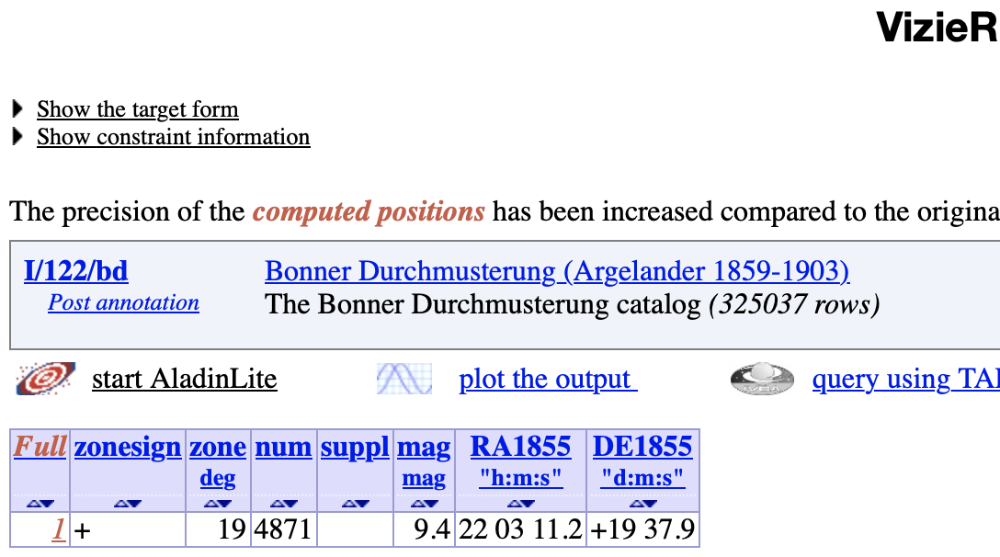

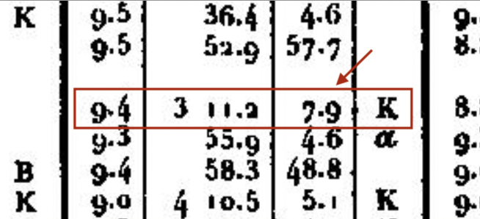

Note 2: Identification error in SIMBAD propagated from IV/5.
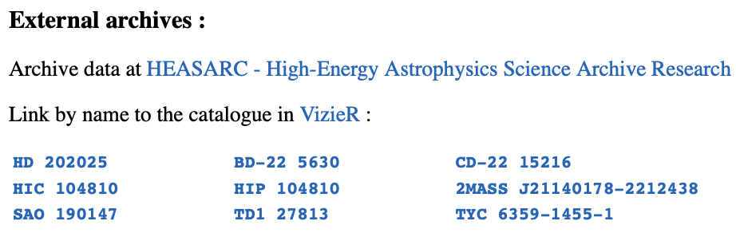
In catalog IV/5 (also 4005), SD -22°5630 is identified
to CD -22°15216 and this identification is also
observed in SIMBAD, see here. However, the angular
distance between both stars is 4356 arcsec. In fact,
SD -22°5630 is the same as HD 202025 while CD
-22°15216 is probably TYC 6358-218-1. On the other
hand, HD 202025 is the same as CD -22°15266.
Note 3: Differences found in digital version of Catálogo General Argentino.

When comparing digital catalog (from GAVO Data Center) vs. printed catalog, i.e. Resultados del Observatorio Nacional Argentino, Vol XIV, and further corrigenda, we found the following differences:

Star | Parameter | Digital | Printed
GC 12588 (1st obs) | RA | 36^{s}03 | 34^{s}00
GC 15231 | obs | 1 (reported 2nd one) | 2
GC 16823 | RA | 05^{s}39 | 04^{s}76
GC 16823 | DE (south) | 79°03'46''6 | 27°07'14''5

Note 4: Differences found in digital version of Gilliss catalog [G]:

Star | Parameter | Digital | Printed
G 3497 | Identification | GZC | Gould
G 5327 | RA | 36^{s}91 | 36^{s}88
G 5327 | DE (south) | 69°55'01''0 | 65°55'1''2
G 5437 | Identification | GZC 08^{h} 1155 | GZC 08^{h} 1156
G 6395 | Identification | GC 13221 | Carinae
G 8894 | RA | 41^{m}05^{s}51 | 42^{m}15^{s}51
G 13514 | RA | 35^{m} | 38^{m}
G 13514 | DE (south) | 46''0 | 46''7

Note 5: Errors found in printed versions of Argentine Catalogs not found in their corrigenda.

- In Resultados del Observatorio Nacional Argentino, Vol XV, we find that the star 691 of pg. 67 reports a declination of 35°16'41''1 (epoch 1881.0):
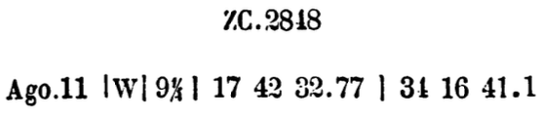
however in the original observation of pg. 35, declination is 34° (see below on the right), also it is cross-identified with ZC 17^{h} 2848, where it also reports 34° for a similar epoch (1875.0), see below on the left:
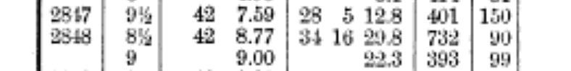

- In Resultados del Observatorio Nacional Argentino, Vol XV, we find that the star 729 of pg. 68 is identified with OA 17773 [OARS] which is clearly wrong when their positions are compared. The original observation, instead, reports that it is OA 11734; below stars 727-733 and their original observations are shown:
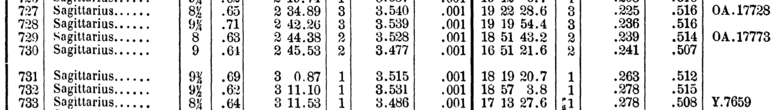
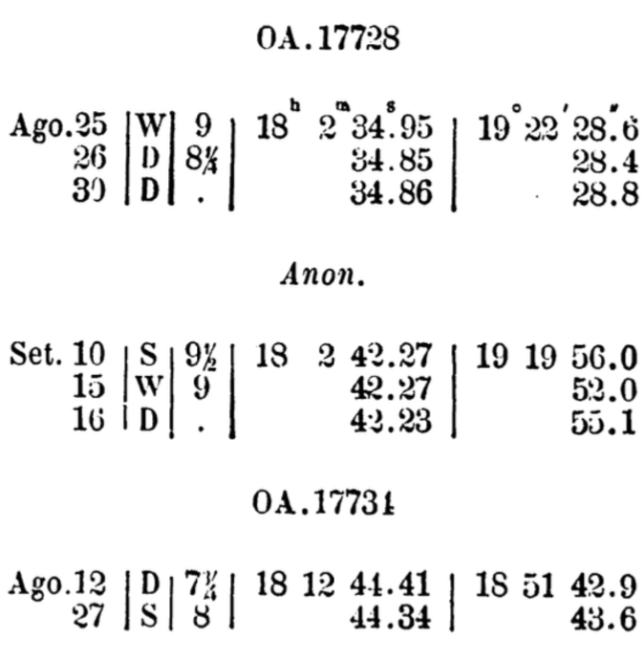
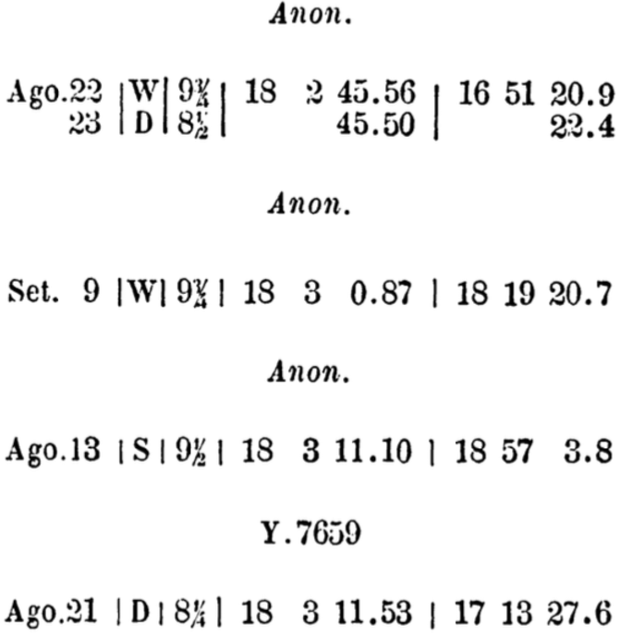
…...
Something similar occurs with star 340 of pg. 238, identified with GC 1325 (very far) but
with G 1325 in the original observation (pg 199):
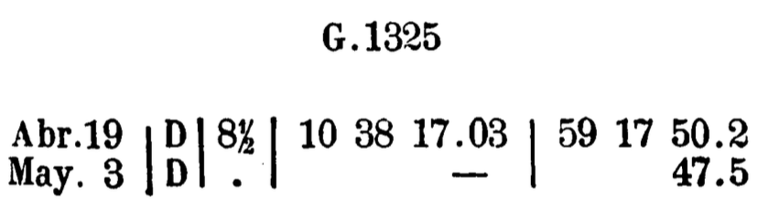

- In Resultados del Observatorio Nacional Argentino, Vol XV, we find that the star 1195 of pg. 161 is misidentified with OA 20291, however its position and the one for OA 20991 are near to each other, and the same as PPM 271859 (within 3 arcsec). Below, pg. 116 and 161:
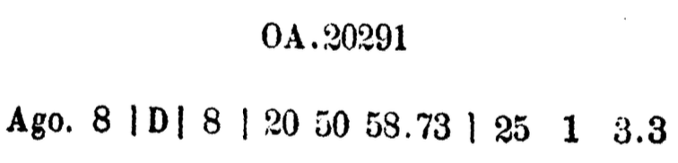

Similar cases to the previous one:
- We find that the star 701 of pg. 68 is misidentified with OA 17643, however its position and the one for OA 17642 are near to each other, and the same as PPM 234052 (within 7 arcsec).
- We find that the star 35 of pg. 232 is misidentified with OA 1098, however its position and the one for OA 1091 are near to each other, and the same as PPM 244325 (within 4 arcsec).

- In Resultados del Observatorio Nacional Argentino, Vol XVIII, there is a corrigenda to previous works, in particular in pg. XLVI says that ZC 08^{h} 1062 does not exists (see below):
The same is further reported in [Minniti] in the first entry of its list. Below, on the left, we see the coordinates of the star (08^{h}12^{m}53^{s}96 -24°12'43''6) given in Resultados del Observatorio Nacional Argentino, Vol VII, pg. 212, note the Zone and Number: 230, 43. Our discovery was that it is a typo error in the ZC printed catalog. With these numbers, we can track the original observation, reported (in this case) in Resultados del Observatorio Nacional Argentino, Vol III, pg. 314 (on the right):
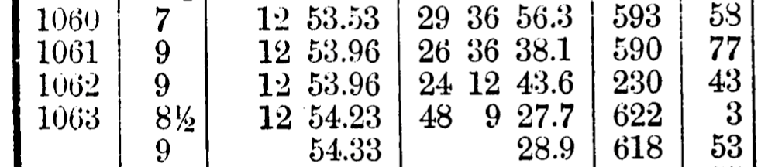
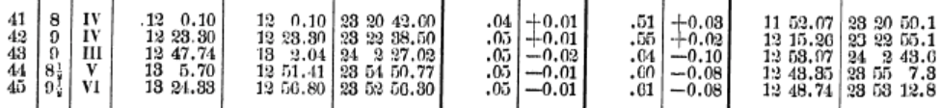

The original observation, also a 9th magnitude star, reveals the following coordinates for epoch 1875.0: 08^{h}12^{m}53^{s}97 -24°02'43''6) which differs in 00^{s}01 in right ascension (negligible) and 10 arcmin in declination, manifesting the typo error. The original observation can indeed be cross-identified with 10th magnitude CD -24°6767 (52 arcsec) and 11th magnitude TYC 6560-648-1 (42 arcsec).

We performed the same work with the second and third entry of the list of [Minniti], but we didn’t find differences between the position of ZC and the original observations (for ZC 08^{h} 1308, 08^{h}15^{m}55^{s}02 -43°59'45''9, mag 9.5, the original observation is in Vol VI, pg. 259, Zone 627, Number 9; for ZC 08^{h} 3084, 08^{h}37^{m}28^{s}91 -31°57'38''9, mag 9.0, the original observation is in Vol V, pg. 489, Zone 609, Number 117, here it just differs in magnitude, being 9.5 in the original register).

Note 6: Errors found in printed versions of other old Catalogs.

- In Yarnall-Frisby USNO printed catalog [U], the star 5990 is identified with OARS 14403 [OARS], however the latter catalog only covers the southern hemisphere. On the other hand, a search in SIMBAD of the star OARN 14403 (14^{h}08^{m}35^{s}90 +57°03'29''4 at epoch 1842.0) gives the star PPM 3440 which is identified to the star 5990, so below it should be corrected to “O. Arg. N. 14403”:
Same mistake happens in star U 9903 identified with OARN 21803, but it should be OARS. Another misidentification happens in star U 8583, identified with BD +19°4170 but it is far from that star and, on the other hand, is very near to BD +19°4070 (PPM 136547). Also, a misidentification occurs with the star U 8888, identified with OARS 20215 (below are the coordinate in both catalogs), whose distance is 710 arcsec:

Here, the USNO star corresponds to PPM 236935 while the OA star corresponds to
PPM 236913 (both identification are within 2 arcsec). Another is U 1121 wrongly cross- matched with OARS 1531, but the correct one is OARS 1551 (note that next star U 1122 is matched with OARS 1554). Same for U 3011 (OARS 7536 → 6536), U 6811 (OARS 16358 → 15358) and U 7541 (Lalande 23418 → 32418).

- In Gilliss printed catalog [G], G 1819 is identified with GC 3450 but the position of this star is too far, outside of the G coverage of the sky. However, G 1819 and GC 3451 corresponds to the same star PPM 376205 (less that 2 arcsec of difference). Same happens for G 11329 misidentified with GC 21512, when the correct one should be GC 21498 (both are PPM 372887), G 11592 misidentified with GC 21922 but the correct is GC 21932 (both are PPM 373015), and G 15240 misidentified with GC 29447 but the correct is GC 29477 (both are PPM 365260).

- A clear misidentification is in G 15367 with is misidentified with ZC 11^{h} 1191, but the former is in 21^{h} of right ascension. By finding, the coordinates of ZC 21^{h} 1191 (given below), we noticed that both stars (G and ZC) are identified with PPM 375168 within 2 arcsec.
Something similar happens with G 5509 and G 5548.

- Another misidentifications (although we don’t be able to establish the correct identification) are the followings: G 3222 is identified with GC 6499, but this star is roughly 1 degree away. However, both stars are identified with (different) PPM stars. Same happens for G 4959 vs. GC 9878, G 5474 vs. GC 12220, G 6538 vs. GC 13472, G 9034 vs. GC 17759, G 9382 vs. GC 18389, and G 10239 vs. GC 18798.
Also G 14324 and G 14338 are identified with the same ZC 19^{h} 2223, but only the latter is near the position of ZC. The only thing we know about G 14324 is that it is in Octantis.

Note 7: Possible historical observation of a Nova.

The star CD -25°12601 (mag. 7.3) was reported as “inexistent” in the paper [Thome1895b]. The same star is also mentioned in [Thome1895a]. A SIMBAD search shows several very dim stars in the neighborhood of the position of CD -25°12601, however V4742 Sgr (also Nova Sgr 2002b) is 83 arcsec. away. The latter was reported to reach 8th. magnitude in 2002. So, there exists a possibility that this Nova were recurrent and Thome had observed it in a previous maximum.
Link about the 2002 discovery: https://www.institutocopernico.org/vs/v4742sgr.php

Bibliography catalogs and papers

[G] Gilliss. A catalogue of 16748 southern stars deduced by the United States Naval Observatory from the zone observations made at Santiago de Chile.

[OARS] OeltzenArgelander's Zonen-Beobachtungen vom 15. bis 31. Grade südlicher Declination, in mittleren Positionen für 1850.0.

[OARN] Oeltzen-Argelander's Zonen-Beobachtungen vom 45. bis 80. Grade noerdlicher Declina-tion in mittleren Positionen für 1842.0.

[U] Yarnall, Frisby. Catalogue of stars observed at the USNO during years 1845 to 1877. 3rd. Ed.

[Thome1895a] Thome. Notes on Variable Stars, AJ 360, 1895.

[Thome1895b] Thome. List of Additional Errors found in the Cordoba Catalogues, AJ 364, 1895.

[Minniti] Minniti Morgan, Estrellas del Cordoba Durchmusterung ausentes:
https://historiadelaastronomia.wordpress.com/wp-content/uploads/2020/12/estrellas_ausentes.pdf

