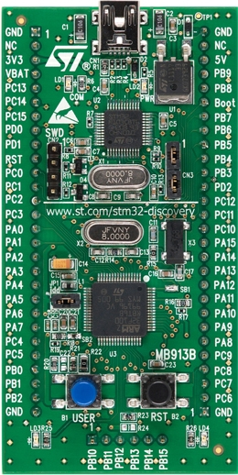

VCC

GND

D7

D6

D4

D5

OBJETO

RELÉ ESTEIRA

E

RW

LED AZUL – PC8

LED VERDE – PC9

PA0 – “SENSOR” OPACO

POT 5K

GND

VCC

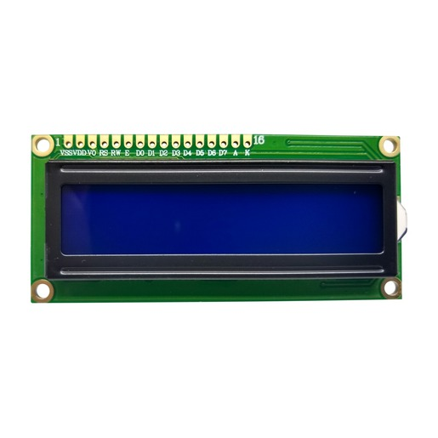

POT 10K

PC5

VCC

PC6

PC7

PC4

PC1

GND

PC0