**Website Structure & Navigation**

* **Text formate :** poppins bold montraz
* **A single page should contain three portions in such a way that it gives a very beautiful visualization when we scroll down .**
  + **Home**

**Title: Intelligent Analytic Solutions for Telecom Networks:**

Empowering telecom networks with end-to-end infrastructure and AI-driven software solutions. Seamlessly install, maintain, and optimize network components for peak performance. Transform data into actionable insights for smarter, more efficient operations.

**Pages in landing page:**

**Building the Future of Telecom: Robust, Reliable, and Ready**

Stay ahead in the telecom industry with cutting-edge, end-to-end hardware solutions designed to power your network's growth. From seamless hardware installation and site maintenance to specialized mobile radio solutions, we ensure your infrastructure is built to perform.

Our expertise installation of mobile radio towers mobile radio containers, and expert consulting to optimize your network. Need to dismantle or reconstruct mobile sites? We handle everything, including safe disposal, ensuring efficiency and sustainability.

Whether expanding your coverage or upgrading existing sites, we provide future-ready, high-performance solutions, so you can focus on delivering seamless, uninterrupted connectivity to your customers.

2. **Transform Your Data with Cutting-Edge End-to-End Analytic Solutions**

Unlock the full potential of your telecom business with our comprehensive software solutions designed to visualize, analyze, and optimize your data effortlessly. We deliver intelligent, AI-powered software architecture that enables seamless data processing and insightful decision-making also for Multi-vendor Network. Whether you're a telecom giant or a growing enterprise, our end-to-end solutions ensure efficiency, scalability, and a competitive edge—helping you turn data into actionable intelligence for smarter business outcomes.  
 **A simple Animation here**

**About Us (Tab)(Place it in 2nd last position)**  
 Founded in 2010 and headquartered in Frankfurt, Germany, we are a leading provider of end-to-end hardware and software solutions for telecom networks across Europe and Africa. With a commitment to innovation and excellence, we specialize in seamless hardware installation, site maintenance, and AI-driven software solutions that empower businesses to visualize, analyze, and optimize their data. Our expertise ensures robust, future-ready infrastructure that drives connectivity and digital transformation. Partner with us for intelligent, scalable, and high-performance solutions tailored to your needs.

**Services (Tab)**

**Seamless Telecom Systems Installation & Multi-Vendor Network Deployment. (Add one or two pictures with text)**

At Inevis, we specialize in comprehensive telecom infrastructure installation, ensuring seamless and future-ready network deployment. Our expertise spans the entire installation process, from site planning and structural design to the construction and setup of mobile radio towers, containers, and transmission networks. With expertise in multi-vendor network deployment, our fully trained installation field teams operate across Europe, delivering high-quality services tailored to diverse network requirements.

We handle antenna installation, commissioning, and integration of all mobile technologies, along with system rollouts, swaps, and upgrades to keep networks at peak performance. Our team also excels in turnkey WLAN and in-building mobile service installations, ensuring optimal coverage in both outdoor and indoor environments. Additionally, we manage the dismantling, reconstruction, and responsible disposal of mobile sites, facilitating smooth network transitions and modernizations.

With a skilled field force capable of deploying multi-vendor solutions, we guarantee the highest industry standards in network performance, scalability, and reliability. Partner with Inevis for a robust, expertly deployed, and future-proof telecom infrastructure—built to support the demands of an ever-evolving digital world.

* + **InVision – Smart Data Monitoring & Troubleshooting by Inevis**

InVision is a cutting-edge software solution developed by Inevis, designed to help telecommunication businesses seamlessly monitor, visualize, and analyze their data through Network probes. Built for telecom companies and enterprises, InVision transforms complex datasets into real-time, actionable insights, ensuring improved network performance, operational efficiency, and resource optimization.

* + With advanced automation, intuitive dashboards, and built-in analytical tools, InVision empowers businesses across Europe and Africa to make faster, smarter, and data-driven decisions. Whether it’s monitoring telecom infrastructure, optimizing network resources, or enhancing digital operations, InVision is your trusted end-to-end data intelligence partner for a more connected and efficient future.

**Footer should look like 450 as discussed**

* + **Satisfied Customers:  
    **      

**Career at Inevis: A picture of career**

**We are hiring:  
Software Developer (Data Visualization & Monitoring)**

Location: Frankfurt, Germany / Remote

Job Type: Full-time

**Responsibilities:**

* Develop and maintain data monitoring and visualization software for telecom networks.
* Work with real-time data processing and analytics to enhance software capabilities.
* Build intuitive dashboards and reporting tools for performance tracking.
* Collaborate with network engineers and data analysts to optimize software solutions.
* Ensure scalability and security in software applications.

**Requirements:**

* Bachelor's/master’s in computer science, Software Engineering, or related field.
* Experience with Python, JavaScript (React), SQL, and cloud platforms.
* Knowledge of data visualization tools like Power BI, Grafana, or Tableau.
* Strong problem-solving skills and ability to work in an agile environment.
* Strong German and English language skills

**Network Engineer (Telecom Infrastructure & Monitoring)  
Location: Frankfurt, Germany / Travel Across Europe & Africa**

**Job Type: Full-time**

**Responsibilities:**

* Install, maintain, and optimize telecommunication network hardware.
* Configure and troubleshoot network performance monitoring systems.
* Ensure seamless integration of hardware and software solutions.
* Conduct site surveys and technical assessments for new projects.
* Work with clients to ensure network reliability and performance.

**Requirements:**

* Bachelor's degree in Telecommunications, Electrical Engineering, or IT.
* Experience with network configuration, routing, and switching.
* Familiarity with 5G, LTE, and fiber-optic network technologies.
* Ability to travel for on-site installations and maintenance.
* Strong English language skills

**Project Manager (Telecom Solutions Deployment)**

**Location: Frankfurt, Germany / Hybrid**

**Job Type: Full-time**

**Responsibilities:**

* Manage end-to-end telecom infrastructure and software deployment projects.
* Coordinate with engineering, software, and operations teams to ensure project success.
* Define project scope, timelines, and deliverables.
* Monitor progress, identify risks, and ensure compliance with telecom standards.
* Act as the primary contact for clients and stakeholders.

**Requirements:**

* Bachelor’s/master’s in engineering, Business, or Project Management.
* Experience in telecom project execution.
* Strong German and English language skills
* Certification in PMP, PRINCE2, or Agile methodologies is a plus.

**Contact form : Email:info@inevis.de   
no phone number**

**Copied from somewhere ,should look something like this.  
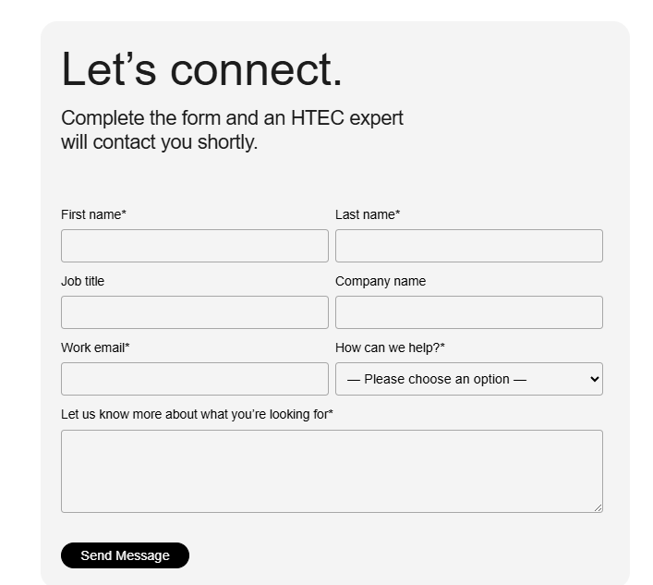**

* + **Legal Information**
  + **Accept cookies.**
  + **theme flow should be same**