Advanced Excel — Exercise Report
  - Week 7 | Python + Advanced Excel | Excel formulas, PivotTables and PivotCharts
This report summarizes the formulas, Excel steps and final results for the three exercises. The screenshots illustrate the finished work.

Exercise 1 | Beetle length classification
Objective: Classify each beetle as Long or Short compared with the overall average, then display an additional message for longer samples.
1. Calculate the average. I used AVERAGE in cell B21 to calculate the mean beetle length from the sample measurements in B4:B20.
=AVERAGE(B4:B20)
2. Classify the samples. In C4, I used IF to compare each length with the average and return Long or Short. The absolute reference $B$21 keeps the comparison fixed when the formula is copied down column C.
=IF(B4>$B$21,"Long","Short")
3. Add the extra comment. In D4, I used another IF formula to display how much a Long sample exceeds the average. ROUND keeps the difference to two decimal places, & combines the number with text, and "" leaves the cell blank for Short samples.
=IF(C4="Long","This sample is "&ROUND(B4-$B$21,2)&" longer than average","")
4. Check the result. The formulas update if a sample length changes. In the final worksheet, B4 is 20.7; the average is shown as 6.7 (about 6.69 internally), and its comment displays a difference of 14.01.
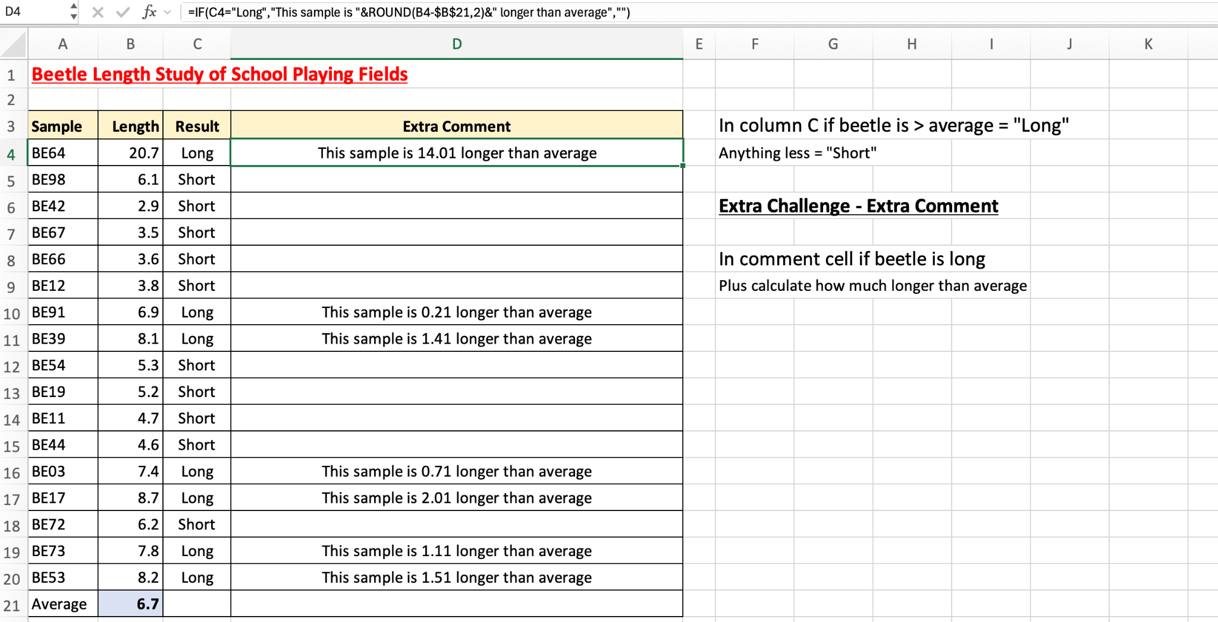
Final beetle classifications and conditional comments.

Exercise 2 | Holiday prices with a PivotTable
Objective: Find the average price of holidays with Plane as the travel method and a resort name beginning with S; confirm the number of matching holidays using drill-down.
1. Create the PivotTable. I selected the holiday dataset and inserted a PivotTable. I placed Resort Name in Rows, Travel Method in Filters and Price in Values.
2. Configure the calculation. In Value Field Settings, I changed Price from Sum to Average to calculate the mean price rather than the total price.
3. Apply both filters. I selected Plane for Travel Method. In the Resort Name row filter, I used Label Filters → Begins With and entered S.
4. Read the filtered results. The PivotTable grouped the two Seville holidays into one row and calculated their average. The Grand Total is based on all three matching holiday records.
Resort | Matching holidays | Average price
Santiago | 1 | £1,259.00
Seville | 2 | £243.50
Grand Total | 3 | £582.00

Calculation: (£1,259 + £199 + £288) ÷ 3 = £582. The screenshot rounds Seville’s displayed average to £244.
5. Confirm with drill-down. I double-clicked the PivotTable Grand Total to open the supporting records in a separate sheet. It showed exactly three holidays: one to Santiago and two to Seville.
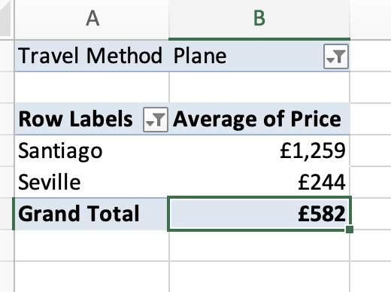 | 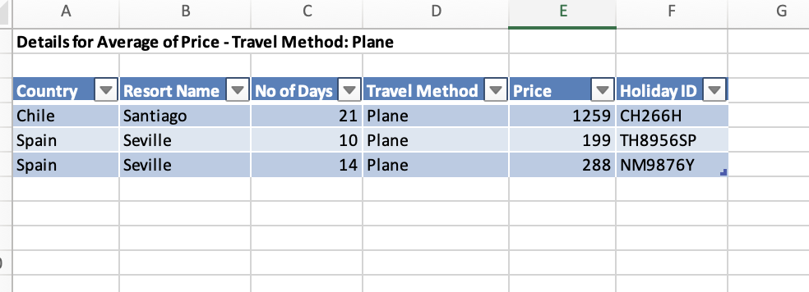
Filtered PivotTable (left) and the three drill-down records (right).
6. Save. I saved the completed analysis workbook with the PivotTable and the drill-down sheet.

Exercise 3 | Oscar nominations PivotChart
Objective: Display the average number of Oscar nominations by film certificate and use an interactive Genre slicer to filter the analysis.
1. Insert the PivotChart. I selected the movie dataset and used Insert → PivotChart. Excel created a linked PivotTable and chart, which I configured together.
2. Arrange the fields. I placed Certificate in Rows and Nominations in Values, then selected Average under Value Field Settings. The Genre field is available as a filter.
3. Format the visualization. I used a column chart to compare average nominations across certificate categories and titled it “Average Oscar Nominations by Film Certificate”. I displayed the table values to two decimal places.
4. Make it interactive. I inserted a slicer for Genre. Selecting a genre filters the linked PivotTable and its chart; clearing the slicer returns to the all-genres view.
5. Review the result. With all genres shown, the overall average is 1.84 nominations per film. The PivotTable and the chart display the same averages for each certificate.
Certificate | Avg. nominations
12 | 1.60
15 | 1.70
18 | 1.41
12A | 1.27
PG | 2.16
U | 3.16
Unknown | 0.00
All certificates | 1.84

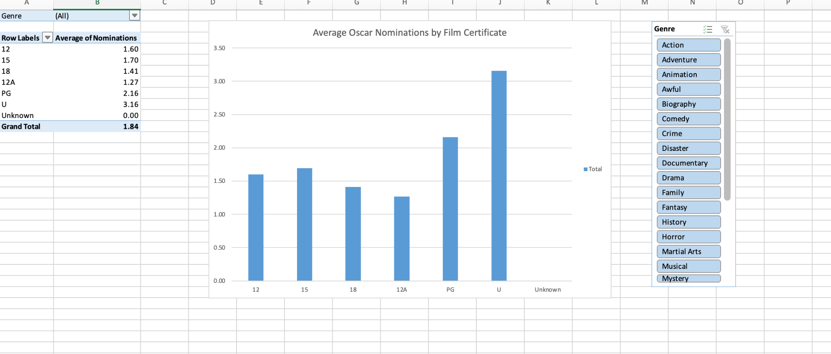
Final PivotTable, PivotChart and Genre slicer (all genres displayed).

