# Biometry / Homework 2 / Auriel Fournier / March 6, 2014

This is an R Markdown document. It allows me to write up my thoughts and also include the R script and outputs in one html document so that others can see exactly what I did, without having to open up R. It also allows for completely reproduceable homework if you do run the .Rmd document yourself.

So first we have to set the working directory and get all the required packages loaded

# When working on my mac  
  
# setwd('~/Dropbox/R/Biometry_HW_2')  
  
# when working on my desktop at school  
setwd("C:/Users/avanderlaar/Dropbox/R/Biometry_HW_2")

## Error: cannot change working directory

library(lattice)  
library(ggplot2)  
library(sciplot)  
library(psych)

Then we import the data. In this case I've take the data I was given for this assignment and saved it as a .csv file.

fish <- read.csv("Biometry_HW_2.csv", header = TRUE)

First we want to check and make sure the data imported correctly and also take a look at it and see what is included.

The head() command shows the first 6 rows of each column

head(fish)

## DATE SEASON SEASNUM STREAM STREAMNUM STREAMTYPE REACH HABITAT V_NAME_  
## 1 37718 April 4 Falling 3 1 1 Run PopEst  
## 2 37718 April 4 Falling 3 1 2 Riffle PopEst  
## 3 37718 April 4 Falling 3 1 3 Pool PopEst  
## 4 37718 April 4 Falling 3 1 4 Riffle PopEst  
## 5 37718 April 4 Falling 3 1 5 Pool PopEst  
## 6 37718 April 4 Falling 3 1 6 Run PopEst  
## V_LABEL_ ALL CRC CSR DSS GSD LES NHS OTD OZM RBD SLM WTS BDS GSF HHC SMB  
## 1 PopEst 94 1 17 34 24 0 0 1 0 8 0 0 0 0 0 0  
## 2 PopEst 42 1 22 0 1 0 0 4 0 4 5 0 0 0 0 0  
## 3 PopEst 88 3 43 14 1 0 4 0 2 2 18 5 0 0 0 0  
## 4 PopEst 156 20 67 1 7 0 0 16 0 16 15 0 0 0 0 0  
## 5 PopEst 25 0 11 2 2 1 0 1 3 0 5 0 0 0 0 0  
## 6 PopEst 47 0 32 21 3 0 0 2 0 0 1 0 0 0 0 0  
## SRD STD AMM OZB BTM FTD NSF TSS RH BLG BES CKM TEMP DO PH SPC  
## 1 0 0 0 0 0 0 0 0 0 0 0 0 9.585 0.91 6.17 15.35  
## 2 0 0 0 0 0 0 0 0 0 0 0 0 9.585 0.91 6.17 15.35  
## 3 0 0 0 0 0 0 0 0 0 0 0 0 9.585 0.91 6.17 15.35  
## 4 0 0 0 0 0 0 0 0 0 0 0 0 9.585 0.91 6.17 15.35  
## 5 0 0 0 0 0 0 0 0 0 0 0 0 9.585 0.91 6.17 15.35  
## 6 0 0 0 0 0 0 0 0 0 0 0 0 9.585 0.91 6.17 15.35  
## LENGTH COVER AREA WIDTH CANOPY DEPTH VELOCITY SUBSTRATE VOLUME  
## 1 26.1 25 128.4 4.920 50.00 17.00 15.867 5.267 21.83  
## 2 11.7 60 125.2 10.700 106.67 11.33 8.556 4.444 14.19  
## 3 42.0 15 359.4 8.557 49.29 46.57 3.762 5.524 167.38  
## 4 67.6 80 535.4 7.920 64.00 15.13 12.433 4.167 81.02  
## 5 22.3 8 193.1 8.660 83.00 47.20 1.267 5.200 91.15  
## 6 23.8 15 123.2 5.175 90.00 27.83 4.417 4.750 34.28  
## TOTDENVOL COVERASN CANOPYASN TOTDENAREA TOTDNARLOG TOTNUMLOG VOLLOG  
## 1 4.3060 14.485 30.02 0.7320 0.23855 1.973 1.339  
## 2 2.9602 36.889 NA 0.3355 0.12564 1.623 1.152  
## 3 0.5258 8.631 29.54 0.2449 0.09512 1.944 2.224  
## 4 1.9254 53.157 39.81 0.2914 0.11105 2.193 1.909  
## 5 0.2743 4.591 56.13 0.1295 0.05287 1.398 1.960  
## 6 1.3710 8.631 64.19 0.3816 0.14038 1.672 1.535  
## TOTDENVOLLOG RICHNESS VELOCITYLOG DEPTHLOG SUBSTRATELOG CSRDNVOL  
## 1 0.7248 6 1.2270 1.255 0.7970 0.7787  
## 2 0.5977 6 0.9803 1.091 0.7360 1.5506  
## 3 0.1835 9 0.6778 1.677 0.8145 0.2569  
## 4 0.4662 7 1.1282 1.208 0.7132 0.8269  
## 5 0.1053 7 0.3554 1.683 0.7924 0.1207  
## 6 0.3749 5 0.7337 1.460 0.7597 0.9335  
## CSRDNVOLLOG CANOPYLOG COVERLOG OTDRBD OTDRBDDEN OTDRBDDNLOG  
## 1 0.25011 1.699 1.3979 9 0.41228 0.149920  
## 2 0.40664 2.028 1.7782 8 0.56385 0.194195  
## 3 0.09930 1.693 1.1761 2 0.01195 0.005159  
## 4 0.26172 1.806 1.9031 32 0.39495 0.144559  
## 5 0.04948 1.919 0.9031 1 0.01097 0.004739  
## 6 0.28634 1.954 1.1761 2 0.05834 0.024626

Then you always want to check the structure of the data, to make sure that all the variables were imported as the right kind of data

str(fish)

## 'data.frame': 150 obs. of 70 variables:  
## $ DATE : int 37718 37718 37718 37718 37718 37718 37718 37719 37719 37719 ...  
## $ SEASON : Factor w/ 4 levels "April","August",..: 1 1 1 1 1 1 1 1 1 1 ...  
## $ SEASNUM : int 4 4 4 4 4 4 4 4 4 4 ...  
## $ STREAM : Factor w/ 6 levels "Bear","Cave",..: 3 3 3 3 3 3 3 2 2 2 ...  
## $ STREAMNUM : int 3 3 3 3 3 3 3 2 2 2 ...  
## $ STREAMTYPE : int 1 1 1 1 1 1 1 1 1 1 ...  
## $ REACH : int 1 2 3 4 5 6 7 1 2 3 ...  
## $ HABITAT : Factor w/ 3 levels "Pool","Riffle",..: 3 2 1 2 1 3 2 3 2 1 ...  
## $ V_NAME_ : Factor w/ 1 level "PopEst": 1 1 1 1 1 1 1 1 1 1 ...  
## $ V_LABEL_ : Factor w/ 1 level "PopEst": 1 1 1 1 1 1 1 1 1 1 ...  
## $ ALL : int 94 42 88 156 25 47 44 848 507 225 ...  
## $ CRC : int 1 1 3 20 0 0 1 77 15 25 ...  
## $ CSR : int 17 22 43 67 11 32 19 395 217 101 ...  
## $ DSS : int 34 0 14 1 2 21 0 8 0 0 ...  
## $ GSD : int 24 1 1 7 2 3 1 0 0 0 ...  
## $ LES : int 0 0 0 0 1 0 1 0 0 0 ...  
## $ NHS : int 0 0 4 0 0 0 0 3 1 0 ...  
## $ OTD : int 1 4 0 16 1 2 12 0 112 4 ...  
## $ OZM : int 0 0 2 0 3 0 0 0 0 0 ...  
## $ RBD : int 8 4 2 16 0 0 4 18 14 0 ...  
## $ SLM : int 0 5 18 15 5 1 3 8 6 0 ...  
## $ WTS : int 0 0 5 0 0 0 0 0 0 0 ...  
## $ BDS : int 0 0 0 0 0 0 0 0 3 0 ...  
## $ GSF : int 0 0 0 0 0 0 0 0 0 2 ...  
## $ HHC : int 0 0 0 0 0 0 0 4 1 2 ...  
## $ SMB : int 0 0 0 0 0 0 0 0 0 2 ...  
## $ SRD : int 0 0 0 0 0 0 0 237 138 87 ...  
## $ STD : int 0 0 0 0 0 0 0 3 6 0 ...  
## $ AMM : int 0 0 0 0 0 0 0 0 0 0 ...  
## $ OZB : int 0 0 0 0 0 0 0 0 0 0 ...  
## $ BTM : int 0 0 0 0 0 0 0 0 0 0 ...  
## $ FTD : int 0 0 0 0 0 0 0 0 0 0 ...  
## $ NSF : int 0 0 0 0 0 0 0 0 0 0 ...  
## $ TSS : int 0 0 0 0 0 0 0 0 0 0 ...  
## $ RH : int 0 0 0 0 0 0 0 0 0 0 ...  
## $ BLG : int 0 0 0 0 0 0 0 0 0 0 ...  
## $ BES : int 0 0 0 0 0 0 0 0 0 0 ...  
## $ CKM : int 0 0 0 0 0 0 0 0 0 0 ...  
## $ TEMP : num 9.59 9.59 9.59 9.59 9.59 ...  
## $ DO : num 0.91 0.91 0.91 0.91 0.91 0.91 0.91 0.985 0.985 0.985 ...  
## $ PH : num 6.17 6.17 6.17 6.17 6.17 ...  
## $ SPC : num 15.3 15.3 15.3 15.3 15.3 ...  
## $ LENGTH : num 26.1 11.7 42 67.6 22.3 23.8 20.8 26.5 112 30.8 ...  
## $ COVER : int 25 60 15 80 8 15 75 65 75 15 ...  
## $ AREA : num 128 125 359 535 193 ...  
## $ WIDTH : num 4.92 10.7 8.56 7.92 8.66 ...  
## $ CANOPY : num 50 106.7 49.3 64 83 ...  
## $ DEPTH : num 17 11.3 46.6 15.1 47.2 ...  
## $ VELOCITY : num 15.87 8.56 3.76 12.43 1.27 ...  
## $ SUBSTRATE : num 5.27 4.44 5.52 4.17 5.2 ...  
## $ VOLUME : num 21.8 14.2 167.4 81 91.2 ...  
## $ TOTDENVOL : num 4.306 2.96 0.526 1.925 0.274 ...  
## $ COVERASN : num 14.48 36.89 8.63 53.16 4.59 ...  
## $ CANOPYASN : num 30 NA 29.5 39.8 56.1 ...  
## $ TOTDENAREA : num 0.732 0.335 0.245 0.291 0.129 ...  
## $ TOTDNARLOG : num 0.2386 0.1256 0.0951 0.1111 0.0529 ...  
## $ TOTNUMLOG : num 1.97 1.62 1.94 2.19 1.4 ...  
## $ VOLLOG : num 1.34 1.15 2.22 1.91 1.96 ...  
## $ TOTDENVOLLOG: num 0.725 0.598 0.183 0.466 0.105 ...  
## $ RICHNESS : int 6 6 9 7 7 5 7 9 10 7 ...  
## $ VELOCITYLOG : num 1.227 0.98 0.678 1.128 0.355 ...  
## $ DEPTHLOG : num 1.26 1.09 1.68 1.21 1.68 ...  
## $ SUBSTRATELOG: num 0.797 0.736 0.815 0.713 0.792 ...  
## $ CSRDNVOL : num 0.779 1.551 0.257 0.827 0.121 ...  
## $ CSRDNVOLLOG : num 0.2501 0.4066 0.0993 0.2617 0.0495 ...  
## $ CANOPYLOG : num 1.7 2.03 1.69 1.81 1.92 ...  
## $ COVERLOG : num 1.398 1.778 1.176 1.903 0.903 ...  
## $ OTDRBD : int 9 8 2 32 1 2 16 18 126 4 ...  
## $ OTDRBDDEN : num 0.4123 0.5638 0.0119 0.395 0.011 ...  
## $ OTDRBDDNLOG : num 0.14992 0.19419 0.00516 0.14456 0.00474 ...

Then you often want to look at the very basic stats of each variable, and you can do that via this command

summary(fish)

## DATE SEASON SEASNUM STREAM STREAMNUM   
## Min. :37718 April :36 Min. : 4.00 Bear :27 Min. :1.00   
## 1st Qu.:37775 August :38 1st Qu.: 6.00 Cave :18 1st Qu.:2.00   
## Median :37783 June :41 Median : 6.00 Falling :28 Median :4.00   
## Mean :37807 October:35 Mean : 6.96 Sylamore:19 Mean :3.59   
## 3rd Qu.:37846 3rd Qu.: 8.00 Tomahawk:33 3rd Qu.:5.00   
## Max. :37899 Max. :10.00 Water :25 Max. :6.00   
##   
## STREAMTYPE REACH HABITAT V_NAME_ V_LABEL_   
## Min. :1.00 Min. :1.00 Pool :46 PopEst:150 PopEst:150   
## 1st Qu.:1.00 1st Qu.:2.00 Riffle:58   
## Median :2.00 Median :4.00 Run :46   
## Mean :1.51 Mean :3.79   
## 3rd Qu.:2.00 3rd Qu.:5.00   
## Max. :2.00 Max. :9.00   
##   
## ALL CRC CSR DSS   
## Min. : 4.0 Min. : 0.00 Min. : 0.0 Min. : 0.0   
## 1st Qu.: 79.5 1st Qu.: 0.00 1st Qu.: 10.2 1st Qu.: 1.0   
## Median :137.5 Median : 0.00 Median : 41.0 Median : 8.0   
## Mean :178.7 Mean : 6.91 Mean : 77.7 Mean :12.1   
## 3rd Qu.:234.8 3rd Qu.: 7.00 3rd Qu.:101.8 3rd Qu.:17.0   
## Max. :883.0 Max. :86.00 Max. :395.0 Max. :80.0   
##   
## GSD LES NHS OTD   
## Min. : 0.00 Min. : 0.000 Min. :0.00 Min. : 0.0   
## 1st Qu.: 0.00 1st Qu.: 0.000 1st Qu.:0.00 1st Qu.: 1.0   
## Median : 0.00 Median : 0.000 Median :0.00 Median : 6.0   
## Mean : 1.37 Mean : 0.727 Mean :0.26 Mean : 14.2   
## 3rd Qu.: 1.00 3rd Qu.: 0.000 3rd Qu.:0.00 3rd Qu.: 17.0   
## Max. :36.00 Max. :22.000 Max. :4.00 Max. :195.0   
##   
## OZM RBD SLM WTS   
## Min. : 0.000 Min. : 0.00 Min. : 0.00 Min. : 0.00   
## 1st Qu.: 0.000 1st Qu.: 0.00 1st Qu.: 0.00 1st Qu.: 0.00   
## Median : 0.000 Median : 0.00 Median : 1.00 Median : 0.00   
## Mean : 0.967 Mean : 3.53 Mean : 2.51 Mean : 1.19   
## 3rd Qu.: 0.000 3rd Qu.: 3.00 3rd Qu.: 3.00 3rd Qu.: 0.00   
## Max. :30.000 Max. :51.00 Max. :28.00 Max. :23.00   
##   
## BDS GSF HHC SMB   
## Min. : 0.00 Min. : 0.000 Min. : 0.00 Min. :0.000   
## 1st Qu.: 0.00 1st Qu.: 0.000 1st Qu.: 0.00 1st Qu.:0.000   
## Median : 2.00 Median : 0.000 Median : 1.00 Median :0.000   
## Mean : 7.11 Mean : 0.393 Mean : 2.38 Mean :0.373   
## 3rd Qu.:11.75 3rd Qu.: 0.000 3rd Qu.: 3.00 3rd Qu.:0.000   
## Max. :81.00 Max. :21.000 Max. :21.00 Max. :8.000   
##   
## SRD STD AMM OZB   
## Min. : 0.0 Min. : 0.00 Min. :0.000 Min. :0.000   
## 1st Qu.: 0.0 1st Qu.: 0.00 1st Qu.:0.000 1st Qu.:0.000   
## Median : 9.0 Median : 0.00 Median :0.000 Median :0.000   
## Mean : 39.7 Mean : 0.66 Mean :0.327 Mean :0.327   
## 3rd Qu.: 59.8 3rd Qu.: 0.00 3rd Qu.:0.000 3rd Qu.:0.000   
## Max. :302.0 Max. :20.00 Max. :5.000 Max. :7.000   
##   
## BTM FTD NSF TSS   
## Min. :0.000 Min. : 0.00 Min. :0.00 Min. :0.000   
## 1st Qu.:0.000 1st Qu.: 0.00 1st Qu.:0.00 1st Qu.:0.000   
## Median :0.000 Median : 0.00 Median :0.00 Median :0.000   
## Mean :0.193 Mean : 1.18 Mean :0.22 Mean :0.087   
## 3rd Qu.:0.000 3rd Qu.: 0.00 3rd Qu.:0.00 3rd Qu.:0.000   
## Max. :7.000 Max. :67.00 Max. :7.00 Max. :5.000   
##   
## RH BLG BES CKM   
## Min. :0.000 Min. :0.0000 Min. :0.00 Min. :0.0000   
## 1st Qu.:0.000 1st Qu.:0.0000 1st Qu.:0.00 1st Qu.:0.0000   
## Median :0.000 Median :0.0000 Median :0.00 Median :0.0000   
## Mean :0.073 Mean :0.0667 Mean :0.02 Mean :0.0133   
## 3rd Qu.:0.000 3rd Qu.:0.0000 3rd Qu.:0.00 3rd Qu.:0.0000   
## Max. :5.000 Max. :3.0000 Max. :1.00 Max. :2.0000   
##   
## TEMP DO PH SPC   
## Min. : 9.01 Min. :0.52 Min. :6.17 Min. : 15.3   
## 1st Qu.:14.81 1st Qu.:0.77 1st Qu.:6.62 1st Qu.: 32.9   
## Median :17.44 Median :0.88 Median :7.46 Median :269.8   
## Mean :17.10 Mean :0.86 Mean :7.24 Mean :195.6   
## 3rd Qu.:19.32 3rd Qu.:0.98 3rd Qu.:7.77 3rd Qu.:359.4   
## Max. :29.35 Max. :1.09 Max. :7.98 Max. :404.8   
## NA's :57 NA's :57 NA's :57 NA's :57   
## LENGTH COVER AREA WIDTH   
## Min. : 11.3 Min. : 1.0 Min. : 41.9 Min. : 2.08   
## 1st Qu.: 19.6 1st Qu.:11.5 1st Qu.: 104.9 1st Qu.: 4.91   
## Median : 25.8 Median :20.0 Median : 158.1 Median : 6.15   
## Mean : 32.0 Mean :27.1 Mean : 211.4 Mean : 6.46   
## 3rd Qu.: 38.3 3rd Qu.:35.0 3rd Qu.: 276.2 3rd Qu.: 7.96   
## Max. :112.0 Max. :90.0 Max. :1201.8 Max. :16.40   
## NA's :18   
## CANOPY DEPTH VELOCITY SUBSTRATE   
## Min. : 10.0 Min. : 1.56 Min. : 0.000 Min. :3.17   
## 1st Qu.: 35.0 1st Qu.:11.42 1st Qu.: 0.667 1st Qu.:3.86   
## Median : 43.9 Median :17.41 Median : 2.185 Median :4.22   
## Mean : 45.6 Mean :20.64 Mean : 4.118 Mean :4.32   
## 3rd Qu.: 55.0 3rd Qu.:25.90 3rd Qu.: 6.095 3rd Qu.:4.75   
## Max. :106.7 Max. :80.24 Max. :23.500 Max. :5.75   
## NA's :23   
## VOLUME TOTDENVOL COVERASN CANOPYASN   
## Min. : 1.02 Min. : 0.24 Min. : 0.57 Min. : 5.74   
## 1st Qu.: 15.98 1st Qu.: 2.51 1st Qu.: 6.61 1st Qu.:20.50   
## Median : 30.32 Median : 4.15 Median :11.54 Median :26.00   
## Mean : 47.25 Mean : 6.97 Mean :16.36 Mean :27.61   
## 3rd Qu.: 57.41 3rd Qu.: 8.45 3rd Qu.:20.50 3rd Qu.:33.29   
## Max. :308.36 Max. :47.03 Max. :64.19 Max. :69.00   
## NA's :18 NA's :24   
## TOTDENAREA TOTDNARLOG TOTNUMLOG VOLLOG   
## Min. :0.061 Min. :0.0257 Min. :0.602 Min. :0.0096   
## 1st Qu.:0.385 1st Qu.:0.1415 1st Qu.:1.900 1st Qu.:1.2034   
## Median :0.783 Median :0.2512 Median :2.138 Median :1.4817   
## Mean :1.062 Mean :0.2780 Mean :2.095 Mean :1.4593   
## 3rd Qu.:1.385 3rd Qu.:0.3776 3rd Qu.:2.371 3rd Qu.:1.7590   
## Max. :7.799 Max. :0.9444 Max. :2.946 Max. :2.4891   
##   
## TOTDENVOLLOG RICHNESS VELOCITYLOG DEPTHLOG   
## Min. :0.0938 Min. : 1.00 Min. :0.000 Min. :0.407   
## 1st Qu.:0.5457 1st Qu.: 6.25 1st Qu.:0.222 1st Qu.:1.094   
## Median :0.7118 Median : 8.00 Median :0.503 Median :1.265   
## Mean :0.7615 Mean : 7.91 Mean :0.540 Mean :1.262   
## 3rd Qu.:0.9754 3rd Qu.: 9.00 3rd Qu.:0.851 3rd Qu.:1.430   
## Max. :1.6815 Max. :14.00 Max. :1.389 Max. :1.910   
##   
## SUBSTRATELOG CSRDNVOL CSRDNVOLLOG CANOPYLOG   
## Min. :0.620 Min. : 0.000 Min. :0.000 Min. :1.00   
## 1st Qu.:0.687 1st Qu.: 0.428 1st Qu.:0.155 1st Qu.:1.54   
## Median :0.718 Median : 1.096 Median :0.321 Median :1.64   
## Mean :0.723 Mean : 2.669 Mean :0.401 Mean :1.62   
## 3rd Qu.:0.760 3rd Qu.: 2.670 3rd Qu.:0.565 3rd Qu.:1.74   
## Max. :0.829 Max. :29.652 Max. :1.486 Max. :2.03   
## NA's :23   
## COVERLOG OTDRBD OTDRBDDEN OTDRBDDNLOG   
## Min. :0.00 Min. : 0.0 Min. : 0.000 Min. :0.0000   
## 1st Qu.:1.06 1st Qu.: 5.0 1st Qu.: 0.142 1st Qu.:0.0575   
## Median :1.30 Median : 10.0 Median : 0.400 Median :0.1462   
## Mean :1.30 Mean : 17.8 Mean : 0.877 Mean :0.2018   
## 3rd Qu.:1.54 3rd Qu.: 24.0 3rd Qu.: 0.806 3rd Qu.:0.2568   
## Max. :1.95 Max. :211.0 Max. :10.511 Max. :1.0611   
## NA's :18

This provides summary stats by group

SEASON

describeBy(fish$TOTDENVOL, group = fish$SEASNUM)

## group: 4  
## vars n mean sd median trimmed mad min max range skew kurtosis  
## 1 1 36 5.51 7.64 3.09 4.13 2.51 0.27 43.44 43.17 3.51 14.21  
## se  
## 1 1.27  
## --------------------------------------------------------   
## group: 6  
## vars n mean sd median trimmed mad min max range skew kurtosis se  
## 1 1 41 4.71 3.34 3.56 4.35 2.4 0.24 15.94 15.7 1.13 1.29 0.52  
## --------------------------------------------------------   
## group: 8  
## vars n mean sd median trimmed mad min max range skew kurtosis  
## 1 1 38 9.29 6.89 7.9 8.55 5.99 0.49 29.28 28.8 1.03 0.62  
## se  
## 1 1.12  
## --------------------------------------------------------   
## group: 10  
## vars n mean sd median trimmed mad min max range skew kurtosis  
## 1 1 35 8.61 11.05 3.61 6.29 2.7 1.17 47.03 45.87 2.03 3.38  
## se  
## 1 1.87

Stream Type

describeBy(fish$TOTDENVOL, group = fish$STREAMTYPE)

## group: 1  
## vars n mean sd median trimmed mad min max range skew kurtosis  
## 1 1 73 7.27 8.69 3.91 5.51 3.66 0.24 47.03 46.79 2.42 6.61  
## se  
## 1 1.02  
## --------------------------------------------------------   
## group: 2  
## vars n mean sd median trimmed mad min max range skew kurtosis  
## 1 1 77 6.7 6.82 5.05 5.48 4.49 0.37 43.44 43.07 2.84 10.7  
## se  
## 1 0.78

# Graphical Examination

## Box Plots

plot(fish$TOTDENVOL ~ as.factor(fish$SEASNUM), ylab = "Fish Density", xlab = "Season")

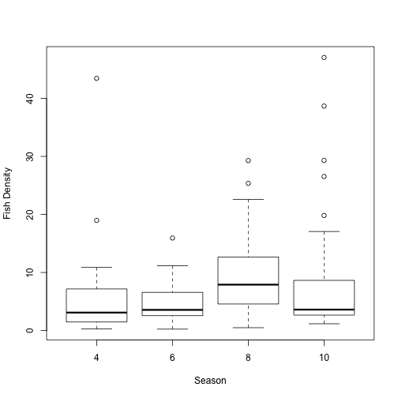

plot of chunk unnamed-chunk-8

### Figure 1

png(filename = "seasonbox.png")  
plot(fish$TOTDENVOL ~ as.factor(fish$SEASNUM), ylab = "Fish Density", xlab = "Season")  
dev.off()

## pdf   
## 2

plot(fish$TOTDENVOL ~ as.factor(fish$STREAMTYPE), ylab = "Fish Density", xlab = "Stream Type")

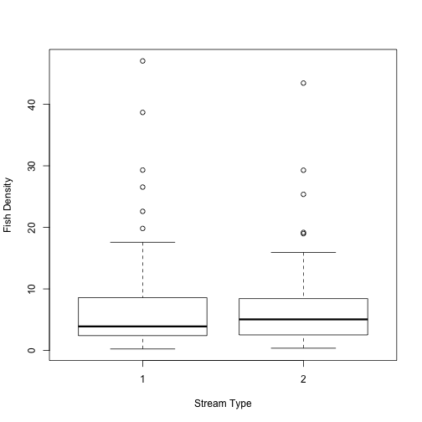

plot of chunk unnamed-chunk-10

### Figure 2

png(filename = "streambox.png")  
plot(fish$TOTDENVOL ~ as.factor(fish$STREAMTYPE), ylab = "Fish Density", xlab = "Stream Type")  
dev.off()

## pdf   
## 2

## Histograms

histogram(~TOTDENVOL | SEASNUM, fish, xlab = "Fish Density")

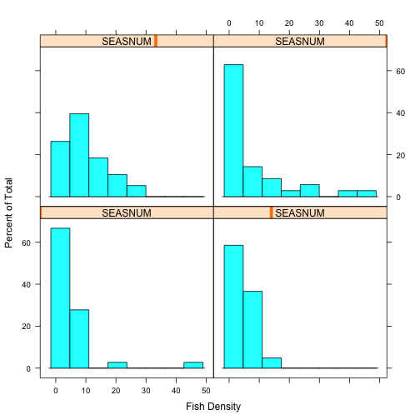

plot of chunk unnamed-chunk-12

### Figure 3

png(filename = "seasonhist.png")  
histogram(~TOTDENVOL | SEASNUM, fish, xlab = "Fish Density")  
dev.off()

## pdf   
## 2

histogram(~TOTDENVOL | STREAMTYPE, fish, xlab = "Fish Density")

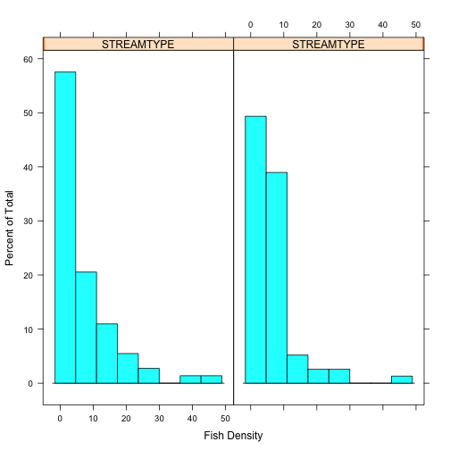

plot of chunk unnamed-chunk-14

### Figure 4

png(filename = "streamhist.png")  
histogram(~TOTDENVOL | STREAMTYPE, fish, xlab = "Fish Density")  
dev.off()

## pdf   
## 2

## Square-root Transformation

fish[, 71] = sqrt(fish$TOTDENVOL)

## Bar Plots

plot(fish$V71 ~ as.factor(fish$SEASNUM), ylab = "Fish Density", xlab = "Season")

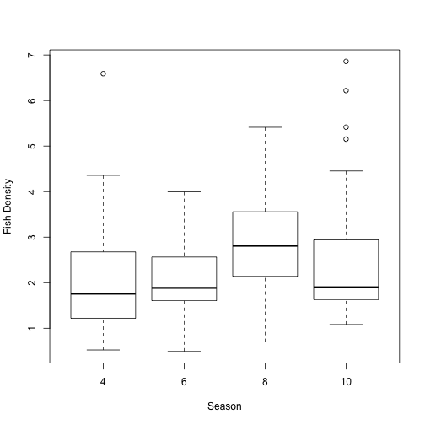

plot of chunk unnamed-chunk-17

### Figure 5

png(filename = "squareboxseason.png")  
plot(fish$V71 ~ as.factor(fish$SEASNUM), ylab = "Fish Density", xlab = "Season")  
dev.off()

## pdf   
## 2

plot(fish$V71 ~ as.factor(fish$STREAMTYPE), ylab = "Fish Density", xlab = "Stream Type")

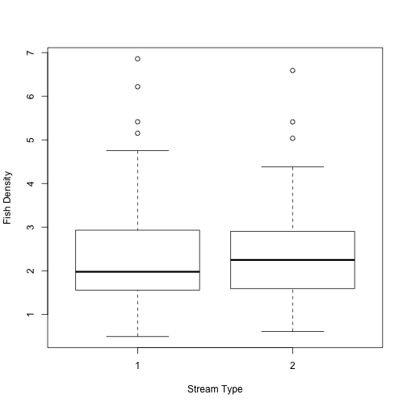

plot of chunk unnamed-chunk-19

### Figure 6

png(filename = "squareboxstream.png")  
plot(fish$V71 ~ as.factor(fish$STREAMTYPE), ylab = "Fish Density", xlab = "Stream Type")  
dev.off()

## pdf   
## 2

## Histograms

histogram(~V71 | SEASNUM, fish, xlab = "Fish Density")

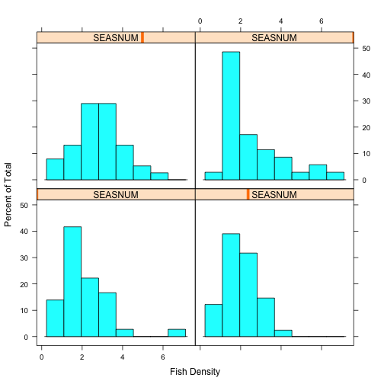

plot of chunk unnamed-chunk-21

### Figure 7

png(filename = "squareseasonhist.png")  
histogram(~V71 | SEASNUM, fish, xlab = "Fish Density")  
dev.off()

## pdf   
## 2

histogram(~V71 | STREAMTYPE, fish, xlab = "Fish Density")

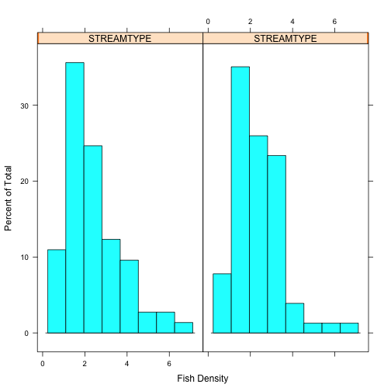

plot of chunk unnamed-chunk-23

### Figure 8

png(filename = "squarestreamhist.png")  
histogram(~V71 | STREAMTYPE, fish, xlab = "Fish Density")  
dev.off()

## pdf   
## 2

## 4th-root transformation

fish[, 72] = fish$V71^(1/4)

## Bar Plot

plot(fish$V72 ~ as.factor(fish$SEASNUM), ylab = "Fish Density", xlab = "Season")

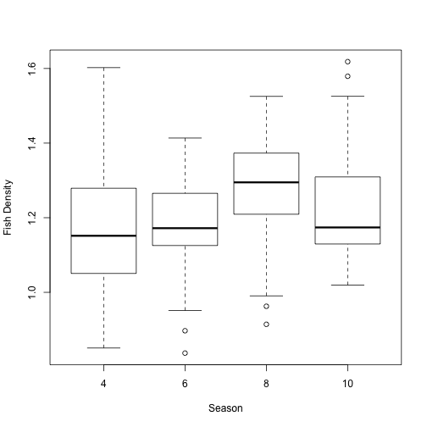

plot of chunk unnamed-chunk-26

### Figure 9

png(filename = "fourboxseason.png")  
plot(fish$V72 ~ as.factor(fish$SEASNUM), ylab = "Fish Density", xlab = "Season")  
dev.off()

## pdf   
## 2

plot(fish$V72 ~ as.factor(fish$STREAMTYPE), ylab = "Fish Density", xlab = "Stream Type")

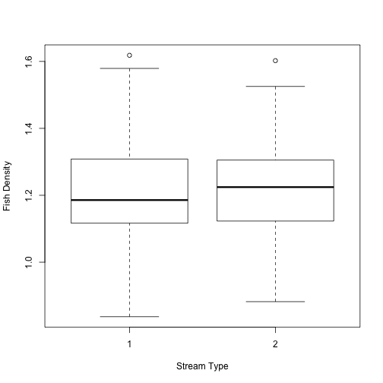

plot of chunk unnamed-chunk-28

### Figure 10

png(filename = "fourboxstream.png")  
plot(fish$V72 ~ as.factor(fish$STREAMTYPE), ylab = "Fish Density", xlab = "Stream Type")  
dev.off()

## pdf   
## 2

## Histogram

histogram(~V72 | SEASNUM, fish, xlab = "Fish Density")

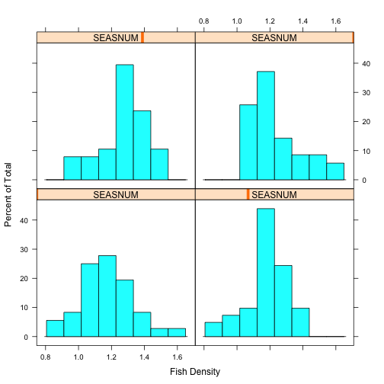

plot of chunk unnamed-chunk-30

### Figure 11

png(filename = "fourhistseason.png")  
histogram(~V72 | SEASNUM, fish, xlab = "Fish Density")  
dev.off()

## pdf   
## 2

histogram(~V72 | STREAMTYPE, fish, xlab = "Fish Density")

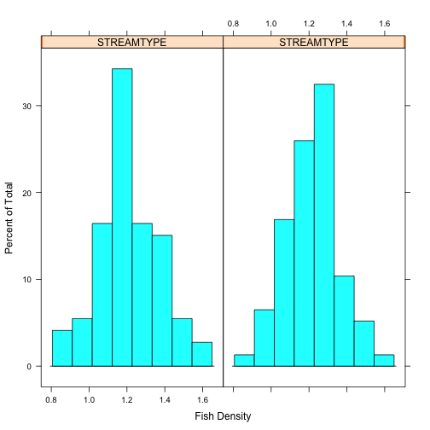

plot of chunk unnamed-chunk-32

### Figure 12

png(filename = "fourhiststream.png")  
histogram(~V72 | STREAMTYPE, fish, xlab = "Fish Density")  
dev.off()

## pdf   
## 2

# Two-Way ANOVA

Two-Way ANOVA on our data looking at the interaction between season and stream type with our fourth-root transformed fish density variable as the response

options(contrasts = c("contr.sum", "contr.poly"))  
model <- lm(V72 ~ STREAMTYPE * SEASNUM, data = fish)  
anova_two <- anova(model)

layout(matrix(c(1, 2, 3, 4), 2, 2))  
plot(model)

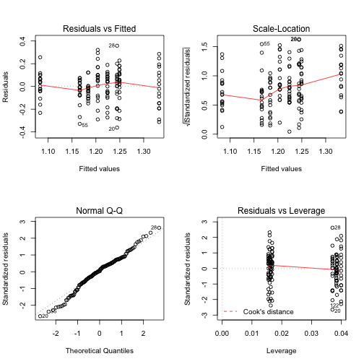

plot of chunk unnamed-chunk-35

### Figure 13

png(filename = "TwoANOVA.png")  
layout(matrix(c(1, 2, 3, 4), 2, 2))  
plot(model)  
dev.off()

## pdf   
## 2

### Table 1

print(anova_two)

## Analysis of Variance Table  
##   
## Response: V72  
## Df Sum Sq Mean Sq F value Pr(>F)   
## STREAMTYPE 1 0.003 0.003 0.14 0.7136   
## SEASNUM 1 0.168 0.168 8.64 0.0038 **   
## STREAMTYPE:SEASNUM 1 0.477 0.477 24.59 1.9e-06 ***  
## Residuals 146 2.832 0.019   
## ---  
## Signif. codes: 0 '***' 0.001 '**' 0.01 '*' 0.05 '.' 0.1 ' ' 1

## Residual Plot

fish.df <- data.frame(M1_Fit = seq(0, 0, length = 150), M1_Resid = seq(0, 0,   
 length = 150), Season = seq(0, 0, length = 150), Stream = seq(0, 0, length = 150))  
  
fish.resid = resid(model)  
fish.fitted = fitted(model)  
  
fish.df$M1_Fit = fish.fitted  
fish.df$M1_Resid = fish.resid  
fish.df$Season = fish$SEASNUM  
fish.df$Stream = fish$STREAMNUM  
  
ggplot(fish.df, aes(M1_Fit, M1_Resid, colour = Stream)) + geom_point() + xlab("Fitted Values") +   
 ylab("Residuals") + ggtitle("Residuals of Two-way Anova")

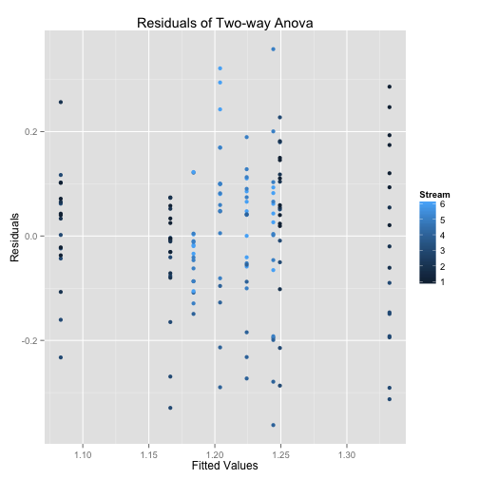

plot of chunk unnamed-chunk-38

### Figure 14

png(filename = "TwoANOVAResidual.png")  
ggplot(fish.df, aes(M1_Fit, M1_Resid, colour = Stream)) + geom_point() + xlab("Fitted Values") +   
 ylab("Residuals") + ggtitle("Residuals of Two-way Anova")  
dev.off()

## pdf   
## 2

## Interaction Plot

lineplot.CI(SEASNUM, V72, group = STREAMTYPE, data = fish, cex = 1.5, xlab = "Season",   
 ylab = "means", cex.lab = 1.2, x.leg = 1, col = c("blue", "red"), pch = c(16,   
 16))

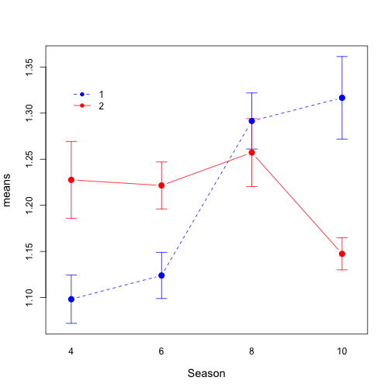

plot of chunk unnamed-chunk-40

### Figure 15

png(filename = "TwoANOVAInteraction.png")  
lineplot.CI(SEASNUM, V72, group = STREAMTYPE, data = fish, cex = 1.5, xlab = "Season",   
 ylab = "means", cex.lab = 1.2, x.leg = 1, col = c("blue", "red"), pch = c(16,   
 16))  
dev.off()

## pdf   
## 2

# One-Way ANOVA On Stream

options(contrasts = c("contr.sum", "contr.poly"))  
stream <- lm(V72 ~ STREAMTYPE, data = fish)

layout(matrix(c(1, 2, 3, 4), 2, 2))  
plot(stream)

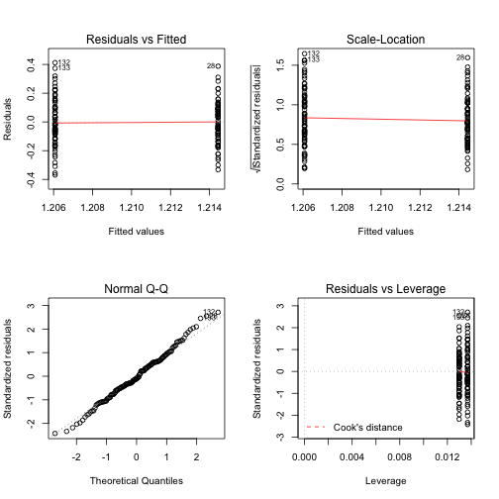

plot of chunk unnamed-chunk-43

### Figure 16

png(filename = "OneANOVAStream.png")  
layout(matrix(c(1, 2, 3, 4), 2, 2))  
plot(stream)  
dev.off()

## pdf   
## 2

### Table 2

print(anova(stream))

## Analysis of Variance Table  
##   
## Response: V72  
## Df Sum Sq Mean Sq F value Pr(>F)  
## STREAMTYPE 1 0.00 0.00262 0.11 0.74  
## Residuals 148 3.48 0.02349

## Residual Plot

stream.df <- data.frame(M1_Fit = seq(0, 0, length = 150), M1_Resid = seq(0,   
 0, length = 150), Stream = seq(0, 0, length = 150))  
  
stream.resid = resid(stream)  
stream.fitted = fitted(stream)  
  
stream.df$M1_Fit = stream.fitted  
stream.df$M1_Resid = stream.resid  
stream.df$Stream = fish$STREAMNUM  
  
ggplot(stream.df, aes(M1_Fit, M1_Resid, colour = Stream)) + geom_point() + xlab("Fitted Values") +   
 ylab("Residuals") + ggtitle("Residuals of One-Way Anova on Stream Type")

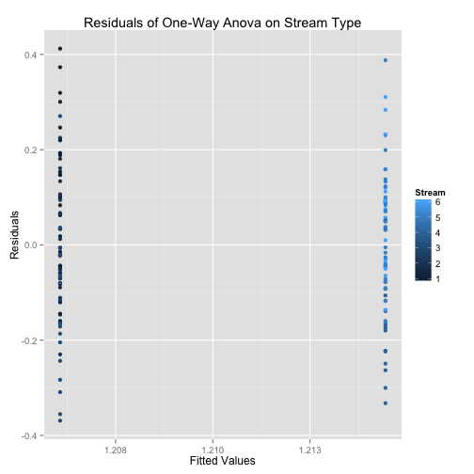

plot of chunk unnamed-chunk-46

### Figure 17

png(filename = "OneANOVAStreamResidual.png")  
ggplot(stream.df, aes(M1_Fit, M1_Resid, colour = Stream)) + geom_point() + xlab("Fitted Values") +   
 ylab("Residuals") + ggtitle("Residuals of One-Way Anova on Stream Type")  
dev.off()

## pdf   
## 2

## Interaction Plot

lineplot.CI(STREAMTYPE, V72, data = fish, cex = 1.5, xlab = "Season", ylab = "means",   
 cex.lab = 1.2, x.leg = 1, pch = c(16, 16))

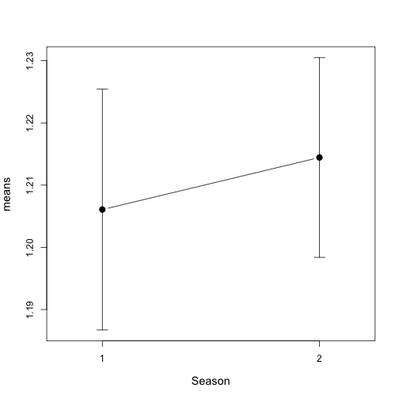

plot of chunk unnamed-chunk-48

### Figure 18

png(filename = "OneANOVAStreamInteraction.png")  
lineplot.CI(STREAMTYPE, V72, data = fish, cex = 1.5, xlab = "Season", ylab = "means",   
 cex.lab = 1.2, x.leg = 1, pch = c(16, 16))  
dev.off()

## pdf   
## 2

# One-Way ANOVA On Season

Now lets look at a One-way ANOVA on season

options(contrasts = c("contr.sum", "contr.poly"))  
season <- lm(V72 ~ SEASNUM, data = fish)

layout(matrix(c(1, 2, 3, 4), 2, 2))  
plot(season)

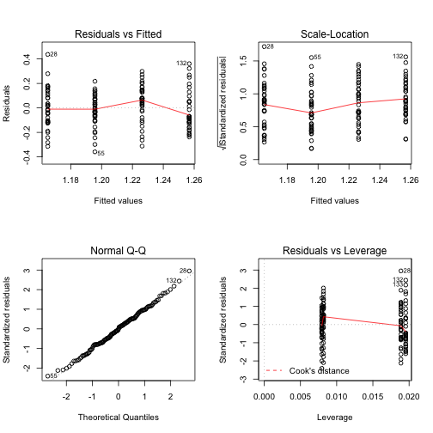

plot of chunk unnamed-chunk-51

### Figure 19

png(filename = "OneANOVA.png")  
layout(matrix(c(1, 2, 3, 4), 2, 2))  
plot(season)  
dev.off()

## pdf   
## 2

### Table 3

print(anova(season))

## Analysis of Variance Table  
##   
## Response: V72  
## Df Sum Sq Mean Sq F value Pr(>F)   
## SEASNUM 1 0.17 0.1677 7.49 0.007 **  
## Residuals 148 3.31 0.0224   
## ---  
## Signif. codes: 0 '***' 0.001 '**' 0.01 '*' 0.05 '.' 0.1 ' ' 1

## Residual Plot

season.df <- data.frame(M1_Fit = seq(0, 0, length = 150), M1_Resid = seq(0,   
 0, length = 150), Season = seq(0, 0, length = 150))  
  
season.resid = resid(season)  
season.fitted = fitted(season)  
  
season.df$M1_Fit = season.fitted  
season.df$M1_Resid = season.resid  
season.df$Season = fish$SEASNUM  
  
ggplot(season.df, aes(M1_Fit, M1_Resid, colour = Season)) + geom_point() + xlab("Fitted Values") +   
 ylab("Residuals") + ggtitle("Residuals of One-Way Anova on Season")

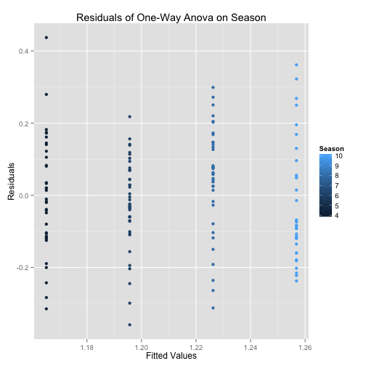

plot of chunk unnamed-chunk-54

### Figure 20

png(filename = "OneANOVASeasonResidual.png")  
ggplot(season.df, aes(M1_Fit, M1_Resid, colour = Season)) + geom_point() + xlab("Fitted Values") +   
 ylab("Residuals") + ggtitle("Residuals of One-Way Anova on Season")  
  
dev.off()

## pdf   
## 2

## Interaction Plot

lineplot.CI(SEASNUM, V72, data = fish, cex = 1.5, xlab = "Season", ylab = "means",   
 cex.lab = 1.2, x.leg = 1, pch = c(16, 16))

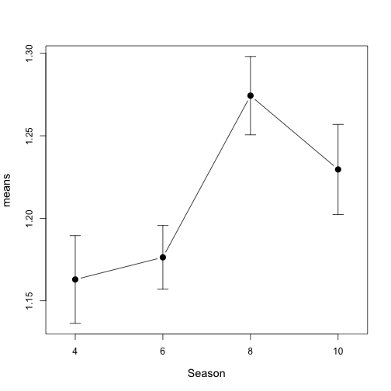

plot of chunk unnamed-chunk-56

### Figure 21

png(filename = "OneANOVASeasonInteraction.png")  
lineplot.CI(SEASNUM, V72, data = fish, cex = 1.5, xlab = "Season", ylab = "means",   
 cex.lab = 1.2, x.leg = 1, pch = c(16, 16))  
dev.off()

## pdf   
## 2