GEOS 4863
Auriel Fournier
January 20, 2015
Homework 1
The first stem and leaf is left skewed. The second is right skewed, and more heavily skewed. Based on the second stem and leaf plot it appears that most of the differences are small, which is good.
Based on the joint table (line 64) it appears we have a fairly even distribution of samples from both regions and all categories of land cover. Forest is a bit under sampled in the north but otherwise good. It is strange to see in the barplot from Line 113 that there are smaller differences in the south then the north. This could be related to some variable of the weather in the atmosphere, differences in equipment, operator error or other factors.
Line 154 did not run. I assume IQR is inner quartile region or something of that nature but it doesn’t appear that tapply supports it. I believe the ‘quantile’ function can be used with tapply.
I had to make the breaks larger in brk.a for Line 245 to run (.2 instead of .125), otherwise x and y did not have the same number of variables.
I don't understand the question at 207. delta.hist shows us the histogram of differences, which is slightly left skewed, since it's with values that are not absolute.
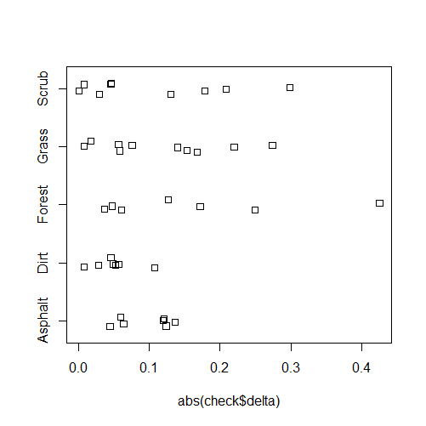
It makes more sense if you take the absolute values and its also easier to interpret when they are all positive. Vegetation could have larger differences for several reasons. Error could be caused to a larger degree in the vegetation for several reasons, including reflectance by the leaves and other materials in the plants. Dirt and Asphalt would have less material to reflect the material incorrectly or indirectly.
I’d never seen stripcharts before, I really liked that for looking at the smaller sample size.

