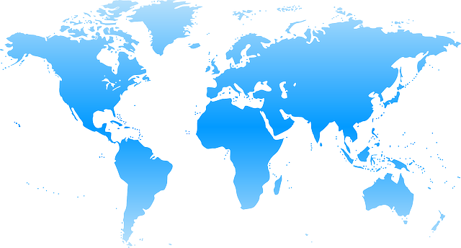World Climate Agreement

**DATE: _________________________________________________**

**LOCATION: ____________________________________________**

**ASSOCIATION (if any): __________________________________**

This template was created in collaboration with the international student Think & Do Tank [CliMates](http://climates.fr/) for the [COP in MyCity](http://copinmycity.weebly.com/) project. World Climate facilitators can use it **to gather all delegation commitments into one common agreement signed by participants**.

Once you’ve run the World Climate Exercise and filled this sheet, please send it to CliMates at [copinmycity@climates.fr](mailto:copinmycity@climates.fr) and Climate Interactive at [info@climateinteractive.org](mailto:info@climateinteractive.org).



PREAMBLE

***The Conference of the Parties,***

***Recalling the ultimate objective of the UN Climate Convention, which is to "prevent dangerous human interference with the climate system”;***

***Affirming the importance of the principle of common but differentiated responsibilities in the light of national contexts;***

***Stressing already experienced climate impacts such as rising temperatures, disruption of rainfall cycles, and rising sea levels, especially in vulnerable countries;***

***Highlighting the major risks to human populations that could result in 250 million climate refugees worldwide by 2050;***

***Reaffirming the international target established at the Cancun Conference (2010), to limit global warming to a maximum of 2 degrees Celsius over pre-industrial levels;***

***Reaffirming the goal of mobilizing $100 billion per year from 2020 through the Green Climate Fund, with contributions from the more developed countries, and for the benefit of the poor and most vulnerable countries;***

***Echoing the scientific recommendations of the United Nations to significantly reduce global emissions by 2050 to meet the 2 degrees Celsius target;***

***Recalling the mandate of the Durban Conference (2011), which was to reach a new international climate agreement, with the force of law;***

***Decides***

**Mitigation of climate change**

**A. Levels of Greenhouse Gas (GHG) emission reduction**

|  |  |  |  |
| --- | --- | --- | --- |
| **PARTIES** | **Year GHG emissions stop growing** | **Year GHG emissions start reducing** | **Annual rate of GHG emission reduction** |
| Annex I countries |  |  |  |
| USA |  |  |  |
| EU |  |  |  |
| Other developed countries |  |  |  |
| Non-Annex I countries |  |  |  |
| China |  |  |  |
| India |  |  |  |
| Other developing countries |  |  |  |

Parties commit to implement actions to reduce greenhouse gas (GHG) emissions in order to fulfill the objectives described above.

**B. Consequences on the climate system**

According to projections based on the C-ROADS model from Climate Interactive, the fulfillment of these objectives will lead to a mean global warming of **[ _____ °C**] by 2100**,** a mean global sea level rise of **[ _____ m]** and a mean global acidification of oceans by  **[ _____ pH]** by the end of the 21st century.

**Forestry Land Use**

**A. Forest - fighting deforestation**

|  |  |  |  |
| --- | --- | --- | --- |
| **Policies to stop deforestation** (1: BAU, 0: maximum fight against deforestation) | Group A  **0 - 0.3** | Group B  **0.4 - 0.6** | Group C  **0.7 - 1** |
| PARTIES | *List of Parties* | *List of Parties* | *List of Parties* |

**B. Forest - promoting reforestation and afforestation**

|  |  |  |  |
| --- | --- | --- | --- |
| **Afforestation**  (1: maximum effort;  0: no afforestation) | Group A  **1 - 0.7** | Group B  **0.6 - 0.4** | Group C  **0.3 - 0** |
| PARTIES | *List of Parties* | *List of Parties* | *List of Parties* |

**Finance**

**A. Commitments**

Parties with the capacity to contribute funding commit to securing financing to support Parties with concerns about poverty and/or vulnerability. Those Parties that request funding also indicate their need:

|  |  |  |  |
| --- | --- | --- | --- |
| **Contributors to the Fund** | **Amount in billions $/yr** | **Beneficiaries to the Fund** | **Amount in billions $/yr** |
|  |  |  |  |
|  |  |  |  |
|  |  |  |  |
|  |  |  |  |
|  |  |  |  |
|  |  |  |  |
|  |  |  |  |
| **TOTAL** |  | **TOTAL** |  |

**B. Financing mitigation to climate change**

Parties decide that **_____ %** of the Green Climate Fund will be allocated to climate change mitigation programs.

**C. Financing adaptation to climate change**

Parties decide that **_____ %** of the Green Climate Fund will be allocated to climate change adaptation programs.

Allocated funds will go proprietarily to the three following programs:

* **_________________________________________________**

* **_________________________________________________**
* **_________________________________________________**

**Other commitments by Parties (*other topic*s)**

**Signatures of the Parties**

***Representing United States of America***

***Representing European Union***

***Representing Peoples Republic of China***

***Representing Republic of India***

***Representing Other Developing Countries***

***Representing Other Developing Countries***