**Lab 4 Report**

Name 吳承軒

Student ID 106598068

Date 2018/05/22

1. **Test Plan**
   1. **Summary**

This system to be tested for this lab is Socify, an online social network platform for allowing users to exchange messages, keep track of events and share photos. In general, it helps users to know each other.

This lab is to test some features on Socify. In the lab, I will execute test requirements for the features of Socify to be tested. I also required design test cases to verify the test requirements.

* 1. **Features to be tested**
* **Create a new event**
  + Edit event
  + Delete event
* **Post comment**
  + Write/delete/edit a comment in response to friend's posts (i.e., comments)
  + Press Like Button and Unlike Button at this comment
* **Create a new status**
  + Add images
  + Delete/Edit a status
* **Follow friends**
* **Find friends**
* **Edit profile**
  + Upload avatar and cover
  + Edit all info of profile
  1. **Success criteria of completing the test**

Bugs will be rated according to their severity. The feature of lab4 has the following severity classes:

* Minor
* Normal
* Serious

|  |  |
| --- | --- |
| **Priority** | **Requirement** |
| High | Average less than 2 unresolved bugs with severity **Minor** /module. Not over 5 unresolved bugs/module. |
| Medium | Same as above, but can contain less than average 1 unresolved bugs of severity **Normal**/module. |
| Low | No unresolved bugs with severity **Serious**. Not more than 5 unresolved bugs/module. |

* 1. **Test environment and infrastructure**
* Hardware: 1 PC
* Software: Chrome, Selenium IDE
* Test Data: Socify website and test data of my use.
  1. **Test approaches**

This lab uses “user scenarios” and “ISP” to design test case, and measure test coverage if there is enough free time. This lab uses Selenium IDE as the test tools, and use multiple testing techniques to ensure that all the test requirements can be satisfied and the goals of the test can be achieved.

* 1. **Testing tasks**

To implement the proposed strategy, the following activities are planned to perform.

|  |  |  |  |
| --- | --- | --- | --- |
| **No.** | **Activity Name** | **Plan hours** | **Schedule Date** |
| 1 | Study Selenium IDE | 3 | 2018/05/16 |
| 2 | Learn and use Socify | 1 | 2018/05/17 |
| 3 | Design test cases for the features | 3 | 2018/5/18 |
| 4 | Implement test cases | 4 | 2018/5/19 |
| 5 | Perform test | 3 | 2018/5/20 |
| 6 | Complete Lab4 report | 3 | 2018/5/22 |

1. **Test Design**

|  |  |
| --- | --- |
| Feature : Create a new Event | |
| User scenario | 1. User click button of create new event 2. User type the new event 3. User click to send event |
| Precondition | User login |
| Postcondition | A User creates a new event |
| Exception | If User doesn’t type anything, then the event won’t successful create. |

|  |  |
| --- | --- |
| Feature : Edit event | |
| User scenario | 1. User click button of edit event 2. User type the new event 3. User click to send event |
| Precondition | The event that user already created. |
| Postcondition | User update event successfully |
| Exception | If User doesn’t type anything, then the event won’t successful edit. |

|  |  |
| --- | --- |
| Feature : Delete event | |
| User scenario | User click button of a delete event |
| Precondition | The event that user already created. |
| Postcondition | User update event successfully |
| Exception | None |

|  |  |
| --- | --- |
| Feature : Write a comment in response to friend’s posts | |
| User scenario | 1. User clicks the button of comment in friend’s event. 2. Type the message 3. User clicks to send event |
| Precondition | The event that user’s friend already created. |
| Postcondition | User leave message successfully. |
| Exception | If User doesn’t type anything, then the message won’t successful replay. |

|  |  |
| --- | --- |
| Feature : Delete a comment in response to friend’s posts | |
| User scenario | User click the button of delete in friend’s event. |
| Precondition | The message that user already send in friend’s event |
| Postcondition | User delete message successfully. |
| Exception | None |

|  |  |
| --- | --- |
| Feature : Press Like Button at this comment | |
| User scenario | User click the button of like in friend’s event. |
| Precondition | The event that user’s friend already created. |
| Postcondition | Add the number of like in friend’s event |
| Exception | None |

|  |  |
| --- | --- |
| Feature : Press Unlike Button at this comment | |
| User scenario | User click the button of like in friend’s event. |
| Precondition | The event that user already press like button. |
| Postcondition | Reduce the number of like in friend’s event |
| Exception | None |

|  |  |
| --- | --- |
| Feature : Create a new status | |
| User scenario | 1. User input the comment and upload picture in a new status. 2. User click button of send |
| Precondition | User login |
| Postcondition | User create new status successfully |
| Exception | There will show error message if there is no comment in status. |

|  |  |
| --- | --- |
| Feature : Edit status | |
| User scenario | 1. User click button of edit status 2. User type the new status or upload the new picture 3. User click to send status |
| Precondition | The status that user already created. |
| Postcondition | User update status successfully |
| Exception | If User don’t type anything, then the status won’t successful update. |

|  |  |
| --- | --- |
| Feature : Delete status | |
| User scenario | User click button of delete status. |
| Precondition | The status that user already created. |
| Postcondition | User delete status successfully |
| Exception | None |

|  |  |
| --- | --- |
| Feature : Follow friends | |
| User scenario | 1. User click button of “Find friends” 2. Click the button of Follow in which friend you want to follow. |
| Precondition | User login |
| Postcondition | User follow a friend successfully. |
| Exception | None |

|  |  |
| --- | --- |
| Feature : Upload avatar and cover | |
| User scenario | 1. User click button of “Edit Profile” 2. User upload Avatar and Cover. 3. User click update. |
| Precondition | User login |
| Postcondition | User upload Avatar and Cover successfully. |
| Exception | None |

|  |  |
| --- | --- |
| Feature : Edit all info of profile | |
| User scenario | 1. User click button of “Edit Profile” 2. User input the new information in the certain column 3. User click Update |
| Precondition | User login |
| Postcondition | User upload profile successfully. |
| Exception | Error occurred when user doesn’t type user name. |

**Because of the restrict in Selenium IDE. There are two test case failure, because both cases need to upload photo from local, it is about security and not in this test purpose.**

|  |  |  |
| --- | --- | --- |
| **No.** | **Test features** | **Test Flow** |
| 1 | Create a new event | 螢幕快照%202018-05-22%20下午4.57.06.png |
| 2 | Edit a event | Lab4/editEvent.png |
| 3 | Delete a event | Lab4/deleteEvent.png |
| 4 | Post write a comment | Lab4/writeComment.png |
| 5 | Post delete a comment | Lab4/deleteEvent.png |
| 6 | Find friends | Lab4/findFriend.png |
| 7 | Follow friends | Lab4/follow.png |

1. **Test Implementation**

There are all feature test case in the following:

I use ISP test technique in every input area (the biggest, longest, negative, etc.), but I fount out that Selenium IDE can’t show the error message about the ISP. For example, I upload profile and type 2018-14-30, this is the correct month which can’t found in the calendar, but there is no any error message. So this is the the shortcomings that I found in this lab.

1. **Test Results**
   1. **Selenium IDE test result snapshot**

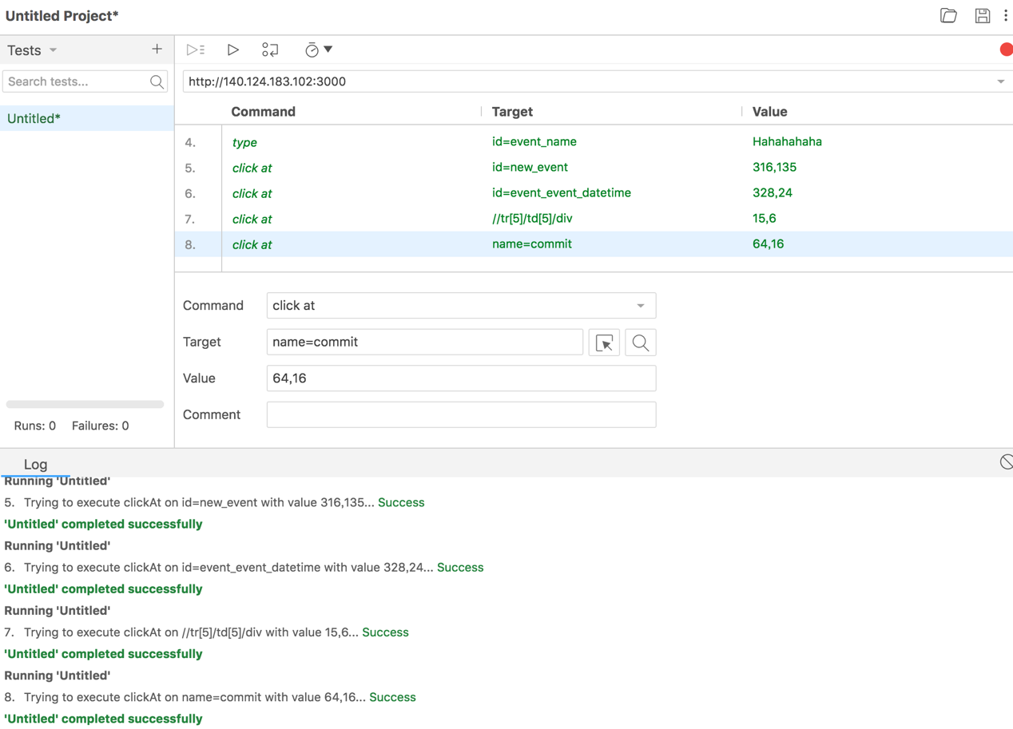

1. **Learning**

In this lab4, different form the lab before finished, which use the “user scenarios” and “ISP” testing technique to fulfill test case, and this lab is black-box test without knowing the source code and any functions to cooperate with each other. I learn a lot of experience from this time because this test tool(Selenium IDE) is very unfamiliar with me.