**Lab 5 Report**

Name 吳承軒

Student ID 106598068

Date 2018/06/13

1. **Test Plan**
   1. **Summary**

This system to be tested for this lab is JMeter, a stress/load testing software for allowing users to execute the program of simulated user behavior. In general, it helps users to know test system load/stress testing.

This lab is to test some features on 2016_ntut_csie_stv_lab4. In this lab, I will execute test requirements for the features of JMeter to be tested. I also required design test cases to verify the test requirements.

* 1. **Features to be tested**
* **Login**
  + **Non Ramp-up**
    - 256 user login in 10 seconds
    - 512 user login in 20 seconds
    - 1024 user login in 40 seconds
  + **Ramp-up**
    - 256 user login in 10 seconds
    - 512 user login in 20 seconds
    - 1024 user login in 40 seconds
* **ISBN Search books**
  + Use ISBN number to search books, and log out all user after all user search done.
    - 256 user login in 10 seconds with Ramp-up
    - 512 user login in 20 seconds with Ramp-up
    - 1024 user login in 40 seconds with Ramp-up
  + Use ISBN number to search books after all user login success, then log out all user after all user search done.
    - 256 user login in 10 seconds with Ramp-up
    - 512 user login in 20 seconds with Ramp-up
    - 1024 user login in 40 seconds with Ramp-up
* **Check in books / Check out books**
  + Use book code to borrow the book and return the book, then log out after all user finished their operation.
    - 256 user login in 10 seconds with Ramp-up
    - 512 user login in 20 seconds with Ramp-up
    - 1024 user login in 40 seconds with Ramp-up
  + Waiting for all user login success, then use book code to borrow the book and return the book, and finally log out after all user finished their operation.
    - 256 user login in 10 seconds with Ramp-up
    - 512 user login in 20 seconds with Ramp-up
    - 1024 user login in 40 seconds with Ramp-up
  1. **Success criteria of completing the test**

Bugs will be rated according to their severity. The feature of lab4 has the following severity classes:

* Minor
* Normal
* Serious

|  |  |
| --- | --- |
| **Priority** | **Requirement** |
| High | Average less than 2 unresolved bugs with severity **Minor** /module. Not over 5 unresolved bugs/module. |
| Medium | Same as above, but can contain less than average 1 unresolved bugs of severity **Normal**/module. |
| Low | No unresolved bugs with severity **Serious**. Not more than 5 unresolved bugs/module. |

* 1. **Test environment and infrastructure**
* Hardware: 1 PC
* Software: JMeter
* Test Data: 2016_ntut_csie_stv_lab4 (docker image)
  1. **Test approaches**

This lab uses “user scenarios” and “ISP” to design test case, and measure test coverage if there is enough free time. This lab uses Selenium IDE as the test tools, and use multiple testing techniques to ensure that all the test requirements can be satisfied and the goals of the test can be achieved.

* 1. **Testing tasks**

To implement the proposed strategy, the following activities are planned to perform.

|  |  |  |  |
| --- | --- | --- | --- |
| **No.** | **Activity Name** | **Plan hours** | **Schedule Date** |
| 1 | Study JMeter IDE | 3 | 2018/06/08 |
| 2 | Learn and use docker | 3 | 2018/06/09 |
| 3 | Design test cases for the features | 5 | 2018/06/10 |
| 4 | Implement test cases | 2 | 2018/6/11 |
| 5 | Perform test | 4 | 2018/6/11 |
| 6 | Complete Lab5 report | 5 | 2018/6/12 |

1. **Test Design**

|  |  |
| --- | --- |
| Scenario: Login | |
| Precondition | Use account and password from csv file to perform login |
| Input actions | 1. login system  2. log out system |
| Expected output | 1. Response status is “success” 2. Authority is “2” 3. Verify text response is “success” |
| Design of workload | The number of users is   1. 256 2. 512 3. 1024 |

|  |  |
| --- | --- |
| Scenario: Login with ramp-up | |
| Preconditions | Use account and password from csv file to perform login |
| Input actions | 1. login system  2. log out system |
| Expected output | 1. Response status is “success” 2. Authority is “2” 3. Verify text response is “success” |
| Design of workload | The number of users is 256, and the ramp-up period is 10 sec  The number of users is 512, and the ramp-up period is 20 sec  The number of users is 1024, and the ramp-up period is 40 sec |

|  |  |
| --- | --- |
| Scenario: ISBN search books | |
| Precondition | Use account and password from csv file to perform login |
| Input actions | 1. Login system 2. Use random number to generate ISBN for search 3. Wait all user operation done 4. Log out system |
| Expected output | 1. Verify response status is “success” and authority is “2’ 2. Verify text response is “success” |
| Design of workload | The number of users is   1. 256   2. 512   1. 1024 |

|  |  |
| --- | --- |
| Scenario: ISBN search books waiting all finished login | |
| Preconditions | Use account and password from csv file to perform login |
| Input actions | 1. Login system 2. Wait all user login 3. Use random number to generate ISBN for search 4. Wait all user operation done 5. Log out system |
| Expected output | 1. Verify response status is “success” and authority is “2’ 2. Verify text response is “success” |
| Design of workload | The number of users is   1. 256 2. 512 3. 1024 |

1. **Test Implementation**

There are upload in the Lab5 folder in gitlab.

* 1. **Jmeter snapshot**

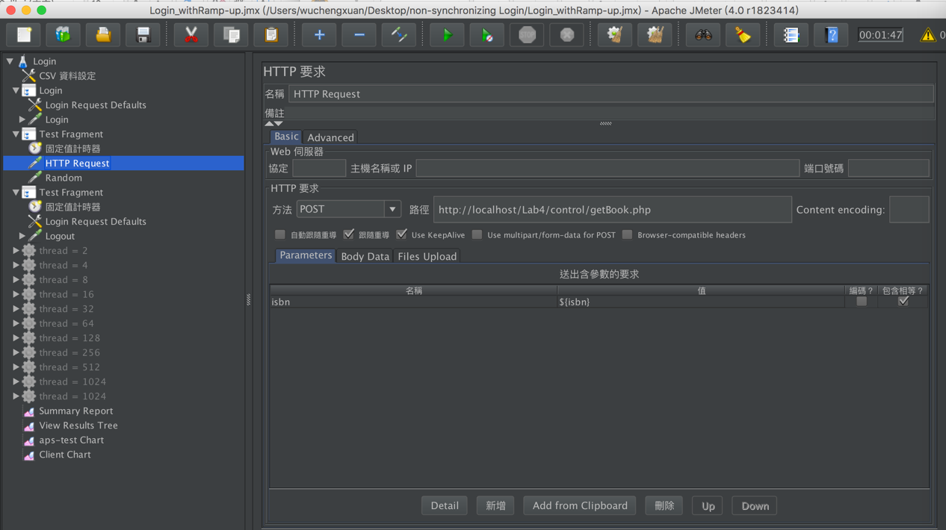

* 1. **Summary Report**
* Login with Ramp-up ( users 256 )

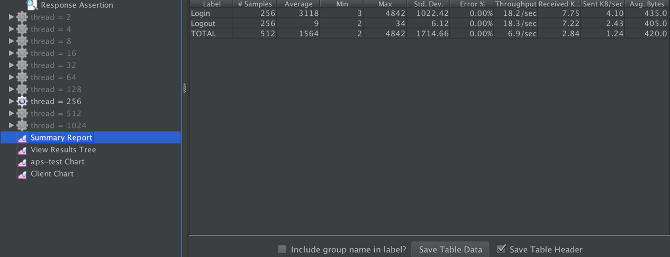

* Login without Ramp-up (users 256)

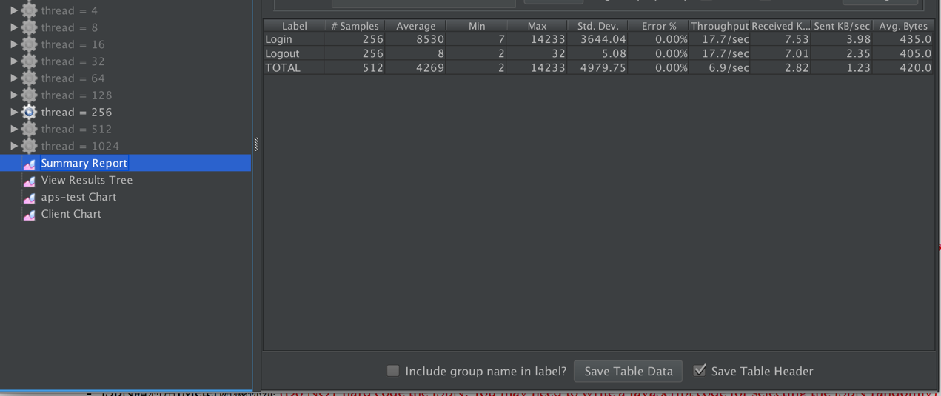

* Login with Ramp-up ( users 512 )

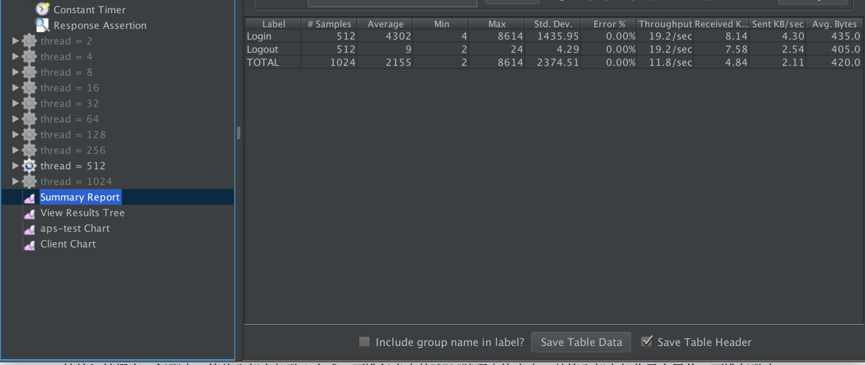

* Login without Ramp-up (users 512)

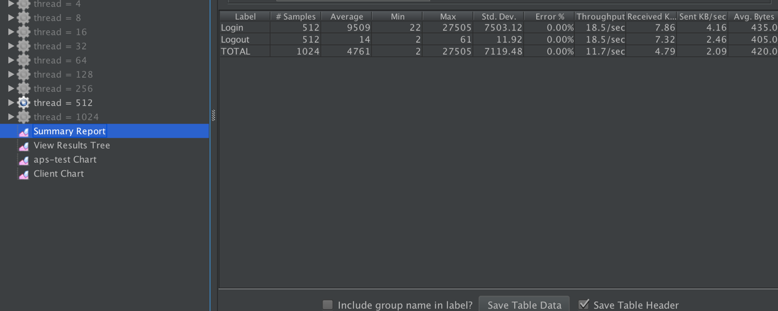

* Login with Ramp-up ( users 1024 )

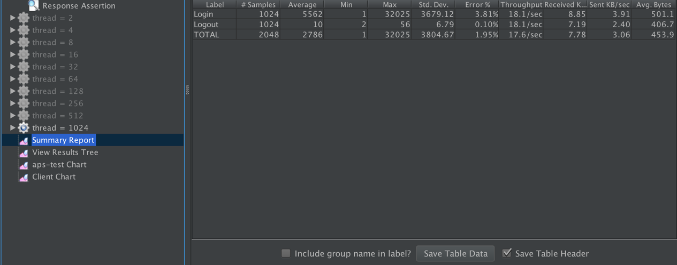

* Login without Ramp-up (users 1024)

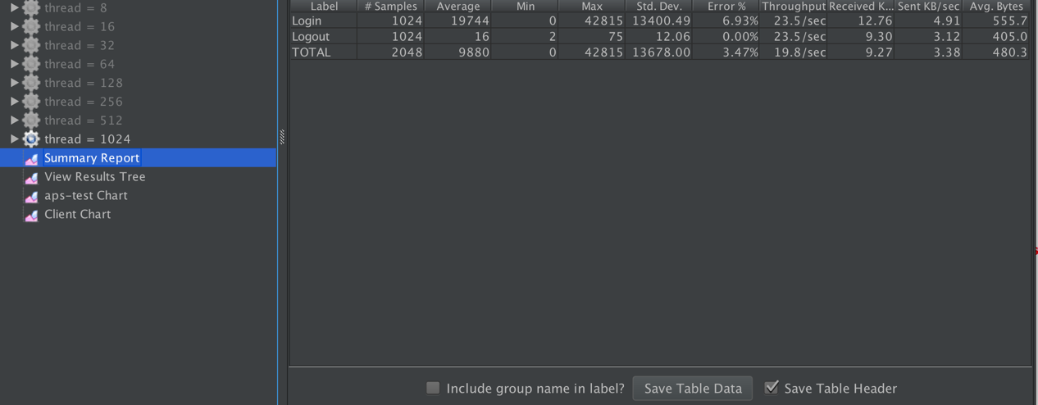

* 1. **Client Chart**
* Login with Ramp-up ( users 256 )

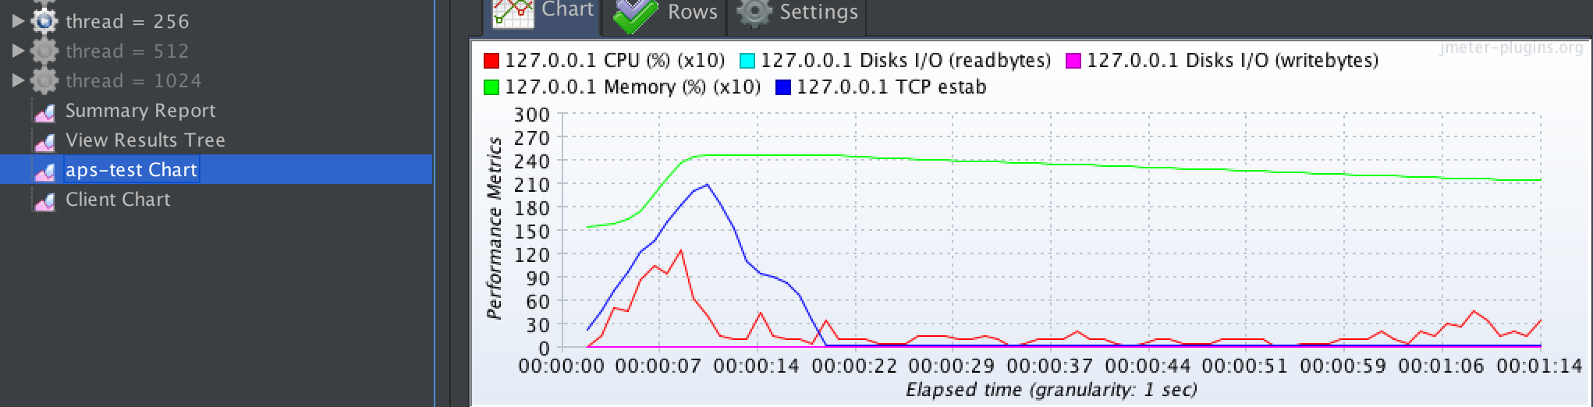

* Login without Ramp-up ( users 256 )

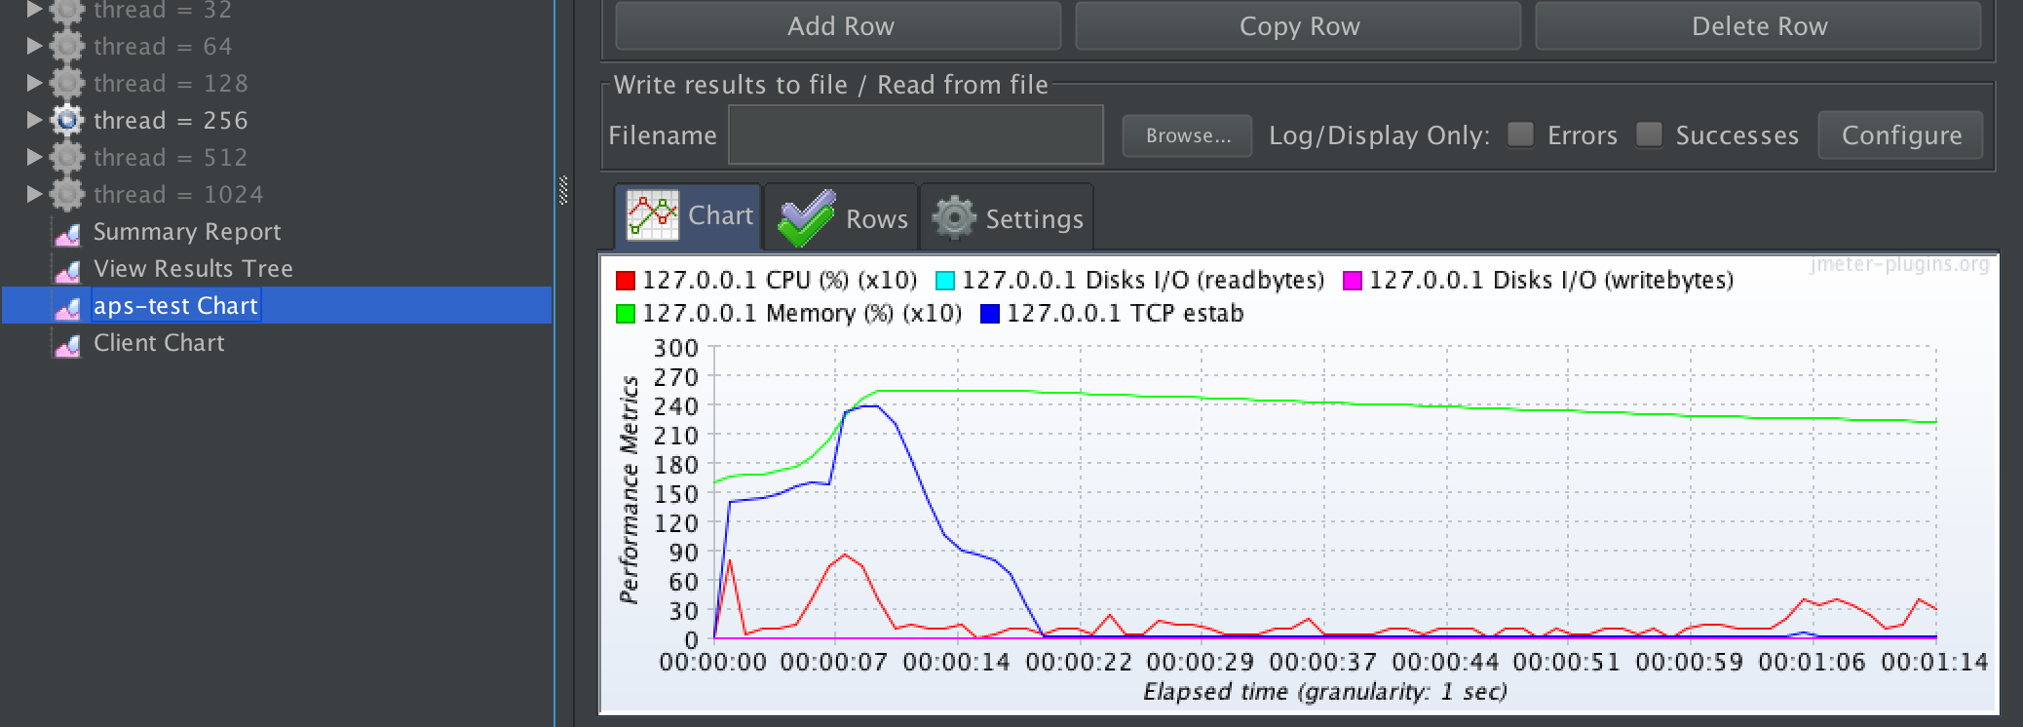

* Login with Ramp-up ( users 512 )

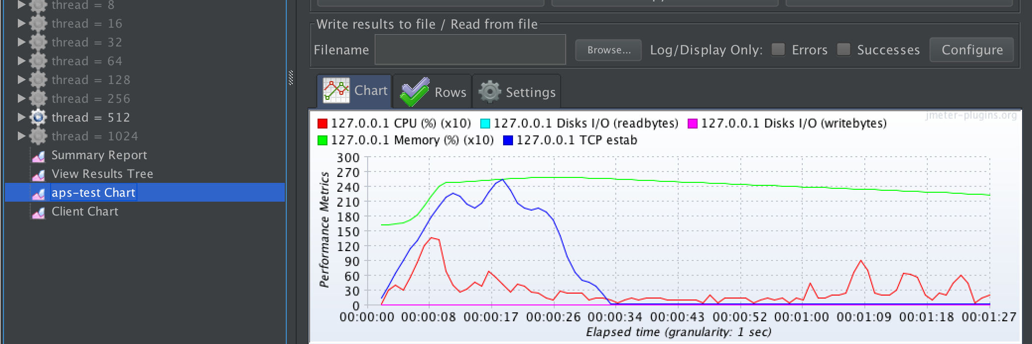

* Login without Ramp-up ( users 512 )

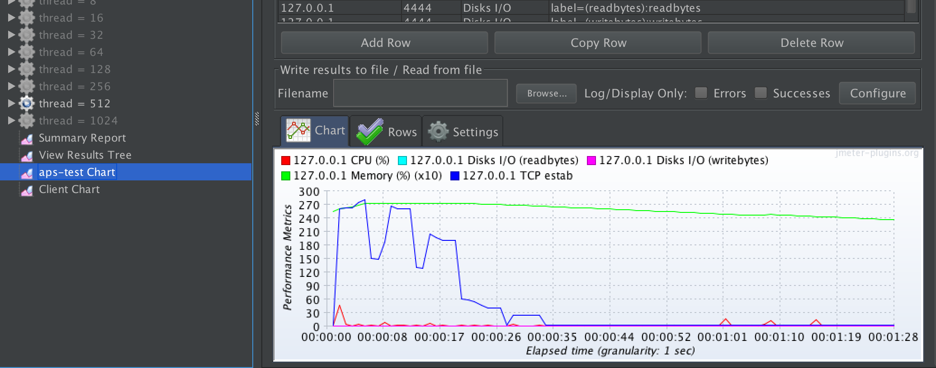

* Login with Ramp-up ( users 1024 )

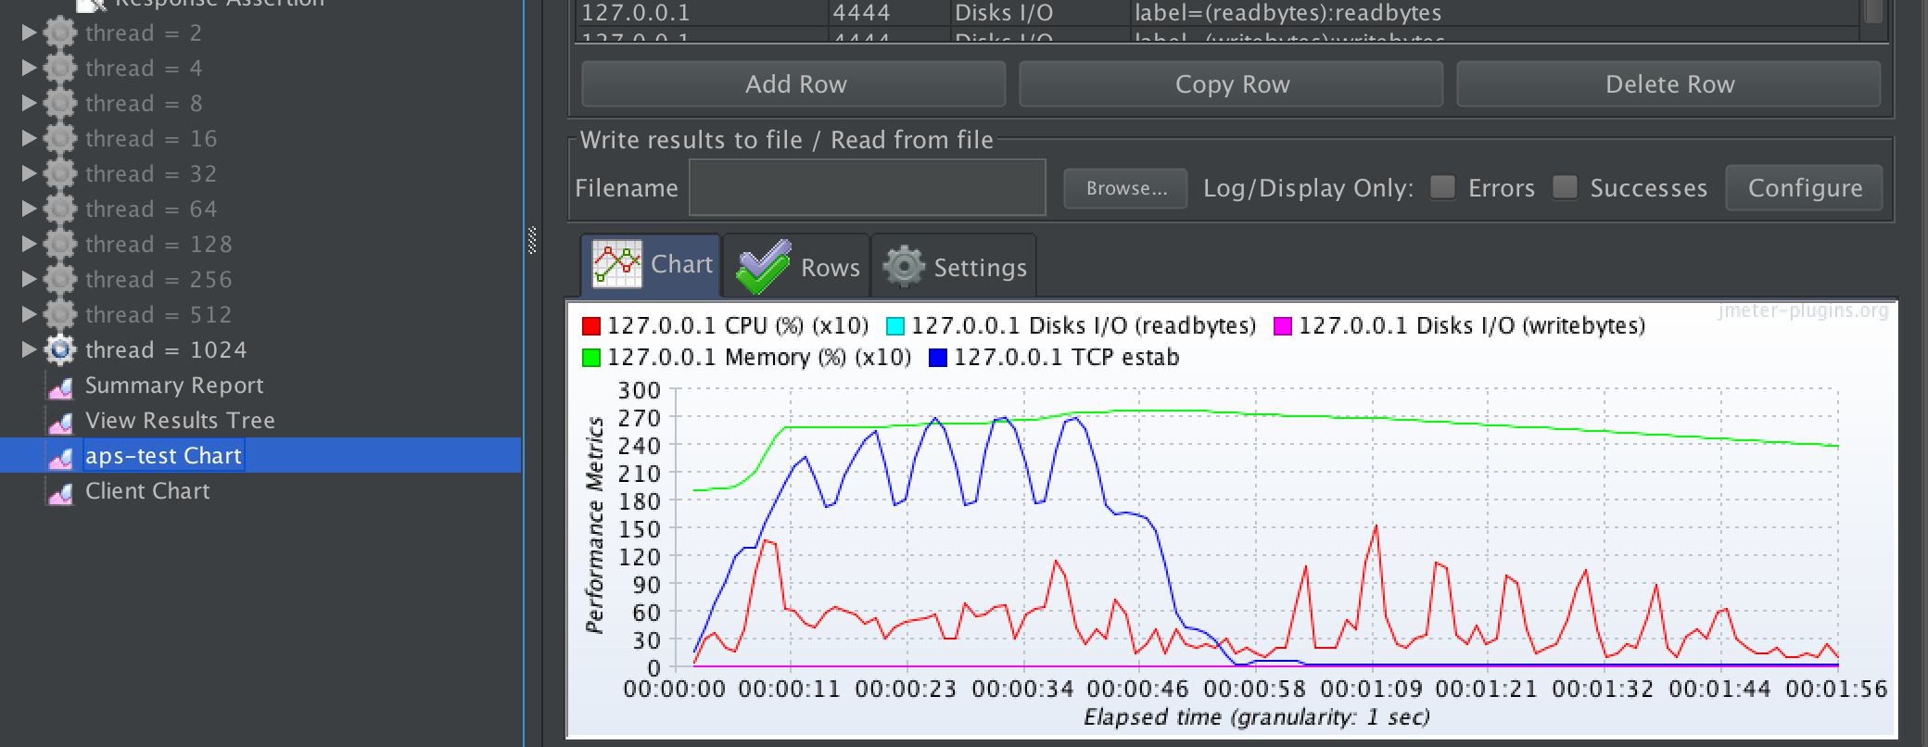

* Login without Ramp-up ( users 1024 )

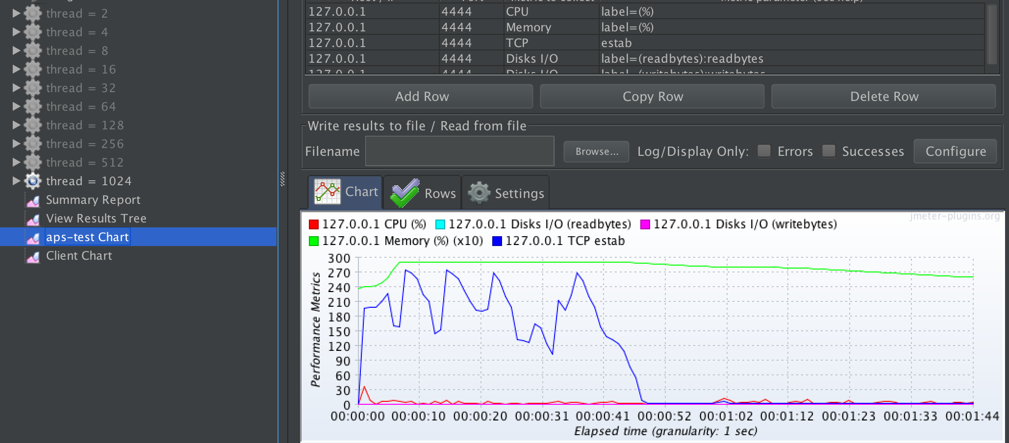

# 由於版面緣故，只放上部分結果圖，Q2題目的結果圖在lab5資料夾內，謝謝。

1. **Learning**

在這次的lab裡，我學習到了壓力測試軟體的使用與好處，藉由透過這種類型的軟體，可以自動化測試軟體的彈性，來幫助我了解所開發軟體的架構與效能是否完善，進而改善整體軟體的品質，獲益匪淺。