ENet Caster Detailed Operating Manual
  - 0.3.6 · 2026-11-02 · PNTMatrix Tech.

01 Guide scope and first use
This manual is for deployment and operations staff. It follows the actual 0.3.6 pages for configuration, monitoring and investigation. Base management owns ingestion and source monitoring; rover services own authentication, GGA positions and nearest-eligible-base selection. There is no management sign-in page. Rovers authenticate with NTRIP credentials.
Screenshots were generated by this version using synthetic users, bases and coordinates. They are examples, not the current computer’s operational data. Gray map backgrounds indicate that online tiles were not loaded in the sample; overlays and diagnostics still work. Use screenshots to locate controls and the text and tables to interpret fields.
Control or field | Meaning and operation
Delivery | Use the matching Setup or portable ZIP; retain Assets with the portable EXE.
Persistence | Local SQLite enet.db; no MySQL service.
Target platforms | Windows 10 22H2 / Windows 11; x64, x86 and ARM64 packages.
Validation scope | x64/x86 executed on Windows 11 x64; ARM64 and Windows 10 not hardware-tested.
Capacity | Up to 50 bases; 10,000 connections is a measured target under stated conditions.

Procedure and verification
1. Install or extract all files. Exit the previous release and back up data before upgrading.
2. Configure listen IP, port, service format and a public mountpoint in Service settings.
3. Add one base, enter the mode-specific endpoint, save and start the service.
4. Confirm valid RTCM reception in Stream monitor; stream-derived positions also require coordinate messages.
5. Create a user and configure the rover endpoint, public mountpoint, credentials and GGA upload.
6. Check the selected base, green delivery status and increasing bytes in Connections.

02 Main window and overview
Navigation opens Overview, Base stations, Users & access, Connections, Service settings and Company & contact. The top-right selector changes the interface language; the bottom bar shows service state and the public endpoint. The sample service is stopped and does not imply that a real device is connected.
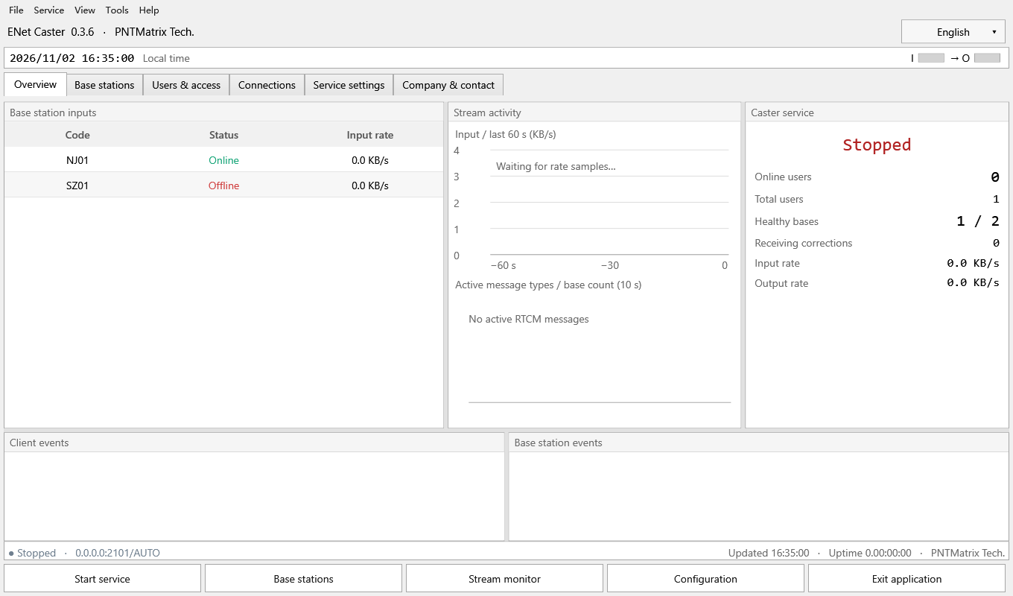
Figure 1 Main window and overview (example page)
Control or field | Meaning and operation
Online / total users | Online users are distinct accounts; total users are account records.
Healthy bases | Number in the Online state / runtime bases.
Receiving corrections | Connections in the Streaming selection state; also inspect actual delivery status.
Input / output rate | Recent source ingress and rover egress, derived from byte-counter changes.
Traffic and message charts | 60-second input history; base counts by message types active in the last 10 seconds.
Events and I / O | Recent events and traffic activity. Lamps do not prove receiver ambiguity resolution.

Procedure and verification
1. Choose Start service to begin listening and source ingestion.
2. Inspect ingress and egress, then open the relevant page.
3. Stop service interrupts delivery. Exit application stops and exits; only the explicit Hide to tray action keeps it running.

03 Base list and selection
Open Base stations > Base stations. Add and Edit maintain ingestion settings. The list describes source health and served sessions. An online base does not imply that a particular user is in coverage, authorized or format-compatible.
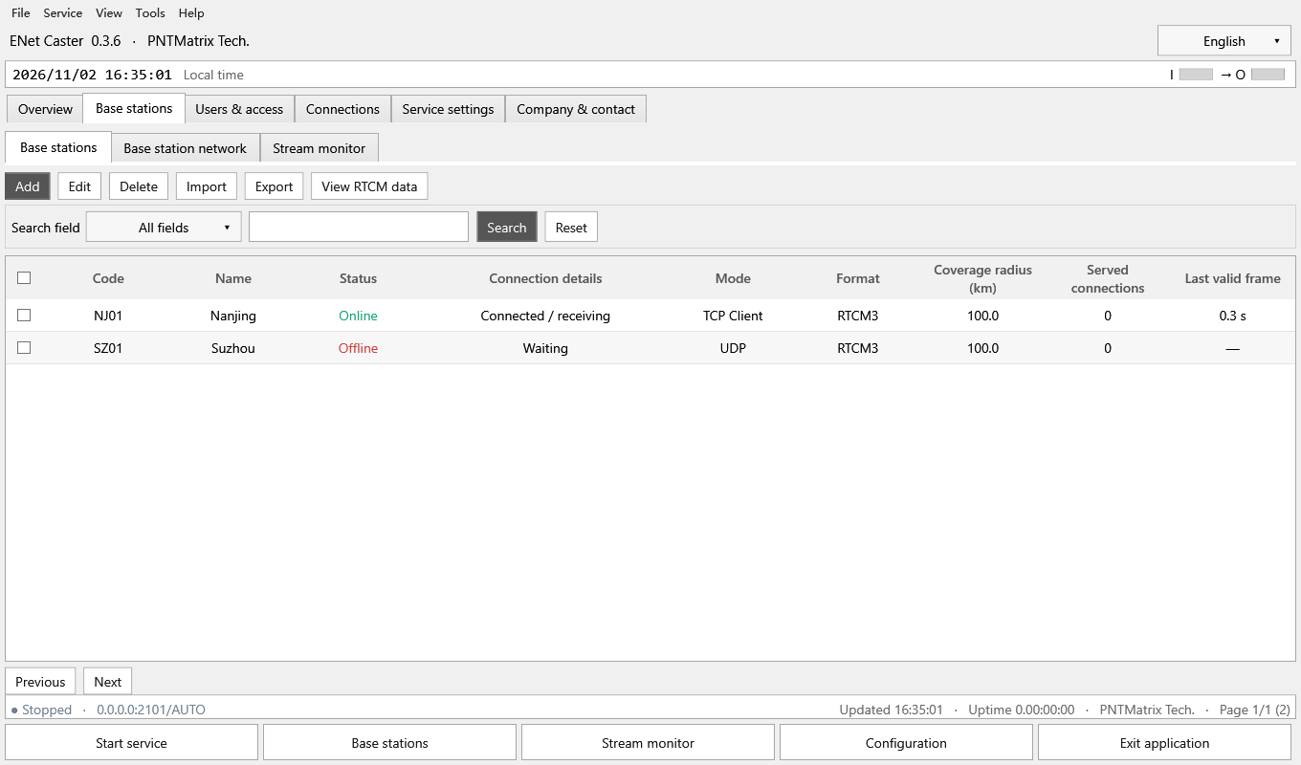
Figure 2 Base list and selection (example page)
Control or field | Meaning and operation
Code / name | The code identifies a base and matches imports; the name is used in display and recording names.
Status / connection details | Distinguish offline, waiting, receiving and recent errors; TCP connection alone is insufficient.
Mode / format | NTRIP, TCP Client, TCP Server or UDP; RTCM2 or RTCM3.
Coverage / clients | Configured radius in km; current subscribed rover sessions.
Last valid frame | Age of the last checksum-valid RTCM frame, not merely the last network packet.
Selection / pagination | The header selects the current page; up to 200 rows per page.

Procedure and verification
1. Choose a search field, enter a keyword and press Search or Enter. Reset clears the criteria.
2. Check one base before Edit or View RTCM data; hover is not a selection.
3. Delete removes one selected configuration after confirmation. Restart when prompted after source changes.

04 Base configuration form
Choose Add, or check one base and choose Edit. The form groups identity, endpoint, position and delivery fields. Changing the input mode shows only applicable fields. Scroll down to reach later settings on a smaller window.
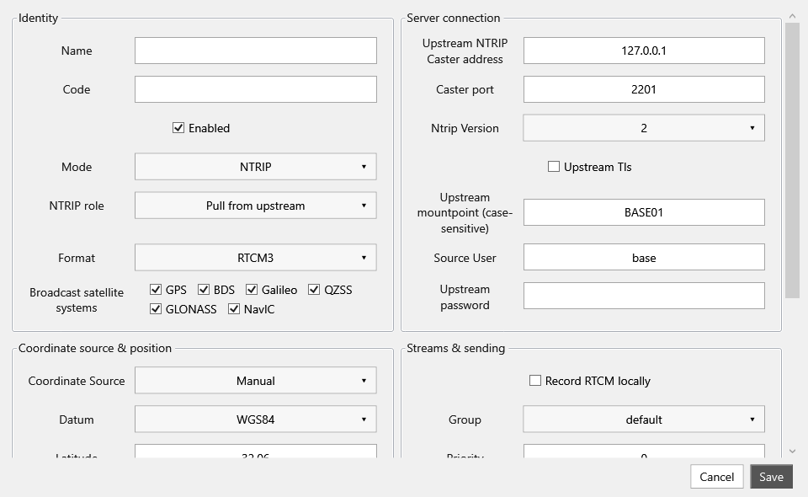
Figure 3 Base configuration form (example page)
Control or field | Meaning and operation
Name | Required; up to 120 characters.
Base code | 1–80 ASCII letters, digits, underscore, hyphen or dot; uniqueness is case-insensitive.
Enabled / input mode | Disabled bases are excluded from service; mode determines connection direction.
NTRIP role | Pull upstream or receive a pushed base; these are different directions.
Format | Must match the input. Public service format is also a selection requirement.
Broadcast satellite systems | Select at least one; controls rover delivery, not upstream configuration.

Procedure and verification
1. Complete the active mode’s endpoint fields. A new pushed base also needs an upload password.
2. Choose the coordinate source, radius, group and local recording preference.
3. Save. Correct highlighted errors before saving. Cancel discards edits.

05 Input modes and NTRIP directions
Raw TCP transports RTCM bytes without NTRIP mountpoints or credentials. NTRIP pull connects to another caster; push receives a base on this caster’s public listener. Rover public mountpoints and base upload mountpoints have different purposes.
Control or field | Meaning and operation
NTRIP pull | Upstream host, port, case-sensitive mountpoint, username, password and version 1/2; optional upstream TLS.
NTRIP push | Set this base’s upload mountpoint, source user and password. The base device connects to the shared caster listener; no separate remote Host/Port is entered for this role.
TCP Client | Remote host and port; optional upstream TLS; no NTRIP mountpoint or credentials.
TCP Server | Local listen IP and a dedicated port; wait for the source device.
UDP | Local listen IP and port for incoming datagrams; no handshake or NTRIP credentials.
Blank password | Preserves an existing secret during editing. New push passwords need at least 8 characters; pull accepts existing short upstream passwords.

Procedure and verification
1. Pull example: 127.0.0.1:2201 and BASE01 are sample values only. Replace them with the real upstream.
2. Push example: the base uploads to BASE01, while rovers use AUTO; names must not collide.
3. TCP Server/UDP require a local listen IP; 0.0.0.0 listens on all IPv4 interfaces. Ports are 1–65535. Avoid listener conflicts.

06 Coordinates and selection parameters
Position is used for maps and distance-based routing. The software does not compare configured and stream positions for consistency, but still validates manual number format and range. A coverage circle illustrates the configured radius; it is not an accuracy guarantee.
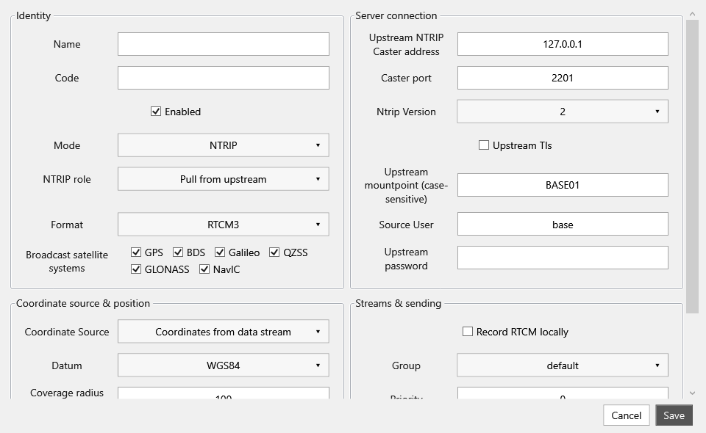
Figure 4 Coordinates and selection parameters (example page)
Control or field | Meaning and operation
Coordinate source | Manual, Surveyed and Imported use configured BLH. Stream mode waits for RTCM3 1005/1006 or RTCM2 type 3.
Reference frame | WGS84 in this release; transform other frames first.
Latitude / longitude / height | Decimal degrees and metres. Stream mode hides manual coordinates.
Coverage radius | km; form range 0.001–20040. Set the intended service coverage.
Selection group | The account must allow the base group; default is the initial group.
Tie priority / station ID | Larger Priority wins equal-distance ties. Expected RTCM station ID is −1 for automatic or 0–4095.

Procedure and verification
1. With stream-derived coordinates, first confirm valid reception, then wait for a coordinate message.
2. While waiting for station coordinates, no invented position is plotted or used in routing.
3. Every valid time-advancing GGA immediately selects the nearest eligible base, without switching hysteresis.

07 Satellite delivery rules
Broadcast satellite systems is an active delivery filter, not descriptive metadata. If a multi-system input is configured as GPS-only, rovers receive recognized GPS messages and necessary shared metadata. The caster cannot generate GPS observations that are absent upstream.
Control or field | Meaning and operation
Selectable systems | GPS, BDS, Galileo, QZSS, GLONASS and NavIC; IRNSS is recognized as NavIC.
Single-system example | GPS-only retains recognized GPS observations, ephemerides and applicable GPS auxiliary messages; recognized other systems are blocked.
Shared metadata | Station and equipment messages may remain. Receiving 1005/1006 does not mean filtering failed.
Restricted selection | Unknown or mixed messages are dropped whole; RTCM2 mixed observations are not split by individual satellite.
MSM groups | Selected frames are retained with corrected final-group flag and CRC. Missing terminators can add a 1–2 second fallback wait.
Full selection / recording | All six systems retain legacy unknown-message pass-through. Monitoring and raw recording retain valid input frames before delivery filtering.

Procedure and verification
1. Select systems, save and restart when prompted.
2. Check delivered message types with a real receiver or independent NTRIP client. The source RTCM viewer shows input, not filtered rover output.
3. A fixed solution also depends on observation completeness, distance and receiver capability.

08 Base station map
Open Base stations > Base station network. Positioned bases are shown with translucent blue coverage circles. Bases waiting for stream coordinates are not assigned invented positions.
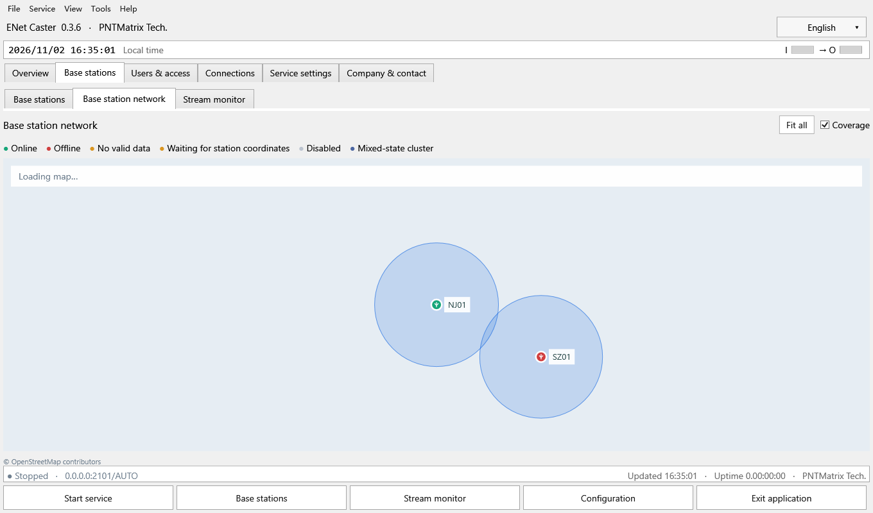
Figure 5 Base station map (example page)
Control or field | Meaning and operation
Fit all | Fits positioned bases.
Coverage | Toggles blue circles only; it does not change configured coverage or routing.
Online / offline | Green means Online; red means Offline.
Abnormal / disabled / clusters | Orange means no valid data or waiting for coordinates; gray means disabled; blue can mark mixed-status clusters.
Hover card | Name, code, state, group, format, position, radius and runtime stream details; clusters show summaries.
Pan / zoom / locate | Drag to pan and use the wheel to zoom. Double-click or right-click a base to locate its management record.

Procedure and verification
1. Read the legend before interpreting colors; blue circles are coverage, not health.
2. Hover over an icon for details. Pan, zoom or leaving the icon closes the card.
3. If tiles fail, inspect network and tile configuration. Tile failure does not stop RTCM forwarding.

09 Stream monitoring and bulk recording
Open Base stations > Stream monitor. This page monitors original source input and supports recording multiple bases. Enabled actions depend on the checked rows and their recording state.
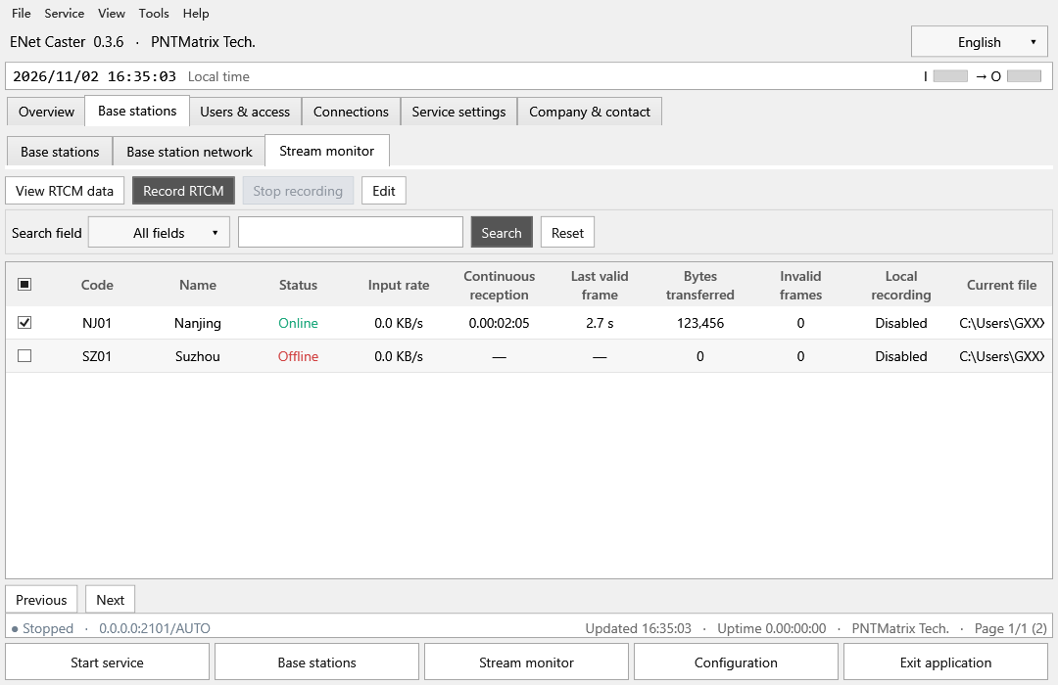
Figure 6 Stream monitoring and bulk recording (example page)
Control or field | Meaning and operation
Input rate / reception duration | Recent input rate and continuous valid-reception interval; reconnects start a new interval.
Last valid frame / bytes | Frame age and runtime byte counters, not total disk-file size.
Checksum errors | Invalid-frame count; continuing growth needs link and format checks.
Local recording / current file | Recording state, output path or write error.
Save RTCM / Stop saving | Apply to all checked targets. Stopping recording does not stop delivery.
View RTCM / Edit | Require one checked base.

Procedure and verification
1. Check the required bases and choose Save RTCM.
2. Verify recording state and current file; set the shared recording root in Service settings.
3. Example: recordings/20261102/LYSK_001_20261102.rtcm3. Local dates define folders; names include base name, code and date. Same-day reconnects append; midnight starts the next date.
4. Stop saving flushes queued writes. Ensure the target is writable and has free space.

10 RTCM message viewer
Check one base and choose View RTCM data. The RTKLIB-style monospaced view describes message headers and selected metadata. It is not a complete GNSS observation decoder and does not calculate a position solution.
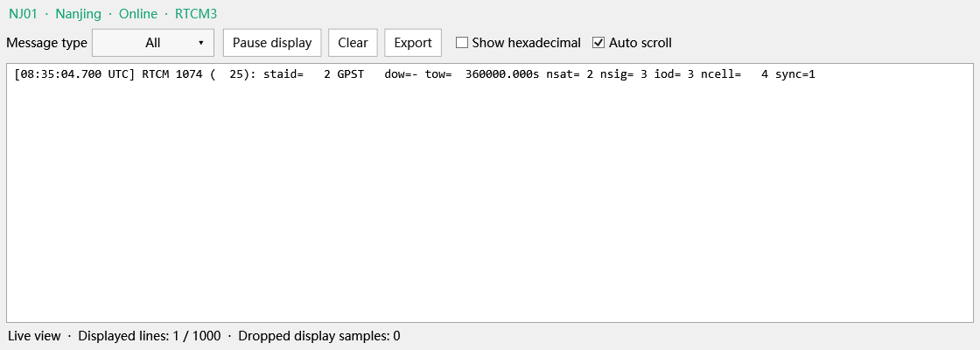
Figure 7 RTCM message viewer (example page)
Control or field | Meaning and operation
Message type | All or a type observed so far; new types appear with input.
Pause / Clear | Pause display consumption without stopping ingestion; Clear removes only the display cache.
Export / Hexadecimal | Export visible text and optionally append full-frame hexadecimal lines. This is not raw RTCM recording.
UTC / RTCM / staid | UTC reception time, message type and byte length, and RTCM station ID.
GPST / GST / BDT / GLOT | Message time system. tow is a message time field, not a complete calendar timestamp.
nsat / nsig / ncell / sync | MSM satellite, signal and cell counts and continuation flag; other messages may omit them.

Procedure and verification
1. Confirm the base code at the top.
2. Filter by type and disable Auto scroll for manual reading.
3. Dropped display samples indicate viewer-buffer pressure, not necessarily forwarding loss; cross-check connection diagnosis.

11 Users and access list
This list manages correction-service accounts, not management sign-in accounts. Active means enabled and within the service period; inspect Connections to determine actual delivery.
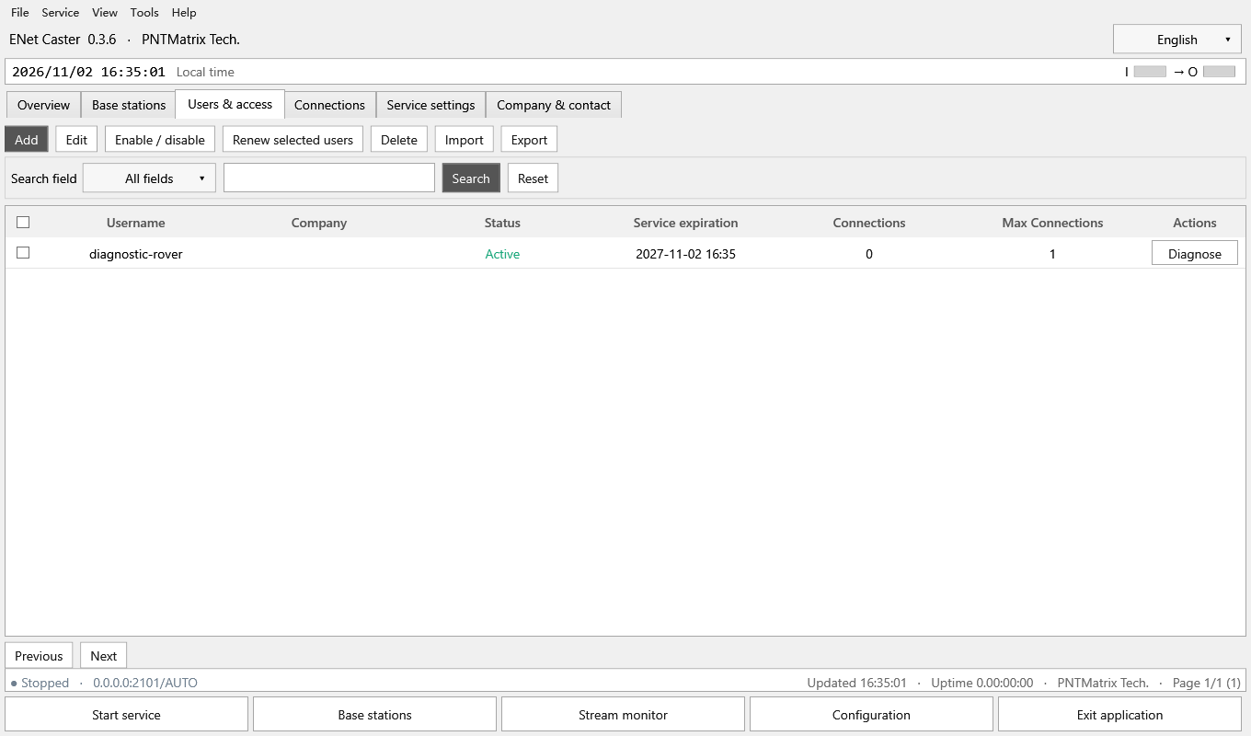
Figure 8 Users and access list (example page)
Control or field | Meaning and operation
Username / company | Account identifier and customer organization.
Status / expiration | Active, disabled, scheduled or expired; no expiry means never expires.
Connections / limit | Current sessions and per-account cap; the global cap also applies.
Add / Edit / Delete | Create, edit one checked account, or delete checked accounts after confirmation.
Enable / disable and Renew | Apply to checked accounts; renewal accepts 1–36500 days.
Diagnose / Import / Export | Row-specific diagnosis and CSV maintenance; exports omit passwords.

Procedure and verification
1. Search by a selected field and check accounts for bulk actions.
2. Renewal extends a future expiry; expired or never-expiring accounts are renewed from the current time.
3. Account changes do not rebuild base sources. Existing disabled or expired sessions are handled by periodic checks.

12 User form and service rights
The form groups identity, contact information, service period and permissions. New accounts require a password; leave it blank during editing to retain the existing password. Dates are displayed in the local time zone.
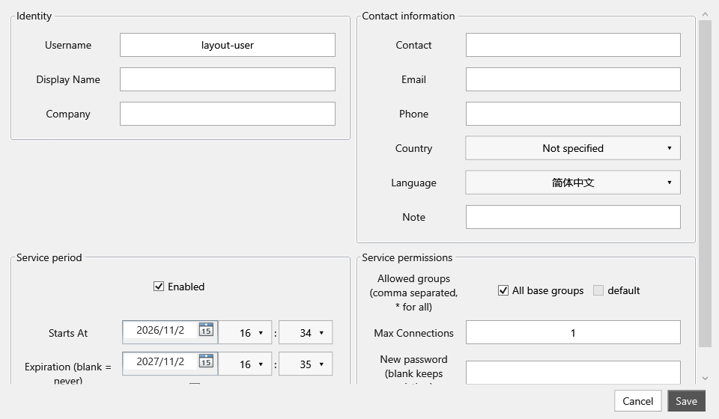
Figure 9 User form and service rights (example page)
Control or field | Meaning and operation
Username | 1–64 ASCII letters, digits or _ . @ -; unique and case-sensitive.
Display name / company / contact | Management information, not the NTRIP username.
Email / phone / region / language | Contact and account metadata; email and phone formats are checked.
Enabled / start / expiry | Must be enabled and within the service period. Expiry must be after start; Never expires is available.
Allowed groups | All groups means *. Otherwise select permitted base groups; a mismatch excludes bases.
Connection limit / password | Per-account cap 1–100000; new passwords need at least 8 characters. Use independent passwords.

Procedure and verification
1. Enter the username, group rights, service period and connection cap.
2. Set a new password and save. Give the customer credentials and the public endpoint.
3. The database stores salted PBKDF2 hashes. User export cannot recover a password; set a new one if lost.

13 Bulk user import and handover
The GUI Import reads CSV and matches records by Username. Existing usernames are updated, so back up and inspect the headers and rows first. Exports omit Password; importing an export cannot supply passwords for new accounts.
Control or field | Meaning and operation
CSV headers | Use model names such as Username, Company, Enabled, StartsAt, ExpiresAt, MaxConnections, Groups and Password.
Dates / booleans | Prefer ISO 8601 with an offset and True/False. Leave ExpiresAt empty for no expiry.
Groups / passwords | * allows all groups. New users need a valid Password; PasswordHash is not an accepted GUI column.
Duplicate behavior | GUI CSV updates matching usernames. Offline --import-accounts rejects the entire batch on duplicates.
Offline hash package | Special JSON contains hashes, not plaintext. Exit the application first; import takes the instance lock and backs up before appending.
Verify | Check totals, first/last names, expiry, limits and original accounts. Keep credential packages private.

Procedure and verification
1. Example CSV header: Username,Company,Enabled,StartsAt,ExpiresAt,MaxConnections,Groups,Password. Keep real credentials and customer details out of public manuals.
2. For the separate 100-account package, follow its private README. CLI arguments are --import-accounts file --data data-root --result result-file.
3. Exit normally before offline import. Do not bypass the lock or directly edit a live SQLite file. Reopen and verify after success.

14 Connections and delivery state
Open Connections > Connection list. An account can have multiple sessions within its per-account and global caps. Select one connection to disconnect it. Each Diagnose button always targets its own row.
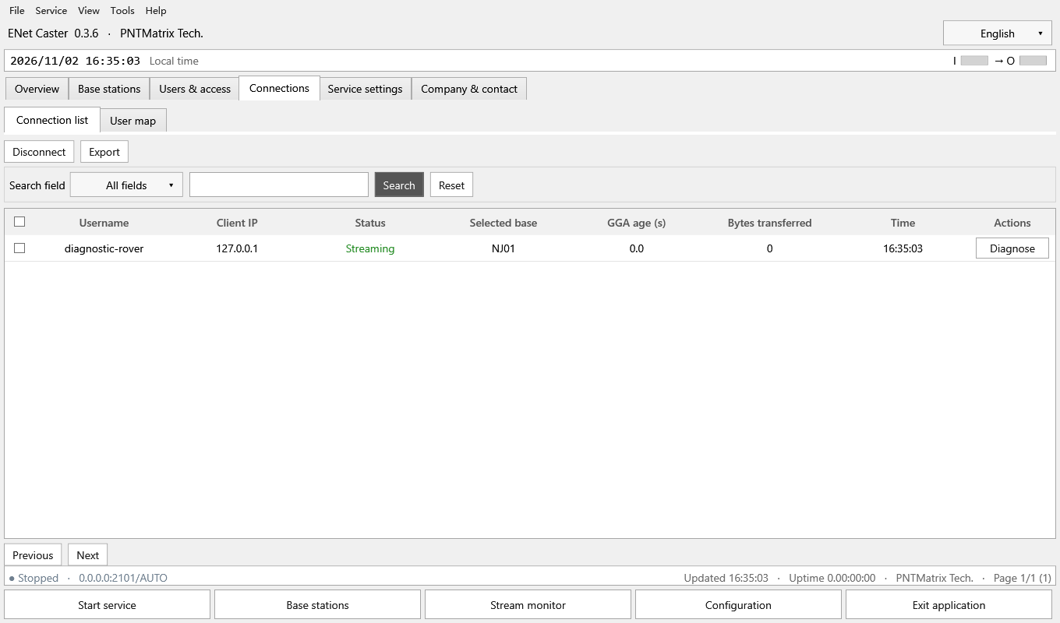
Figure 10 Connections and delivery state (example page)
Control or field | Meaning and operation
Green | GGA is current, an eligible base is selected and RTCM was recently written to the connection.
Yellow | Waiting for GGA, no eligible base, first data pending, stale GGA or stalled delivery.
Client IP / selected base | Remote endpoint and selected source. Diagnose a missing base.
GGA age | Time since the last accepted GGA; invalid or repeated-time GGA does not refresh position.
Bytes / time | Bytes written during the session and connection start time.
Disconnect / Export | Disconnect one selected session or export a session summary.

Procedure and verification
1. Check GGA age and the selected base, then confirm that bytes increase.
2. Choose the row’s Diagnose action for yellow sessions and inspect candidate exclusions.
3. Green means the caster recently wrote data; it is not a receiver acknowledgement or proof of a fixed solution.

15 User map and layer buttons
Open Connections > User map. User markers and labels render above bases and coverage. At overlaps, users receive hover, double-click and right-click priority. Layer buttons control presentation only, not authorization or base service.
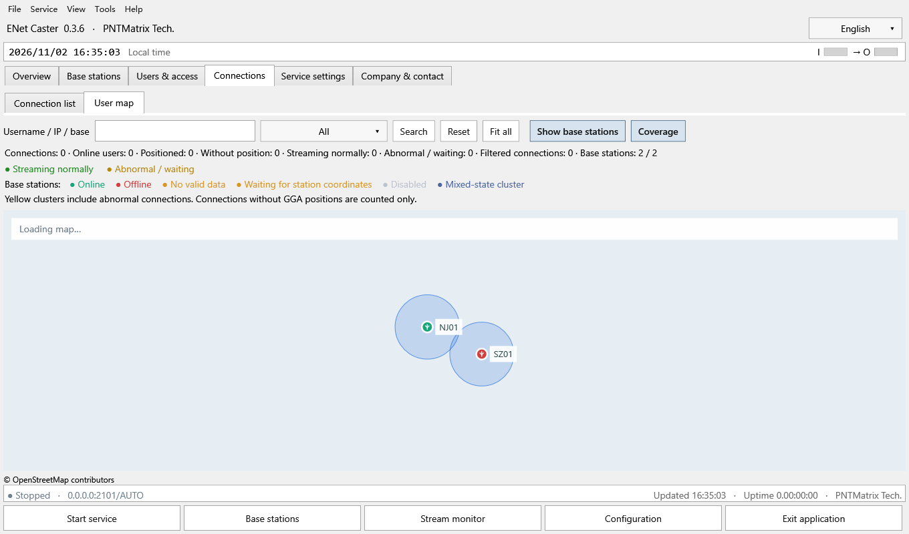
Figure 11 User map and layer buttons (example page)
Control or field | Meaning and operation
Show base stations | Pressed blue-gray shows base icons and labels. White hides them and disables base hit testing.
Coverage | Independently shows or hides blue base circles. It is separate from base icons.
User-only view | Turn both buttons off. Fit all then fits filtered users only.
Search / status | Search username, IP or selected base and filter normal/abnormal sessions. User filters retain enabled base layers.
Counts / no position | Shows sessions, distinct accounts, positioned/unpositioned and health/filter counts; missing positions contribute counts only.
Clusters / diagnosis | Dense users aggregate with counts; any abnormal member makes the cluster yellow. Activate one user for diagnosis or a cluster to zoom.

Procedure and verification
1. Choose Fit all and locate the user or cluster.
2. Turn off Show base stations and Coverage to reduce clutter. Their state survives navigation and language changes in the current run.
3. The map takes lightweight snapshots about every 2 seconds, culls the viewport and aggregates in a 48-DIP grid; it does not create a WPF control per user.

16 Per-user diagnosis and coverage
Open Diagnose on a user or connection row. Select the current or a historical session at the top and distinguish live status from historical snapshots. Retained history can be available without a live connection, subject to retention.
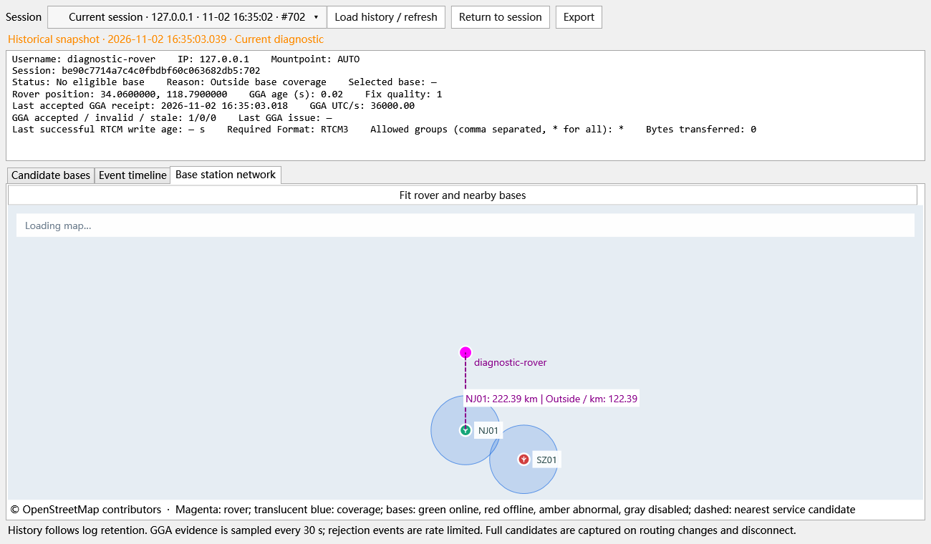
Figure 12 Per-user diagnosis and coverage (example page)
Control or field | Meaning and operation
Summary | Account, session, IP, public mount, state, GGA counters, position and recent writes.
Candidate bases | Eligibility, distance, radius, group, format and exclusion reasons.
Event replay | Key selection, disconnect and GGA-rejection events; select an event to inspect its snapshot.
Base map | Magenta user, blue coverage circles, and a dashed line to a suitable nearest candidate with distance and shortfall.
History / return / export | Load archived evidence, return to session status, or export diagnosis.

Procedure and verification
1. Check GGA validity and age, then candidate rejection reasons.
2. Treat coverage as the primary cause only when OutsideCoverage is the sole rejection. At 45 km distance and 30 km radius, the shortfall is 15 km.
3. Also resolve offline sources, missing data/coordinates, format and group exclusions. Do not merely enlarge coverage. Historical GGA evidence is sampled, not a full trajectory.

17 Service listener settings
Open Service settings > Service settings. Save changes and restart when prompted for listener, source or timeout changes. Port or TLS changes also require rover configuration updates.
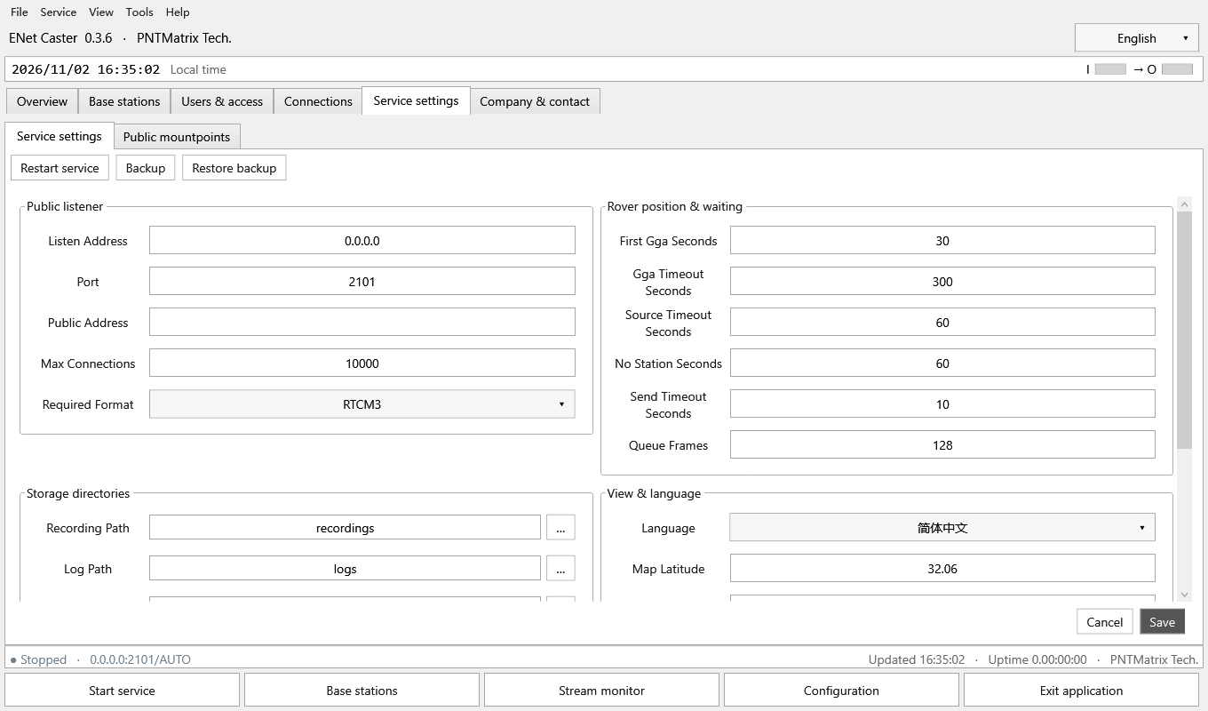
Figure 13 Service listener settings (example page)
Control or field | Meaning and operation
Local listen IP | Must be bindable on this host. 0.0.0.0 listens on all IPv4 interfaces and is not the remote address given to customers.
Port | 1–65535; default 2101, subject to deployment configuration.
Public domain / IP | Displayed public endpoint; does not configure NAT, routing or firewall rules.
Max connections | Global cap independent of account caps. The input range is not a performance guarantee.
Service format | RTCM3 or RTCM2; incompatible sources are excluded.
Save / Restart | Save first, then restart. Restart interrupts active sessions; allow clients to reconnect.

Procedure and verification
1. Confirm that the host owns the listen IP and the port is free.
2. Set and save the service format; ensure at least one public mount is enabled.
3. Start the service and validate locally or on the LAN before checking external reachability.

18 Timeouts capacity and storage
These are factory defaults, not necessarily the saved deployment values. Timeouts use seconds. Paths may be absolute or relative to the data root. Do not enter the database filename into a directory field.
Control or field | Meaning and operation
First GGA 30 | Wait for a valid GGA after connection.
GGA expiry 300 | Disconnect after the latest accepted, advancing GGA expires.
Source timeout 60 | A source is ineligible after valid RTCM becomes stale; this is not TCP keepalive.
No base wait 60 | Close a positioned session that has no eligible source for too long.
Send timeout 10 / queue 128 | Bound slow-session waits and buffered frames. Full queues or timeouts may close a session.
Recording / logs / backup / map cache | Defaults: recordings, logs, backups and map-cache under the data root.
Log retention / size | Defaults: 30 days and 512 MB. Backend evidence supports diagnosis; the log page is removed.

Procedure and verification
1. Adjust to actual GGA cadence and link behavior rather than extending timeouts merely to keep sessions connected.
2. Check disk space and write access for recording. Relative paths move with the data root.
3. After saving and restarting, validate stale-source, GGA and slow-client behavior.

19 Map settings and TLS
Scroll down in Service settings to reach map and certificate parameters. Map access is independent of NTRIP delivery; changing a tile source does not change user or base positions.
Control or field | Meaning and operation
Language / map center | Initial language and map center; not a service-area boundary.
Zoom | Initial level 2–17. Fit all can refit actual markers.
Tile URL | HTTPS template containing {z}/{x}/{y}; OpenStreetMap is the default.
Attribution / link | Retain the provider’s attribution and copyright link; update them when changing provider.
TLS PFX | Expand certificate settings and select PFX/P12. An empty path uses plaintext listening.
Certificate password | Blank keeps the existing value. With a certificate, the public listener uses TLS and clients must match.

Procedure and verification
1. Check the provider URL, network reachability and cache directory. Tile status does not determine caster delivery health.
2. Prepare a valid certificate and confirm rover and pushed-source TLS support.
3. Save, restart and verify with a matching TLS client. Changing a mountpoint does not switch TLS mode.

20 Public mountpoint management
Open Service settings > Public mountpoints. These are shared automatic-selection endpoints, not fixed-base mounts. Multiple public mounts use the same format, access rules and nearest-base logic.
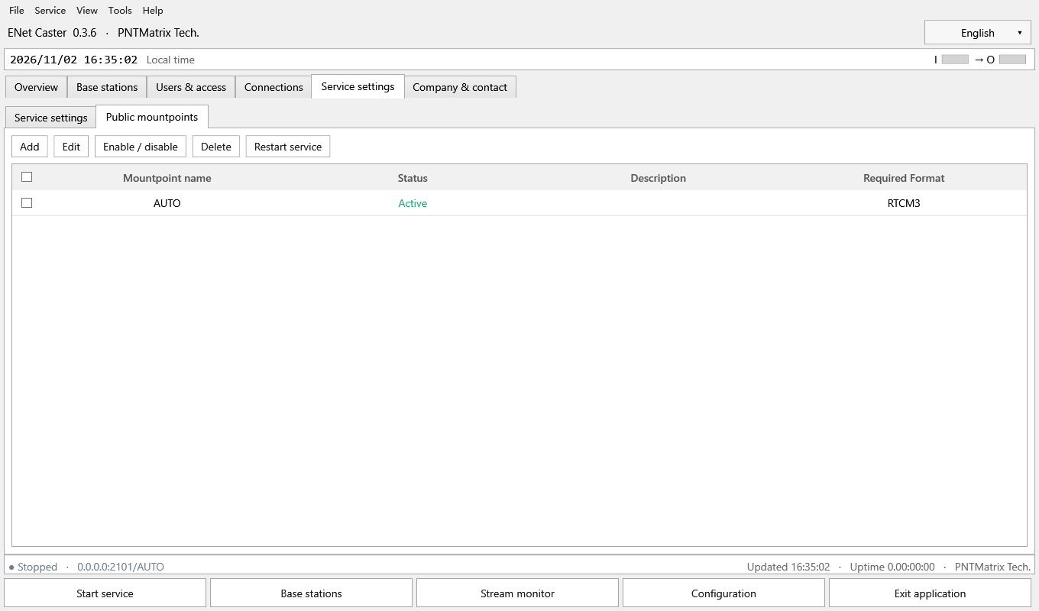
Figure 14 Public mountpoint management (example page)
Control or field | Meaning and operation
Name | 1–80 ASCII letters, digits or _ - .; unique and case-sensitive.
Enabled / description | Enabled endpoints accept clients; description up to 120 characters without semicolons or line breaks.
Count / active endpoint | 1–64 entries with at least one enabled; changes cannot disable them all.
Push-source relationship | Public names must not collide with base upload mountpoints.
Add / Edit / Enable / Delete | Act on one selected mount; deletion requires confirmation.
Restart | Restart when prompted; rovers must use the exact enabled name.

Procedure and verification
1. Add a name such as AUTO or NEAREST, enter a description and enable it.
2. Save, inspect state and format, then restart.
3. Configure the public name on rovers and upload GGA. Do not use a base’s BASE01 upload mount as a public rover endpoint.

21 Backup restore upgrade and exit
The default data root is the current Windows user’s %LOCALAPPDATA%/PNTMatrix/ENetCaster. --data selects a custom root; --portable uses data beside the EXE. Opening the wrong root may show an empty database and does not imply that previous accounts were lost.
Control or field | Meaning and operation
Backup | Service settings > Backup creates a SQLite backup and displays its actual path.
Restore | Choose a trusted .db and confirm. Service is stopped, the current database is backed up, then backup content is loaded.
Move data | Exit first and preserve the complete database and related directories; relative paths follow the new root.
Secret portability | User passwords are hashes; upstream secrets use Windows DPAPI and may need re-entry under another user/computer.
Recordings / customization | Retain recordings and customization separately; a database backup does not include every related directory.
Exit / tray | Normal close and Exit stop service and release the port. Only explicit Hide to tray keeps running.

Procedure and verification
1. Record version, architecture, launch arguments and the actual data root; make a backup.
2. Exit the old process before installing or extracting the update; use the intended existing data root.
3. Verify bases and accounts before starting. Test one rover. Start service explicitly after restoration.

22 Layout language and company details
Company & contact shows brand, profile, website, support email and copyright. Empty phone and address values are omitted in the sample. The Interface resources page is removed; layout controls are in the View menu.
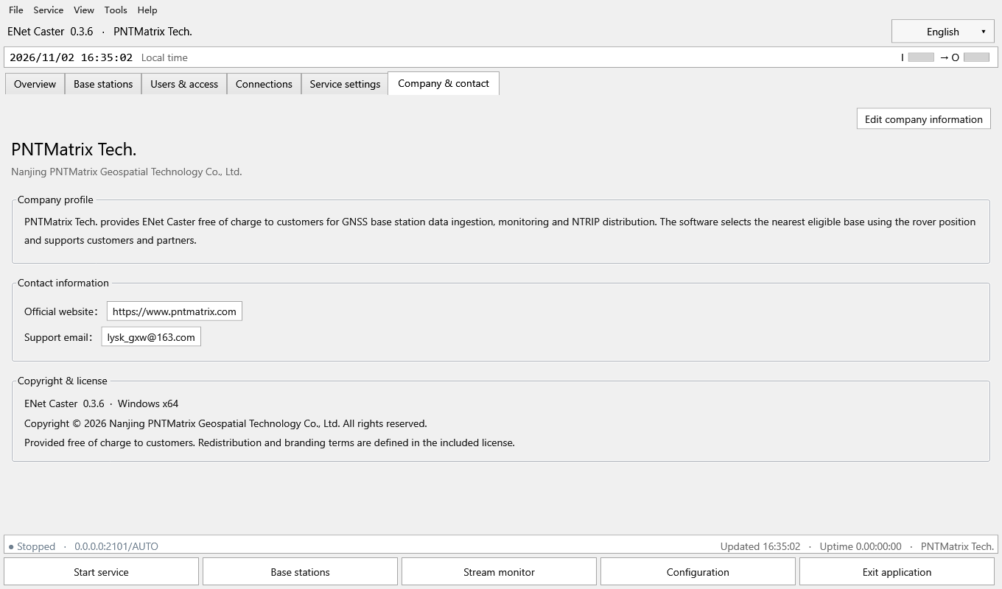
Figure 15 Layout language and company details (example page)
Control or field | Meaning and operation
Edit company details | Set legal name, brand, Chinese/English profiles, website, email, phone and address.
Website / email | Website must use HTTPS; email and phone are validated on save.
Language selector | Choose Simplified Chinese or English. Pages rebuild; user-map layer choices remain.
View menu | Layout settings adjust Overview panel order and width/height weights; reset restores defaults.
Copyright / distribution | Free use and redistribution follow LICENSE-BINARY. Source delivery does not automatically authorize public release.

Procedure and verification
1. Save accurate company details and review both profiles and contact information.
2. Use View > Layout settings for Overview proportions; this is not an arbitrary drag-and-drop editor for every control.
3. Retain licensing, third-party notices and attribution. Keep credentials, databases and actual user positions private.

23 Troubleshooting sequence
Investigate in order: connectivity, valid input, coordinates, rights, distance and delivery. Recent events and per-user diagnosis provide evidence, but sampled/retained history is not a record of every raw byte.
Control or field | Meaning and operation
Service will not start | Check bind IP, port conflicts, certificate path/password and data-directory permissions.
NTRIP pull offline | Check direction, reachability, port, mountpoint case, credentials, version and TLS; read connection details first.
Connected but no valid data | Check format and checksums. Heartbeats or generic network bytes are not RTCM.
Waiting for coordinates | Ensure 1005/1006 or RTCM2 type 3 is transmitted; use verified manual coordinates if appropriate.
Account cannot connect | Check username case, password, service period, enabled state, account/global caps and public mount.
No base / out of range | Inspect format, groups, health and coordinates, then distance and radius; do not only enlarge coverage.
Yellow / bytes not increasing | Check accepted GGA, last successful write, stale source, first-frame wait, slow link and queue closure.
Map / recording failure | Check HTTPS tiles and cache for maps; permissions, disk space and file errors for recording. Investigate separately from routing.

Procedure and verification
1. Record the time, version, user, public mount and base without publishing passwords.
2. Export user-specific evidence from Diagnose; use Tools > Export diagnostics for environment information.
3. Validate capacity with actual bitrate, TLS, network and duration. The local synthetic 10,000-user short run is not public-network endurance certification.

