Title
A machine learning approach to measure energ savings in smart buildings
Applied data analytics in smart buildings for measuring energy savings
Authors
xxx
Abstract
Many efforts from several organisms are focused on the increasement of energy efficiency. It is on the interest of everybody, from particulars to governments, since energy efficiency yields to economical savings for households and companies, reduces greenhouse gas emissions benefiting environment, helps alleviate energy poverty and contributes to growth and jobs.
Before implementing an energy efficiency solution, it is neccesary to define the relationship which exists between energy use and the current operating conditions in order to determine energy savings that result form the implementation of the solution.
We propose a machine learning approach for the creation of an energy consumption prediction model that is used to estimate the energy consumption in normal operation state, i.e., if the system would not have been altered by the solution. This allows us to compare the predicted for normal operating state and the actual consumption in order to quantify the energy savings.
Our method shows better prediction accuracy than the so-called white box methods.
(...)

Introduction
- Why electricity demand forecasting is useful for measuring energy savings
-Why daily and weekly is our interest
-Expalin why we choose data analytics approach (lots of data)

With recent advances in sensor and communication technologies, the generation of data about our surrounding environment and ourselves is explosively growing in terms of \emph{velocity}, \emph{variety} and \emph{volume} \cite{ali2014}. The treatment of huge data sets challenges traditional technologies and promotes the emergence of \textbf{Big Data} tools in order to capture, store, manage and analyze such data. In this context, \textbf{Internet of Things (IoT)} is one of the key enablers of \textbf{Smart Cities}. We are part of a new \emph{Era} where sensing technologies are being exploited to create innovative services for Citizens and Service Providers.

Related work

-Explain other works of electricity demand forecasting. Make a judgment of the weaknesses and strengths of each one. Mentionning them is not enough.

Most of the building energy systems are complex nonlinear systems, which are strongly influenced by weather conditions, building operating modes, and occupant schedules.
Energy forecasting models for building energy systems are essential to building energy control and operation. Three general categories of building energy forecasting models have been reported in the literature which include white-box (physics-based), black-box (data-driven), and gray-box (combination of physics based and data-driven) modeling approaches

Weakness: they are focused on future prediction. That way, they normaly use past values of consumption (last week, previous similar day…) but cannot use it now. However, we don't need forecasting weather since we can use the real one.

-Group all the weaknesses of the previous works and use that to justify the work you will be doing here
Methodology
[Describe the data you are going to use]

In order to predict energy consumption, we use hourly historical data of consumption from power meters. Also, we collect outdoor environmental conditions using the meteorological station.
[Describe the method you are going to use]
We are using time series
[Describe the application of the methods to the data]
Results

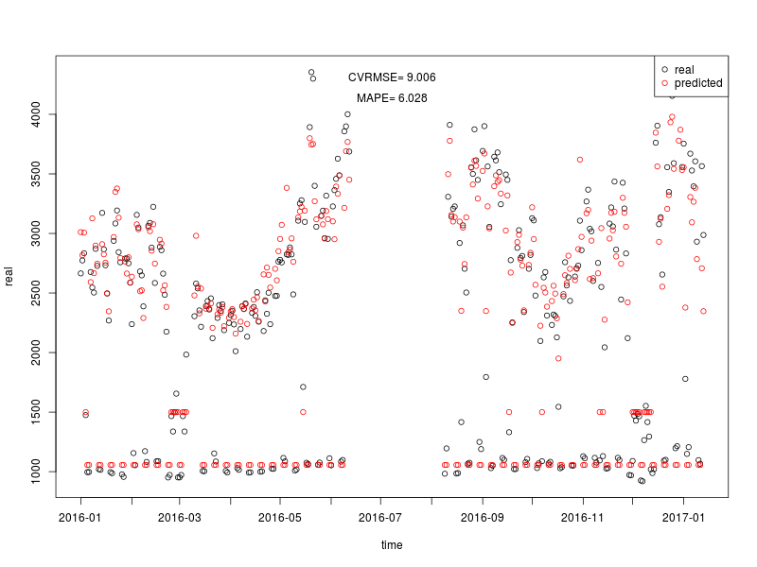
Conclusions

