A SYSTEMATIC REVIEW OF EVENT TECHNOLOGIES IN THE CONTEXT OF SMART TOURISM: TRENDS AND FUTURE DIRECTIONS

ABSTRACT
This study presents a systematic review of the integration of emerging digital technologies in smart tourism events, with the purpose of understanding how technological innovation is transforming event design, management and visitor experience. The review examines peer-reviewed journal articles and conference proceedings published between 2014 and 2024 and indexed in the Scopus and Web of Science databases. The analysis was conducted using the Bibliometrix package in the R environment, while descriptive and thematic analyses were performed with the Statistical Package for the Social Sciences. The findings show that several technological domains, including Artificial Intelligence, the Internet Of Things, Big Data analytics and immersive technologies, are driving significant advances in the development of smart tourism events. These technologies support improvements in personalisation, behavioural analysis, sustainability, accessibility and real-time decision making. The review also reveals conceptual fragmentation, methodological diversity and geographical imbalances across the existing literature. Overall, this study contributes to consolidating the theoretical foundations of smart events and identifies promising directions for future research and innovation within technology-enhanced tourism event ecosystems.

KEYWORDS
Smart Tourism, Emerging Technologies, Artificial Intelligence, Event Management, Smart Technologies, Systematic Review.

- Introduction
In recent years, the notion of Smart Tourism has garnered considerable attention, as the tourism industry has come to adopt technological advancements with the goal to enhance the visitor experience and promote sustainable development (Buhalis & Amaranggana, 2013; Gretzel, Werthner, et al., 2015; Jovicic, 2019; J. Liu et al., 2024; Pencarelli, 2020; Wael et al., 2023). According to Gretzel et al. (2015) is a concept that leverages advanced technologies to transform data from physical infrastructure, social connections, and organizational sources into enriched tourism experiences and valuable business propositions, with a focus on sustainability, efficiency, and personalization.

Extensive research has analysed the multifaceted dimensions of Smart Tourism, which encompass technological (Huang et al., 2017; Jeong & Shin, 2020; Pai et al., 2020, 2025; Um & Chung, 2021), social (Cacho et al., 2016; Lam et al., 2020; Liberato et al., 2018; Poli et al., 2024; Tlili et al., 2021; Zhou et al., 2024), economic (Kuandykovna Suyendikova et al., 2022; Lee & Hlee, 2021; O’Connor, 2023; Pujakusumah et al., 2024; Shanmugam et al., 2024), and environmental aspects (El Archi et al., 2023; Flores-Crespo et al., 2022; Gelbman, 2020; Hiererra et al., 2023; Saputra, 2023). These interrelated dimensions collectively contribute to the development of a more intelligent, sustainable, and efficient tourism ecosystem.

Smart Tourism approaches are applied across a diverse range of contexts and scenarios, all aimed at enhancing visitor experiences, optimizing resource management, and promoting sustainability. Key areas of Smart Tourism implementation include Smart Cities (Gelbman, 2020; Habeeb & Weli, 2020; Ismagilova et al., 2019; Khan et al., 2017; Kuandykovna Suyendikova et al., 2022; Lopes & Oliveira, 2018; Matos et al., 2019; Parameswaran et al., 2021; Salmi & Hmioui, 2024; Um & Chung, 2021; Wael et al., 2023), cultural and natural heritage sites (Angelaccio et al., 2013; Balakrishnan et al., 2023; Berjozkina & Kuruvilla, 2023; Chung et al., 2015, 2018; dos Santos, 2022; Li et al., 2022; T. T. Nguyen et al., 2017; Oxoli et al., 2019), rural destinations (Ballina, 2022; Cvar et al., 2024; Inversini et al., 2024; Luo, 2024; Sustacha et al., 2024; Torabi, Pourtaheri, et al., 2023; Torabi, Rezvani, et al., 2023), shopping districts (Al-Sulaiti, 2022; Garcia-Milon et al., 2020; Wanyi, 2021), event and festival venues (Boodnah et al., 2016; Cimbaljević et al., 2021; Dalli & Bri, 2016; M & P, 2024; T. Nguyen et al., 2020; Sebata & Mollah, 2022), transport (Battarra et al., 2018; Bogicevic et al., 2017; Burlacu et al., 2022; Marchesani et al., 2023), or smart accommodations (Buhalis et al., 2023; Cumlievski et al., 2022; Gautam et al., 2017; Pachoulas et al., 2024).
In this context, Smart Tourism is characterized as a crucial tool that harnesses emerging technologies, including the Internet of Things (IoT), Artificial Intelligence (AI), and Big Data Analytics, to optimize tourism management and personalize as well as enhance the tourist experience (Aliyah et al., 2023; Ferras et al., 2020; Gajdosik & Marcis, 2019; Kang & Jwa, 2018; Kontogianni et al., 2018; Kontogianni & Alepis, 2022; Y. Liu & Niu, 2024; Ramos et al., 2016; Stroumpoulis et al., 2022; Suanpang & Pothipassa, 2024). These technologies have revolutionized the way various aspects of tourism are managed and experienced, particularly in dynamic domains such as events, which have become a pivotal component in attracting visitors, stimulating local economies, and positioning destinations in an increasingly competitive and digitalized environment. Events are recognized as crucial components of tourism from both demand and supply perspectives (Getz, 2008, 2010; Getz & Andersson, 2009; Getz & Page, 2024; Gursoy & Kendall, 2006; Tuck & Xinyi, 2023).
In their research, Getz & Page (2014) emphasize the significance of events within the tourism domain, redefining the concept of event tourism to encompass a broad range of planned events, including festivals, sporting competitions, conferences, and mega-events. The application of smart technologies in events and festivals can significantly impact various areas, such as visitor management and safety, event logistics, and environmental sustainability. Celuch (2021) examined the role of Information and Communication Technologies (ICTs) in event management and their potential for sustainability. His study identifies key areas for future research, including virtual events, Artificial Intelligence, Big Data Analytics, and Augmented or Virtual Reality.
Despite the interest in event tourism as a research area, there is a significant gap in the literature on the application of emerging technologies in events and festivals. In light of this, this paper attempts to analyse the concept of Smart Event in the context of Smart Tourism. The aim is to identify and analyse trends, emerging technologies and lines of research associated with the term, particularly in relation to the Smart Event/Smart Music Festival. More in detail, this study addresses the following research question: “How have emerging technologies applied to events and festivals evolved within the context of Smart Tourism?”
To achieve the objective of the study, a systematic literature review methodology was used. The following sections will describe the methodology applied in this review. Afterward, a bibliometric analysis related to the use of emerging technologies in events within the framework of Smart Tourism will be presented. Next, the most commonly used technologies in events will be discussed. Then, possible future research directions in terms of theories, sustainability, and management strategies will be proposed. Finally, the conclusion will address the theoretical and practical implications for planning and managing Smart Events.
Furthermore, this review provides a practical perspective for event planners, destination managers and marketing professionals, providing strategies to enhance the impact of events in the context of Smart Tourism. This includes the possibility of incorporating emerging technologies, fostering sustainability and maximizing economic and social return while applying current trends in tourism.
- Methodology
To conduct a literature review, a systematic methodology is utilized to locate, select, and evaluate pertinent studies on the given topic, with the aim of providing a comprehensive understanding of the current state of knowledge (Bandara et al., 2015; Fisch & Block, 2018; Xiao & Watson, 2019). This review followed a two-stage methodological approach. The first phase entailed the identification, close reading and comprehensive understanding of relevant academic sources. The second phase involved a bibliometric analysis of the selected articles, conducted using SPSS and Biblioshiny powered by R Studio.
The selected databases were Web of Science (WoS) and Scopus (Birkle et al., 2020; Pranckutė, 2021). The data collection process took place between September 2024 and October 2024. To mitigate potential bias in the study selection, the following inclusion criteria were established: (1) The studies included in this review were from 2014 to September 2024 and had to directly contribute to the stated research objective, excluding those with a primary focus outside it. (2) Only articles and Conference Proceedings indexed in CORE and written in English were selected. (3) The selected studies focused on the application of emerging technologies in events or music festivals within the context of Smart Tourism or on the impact of technological tools on attendee experience, event management, and sustainability. Studies addressing other characteristics not related to events or aspects unrelated to information technology or digitization were excluded.
All selected studies met all three criteria. Additionally, all studies included in the review were read and evaluated for their alignment with the research objective.
To conduct a comprehensive literature search for this study, structured queries were formulated by combining three groupings of search strings:
Grouping 1: events and festivals in the context of Smart Tourism.
Grouping 2: emerging technologies applied to the concept of Smart Tourism.
Grouping 3: emerging technologies applied to event management.
This grouping strategy aimed to capture a comprehensive range of relevant studies. The search was conducted across the Web of Science and Scopus databases, focusing on the title, abstract, and keyword fields (Table 1).
The construction of the groups involved the use of the 'AND' operator to combine the key concepts.
Table 1. Search strings
EVENTS AND FESTIVALS IN THE CONTEXT OF SMART TOURISM
"Smart Tourism" AND "Events"
"Smart Tourism" AND "Festival"
“Smart Cities” AND “Events”
EMERGINGS TECHNOLOGIES APPLIED TO THE SMART TOURISM CONCEPT
"Smart Tourism" AND "Artificial Intelligence"
"Smart Tourism" AND "Blockchain"
"Smart Tourism" AND "Internet of Things"
"Smart Tourism" AND "Virtual Reality"
"Smart Tourism" AND "Platform"
"Smart Tourism" AND "Big Data"
EMERGING TECHNOLOGIES APPLIED TO EVENT MANAGEMENT
"Crowd Management"
"Event Management" AND "Artificial Intelligence"
"Event Management" AND "Blockchain"
"Event Management" AND "Internet of Things"
"Event Management" AND "Virtual Reality"
"Event Management" AND "Platform"
"Event Management" AND "Big Data"
Source: Own elaboration

At the end of this phase, the literature search generated 183 records. A total of 146 remained after eliminating duplicates. 76 of these items were eliminated because they were not related to the object of the study or did not meet any of the inclusion criteria. Therefore 58 articles and 12 Proceedings Papers in CORE were retrieved. Of these 70, a cross-check was carried out to exclude 4 (Figure 1). The reporting format adheres, with minor adaptations, to the Preferred Reporting Items for Systematic Reviews and Meta-Analyses (PRISMA) (Page et al., 2021).

Figure 1. Literature search overview

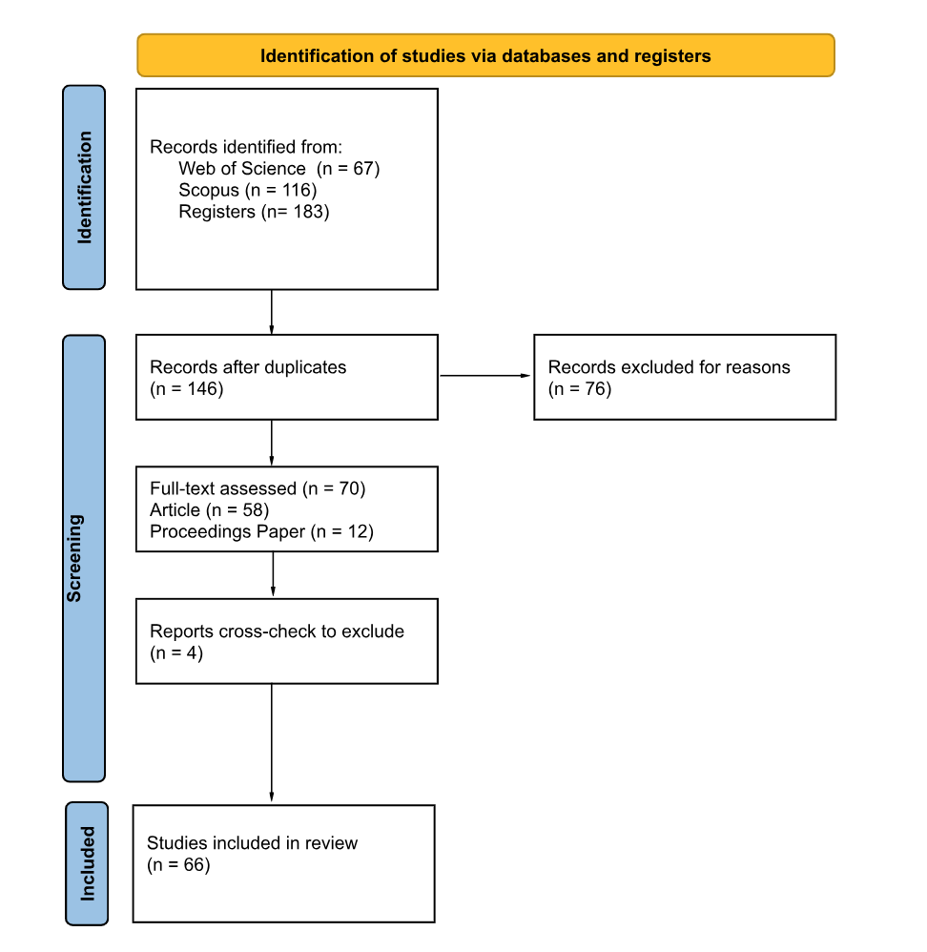
Source: Own elaboration

Table 2. Identified Journals
Journal title | Count | Share (%)
ACM Transactions On Intelligent Systems And Technology | 1 | 1,79
Asia Pacific Journal Of Tourism Research | 2 | 3,57
Asian Journal Of Pharmaceutical And Clinical Research | 1 | 1,79
Case Studies In Fire Safety | 1 | 1,79
Event Management | 6 | 10,71
Expert Systems With Applications | 1 | 1,79
Frontiers In Ecology And Evolution | 1 | 1,79
Frontiers In Psychology | 1 | 1,79
Future Internet | 2 | 3,57
Ieee Access | 1 | 1,79
Information Processing & Management | 1 | 1,79
International Journal Of Communication Systems | 1 | 1,79
International Journal Of Consumer Studies | 1 | 1,79
International Journal Of Contemporary Hospitality Management | 1 | 1,79
International Journal Of Event And Festival Management | 3 | 5,36
International Journal Of Hospitality Management | 1 | 1,79
International Journal Of Intelligent Systems And Applications In Engineering | 1 | 1,79
International Journal Of Nonlinear Analysis And Applications | 1 | 1,79
ISPRS International Journal Of Geo-Information | 1 | 1,79
Journal Of Convention & Event Tourism | 4 | 7,14
Journal Of Engineering And Applied Sciences | 1 | 1,79
Journal Of Engineering Research | 1 | 1,79
Journal Of Hospitality And Tourism Technology | 3 | 5,36
Journal Of Internet Services And Applications | 2 | 3,57
Journal Of Sensors | 2 | 3,57
Multimedia Tools And Applications | 1 | 1,79
NEC Technical Journal | 1 | 1,79
Periodica Polytechnica Social And Management Sciences | 1 | 1,79
Quality And Quantity | 1 | 1,79
Sensors | 1 | 1,79
Signal Image And Video Processing | 1 | 1,79
Soft Computing | 1 | 1,79
Sports | 1 | 1,79
Sustainability | 2 | 3,57
Tourism Management | 1 | 1,79
Tourism Management Perspectives | 1 | 1,79
Tourism Planning & Development | 1 | 1,79
Tourism Review | 1 | 1,79
Wireless Personal Communications | 1 | 1,79
Total | 56 | 100,00
Source: Own elaboration
The journals in which the articles were surveyed are listed (Table 2). The articles were exclusively drawn from journals indexed in reputable bibliometric databases, such as the Journal Citation Report and Scimago Journal Rank, to ensure the quality of the sampled articles.
Table 3. Identified Conference Proceedings
Source | ICORE Source | ICORE Rank
ICEIS: Proceedings Of The 19th  International Conference On Enterprise Information Systems - Vol 1 | CORE2018 | C
2018 IEEE International Conference On  Big Data (Big Data) | CORE2023 | B
34th Australasian Conference On  Information Systems, ACIS 2023 | CORE2018 | Australasian
ICC 2020 - 2020 IEEE International  Conference On Communications (Icc) | CORE2018 | B
16th ACS/IEEE International Conference  On Computer Systems And Applications, AICCSA 2019 | CORE2023 | C
Proceedings Of 2016 IEEE 18th  International Conference On High Performance Computing And Communications;  Ieee 14th International Conference On Smart City; IEEE 2nd International  Conference On Data Science And Systems (HPCC/SMARTCITY/DSS) | CORE2023 | C
14th International Conference On Mobile  Systems And Pervasive Computing (MOBISPC 2017) / 12th International  Conference On Future Networks And Communications (FNC 2017) / Affiliated  Workshops | CORE2023 | Unranked
20th IEEE International Wireless  Communications And Mobile Computing Conference, IWCMC 2024 | CORE2023 | B
37th International Conference On  Advanced Information Networking And Applications, AINA 2023 | CORE2023 | B
IEEE International Conference On  Advanced Learning Technologies | CORE2023 | B
Source: Own elaboration
The inclusion of Conference Proceedings in this systematic review is justified by their role in disseminating cutting-edge research on emerging technologies, particularly in the domains of information technology and Smart Tourism (Table 3). According to CORE (Fekete et al., 2021), conference papers capture key trends, present innovative studies prior to journal publication, and demonstrate rigorous methodologies at relevant academic conferences. Incorporating these sources ensures a comprehensive and current analysis of the technological impact on events and festivals in the context of Smart Tourism.
Table 4. Summary of how each methodological step aligns with the research objective
Objective | Methodology
1. Analysis of the temporal evolution of scientific production | Systematic literature review on Smart Tourism technologies applied to events and festivals.
2. Examination of sources, countries, methodologies and research areas | Systematic literature review on Smart Tourism technologies applied to events and festivals.
2. Identification of key technologies | Extraction of recurring technological trends.
3. Proposal of future research directions | Identification of gaps in the literature through thematic analysis.
Source: Own elaboration
- Findings

This section presents the results which are organised as follows: (1) Analysis of the temporal evolution of scientific production, (2) Examination of the most influential sources, countries, methodological contributions and main research areas, (3) Identification of key emerging event technologies in the context of events in Smart Tourism, (4) Thematic structure analysis

3.1 Analysis of the temporal evolution of scientific production
In order to ensure that this review is grounded in pertinent research, the authors include an overview of the publication timelines encompassed in the study. Studies published over the past ten years were included. This temporal dimension is crucial for understanding the evolution of research in Smart Tourism in events and festivals, revealing trends in research focus, the emergence of new themes, and shifts in methodological approaches that might otherwise remain hidden, thus providing a valuable perspective on the development of the field.
Figure 2 shows the integration of Smart Tourism technologies in events. The increasing academic interest in the field can be attributed to the rising significance of Smart technologies in providing tourism consumers and service providers with relevant information, improved decision-making capabilities, enhanced mobility, real-time awareness, and high-quality and personalized tourism experiences in large-scale events (Gretzel, 2011; Luxford & Dickinson, 2015).
Figure 2. Number of publications per year
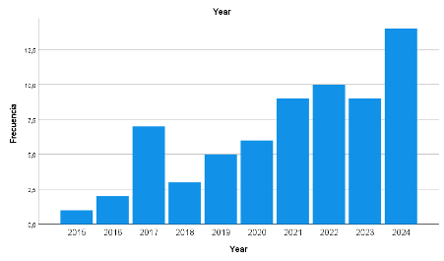
Source: Own elaboration
3.2 Examination of the most influential sources, countries, methodological contributions and main research areas
Figure 3. Most relevant sources
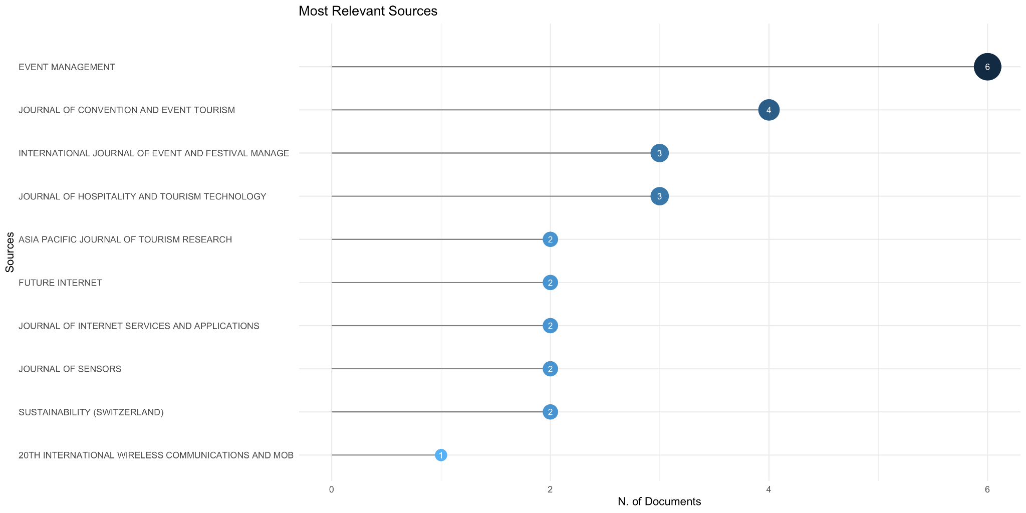
Source: Own elaboration
Figure 3 presents the most significant sources, determined by the number of documents included in the literature review. This analysis allows for the identification of journals that have shown the most interest in the topic, which is essential for understanding the structure of scientific production in this field.
Event Management stands out as the leading journal, contributing 6 publications and thus demonstrating the highest publication volume. The Journal of Convention and Event Tourism follows with 4 articles, succeeded by the International Journal of Event and Festival Management and the Journal of Hospitality and Tourism Technology, both with 3 articles.
Several sources with comparable publication volumes follow, 2 contributions each, including the Asia Pacific Journal of Tourism Research, Future Internet, Journal of Internet Services and Applications, Journal of Sensors, and Sustainability. The remaining publications have a singular contribution, indicating a more sporadic or focused interest.
This indicates that, although a significant number of publications originate from a limited number of specialized sources, there is also thematic diversification, with technology and sustainability-focused journals beginning to publish on the subject, likely within interdisciplinary frameworks such as smart, sustainable, or digital events.
Figure 4. Source’s production over time
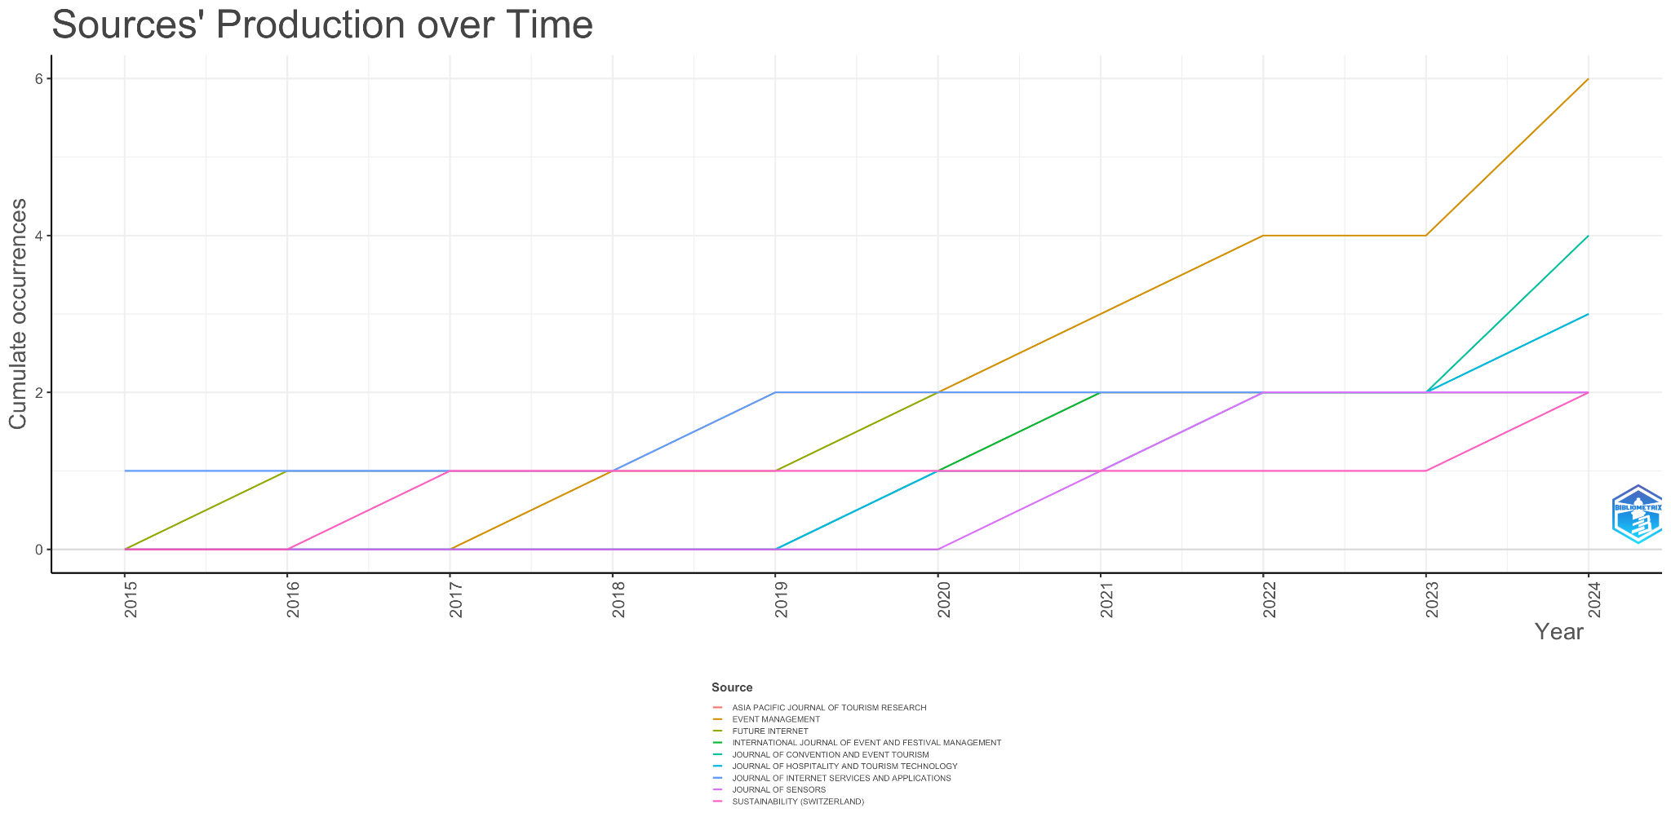
Source: Own elaboration
The temporal analysis (Figure 4) further supports the significance of Event Management, demonstrating its consistent publication output from 2017 to 2024, thus illustrating its enduring influence in the field. Other journals, such as the Journal of Convention and Event Tourism and the Journal of Hospitality and Tourism Technology, have focused their publications primarily in the years 2023 and 2024, indicating a more recent focus on the topic.

Figure 5. Country production over time
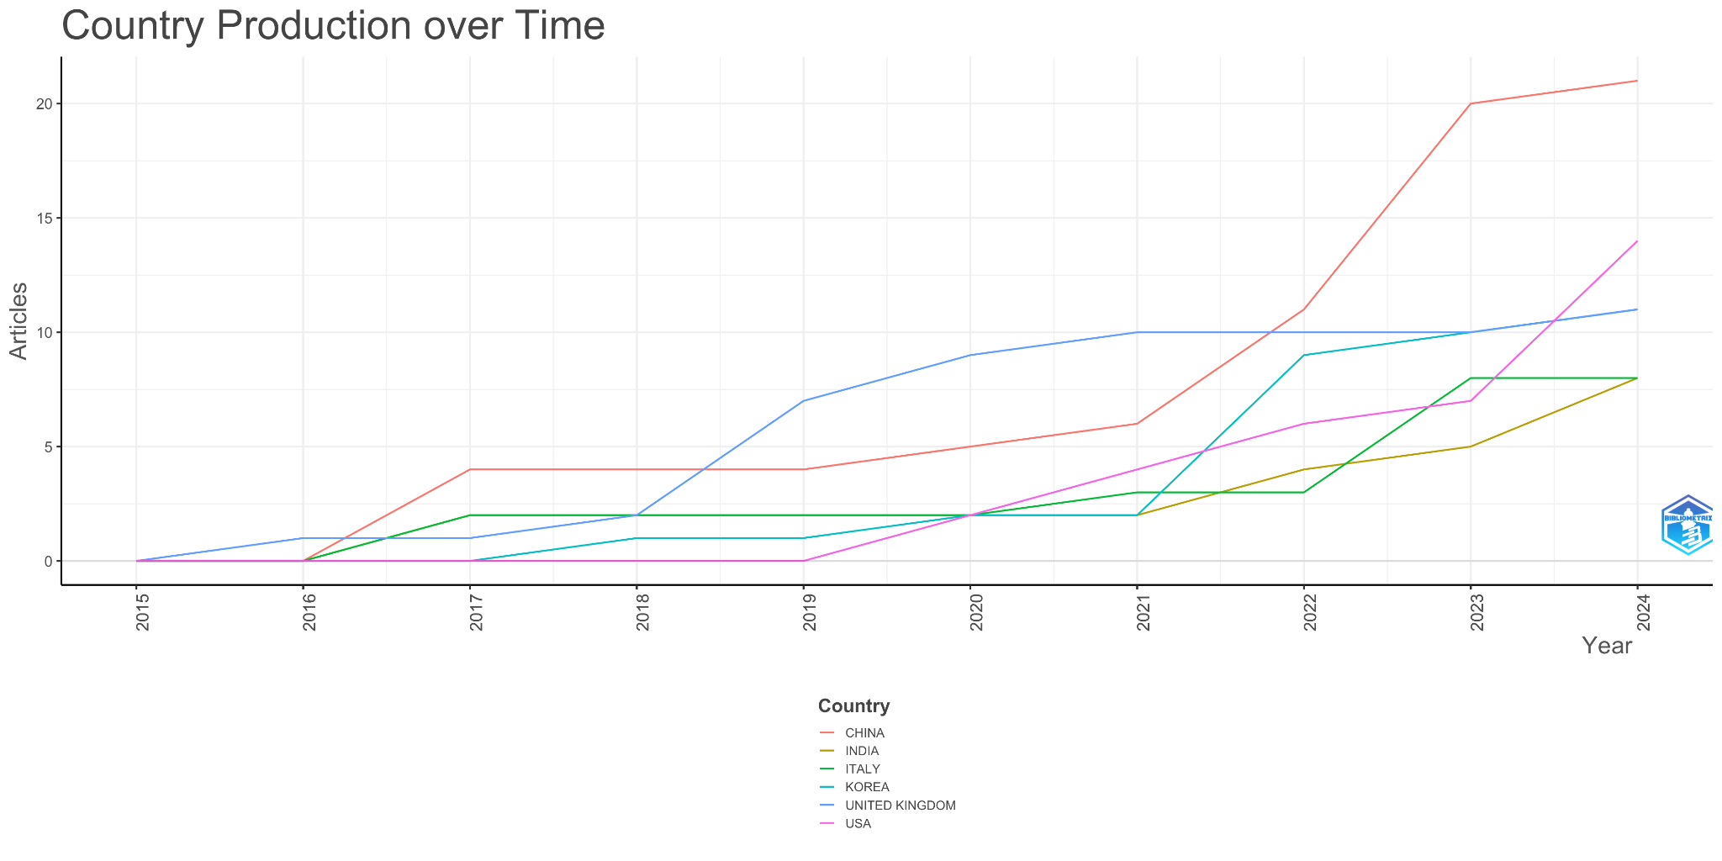
Source: Own elaboration
Apart from the temporal analysis of sources, another analysis was carried out to identify which countries lead scientific production in this field of knowledge (Figure 5). The data indicates that China is the foremost contributor to scientific output, exhibiting rapid growth from 2021, and surpassing 20 articles in 2024. The United Kingdom follows, demonstrating consistent progress since 2015, with a consistent output of 11 articles. The United States and South Korea have also shown steady expansion, particularly from 2020, each with over 10 publications. India has gradually increased its output since 2019, though at a lower volume. Italy shows more modest growth, though progress has been evident in recent years. These six countries are the primary contributors to scientific production during the analyzed period.
Beyond examining the temporal characteristics of scientific production in terms of countries and sources, it is crucial to examine the methodological characteristics of the reviewed studies. This approach enables the identification of not only the evolution of academic interest, but also the nature of the knowledge generated around the incorporation of smart technologies in events. Table 5 shows the research methodologies used. The trend supports the need for meaningful integration between quantitative and qualitative approaches for a more comprehensive development of the field (Provenzano & Baggio, 2019).
Table 5. Research methodologies
 | Count | Share
Qualitative data analysis | 8 | 12,1%
Quantitative data analysis | 46 | 69,7%
Mixed methods | 12 | 18,2%
Total | 66 | 100%
Source: Own elaboration
It has also been analysed whether the studies adopt a theoretical or empirical approach in order to understand the orientation and applicability of research in this field. In this regard, 58 articles (87.9%) were found to be empirical and 8 (12.1%) theoretical. The predominance of empirical studies indicates a practical orientation in the research related to the application of Smart technologies in events and festivals.
This analysis also examined the extent to which the reviewed studies have developed theoretical models, as this allows for an evaluation of the level of conceptual development and the contributions to the theoretical advancement regarding the application of Smart technologies in events. The analysis reveals that 43 articles (65.2%) develop a theoretical model and 23 (34.8%) do not. A strong theoretical framework helps identify the research design and the evaluation of the problem, offering clarity on how the study has been assembled and allowing the theory to be tested, measured, and potentially extended (Grant & Osanloo, 2015).
The analysis has identified that the proportion of studies that include explicit hypotheses as 18 (25,8%). This examination enables the differentiation between studies focused on validating theoretical relationships through experimental or statistical methods, and those of a more exploratory or descriptive nature.
Additionally, Table 6 examines the articles that utilize or provide open data, enabling an assessment of the transparency, replicability, and potential for reuse of the research findings in future studies. The use of open data promotes greater research transparency, allowing other researchers and practitioners to validate and build upon existing results (Numajiri & Hayashi, 2024).
Table 6. Use of open data
Authors | Date | Themes
Zhang et al. | 2021 | Optimization of Sports Event Management System Based on Wireless Sensor Network
Jiang et al | 2022 | Predicting Citywide Crowd Dynamics at Big Events: A Deep Learning System
Mu | 2022 | Digitalization and Information Management Mechanism of Sports Events Based on Cooperative Sensing Model of Multisensor Nodes
Peckover et al. | 2022 | Implementation of Congestion-Related Controls Improves Runner Density, Flow Rate, Perceived Safety, and Satisfaction during an Australian Running Event
Zhang | 2023 | Artificial intelligence carbon neutrality strategy in sports event management based on STIRPAT-GRU and transfer learning
Sui | 2024 | AI approach on identifying change in public sentiment for major events: Dubai Expo 2020
Source: Own elaboration
The distribution of research areas shows a clear dominance of studies situated within the Social Sciences – Other Topics, which comprise 21 publications (28.38%), making it the most represented field in the dataset. This is followed by Computer Science with 12 publications (16.22%) and Engineering with 10 publications (13.51%), reflecting the strong technological and computational orientation of current research in smart tourism and event-related innovation. Telecommunications also holds a notable presence with 7 publications (9.46%), highlighting the central role of connectivity infrastructures. Secondary but consistent contributions come from Business & Economics, Environmental Sciences & Ecology, and Instruments & Instrumentation, each with 4 publications (5.41%). The remaining areas, including Education, Imaging Science, Information Science, Mathematics, Psychology, Physical Geography, Remote Sensing, Science & Technology (Other Topics), and Sport Sciences, appear marginally, each contributing 1 publication (1.35%), while Operations Research & Management Science accounts for 2 publications (2.70%). Overall, the dataset reflects a socio-technical research structure where theoretical insights from the social sciences intersect with applied developments from computing and engineering.
3.3 Identification of key emerging event technologies in the context of events in Smart Tourism
An examination of 66 scholarly articles revealed the identification of 87 nascent technologies (Table 7). Among these, Artificial Intelligence and Machine Learning are particularly prominent, facilitating applications such as predictive analytics and the delivery of personalized visitor experiences. Specifically, deep learning algorithms contribute to capabilities like crowd forecasting and comprehensive content analysis. Furthermore, Big Data Analytics plays a crucial role in supporting real-time decision-making processes and effective crowd management strategies (Wang & Uysal, 2024; Wan et al., 2021; Wang et al., 2024; Lu et al., 2024; Hur et al., 2022; Zhang et al., 2021; Akbarpour et al., 2020; Sui, 2024).
Virtual Reality, Augmented Reality, and Mixed Reality transforms immersive experiences (Dieck et al., 2021; Hur et al., 2022; Devine et al., 2024). Internet of Things and sensor networks provide infrastructure through wireless networks, biometric sensors, and NFC technology (Sugawara et al., 2022; Mu, 2022; Bustard et al., 2019). Mobile applications enable user engagement (Kim et al., 2022; Kang & Jwa, 2018).
Additional technologies include Location-Based Services (Carrino et al., 2016; Jiang et al., 2022), Cloud Computing (Li et al., 2017; Kubler et al., 2017), and Crowd Management Systems (Ronchi et al., 2016; Peckover et al., 2022).
The technological trajectory reveals three distinct developmental periods: foundational technologies (2015-2017), the advent of Artificial Intelligence (2018-2020), and the integration of advanced AI with immersive experiences (2021-2024).
Table 7. Identified technologies
Technology | Count | Share
Artificial Intelligence (AI) | 17 | 19,54%
Big Data Analytics | 12 | 13,79%
Internet of Things (IoT) | 12 | 13,79%
Virtual Reality | 10 | 11,49%
Mobile Applications | 11 | 12,64%
Machine Learning (ML) | 7 | 8,05%
Artificial Neural Networks | 2 | 2,30%
Cloud Computing | 5 | 5,75%
Crowd Management Systems | 4 | 4,60%
Deep Learning (DL) | 3 | 3,45%
GPS Data | 3 | 3,45%
Information and Communication Technologies (ICT) | 4 | 4,60%
Natural Language Processing (NLP) | 3 | 3,45%
NFC | 2 | 2,30%
Wearables | 3 | 3,45%
Unmanned Aerial Vehicle (UAV) | 1 | 1,15%
Metaverse | 1 | 1,15%
Wireless Sensor Networks | 2 | 2,30%
Mixed Reality | 1 | 1,15%
Robotics | 1 | 1,15%
Total | 87 | 100,00%

Source: Own elaboration

3.4 Thematic structure analysis
A thematic mapping strategy (Figure 6) was employed to investigate the strategic placement and evolution of the subjects within the research domain. The analysis was performed using 100 author’s keywords and a minimum cluster frequency of 5 per thousand documents. The thematic map is structured based on two dimensions: centrality, which measures a theme's structural importance within the research, and density, which reflects the theme's internal development.
Figure 6. Thematic mapping strategy
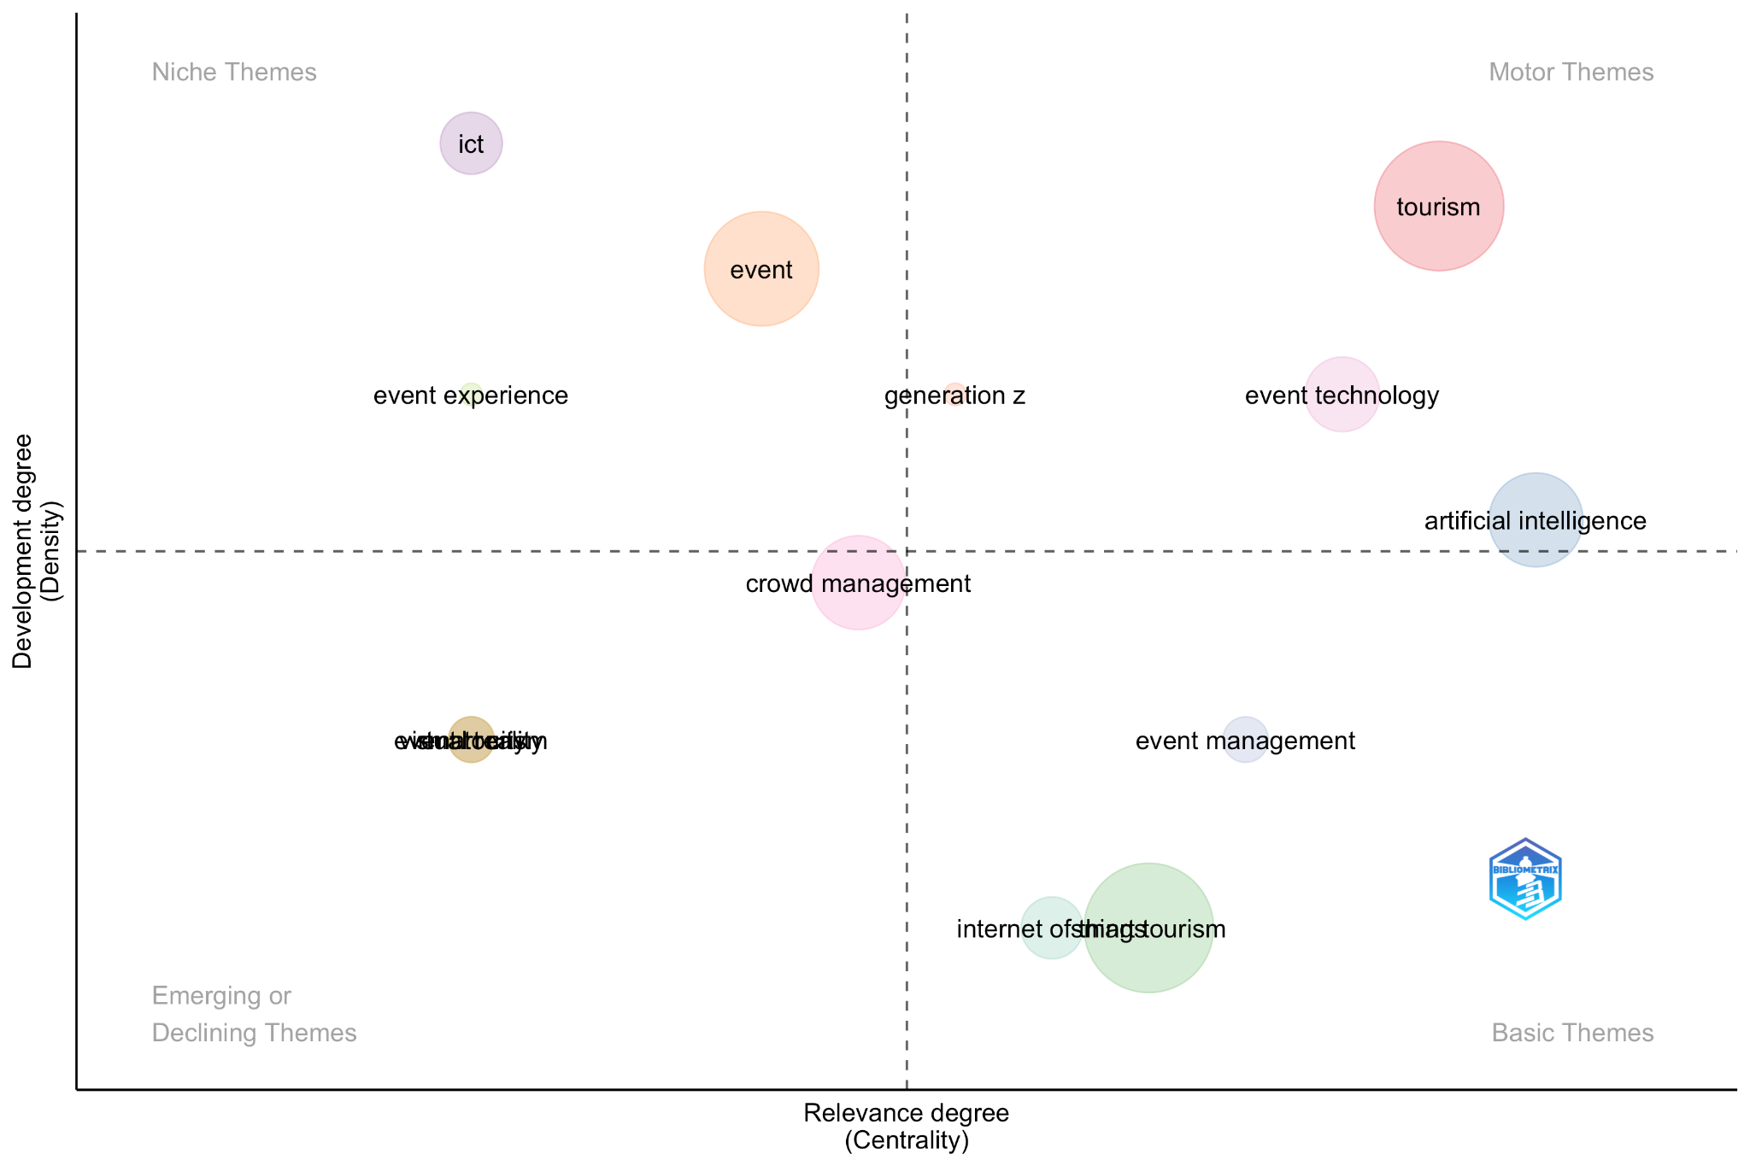
Source: Own elaboration
The thematic mapping strategy delineates a distinct hierarchical organization of research domains, categorized by their respective stages of maturation and academic salience. Within the upper-right quadrant, 'motor themes' such as tourism, artificial intelligence, and event technology are prominent, characterized by robust internal consistency and substantial influence within the scholarly discourse. Conversely, the upper-left quadrant encompasses 'niche themes,' including information and communication technologies, tourism studies, and event studies. These themes, despite demonstrating considerable development, exhibit limited integration with the wider thematic landscape. The lower-right quadrant identifies 'basic themes,' comprising the Internet of Things, event management, and tourism management-related concepts. These represent domains of significant relevance that are currently nascent in their development, thereby presenting substantial opportunities for further scholarly inquiry. Lastly, the lower-left quadrant consolidates 'emerging or declining themes,' such as crowd management, Generation Z, sustainability, and event design. These topics manifest both low thematic density and low centrality, potentially indicating either nascent conceptualizations or diminished scholarly focus. Collectively, the analysis underscores a research paradigm progressively influenced by technological advancements, presenting extensive avenues for conceptual refinement and empirical investigation.
4. Conclusion
This analysis elucidates the transformative impact of emerging technologies on smart tourism events, revealing how digital innovation is reshaping event design, management and experiential value. Artificial Intelligence emerges as a pivotal technological facilitator, supporting a wide range of applications that span from personalised service delivery and operational optimisation to enhanced decision-making and the creation of immersive experiential environments. Alongside Artificial Intelligence, the Internet of Things, Big Data analytics and immersive technologies further contribute to the development of dynamic, responsive and data-driven event ecosystems capable of adapting to visitor needs in real time.
Furthermore, the continuous expansion of scholarly discourse in recent years not only signifies intensifying academic interest in smart tourism but also highlights a progressive shift in research priorities toward understanding and improving the attendee experience. This growing emphasis on experience reflects a broader transition in tourism research, where value creation, personalisation and technological mediation are increasingly central to theoretical and managerial debates. Consequently, events are positioned as critical arenas for examining the complex interplay between technological advancement, visitor behaviour, perceived value and destination competitiveness.
4.1 Implications
This investigation yields significant implications for both theoretical understanding and practical application. Theoretically, the findings underscore the imperative to advance and solidify the conceptual underpinnings of Smart Events, given the extant literature's observed fragmentation and predominant technological orientation. Furthermore, this review identifies a substantial opportunity to construct integrative frameworks that bridge technological adoption, visitor experience, sustainability initiatives, and comprehensive event management strategies. Practically, the outcomes furnish event planners and destination managers with actionable insights into leveraging advanced technologies, including Artificial Intelligence, the Internet of Things, Big Data analytics, and immersive tools, to augment safety, operational efficiency, personalization, and sustainability within event environments. The analysis concurrently emphasizes the critical necessity of addressing profound ethical and societal considerations, such as data privacy, digital accessibility, and the equitable distribution of smart technology benefits (Gretzel et al., 2015). Collectively, these implications affirm the strategic significance of smart technologies in shaping the evolutionary trajectory of events within the broader Smart Tourism ecosystem.
4.2 Limitations and future research directions
This systematic review, while providing valuable insights into the integration of emerging technologies within the Smart Tourism event context, is subject to several limitations that may have influenced its findings. The search strategy was confined to Scopus and Web of Science, encompassing only English-language studies published between 2014 and 2024. This restrictive approach may have inadvertently omitted pertinent research from other linguistic backgrounds, regional databases, or earlier foundational scholarship. Furthermore, the review exclusively considered peer-reviewed journal articles and CORE-indexed conference proceedings, thereby excluding industry reports and practitioner literature, which often serve as primary sources for technological innovation. The underrepresentation of specific event typologies and geographical regions also curtails the generalizability of the findings. Lastly, despite the utility of bibliometric tools for thematic classification, the interpretation of emergent clusters and themes inherently involves a degree of subjectivity.

Building on these limitations, the extant literature underscores a burgeoning multidisciplinary interest in the application of nascent technologies within the context of smart tourism events, revealing several avenues for further exploration. Researchers advocate for an expansion of scholarly inquiry through the replication of existing models across varied event typologies and underrepresented geographical areas to facilitate the evaluation of technological scalability. Artificial Intelligence, Big Data, Virtual Reality, and the Internet of Things are recognized as pivotal facilitators for personalized services, automated processes, and real-time data analysis. Nevertheless, their implementation necessitates a meticulous appraisal of associated concerns, including privacy infringements, security vulnerabilities, and the imperative of obtaining informed user consent. Furthermore, a number of scholars advocate for longitudinal investigations to elucidate the long-term impact of these technologies on visitor satisfaction, loyalty, and behavioral patterns, thereby encouraging the formulation of more robust theoretical frameworks that integrate psychological and situational determinants of experiential evaluation. Concurrently, the scholarly discourse emphasizes the criticality of assessing the socio-ethical ramifications of technological integration, with particular attention to sustainability considerations, digital accessibility, and potential impacts on marginalized populations. Lastly, there is a call for the adoption of more comprehensive methodological paradigms that synthesize qualitative, quantitative, and computational techniques to more effectively delineate the inherent complexities of nascent phenomena.
Taken together, these proposals outline an ambitious yet essential future research agenda that encourages deeper exploration of the relationship between technological innovation and user experience within the domain of smart tourism events.
REFERENCES

Aliyah, Lukita, C., Pangilinan, G. A., Chakim, M. H. R., & Saputra, D. B. (2023). Examining the Impact of Artificial Intelligence and Internet of Things on Smart Tourism Destinations: A Comprehensive Study. APTISI Transactions on Technopreneurship 5(2), 12-22. https://doi.org/10.34306/att.v5i2sp.332
Al-Sulaiti, I. (2022). Mega shopping malls technology-enabled facilities, destination image, tourists’ behavior and revisit intentions: Implications of the SOR theory. Frontiers in Environmental Science, 10. https://doi.org/10.3389/fenvs.2022.965642
Angelaccio, M., Basili, A., & Buttarazzi, B. (2013). Using Geo-Business Intelligence and Social Integration for Smart Tourism Cultural Heritage Platforms. En S. Reddy & M. Jmaiel (Eds.), 2013 IEEE 22nd international workshop on enabling technologies: infrastructure for collaborative enterprises (wetice) (196-199). https://doi.org/10.1109/wetice.2013.87
Balakrishnan, J., Dwivedi, Y. K., Malik, F. T., & Baabdullah, A. M. (2023). Role of smart tourism technology in heritage tourism development. Journal of Sustainable Tourism, 31(11), (2506-2525). https://doi.org/10.1080/09669582.2021.1995398
Ballina, F. J. D. L. B. (2022). Smart Concept In Rural Tourism: A Comparison Between Two Phases (2016-2019). Revista de Economia e Sociologia Rural, 60(1), 1-15. https://doi.org/10.1590/1806-9479.2021.234629
Bandara, W., Furtmueller, E., Gorbacheva, E., Miskon, S., & Beekhuyzen, J. (2015). Achieving Rigor in Literature Reviews: Insights from Qualitative Data Analysis and Tool-Support. Communications of the Association for Information Systems, 37(1). https://doi.org/10.17705/1CAIS.03708
Battarra, R., Gargiulo, C., Tremiterra, M. R., & Zucaro, F. (2018). Smart mobility in Italian metropolitan cities: A comparative analysis through indicators and actions. Sustainable Cities and Society, 41, 556-567. https://doi.org/10.1016/j.scs.2018.06.006
Berjozkina, G., & Kuruvilla, K. J. (2023). Smart tourism and cultural heritage in the Baltic states: Exploring strategies and tools for sustainable development. Worldwide Hospitality And Tourism Themes, 15(5), (517-527). https://doi.org/10.1108/WHATT-06-2023-0077
Birkle, C., Pendlebury, D. A., Schnell, J., & Adams, J. (2020). Web of Science as a data source for research on scientific and scholarly activity. Quantitative Science Studies, 1(1), 363-376. https://doi.org/10.1162/qss_a_00018
Bogicevic, V., Bujisic, M., Bilgihan, A., Yang, W., & Cobanoglu, C. (2017). The impact of traveler-focused airport technology on traveler satisfaction. Technological Forecasting and Social Change, 123, (351-361). https://doi.org/10.1016/j.techfore.2017.03.038
Boodnah, K. D., Jaunky, V. C., Armoogum, V., & Armoogum, S. (2016). Towards Smart Tourism: An Individual Appreciation of Porlwi-By-Light Festival. 2016 IEEE International Conference On Emerging Technologies And Innovative Business Practices For The Transformation Of Societies (EMERGITECH) (pp. 323-328).
Buhalis, D., & Amaranggana, A. (2013). Smart Tourism Destinations. Information and communication technologies in tourism 2014, 553-564. https://doi.org/10.1007/978-3-319-03973-2_40
Buhalis, D., O’Connor, P., & Leung, R. (2023). Smart hospitality: From smart cities and smart tourism towards agile business ecosystems in networked destinations. Information and Communication Technologies in Tourism 35(1), (369-393). https://doi.org/10.1108/IJCHM-04-2022-0497
Burlacu, M., Boboc, R. G., & Butilă, E. V. (2022). Smart Cities and Transportation: Reviewing the Scientific Character of the Theories. Sustainability (Switzerland), 14(13). https://doi.org/10.3390/su14138109
Cacho, A., Figueredo, M., Cassio, A., Araujo, M. V., Mendes, L., Lucas, J., Farias, H., Coelho, J., Cacho, N., & Prolo, C. (2016). Social Smart Destination: A Platform to Analyze User Generated Content in Smart Tourism Destinations. New Advances In Information Systems and Technologies, 444, (817-826). https://doi.org/10.1007/978-3-319-31232-3_77
Celuch, K. (2021a). Event technology for potential sustainable practices: A bibliometric review and research agenda. International Journal of Event and Festival Management, 12(3), (314-330). Emerald Group Holdings Ltd. https://doi.org/10.1108/IJEFM-08-2020-0051
Celuch, K. (2021b). Event technology for potential sustainable practices: A bibliometric review and research agenda. International Journal of Event and Festival Management. https://doi.org/10.1108/IJEFM-08-2020-0051
Chung, N., Han, H., & Joun, Y. (2015). Tourists’ intention to visit a destination: The role of augmented reality (AR) application for a heritage site. Computers in Human Behavior, 50 (588-599). https://doi.org/10.1016/j.chb.2015.02.068
Chung, N., Lee, H., Kim, J.-Y., & Koo, C. (2018). The Role of Augmented Reality for Experience-Influenced Environments: The Case of Cultural Heritage Tourism in Korea. Journal of Travel Research, 57(5), 627-643. Scopus. https://doi.org/10.1177/0047287517708255
Cimbaljević, M., Stankov, U., Demirović, D., & Pavluković, V. (2021). Nice and smart: Creating a smarter festival–the study of EXIT (Novi Sad, Serbia). Asia Pacific Journal of Tourism Research, 26(4), 415-427. https://doi.org/10.1080/10941665.2019.1596139
Cumlievski, N., Bakaric, M. B., & Matetic, M. (2022). A Smart Tourism Case Study: Classification of Accommodation Using Machine Learning Models Based on Accommodation Characteristics and Online Guest Reviews. Electronics, 11(6), 913. https://doi.org/10.3390/electronics11060913
Cvar, N., Stojanova, S., Trilar, J., Kos, A., & Duh, E. S. (2024). Transformative smart rural tourism in adversity of the COVID-19 pandemic and beyond. Journal of Infrastructure, Policy and Development, 8(6). https://doi.org/10.24294/jipd.v8i6.4065
Dalli, A., & Bri, S. (2016). Design of Electronic Ticket System for Smart Tourism. 2016 12th International Conference On Signal-Image Technology & Internet-Based Systems (SITIS) (490-492). https://doi.org/10.1109/SITIS.2016.82
dos Santos, S. R. (2022). Urban spaces of dislocation in Brazilian cultural heritage city from UNESCO under smart tourism conception. PASOS Revista de Turismo y Patrimonio Cultural, 20(2), 371-387. https://doi.org/10.25145/j.pasos.2022.20.027
El Archi, Y., Benbba, B., Nizamatdinova, Z., Issakov, Y., Vargane, G. I., & David, L. D. (2023). Systematic Literature Review Analysing Smart Tourism Destinations in Context of Sustainable Development: Current Applications and Future Directions. Sustainability, 15(6). https://doi.org/10.3390/su15065086
Fekete, A., Grundy, J., Garcia De La Banda, M., Winikoff, M., Sadiq, S., & Padgham, L. (2021). CORE rankings uses. ICORE Conference Portal.
Ferras, X., Louise Hitchen, E., Tarrats-Pons, E., & Arimany Serrat, N. (2020). Smart Tourism Empowered by Artificial Intelligence: The Case of Lanzarote. Journal Of Cases On Information Technology, 22(1), (1-13). https://doi.org/10.4018/JCIT.2020010101
Fisch, C., & Block, J. (2018). Six tips for your (systematic) literature review in business and management research. Management Review Quarterly, 68(2), 103-106. https://doi.org/10.1007/s11301-018-0142-x
Flores-Crespo, P., Bermudez-Edo, M., & Garrido, J. L. (2022). Smart tourism in Villages: Challenges and the Alpujarra Case Study. Procedia Computer Science, 204, (663-670). Elsevier B.V. https://doi.org/10.1016/j.procs.2022.08.080
Gajdosik, T., & Marcis, M. (2019). Artificial Intelligence Tools for Smart Tourism Development. R. Silhavy (Ed.), Artificial Intelligence Methods In Intelligent Algorithms (Vol. 985, pp. 392-402). https://doi.org/10.1007/978-3-030-19810-7_39
Garcia-Milon, A., Juaneda-Ayensa, E., Olarte-Pascual, C., & Pelegrin-Borondo, J. (2020). Towards the smart tourism destination: Key factors in information source use on the tourist shopping journey. Tourism Management Perspectives, 36. https://doi.org/10.1016/j.tmp.2020.100730
Gautam, B. P., Asami, H., & Batajoo, A. (2017). Cost Effective Accommodation Planning in a Trip by Using Accomodation Advisor Query (AA-Query) in STPF. 2017 International Conference On Networking And Network Applications (NANA) (330-336). https://doi.org/10.1109/NaNA.2017.60
Gelbman, A. (2020). Smart tourism cities and sustainability. Geography Research Forum, 40(1), (137–148). Ben Gurion University of the Negev. https://www.scopus.com/inward/record.uri?eid=2-s2.0-85110514395&partnerID=40&md5=eabf3f243753a0f45d8120029ae56cf4
Getz, D. (2008). Event tourism: Definition, evolution, and research. Tourism Management, 29(3), (403–428). https://doi.org/10.1016/j.tourman.2007.07.017
Getz, D. (2010). The nature and scope of festival studies. International Journal of Event Management Research, 5(1), (1–47).
Getz, D., & Andersson, T. D. (2009). Sustainable festivals: On becoming an institution. Event Management, 12(1), (1–17). https://doi.org/10.3727/152599509787992625
Getz, D., & Page, S. J. (2014). Progress and prospects for event tourism research. Tourism Management, 52, (593–631). https://doi.org/10.1016/j.tourman.2015.03.007
Getz, D., & Page, S. J. (2024). Event studies: Theory and management for planned events (5.ª ed.). https://doi.org/10.4324/9781003374251
Grant, C., & Osanloo, A. (2015). Understanding, selecting, and integrating a theoretical framework in dissertation research: Developing a “blueprint” for your house. Administrative Issues Journal, 4. https://doi.org/10.5929/2014.4.2.9
Gretzel, U. (2011). Intelligent systems in tourism: A social science perspective. Annals of Tourism Research, 38(3), (757–779). https://doi.org/10.1016/j.annals.2011.04.014
Gretzel, U., Sigala, M., Xiang, Z., & Koo, C. (2015). Smart tourism: Foundations and developments. Electronic Markets, 25(3), (179–188). https://doi.org/10.1007/s12525-015-0196-8
Gretzel, U., Werthner, H., Koo, C., & Lamsfus, C. (2015). Conceptual foundations for understanding smart tourism ecosystems. Computers in Human Behavior, 50, (558–563). https://doi.org/10.1016/j.chb.2015.03.043
Gursoy, D., & Kendall, K. W. (2006). Hosting mega events: Modeling locals’ support. Annals of Tourism Research, 33(3), (603–623). https://doi.org/10.1016/j.annals.2006.01.005
Habeeb, N. J., & Weli, S. T. (2020). Relationship of smart cities and smart tourism: An overview. HighTech and Innovation Journal, 1(4), (194–202). https://doi.org/10.28991/HIJ-2020-01-04-07
Hiererra, S. E., Meyliana, M., Ramadhan, A., & Purnomo, F. (2023). The requirement aspect for sustainability smart tourism destinations: A systematic literature review and proposed model analysis. Journal of Engineering Science and Technology, 18(6), (2895–2914).
Huang, C. D., Goo, J., Nam, K., & Yoo, C. W. (2017). Smart tourism technologies in travel planning: The role of exploration and exploitation. Information & Management, 54(6), (757–770). https://doi.org/10.1016/j.im.2016.11.010
Inversini, A., Aeberli, C., & Talhouk, S. N. (2024). Smart host-guest relationship in a rural context: The case of Lebanon. Journal of Destination Marketing & Management, 31. https://doi.org/10.1016/j.jdmm.2023.100851
Ismagilova, E., Hughes, L., Dwivedi, Y. K., & Raman, K. R. (2019). Smart cities: Advances in research—An information systems perspective. International Journal of Information Management, 47, (88–100). https://doi.org/10.1016/j.ijinfomgt.2019.01.004
Jeong, M., & Shin, H. H. (2020). Tourists’ experiences with smart tourism technology at smart destinations and their behavior intentions. Journal of Travel Research, 59(8), (1464–1477). https://doi.org/10.1177/0047287519883034
Jovicic, D. Z. (2019). From the traditional understanding of tourism destination to the smart tourism destination. Current Issues in Tourism, 22(3), (276–282). https://doi.org/10.1080/13683500.2017.1313203
Kang, H. C., & Jwa, J. W. (2018). Development of android based smart tourism application based on tourism bigdata analytics. Journal of Engineering and Applied Sciences, 13(5), (1164–1169). https://doi.org/10.3923/jeasci.2018.1164.1169
Khan, M. S., Woo, M., Nam, K., & Chathoth, P. K. (2017). Smart city and smart tourism: A case of Dubai. Sustainability, 9(12). https://doi.org/10.3390/su9122279
Kontogianni, A., & Alepis, E. (2022). AI, Blockchain & Cyber tourism joining the smart tourism realm. En 13th International Conference on Information, Intelligence, Systems and Applications (IISA 2022). Institute of Electrical and Electronics Engineers. https://doi.org/10.1109/IISA56318.2022.9904393
Kontogianni, A., Kabassi, K., & Alepis, E. (2018). Designing a smart tourism mobile application: User modelling through social network user implicit data. En S. Staab, O. Koltsova, & D. Ignatov (Eds.), Social Informatics (SOCINFO 2018), Part II (pp. 148–158). https://doi.org/10.1007/978-3-030-01159-8_14
Kuandykovna Suyendikova, G., Evgenievich Barykin, S., Mikhailovich Sergeev, S., Vasilievna Kapustina, I., Krupnov, Y., & Nikolaevna Shchepkina, N. (2022). Sustainable development of smart cities and smart territories based on the model of minimizing externalities. F1000Research, 11. https://doi.org/10.12688/f1000research.114630.2
Lam, K. L., Chan, C.-S., & Peters, M. (2020). Understanding technological contributions to accessible tourism from the perspective of destination design for visually impaired visitors in Hong Kong. Journal of Destination Marketing & Management, 17. https://doi.org/10.1016/j.jdmm.2020.100434
Lee, H., & Hlee, S. (2021). The intra- and inter-regional economic effects of smart tourism city Seoul: Analysis using an input-output model. Sustainability, 13(7). https://doi.org/10.3390/su13074031
Li, D., Du, P., & He, H. (2022). Artificial intelligence-based sustainable development of smart heritage tourism. Wireless Communications & Mobile Computing, 2022. https://doi.org/10.1155/2022/5441170
Liberato, P., Liberato, D., Abreu, A., Alén, E., & Rocha, Á. (2018). LGBT tourism: The competitiveness of tourism destinations based on digital technology. Advances in Intelligent Systems and Computing, 745, (264–276). https://doi.org/10.1007/978-3-319-77703-0_27
Liu, J., Hall, C. M., Zhu, C., & Cheng, V. T. P. (2024). Redefining the concept of smart tourism in tourism and hospitality. Anatolia, 35(3), (553–565). https://doi.org/10.1080/13032917.2023.2282712
Liu, Y., & Niu, X. (2024). AI virtual travel assistant based on smart city—An application interface design study. En N. Streitz & S. Konomi (Eds.), Distributed, Ambient and Pervasive Interactions, Part I (DAPI 2024) (pp. 241–254). https://doi.org/10.1007/978-3-031-59988-0_14
Lopes, I. M., & Oliveira, P. (2018). The relationship between smart cities and smart tourism in low density regions. En 2018 13th Iberian Conference on Information Systems and Technologies (CISTI).
Luo, S. (2024). Rural tourism management cloud service platform based on interactive mobile embedded systems. International Journal of Interactive Mobile Technologies, 18(13), (130–147). https://doi.org/10.3991/ijim.v18i13.49065
Luxford, A., & Dickinson, J. (2015). The role of mobile applications in the consumer experience at music festivals. Event Management, 19. https://doi.org/10.3727/152599515X14229071392909
M, H. S., & P, A. A. (2024). Smart tourism technology, a boon or a bane for event tourism? In the context of Kochi Muziris Biennale. Journal of Convention and Event Tourism, 25(3), (145–164). https://doi.org/10.1080/15470148.2024.2306994
Marchesani, F., Masciarelli, F., & Bikfalvi, A. (2023). Cities (r)evolution in the smart era: Smart mobility practices as a driving force for tourism flow and the moderating role of airports in cities. International Journal of Tourism Cities, 9(4), (1025–1045). https://doi.org/10.1108/IJTC-05-2023-0104
Matos, A., Pinto, B., Barros, F., Martins, S., Martins, J., & Au-Yong-Oliveira, M. (2019). Smart cities and smart tourism: What future do they bring? En A. Rocha, H. Adeli, L. Reis, & S. Costanzo (Eds.), New Knowledge in Information Systems and Technologies, Vol. 3 (pp. 358–370). https://doi.org/10.1007/978-3-030-16187-3_35
Nguyen, T., Lee, K., Chung, N., & Koo, C. (2020). The way generation Y enjoys a jazz festival: A case of the Korea (Jarasum) music festival. Asia Pacific Journal of Tourism Research, 25(1), (52–63). https://doi.org/10.1080/10941665.2019.1580755
Nguyen, T. T., Camacho, D., & Jung, J. E. (2017). Identifying and ranking cultural heritage resources on geotagged social media for smart cultural tourism services. Personal and Ubiquitous Computing, 21(2), (267–279). https://doi.org/10.1007/s00779-016-0992-y
Numajiri, H., & Hayashi, T. (2024). Analysis on open data as a foundation for data-driven research. Scientometrics, 129(10), (6315–6332). https://doi.org/10.1007/s11192-024-04956-x
O’Connor, P. (2023). Small- and medium-sized tourism enterprises and smart tourism: Tourism agenda 2030 perspective article. Tourism Review, 78(2), (339–343). https://doi.org/10.1108/TR-09-2022-0431
Oxoli, D., Cannata, M., Terza, V., & Brovelli, M. A. (2019). Natural heritage management and promotion through free and open source software: A preliminary system design for the Insubriparks project. En M. Brovelli & A. Marin (Eds.), FOSS4G 2019—Academic Track (pp. 179–183). https://doi.org/10.5194/isprs-archives-XLII-4-W14-179-2019
Pachoulas, G., Florou, K., Besarat, J., & Stylios, C. (2024). Enhancing visitor experience and hospitality in accommodation facilities through smart tourism and mobile technology. SEEDA-CECNSM 2024, (36–41). https://doi.org/10.1109/SEEDA-CECNSM63478.2024.00016
Page, M. J., McKenzie, J. E., Bossuyt, P. M., Boutron, I., Hoffmann, T. C., Mulrow, C. D., … Moher, D. (2021). The PRISMA 2020 statement: An updated guideline for reporting systematic reviews. BMJ, 372, (n71). https://doi.org/10.1136/bmj.n71
Pai, C.-K., Chen, H., Lai, I. K. W., & Li, T. (2025). Assessing the quality of smart tourism technology: Development and validation of a measurement scale. Journal of Hospitality and Tourism Technology. https://doi.org/10.1108/JHTT-01-2024-0013
Pai, C.-K., Liu, Y., Kang, S., & Dai, A. (2020). The role of perceived smart tourism technology experience for tourist satisfaction, happiness and revisit intention. Sustainability, 12(16). https://doi.org/10.3390/su12166592
Parameswaran, A. N., Shivaprakasha, K. S., & Bhandarkar, R. (2021). Smart tourism development in a smart city: Mangaluru. Smart Innovation, Systems and Technologies, 213 SIST (pp. 325–332). Springer. https://doi.org/10.1007/978-981-33-4443-3_31
Pencarelli, T. (2020). The digital revolution in the travel and tourism industry. Information Technology and Tourism, 22(3), (455–476). https://doi.org/10.1007/s40558-019-00160-3
Poli, M., Malagas, K., & Papakostas, C. (2024). The contribution of advanced technologies to the tourism experience of disabled people: The Greek case. Lecture Notes in Networks and Systems, 1170, (429–442). https://doi.org/10.1007/978-3-031-73344-4_36
Pranckutė, R. (2021). Web of Science (WoS) and Scopus: The titans of bibliographic information in today’s academic world. Publications, 9(1). https://doi.org/10.3390/publications9010012
Provenzano, D., & Baggio, R. (2019). Quantitative methods in tourism and hospitality: A perspective article. Tourism Review, 75(1), (24–28). https://doi.org/10.1108/TR-07-2019-0281
Pujakusumah, R., Tonang, A. S. P. A., & Mutaqin, J. N. (2024). Smart tourism destinations of Sumedang Regency: Future trends and challenges. ICISS 2024 Proceedings. https://doi.org/10.1109/ICISS62896.2024.10751014
Ramos, C. M. Q., Henriques, C. H. N., & Lanquar, R. (2016). Augmented reality for smart tourism in religious heritage itineraries: Tourism experiences in the technological age. En Handbook of Research on Human-Computer Interfaces, Developments, and Applications. IGI Global. https://doi.org/10.4018/978-1-5225-0435-1.ch010
Salmi, K., & Hmioui, A. (2024). The smart tourist destination as a smart city project. En F. Y., H. A., S. T., T. H., & V. A. (Eds.), Lecture Notes in Networks and Systems, 838 LNNS (pp. 222–228). Springer. https://doi.org/10.1007/978-3-031-48573-2_32
Saputra, R. A. (2023). Economic improvement, environmental sustainability, and community empowerment in Indonesia: Bibliometric analysis (smart city and smart tourism) 2013–2022. E3S Web of Conferences, 440. EDP Sciences. https://doi.org/10.1051/e3sconf/202344001006
Sebata, E., & Mollah, M. R. A. (2022). Technology application in tourism festivals in Asia: Theoretical discussions. Technology Application in Tourism Fairs, Festivals and Events in Asia. https://doi.org/10.1007/978-981-16-8070-0_2
Shanmugam, K., Rana, M. E., & Kong, Z. Y. (2024). A comprehensive analysis of technological advancements and smart tourism strategies in Malaysia’s post-pandemic tourism industry. ICETSIS 2024, (909–916). https://doi.org/10.1109/ICETSIS61505.2024.10459443
Stroumpoulis, A., Kopanaki, E., & Varelas, S. (2022). Role of artificial intelligence and big data analytics in smart tourism: A resource-based view approach. WIT Transactions on Ecology and the Environment, 256 (pp. 99–108). WITPress. https://doi.org/10.2495/ST220091
Suanpang, P., & Pothipassa, P. (2024). Integrating generative AI and IoT for sustainable smart tourism destinations. Sustainability, 16(17). https://doi.org/10.3390/su16177435
Sustacha, I., Baños-Pino, J. F., & Del Valle, E. (2024). How smartness affects customer-based brand equity in rural tourism destinations. Journal of Destination Marketing & Management, 34. https://doi.org/10.1016/j.jdmm.2024.100949
Tlili, A., Altinay, F., Altinay, Z., & Zhang, Y. (2021). Envisioning the future of technology integration for accessible hospitality and tourism. International Journal of Contemporary Hospitality Management, 33(12), (4460–4482). https://doi.org/10.1108/IJCHM-03-2021-0321
Torabi, Z.-A., Pourtaheri, M., Hall, C. M., Sharifi, A., & Javidi, F. (2023). Smart tourism technologies, revisit intention, and word-of-mouth in emerging and smart rural destinations. Sustainability, 15(14). https://doi.org/10.3390/su151410911
Torabi, Z.-A., Rezvani, M. R., Hall, C. M., & Allam, Z. (2023). On the post-pandemic travel boom: How capacity building and smart tourism technologies in rural areas can help—Evidence from Iran. Technological Forecasting and Social Change, 193. https://doi.org/10.1016/j.techfore.2023.122633
Um, T., & Chung, N. (2021). Does smart tourism technology matter? Lessons from three smart tourism cities in South Korea. Asia Pacific Journal of Tourism Research, 26(4), (396–414). https://doi.org/10.1080/10941665.2019.1595691
Wael, R., Talaat, H., & Soubra, H. (2023). Smart tourism in smart cities: Current trends and future challenges in sustainability and digitization. Smart Cities 4.0 2023, (95–98). https://doi.org/10.1109/SmartCities4.056956.2023.10526099
Wanyi, X. (2021). Research on data mining of smart tourism e-commerce based on data mining model. ACM International Conference Proceeding Series (pp. 361–364). https://doi.org/10.1145/3516529.3516602
Xiao, Y., & Watson, M. (2019). Guidance on conducting a systematic literature review. Journal of Planning Education and Research, 39(1), (93–112). https://doi.org/10.1177/0739456X17723971
Zhou, L., Buhalis, D., Fan, D. X. F., Ladkin, A., & Lian, X. (2024). Attracting digital nomads: Smart destination strategies, innovation and competitiveness. Journal of Destination Marketing & Management, 31. https://doi.org/10.1016/j.jdmm.2023.100850

