**USE GITHUB AS FREE WEBHOST WINDOWS**

Yes it is possible to use GitHub as a free webhost with no cost involved at all. I have tested this process and hosted a sample website on it.

Follow the instruction below to host yours:

**Requirements**

1. GitHub Account
2. Download GitBash (windows)
3. PowerShell ( I will show you the important GitHub commands to upload websites)
4. knowledge of html

**Step1. Signup Process**

**Visit https://github.com/join to create personal account**

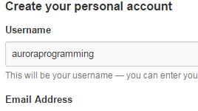

**Choose you desired username *this should be unique to GitHub**

**Choose the Free Account option and click finish signup**



**Important to verify your email address by logging into your email**

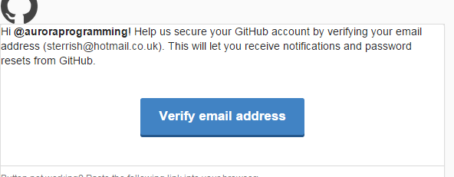

**Create a repository by clicking on the Plus button on far right**

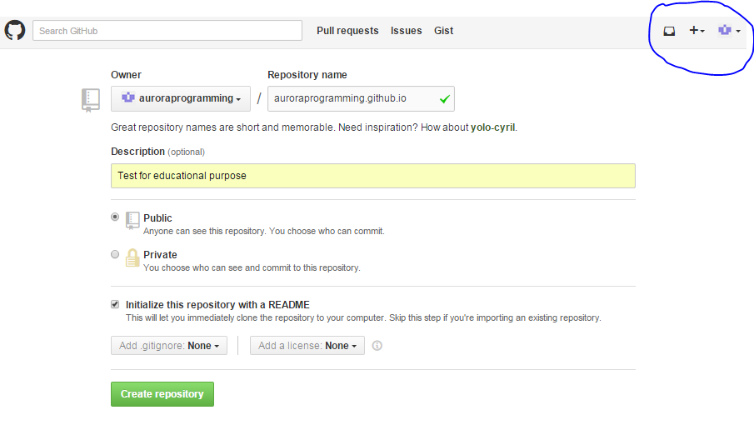

1. Give your Repository a name in the form [sitename.github.io]
2. Add a brief description (optional)
3. Set the repository to public
4. Select Initialize this repository with a README

**Important things to note**

**Clone URL**

**From the new repository member homepage, note your clone HTTPS URL (we will need this later on)**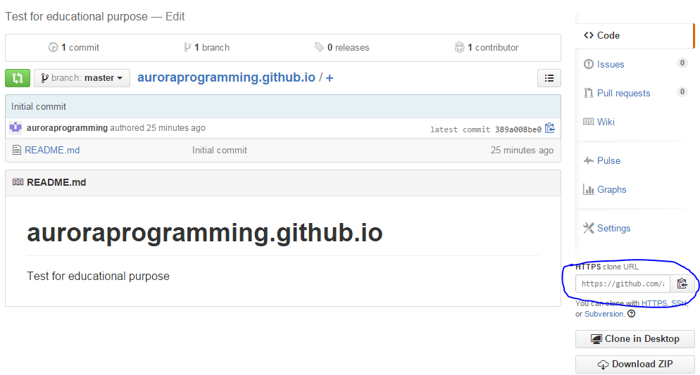

**Website (repository URL) and how to delete website (repository)**

**Click setting from the new repository member homepage.**

**For the purpose of this blog, we will only use this section for the following:**

**Knowing our website address. In this example our website is http://auroraprogramming.github.io/**

**Deleting our website( repository)**

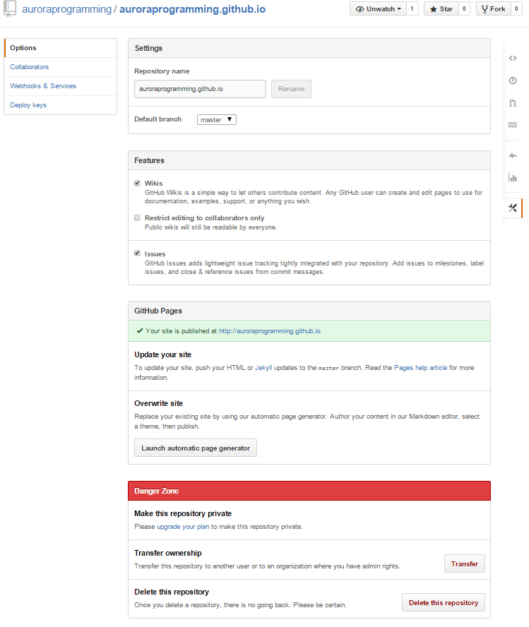

IF YOU WANT TO DELETE REPOSITORY

KNOWING YOUR WEBSITE ADDRESS

**2) ADDING GITBASH FOR WINDOWS POWERSHELL**

**Navigate your browser to https://msysgit.github.io/**

**Click Download (17.1 MB) at the time of creating this blog**

**Install Gitbash**

**Simply make sure you select "Use Git from the windows command prompt" option**

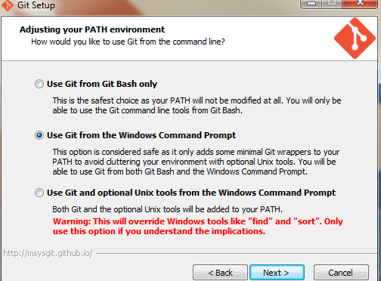

**Accept all defaults and finish installation**

**3) using PowerShell to interact with PowerShell**

**Open PowerShell after a successful installation of Gitbash**

**Start**

* **All programs**
* **Accessories**
* **Expand windows PowerShell folder**
* **Click on windows power Shell folder**

**Using PowerShell and GitHub**

I recommend you create a folder in your c:\ drive as demonstrated below

Navigate to c:\ by using

**CD C:\**

Create new folder on C: named githubpages using

**md githubpages**

Navigate to githubpages using command

**Cd githubpages**

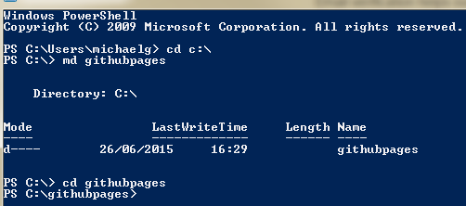

**Copying your repository popularly known as Cloning.**

We need to clone our repository to c:\ so we can add our website html files the folder and upload it GitHub using our public https URL noted earlier.

**Copy your GitHub website using the command below**

git clone https://github.com/auroraprogramming/auroraprogramming.github.io

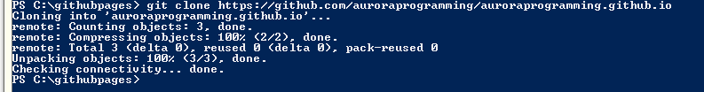

**You may check the cloned folder by browsing to githubpages the folder created on c:\**

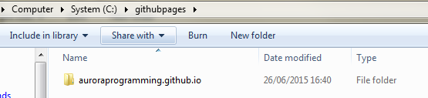

**If you see your GitHub folder then GitHub has successfully cloned your website folder locally.**

**Add you HTML page(s) to the folder**

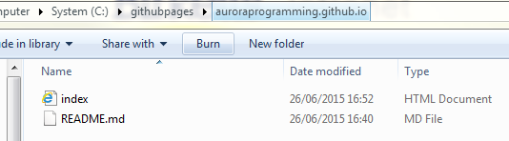

**Uploading your website using PowerShell**

From PowerShell, navigate to the repository folder using command

cd auroraprogramming.github.io



**Check changes between folder and online repository by using**

**Git status**

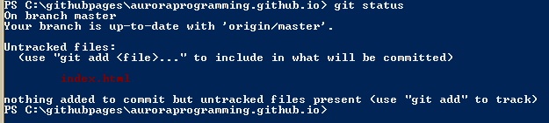

**Index .html is highlighted as a new file**

**Add file(s) index.html by using command**

**git add index.html (use * if you have many files thus git add *)**



**Commit the changed file.**

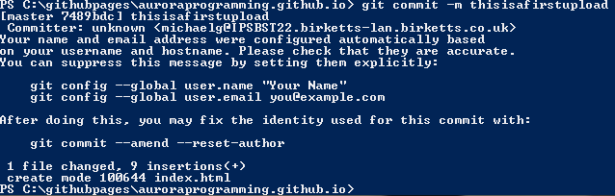

**-m = description of what you are uploading or a message**

**Finally make the file changes live by using the command**

**Git push origin master**

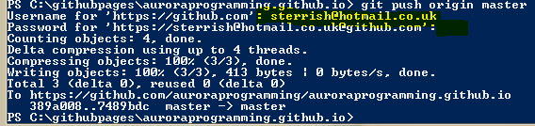

**Enter your username**

**Add your password**

**That’s it. Your website is now live**

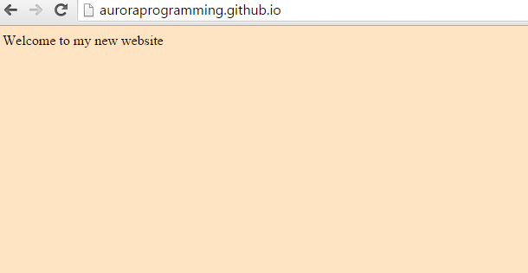

**Recap**

**Add new files or edit html file**

Use ***git status*** to find changes in local files and online repository

Use ***git add \**** to stage all new files

Use ***git commit -m 'First commit'*** to commit staged files

Use ***git push origin master to push*** the changes to your online repository(website)

Enter your github username and password

All done. I hope this has been informative.