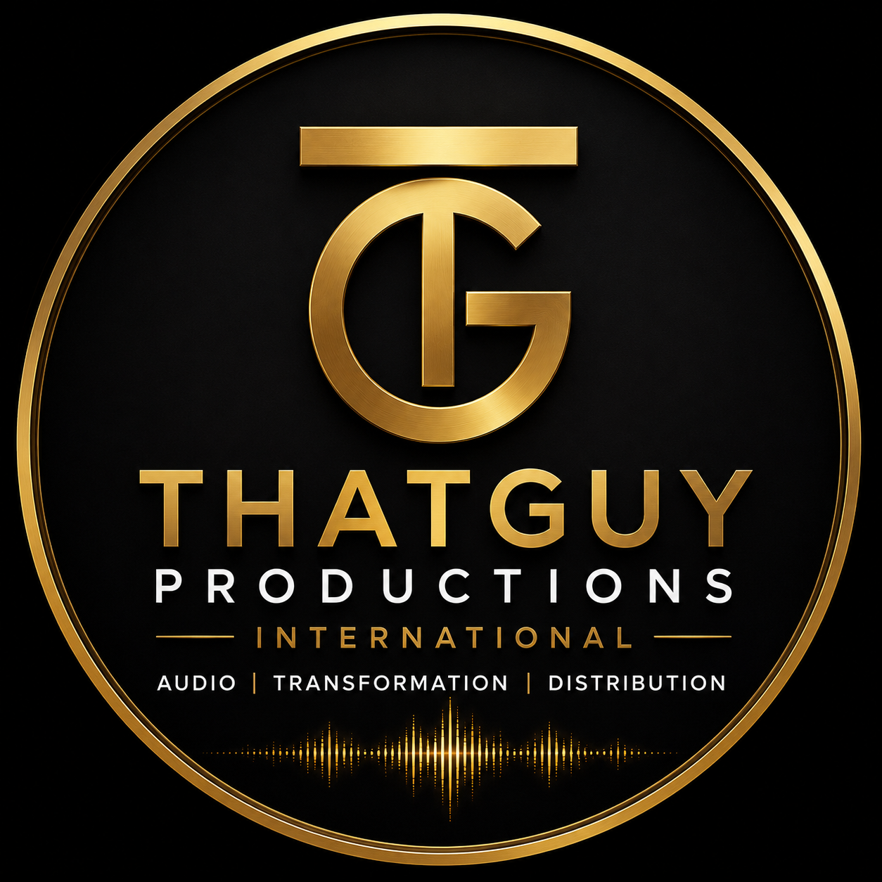
ThatGuy Productions International
AUDIO | TRANSFORMATION | DISTRIBUTION
Baviaanskloof, Eastern Cape, South Africa

ARTIST DEVELOPMENT & PRODUCTION AGREEMENT
Between Phil Bölke (ThatGuy Productions International) and Zinhle
Date of Agreement: ___________________________

1. THE PARTIES
This Artist Development and Production Agreement ("Agreement") is entered into between the following parties:

THE PRODUCER
Dr. Philippus Weyers Bölke, PhD(Eng)
Owner & Executive Producer, ThatGuy Productions International
Founder & CEO, Arcovel Technologies International (Pty) Ltd
Baviaanskloof, Eastern Cape, South Africa
Identity Number: ___________________________________________

THE ARTIST
Zinhle [full legal name to be completed at signing]
Identity Number: ___________________________________________
Residential Address: ___________________________________________
Contact Number: ___________________________________________
Email Address: ___________________________________________

2. DEFINITIONS
In this Agreement the following definitions apply:
- "Agreement" means this Artist Development and Production Agreement together with all schedules and addenda.
- "Album" means Zinhle's debut full-length studio album to be produced in terms of this Agreement.
- "Development Period" means the twelve (12) calendar months commencing on the date of this Agreement.
- "Fund" means all monies raised through the Back a Buddy crowdfunding campaign titled "She Sang to a Tortoise — And Didn't Know I Was There" or any successor campaign.
- "Joint Account" means the dedicated business bank account opened jointly in the names of the Producer and the Artist for the exclusive purpose of holding and disbursing Fund monies.
- "Marketing Account" means the ring-fenced R50,000 portion of the Fund held within the Joint Account and released only upon the conditions set out in Clause 9.
- "Masters" means the master sound recordings of all tracks recorded under this Agreement.
- "Studio" means ThatGuy Productions International, situated at Baviaanskloof, Eastern Cape.
3. TERM
This Agreement commences on the date of signing and continues for the full Development Period of twelve (12) months. At the expiry of the Development Period, the parties may by mutual written agreement extend or renegotiate terms. Obligations relating to the Masters, ownership, and royalties survive expiry of the Agreement.
4. OBLIGATIONS OF THE PRODUCER
The Producer commits to the following, in full, at no cost to the Artist or to the Fund:
4.1 ALBUM PRODUCTION
- Full production of the Artist's debut album at the Studio, including all recording sessions, engineering, editing, mixing, and mastering.
- Processing through the RAIN V6 audio transformation pipeline at the Producer's professional standard.
- ISRC registration, DDEX ERN 4.3.2-compliant metadata, C2PA v2.2 provenance certification, and Ed25519 integrity signing on all released tracks.
- Distribution to all major DSP platforms including Spotify, Apple Music, YouTube Music, and any other platforms mutually agreed.
- All studio time, equipment, software licences, and production labour are the Producer's personal contribution and are not charged to any Fund.
4.2 LOGISTICS & DEVELOPMENT SUPPORT
- Booking and managing all travel arrangements for industry exposure trips to Johannesburg, Cape Town, and such other destinations as are mutually agreed.
- Facilitation of introductions to music industry professionals, established artists, A&R representatives, and mentors.
- Calendar, scheduling, and diary management throughout the Development Period.
- Administrative costs relating to logistics borne by the Producer personally.
4.3 FUND MANAGEMENT
- Opening and maintaining the Joint Account in terms of Clause 8.
- Ensuring all Fund disbursements are milestone-based, documented, and transparent.
- Maintaining and making available to the Artist, on request, a full accounting of all Fund receipts and disbursements.
5. OBLIGATIONS OF THE ARTIST
The Artist commits to the following throughout the Development Period:
- Making herself available for recording sessions at the Studio on reasonable notice.
- Participating in industry exposure activities and travel arrangements facilitated by the Producer.
- Engaging with introductions and meetings arranged by the Producer in good faith and with professional conduct.
- Communicating material changes to her availability, circumstances, or career intentions to the Producer with reasonable notice.
- Not entering into any recording, management, or exclusive representation agreement with any third party during the Development Period without prior written notice to the Producer.
6. OWNERSHIP, RIGHTS & INTELLECTUAL PROPERTY
6.1 ARTIST'S NAME & IDENTITY
The Producer holds no claim, present or future, over the Artist's name, stage name, likeness, image, brand identity, or persona. The Artist's identity is wholly her own.
6.2 MASTERS
The Masters produced under this Agreement shall vest in the Artist subject to the following:
- The Artist grants the Producer a non-exclusive licence to use the Masters for promotional, portfolio, and demonstration purposes without further compensation.
- The Artist retains full commercial ownership of the Masters and all income derived therefrom, including streaming royalties, sync licensing, and performance income.
- No equity, royalty share, or ownership interest in the Masters is claimed by or granted to the Producer in exchange for production services rendered.
6.3 PUBLISHING & PERFORMANCE RIGHTS
The Artist retains 100% of all publishing rights, composition rights, and performance rights in all original compositions recorded under this Agreement. The Producer makes no claim on any such rights.
6.4 PRODUCTION CREDIT
The Producer shall receive appropriate production credit on all released material in the form: "Produced by Phil Bölke at ThatGuy Productions International."
7. CROWDFUNDING CAMPAIGN
The Producer has initiated or may initiate a Back a Buddy crowdfunding campaign on behalf of the Artist's development. The following terms govern that campaign:
- The Artist acknowledges and consents, by signing this Agreement, to the existence and terms of the crowdfunding campaign.
- The campaign narrative shall not use the Artist's surname or any information she has communicated in confidence without her written consent.
- All funds raised belong to the Artist and are subject to the disbursement structure in Clause 8.
- If the campaign does not reach its target, no funds shall be disbursed and all contributions shall be returned to donors or redirected only with their explicit consent, in accordance with Back a Buddy's terms.
8. JOINT ACCOUNT & FUND DISBURSEMENT
All crowdfunding proceeds shall be deposited into the Joint Account, governed as follows:
- The Joint Account shall require the co-signature of both parties for any withdrawal or transfer. Neither party may access funds unilaterally.
- If aggregate funds exceed R100,000, the Producer shall at his own cost appoint a registered independent accounting firm as a third oversight party.
- Disbursements shall be made according to agreed milestones and purposes as set out in the campaign description: travel, clothing and accessories, living costs for twelve months, and the ring-fenced marketing amount.
- The Producer shall provide the Artist with a written statement of account no less than monthly throughout the Development Period.
9. MARKETING ACCOUNT — RELEASE CONDITIONS
The sum of R50,000 (or such portion of the Fund as is designated for marketing purposes) shall be held within the Joint Account as a ring-fenced Marketing Account. Release of these funds is conditional on:
- The Artist's return from the development travel period;
- The Album being in an advanced state of production or complete;
- Written agreement between both parties on a marketing and release plan for the Album.
The Marketing Account may not be used for any purpose other than Album marketing and release costs without the written consent of both parties.
10. CONFIDENTIALITY
Both parties agree to treat as confidential the terms of this Agreement, the Artist's personal circumstances, and any information exchanged in confidence during the Development Period. Neither party shall disclose confidential information to third parties without the prior written consent of the other, save where required by law.
11. EXIT & TERMINATION
11.1 TERMINATION BY THE ARTIST
The Artist may terminate this Agreement by giving thirty (30) days' written notice to the Producer. Upon termination:
- The Artist retains all Masters recorded to date.
- The undisbursed balance of the Joint Account is transferred entirely to the Artist.
- The Marketing Account is released to the Artist for use at her discretion.
- The Producer's production credit obligations on completed tracks survive termination.
11.2 TERMINATION BY THE PRODUCER
The Producer may terminate this Agreement by giving sixty (60) days' written notice only in the event of a material breach by the Artist that has not been remedied within thirty (30) days of written notice of such breach. Upon termination:
- The Artist retains all Masters recorded to date.
- The undisbursed balance of the Joint Account is transferred entirely to the Artist.
- The Marketing Account is released to the Artist unconditionally.
11.3 EFFECT OF TERMINATION
Termination of this Agreement shall not extinguish the Artist's ownership of the Masters, her name and identity rights, her publishing and performance rights, or her entitlement to the Joint Account balance. Provisions relating to intellectual property ownership, confidentiality, and the Artist's rights survive termination.
12. DISPUTE RESOLUTION
In the event of any dispute arising from this Agreement, the parties undertake to:
- First attempt resolution by good-faith direct negotiation within fourteen (14) days of written notice of dispute;
- If unresolved, refer the matter to mediation before a mutually agreed mediator within thirty (30) days;
- Only if mediation fails, refer the matter to arbitration under the rules of the Arbitration Foundation of Southern Africa (AFSA).
This Agreement is governed by the laws of the Republic of South Africa.
13. GENERAL PROVISIONS
- This Agreement constitutes the entire agreement between the parties on its subject matter and supersedes all prior discussions and representations.
- No amendment to this Agreement is valid unless reduced to writing and signed by both parties.
- If any provision of this Agreement is found to be invalid or unenforceable, the remaining provisions continue in full force.
- The failure of either party to enforce any provision shall not constitute a waiver of that provision.
- This Agreement may be signed in counterparts, each of which shall constitute an original.

SIGNATURES
By signing below, each party confirms they have read, understood, and freely agree to all terms of this Agreement.

THE PRODUCER
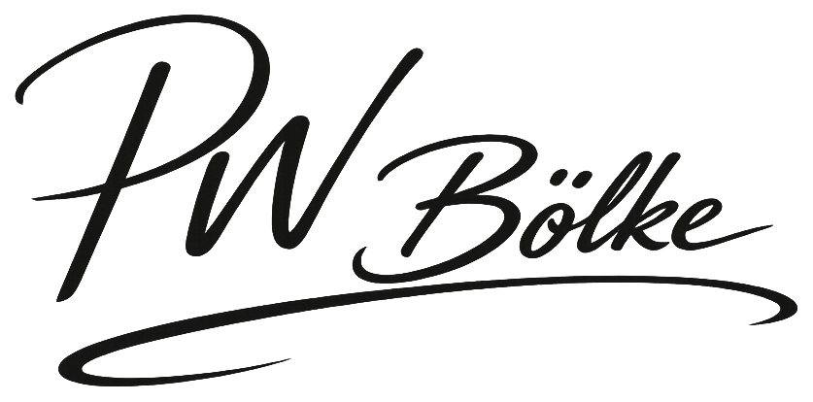
___________________________________________
Signature: Dr. Philippus Weyers Bölke, PhD(Eng) — ThatGuy Productions International
Full Name: ___________________________________________
Date: ___________________________________________
ID Number: ___________________________________________

THE ARTIST
___________________________________________
Signature: Zinhle [full legal name]
Full Name: ___________________________________________
Date: ___________________________________________
ID Number: ___________________________________________

WITNESS
___________________________________________
Signature: Witness to both signatures
Full Name: ___________________________________________
Date: ___________________________________________
ID Number: ___________________________________________
Witness Full Name: ___________________________________________
Witness Occupation: ___________________________________________

ThatGuy Productions International · Baviaanskloof, Eastern Cape, South Africa
Audio is our craft. Transformation is our mission. Distribution is our reach.

