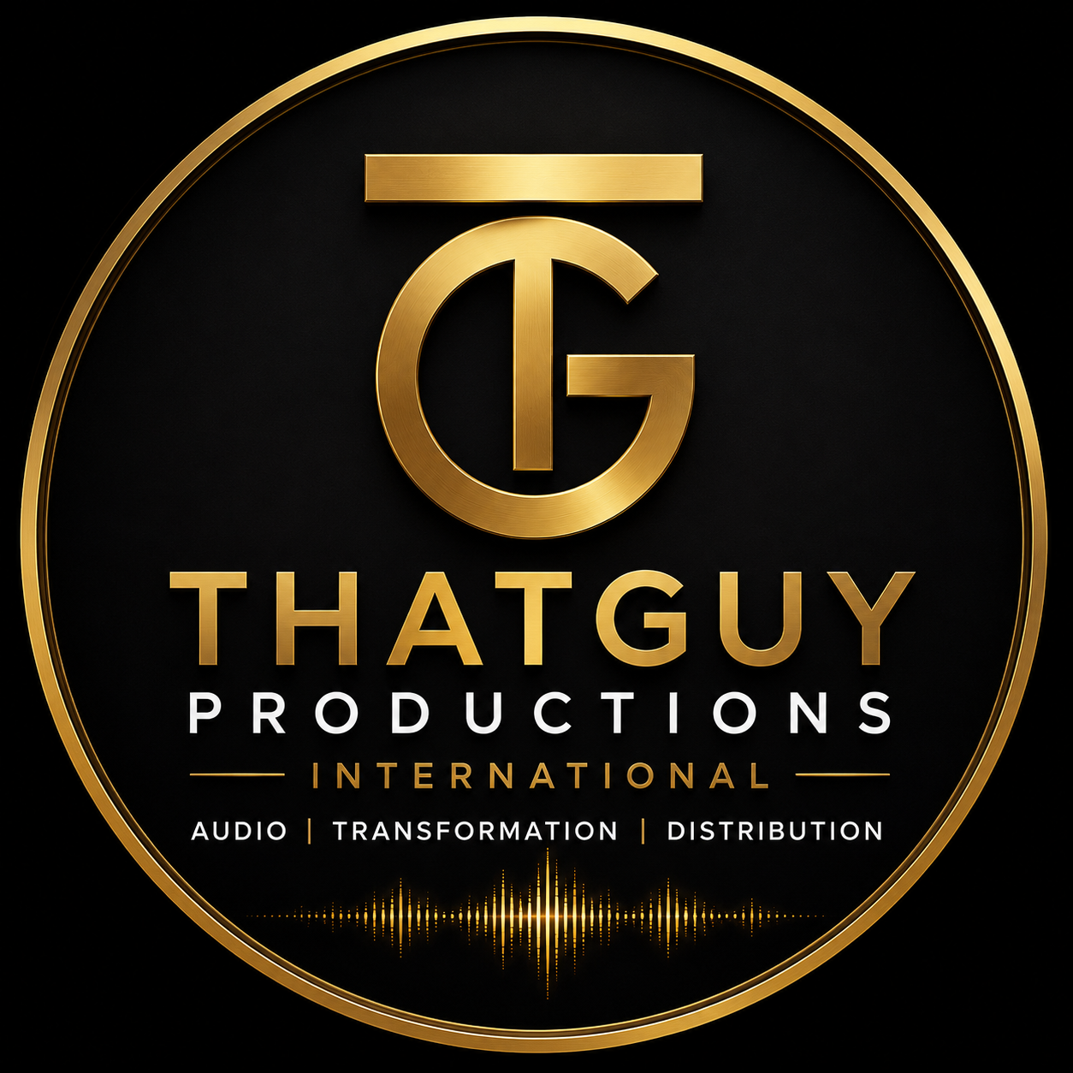
ThatGuy Productions International
AUDIO | TRANSFORMATION | DISTRIBUTION
Baviaanskloof, Eastern Cape, South Africa

COMMITMENT LETTER
Artist Development & Production Support — Zinhle
22 June 2026

ISSUED BY
Dr. Philippus Weyers Bölke, PhD(Eng) · MEng · BEng
Founder & Chief Executive Officer — Arcovel Technologies International (Pty) Ltd
Owner & Executive Producer — ThatGuy Productions International
Baviaanskloof, Eastern Cape, South Africa

1. PURPOSE OF THIS LETTER
This Commitment Letter is issued publicly by Phil Bölke, in his capacity as owner and executive producer of ThatGuy Productions International, to document the personal and professional commitments he has made in connection with the discovery, development, and support of an emerging artist known publicly as Zinhle.
This letter is intended to provide transparency to all stakeholders — including donors to any associated crowdfunding campaign, members of the public, journalists, and industry professionals — regarding the nature of the commitments made and the protections in place for the artist.
This letter does not create a bilateral contract. The full bilateral agreement will be entered into separately between Phil Bölke and Zinhle upon her informed consent and at the appropriate stage of the project.
2. STUDIO & PRODUCTION COMMITMENT
Phil Bölke commits unconditionally to the following, at no cost to Zinhle or to any associated crowdfunding fund:
- Full production of Zinhle's debut album at ThatGuy Productions International, Baviaanskloof.
- All recording sessions, engineering, mixing, mastering, and quality assurance through the RAIN V6 pipeline.
- Professional distribution infrastructure, ISRC registration, DDEX-compliant metadata, and provenance certification on all released material.
- All studio time, equipment, software, and production labour contributed as a personal investment — not charged to any fund.

3. LOGISTICS & DEVELOPMENT COMMITMENT
Phil Bölke commits to managing the following on behalf of Zinhle, at no personal profit:
- Travel and accommodation bookings for industry exposure trips to Johannesburg and Cape Town.
- Facilitation of introductions to industry professionals, artists, and mentors.
- Scheduling, calendar management, and meeting logistics throughout the development period.
- All associated administrative costs borne by Phil Bölke personally, not from any crowdfunding fund.
4. FUND MANAGEMENT & ACCOUNTABILITY
Should the associated Back a Buddy crowdfunding campaign be successful, all funds raised will be governed by the following structure:
- A dedicated business account will be opened in Zinhle's name with joint signatory control — Phil Bölke and Zinhle. Neither party may access funds without the consent and co-signature of the other.
- If the fund size warrants it, an independent registered accounting firm will be appointed as a third oversight party, at Phil Bölke's personal cost.
- All disbursements will be milestone-based and fully transparent.
- The R50,000 ring-fenced marketing account will be held and released only upon Zinhle's return and at the album rollout stage. It may not be redirected for any other purpose.
- Nothing raised in any crowdfunding campaign will be paid to Phil Bölke or to ThatGuy Productions International in any form whatsoever.
5. OWNERSHIP, RIGHTS & INTELLECTUAL PROPERTY
Phil Bölke commits unconditionally that:
- He holds no ownership claim, present or future, over Zinhle's name, likeness, brand identity, or stage persona.
- He holds no claim over the master recordings produced at ThatGuy Productions International on Zinhle's behalf. Masters vest in Zinhle subject to terms to be agreed in the bilateral contract.
- He holds no claim over Zinhle's publishing rights, performance rights, or any future earnings from her music career.
- The production of Zinhle's debut album constitutes a gift, not an investment in exchange for equity, royalties, or any form of financial return.
6. CONFLICT OF INTEREST DECLARATION
Phil Bölke acknowledges that he occupies a dual role as both campaign facilitator and studio production partner. He declares that no financial benefit accrues to him or to ThatGuy Productions International from any crowdfunding campaign associated with this project. All value contributed by Phil Bölke is outgoing — studio infrastructure, production labour, logistics, and time — and nothing is received in return beyond the creative and personal satisfaction of supporting an artist he believes in.
Phil Bölke further declares that this project is being undertaken in personal time alongside active research and patent obligations, including a PCT international filing deadline of December 13, 2026. The time invested represents a deliberate personal sacrifice, not a commercial calculation.
7. FUTURE BILATERAL AGREEMENT
Upon Zinhle being informed of this project and upon her free, informed, and uncoerced consent, a full bilateral agreement will be entered into between Phil Bölke and Zinhle. That agreement will incorporate all commitments in this letter as binding obligations and will address reciprocal terms, exit provisions, album terms, and any other matters requiring mutual agreement.
Until that bilateral agreement is signed, this Commitment Letter stands as Phil Bölke's public and accountable statement of intent.

SIGNED
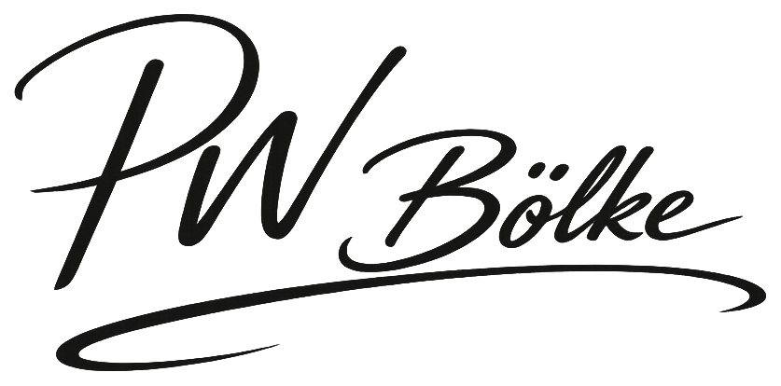
___________________________________________
Dr. Philippus Weyers Bölke, PhD(Eng)
Founder & CEO — Arcovel Technologies International (Pty) Ltd
Owner & Executive Producer — ThatGuy Productions International
Baviaanskloof, Eastern Cape | 22 June 2026

ThatGuy Productions International · Baviaanskloof, Eastern Cape, South Africa · Audio | Transformation | Distribution

