TABLE OF CONTENTS
TABLE OF CONTENTS i
LIST OF FIGURES iii
ABSTRACT iv
INTRODUCTION 1
Background 1
Problem Statement 1
Project Justification 2
Objectives 3
General Objective 3
Specific Objectives 3
Scope 4
Included 4
Excluded 4
LITERATURE REVIEW 5
Introduction 5
Review of Existing Works 5
Identification of Gaps 6
Summary 6
PROPOSED SOLUTION 7
Overview of the Solution 7
Brief Description of the Solution 7
Core Concept of the Methodology Behind the Solution 7
How the Solution Ties Back to the Problem Identified 7
System Design 8
Key Features 10
METHODOLOGY 11
Development Approach 11
Tools and Technologies 11
Data Collection 13
Testing and Validation 14
WORK PLAN AND TIMELINE 15
Tasks and Milestones 15
Timeline (Gantt Chart) 18
EXPECTED OUTCOMES 20
Final Deliverables 20
Potential Limitation 20
CONCLUSION 21
REFERENCES 22
APPENDICES 23
Data Collection Letter 24
Case Study Organization Approval Letter 26
CURRENT SYSTEM ANALYSIS 28
PART I 30
AS IS PROCESS MODEL 30
Introduction 30
PARTII 33
PROBLEMS WITH THE CURRENT SYSTEM 33
Performance 33
Information 33
Economic 33
Control 34
Efficiency 34
Service 34

LIST OF FIGURES
Figure 1: System Architecture 9
Figure 2: Work Breakdown Structure 15
Figure 3: Gantt Chart 18
Figure 4: Strategic Intelligence and Investigation System 31

ABSTRACT
The Strategic Intelligence and Investigation Division System (SIIDS) is designed to enhance the management of intelligence, investigations, and surveillance within the Rwanda Revenue Authority (RRA). Currently, many of these processes are handled manually, leading to inefficiencies, security vulnerabilities, and difficulties in tracking tax fraud cases. The system aims to automate these activities, ensuring seamless collaboration between the Intelligence, Surveillance, and Investigation Units.
An Agile approach was used to ensure iterative development with continuous feedback from stakeholders. This helped develop a high-quality system that meets users' needs and requirements.
This development approach improved the efficiency and accuracy of investigation processes, reduced risks associated with manual data handling, and enhanced the tracking and enforcement of tax-related cases.
In conclusion, by implementing SIIDS, the RRA will strengthen its ability to detect and investigate tax fraud, ultimately improving tax compliance and revenue collection.

INTRODUCTION

Background
The Strategic Intelligence and Investigation Division System (SIIDS) is designed to modernize intelligence, investigation, and surveillance processes within the Rwanda Revenue Authority (RRA). The digital transformation of government operations has become increasingly important in combating fraud, ensuring compliance, and improving operational efficiency. Tax fraud remains a significant challenge for revenue authorities worldwide, leading to substantial losses in government revenue and undermining economic stability.
Globally, many tax administrations have adopted advanced digital solutions to enhance their investigative capabilities. The integration of technology in intelligence gathering and fraud detection has proven to improve accuracy, speed, and security. However, RRA currently relies on partially manual processes, which limit the efficiency of intelligence operations and expose data to potential security threats.
Challenges such as limited accessibility to real-time data, inefficient case tracking, and inadequate collaboration between intelligence and investigation units highlight the need for an advanced system. SIIDS aims to bridge these gaps by automating intelligence and investigation workflows, ensuring secure access to data, and streamlining case management processes.
The implementation of SIIDS aligns with Rwanda’s broader digital transformation goals, ensuring the RRA remains at the forefront of tax administration innovation. This project will enhance the ability to detect, investigate, and prosecute tax fraud, ultimately increasing compliance and revenue collection.

Problem Statement
The current tax intelligence and investigation system at RRA lacks a centralized and automated platform to manage intelligence gathering, investigation tracking, and case resolution. This deficiency results in inefficiencies, data inconsistencies, and security vulnerabilities, hindering the agency’s ability to fight tax fraud effectively.
Manual processes contribute to delays in detecting fraudulent activities, difficulty in tracking cases, and limited access to real-time intelligence. The lack of integration with external databases such as NIDA, RDB, and RLMUA further complicates investigations, making it challenging to validate taxpayer information promptly.
The impact of these inefficiencies is significant, leading to uncollected taxes, legal challenges, and diminished public trust in the tax administration system. Without a secure, automated, and integrated solution, RRA faces increasing difficulty in enforcing tax compliance and reducing fraudulent activities.

Project Justification
Addressing these challenges is crucial to enhancing RRA’s ability to combat tax fraud and improve revenue collection. The manual handling of intelligence and investigations not only slows down case resolution but also increases the risk of human error and data breaches. A centralized and automated system will provide improved data integrity, enhanced security, and real-time case monitoring.
The SIIDS project aligns with RRA’s mission to improve tax compliance and revenue collection through innovative and efficient processes. By integrating with existing RRA systems and external stakeholder databases, the project will enable seamless data exchange, improving the accuracy and reliability of tax fraud investigations.
The expected direct outcomes include faster case resolution, reduced tax fraud incidents, and improved collaboration among intelligence and investigation teams. Indirectly, the project will enhance the credibility of RRA, increase taxpayer confidence, and support Rwanda’s broader digital governance strategy.
Research indicates that countries implementing digital intelligence systems in tax administration have experienced a reduction in fraud cases and improved compliance rates. Rwanda’s adoption of a similar system will ensure the country remains competitive and efficient in tax enforcement.

Objectives

General Objective
- To develop and implement a centralized, automated system for managing intelligence, investigations, and enforcement processes at the Rwanda Revenue Authority.

Specific Objectives
- Enhance Efficiency: Reduce manual processing and automate case tracking to improve investigation workflows.
- Improve Data Accuracy: Integrate with external databases (NIDA, RDB, RLMUA) for real-time verification and fraud detection.
- Strengthen Security: Implement advanced security measures, including role-based access control and audit trails.
- Increase Fraud Detection Capabilities: Leverage AI-driven analytics to identify suspicious tax activities more effectively.
- Optimize Decision-Making: Provide real-time reports and insights to assist investigators and policymakers in enforcement actions.
- Enhance Communication: Automate alerts and notifications to ensure seamless information flow between stakeholders.
- Ensure System Scalability: Design the system to handle growing data volumes and adapt to future requirements efficiently.

Scope
This section outlines the boundaries and extent of the Strategic Intelligence and Investigation Division System (SIIDS) project. It defines what functionalities and components are included in the system, as well as what falls outside the project’s scope.

Included
- Development of a web-based SIIDS platform.
- Integration with RRA’s existing software and external databases.
- Automation of case tracking, intelligence gathering, and report generation.
- Implementation of role-based access control and security features.
- Training of RRA personnel on system usage and best practices.
- Ongoing system maintenance and support.

Excluded
- Development of hardware infrastructure (existing infrastructure will be utilized).
- Broader tax administration functions outside of intelligence and investigation.
- Manual data entry beyond initial system migration.
By implementing SIIDS, RRA will enhance its capacity to detect, investigate, and prosecute tax fraud, ensuring a more efficient and secure tax administration process.

LITERATURE REVIEW

Introduction
The Rwanda Revenue Authority (RRA), like many tax administrations globally, recognizes the need to leverage technology to enhance efficiency, accuracy, and security in fraud detection and case management.
This literature review explores existing research, case studies, and technological implementations relevant to building a Strategic Intelligence and Investigation Division System (SIIDS). It examines how different jurisdictions have adopted automation and integration strategies to improve investigative outcomes, identifies the challenges and gaps encountered—especially in developing economies—and highlights best practices that can inform the design and deployment of SIIDS at RRA. The review also evaluates the importance of data-driven decision-making, secure information exchange, and user-centered system design in enhancing the effectiveness of tax intelligence operations.

Review of Existing Works
The implementation of intelligence and investigation systems has been widely explored in tax administration and law enforcement. Various studies and technologies have highlighted the benefits of automation, data integration, and advanced analytics in fraud detection. Tax authorities in developed countries have successfully implemented digital platforms that streamline investigations, improve data accuracy, and enhance compliance monitoring.
Several methodologies, including artificial intelligence (AI), machine learning, and big data analytics, have been applied to detect patterns of tax evasion. Research suggests that predictive modeling techniques significantly improve fraud detection rates. Furthermore, case studies from international revenue authorities demonstrate that automated systems reduce investigation timelines and increase efficiency.
Despite these advancements, there are still challenges in the implementation of such systems, particularly in developing economies. Limited technical infrastructure, data silos, and resistance to change are common barriers. Studies emphasize the need for customized solutions that align with the specific needs and regulatory frameworks of each jurisdiction.

Identification of Gaps
While existing systems provide valuable insights into fraud detection and case management, they often lack seamless integration with multiple government databases. Many platforms are designed for general fraud detection rather than tax-specific intelligence gathering. Additionally, user access controls and security measures remain a challenge in ensuring data confidentiality and system integrity.
Another major gap is the limited use of AI-driven analytics in tax fraud investigations within developing economies. While advanced economies have adopted machine learning techniques, many developing nations still rely on rule-based systems, which may not be as effective in identifying complex fraudulent activities.

Summary
The literature review underscores the importance of automated intelligence and investigation systems in tax administration. While significant advancements have been made globally, challenges such as data integration, security, and the adoption of AI-driven analytics persist. SIIDS aims to address these gaps by implementing a tailored, secure, and scalable platform that integrates with RRA’s existing infrastructure, improves fraud detection, and enhances investigative efficiency.

PROPOSED SOLUTION

Overview of the Solution
SIIDS is a centralized, web-based platform designed to enhance the intelligence, investigation, and surveillance processes within RRA. The system will automate workflows, integrate with external databases, and enhance security measures. By utilizing advanced analytics and automation, SIIDS will ensure efficient case tracking and fraud detection, addressing the limitations of the current manual processes.

Brief Description of the Solution
The Strategic Intelligence and Investigation Division System (SIIDS) is a centralized, web-based platform designed to automate and modernize the Rwanda Revenue Authority's (RRA) tax intelligence and investigation processes. The system enables secure data collection, automated case management, real-time fraud detection, and seamless integration with external government databases. By providing a digital workspace for Intelligence Officers, Directors, and Investigators, SIIDS streamlines collaboration, reduces manual errors, and accelerates decision-making in tax fraud investigations.

Core Concept of the Methodology Behind the Solution
The development of SIIDS follows an Agile software development methodology, emphasizing iterative development, stakeholder feedback, and incremental improvements. Agile ensures that the system can rapidly adapt to RRA’s evolving needs and challenges. The architecture is based on a layered modular design that separates data collection, business logic, analysis, user presentation, and security functions

How the Solution Ties Back to the Problem Identified
SIIDS directly addresses these challenges by:
- Automating manual processes: Reduces processing time and human errors through digital case tracking and workflow management.
- Enhancing real-time access to data: Integrates external data sources for immediate verification and validation, solving the problem of data inaccessibility.
- Improving security and accountability: Implements strict access controls and audit trails, mitigating risks of fraud, manipulation, or unauthorized data access.
- Supporting faster and smarter decision-making: Provides dashboards, analytics, and alerts to investigators and decision-makers for proactive case handling.

System Design
The Strategic Intelligence and Investigation Division System (SIIDS) is built on a multi-layered web-based architecture that emphasizes scalability, security, maintainability, and interoperability with existing systems at the Rwanda Revenue Authority (RRA). The system is logically divided into several layers and integrated components, each responsible for distinct functionality. This architectural design supports modular development and ensures high performance in tax fraud detection and case management.
  - Presentation Layer (Frontend): This layer Provides a user-friendly interface through which authorized users (e.g., Intelligence Officers, Directors, Investigators) interact with the system. It includes Dynamic dashboards for case monitoring, Forms for submitting reports, uploading evidence, and managing cases and Real-time notifications to all authorized users
  - Application Layer(Backend): This layer Handles business logic, processing user requests, managing workflows (case approval, investigation tracking, case rejection), and enforcing role-based access controls. It includes API endpoints for all system functionalities and Case management logic, including automatic case assignment and escalation procedures.
  - Integration Layer: This layer Facilitates real-time data exchange with external government agencies these include:

    - NIDA: National ID verification
    - RDB: Business registration
  - Data Layer (Database Management): This layer Persistent storage of system data. It includes Regular backups and disaster recovery mechanisms
  - Security Layer: This layer provides Role-Based Access Control (RBAC) which ensures only authorized users perform specific actions and Secure token expiration and renewal policies.
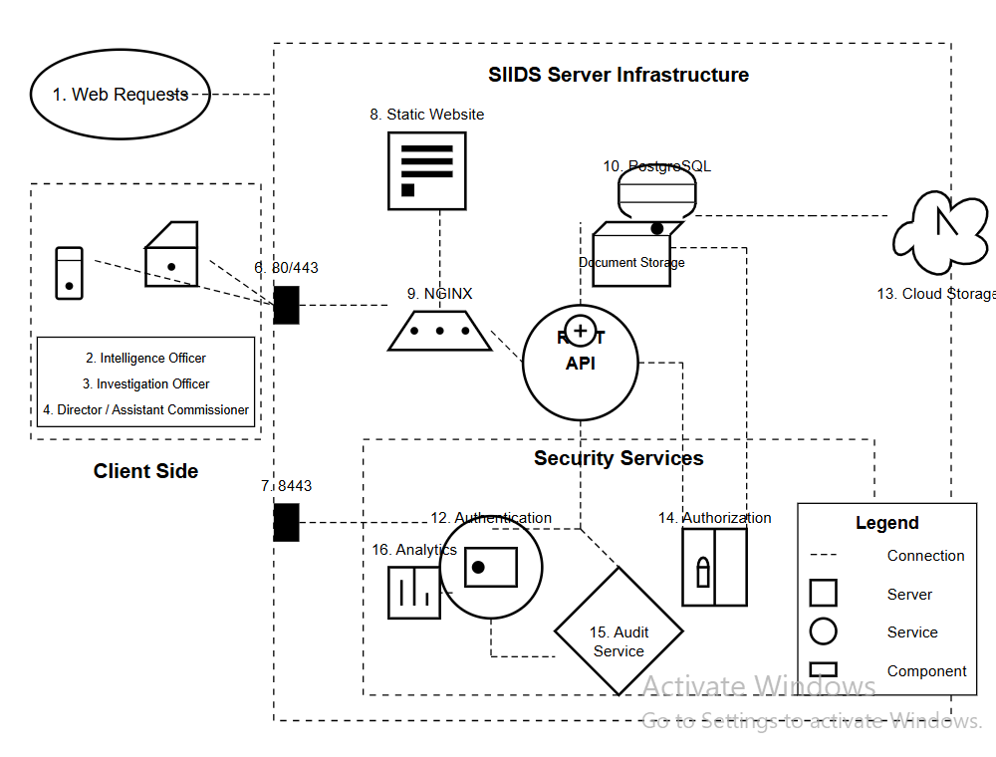
Figure 1: System Architecture

Key Features
- User Authentication & Role-Based Access Control:
  - SIIDS enforces secure access to the system through a robust authentication mechanism. Each user must log in using unique credentials, and their access rights are determined based on predefined roles (e.g., Intelligence Officer, Director, Investigator, Admin). RBAC ensures that users only interact with modules and data relevant to their responsibilities, reducing the risk of unauthorized access and data breaches.
- Automated Case Tracking & Management:
  - Cases reported to the intelligence division are automatically logged, assigned, and tracked throughout their lifecycle. The system maintains a digital trail of all activities related to each case, including reviews, approvals, and investigation outcomes. Automated status updates reduce delays and improve visibility into case progress for all relevant stakeholders.
- Integration with External Databases:
  - SIIDS connects with key national databases—such as NIDA and RDB to enable real-time validation of taxpayer identities, business registration details, and property records. This integration reduces reliance on manual verification, speeds up investigations, and ensures higher data accuracy when detecting inconsistencies or fraudulent activities.
- Automated Alerts & Notifications:
  - Users receive real-time alerts and system-generated notifications based on key events—such as new case assignments, pending approvals, overdue investigations, or updates from integrated databases. These notifications are delivered through in-app messages and email (if configured), helping maintain effective communication and prompt response.

METHODOLOGY

Development Approach
The SIIDS project will follow an Agile methodology, ensuring iterative development, continuous feedback, and flexibility in adapting to changing requirements. Agile is suitable for this project because it allows frequent testing, stakeholder collaboration, and incremental improvements, reducing risks associated with system implementation.

Tools and Technologies
- Programming Languages:
  - Java:
    - Java is chosen for backend development due to its platform independence, stability, and extensive ecosystem for enterprise applications. It is widely adopted in government and financial systems because of its robustness, strong community support, and security features.
  - JavaScript:
    - JavaScript will be used primarily on the client side to build a dynamic and responsive user interface. It enables rich interactivity and real-time updates, improving user experience.
- Frameworks:
  - Spring Boot (Backend Framework):
    - Spring Boot simplifies the development of Java-based web applications. It supports microservices architecture and provides built-in tools for dependency injection, security, and RESTful API development. Its modularity and production-readiness make it ideal for a system like SIIDS.
  - React.js (Frontend Development):
    - React allows the creation of reusable UI components and supports a responsive user experience. It enhances maintainability and scalability while enabling fast rendering through a virtual DOM.

  - Redux (State Management):
    - Redux helps manage and centralize application state, ensuring consistent data flow across components. It is essential for a complex system like SIIDS that handles sensitive case data and dynamic updates.
- Database:
  - PostgreSQL:
    - PostgreSQL is a powerful open-source relational database known for its reliability, data integrity, and advanced querying capabilities. It supports complex data relationships and provides security features such as role-based access and encryption. PostgreSQL is suitable for handling structured case records and maintaining audit trails.
- Security Tools:
  - JWT
    - JWT is used for implementing secure authentication and authorization across the system. It enables stateless and tamper-proof session management, essential for protecting sensitive investigation data.
- Testing Tools:
  - Selenium & JUnit:
    - Selenium is an open-source tool for automating web browsers. It allows for end-to-end testing of the user interface, verifying that all components work as expected under real user interactions
    - JUnit is a widely used framework for testing Java applications. It supports test automation, helping ensure the correctness of backend logic and promoting continuous integration practices.

Data Collection
To ensure accurate and efficient fraud detection, SIIDS will collect and process various types of data:
- Types of Data Needed:
  - Taxpayer Information: Basic identification details (e.g., TIN, name, address) and financial data.
  - Case Reports: Internal reports generated during the investigation and enforcement process.
  - Investigation History: Records of past cases, outcomes, and investigative decisions.
- Data Collection Methods:
  - System Integration: The system will establish secure APIs to retrieve data automatically from external databases like NIDA and RDB. This reduces human error and speeds up verification processes.
  - User Input Forms: Authorized personnel (e.g., Intelligence Officers) can manually submit or update data through structured digital forms within the SIIDS interface.
  - Log Collection: SIIDS will automatically log system usage, case progress, and actions performed by users, creating a transparent audit trail.
  - File Uploads: Investigators may upload supporting documents such as evidence files, or field notes.
- Data Sources:
  - RRA Internal Systems: Existing tax filing systems, taxpayer records, and compliance modules.
  - User-Generated Reports: Submitted by investigators, whistleblowers, or system users.
- Data Usage:
  - Fraud Detection: Investigation Officers will analyze data to detect anomalies or suspicious patterns.
  - Case Analysis: Investigation teams will access consolidated profiles that include taxpayer activities and compliance history.
  - Reporting and Decision-Making: Real-time dashboards and automated reports will aid management in enforcement actions.
  - Alerts and Notifications: The system will allow collaboration among the different units involved to share findings of different cases.

Testing and Validation
The system will undergo unit testing, integration testing, user acceptance testing (UAT), and performance testing. Each component will be evaluated independently before full system testing.
Testing Tools & Frameworks:
- Unit Testing: Unit testing involves verifying individual components of the system in isolation, such as services, controllers, and utility classes developed in Spring Boot.
- Integration Testing: Integration testing validates that different modules and components interact correctly. This includes testing the communication between the frontend and backend, as well as connections to external databases (NIDA, RDB). E.g. Postman for API validation.
- UI Testing: UI testing checks the behavior, appearance, and usability of the web application from a user’s perspective. It also Ensures that buttons, forms, alerts, and dashboards function correctly and Verifies responsiveness across different browsers and devices. Selenium for frontend testing to ensure usability.

WORK PLAN AND TIMELINE

Tasks and Milestones
To effectively plan and track progress, the project follows WBS (Work Breakdown Structure) and SMART (Specific, Measurable, Achievable, Relevant, Time-bound) criteria.
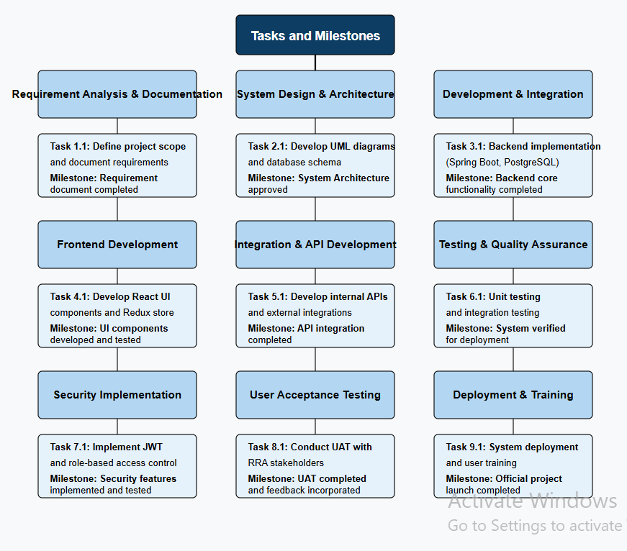
Figure 2: Work Breakdown Structure

Breakdown of Tasks & Milestones:

1. Requirement Analysis & Documentation
- Define project scope: Clarify the project's objectives, boundaries, and deliverables. Identify what will and won't be included in the project.
- Identify stakeholders: Determine who the stakeholders are (e.g., clients, team members, users) and their roles and responsibilities.
- Document requirements: Gather and document both functional and non-functional requirements to ensure all aspects of the project are covered.
- Milestone: Completion of Requirement Document: This marks the official sign-off of the project’s scope and requirements. It sets a clear understanding of the project objectives and expectations.
2. System Design & Architecture
- Define system components: Identify and define the key components of the system, including both hardware and software requirements.
- Develop UML diagrams (Use Case, Class, Sequence, Activity): Create Unified Modeling Language (UML) diagrams to visually represent system interactions, class structures, and workflows. These diagrams help clarify the design.
- Plan database schema: Design the structure of the database, including tables, relationships, and normalization to ensure efficient data storage and retrieval.
- Milestone: System Architecture Approved: The system design and architecture are reviewed and approved, marking the transition from planning to development.
3. Development & Integration
- Backend implementation (Spring Boot, PostgreSQL): Develop the backend system using Spring Boot framework for Java-based development and PostgreSQL for database management.
- Frontend development (React, Redux): Build the frontend using React for creating interactive user interfaces and Redux for managing state across the application.
- API development & integration: Develop and integrate APIs to allow communication between the frontend and backend systems, ensuring smooth data flow.
- Milestone: MVP (Minimum Viable Product) Completed: The MVP is the first functional version of the product, containing the core features and functionalities necessary to demonstrate its viability.
4. Testing & Quality Assurance
- Unit testing: Test individual components of the system (e.g., functions, methods) to ensure they work as intended in isolation.
- Integration testing: Test the interactions between different system components (e.g., backend and frontend, or frontend and API) to ensure they work together as expected.
- User acceptance testing (UAT): Allow end users to test the system to verify it meets their needs and expectations before going live.
- Milestone: System Verified for Deployment: After thorough testing, the system is confirmed to be ready for deployment, ensuring it functions as required and meets quality standards.
5. Deployment & Training
- Deploy to production server: Release the system to the live production environment, making it available to end users.
- Conduct user training sessions: Train users on how to effectively use the system, ensuring they understand its features and functionality.
- Gather feedback & improvements: Collect feedback from users after deployment to identify areas for improvement or additional features.
- Milestone: Official Project Launch, The official go-live of the project, marking its readiness for widespread use and completion of the core project goals

Timeline (Gantt Chart)
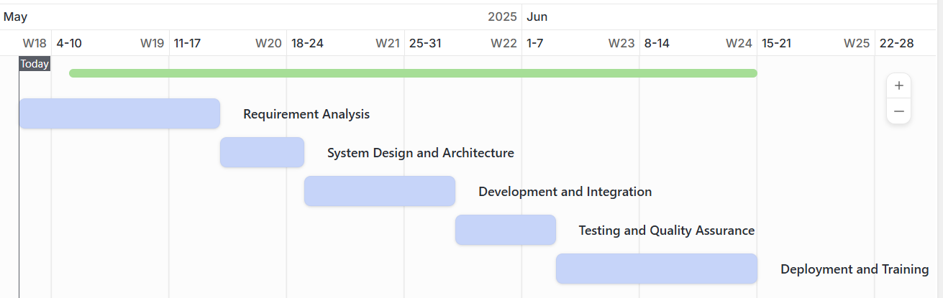
Figure 3: Gantt Chart
Requirement Analysis & Documentation (Orange Bar)
- Starts on May 5, 2025
- Ends around May 13, 2025
- This phase involves gathering and documenting requirements for the project.
System Design & Architecture (Blue Bar)
- Starts immediately after the Requirement Analysis phase (May 14, 2025)
- Ends around May 18, 2025
- This phase includes designing the system's architecture and technical specifications.
Development & Integration (Light Blue Bar)
- Starts in parallel with System Design around May 19, 2025
- Ends on May 27, 2025
- This phase involves coding, integrating different modules, and developing core functionalities.
Testing & Quality Assurance (Gray Bar)
- Begins immediately after Development & Integration on May 28, 2025
- Ends around June 2, 2025
- This phase involves testing the software to ensure it meets quality standards and is bug-free.
Deployment & Training (Dark Gray Bar)
- Starts right after Testing & Quality Assurance on June 3, 2025
- Ends around June 14, 2025.
- This phase includes deploying the system and training users on how to use it.

EXPECTED OUTCOMES

Final Deliverables
- Fully Functional SIIDS Platform
  - A centralized, web-based system designed to streamline intelligence gathering, investigation, and surveillance within RRA.
  - User-friendly interface for authorized personnel to access and manage case records.
- Seamless Integration with Relevant Databases and Systems
  - Secure and automated connections to external data sources such as NIDA, RDB, and RLMUA to enhance fraud detection.
  - Real-time data retrieval and validation to improve investigation accuracy.
- Comprehensive Documentation
  - Detailed user manuals and technical documentation to support training and onboarding.
  - System architecture diagrams, data flow models, and API integration guides.

Potential Limitation
- Initial Resistance to System Adoption
  - Training and change management strategies will be required to help RRA personnel transition from manual processes.
- Dependence on External Data Sources
  - System effectiveness relies on timely access to external databases, which may introduce delays if data sources are unavailable.
- Ongoing Security Challenges
  - Continuous monitoring and updates will be necessary to protect against cyber threats and ensure compliance with data privacy regulations.

CONCLUSION
The SIIDS project is a crucial step in modernizing tax intelligence and investigation processes at RRA. By automating case tracking, integrating external data sources, and enhancing security, the system will significantly improve efficiency and accuracy in fraud detection.
The project will be developed using an Agile methodology, ensuring iterative improvements and stakeholder involvement. With robust testing and validation processes, SIIDS will provide a reliable and scalable solution for tax compliance enforcement.
In the long term, SIIDS will not only enhance RRA’s investigative capabilities but also build public trust in tax administration, ensuring a more transparent and efficient revenue collection system.

REFERENCES
Rwanda Revenue Authority (RRA). (2023). Annual Performance Report 2022–2023. Kigali, Rwanda.
OECD. (2017). Technology Tools to Tackle Tax Evasion and Tax Fraud. OECD Publishing. https://www.oecd.org/tax/crime/technology-tools-to-tackle-tax-evasion-and-tax-fraud.pdf
Musoni, S. (2021). Automating Tax Intelligence Systems in Rwanda: A Case for Enhanced Compliance. Rwanda Journal of Information Technology, 2(1), 34–47.
Rwanda Utilities Regulatory Authority (RURA). (2021). Annual Report 2020/2021. Kigali, Rwanda.
Rwanda Governance Board (RGB). (2022). Rwanda E-Governance Development Report. Kigali, Rwanda.
National Institute of Statistics of Rwanda (NISR). (2023). Statistical Yearbook 2023. Kigali, Rwanda. Retrieved from https://www.statistics.gov.rw

APPENDICES

Data Collection Letter



Case Study Organization Approval Letter

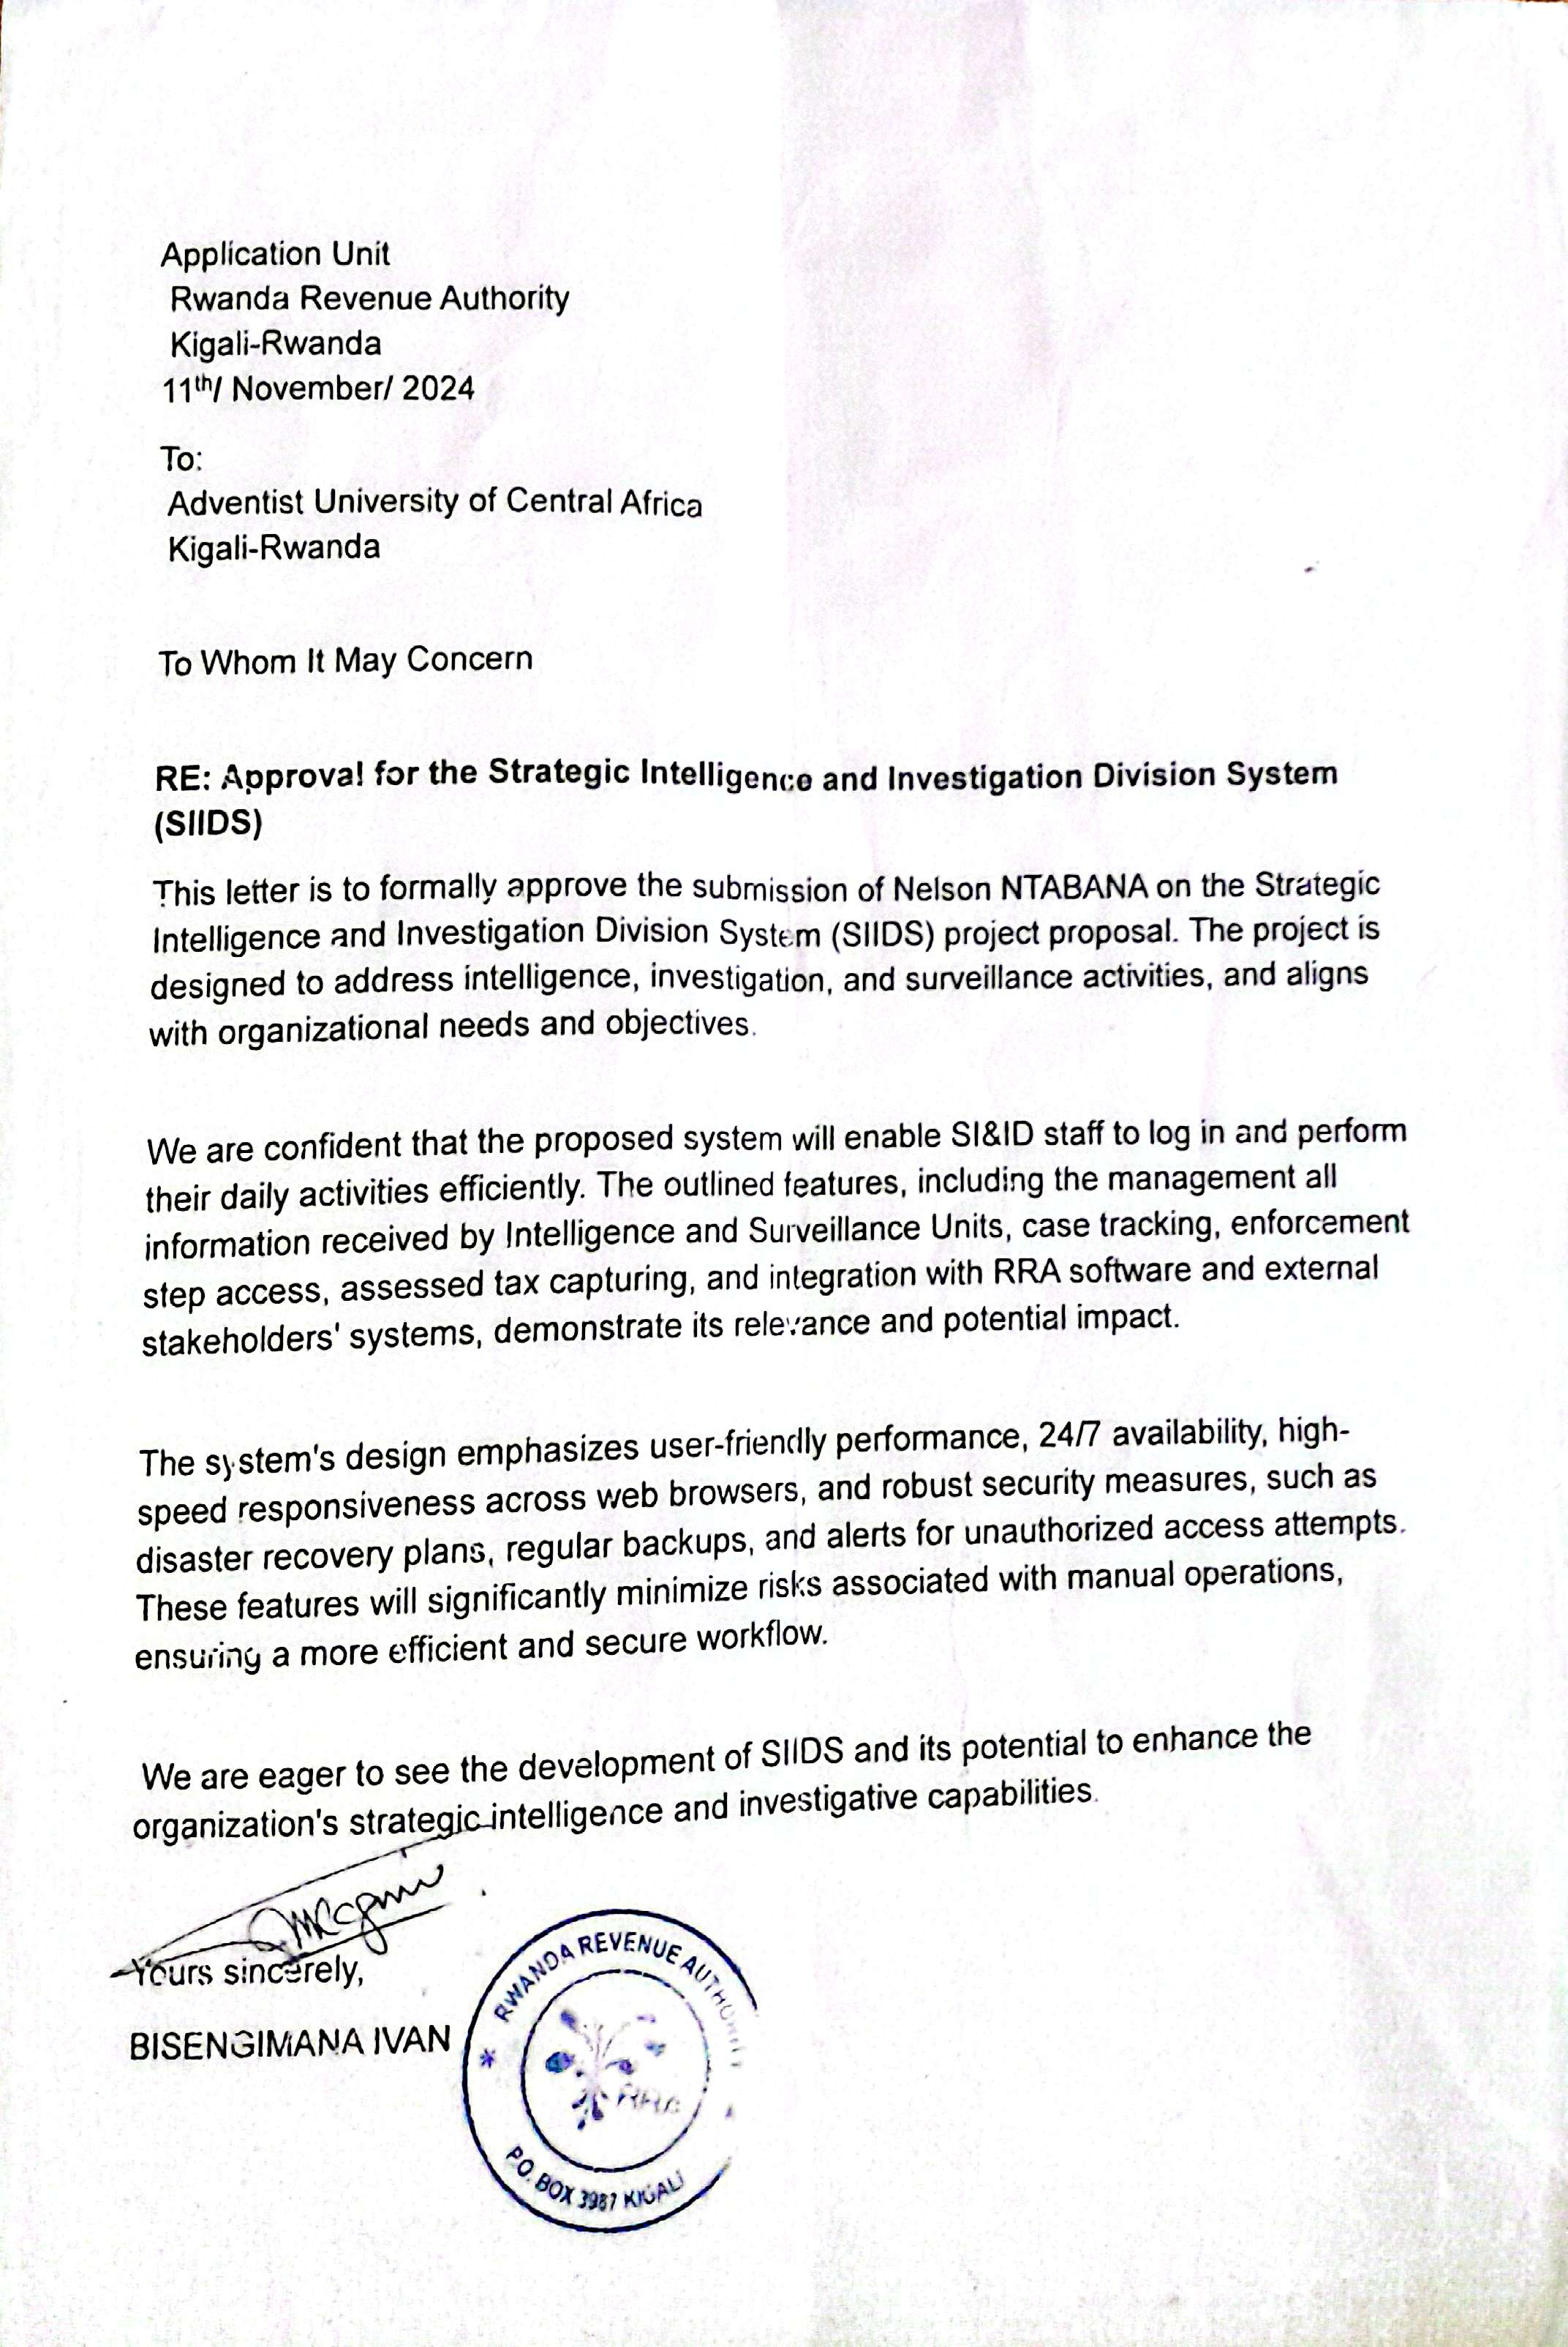

CURRENT SYSTEM ANALYSIS

Adventist University of Central Africa

Strategic Intelligence and Investigation Division system(SIIDS)

CASE STUDY: RWANDA REVENUE AUTHORITY (RRA)

A topic for a final year project, submitted to the faculty of Information Technology
for approval
By
Ntabana Nelson, 24562

Majoring in
Software Engineering

May, 2025

PART I

AS IS PROCESS MODEL

Introduction
The Strategic Intelligence and Investigation Division System (SIIDS) aims to modernize the Rwanda Revenue Authority’s (RRA) intelligence and investigation processes to combat tax fraud and enhance compliance. Traditionally, RRA has relied on manual methods, including physical documentation and spreadsheets, which are inefficient and vulnerable to fraud. With evolving tax evasion tactics, there is a growing need for a centralized digital system to streamline intelligence gathering and fraud detection.
RRA operates multiple business models, including revenue collection, compliance audits, and intelligence-led investigations. This study focuses on the intelligence-led investigation model, which is crucial for identifying tax fraud cases through data-driven insights. However, the current system is hindered by fragmented processes, lack of automation, and slow access to external data sources, making fraud detection less effective.
The main challenges include inefficient case tracking, delays in fraud detection due to manual workflows, and security vulnerabilities arising from inconsistent data management. Additionally, limited integration with key databases slows down taxpayer verification, prolonging investigations and allowing fraudulent activities to persist. These inefficiencies result in significant revenue losses and weaken public trust in the tax system.
To address these issues, SIIDS will automate intelligence gathering, integrate external data sources, and enhance investigative capabilities. This digital transformation will improve efficiency, increase fraud detection accuracy, and strengthen tax compliance enforcement. The research will analyze the current system’s limitations and propose a framework for SIIDS implementation, contributing to Rwanda’s broader digital governance objectives.
Modeling of the Current Grade Claim System
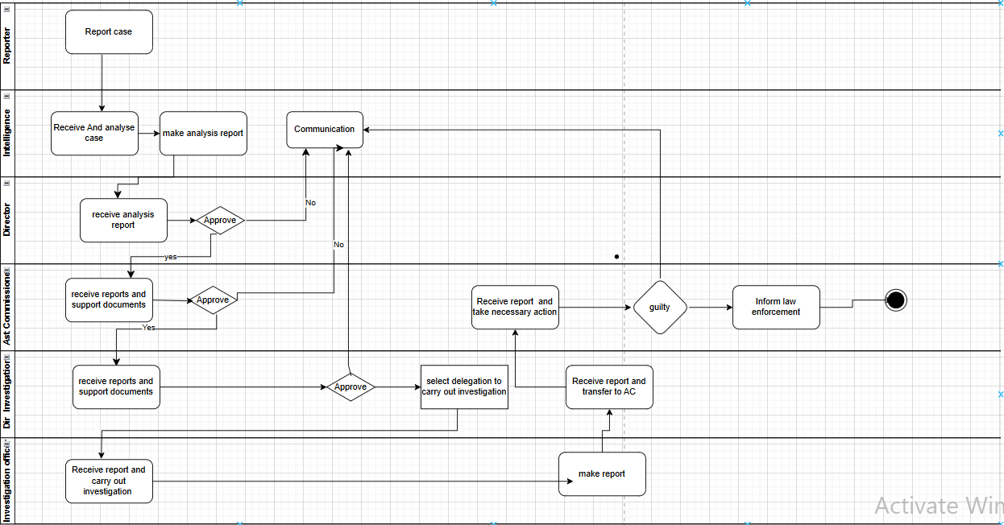
Figure 4: Strategic Intelligence and Investigation System
Step 1: Reporter: A concerned individual reports a case to the relevant department, the case is forwarded to the Intelligence department for further analysis.
Step 2: Intelligence Officer: Receives, analyzes the case and Prepares an analysis report summarizing findings. Sends the report to the Director for review and approval. If the Director rejects it, the process stops or requires more communication.
Step 3: Director Intelligence: Reviews the analysis report received from Intelligence. Decides whether to approve or reject the report: -If approved, it is forwarded to the Assistant Commissioner (AC) for further action. Else, communication is sent back to the Intelligence department for clarifications.
Step 4: Assistant Commissioner (AC): Receives reports & supporting documents. Decides whether to approve the case for investigation: If approved, the case moves to the Director of Investigation. Else, communication is sent back for clarification or case dismissal.
Step 5: Director of Investigation: Receives reports and supporting documents. If approved, assigns the case to an investigation officer.
Step 6: Investigation Officer: Receives the report and conducts an investigation and Makes an investigation report based on findings. Transfers the report to the Assistant Commissioner (AC) for final action.
Step 7: Final Decision & Law Enforcement: The report is reviewed to determine if the accused is guilty. If guilty, the case is forwarded to law enforcement for legal action. If not guilty, the case is closed or further reviewed.

PARTII

PROBLEMS WITH THE CURRENT SYSTEM

Performance
- Low Throughput: The manual system processes a limited number of investigation cases per day due to paperwork and human dependencies. This restricts the volume of cases that can be completed within a given period, creating a backlog and slowing investigations.
- High Response Time: Case processing and approval times are significantly delayed as each step requires physical movement or manual communication between departments. This leads to longer wait times for case updates, decisions, and resolution.

Information
- Storage Challenges: Physical filing systems or scattered Excel files are used for data storage, posing risks of data loss, redundancy, and inaccessibility. There's no centralized digital repository to store, retrieve, or analyze case histories effectively.
- Input Issues: Data is often captured manually through handwritten or typed forms, which increases the chances of data entry errors and delays. There's no standardized format for input, leading to inconsistencies.
- Output Limitations: Reports and analysis results are manually generated and printed, making it difficult to quickly share findings or provide real-time insights. There is also a lack of automated alerts or dashboards for decision-makers.

Economic
- High Operational Costs: Printing, storing, and managing physical documents increases operational expenses.
- Inefficient Resource Utilization: More staff and time are required to manage and track cases manually, leading to increased labor costs.
- Delayed Financial Decisions: The slow processing of reports and approvals can lead to missed opportunities or delayed enforcement actions, affecting revenue collection.

Control
- Weak Oversight & Tracking: Tracking case progress and responsibilities is difficult, leading to accountability issues.
- Risk of Fraud and Manipulation: Manual handling increases the possibility of unauthorized alterations or misreporting.
- Limited Audit Trail: The system lacks an effective way to trace modifications or approvals, making investigations difficult in case of discrepancies.

Efficiency
- Redundant Tasks: Multiple approvals and case reviews require repeated manual verification, slowing down the process.
- Difficulty in Collaboration: Officers must rely on physical meetings or calls to discuss cases, leading to inefficiencies.
- Delayed Decision-making: Since reports require multiple approvals, cases take longer to reach resolution.

Service
- Poor Customer Experience: Individuals affected by enforcement actions face delays and frustrations due to slow case processing.
- Lack of Transparency: The status of cases is not easily accessible to relevant stakeholders, reducing public trust in the process.
- Limited Scalability: As case volumes increase, the system becomes more difficult to manage, leading to bottlenecks and increased delays.

