Below are some data discrepancies that we encoountered trying to map SDG goals from a csv file downloaded from <https://unstats.un.org/sdgs/dataportal/database>.

The issue encountered is that:

* a single SDG indicator is returning multiple values making diffucul to know one to select e,g 1.3.1, 3.3.1
* difference between carpha SDG description and those found in the csv files for example: SDG 3 – 3.2.1 Under-five mortality rate is not equal to Under-five mortality rate by sex (deaths per 1000 live births) – This is make it impossible to dynamically map SDGs

We need to know how to select which values, how to know when to add and which values – These discrepancies prevent the electronic automatic matching from the csv. We might need to propose a manually formatted file following some agreed upon criteria or rules hence making the automatic mapping swift.

**Goal 1**

SDG 1 - 1.3 Proportion of population covered by social protection floors/systems by sex

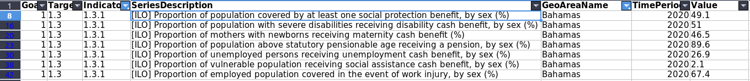

SDG 1 - 1.4.1 Proportion of population living in households with access to basic services



**Goal 2**

SDG 2 - 2.2.1 Prevalence of stunting (height for age < -2 standard deviation from the median of the WHO) among children under 5 years of age.



SDG 2 - 2.2.2 Prevalence of malnutrition among children under 5 years of age by type



**Goal 3**

SDG 3 - 3.2.1 Under-five mortality rate

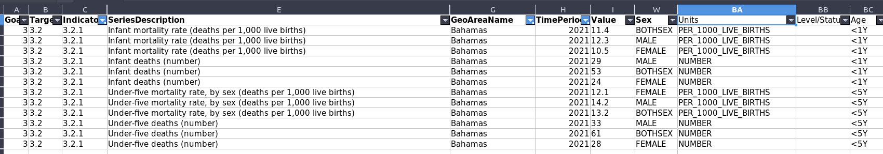

SDG 3 - 3.2.2 Neonatal mortality rate



SDG 3 - 3.3.1 Number of new HIV infections per 1,000 uninfected population

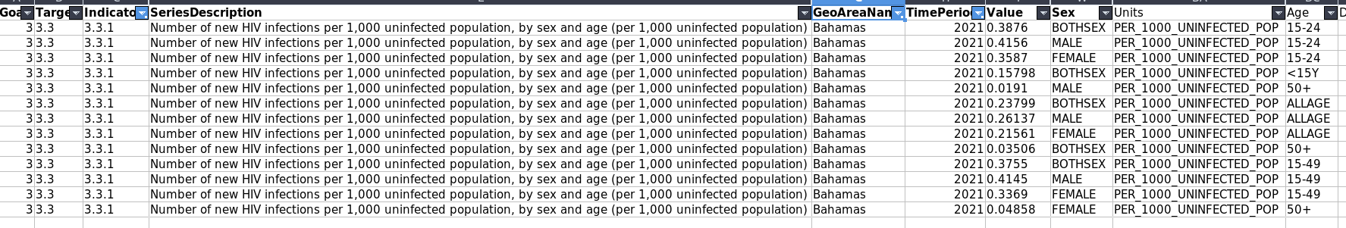

SDG 3 - 3.d.1 International Health Regulations (IHR) capacity and health emergency preparednes

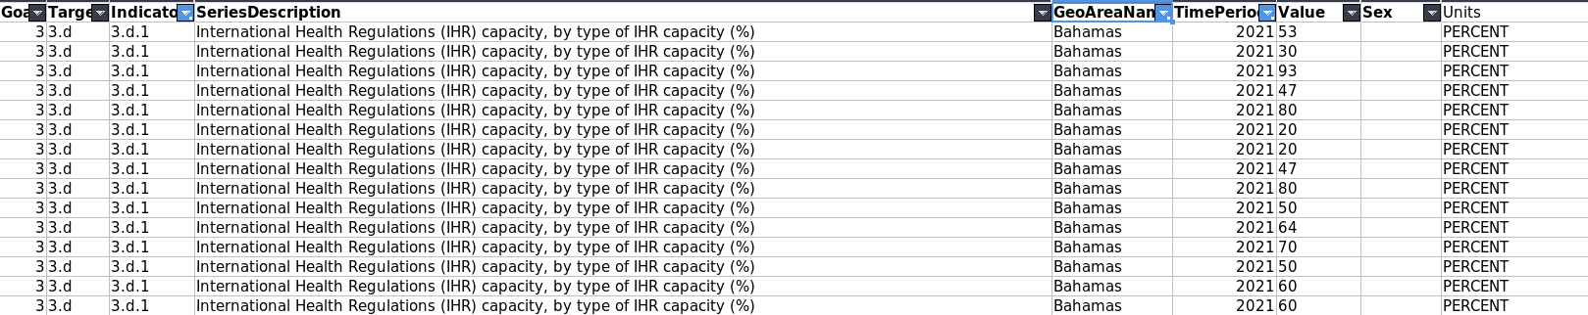

**Goal 4**

SDG 4 - 4.2.2 Participation rate in organized learning (one year before the official primary entry age), by sex



**Goal 5**

SDG 5 - 5.6.2 Number of countries with laws and regulations that guarantee women aged 15-49 years access to sexual and reproductive health care, information and education

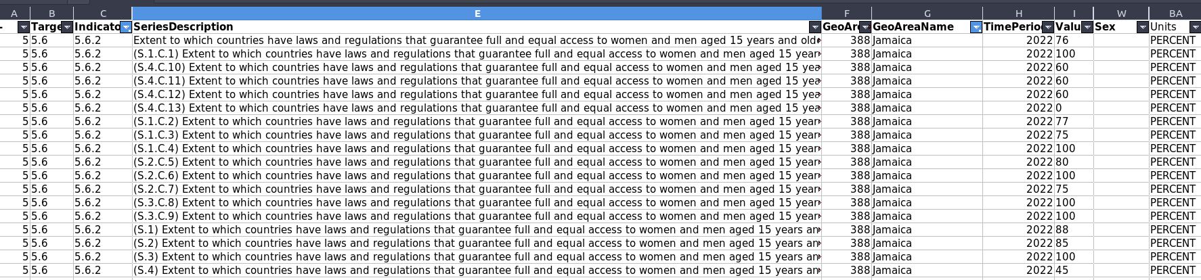

**Goal 6**

SDG 6 - 6.2.1 Proportion of population using (a) safely managed sanitation services and (b) a hand-washing facility with soap and water



SDG 6 - 6.3.2 Proportion of bodies of water with good ambient water quality



**Goal 7**

SDG 7 - 7.1.1 Proportion of population with access to electricty



SDG 7 - 7.1.2 Proportion of population with primary reliance on clean fuels and technology



**Goal 8**

SDG 8 - 8.a.1 Aid for Trade commitments and disbursement



**Goal 11**

SDG 11 - 11.5.1 Number of deaths, missing persons and directly affected persons attributed to disasters per 100,000 population



SDG 11 - 11.5.2 Direct economic loss attributed to disasters in relation to global domestic product (GDP)



SDG 11 - 11.7.1 Average share of the built-up area of cities that is open space for public use for all, by sex, age and persons with disabilities



SDG 11 - 11.a.1 Number of countries that have national urban policies or regional development plans that (a) respond to population dynamics



**Goal 13**

SDG 13 - 13.1.1 Number of deaths, missing persons and directly affected persons attributed to disasters per 100,000 population

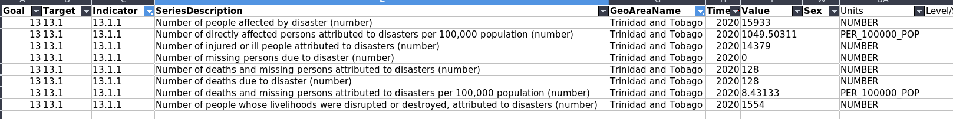

SDG 13 - 13.1.2 Number of countries that adopt and implement national disaster risk reduction strategies in line with the Sendai Framework for Disaster Risk Reduction 2015–2030



SDG 13 - 13.1.3 Proportion of local governments that adopt and implement local disaster risk reduction strategies in line with national disaster risk reduction strategies



**Goal 14**

SDG 14 - 14.1.1 (a) Index of coastal eutrophication; and (b) plastic debris density

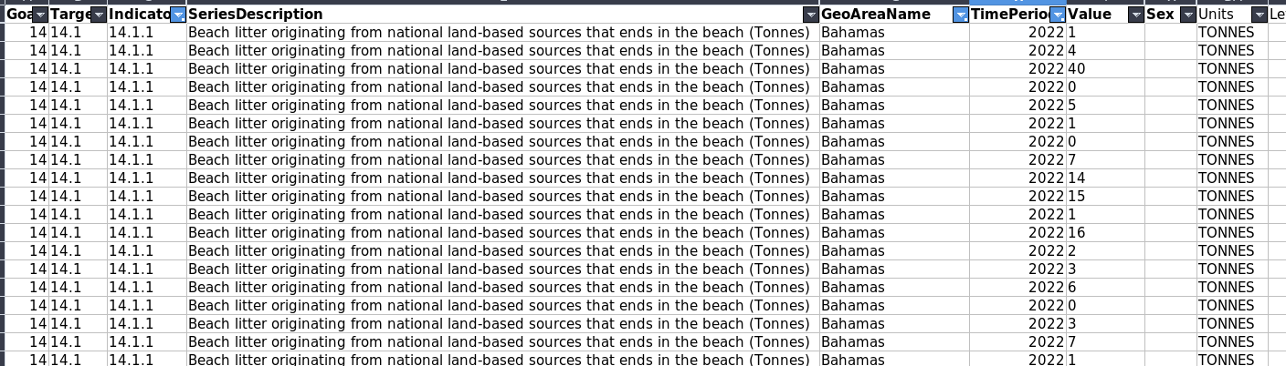

**Goal 15**

SDG 15 - 15.1.2 Proportion of important sites for terrestrial and freshwater biodiversity that are covered by protected areas, by ecosystem type



**Goal 17**

SDG 17 - 17.1.1 Total government revenue as a proportion of GDP, by source



SDG 17 - 17.3.1 Additional financial resources mobilized for developing countries from multiple sources



SDG 17 - 17.8.1 Statistical capacity indicator for Sustainable Development Goal monitoring

