Aurora Pia Ghiardelli, i6367385
Robust Image Stitching through RANSAC-Based Homography Estimation
In the context of Computer Vision, the automatic construction of panoramas represents a concrete and stimulating application of image alignment and fusion. In this project, the main objective was to develop a custom pipeline for image stitching, based on identifying correspondences between images and estimating a robust geometric transformation using the RANSAC (RANdom SAmple Consensus) method.
To tackle this challenge, techniques such as local feature detection (Harris corners), descriptor extraction and matching, selection of the best correspondences, and a custom implementation of the RANSAC algorithm were used to estimate an affine transformation between pairs of images. The work also includes a parameter sensitivity analysis and experimental evaluation on different image sets.
The aim of this report is to critically present the design choices, challenges encountered, and results obtained, highlighting how the robustness of the geometric estimation directly impacts the quality of the final panorama.
IMAGE LOADING and IMAGE PROCESSING
For the image loading and preprocessing phase, the main experiments related to corner detection and image stitching were conducted using the reference images shown in Figure 1. These images were generated via a simple cropping operation, ensuring that the transformation required for stitching corresponds to a pure translation. Since feature detectors such as Harris Corner detection operate on single-channel greyscale images, a preliminary colour-to-grayscale conversion was applied [1]. To enhance the quality of feature detection and subsequent matching, several preprocessing steps were applied:
- Normalization
- Histogram Equalization
- Gaussian Blur.

Additionally, an intensity histogram was extracted to evaluate the distribution of pixel intensities across the grayscale image (Figure 3) . The histogram appears relatively uniform.

Figure 1
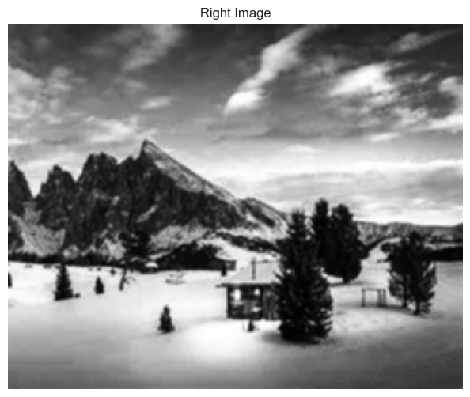
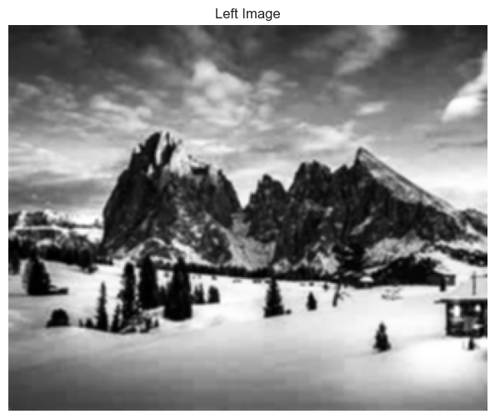
Figure 2. Images after preprocessing.
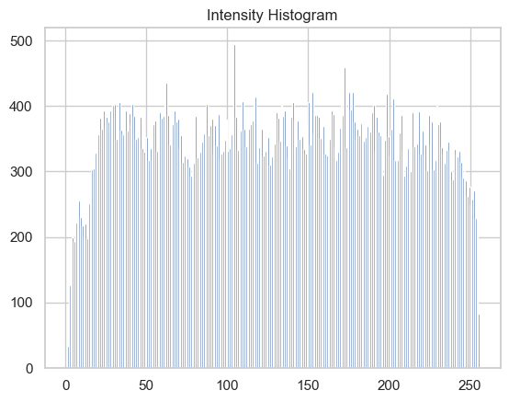
Figure 3. Intensities Histogram

[1] Harris, C., & Stephens, M. (1988). A combined corner and edge detector. In Alvey Vision Conference, 1988.
(OpenCV Reference: cv2.cornerHarris, grayscale input requirement: OpenCV Docs)
HARRIS CORNER DETECTION: METHOD, PARAMETERS and SENSITIVITY ANALYSIS
The Harris Corner Detector is a classic algorithm in computer vision used to identify points in an image with significant changes in intensity in multiple directions — typically indicating corners or interest points. These points are highly useful for establishing correspondences across images for tasks like image stitching, motion tracking, or 3D reconstruction. In our implementation, Harris corners were extracted using the corner_harris function from the skimage library. This algorithm computes the corner response function based on image gradients, and we used corner_peaks to locate local maxima as key points. An example is shown in Figure 4. Notably, corners are densely detected along high-contrast regions such as the mountain edges, tree outlines, and roof structures, which are ideal for matching.
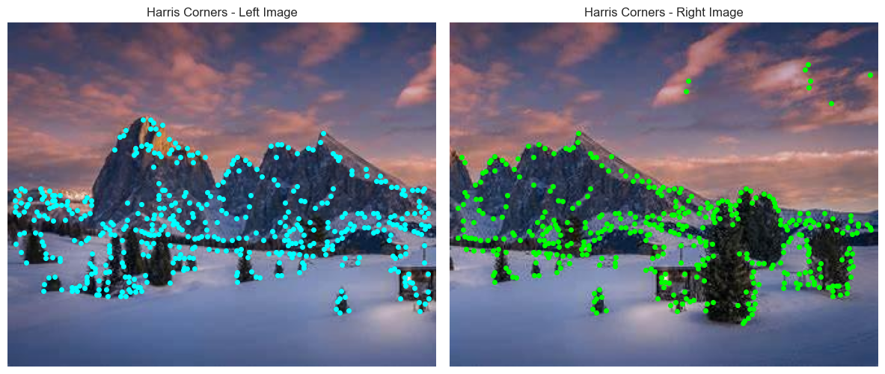
Figure 4. Harris Corners results (sigma=1, k=0.005, min_distance=1, size=10)
We extracted patches of different sizes (8, 16, 24, 32, 40) around each Harris corner to describe local image texture.
PATCH EXTRACTION AROUND KEYPOINTS
To analyze the local texture around detected Harris corners, we extracted square image patches of increasing sizes centered on the same set of keypoints. The patch sizes used were: 8, 16, 24, 32, 40, 48, 56, and 64 pixels.
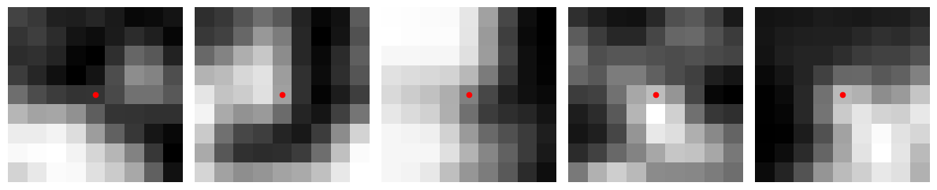
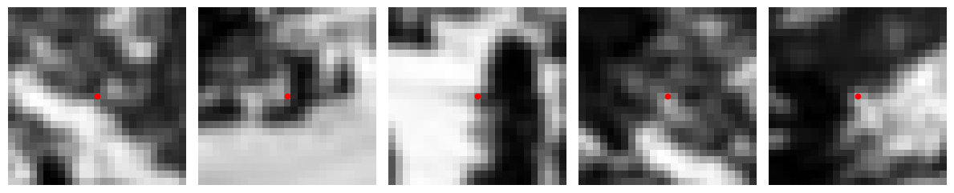
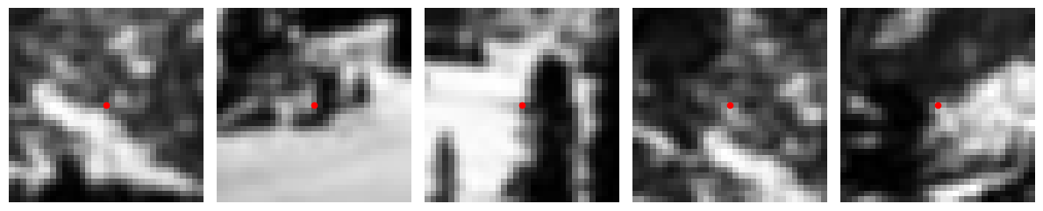
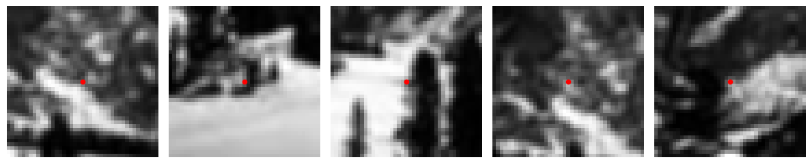
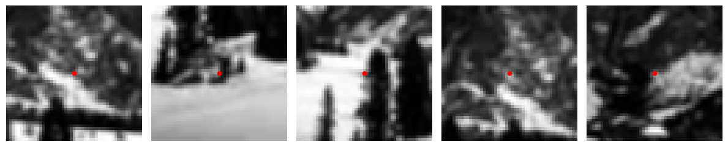
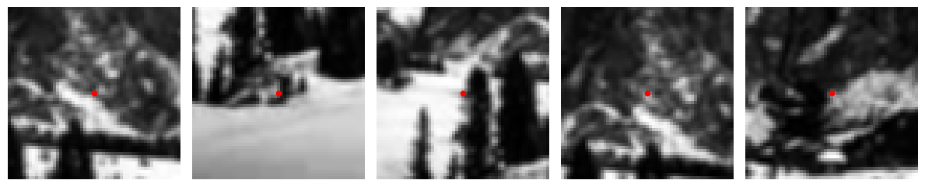
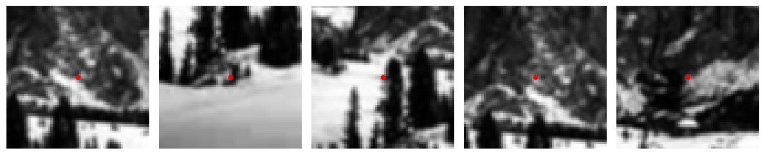
Figure 5. Extracted patches. Sizes: 8, 16, 24, 32, 40, 48, 56, 64.
ANALYSIS OF HARRIS RESPONSE (R) ACROSS PATCH SIZES.
The boxplot shows the distribution of Harris R values for various patch sizes ranging from 8 to 64 pixels. Key insights include:
- Mean R values: remain fairly stable across patch sizes, but there is an increase for the maximum patch size (equal to 64). However, because a patch size of 64 can be considered big, given the resolution of the image, to compute the descriptors, it risks containing too much irrelevant information. So, better to opt for a patch size of 24.
- Median values: also consistent, suggesting that the typical corner response is unaffected by patch size.
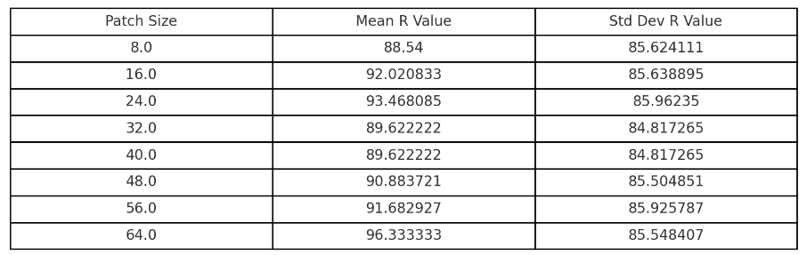
Table 6. Mean and Std for Harris Response.
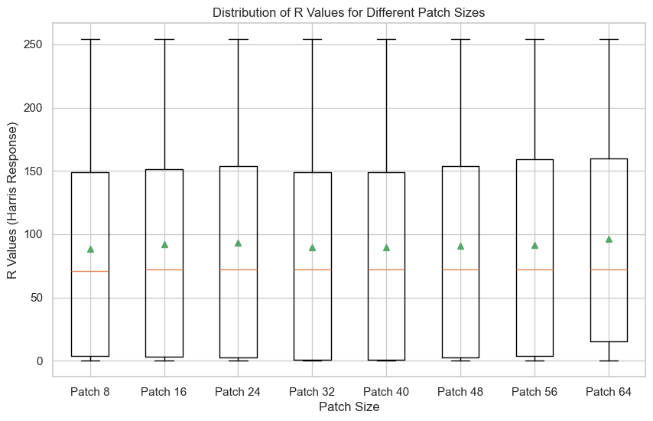
Figure 8. Boxplot Harris response.

We see some examples of gradient distributions within individual patches (Figure 9).
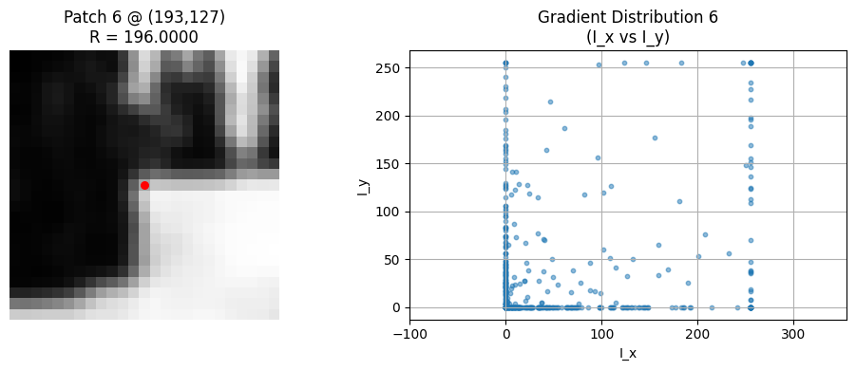
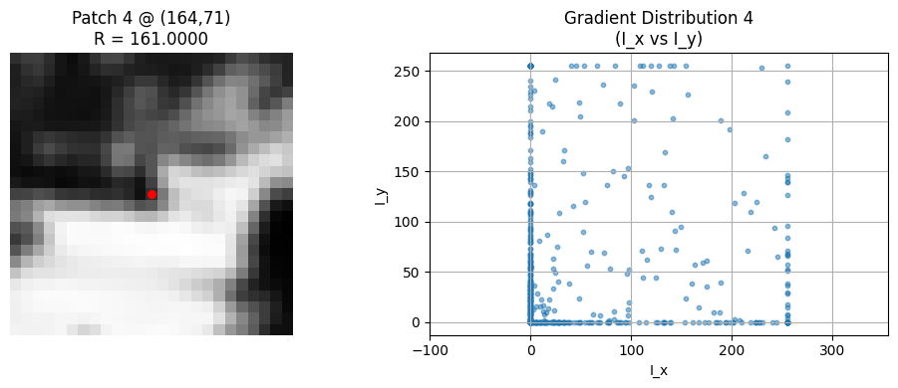
Figure 1. Gradient-Based Analysis of Harris Key Points. Patch size = 24.
In patch 1, the gradient scatter plot shows a wide spread in both Ix and Iy, confirming strong changes in multiple directions. In patch 4, the gradients are slightly more concentrated along one direction, suggesting the presence of an edge near a corner.
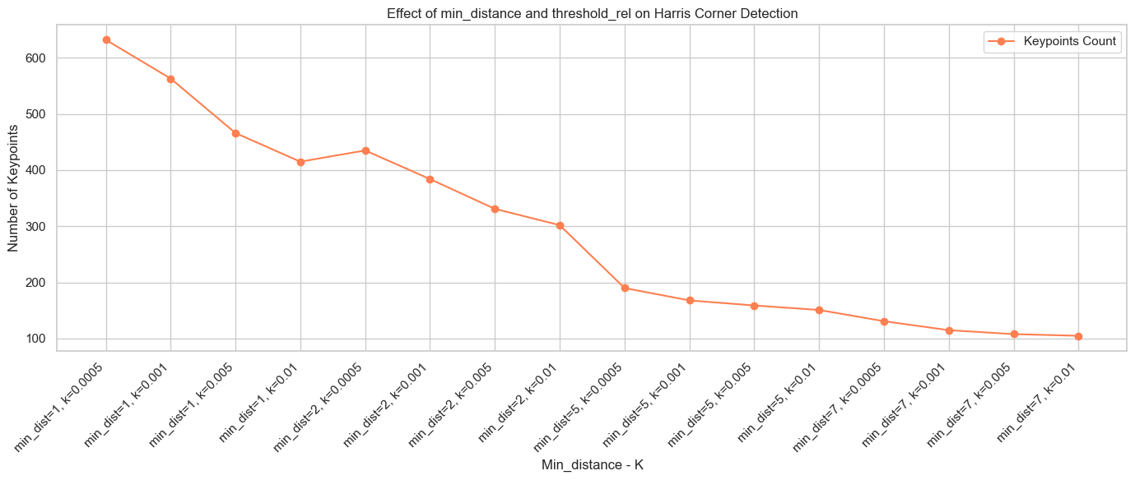
Figure 10. Number of key points with changes in min_distance and k.
In Figure 10, we see that increasing either parameter leads to fewer keypoints. We see that there is a sharp initial drop in the number of keypoints as parameters become more restrictive. But after a certain point, the curve flattens, meaning we are not gaining much in filtering keypoints anymore. I choose the parameters where min_dist = 5 and k = 0.005.
I computed the sift descriptor for the Harris corners with respect ot different patch sizes, detected using the parameters tuned in the previous sensitivity analysis (min_distance and k), we found the matches with a threshold of 0.3 and we checked for the distributions of distances.
In Figure 11 we evaluated the impact of patch size on the quality of feature matching by computing SIFT descriptors over Harris corners, using parameter configuration tuned in the previous sensitivity analysis and a threshold of 1.
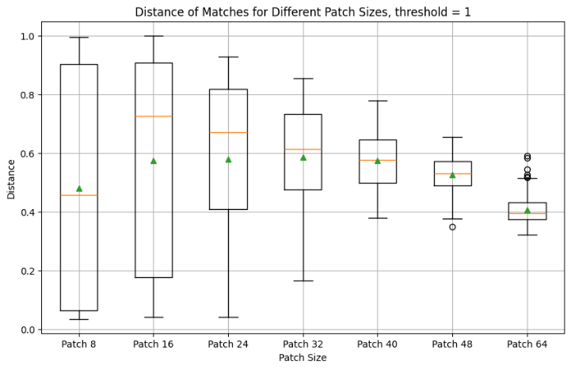
We see that smaller patch sizes show a wider spread. This is expected as small patches are more sensitive to noise and slight variations.

SIFT DESCRIPTOR
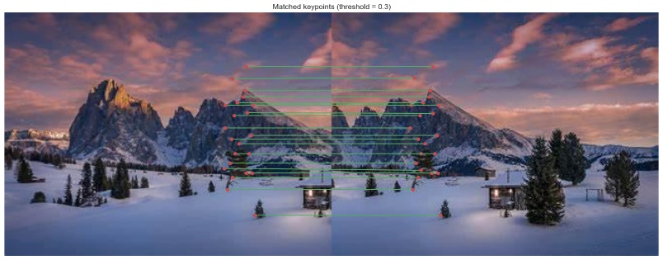
I computed the SIFT descriptors for each Harris corner and then calculated the pairwise Euclidean distances between every pair of key points across the two images.
I computed the matches with a threshold of 0.3.

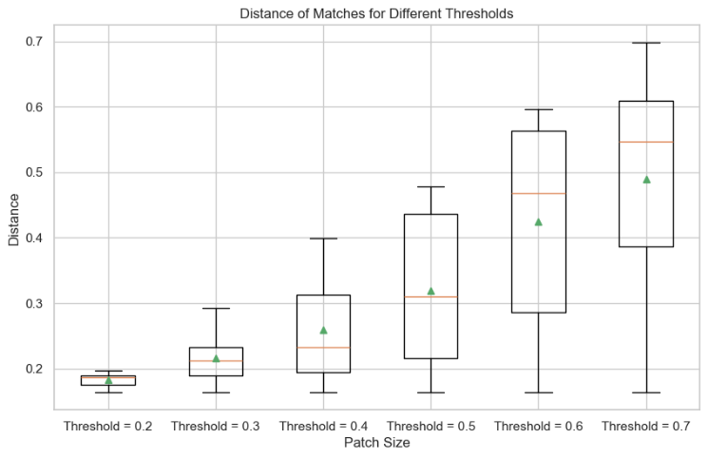
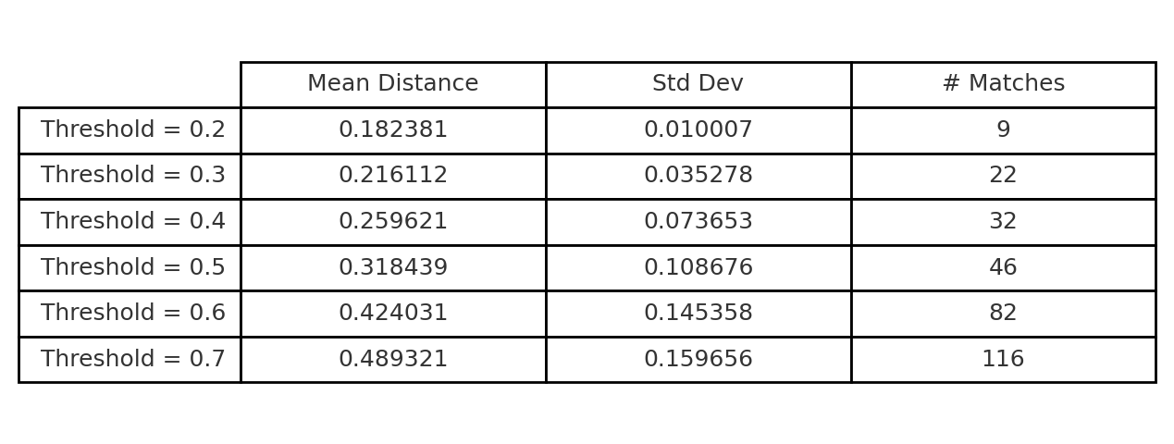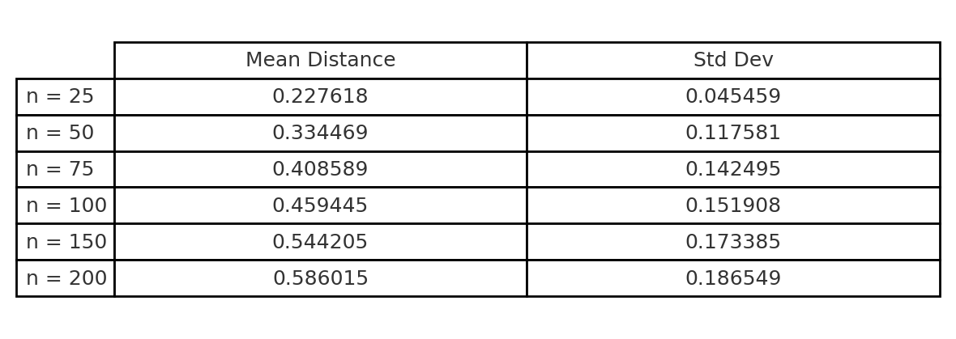
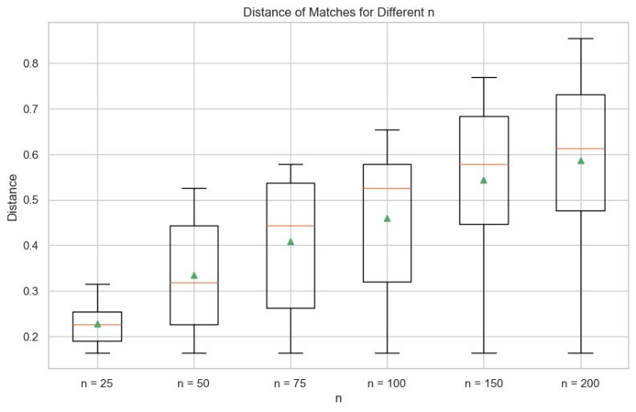
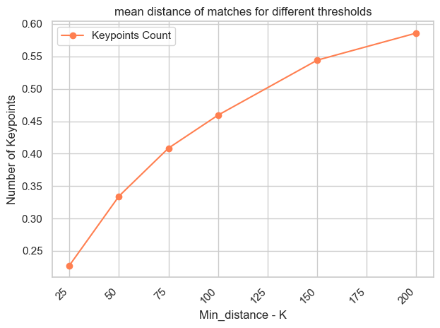
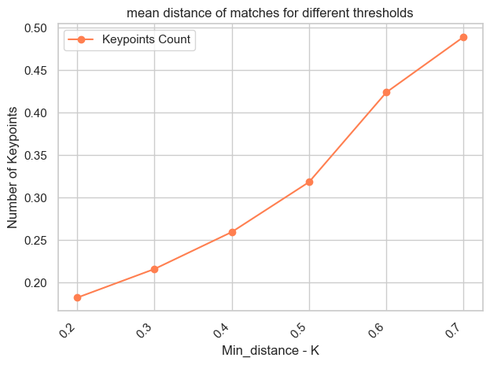
We compared two strategies to select SIFT matches: Distance thresholding and Top n-selection. Considering both the number of matches and their quality, I would opt for either the threshold-based selection at 0.3, which provides 22 high-quality matches with low variance, or the top-50 match selection, which yields a slightly higher average distance of 0.33 with a relatively high standard deviation of 0.12. The threshold approach ensures more consistent matches, while the top-n strategy offers greater coverage at the cost of increased variability.

RANSAC
We extract the best transformation (Homography)
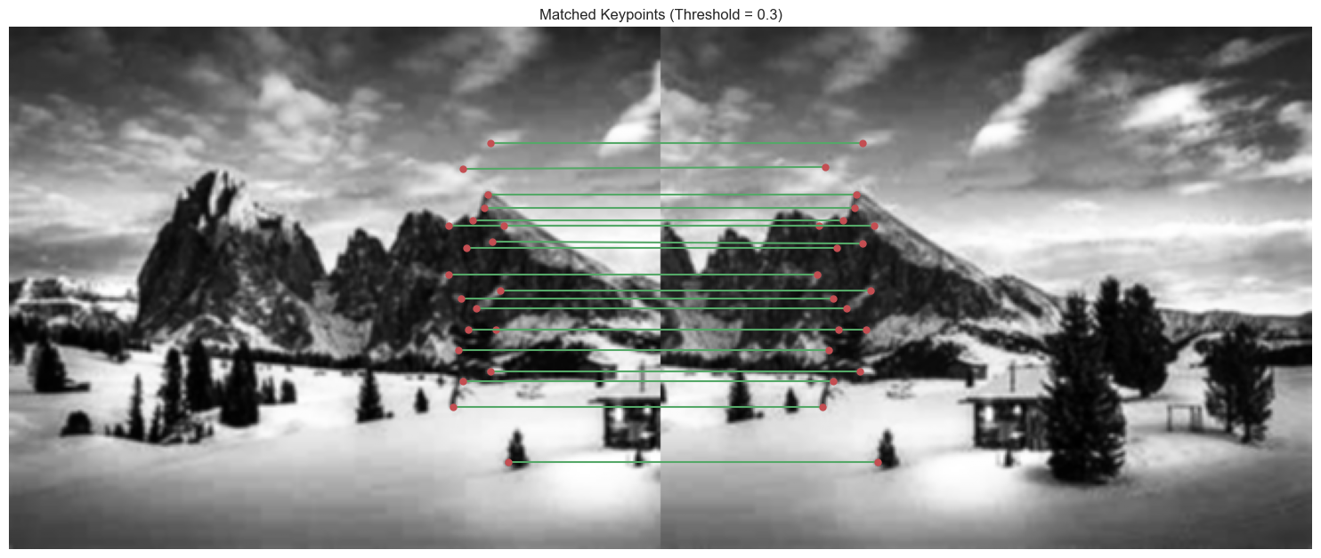
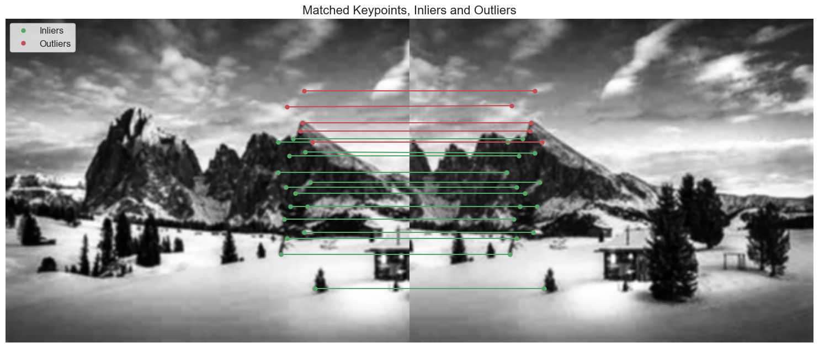
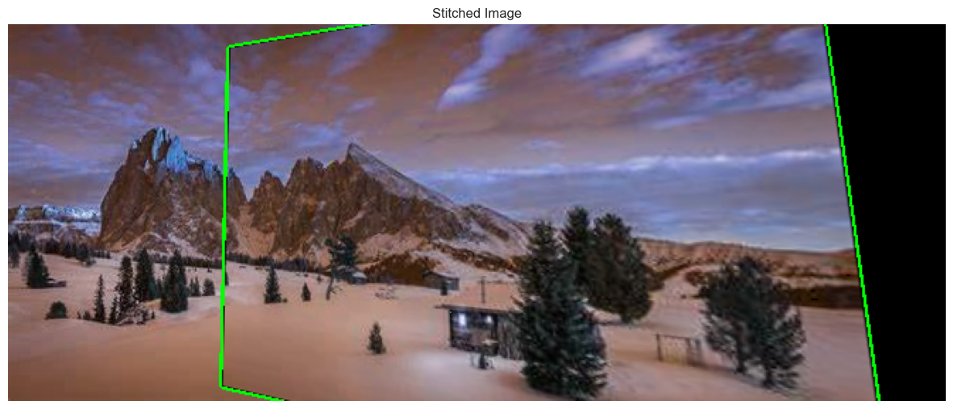
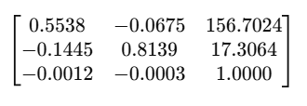
Best Estimated Transformation Matrix (Homography):

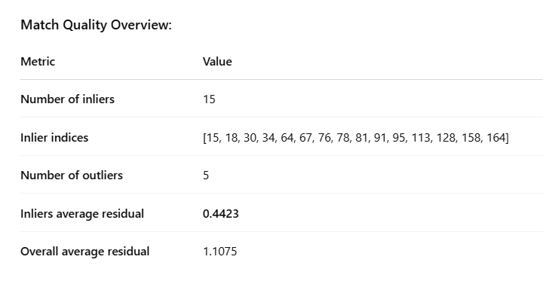
EXPERIMENTS
We conduct a comprehensive hyperparameter sweep to evaluate the performance of a RANSAC-based image alignment pipeline. The experiment systematically explores combinations of key parameters such as:
- Feature matching threshold
- RANSAC sample size and number of iterations
- Corner detection threshold (k)
- Patch size and minimum distance between corners
- Inlier error threshold
We perform the experiments for a total of 1728 parameter combinations and we extract the combinations leading to the minimum and maximum values of these metrics:
- Number of Inliers detected by Ransac.
- Number of outliers rejected by Ransac.
- Average residuals: the average residual across all matched keypoints (both inliers and outliers). This gives a general sense of how well the model fits the data. Lower residuals mean better alignmen
- Average residuals: The average residual restricted to inliers only. This focuses on how closely the inlier points agree with the transformation model, serving as a more accurate quality indicator of the estimated alignment.
- From the boxplots, we observe that a lower match threshold is associated with a reduced number of outliers, although it does not necessarily correlate with a higher number of inliers. We got the max number of inliers with 0.7 and the lowest number of total average residuals when the threshold is 0.6, meaning 0.6 is the best in terms of keypoints alignment. Regarding sample size, it is notable that using a sample size of 4/5 results in lower average inlier residuals compared to a sample size of 6. The number of iterations (whether 1000 or 2000) does not appear to significantly affect performance. As expected, increasing the allowed error leads to higher residuals among the inliers and an increasing number of residuals among all the key points. In terms of the corner detection threshold, the lowest number of residuals is obtained with an increasing threshold. Interestingly, the highest number of inliers is obtained with a patch size of 16, while the lowest average residuals are achieved with a patch size of 32—both observations are reasonable considering the trade-off between local detail and noise. Finally, no significant differences are observed concerning the minimum distance parameter. In Table 4, I summarized the parameters that led to the maximum and minimum results.

Table 4. Max and Min metrics and relative parameters.
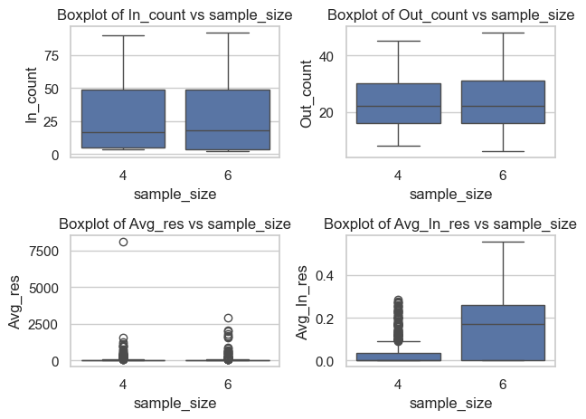
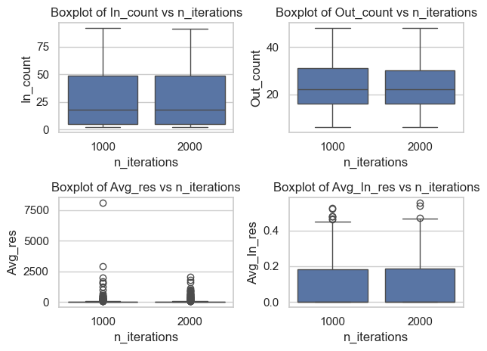
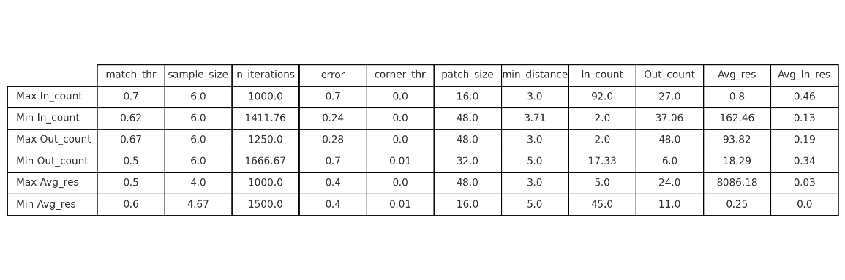
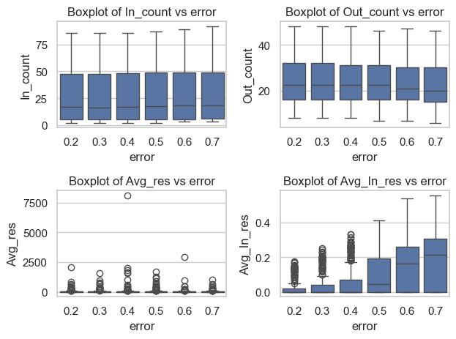
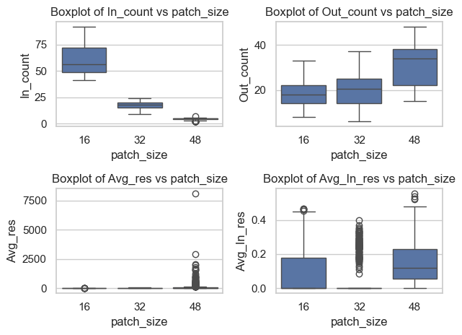

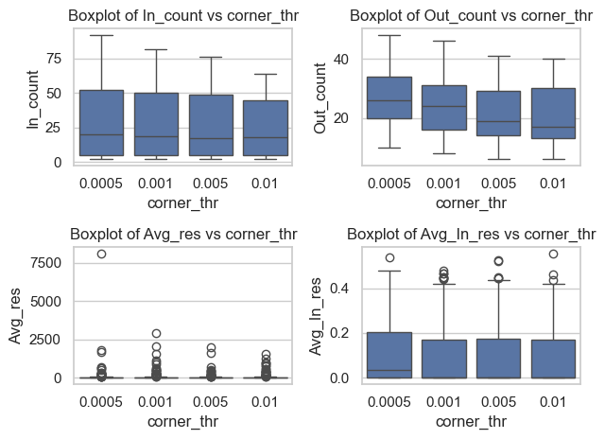

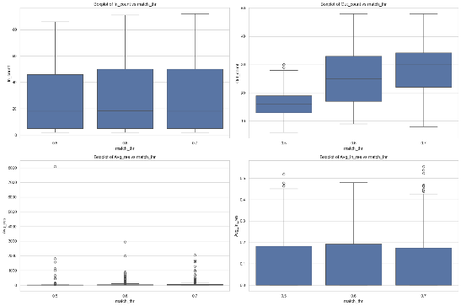
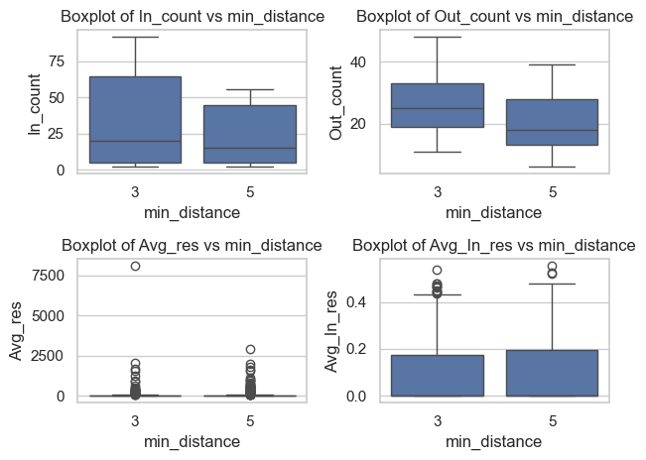
EXPERIMENTS WITH VARIOUS IMAGES
IMAGE 2
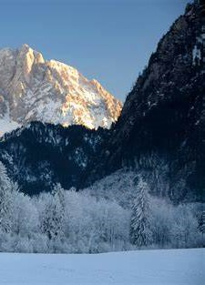
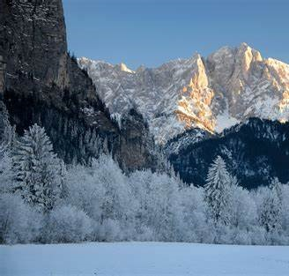
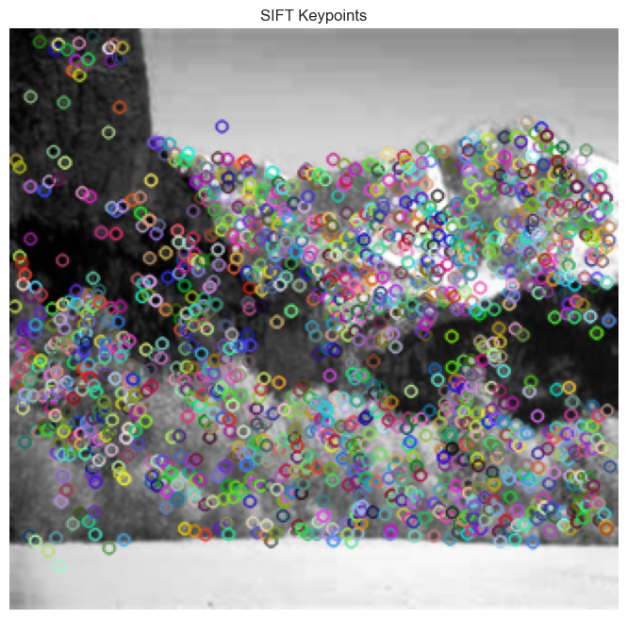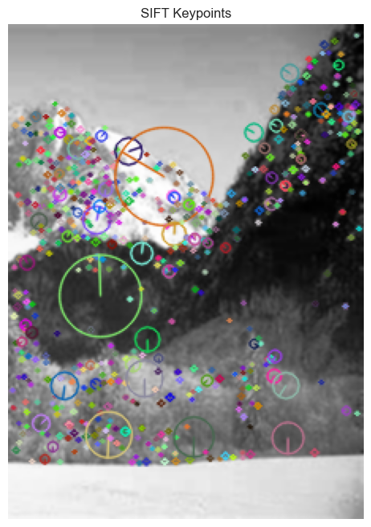
Detected 695 points.
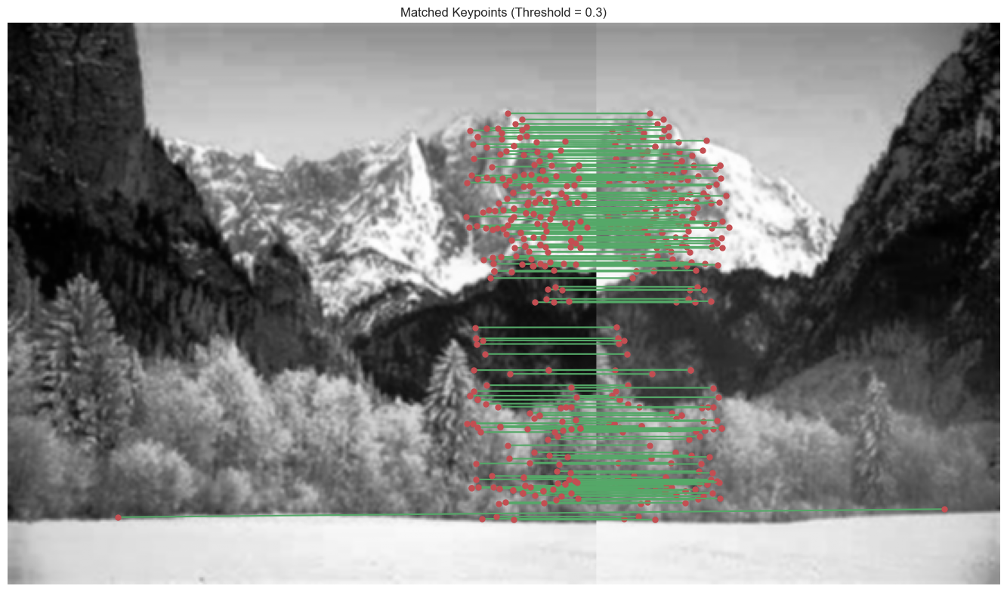
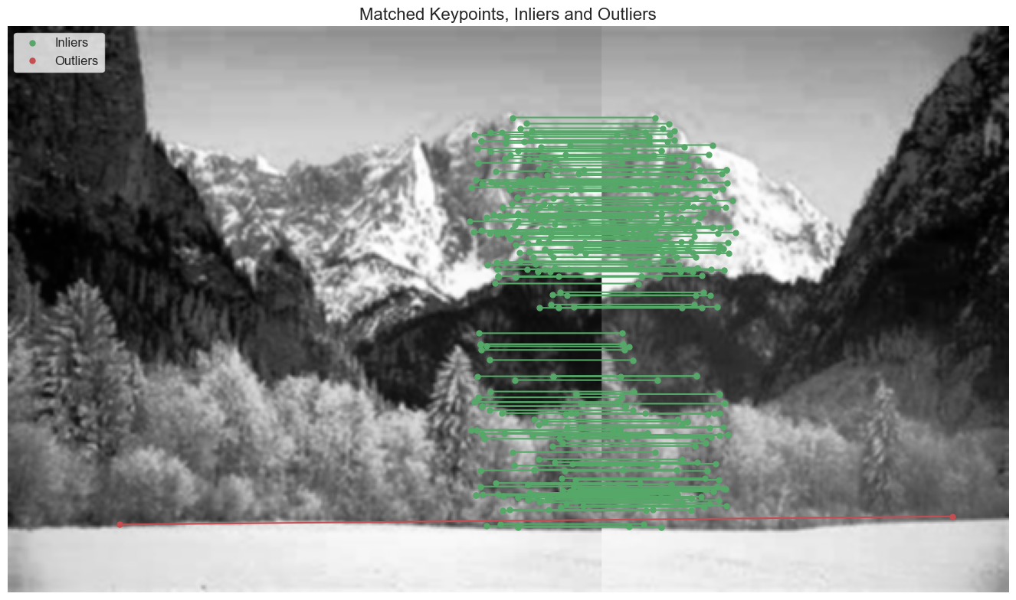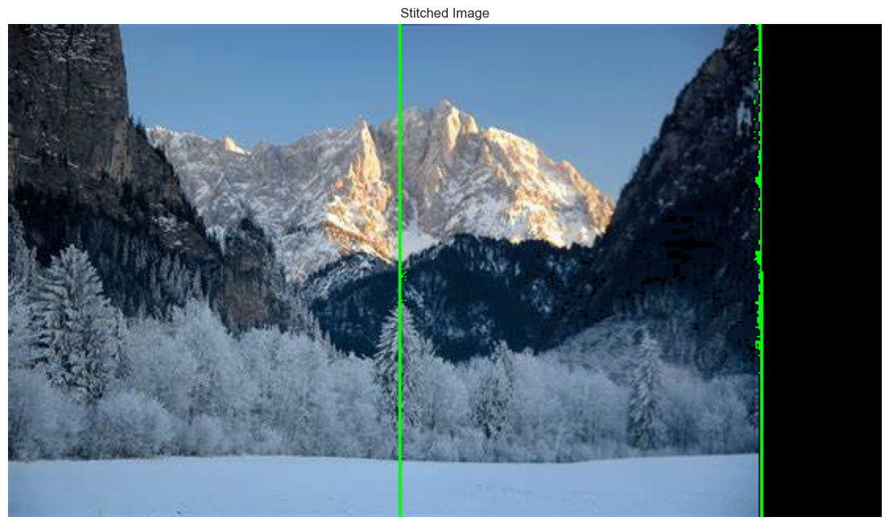
Best Estimated Transformation Matrix (Homography): 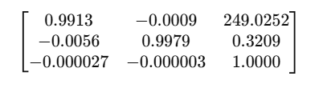
Number of inliers: 174

IMAGE 3


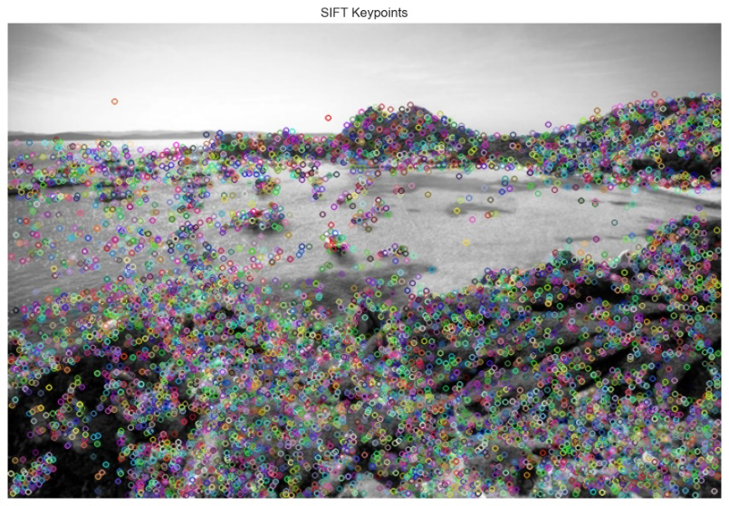
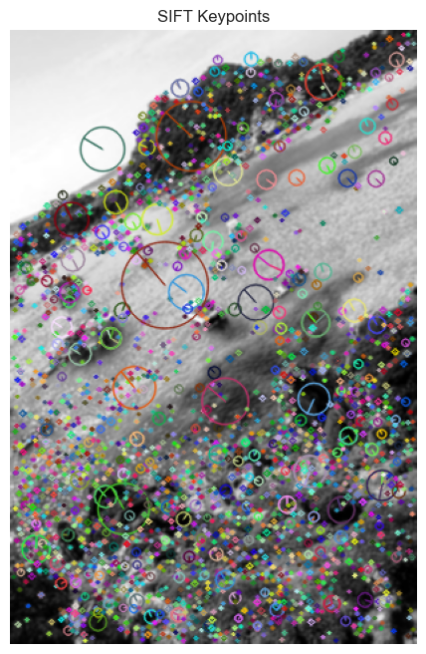
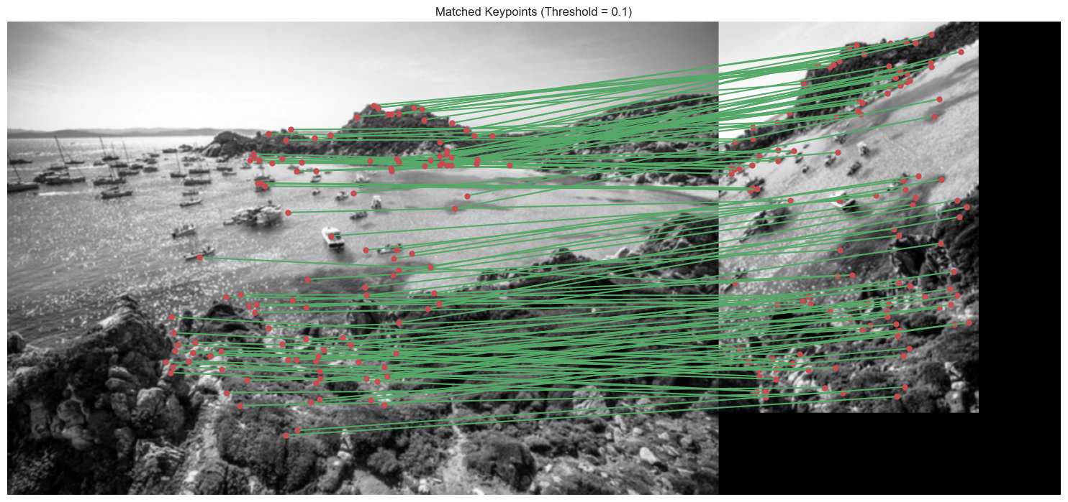
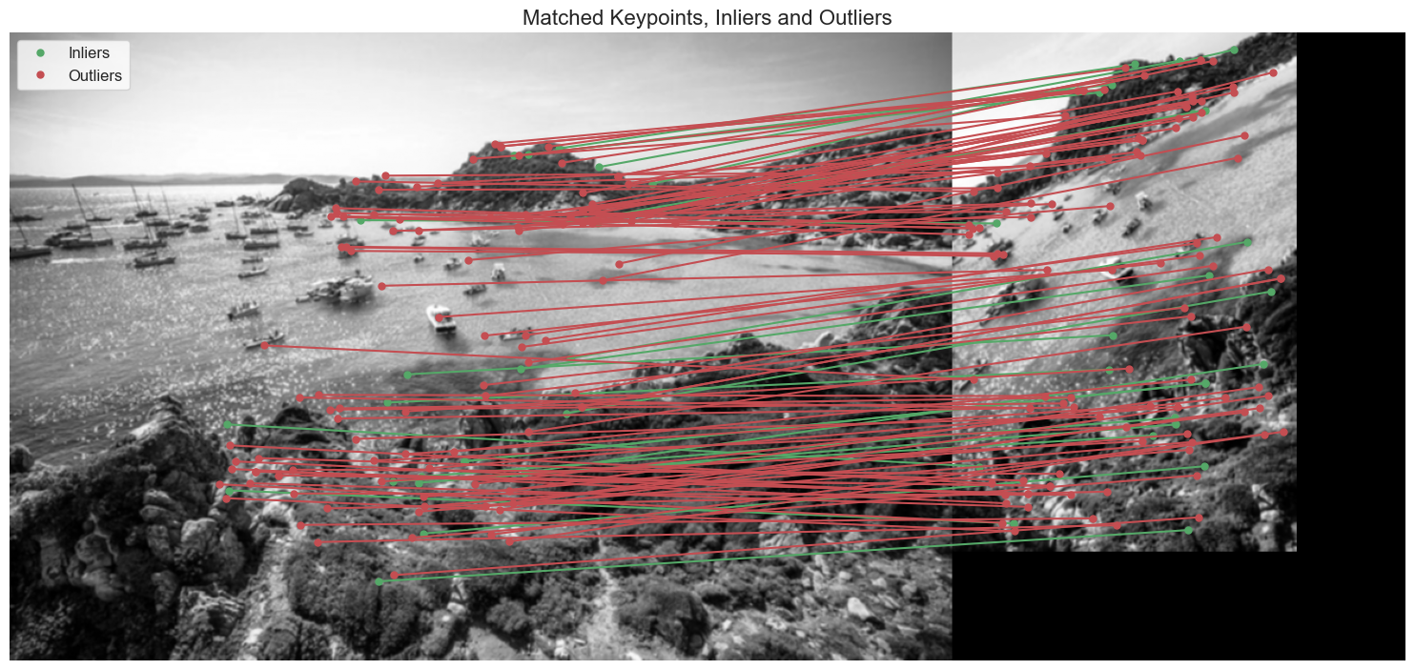
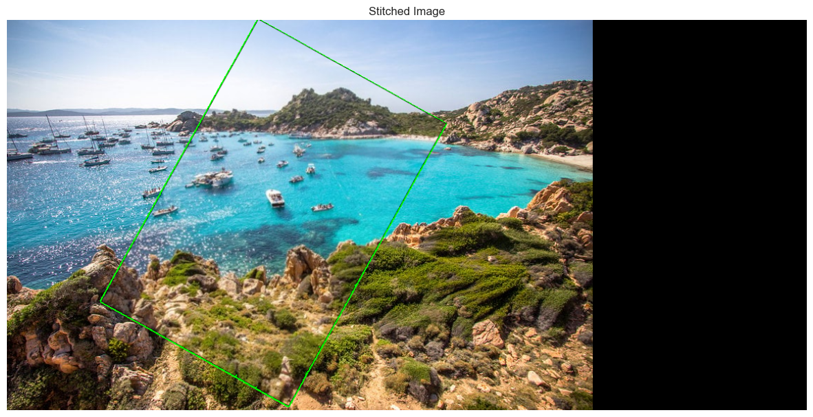
IMAGE 4


