Top Crypto Coins Compared:2025-26 Price Variations Revealed Bitcoin (BTC)
Step 1: Launched in 2009 as digital gold, BTC enables peer-to-peer transactions via proof-of-work mining.
Step 2: It dominates market cap at ~$1.7T, used for store-of-value and institutional holdings.
Step 3: Price variations show stability post-2024 halving—e.g., ~$90K in Dec 2025 from lower early-year levels, with 16.82% YTD gain amid ETF inflows

Ethereum (ETH)
Step 1: Introduced in 2015, ETH powers dApps, DeFi, and NFTs through smart contracts on its layer-1 chain.
Step 2: Upgrades like Dencun enhance scalability, boosting usage.
Step 3: Prices rose ~30% YTD to $2,215 by Dec, peaking mid-year on restaking hype before stabilizing.

Solana (SOL)
Step 1: Known for high-speed, low-cost transactions via proof-of-history, SOL supports DeFi and memecoins.
Step 2: It competes with ETH for dApp dominance, with mobile integrations driving growth.
Step 3: From $146 in Dec listings, it gained strongly YTD (implied >30%), surging in Q3 on network upgrades but dipping in volatile Oct.
XRP (Ripple)
Step 1: Designed for cross-border payments, XRP facilitates fast fiat-crypto exchanges on RippleNet.
Step 2: Legal wins against SEC fueled adoption by banks.
Step 3: Explosive 37%+ YTD to $2.4 by Dec, with massive 502% YoY earlier, peaking May post-clarity then consolidating.

BNB (Binance Coin)
Step 1: Native to BNB Chain, it reduces fees on Binance exchange and powers its ecosystem.
Step 2: Supports high-throughput DeFi and gaming apps.
Step 3: Steady 22% YTD climb to levels supporting $87B+ cap, with gains in Apr-Jun on chain expansions.
Crypto Coin Trends: Visualizing Divergent Graph Patterns
1)Bitcoin:
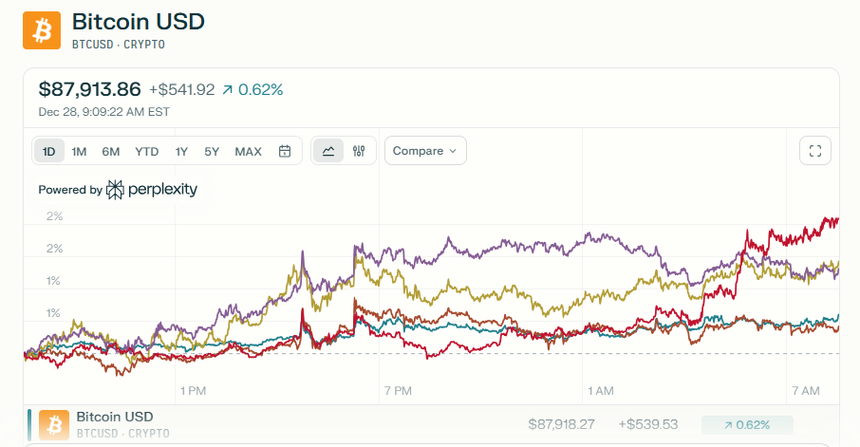
2)Ethereum:
