The Ground-Truth Reference
THE ADDITIVE-CONTRACT ARCHITECTURE
A Team Onboarding Guide
❦
How our projects are structured, why they are structured that way,
and how to work inside them without stepping on anyone else.
ANNO MMXXVI
Companion to the reference specification — META-ARCHITECTURE.md (spec v0.4.0)

How to read this guide
This guide has two parts, written for two different moments in your onboarding. The operational recipes that once formed a third part live where they belong: in the spec's standing rules and your project's WORKFLOW.md — those are project-specific by nature.
Part | What it is | When to read it
I — The Primer | The whole architecture in a few pages, with pictures and almost no jargon. | Today, with a coffee. ~15 minutes.
II — The Guided Tour | Every concept explained properly: what it is, why it exists, what it costs. | Across your first week.

Two housekeeping notes before you start.
Placeholders. This architecture is domain-agnostic, so the guide uses placeholder names: {ecosystem} is the project family, {workspace} is the coordination repo, {service} is any individual service, {ecosystem}-interfaces is the shared contract package, and {deploy} is the deployment repo. Your project fills in the real names.
The source of truth. This guide explains; it does not govern. The precise, binding specification is META-ARCHITECTURE.md in the workspace repo. If this guide and that file ever disagree, the file wins — and please flag the disagreement so the guide gets fixed. The spec is itself versioned (the version sits in its header — this edition tracks v0.2.0), and your project records the version it adopted in its first ADR.

Contents

If the table above shows no entries, right-click it and choose "Update Field" — Word builds it on demand.
PART I

The Primer
Everything important in this architecture fits in one sitting. The rest of the guide is detail; this part is the shape.
❦

The problem we are solving
Imagine a system built by several people — or several AI agents — each responsible for one piece. The pieces have to work together, but the people building them work at completely different speeds. One finishes her piece in a week. Another needs six months. A third inherits a piece someone else abandoned.
In most architectures, this goes wrong in a very specific way: someone changes a piece of shared data — renames a field, changes what a value means — and suddenly everyone else’s code is wrong. Now the whole team has to upgrade together, this week, whether it suits them or not. Every shared change becomes a coordination meeting. Every deploy becomes a synchronized jump.
Our architecture is built to make that scenario impossible by construction. The goal, in one sentence:
The mission
Many small services, developed at wildly different speeds, by different people or agents, that still compose into one working system — without a coordination meeting for every change.

The one rule
Almost everything in this architecture is a consequence of a single rule, applied everywhere shared data is defined:
Contracts only grow. They never shrink or mutate.
A "contract" is a shared data shape — the schema of a message one service sends and another receives. You may add new optional fields to a contract. You may never rename, remove, or change the meaning of anything that is already there.

Why does this one promise matter so much? Because it means anyone who built against an old version of a contract can safely read data produced with a new version. Everything they depended on is still there, untouched. The new fields they have never heard of are simply ignored.
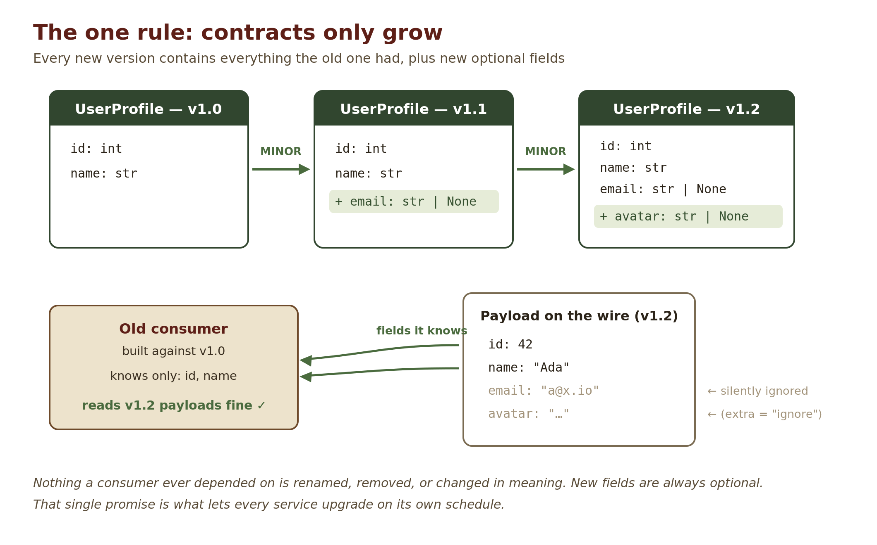
The practical consequence: nobody is ever forced to upgrade. A service upgrades its copy of the contract when it wants the new fields — not because someone else’s change broke it. The hardest problem in multi-team development ("everyone upgrade together, now") simply stops existing.

The map
A grown-up project in this architecture is a small fleet of git repositories. Most of them are services — independent programs, each in its own repo, each with its own version number and release pace. Alongside them sit three special repos with bookkeeping jobs.
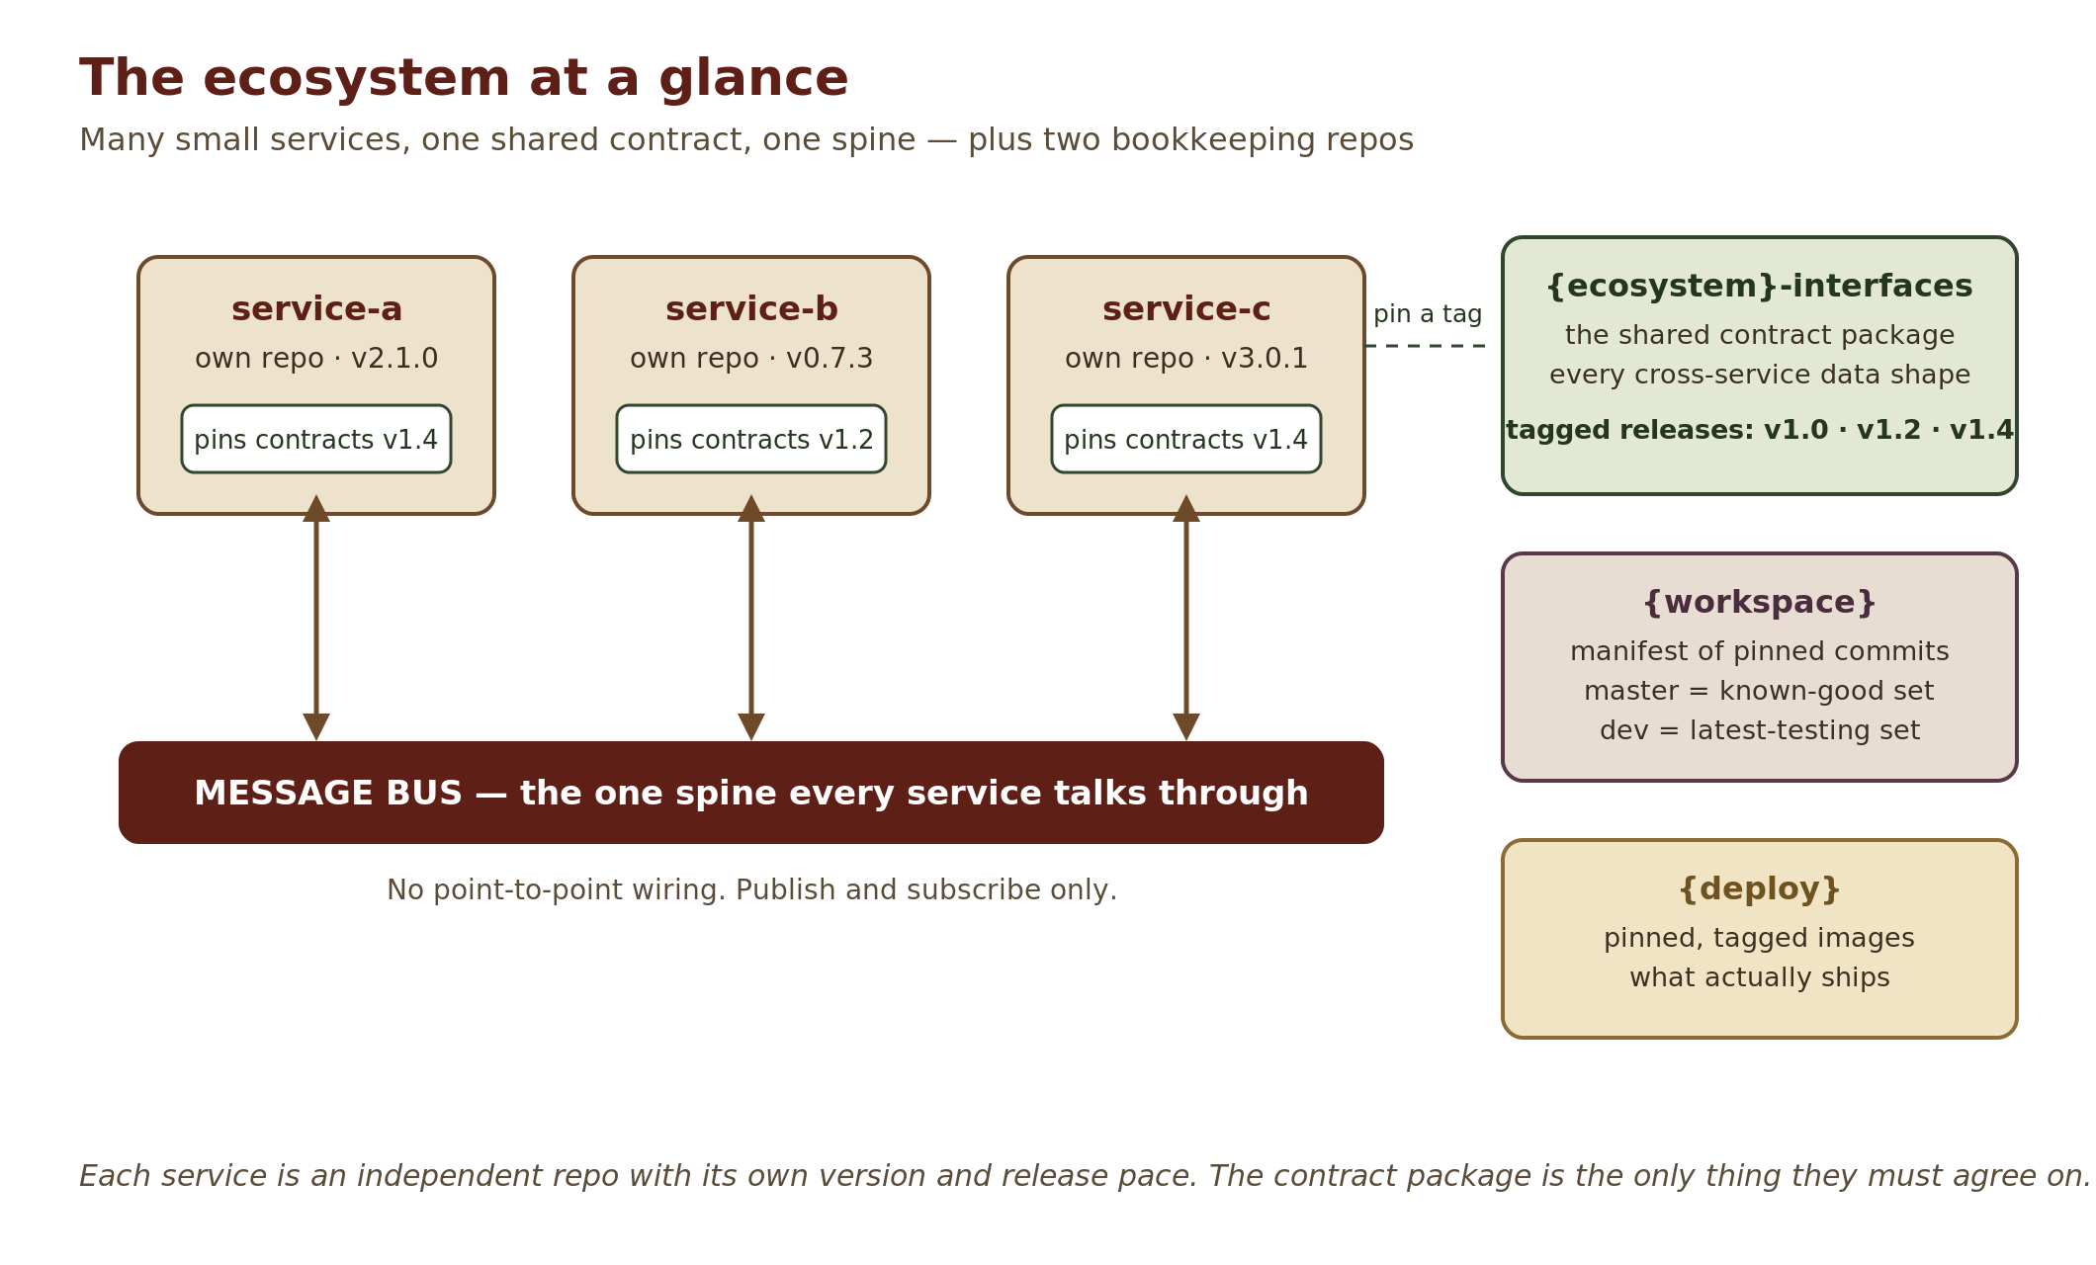
- The services do the actual work. They never talk to each other directly (usually — more on that in Chapter 6) — everything goes through one shared message bus, like a public bulletin board: you publish what you produce, you subscribe to what you need.
- {ecosystem}-interfaces is the shared contract package: every data shape that crosses a service boundary lives here, and nowhere else. It is a pure library — data definitions only, no logic. This is the one thing all services must agree on, and it is where the "contracts only grow" rule is enforced.
- {workspace} is the coordination repo. It contains no code of its own — just a recorded list of "this exact version of service A, with this exact version of service B, is a combination we tested and trust." Think of it as a photo album of moments when the whole city fit together.
- {deploy} says what actually ships to production: a compose file (or equivalent) pinning tagged, built images. It only ever ships one of {workspace}’s tested combinations — never a mix, never something untested.

Version skew is normal here
Because nobody is forced to upgrade, different services will routinely be running against different versions of the shared contract. In most systems that is a bug. Here it is the expected, permanent state of the world — and it is safe, because every version is a superset of the last.
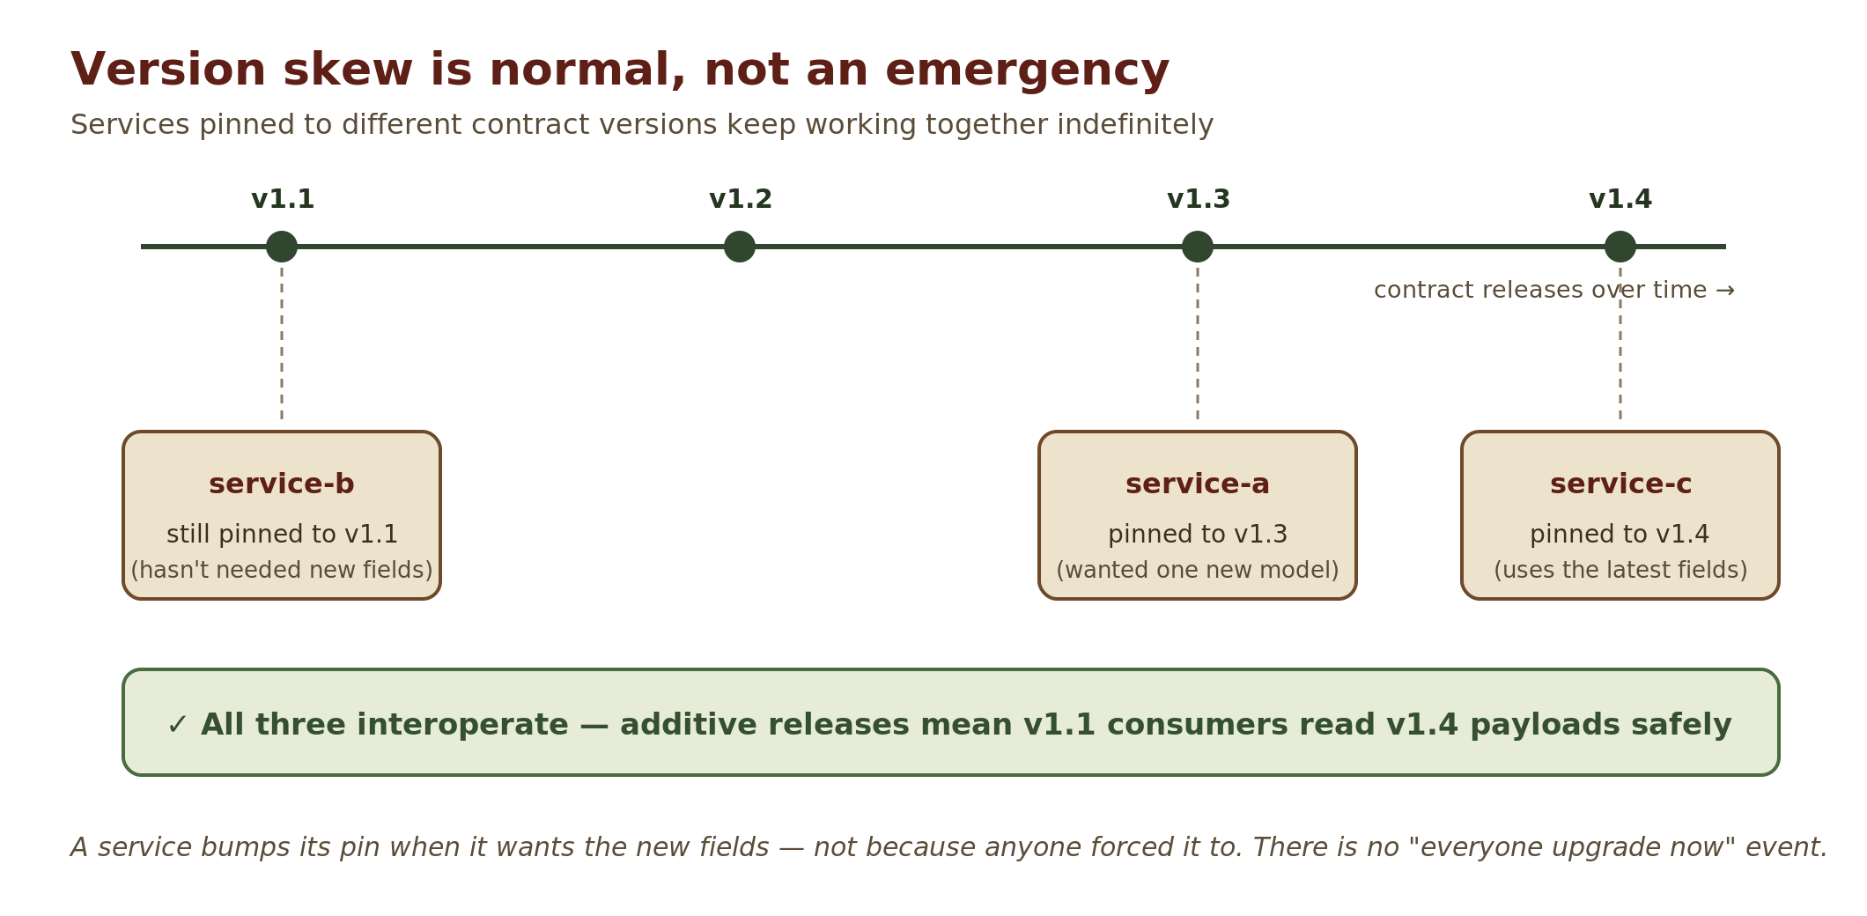
There is one situation this cannot cover. The additive rule guarantees that every service can understand every message — not that it can act on it. Say a newer dashboard adds a Zoom button that sends a zoom command. An older camera reads that command without complaint, but it was written before zoom existed and has no code to do it — the click silently goes nowhere. To close that gap, services ask each other at runtime — "what can you do?" — and gracefully switch off anything the other side does not support. The one forbidden response to a missing feature is crashing.

Six things to remember
If you retain nothing else from this primer, retain these.
- Never remove or change what is already in a shared contract. Need something different? Add a new optional field and deprecate the old one.
- The contract pin is the only interop authority. "Can service A talk to service B?" is answered by which version of {ecosystem}-interfaces each one pins — nothing else.
- Missing feature at runtime? Disable and log, never crash. Check capabilities, degrade gracefully, tell the human why in plain language.
- Forwarders pass raw payloads through. Only the final consumer of a message parses it through its own models. Anything that re-publishes must not re-serialize (Chapter 5 explains the trap).
- Check out a branch before editing inside a submodule. Submodules arrive in "detached HEAD" state; commits made there quietly land on no branch. This is the #1 day-one mistake. When you are done, commit the updated pin in {workspace} as well — the service has moved on, but the workspace still points at the old commit.
- Software that acts on the world starts read-only. Discovery may suggest; a human confirms. The first write to anything the system does not own is operator-confirmed, never automatic. Chapter 5 has the full safety ladder.

One more thing: we start small
Reading all this, you might picture every project as a sprawling fleet of repos from day one. The opposite is true. New projects start as one repo — a "modular monolith" that practices all the disciplines above (shared contract package, additive rule, bus-style communication) without any of the multi-repo machinery.
The fleet appears only when growth demands it: a second independent owner, a piece that needs its own deploy schedule, a module that needs different hardware. Because the disciplines were practiced from day one, breaking a module out into its own repo is mechanical surgery, not a redesign. Part II, Chapter 7 walks the whole path.
PART II

The Guided Tour
Eight chapters, one concept each. Every chapter answers three questions: what is it, why does it exist, and what does it cost?
❦

Chapter 1 — Why this architecture exists

The coordination tax
Here is the Tuesday that this architecture is designed to delete from your life.
You need to add a delivery-time estimate to the order data your service publishes. Simple enough — one field. But three other services consume that data, owned by three other people. If your change touches the shared format in any breaking way, all three must update their code, test it, and deploy in step with you. So you schedule a meeting. Someone is on vacation. One consumer is mid-refactor and begs for two weeks. Your one-field change is now a four-team project with a spreadsheet.
Multiply that by every shared change in the life of a system, and you get the coordination tax: the cost of a system is no longer the code, it is the synchronization. Teams stop proposing improvements because the ceremony outweighs the benefit. The architecture ossifies.

The design goal: make skew survivable
Version skew is the state where different parts of a system are built against different versions of a shared definition. Most architectures treat skew as a failure to be prevented — with lockstep upgrades, big-bang deploys, and the meetings above.
This architecture makes the opposite bet: skew is inevitable in any system with independent owners, so make it legal, visible, and safe. Every design decision in the following chapters — additive contracts, capability discovery, pinned manifests — is downstream of that one bet.

Why many repos instead of one
Each service lives in its own git repository, with its own version number and its own release cycle. This is called a polyrepo layout, and we choose it deliberately, knowing it costs more plumbing than a single shared repo.
The reason is discipline. In a single repo, version skew hides until deployment — everything compiles together, so it looks consistent right up until two deployed versions disagree in production. In a polyrepo, skew is in your face constantly: your service pins version 1.2 of the contract while your neighbor pins 1.4, and both of you can see it. Living with visible skew every day forces everyone to build the graceful-degradation habits that make the system robust. Independent repos also map cleanly onto independent owners — human or AI — each with real authority over their own release.
The honest trade-off
A polyrepo multiplies CI pipelines, release ceremonies, and git bookkeeping. That overhead only pays for itself once several independently-owned services exist. This is exactly why new projects start as a single-repo modular monolith (Chapter 7) and graduate only when a real trigger fires.

Chapter 2 — Contracts that only grow

What a contract is
A contract is the definition of data that crosses a boundary: the schema of a message, the name of a topic, a set of shared constants. All contracts between services live in one place — the {ecosystem}-interfaces package — and that package is a pure library. Data models, topic names, capability constants. No logic, ever, and it never imports from any service. If two services need the same type, that type belongs here; there is no other legal home for it.
One deliberate non-rule: consistency of location is required, consistency of shape is not. Each type should have whatever structure its data semantics call for. Forcing every model to look uniform for its own sake produces awkward schemas; the package is a collection of well-fitted shapes, not a grid.

The additive rule, precisely
The rule from the Primer — contracts only grow — has a precise engineering meaning. A change to the contract package is additive when every payload that was valid before the change is still valid, and still means the same thing, after it. Additive changes are safe to release as MINOR versions; anything else is a MAJOR and a planned, rare event.
Change to the contract | Version bump
Add an optional field (with a default) to a model | MINOR — safe by construction
Add a new model, topic, or constant | MINOR — nothing existing changes
Rename, remove, or change the type or meaning of anything existing | MAJOR — rare, scheduled, coordinated
Documentation or bug fix with no shape change | PATCH

Two mechanisms make MINOR bumps safe in practice, not just in principle:
- Tolerant readers. Every model in the package is configured to ignore unknown fields (extra="ignore" in Pydantic terms). A consumer built against v1.0 parses a v1.2 payload and simply never sees the fields it does not know.
- Machine-checked supersets. The rule is not left to good intentions. CI on the contract repo snapshots every released model’s JSON schema, and a MINOR release fails automatically unless the new schema is a strict superset of the old one — all old fields present, same types, new fields optional. Nested models are checked field by field as well, and a field the checker cannot see inside — a bare dict — fails the check unless it is declared as a known blind spot. (Spec rules 3 and 8.1.)

The fine print: edge cases of the additive rule
Version numbers are too coarse to catch every hazard. A handful of changes pass a naive "did anything get deleted?" test and still break consumers; a few others are safe only if you get them right early. Learn these; they are the sharp edges of the whole system.
Change | Verdict | Why
Adding a new enum value | Breaking ⚠ | Any consumer doing exhaustive matching on the enum now hits a case it never wrote. Treat as MAJOR — or mandate from day one that consumers must handle unknown enum values.  e.g. a camera status of IDLE / RECORDING / ERROR gains CALIBRATING. An older dashboard that maps each status to a colour has no case for it — it may reject the message, crash, or show nothing.
Widening a type (int → int | None) | Breaking ⚠ | Consumers that assumed the value was never null now receive nulls.  e.g. battery_pct changes from int to int | None so a sensor can report "unknown". An older consumer that checks battery_pct < 20 now fails on None.
Tightening a validator / narrowing a range | Breaking | Payloads that used to parse now fail validation.  e.g. a speed limit that accepted 0–100 is narrowed to 0–50. An older producer still sending 80 now has every message rejected.
Same field name, same type, new meaning | Forbidden | Invisible to semver and to schema diffing — the one hazard no tooling can catch. Add a new field and deprecate the old one instead.  e.g. temperature quietly switches from Celsius to Fahrenheit — see "Semantics never mutate" below.
Adding keys inside a dict-valued field | Additive ✓ | Unknown keys are simply absent — never null-stuffed. The dict’s shape is outward contract, not the producing service’s private business.  e.g. a free-form tags mapping gains a "firmware" key. Older consumers never look it up and carry on; a producer with no value omits the key rather than sending firmware: null.
Typing a bare dict after it has shipped | Breaking ⚠ | A schema checker sees a bare dict as opaque — keys inside it can vanish and nothing fails. Typing it later changes what CI asserts, so it is a MAJOR. Give every structured entry its own small model the day the field is born.  e.g. a route ships its waypoints as bare dicts. Months later someone renames "lat" to "latitude" inside them; CI passes and every consumer breaks. Introducing a Waypoint model to fix it is now itself a MAJOR.
Adding a discriminator field after a second producer exists | Additive, but too late | The field itself is safe to add, but old data can never be retro-tagged. If two producers will ever publish the same model, plant the discriminator (say, origin) before the second one exists.  e.g. a thermal camera starts publishing the same Detection model as the visible one. Adding origin works from now on, but a year of stored detections can no longer say which camera made them.
Documents are contracts too. Everything above applies beyond the bus. Reports, exports, and on-disk stores are versioned data too; each gets its own version constant, evolving independently — and the additive rules attach the day the first cross-version reader appears.
Semantics never mutate
Suppose a temperature field has always held Celsius, and someone quietly redefines it as Fahrenheit. Every schema check passes. Every consumer keeps parsing happily. And every downstream number is silently wrong. This is the worst failure mode in the architecture precisely because nothing crashes.
The rule is absolute: a field’s meaning is frozen the moment it ships. New meaning → new field, old one deprecated.

Living with skew
Each service records which contract version it builds against — a pinned dependency like {ecosystem}-interfaces @ v1.4.0 in its requirements file. That pin is the sole interop authority: it is the one place to look to answer "can these two services understand each other?"
When do you bump your pin? When you want the new fields, and not before. There is no virtue in staying current for its own sake; a service pinned to v1.1 for a year is not "behind," it is stable.

How a contract release happens
Releases are cut from the known-good line: the version is bumped on the dev branch, promoted to master, and tagged vX.Y.Z. The tag is the release. Until the tag exists, no service may pin the new version — and CI across all services enforces that every pin references a tag that actually exists.
Bumping the version string is not a release
Cutting the tag is. A pin that references a version nobody tagged is the only unforgivable versioning crime in this architecture, because it makes the interop authority lie.

Chapter 3 — The map: repos, branches, and versions

The cast of repositories
Repo | Job
{service} (one per service) | An independent program with its own semver and release cycle. Chapter 4 dissects one.
{ecosystem}-interfaces | The shared contract package from Chapter 2. Slow-moving, tagged, ceremonial.
{workspace} | The superproject manifest: records which commit of each service belongs together. Holds no service code.
{deploy} | Deployment authority: docker-compose (or equivalent) pinning built, tagged images. Created only once two services can actually run together.

The workspace: a photo album of working combinations
The {workspace} repo uses git submodules: each service appears as a directory that is really a full, independent clone of that service’s repo, pinned to one exact commit. A commit in the workspace is therefore not code — it is a version manifest: a complete, checkoutable snapshot of "these exact commits, together."
Its two branches encode two levels of trust:
- master — the known-good set. Every submodule pinned to a commit that was validated together. Check it out and you get a combination proven to work.
- dev — the latest-testing set. Configured so each submodule tracks its service’s dev branch; running git submodule update --remote pulls every service’s newest work. The resulting pins are committed, so even "latest" is exactly reproducible later.

Promotion: how dev becomes master
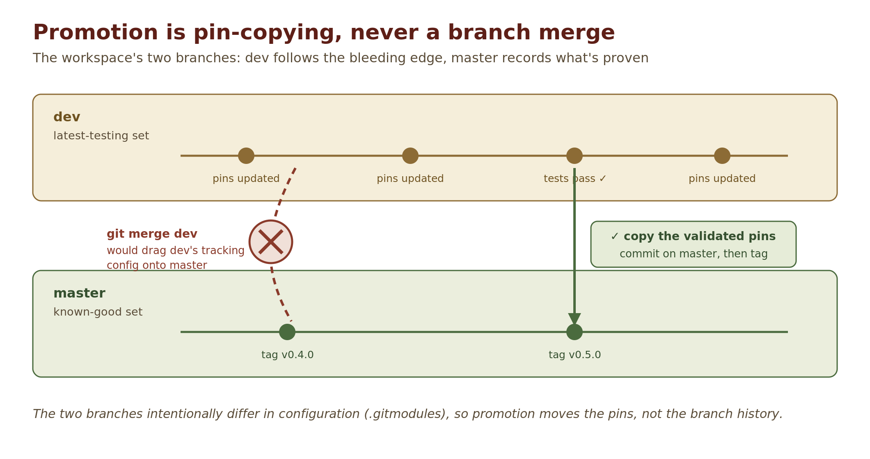
Because the two branches intentionally differ in configuration (dev’s .gitmodules tracks branches; master’s pins commits), promoting a validated combination is never a git merge — a merge would drag dev’s tracking configuration onto master. Instead, promotion copies the pins: check out master, point each submodule at the commit dev validated, commit, tag. A script (promote.sh) does this so nobody does it wrong by hand.
The #1 submodule footgun: detached HEAD
Submodules check out at pinned commits in "detached HEAD" state — you are standing on a commit, not a branch. If you start editing right away, your commits land on no branch and can be silently lost the next time the submodule updates.Always run git checkout <branch> inside a service directory before editing. A pre-commit guard should back this rule up, but the habit is yours to build.

Three version surfaces
By now three different kinds of "version" have appeared. Confusing them causes real incidents, so the architecture names them explicitly and forbids cross-talk:
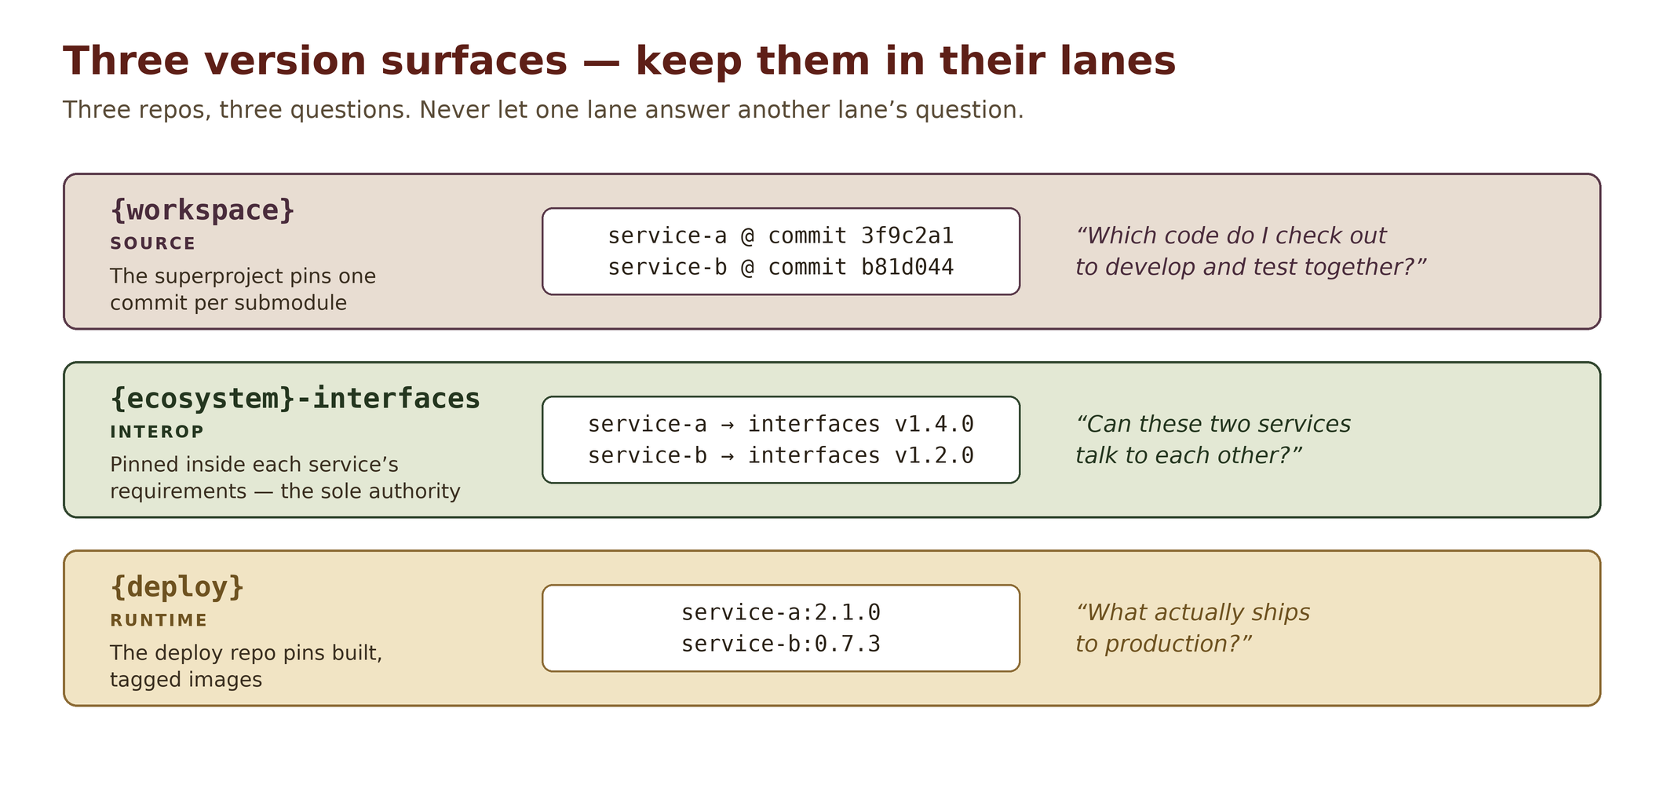
{workspace} answers a source question, each service’s {ecosystem}-interfaces pin answers an interop question, and {deploy} answers a runtime question. When someone asks "what version is the system on?", the correct response is: which surface do you mean?

From the album to production: only promoted sets ship
The three surfaces stay in their lanes, but one rule connects two of them. Every {deploy} release names exactly one {workspace} tag — one photo from the album — and everything it ships is built from the commits that tag pins. Never a dev pin, never an untagged commit, never a hand-picked mix of two tags: a mix is a combination nobody tested. Each built artifact carries the commit it was built from, and {deploy}’s CI checks every one against the tag.
{deploy} may lag behind master (not every promoted set ships), but it never runs ahead of it. That holds in an emergency too: an urgent fix takes the ordinary path — dev, promote, tag, deploy — just faster. There is no deploy-only side door. At Stage 0, with no {workspace} yet, the monolith’s own release tag plays the same role.
e.g. a camera bug needs fixing tonight. The tempting shortcut is to rebuild just the camera image from a fix branch and push it straight into {deploy}. That runs a camera commit beside a dashboard commit it was never tested with, and nothing records what is actually running. The sanctioned path: merge the fix to the camera’s dev, promote the new set on {workspace} (say v1.4.1), and point {deploy} at v1.4.1. Same night, one extra step, and “what’s running?” still has a one-word answer.

Chapter 4 — Inside a service

One anatomy, every service
Every service repo follows the same internal layout, and the layout enforces one division of labor: the core only moves data; features do all the thinking.
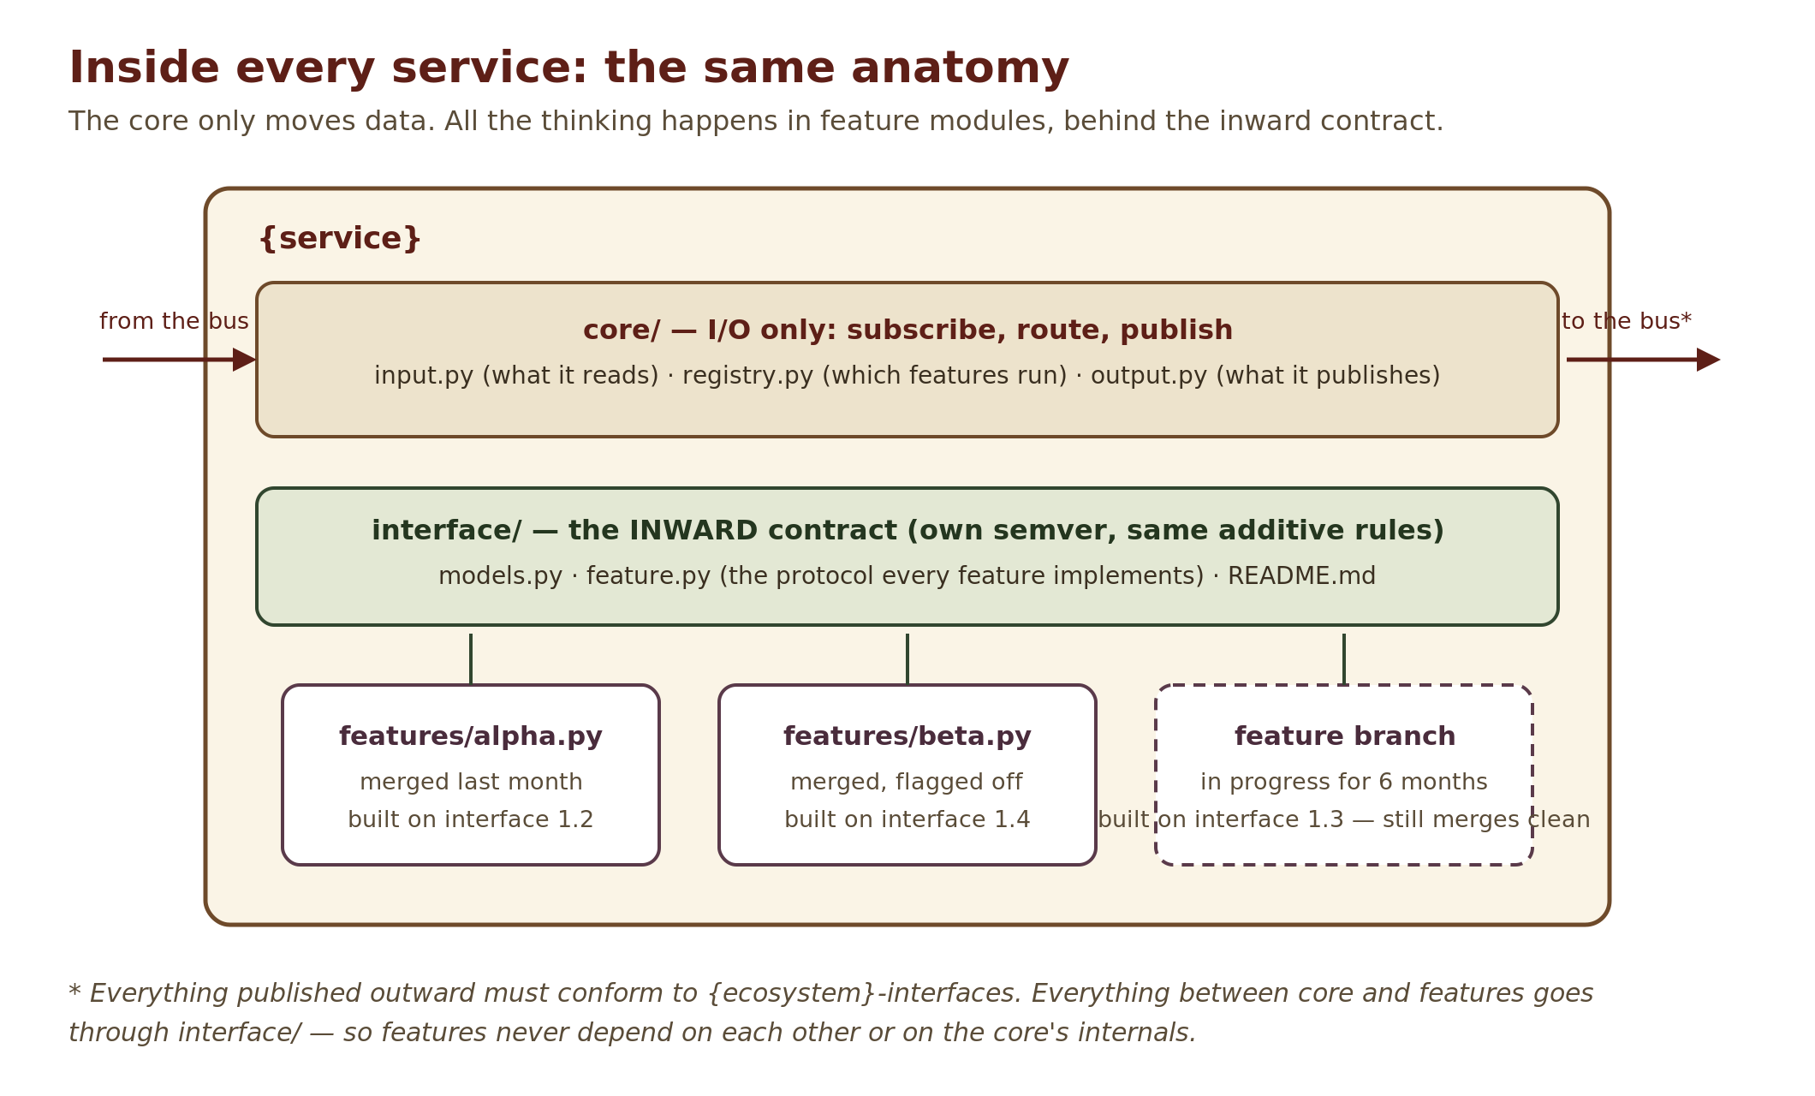
- core/ subscribes to the service’s inputs, routes work to registered features, and publishes their output. It contains no business logic at all. Everything it publishes outward must conform to {ecosystem}-interfaces.
- interface/ is the service’s inward contract — data models, plus the Feature protocol that every feature must implement. It carries its own semver and obeys the same additive rules as the ecosystem contract.
- features/ holds one module per feature. Features implement the protocol, speak only through interface/, and never import each other or reach into the core.
- docs/adr/ records the why behind each significant design decision, and CLAUDE.md gives any newcomer — human or agent — the service’s role, its interfaces, and its current feature list.
One consequence of the features/ rule is worth calling out, because it trips people up: a feature often needs the module’s own name — for a capability flag or a log line. The temptation is to grab it from the core (say, core/registry.py). Don’t. Features may not import the core, so the module-name constant lives in interface/__init__.py — the one package features are allowed to import. Identity belongs to the interface, not the core.

More boxes than modules: the full ontology
Now step back out of the single service. Across the whole project, code falls into six kinds — the spec calls them boxes — and a module is only one of them. Each box has its own home, its own import rules, and its own fate when the Stage 0 monolith is split into repos at Stage 1 (Chapter 7). The rules are enforced by an import-boundary checker in CI — like the schema check in Chapter 2, a load-bearing rule encoded as tooling, not convention — and it also refuses any top-level package nobody has assigned to a box. (And the checkers are themselves tested, with planted violations: a checker that never flags anything looks identical to a healthy codebase.)
- The contract package (interfaces/) — every cross-boundary shape and constant; no logic; imports nothing. At Stage 1: it becomes the tagged {ecosystem}-interfaces repo.
- Modules / services (modules/{module}/) — the anatomy above; never import one another's internals. At Stage 1: each becomes its own service repo.
- Neutral shared packages (each a top-level package named for what it does, like pcap/ or geodesy/) — logic over open standards and formats (file decoders, protocol catalogs, diff engines). Stateless, importable by anyone, never importing a module, never holding a bus reference. Without this box, standards-logic has no legal home and gets smuggled into cores. At Stage 1: a shared library package.
- Bus-coupled infrastructure (also top-level and named for its job, like log_bridge/) — plumbing wired by the composition root that produces or consumes bus traffic without being a module. At Stage 1: it moves into the service that owns it, or graduates into its own.
- The ops tier (ops/) — host installer, doctor script, service units, pinned host binaries, vendored drivers. Nothing imports it. This is also where the container question lives: deployment form is a recorded decision per project, not a default. At Stage 1: it becomes the {deploy} repo plus per-host provisioning.
- The composition root (the project-level main.py, not the one inside a service) — composes modules onto the bus and grows faster than you expect: the serve loop, one-shot CLI modes isolated on private bus instances, defensive config handling, version aggregation. Budget for it. At Stage 1: it splits into per-service entrypoints — each service’s own main.py.

One authority per fact
Some shared logic is more than convenient to share — it is dangerous to duplicate. When two parts of the system computing the same derived value differently would be a safety event (the geometry of a near-collision, “are we in simulation?”, which sensor is the truth), that value gets exactly one implementation: a canonical authority. It lives in a neutral package, every consumer imports it, and nobody writes “a quick local version.”
When the authority is a port of someone else's algorithm, its tests run the original — compile it, call it, diff the answers — and every time the original's version is bumped, that cross-check runs again. One subtlety is worth getting right: the definition is centralized, but enforcement is not. Every consumer that could violate a safety predicate checks it over its own inputs, rather than trusting one upstream gate to have done it for everyone.

Two version numbers per module
A single version conflates two questions: did the contract change, and did the code change? A module can ship real features for months without touching its interface — one number makes it look frozen. So every module carries two, both in interface/__init__.py: VERSION, the release version, bumps with implementation; __version__, the inward contract version, bumps only when interface/ changes. At Stage 1, VERSION becomes the extracted service's repo semver.

Two moves you will reuse constantly
- Features meet in interface objects. When two features in one module must share live state — a coordinator, an interlock, a tuning store — the sanctioned channel is a shared object defined and versioned in the inward interface/, built by the core and handed to both. Features never import each other, and the bus is wrong for intra-module state; this is the third option, legal by design.
e.g. a camera module has a recording feature and a calibration feature, and both drive the same sensor — never at once. interface/ defines a SensorLock; the core builds one and hands it to both. Recording acquires it before it starts; calibration waits or reports busy. Neither feature imports the other, and nobody has to announce “I’m recording” on the bus and hope the other one was listening.
- The vendor-neutral seam. Define a vendor-neutral protocol in interface/, implement one adapter per vendor in core/, inject it. A second vendor is one new adapter and zero feature changes. This applies to every external dependency — hosts, cameras, hardware buses, external servers, protocol decoders — not just message brokers. It is the single most-reused design move in field use.
e.g. interface/ defines a CameraDriver protocol (start(), stop(), read_frame()). core/ holds one adapter wrapping the current vendor’s SDK and a simulated one for tests. When a second camera brand arrives, it is one new adapter in core/ and one config line; the recording and detection features never change, because they only ever saw CameraDriver.

Why a second contract tier?
It may seem extravagant: the ecosystem already has a contract package, and now every service carries a miniature one inside it. The two tiers exist because they have wildly different blast radii.
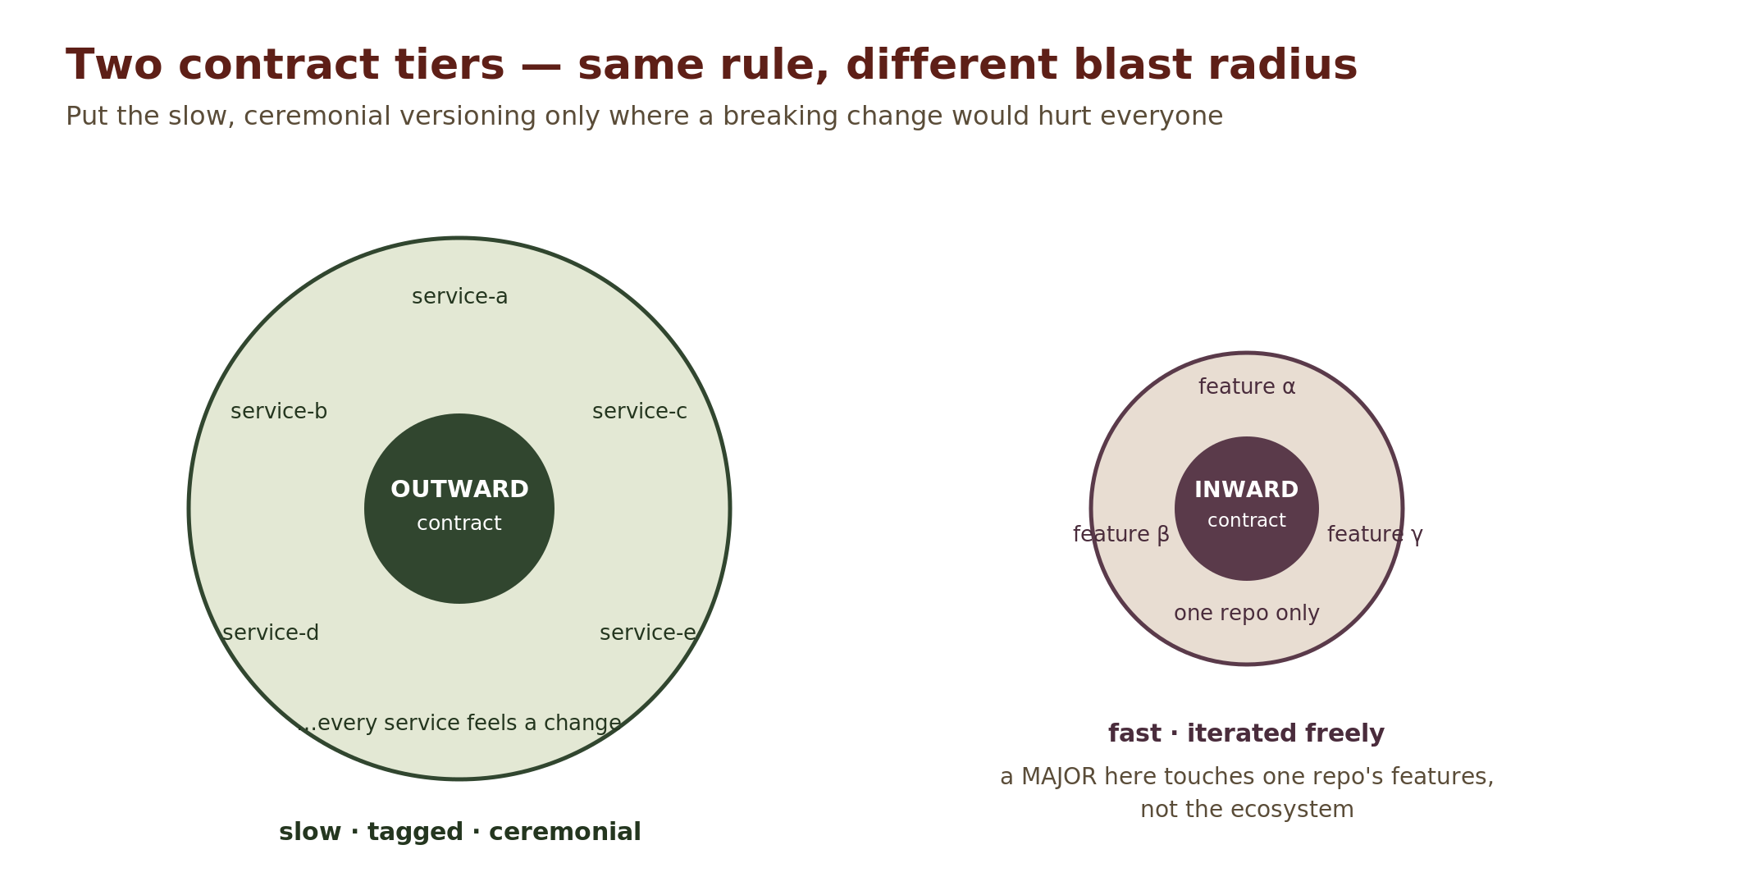
 | Outward (ecosystem) | Inward (one service)
Scope | Every service in the system | One service’s features
Cost of a MAJOR | Ecosystem-wide coordination | One repo’s feature branches
Pace | Slow, tagged, ceremonial | Fast, iterated freely

One contract tier for everything would make every internal schema tweak a cross-team event. No shared contracts at all would make every integration bespoke. Two tiers put the ceremony only where a mistake would hurt everyone — and let everything else move at feature speed. The inward interface may mirror outward shapes when convenient, but it is never required to.

Why slow features are safe here
Interface versions are bumped by interface changes, not by feature count — and MINOR bumps are additive-only. So a feature branched when the inward interface was at 1.2.0 still merges cleanly when the interface has reached 1.5.0: everything the feature depended on still exists, untouched. One feature can take a month and another two years, and neither blocks the other. Only a MAJOR bump — rare and planned — forces feature branches to coordinate.
The guarantee has a boundary
Additivity protects compatibility at the interface layer. It says nothing about two years of drift in the core, the tests, or the dependency tree. So treat branch longevity as a safety net, not a lifestyle: the preferred workflow is merge early, register disabled — merge to dev frequently with the feature unregistered or flagged off (spec rule 8.4).

Starting a feature, in brief
- Branch from dev, named feature/{name}.
- Implement the Feature protocol from interface/feature.py.
- Need new data fields? Bump the interface MINOR on dev first, then branch from that updated dev. Other branches are unaffected — the change is additive.
- Merge back to dev when complete. master receives promotions, never direct merges.
The exact commands live in your project's WORKFLOW.md.

When a feature outgrows its home
Features start as modules inside a service. Some grow up and move out. The signal is always the same: the service is being forced to carry data, connections, or logic that no other feature needs — it has become a middleman for something it does not own. The progression looks like this: a feature speaks the inward interface (normal) → it starts needing foreign data passed through the service (tolerable) → the foreign scope grows until the service is pure bureaucratic overhead for it (time to move out). The feature is then extracted into its own repo and speaks {ecosystem}-interfaces directly, like any other service.

Chapter 5 — Staying alive at runtime

Capability discovery
Chapters 2 and 3 made version skew legal at build time. That has a runtime consequence: your service will meet older services that lack features you rely on. This must be survivable, and the mechanism is disarmingly simple: ask.
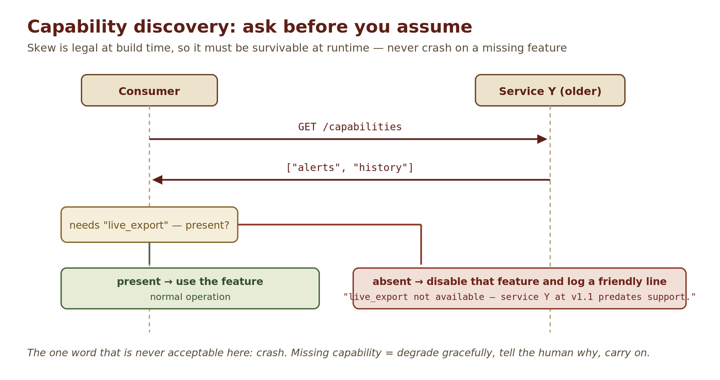
Every service exposes a /capabilities endpoint (or bus equivalent) listing its feature flags. Consumers check before using a feature. If it is absent, they disable that code path and log one clear, human-readable line:
"live_export not available — service Y at v1.1 predates support."
That log format is deliberate: it names the feature, the service, the version, and the reason in one sentence a tired operator can act on. Because contracts grow additively and consumers discover capabilities, services pinning different MINOR versions interoperate indefinitely — not "until the next release," indefinitely.
The one forbidden response
Crashing on a missing capability is never acceptable. A missing feature is a normal, expected condition — the system was explicitly designed so that it would occur. Disable, log, carry on.

Who checks — and what a refusal looks like
Only active invokers check capabilities: anything that publishes a command and needs someone listening declares what it requires and refuses, politely and visibly, when it is absent. Passive consumers never check — an absent producer is just silence, which is already safe. The corollary matters: a command that reaches zero subscribers is a refusal to the caller, never a silent success. Delivering into the void is exactly the failure capability discovery exists to prevent.
The natural end point of this is the action manifest: a machine-readable list of every invokable operation — name, parameter schema, what it requires, whether it is currently available, and any risk warnings. A human UI and an LLM caller consume it identically; capability discovery becomes a tool schema. External devices get the same treatment behind their vendor seam: probe what the hardware actually supports, gate on that, degrade politely when a probe premise turns out false.

The forwarding trap
The same tolerant reading that makes old consumers safe has a dark side. If a relay pinned to an older contract parses a message into its own models and serializes it back out, every field it does not know is silently deleted — and a newer consumer downstream loses data with no error anywhere in the chain.
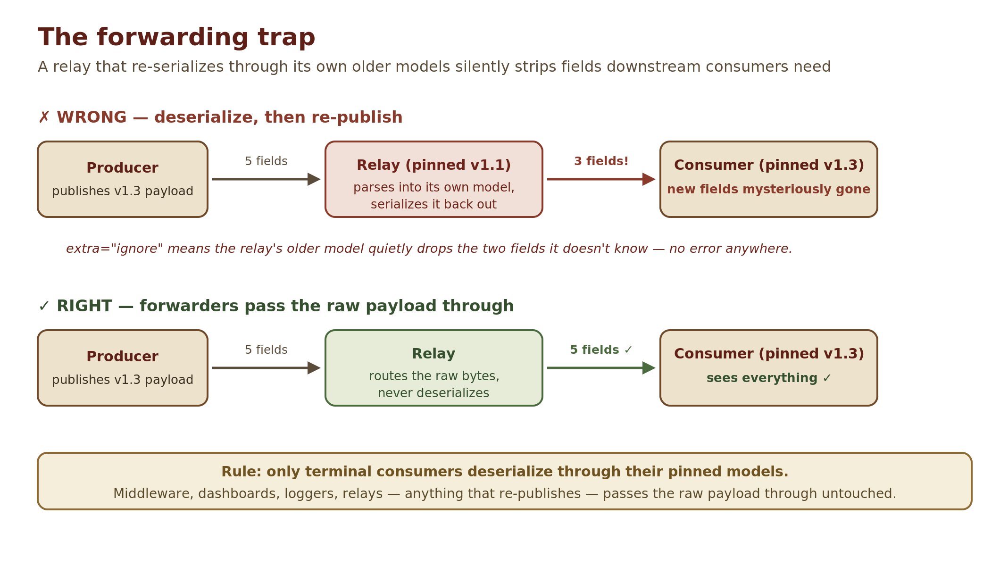
The rule: forwarders pass the raw payload through; only terminal consumers deserialize through their pinned models. It binds per feature, not per service — one dashboard legitimately hosts a forwarder, a terminal consumer (which may parse, with the caveat: if it ever re-publishes, revisit), and a command producer (building a new message from operator input is ordinary producer behavior, not forwarding).

Version on the wire
The contract pin answers interop questions at build time — but it is invisible at runtime. When production misbehaves, "which schema version did this message actually use?" must be answerable in seconds, not by spelunking through requirements files.
So every published envelope carries a schema_version field. Skew becomes directly observable in live traffic, ops tooling can display wire versions next to pinned versions, and the eternal mystery "why did this consumer miss a field?" becomes a lookup instead of an investigation.

Grants that expire, feeds that fail safe
Two runtime habits keep a long-running system honest. The first: any grant of liveness or authority — a lease on a resource, a membership, a “keep going” command — is a level, held by renewing it on a declared schedule, not an edge sent once. An edge that gets lost, or is never revoked, leaves the grant standing forever. A level that stops being renewed simply lapses, and the system falls back to its safe state without anyone having to remember to switch it off.
e.g. an operator console tells a mobile robot to drive forward. Sent once as an edge, “go” survives the console crashing or the network dropping — the robot keeps driving with nobody at the wheel. Held as a level, the console re-sends “keep driving for the next 500 ms” every 200 ms, and the robot stops on its own within half a second of the console going quiet. The SensorLock from Chapter 4 works the same way: held as a lease, a lock whose holder crashed simply expires instead of blocking the sensor forever.
The second: when a consumer enriches data from a feed that can disappear — a membership list that exempts some targets, a trust list that relaxes a check — the enrichment must say which way it fails. “Degrade gracefully” is not enough when one degradation is cautious and the other is dangerous. A stale or missing feed collapses to the cautious reading, loudly, after a stated threshold.
e.g. a collision checker warns about anything near the robot, except vehicles on a “friendly fleet” list fed from another node. If that feed goes quiet, the dangerous degradation is to keep trusting the last list it saw — a vehicle that has since left the fleet is still silently exempted. The cautious reading: once the list is older than, say, 30 seconds, treat every vehicle as unknown, warn about all of them, and raise an alarm that the fleet feed is stale. More noise, but no silent misses.

Capabilities with consequences: the safety ladder
Observing the world and acting on it are different classes of feature. The moment software can write to hardware, shared infrastructure, or someone else's systems, capability discovery gains a second dimension: capabilities do not just exist or not — they carry consequences. The spec's ladder, from its first actuator:
- Read-only by default; write ability is an explicit, per-capability grant.
- Discovery suggests; the operator confirms. Adoption is a human act.
- The first write to an unowned device — anything the system did not provision itself — is operator-confirmed, never automatic.
- May-disturb actions carry an explicit confirm, and the warning lives in the action manifest, so an LLM caller sees exactly what a human sees.
- Mutually exclusive hardware operations get real interlocks — a per-resource lock owned by one coordinator object — never a convention. The sharp form is a lease that expires on its own, with deliberately no “force” override: a break-the-lock-anyway door defeats the lock.
- Declared state is always restored, exception-safely; a failed restore leaves the resource safe and loudly warned, never silently misconfigured.
- Refusals are observable to the caller, in-band — journal-only refusals teach operators to distrust the system.
- Control of a safety-critical medium is its own ADR, its own safety review, and an independent hardware kill — never bolted onto an observation feature.
Those eight rungs decide who confirms a write. Field use added five structural rungs, which decide where the safety properties live — so they hold no matter who is writing:
- One writer per safety-critical store. Exactly one piece of code writes to the actuator or controller, and that writer is the single place the safety rules are enforced.
- One ownership door. Every mutating action passes one authorization check; an act by anyone but the current owner is recorded as a request, never applied and never silently dropped.
- A dead-man level. Outputs stay safe unless a fresh heartbeat says otherwise. The sender declares its own cadence and the receiver derives its timeout from it, so the two sides never drift apart.
- Removing a safety behaviour names its replacement. Until the replacement ships, the change stays behind a flag or a test scenario — never the default.
- Safety predicates are enforced at each consumer, from one shared definition.
One habit ties the ladder together: when a measured hardware fact creates the risk (the adapter cannot listen silently, so every touch disturbs the bus), record the fact next to the convention it forced — in the ADR and near the code — or the next reviewer cannot know why the gate exists.

Never decode for nobody
Contract entropy has a runtime twin: cost that accretes because nobody asked whether anyone was looking. The standing rule: hot paths stay cheap — identity, counters, bounded latest-value state — and expensive work (decoding, reassembly, enrichment) runs only while a consumer is actively watching, spinning up when used and tearing down when idle. Two supporting habits: time-series consumers get bounded ring buffers keyed by entity (not by topic, or multi-instance announcements clobber each other), and anything that spools to disk ships with a retention policy on day one, not as a deferred TODO.

Numbers come from measurements
Behavioural and safety systems are full of numbers — thresholds, timeouts, gains, distances — and every one of them is a decision. The rule: a number that changes behaviour or safety is backed by a measurement, not chosen by feel. The measurement lives in a ledger in the repo, with the logged data and a script that re-derives the number, so changing the constant means re-running the evidence rather than editing a digit. Alongside the ledgers sits a replay corpus: recorded real (or rehearsed) episodes that are re-run against the live code as an acceptance gate for any behavioural change. Unit tests tell you the code does what you meant; the corpus tells you what you meant still works on the world.

Chapter 6 — How services talk

One spine
All inter-service communication flows through a single shared bus — a message queue, pub/sub broker, or shared database of record, whatever fits the project. Services never call each other point-to-point. The bus is why the topology stays comprehensible as the service count grows: adding a service means one connection to the spine, not a web of bilateral agreements.
One property to state out loud on day one: whether bus dispatch is synchronous. In-process Stage 0 dispatchers usually are — a slow handler stalls everyone on the bus. Plan the worker-thread seam and “queue results, drain on next tick” publishing before the first slow feature discovers this for you.

No aggregation for its own sake
A tempting pattern, resisted deliberately: the "merge layer" that collects several streams and republishes them as one. If a layer neither transforms nor filters, it adds latency and a failure point while providing nothing — each consumer should simply subscribe to exactly the streams it needs.

Unreliable links are asynchronous
Any intermittent connection — a remote operator, a cloud uplink, hardware that sleeps — gets a command queue, never synchronous RPC. Synchronous calls across an unreliable link export that link’s unreliability to every caller; a queue absorbs it.

Provider-specific code is middleware
Generic services define stable interfaces; thin adapters translate a specific provider’s wire protocol to and from those interfaces. When a provider changes or gets replaced, you write a new adapter — and nothing above it moves. If you find provider-specific types leaking into a service’s core, an adapter boundary has been breached.

The sanctioned exception: configuration
Config is not a message. A declarative registry — features declare their fields; an operator surface reads and edits them — may be process-wide shared state outside the bus. It is the one blessed exception to bus-only, and it is blessed with paperwork: documented as a deliberate deal, its graduation cost named in advance (an extracted service cannot reach an in-process registry). Any further bus-bypass proposal faces the same bar — named, justified, budgeted, never smuggled in.

Bridges and foreign runtimes
Sooner or later the spine meets something that is not yours: a third-party runtime with its own bus, a broker for an embedded edge, a field network. Two rules keep that meeting contained. A foreign runtime is a sidecar, never the spine — it runs beside your system and is reached through one bridge module, which is also where its measured quirks are recorded and re-checked whenever its version is bumped.
And a bridge is never transparent. It publishes an explicit allowlist of what crosses in each direction, and nothing else crosses. The bridge is the only part of the system that knows the other transport exists, and its crossing list is the boundary a security review audits.

Transport tiering — a lever you probably won’t pull
The single reliable spine is the default, and for almost every project it is also the finish line. But there is one situation it cannot serve well, and the architecture keeps a lever ready for it — deferred, not day-one.
The spine adds a small, honest cost: a message hops through the broker, which orders it, acknowledges it, and forwards it. For commands, config, state, and telemetry that cost is invisible and the reliability is priceless. The exception is a high-rate real-time stream — audio, video, a tight control loop — where a late sample is worse than a dropped one. There, the broker’s hop and ordering are pure overhead. That is the one trigger: when newest-and-fast beats complete-and-ordered.
The answer is to run two spines split by job, a pattern with an established name: control plane vs. data plane.
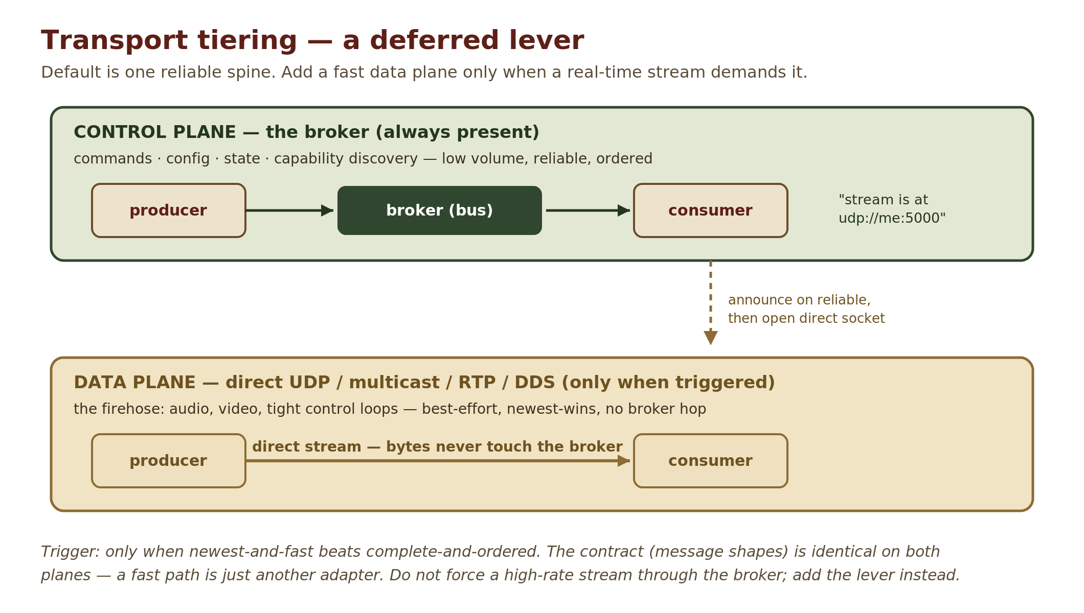
- Control plane — the broker, exactly as described. Commands, config, state, capability discovery. Low volume, reliable, ordered.
- Data plane — the firehose. Direct UDP, multicast, RTP, or DDS for real-time-grade work. Best-effort, newest-wins, no broker hop.
The two cooperate through a pattern you already have: announce over reliable, stream over fast. A producer advertises the stream on the control plane — "I’m sending video at this endpoint, best-effort" — which is just capability discovery (Chapter 5). Consumers that care then open a direct socket to that endpoint. The bytes never touch the broker. (It is the same split as WebRTC’s signalling versus its media.)
The contract does not change — only the transport does
Message shapes still live in the contract package and still obey the additive rule, whichever spine carries them. A fast path is just another adapter behind the same interface — the “provider-specific code is middleware” rule again. So the lever costs you a second Bus implementation, not a redesign.
The anti-pattern to avoid: forcing a high-rate stream through the broker because it’s already there. When the trigger fires, add the lever — don’t overload the spine.

Two field refinements. First, the fast path is often provisioned rather than written: a media server's native protocols, say, with the bus carrying only the announcement — the ops tier owns the server. Second, the line between the planes has a test: bounded latest-sample metadata (a status card, a per-key census) belongs on the bus; if you could reconstruct the traffic from it, it is data plane.

Chapter 7 — Start small, grow deliberately

The growth path
Everything in Chapters 1–6 describes the destination. Almost no project should start there. The polyrepo’s costs — submodule ceremony, tagging rituals, distributed debugging — are fixed, while its benefit (independent shipping without coordination) scales with the number of independent owners. With one owner, the ledger is negative.
So new projects begin at Stage 0: a modular monolith. One repo, one deployable — but structured so that every discipline from this guide is already being practiced, and every ceremony is deferred until a trigger proves it buys something.
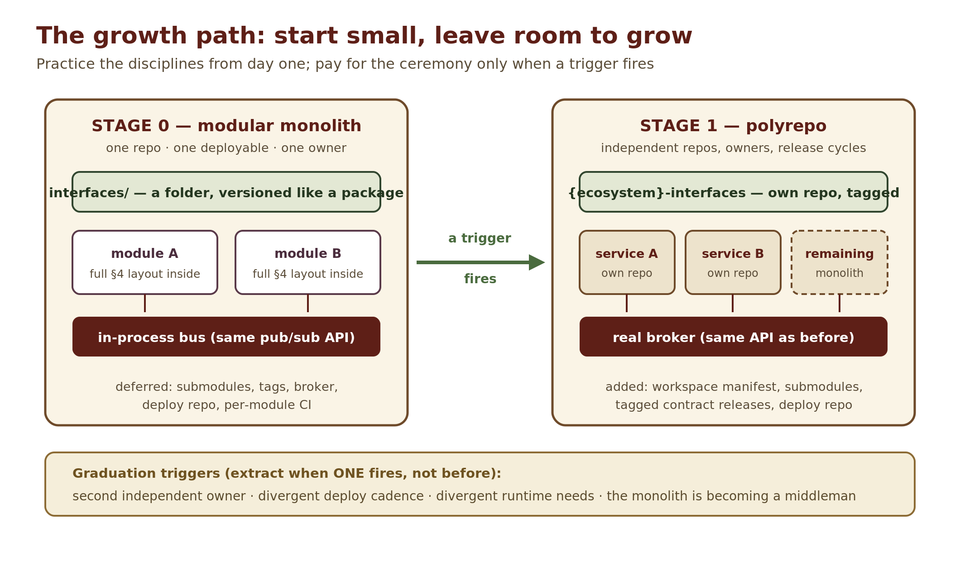

Stage 0: the extraction-ready monolith
Inside the monolith, each would-be service is a module — with the exact internal anatomy from Chapter 4. The two lists below are the whole stage in miniature: the left one is cheap now and brutal to retrofit; the right one is pure overhead until scale demands it.
Non-negotiable from day one | Deliberately deferred
Cross-module types live only in interfaces/ — a folder versioned like a package, additive rules and extra="ignore" included | Separate repos and git submodules
Modules communicate only through the bus abstraction (an in-process dispatcher with the same publish/subscribe API a real broker will have) | The superproject workspace and pin-promotion ritual
schema_version on every envelope; semantics never mutate | Tagged contract releases and the release script
Capability discovery as an in-process registry lookup | A real message broker; the {deploy} repo; per-module CI

Graduation triggers
Extraction happens when one trigger fires — not before, and not on ambition:
- A second independent owner — someone (or some agent) needs to ship without coordinating with you.
- Divergent deploy cadence — one module needs releases the rest cannot ride along with.
- Divergent runtime — different hardware, scaling profile, language, or placement.
- The middleman smell, at monolith scale — the monolith carries data or connections that only one module uses (the same signal as feature graduation in Chapter 4).

Extraction mechanics
Because Stage 0 practiced the disciplines, going to Stage 1 is mechanical repo surgery, not a redesign:
- interfaces/ becomes its own repo — {ecosystem}-interfaces — semver carried over, first tag cut, superset CI check installed.
- The extracted module’s directory becomes its own repo, layout unchanged, pinning the contract tag.
- The in-process dispatcher is swapped for a real broker behind the same API; the topic constants already live in the contract package.
- The workspace, submodules, and automation kit are bootstrapped around what now exists.
Note what did not happen: the remaining monolith did not get decomposed. It simply becomes another (large) service, shedding further modules one at a time, each when its own trigger fires.

One lever at a time
Stage 1 is not all-or-nothing. Its pieces — a real broker, an out-of-process component, a second programming language — are separate levers, and any one of them can be pulled early, behind a single module seam, with its own ADR naming the trigger, while the code stays in one repo. When the contract crosses into another language, the bindings are generated from the contract models and CI compiles them; anything shipped verbatim gets the same treatment. A check that needs a tool not every machine has may be skipped — but it says so, loudly.

Environments: real and disposable
Two habits about where the code runs. The development environment should be a real instance of the stack — the same daemon and configuration surface — running against simulated or rehearsal inputs, not an approximation with its own code paths. And environments that are disposable by design (cloud dev nodes, CI runners, simulated fleets) say up front how in-flight work survives their destruction: parked on a work-in-progress branch, synced to storage, whatever fits — so that throwing one away is never lossy.

Chapter 8 — Rehearsal, fleets, and trust
The first seven chapters describe one system, built by many hands. This last chapter covers three things that appear once that system grows up: practising safely in a simulated world, running many copies of the same stack, and knowing who is allowed to act. Not every project needs them; the ones that do need them to be designed rather than discovered.

Rehearsing in a simulated world
A simulator can be a test harness, or it can be the real stack running in a simulated world. This architecture means the second. In simulation mode the whole system runs — the same modules, safety gates, and operator screens — and only the world is swapped: the simulator joins as an ordinary producer and emits the same traffic real sensors would. Nothing downstream can tell the difference, which is the point: you rehearse the real mission, then turn the simulation off.
Because the stack cannot tell, the switch itself is safety-bearing. Simulation mode is exclusive — live inputs are ignored, never blended in — and switching modes flushes every store that could carry a real datum into a simulated picture, or the reverse. Rehearsed runs are logged like real ones and feed the ledgers and the replay corpus from Chapter 5, labelled as simulated.
The failure this prevents
A real position sensor left running beside a simulation, its readings merged into the simulated picture, can move a reported position by hundreds of kilometres. “Are we simulated, and which inputs are ours?” is therefore one canonical authority (Chapter 4), checked independently by every consumer that could be fooled.

Many copies of the same stack
The polyrepo of Chapter 3 is many different services under one owner. A different shape appears when many instances of the same stack run at once — several devices, or one real node plus disposable simulated ones — and must be aware of each other. They are peers, not a hierarchy: no central coordinator, no elected leader.
Each node serves a read-only card describing itself — identity, state, versions — and every peer pulls every other peer's card on a schedule. The card is strictly separate from the command surface: reading one never acts, and nothing a card says is an instruction. Where peers must not conflict, each applies the same deterministic rule to the same shared picture and reaches the same answer alone. Membership is a level, so a peer whose card goes stale drops out — and anything a node relaxed because a peer was “one of ours” snaps back to the cautious default.

Who is allowed to act
Every project states its trust boundary at the start. When the answer is “the network,” this architecture turns it into mechanism. Identity is read from the authenticated network itself rather than re-checked by each application, and one ownership door — the structural rung from Chapter 5 — is its consumer. Machine-to-machine links outside that network use mutual TLS from the node's own certificate authority, so pairing a device is simply issuing its certificate.
The strongest form of a secret is one that can never be transmitted. Where the hardware allows it, a device's private key is generated inside a secure element and never leaves it. Enrolment carries only the public key and an operator's approval; no image, flash, or file transfer ever holds a secret. The approval is the pairing.

Glossary
Term | Meaning
Additive change | A contract change after which every previously-valid payload is still valid and still means the same thing. Safe as a MINOR release.
ADR | Architecture Decision Record — a short document capturing a decision and its why. Lives in each service’s docs/adr/.
Action manifest | A machine-readable list of a service's invokable operations — name, parameters, requirements, availability, risk warnings — consumed identically by human UIs and LLM callers.
Blind spot (checker) | A field a checker cannot see inside — typically a bare dict. Allowed only when declared, with a reason and a plan to type it.
Canonical authority | The single implementation of a load-bearing derived fact, imported by every consumer and never re-implemented.
Capability discovery | Asking a service at runtime which features it supports, and disabling gracefully whatever is missing.
Composition root | The entrypoint (main.py) that composes modules onto the bus and owns the serve loop, one-shot modes, and config resolution.
Contract | A shared data definition that crosses a boundary: message schemas, topic names, constants.
Contract pin | The exact tagged version of the contract package a service builds against (e.g. interfaces @ v1.4.0). The sole authority on interoperability.
Dead-man level | An authority to act that holds only while fresh heartbeats keep arriving; silence returns the outputs to safe.
Detached HEAD | Git state where you stand on a commit rather than a branch — the default state of a checked-out submodule, and a trap for the unwary editor.
Forwarder | Any component that re-publishes a message it received (relay, dashboard, logger). Must pass payloads through raw.
Inward contract | A service’s internal interface/ package: the stable boundary between its core and its features. Own semver, same additive rules, one-repo blast radius.
Known-good set | The workspace master branch: submodule pins validated to work together.
Lease | A grant (of a resource, a membership, a permission) that lapses unless renewed. Used for interlocks, with no force override.
Ledger | Repo-kept evidence behind a behaviour or safety constant: the data, the number, and a script that re-derives it.
MAJOR / MINOR / PATCH | Semantic versioning. MINOR = additive only. MAJOR = something existing changed — rare and planned. PATCH = no shape change.
Middleman smell | A service (or monolith) carrying data, connections, or logic that only one feature/module uses — the trigger for graduation or extraction.
Neutral shared package | A stateless library of standards-logic importable by anyone; imports no module, holds no bus reference. Machine-checked.
Outward contract | The {ecosystem}-interfaces package: every data shape that crosses a service boundary.
Peer card | A node's read-only self-description, pulled by its peers. Never a command.
Polyrepo | One git repository per service, each with independent versioning and releases.
Promotion | Copying validated submodule pins from the workspace dev branch to master, then tagging. Never a git merge.
Quirk registry | Measured silent behaviours of a pinned third-party dependency, re-verified whenever its version is bumped.
Replay corpus | Recorded real or rehearsed episodes re-run against the live code as a gate for behavioural change.
Safety ladder | The graduated rules for software that acts on the world: read-only by default, operator-confirmed writes, interlocks as leases, exception-safe restores, observable refusals — plus the structural rungs: one writer, one ownership door, dead-man levels.
Schema version on the wire | The schema_version field carried in every published envelope, making skew observable at runtime.
Simulation mode | The real stack running against a simulated world; exclusive, and flushed on every switch.
Single writer | The one piece of code allowed to write to a safety-critical store — the sole place its safety rules are enforced.
Spine / bus | The single shared communication channel (queue, pub/sub, or DB of record) all services publish to and subscribe from.
Stage 0 / Stage 1 | The growth path: modular monolith practicing the disciplines (0), graduating to the full polyrepo when a trigger fires (1).
Superproject / submodule | The workspace repo (superproject) whose service directories are git submodules — full independent clones pinned to exact commits.
Terminal consumer | The final recipient of a message — the only kind of component allowed to deserialize it through pinned models.
Version skew | Different parts of the system built against different contract versions. Legal, expected, and survivable here.

Where to go next
- Skim META-ARCHITECTURE.md in the workspace — now that you have the shape, the terse spec will read easily. It is the binding source of truth.
- Open one service repo and read its CLAUDE.md and interface/README.md — see the anatomy from Chapter 4 in the flesh.
- Pair on your first feature — your project's WORKFLOW.md has the exact recipe. The architecture is learned by doing; the guide is here when you need to check a rule.

Welcome aboard. Build something that outlives its branches.

