Software Test Plan
for
Online Course Enrollment Website
Version 1.0 approved
Prepared by: Austin Blair
UAGC
2-27-2025
Table of Contents
Table of Contents ii
Revision History ii
1. Test Management Strategy 1
1.1 Purpose 1
1.2 Test Teams 1
1.3 Exit Criteria 2
1.4 Test Effort Estimation 3
1.5 Test and Risk 3
1.6 Incident Reporting 4
1.7 Defect Classification 4
1.8 Configuration Management 5
2. Test Tools 6
2.1 Introduction 6
2.2 Test Management Tools 7
2.3 Test Specification Tools 7
2.4 Static Testing Tools 8
2.5 Dynamic Testing Tools 8
2.6 Non-Functional Testing Tools 9

References 10

Revision History
Name | Date | Reason For Changes | Version
Austin Blair | 2/27/2025 | Section 1: Test Management Strategy  Section 2: Test Tools | 1

Test Management Strategy

Purpose
The purpose of this document is to ensure that testing of the Online Student Enrollment Website is managed correctly by implementing a specific testing strategy. The test management strategy includes the planning, monitoring and documenting of testing activities used for product quality assurance (IBM, 2023). The goal of testing is to identify and resolve issues that would otherwise prevent the product from meeting end user expectations. Therefore, test management can help to mitigate challenges such as prioritization and optimization of test cycles which allows development teams to accelerate the delivery of high-quality software while meeting scalability demands (IBM, 2023). Throughout these next subsections, a deeper explanation will be provided into the test management strategy for the Online Student Enrollment Website.

Test Teams
The members of the software testing teams are an essential aspect to the overall success and quality of the finalize Online Student Enrollment website. As the saying goes, a team is only as strong as its weakest link! Each team member has an important position to uphold in the overall development process, but especially when testing. Testing is an activity that occurs throughout the entire SDLC; therefore, it is important that each member understands their responsibility and importance towards success of the end product. There are three primary positions within the testing team, the test manager, the testers, and the developers. The test manager possesses the knowledge and experience in software testing, and project, quality, and personnel management (Spillner, 2014). Software testers are responsible for reviewing test plans and cases, executing testing, and reporting failures. The developers are responsible for writing the code and providing peer support and reviews as needed. As mentioned by Spillner, the easiest solution to testing would be to let the developer perform the testing (Spillner, 2014). Although it would be the easiest, there can be a sense of biased during testing and code review when complete by the developer. Instead, independent testing is used which provides an unbiased approach and often finds additional defects that were missed by developers. Throughout the testing phases of the Online Student Enrollment website, independent testing will be utilized. In component testing, independent testing will be used by having designated developers test the programs of colleagues for conformance to requirements and specifications. For the integration testing phase, a designated testing team composed of representatives from the involved testing groups will be used to validate the integration of software components (Spillner, 2014). The last testing phase, system, will be tested completely from an independent, outside, testing team. This will provide realistic and constructive feedback before deployment of the Online Student Enrollment website.

Exit Criteria
Software testing is an essential component to developing quality, effective, and efficient software, but it is also very costly. To determine when to stop testing, the term exit criteria is used to set a standard by which test cases are considered complete and software can move forward towards deployment. The exit criteria are defined by the test manager and are often defined by when test cases are completed with a maximum pass percentage, when the defect rate drops from the calculated level, when the budget has dried up, or when release deadlines have been reached (Srivastava, 2024). Additionally, metrics such as the defect closure rate, test case coverage, and time-based criteria play a pivotal role in deciding when to come to the consensus that testing is complete. Utilizing the aforementioned exit criteria will aid in determining when testing the Online Student Enrollment website should either be halted or continued.

Test Effort Estimate
Within the software testing process, it is the test manager’s responsibility to estimate the expected testing effort. The effort for every testing task depends on the maturity, quality and testability of the software, test infrastructure, employee qualifications, the quality requirements, and the test approach (Spillner, 2014). These factors often influence one another, making it difficult to analyze them completely. To effectively estimate the test effort required for the Online Student Enrollment website, experience data from other similar websites will be used to provide a baseline for the amount of resources and costs necessary to produce a quality product (Spillner, 2014).

Test and Risk
When evaluating risk as it applies to software testing, it is best summed up as damage times the probability of occurrence of a product failure upon deployment (Spillner, 2014). Operating with a high-level of risk is “risky business”, therefore the Online Student Enrollment website with be tested with a risk-based approach. This approach aids in minimizing and fighting product risks from the start of the project by using information about identified risks for planning, specification, preparation, and execution of the tests. In align with the IEEE 730 and 829 standard, a systematic risk management plan will also be followed to regularly identify risks, prioritize those risks, and implement actions to mitigate those risks. Additionally, when testing the Online Student Enrollment website a risk-based prioritization approach will be taken to ensure that risky software parts are tested more intensively and earlier in the process than parts that are less significant.

Incident Reporting
Incident reporting, also referred to as problem, anomaly, defect, or failure reporting, will be used throughout the development and testing process of the Online Student Enrollment website to point out problems in the tested parts of the program as well as to faults in specifications, user manuals, and other documents (Spillner, 2014). Automated incident tracking tools such as JIRA and Bugzilla will be used to streamline defect documentation and resolution. Each incident report will be collected in a central database for the Online Student Enrollment website to ensure that developers and testers have access to the report’s content. The incident report will contain information identifying the tested software, the test environment, the name of the tester, and the defect class and prioritization as well as other information that’s important for reproducing and localizing the fault. Each report will be written so that the responsible developer can identify the problem with minimal effort and find its cause as fast as possible.

Defect Classification
Defect classification will be used for managing reported problems within the Online Student Enrollment website. A set of criteria will be used to determine the severity and priority of reported issues. The severity is assigned from the point of view of the user of the test object and is often classified into five levels of severity. These levels are Fatal, Very Serious, Serious, Moderate, and Mild (Spillner, 2014). The priority indicates how quickly a particular problem should be corrected and is classified into four levels. These levels are Immediate, Next Release, On Occasion, and Open. The Online Student Enrollment website test manager will be responsible for analyzing the severity and priority of reported incidents and make statements about product robustness and delivery. Additionally, trended data from incident reports will be used to improve the overall testing process. Failure severity criteria for the Online Student Enrollment website will be documented in accordance with Figure 6-2, and fault priority will be established in accordance with Figure 6-3 below.
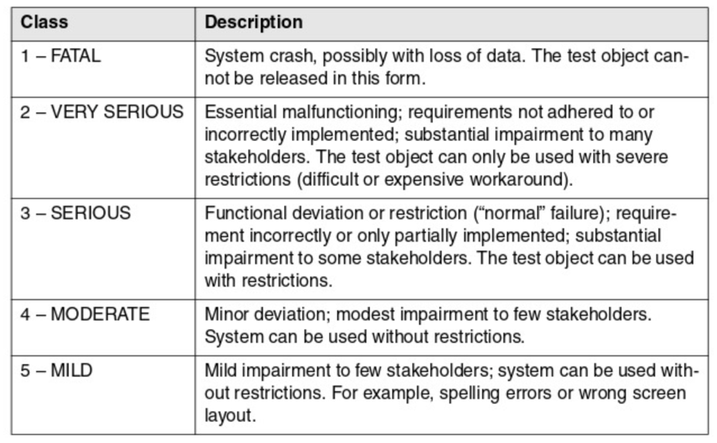
Figure 6-2. Failure Severity
(Spillner, 2014)
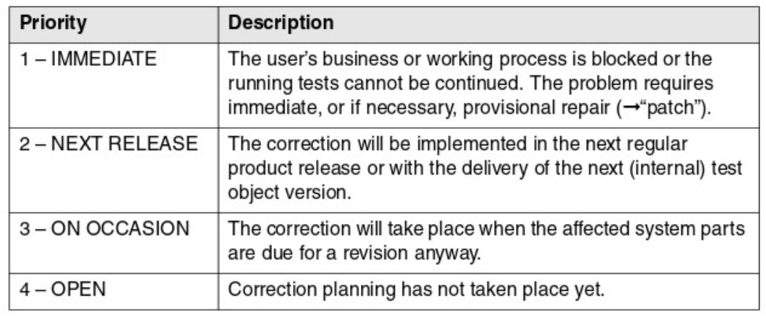
Figure 6-3. Fault Priority
(Spillner, 2014)

Configuration Management
Configuration management will play a crucial role in the test process of the Online Student Enrollment website. It will organize the test team’s files and directories, and document how and when test components are modified (Homès, 2012). Utilizing the configuration management process will ensure that developers do not overwrite each other’s source code, ensuring there is a record of which code versions and compilers are used, and document when changes were made to specific versions, therefore preventing tests and test evaluations from being impeded upon. This is accomplished through implementing the configuration requirements of version management, configuration identification, incident and change status control, and configuration audits (Spillner, 2014). Each of these requirements should be incorporate into the configuration management plan of the Online Student Enrollment website in accordance with the standards outlined in IEEE 828.

Test Tools

Introduction
Software testing is a vital part of the software development life cycle, in fact it undergoes its own life cycle often called the software testing life cycle. This life cycle consists of a series of phases: evaluation of requirements, test planning, test case design, test environment setup, test execution, and test closure. Due to the extensive amount of work and time involved with testing, automated testing tools were developed to increase efficiency of time as compared to solely manually testing software applications. Each complex component of the Online Student Enrollment website will benefit drastically through using these automated testing tools. Automated tools covering test management, test specification, static and dynamic testing, as well as non-functional testing will improve test efficiency, improve test reliability, and provide the ability to execute tests where impossible in manual approaches (Spillner, 2014).

Test Management Tools
Test management tools provide mechanisms for easy documentation, prioritization, listing, and maintenance of test cases. They allow the tester to document and evaluate if, when, and how often a test case has been executed (Spillner, 2014). Tools for requirements management store and manage information about requirements and allow testers to prioritize requirements and to follow their implementation status. These tools can exchange information with test management tools. Incident management tools are used to document, manage, distribute, and statistically evaluate incident and failure messages within the testing life cycle. Configuration management tools are not necessarily testing tools, but they make it possible to keep track of different versions of the software to be tested as well as the documentation and test ware (Spillner, 2014). Lastly, integration test tools are vital to managing the integration of the previously mentioned test management tools to ensure that test status’ can be traced from requirements all the way through code changes. The Online Student Enrollment website will utilize BrowserStack which is a cloud-based testing tool that enables cross-browser testing on various devices and browsers without the need for maintaining a complex infrastructure (BrowserStack, n.d.).

Test Specification Tools
Test specification is made reproducible using test generators, which support the test designer in generating test data. There are different types of test generators that can be used depending on the basis for which the test is needed. The most common are database-based, code-based, interface-based, and specification-based (Spillner, 2014). The Online Student Enrollment website will utilize Spawner to generate sample test data which will be used to measure database communication. Additionally, Benerator will be used to generate data for load, performance, unit, and business tests (Benerator, n.d.).

Static Testing Tools
Static testing tools will be used to analyze the source code and specifications of the Online Student Enrollment website before releasing for deployment. Static testing tools are used in the early phases of development to find faults in the software and fix them before reaching the dynamic testing phase. Reviews are structured manual examinations which will be used to help plan, execute, and evaluate tests. They store information about planned and executed review meetings, meeting participants, and findings and their resolution and results (Spillner, 2014). Static analyzers will provide measures of miscellaneous characteristics of the Online Student Enrollment program code, such as the cyclomatic number and other code metrics. Analyzers list all the “suspicious” areas and check that safety and security-related coding requirements have been followed and identify portability issues in the code. In addition to code analysis through static analyzers, model checkers will analyze the Online Student Enrollment website model structure and different static characteristics of the models. The static testing tool SourceMeter will analyze the source code of the Online Student Enrollment website to aid in finding vulnerable spots of the system, generating reports from collected data, and use the analyzed data to enhance the overall website (SourceMeter, n.d.).

Dynamic Testing Tools
To reduce the mechanical work involved in test execution by automatically sending input data to the test object, recording its reaction, and documenting the results, the Online Student Enrollment website will use dynamic automated testing tools. The first of these dynamic tools are test drivers, which provide the input data. The test bed is where the source code is displayed along with the program under execution (GeeksforGeeks, 2024). Emulators are used to provide the response facilities which imitate the undeveloped parts of the system. Lastly, mutation analyzers test the fault tolerance of the system by providing errors in the source code of the software. The Online Student Enrollment website will apply the open-source dynamic analysis platform PANDA which can record and replay executions, enabling iterative, deep, whole system analyses (Panda, n.d.).

Non-Functional Testing Tools
Non-functional testing of the Online Student Enrollment website will be evaluated using the OpenText tool LoadRunner. It will evaluate generate a synthetic load which will simulate executing volume, stress, or performance tests (OpenText, n.d.). Performance testing tools measure and log the response time behavior of the system being tested depending on the load input. The security testing tool IBM Guardium will test access control and data security by detecting security vulnerabilities (IBM, n.d.).

References
Benerator. (n.d.). Introduction to Benerator. https://docs.benerator.de/1.1.0/benerator_goals_features.html
BrowserStack. (n.d.). Test Management. https://www.browserstack.com/test-management?utm_source=google&utm_medium=cpc&utm_platform=paidads&utm_content=669184443352&utm_campaign=Search-Brand-US-AMER-Intent&utm_campaigncode=Competitors+9008653&utm_term=e+browserstack vs
Geeks for Geeks. (2024, July 30). System Testing-Software Engineering. https://www.geeksforgeeks.org/system-testing/
Homès, B. (2012). Fundamentals of Software Testing. ProQuest Ebook Central. https://ebookcentral.proquest.com/lib/ashford-ebooks/detail.action?docID=1120766.
IBM. (2023, December 29). What is Test Management? https://www.ibm.com/topics/test-management
OpenText. (n.d.). OpenText LoadRunner Enterprise. https://www.opentext.com/products/loadrunner-enterprise
Panda. (n.d.). Home. https://panda.re/
SourceMeter. (n.d.). What is SourceMeter? https://sourcemeter.com/
Spillner, A., Linz, T., & Schaefer, H. (2014). Software testing foundations: A study guide for the certified tester exam (4th ed.). Rocky Nook.
Srivastava, A. (2024, May 16). When to Stop Testing (Exit Criteria in Software Testing). https://www.scaler.com/topics/software-testing/when-to-stop-testing-exit-criteria-in-software-testing/

