DriverPass System Design Document

This document presents the proposed DriverPass system design based on the Project One business requirements and client interview.

UML Diagrams

UML Use Case Diagram
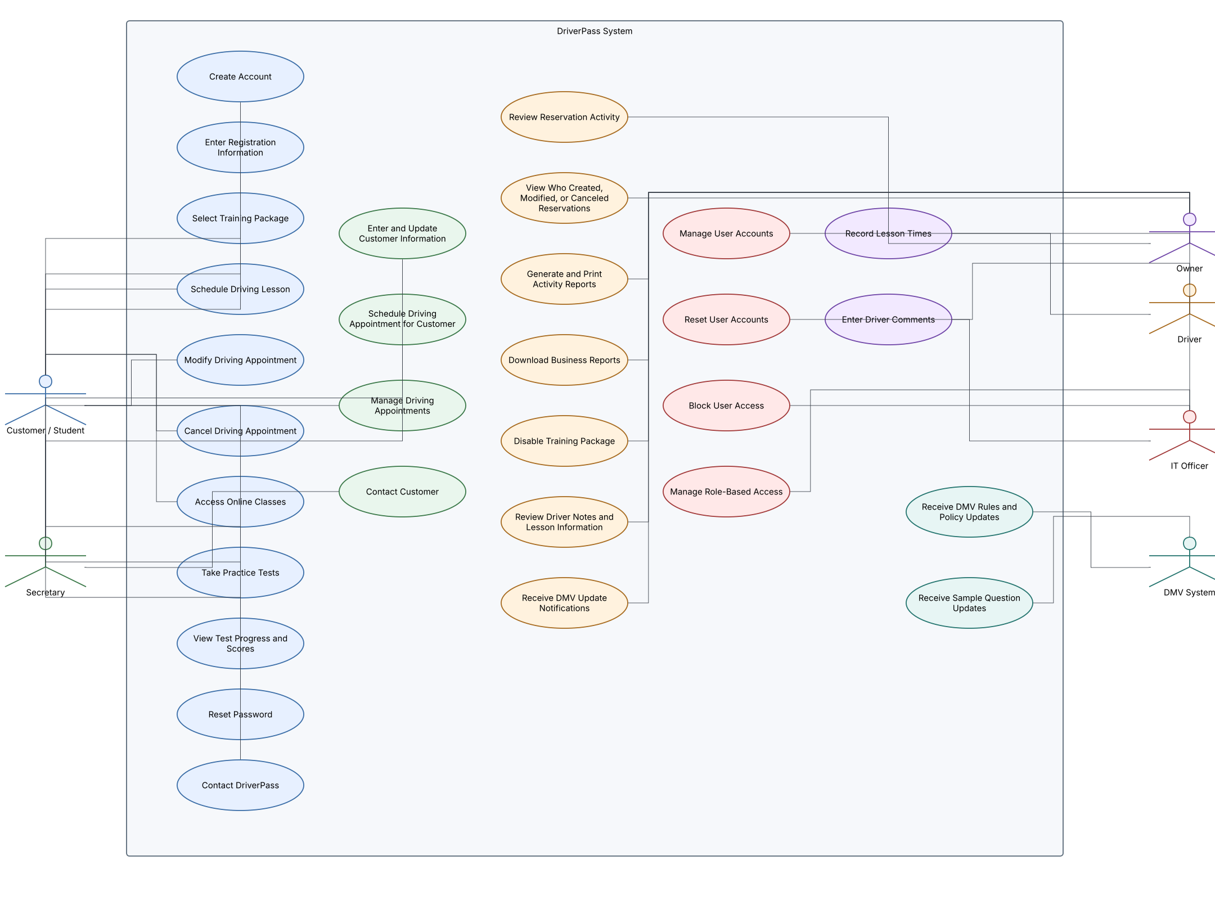

UML Activity Diagrams
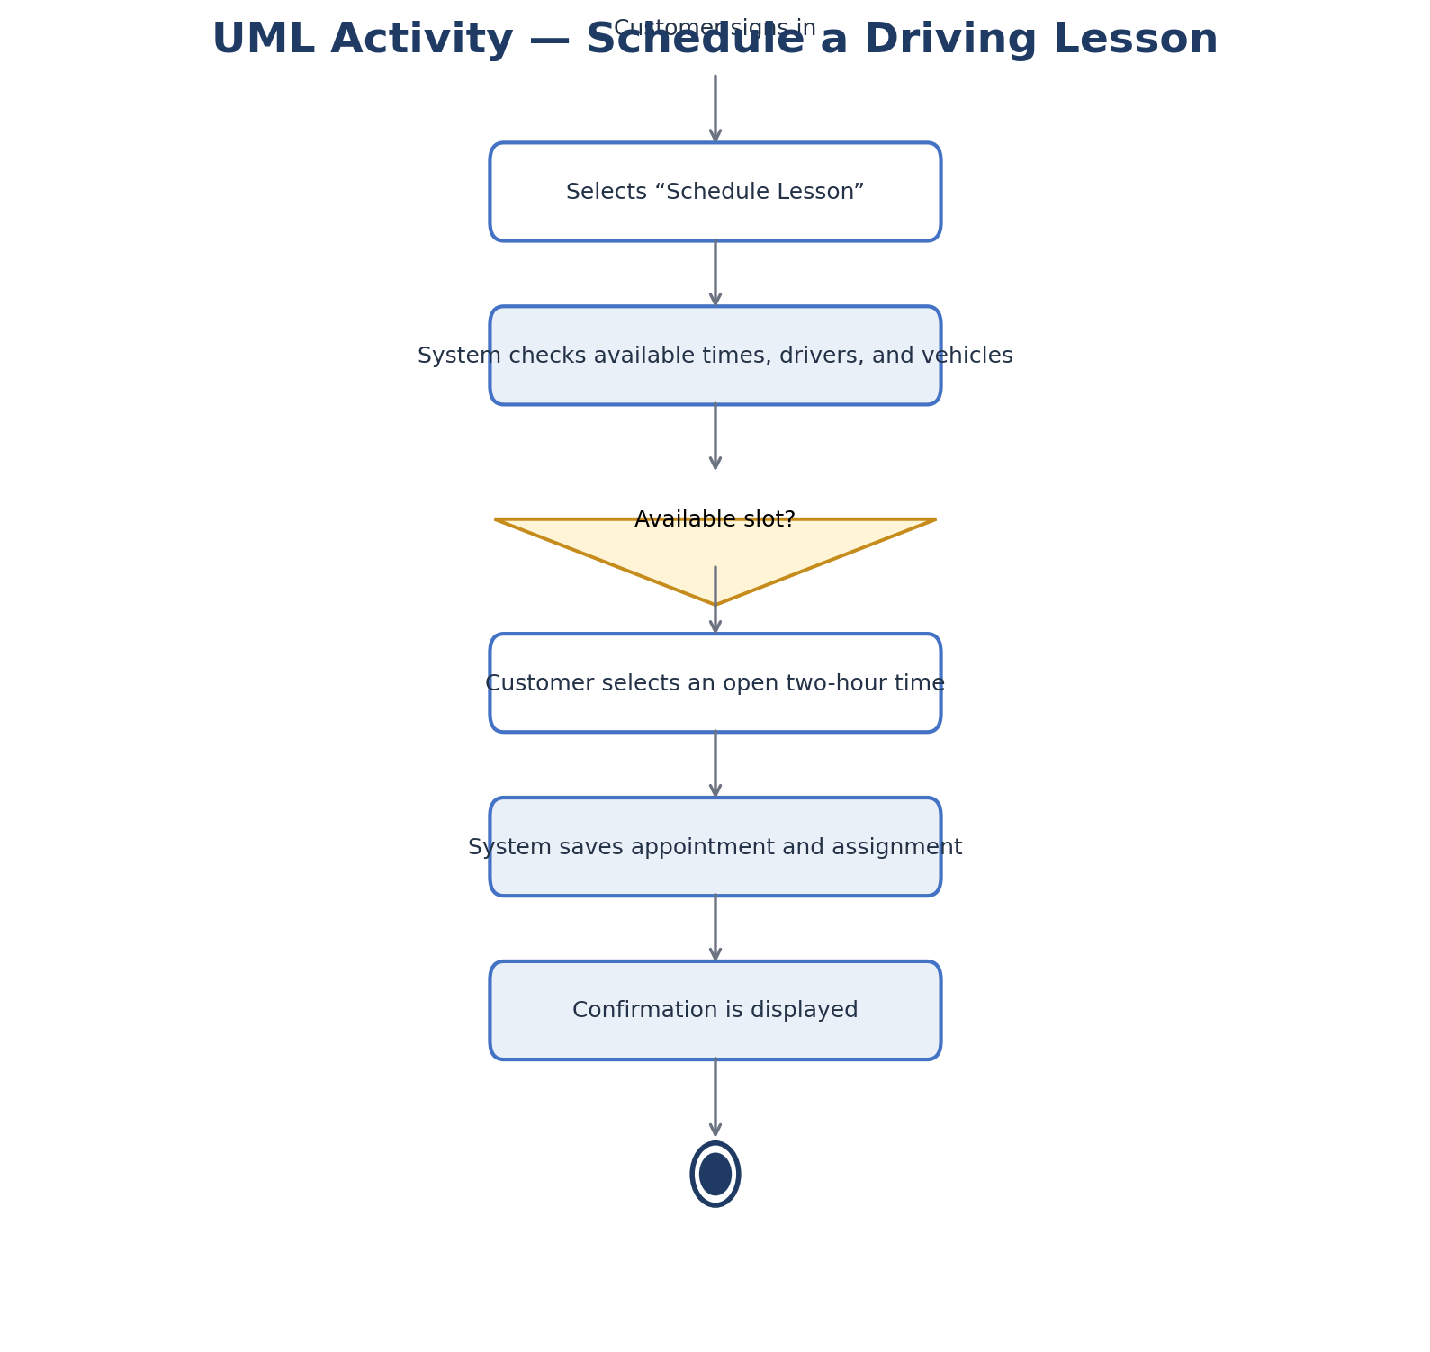
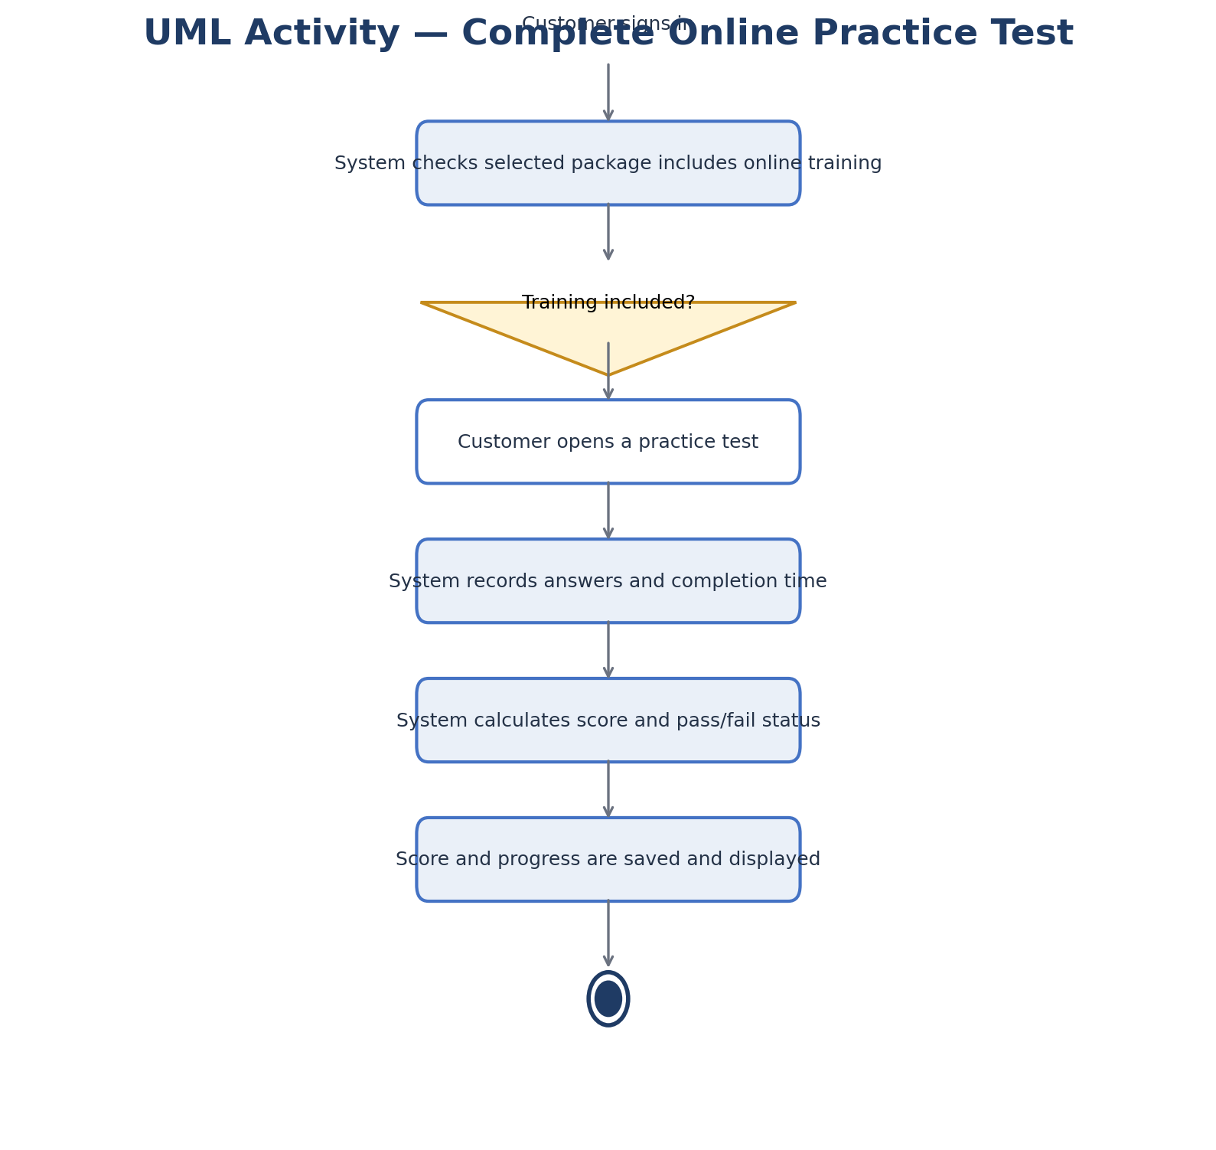

UML Sequence Diagram
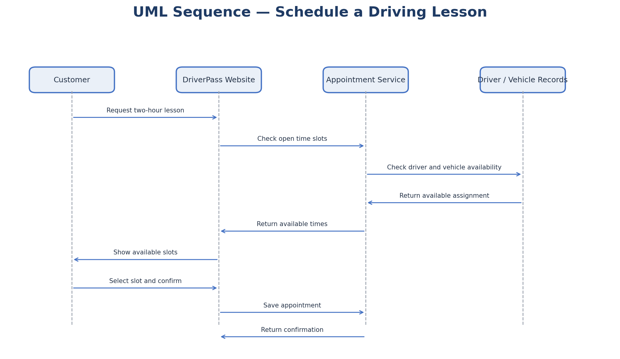

UML Class Diagram
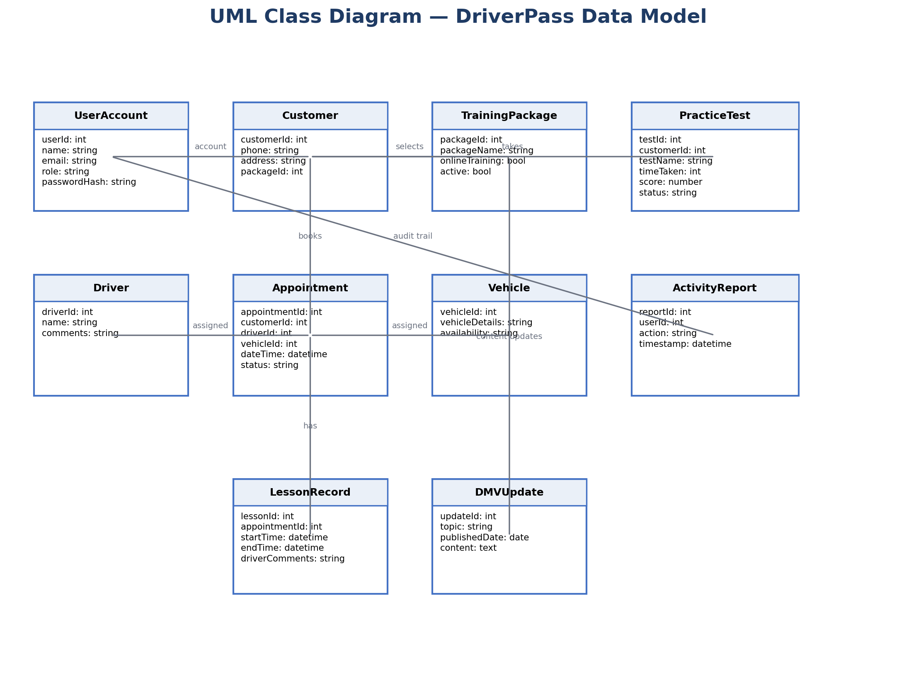

Technical Requirements
Hardware
Customers and employees need a computer, tablet, or smartphone with a supported web browser and internet access. DriverPass staff need reliable office computers. A compatible server environment is provided by the cloud hosting provider rather than maintained onsite.
Software
The system requires a responsive web application, a server-side application, a relational database, a supported web browser, and secure integration for receiving DMV updates when an approved feed or interface is available. Online training and practice-test functions are available only for packages that include them.
Tools and infrastructure
Use a cloud-hosted environment with encrypted network connections (HTTPS/TLS), database backups, monitoring, and a recovery process. A relational database stores customer accounts, package selections, appointments, drivers, vehicles, lesson notes, test results, DMV updates, and activity history. Development and maintenance require source control, testing, deployment, and database administration tools.
Security and access
Require individual accounts and role-based permissions for customers, secretary, owner, drivers, and IT staff. Store password hashes rather than readable passwords; provide secure password reset; limit repeated sign-in attempts; log important reservation changes; encrypt data in transit; and restrict access to payment information. Payment card details should be handled by a compliant payment provider rather than stored directly unless DriverPass meets applicable payment-card requirements.
Availability and performance
The web application should provide current appointment and training information when users are connected. Prevent conflicting bookings by checking driver and vehicle availability at the time an appointment is saved. Schedule regular backups and test restoration. The service depends on internet access and the availability of the cloud host and DMV update source.
Maintenance and limitations
The initial release supports the three packages described by the client, with the ability to disable an existing package. Creating new package types or adding/removing training modules is reserved for a future release. Updates to system data require an internet connection; downloaded reports can be reviewed offline. DMV updates depend on a supported source being available.

