1. Change E-Diagnostic assessment to - **D’Rx e-Diagnostic Tool**

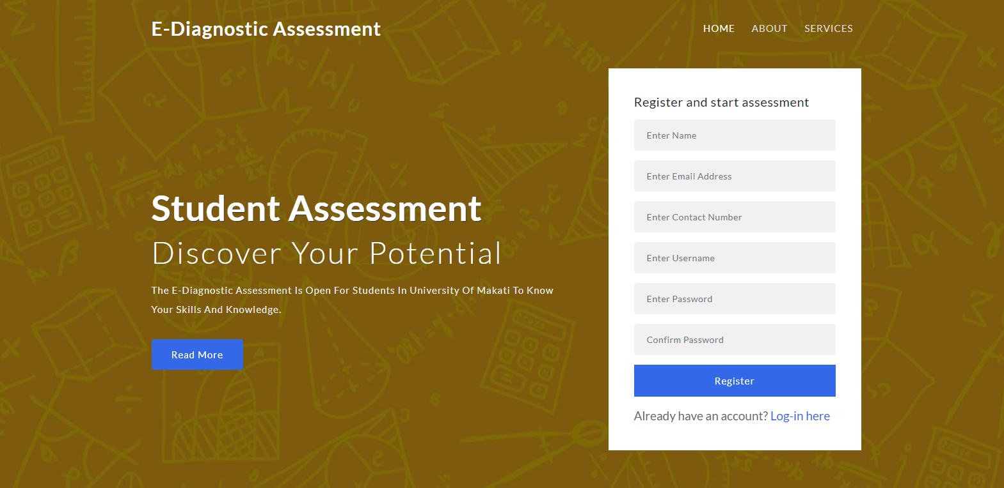

1. **About** section



D’Rx is an e-diagnostic assessment tool will be able to assess students’ mathematics learning competencies in the following areas: number sense; memorization of arithmetic facts; accurate calculation; fluent calculation; and accurate math reasoning and application. Further, the said tool will also serve as guide among grade 11 HSU (senior high school) math teachers to remediate specific weaknesses and to structure their lessons based on the result of the assessment.

Instructions on how to take the exam.

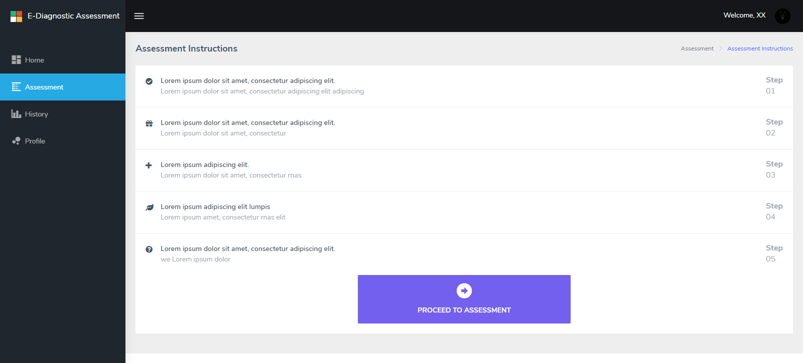

1. This is a 50-item test that will measure your learning competencies in Mathematics.
2. Finish all items, then click the Submit button at the bottom of the page.
3. Please make sure to review all your answers before submitting because you can only take the exam once, or as advised by your subject teacher.