Generating .DLL and .jar wrapper from yad2xx-lib4222

<https://github.com/aushacker/yad2xx>

https://sourceforge.net/projects/yad2xx/

1. Follow the steps in:

<https://github.com/aushacker/yad2xx/wiki/Building-on-Windows>

1. In D2xx folder have:

* ftd2xx.h
* LibFT4222.h
* ftdxx.lib (amd64) and
* LibFT4222.lib (amd64)

1. Installed d2xx drivers
2. To generate .dll and .jar:

* Open mingw64 terminal

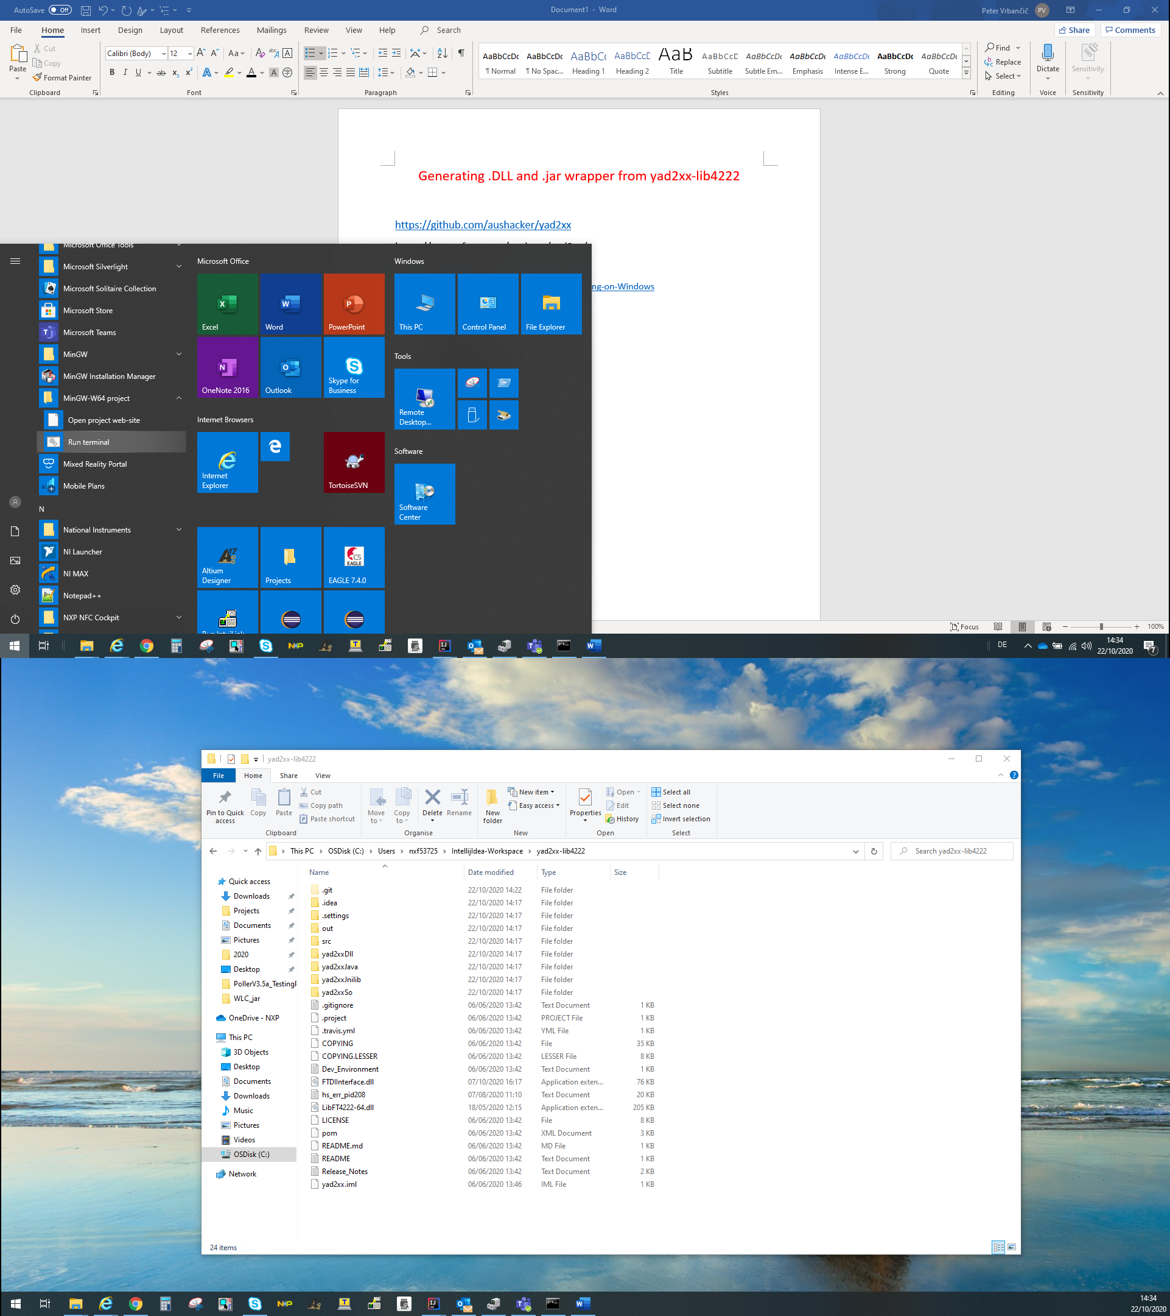

* Insert :cd <src directory>
* Insert: mvn install

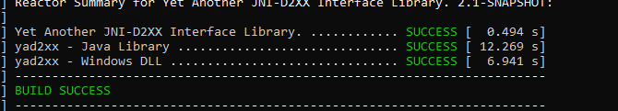

* Generated .dll : yad2xx-lib4222\yad2xxDll\target\FtdiInterface.dll
* Generated .jar: yad2xx-lib4222\yad2xxJava\target\yad2xxJava-2.1-SNAPSHOT-jar-with-dependencies.jar

How to build wrapper

1. Include javah builder into intellijIdea

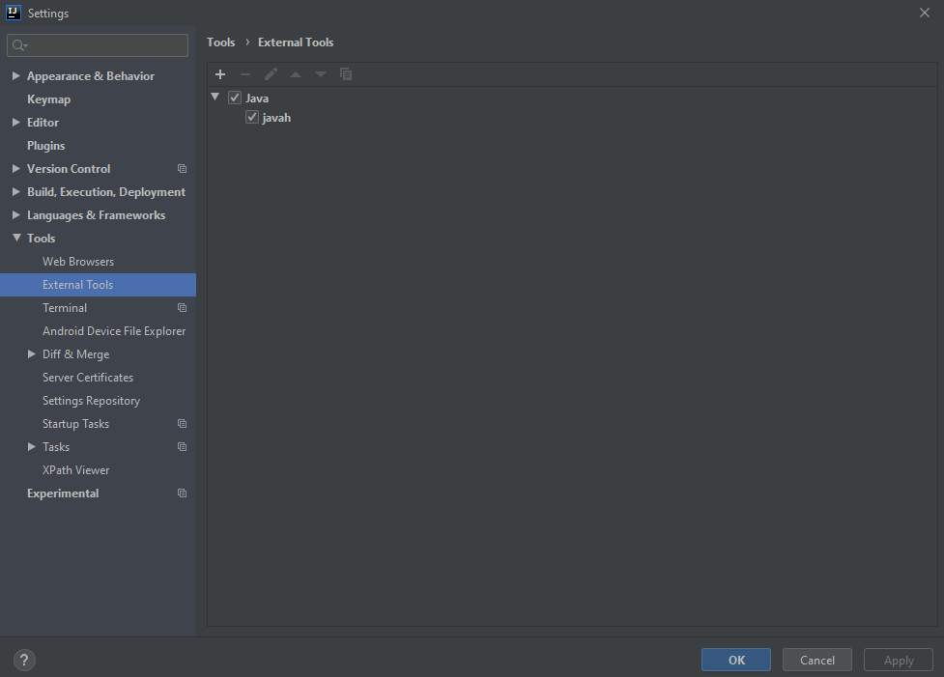

* Build FTDIInterface.class with C builder(javah) by pressing on the desired method then press Tools/java/javah

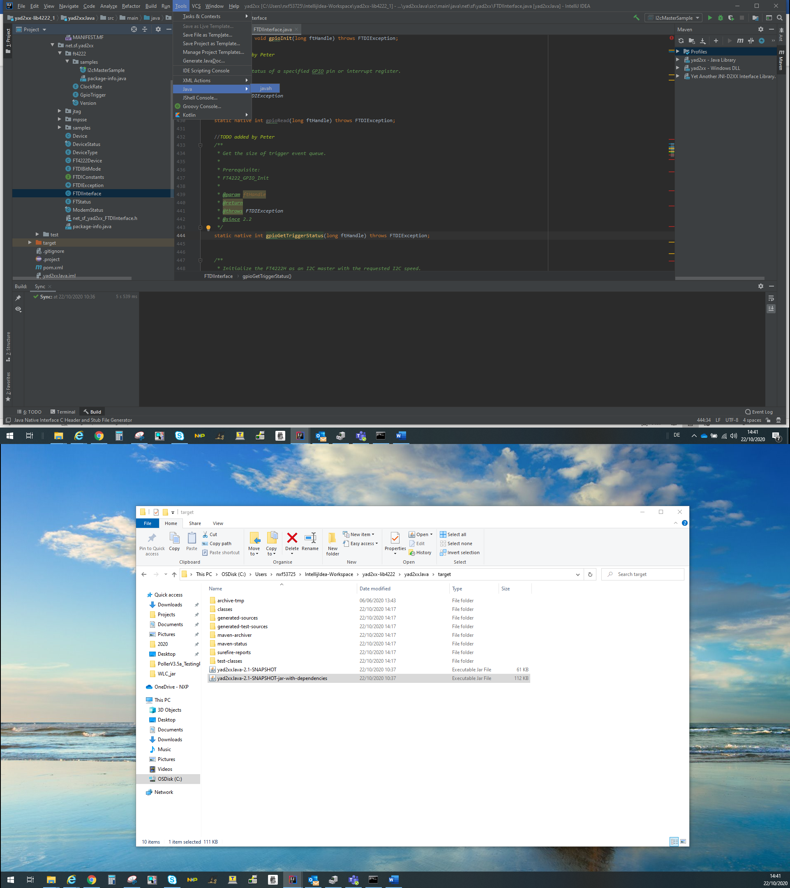

* Go to net_sd_yad2xx_FTDIInterface.h and find generated header

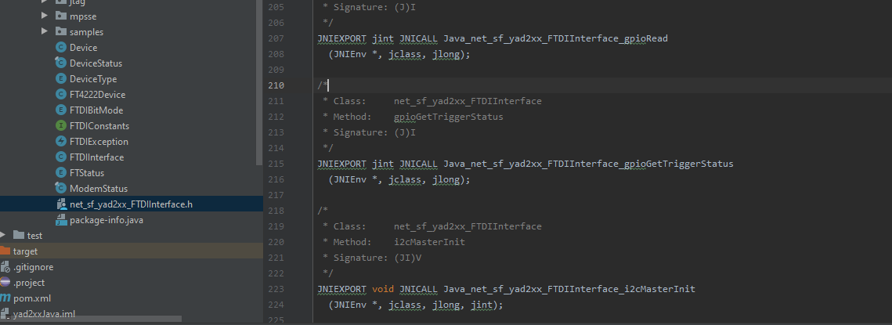

* Copy header to yadxx-lib4222/src/main/native/FTDIInterface.c and start coding

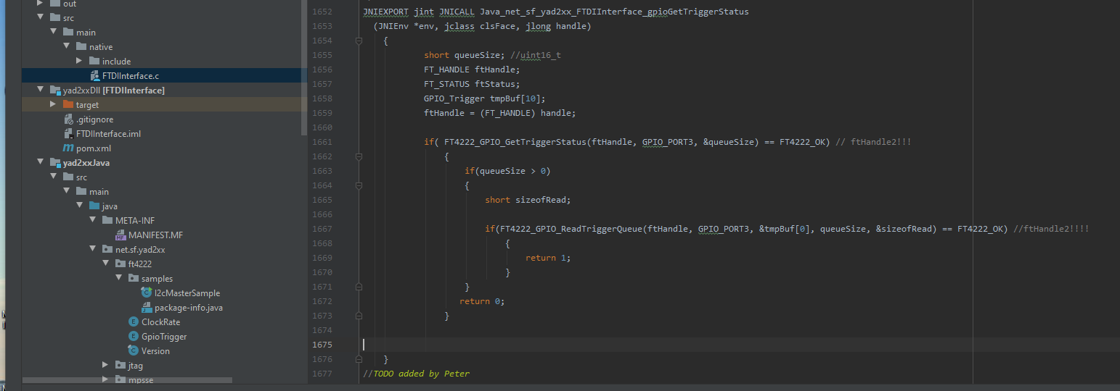

* Generate new .dll and .jar