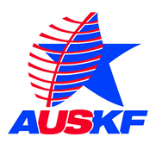

December 7, 2017

All Regional Federation Presidents Via email

Re: 2018 AUSKF Junior National Championships Save the Date Announcement.

Presidents:

The All United States Kendo Federation Competition Committee is pleased to announce that
the 2018 AUSKF Junior National Championships will be held on Sunday Apr. 8, 2018 at Marina High School, 15871 Springdale St. Huntington Beach, CA 92649.

Please advise your members so they may “Save the Date” for this important event. Additional details are pending and will be announced as soon as possible.

Warmest regards,
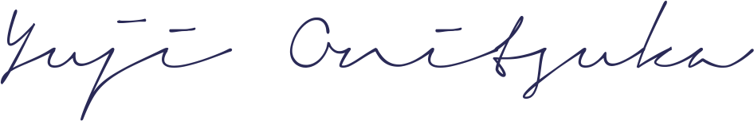
Yuji Onitsuka
Chair
AUSKF Competition Committee

cc: Seiji Mamiya - seijimamiya@hotmail.com
Mark A. Kerstein - kersteinlaw@gmail.com

