

September 30, 2019

All Regional Federation Presidents Via email

Re: 2020 AUSKF Junior Open National Championships Save the Date Announcement

Presidents:

The All United States Kendo Federation Competition Committee is pleased to announce that
the 2020 AUSKF Junior Open National Championships will be held on Saturday, April 4th 2020 in Los Angeles, California. The venue location is TBD and will be shared once it is confirmed.

Please advise your members to “Save the Date” for this important event. Additional details are pending and will be announced as soon as possible.

Warmest regards,
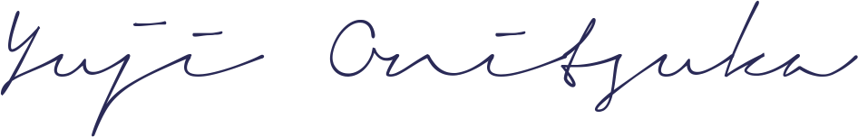
Yuji Onitsuka
Chair
AUSKF Competition Committee

