

August 22, 2018

All Regional Federation Presidents Via email

Re: 2019 AUSKF Junior Open National Championships Save the Date Announcement

Presidents:

The All United States Kendo Federation Competition Committee is pleased to announce that
the 2019 AUSKF Junior Open National Championships will be held on Saturday, April 6th 2019 at South Forsyth High School, 585 Peachtree Pkwy, Cumming, Georgia, 30041.

Please advise your members to “Save the Date” for this important event. Additional details are pending and will be announced as soon as possible.

Warmest regards,
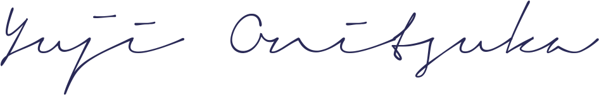
Yuji Onitsuka
Chair
AUSKF Competition Committee

CC: Seiji Mamiya - seijimamiya@hotmail.com
Mark A. Kerstein - kersteinlaw@gmail.com

