Methods

Dynamic Window Determination
We calculated state-specific dynamic windows using a growth-rate algorithm applied to the 3-week rolling average of the weekly metric. The baseline was established as the median value of the first four weeks of the season (July).
- Onset: Defined as the first of two consecutive weeks where the week-over-week growth rate exceeded 10% (ratio >1.10) and the smoothed value exceeded a minimum activity threshold (0.08% for NSSP).
- Offset: Defined using a return-to-baseline approach. The offset was identified as the first week following the season peak where the smoothed value remained below a baseline recovery threshold (defined as the maximum of: the baseline median plus three standard deviations, three times the baseline median, or a minimum floor of 0.15%) for two consecutive weeks.
Additional Figures
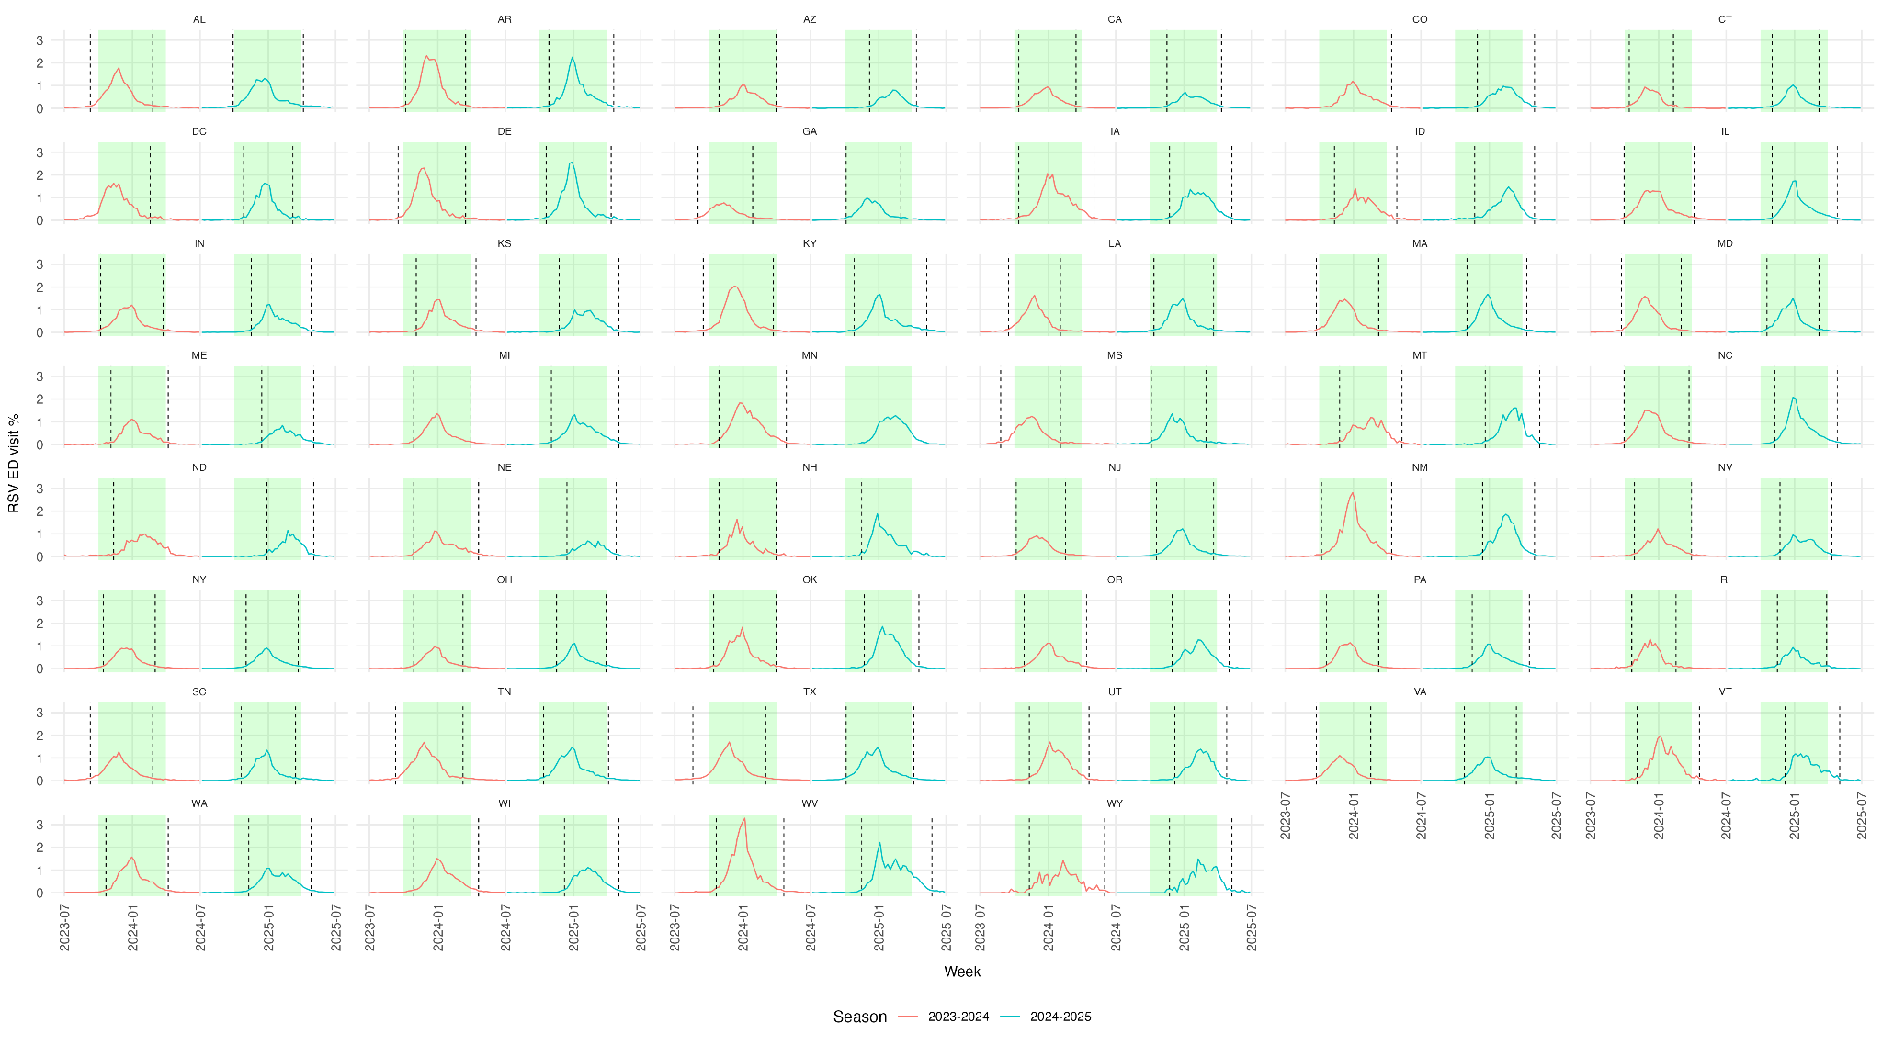
Figure S1: State-level RSV-associated emergency department visit trends, 2023-24 and 2024-25 seasons. Weekly percentage of emergency department visits associated with RSV from the National Syndromic Surveillance Program (NSSP). The 2023-24 season (July 1, 2023–June 30, 2024) is shown in red; the 2024-25 season (July 1, 2024–June 30, 2025) is shown in blue. The green shaded region indicates the October–March Nirsevimab administration window; vertical dashed lines mark the onset and offset according to the dynamic growth algorithm. States are arranged alphabetically. Florida, Missouri and South Dakota are excluded due to unavailable NSSP data.

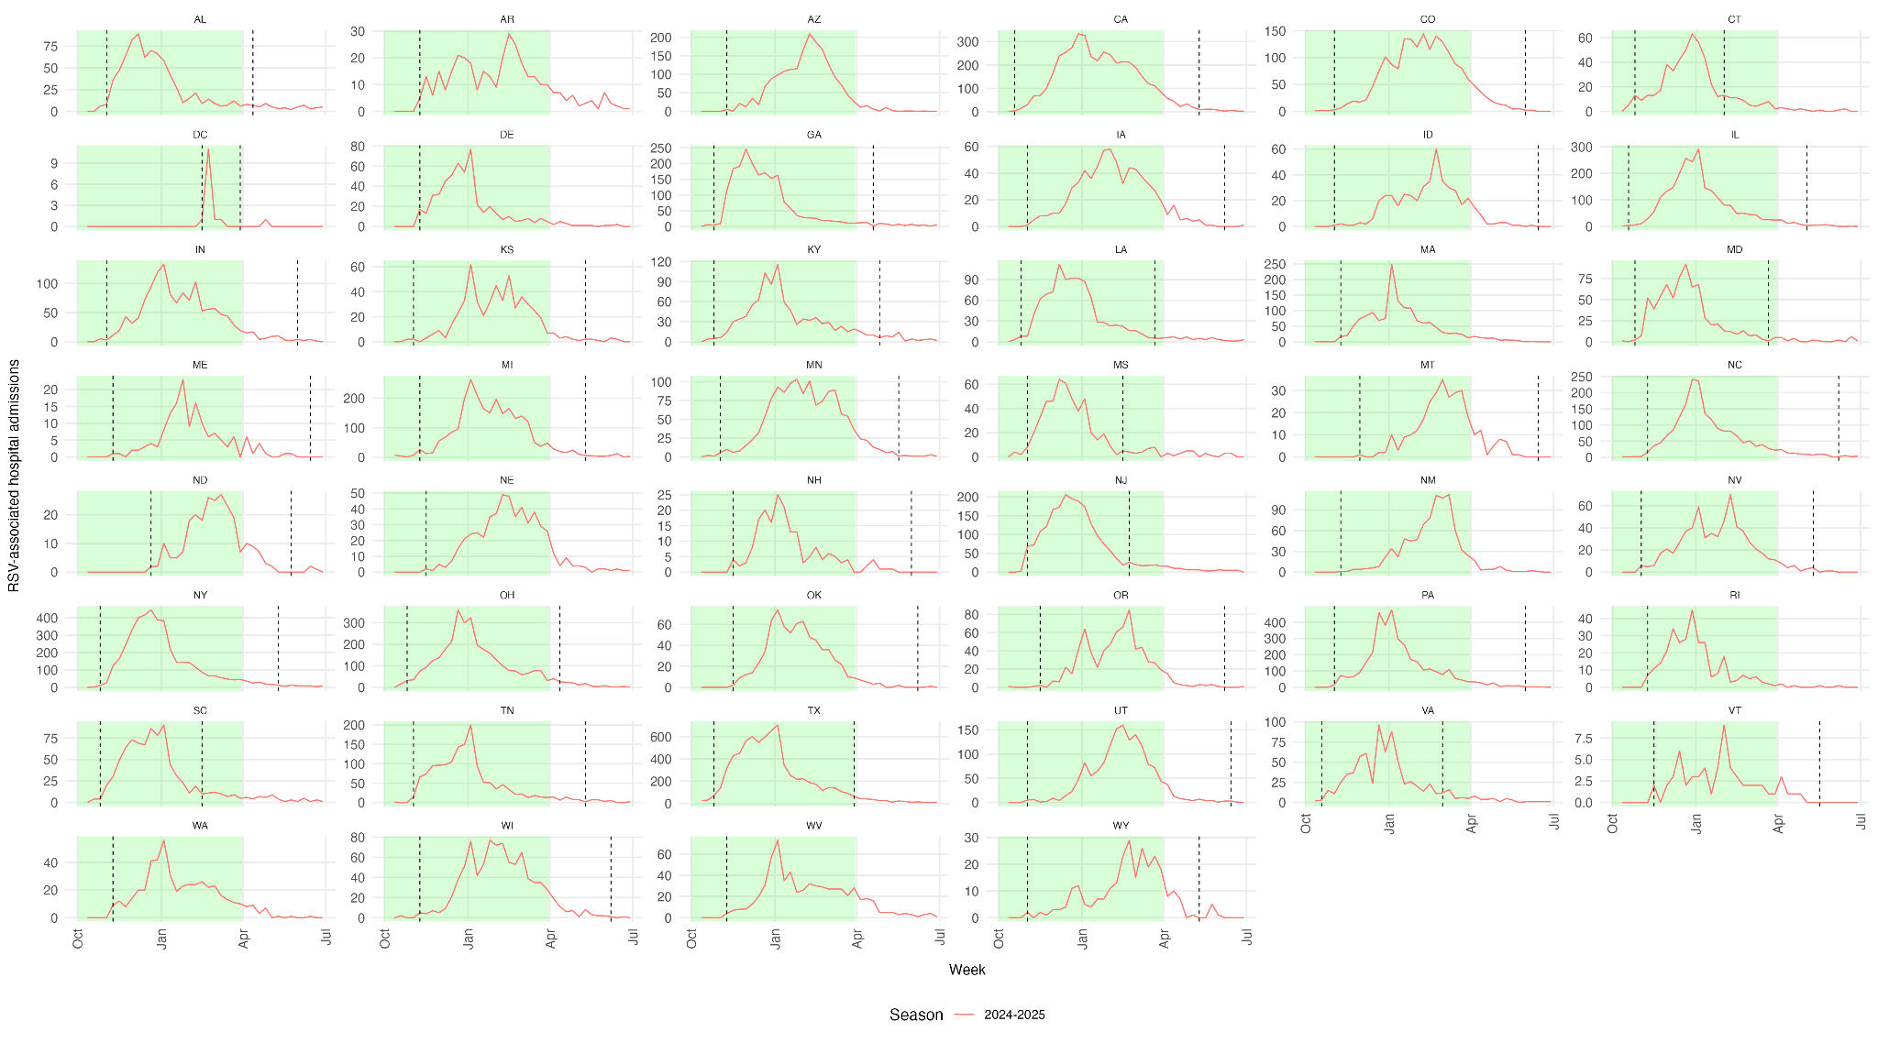
Figure S2: State-level RSV-associated pediatric hospital admissions, 2024-25 season. Weekly counts of laboratory-confirmed RSV-associated hospital admissions among children aged 0–4 years from the National Healthcare Safety Network (NHSN). The green shaded region indicates the October–March Nirsevimab administration window; vertical dashed lines mark the onset and offset according to the dynamic growth algorithm. States are arranged alphabetically. Note that y-axis scales vary by state to accommodate differences in population size and admission volume. Florida, Missouri, and South Dakota are excluded due to unavailable data.

