Quantifying the Protection Gap: RSV Activity Outside the Nirsevimab Administration Window

Austin G. Meyer, MD, PhD, MS, MPH, MS^{1,3*}; George Dewey, PhD, MPH⁴; Stephanie Blasick, DO^{1,3}; Christopher Hovland, MD^{2,3}; Mauricio Santillana, PhD, MS⁴

¹Division of Pediatric Hospital Medicine, Department of Pediatrics, Baylor Scott and White Health, Temple, TX.
²Division of Primary Care Pediatrics, Department of Pediatrics, Baylor Scott and White Health, Temple, TX.
³Department of Pediatrics, Baylor College of Medicine, Temple, TX.
⁴MIGHTE Lab, Department of Physics, Northeastern University, Boston, MA.

*Address correspondence to: Austin Meyer, MD, PhD, MS, MPH, MS, Division of Pediatric Hospital Medicine, Department of Pediatrics, Baylor Scott and White, Temple, TX, USA. austin.g.meyer@gmail.com

Introduction

Nirsevimab is recommended for all infants less than 8 months of age entering their first respiratory syncytial virus (RSV) season, with administration advised from October through March in most of the continental United States.^{1,2} This recommendation is based on historical RSV seasonality data and operational simplicity;³ however, the granular data available in the post-COVID era shows the epidemiology of RSV is highly variable.⁴ While current guidance acknowledges flexibility based on local epidemiology,¹ state Medicaid and Vaccines for Children programs, which cover most eligible infants, generally adhere to this fixed administration window. However, the fraction of RSV burden falling outside this window has not been quantified using contemporary national surveillance data. Therefore, we analyzed national syndromic and hospital surveillance data to quantify RSV activity outside the October–March window and characterize geographic variability.

Methods

We analyzed respiratory surveillance data from two national systems with distinct populations and metrics. We utilized the National Syndromic Surveillance Program (NSSP)⁵ to assess the percentage of total emergency department visits associated with RSV across all age groups for the 2023-24 and 2024-25 seasons. Additionally, we analyzed data from the National Healthcare Safety Network (NHSN)⁶ for the 2024-25 season, restricting the analysis to weekly counts of laboratory-confirmed RSV-associated hospital admissions among pediatric patients aged 0 to 4 years.

To quantify the burden of RSV activity, we calculated the cumulative intensity of the season for each state. For NSSP, only the ratio of RSV visits to total ED visits is available. Thus, annual intensity was calculated as the sum of weekly RSV percentages across the 52-week season. For NHSN data, annual burden was calculated as the sum of weekly pediatric admission counts. We calculated the out-of-window fraction for each state and season by dividing the sum of RSV burden (percentages or counts) occurring during the out-of-window weeks by the total annual burden.

We also evaluated a state-specific dynamic onset–offset approach (see supplement).

Results

Across states, a median of 5.8% (IQR: 4.7–8.5%) of RSV-associated ED visits (NSSP) occurred outside the October–March window in 2023-24, and 7.3% (IQR: 6.1–9.6%) in 2024-25. For RSV-associated hospitalizations (NHSN, 2024-25), the median was 5.2% (IQR: 4.4–7.7%). State-level variability was substantial (Fig. 1). Out-of-window fractions ranged from 2.5% to 18.2%, with regional values varying widely by season. Geographic patterns showed some variability between NSSP seasons but remained consistent between NSSP and NHSN data for 2024-25.

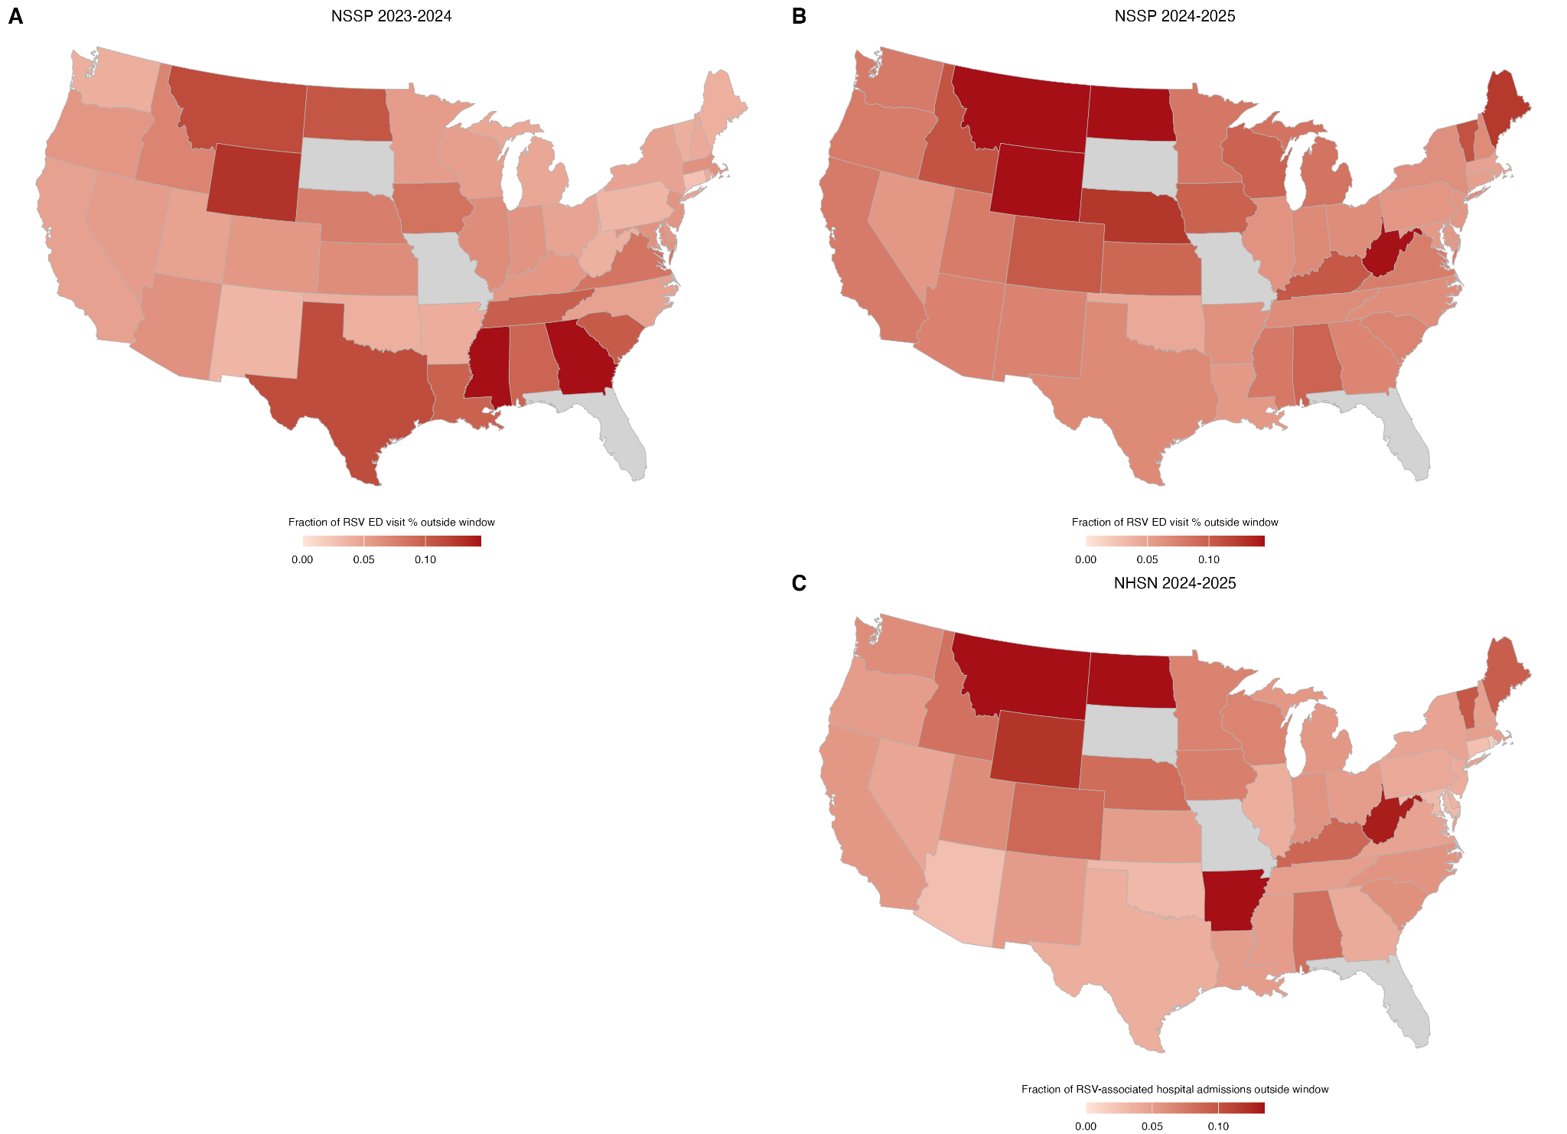
Figure 1: Geographic distribution of RSV activity occurring outside the October–March Nirsevimab administration window. A. NSSP RSV-associated emergency department visit percentage, 2023-24 season. B. NSSP RSV-associated emergency department visit percentage, 2024-25 season. C. NHSN RSV-associated hospital admissions, 2024-25 season. Darker shading indicates a higher fraction of RSV activity outside the window. States with no available data are gray.

Alternative window definitions would have captured substantially more RSV activity (Fig. 2). The Baseline window (October–March) captured a median of 92.7% to 94.8% of activity across the datasets. The Early window (September–March) increased median coverage to 93.5%–95.9%. The Extended window (September–April) achieved approximately 97–98% median coverage (NSSP 23-24: 97.9%; NHSN 24-25: 98.1%). An example dynamic, state-specific onset–offset approach was able to reliably capture greater than 95% depending on the season and dataset. Full epidemic curves are available in the supplementary materials.

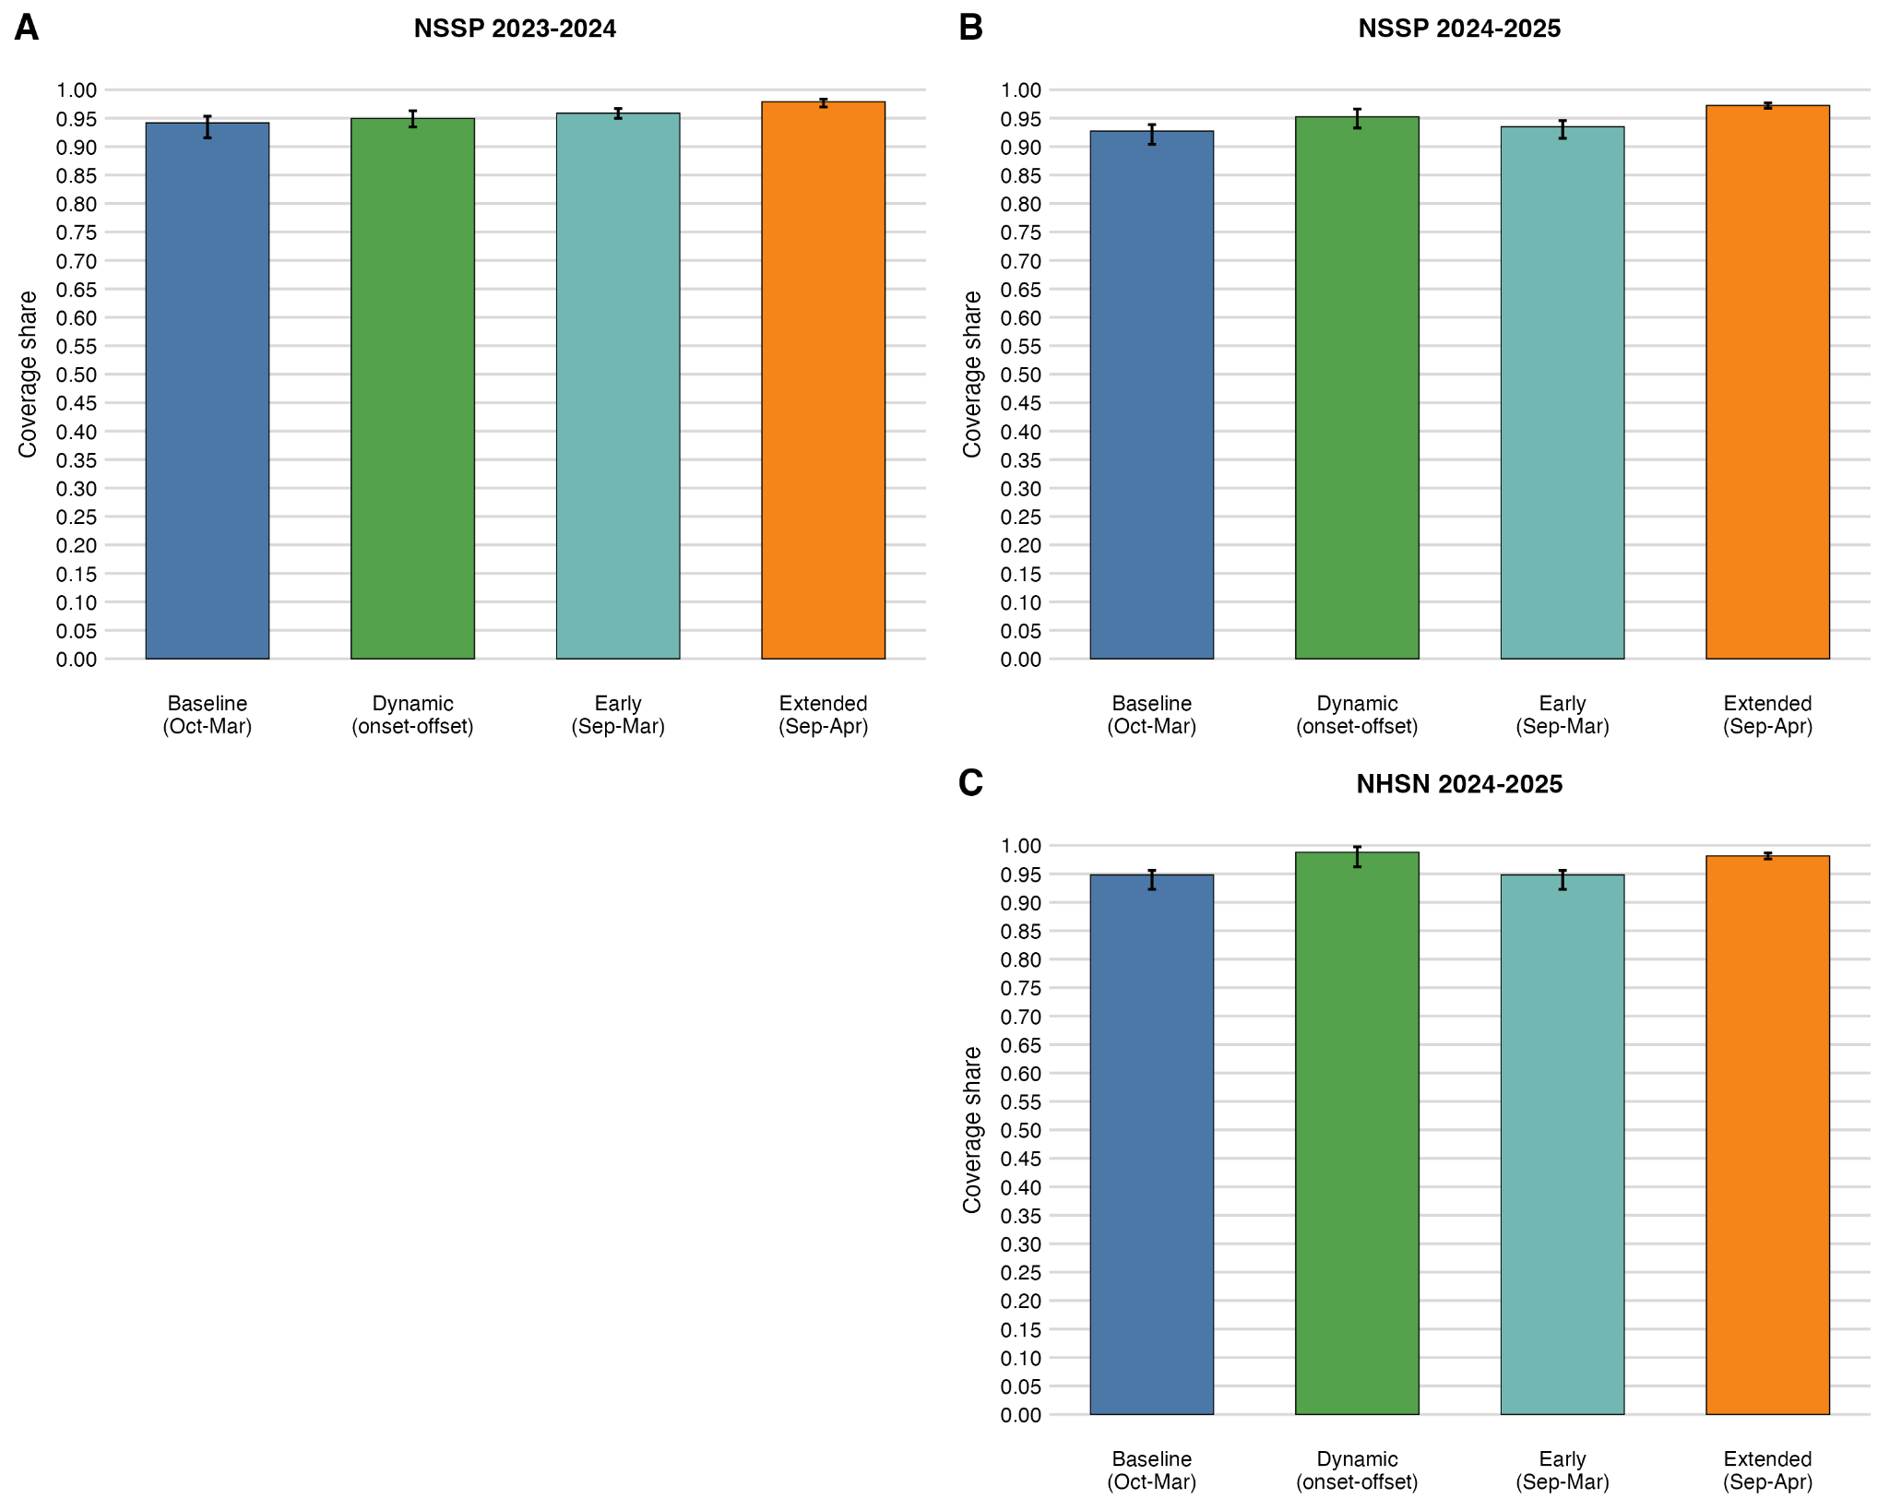
Figure 2: Proportion of RSV activity captured under alternative Nirsevimab administration window scenarios. Baseline: October–March; Early: September–March; Extended: September–April; Dynamic: state-specific onset–offset. A. NSSP 2023-24. B. NSSP 2024-25. C. NHSN 2024-25. The Early window did not meaningfully change the vaccine coverage while an example Dynamic and Extended could significantly improve coverage.

Discussion

Our analysis highlights significant geographic variability consistent across two post-COVID seasons and independent surveillance systems. While previous studies have documented seasonality shifts or variability,^{7,8,9} our work quantifies the specific protection gap created by the standard October through March recommendation.
These findings have immediate policy implications. Although current guidance encourages flexibility based on local epidemiology, state Medicaid programs covering the majority of eligible infants often lack the operational mechanisms or expertise to deviate from fixed windows. This rigidity likely leaves some infants unprotected during early-season surges and late-season tail cases, despite Nirsevimab’s demonstrated efficacy against RSV hospitalization.¹⁰ We acknowledge limitations in this analysis, including reliance on aggregate surveillance data that cannot account for individual administration timing, do not quantify Nirsevimab uptake, and have broader age ranges than those recommended to receive Nirsevimab. However, our analyses suggest that a fixed window would need to be extended to be both a month earlier and a month later (September–April) to more definitively capture the entire RSV season, which would raise questions about the durability of protection beyond 6 months and the need to redose for the following season. Thus, future research directed at data-driven approaches to the start and end of the administration window would be ideal.

References

- Jones JM, Fleming-Dutra KE, Prill MM, et al. Use of Nirsevimab for the Prevention of Respiratory Syncytial Virus Disease Among Infants and Young Children: Recommendations of the Advisory Committee on Immunization Practices — United States, 2023. MMWR Morb Mortal Wkly Rep. 2023;72.
- O'Leary ST, Yonts AB, Gaviria-Agudelo C, Kimberlin DW, Paulsen GC. Summer 2023 ACIP Update: RSV Prevention and Updated Recommendations on Other Vaccines. Pediatrics. 2023;152:e2023063955.
- Rose EB, Wheatley A, Langley G, Gerber S, Haynes A. Respiratory Syncytial Virus Seasonality — United States, 2014-2017. MMWR Morb Mortal Wkly Rep. 2018;67.
- Dewey G, Meyer AG, Garrido Garcia R, Santillana M. Uncovering the post-pandemic timing of influenza, RSV, and COVID-19 driving seasonal influenza-like illness in the US: a retrospective ecological study. Lancet Reg Health Am. 2026;55.
- Centers for Disease Control and Prevention. National Syndromic Surveillance Program (NSSP). Accessed January 16, 2026. https://www.cdc.gov/nssp/
- Centers for Disease Control and Prevention, Division of Healthcare Quality Promotion. Weekly United States Hospital Respiratory Data (HRD) Metrics by Jurisdiction. National Healthcare Safety Network (NHSN). Accessed January 16, 2026. https://www.cdc.gov/nhsn/
- Mullins JA, Lamonte AC, Bresee JS, Anderson LJ. Substantial variability in community respiratory syncytial virus season timing. Pediatr Infect Dis J. 2003;22:857-862.
- Zachariah P, Shah S, Gao D, Simões EAF. Predictors of the duration of the respiratory syncytial virus season. Pediatr Infect Dis J. 2009;28:772-776.
- Staadegaard L, Caini S, Weidemann F, et al. Defining the seasonality of respiratory syncytial virus around the world: National and subnational surveillance data from 12 countries. Influenza Other Respir Viruses. 2021;15:732-741.
- Hammitt LL, Dagan R, Yuan Y, et al. Nirsevimab for Prevention of RSV in Healthy Late-Preterm and Term Infants. N Engl J Med. 2022;386:837-846.

