YUVA INTERN
Virtual R Data Analyst Internship
WEEK 1 TASK REPORT
Data Cleaning and Preliminary Analysis with R
Dataset: New York Air Quality Measurements (airquality)
Period: May–September 1973 | 153 observations | 6 variables
Submitted by: Pratiksha
Date: 27 September 2026

Table of Contents
1. Executive Summary
2. Project Objective
3. Dataset Overview and Source
4. Data Dictionary
5. Initial Data Inspection
6. Data Cleaning and Preprocessing
7. Exploratory Data Analysis
8. Correlation Analysis
9. Outlier Assessment
10. Normalization and Categorical Encoding
11. Key Findings and Initial Insights
12. Reproducible R Code
13. Limitations
14. Conclusion
15. References

1. Executive Summary
This report documents a complete Week 1 data-analysis workflow in R using the publicly available airquality dataset. The dataset contains 153 daily observations of New York air-quality and weather measurements collected from May through September 1973. The analysis focuses on data inspection, missing-value assessment, categorical conversion, outlier identification, normalization, descriptive statistics, visual exploration and correlation analysis.
The dataset is particularly suitable for this internship task because it contains both continuous measurements and a month variable that can be treated as categorical, while also containing missing values in Ozone and Solar.R. The original data contain 37 missing Ozone observations and 7 missing Solar.R observations. Rather than silently deleting observations, the cleaning workflow documents the missingness first and uses median imputation for the prepared analytical dataset. Extreme observations are flagged using the IQR rule rather than automatically deleted, because unusual environmental values may represent genuine conditions.
Preliminary analysis shows a positive association between ozone and temperature (r ≈ 0.70) and a negative association between ozone and wind speed (r ≈ −0.60). Solar radiation has a smaller positive association with ozone (r ≈ 0.35). These are descriptive relationships, not causal conclusions.

2. Project Objective
- Inspect the structure, dimensions, variable types and quality of the selected dataset.
- Identify and document missing values before performing statistical calculations.
- Clean and preprocess the data using reproducible R code.
- Handle missing numeric observations using a documented imputation rule.
- Identify potential outliers using the interquartile-range (IQR) method.
- Convert Month into a categorical factor and prepare normalized numeric variables.
- Generate descriptive statistics, visualizations and a correlation matrix.
- Document initial insights, code and evidence in a professional report.

3. Dataset Overview and Source
The analysis uses R's built-in airquality dataset, described in the official R datasets documentation as daily air-quality measurements in New York from May to September 1973. The dataset has 153 observations and six variables: Ozone, Solar.R, Wind, Temp, Month and Day. Ozone and Solar.R contain missing values. The measurements originate from the New York State Department of Conservation and the National Weather Service.
Official dataset documentation:
https://stat.ethz.ch/R-manual/R-devel/library/datasets/html/airquality.html
An additional public CSV mirror can be used when a standalone CSV file is required: https://csvbase.com/r-datasets/airquality . The R-native dataset is preferred for this report because it can be loaded reproducibly with data(airquality).

4. Data Dictionary
Variable | Type | Meaning | Role in analysis
Ozone | Numeric | Mean ozone concentration (ppb) | Main environmental measure
Solar.R | Numeric | Solar radiation (Langley) | Environmental predictor
Wind | Numeric | Average wind speed (mph) | Environmental predictor
Temp | Numeric | Maximum daily temperature (°F) | Environmental predictor
Month | Numeric → Factor | Month of observation | Categorical/time grouping
Day | Numeric | Day of month | Date-related index

5. Initial Data Inspection
The first inspection uses dimension, structure, summary and missing-value checks.
data("airquality")
dim(airquality)
str(airquality)
summary(airquality)
colSums(is.na(airquality))
Expected key output:
dim(airquality)
# [1] 153 6
colSums(is.na(airquality))
# Ozone Solar.R Wind Temp Month Day
# 37 7 0 0 0 0
The initial structure confirms 153 rows and 6 columns. Missingness is concentrated in Ozone (37 values, about 24.2% of observations) and Solar.R (7 values, about 4.6%). Wind, Temp, Month and Day have no missing values.
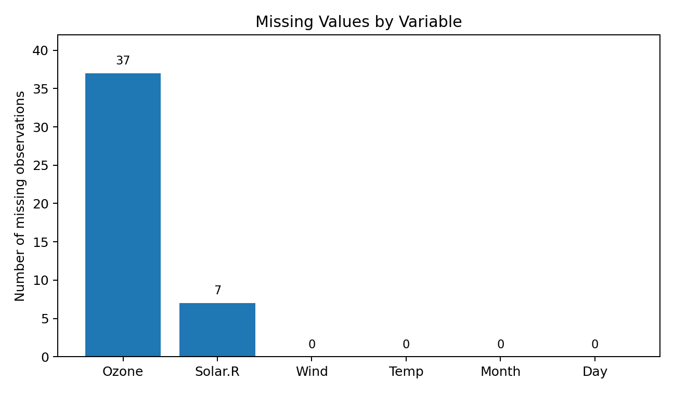
Figure 1. Missing-value profile of the original dataset.

6. Data Cleaning and Preprocessing

6.1 Missing-value strategy
Missing values were first quantified rather than immediately removed. For the cleaned analytical copy, numeric missing values in Ozone and Solar.R are replaced with the corresponding column median. Median imputation is used because it is less sensitive to extreme values than mean imputation. The original dataset is retained unchanged so that the cleaning process remains auditable.
aq_clean <- airquality
# Median imputation
aq_clean$Ozone[is.na(aq_clean$Ozone)] <-
median(aq_clean$Ozone, na.rm = TRUE)
aq_clean$Solar.R[is.na(aq_clean$Solar.R)] <-
median(aq_clean$Solar.R, na.rm = TRUE)
colSums(is.na(aq_clean))
# Key result
# Ozone Solar.R Wind Temp Month Day
# 0 0 0 0 0 0

6.2 Categorical conversion
Month is converted from an integer code to a factor with meaningful labels. This prevents a purely numeric interpretation of month categories in grouped summaries and visualizations.
aq_clean$Month <- factor(
aq_clean$Month,
levels = 5:9,
labels = c("May","June","July","August","September")
)

6.3 Duplicate and validity checks
sum(duplicated(aq_clean))
range(aq_clean$Wind, na.rm = TRUE)
range(aq_clean$Temp, na.rm = TRUE)
range(aq_clean$Ozone, na.rm = TRUE)
The checks are designed to detect exact duplicate rows and impossible or unexpected ranges. No automatic row deletion is performed merely because an observation is extreme.

7. Exploratory Data Analysis

7.1 Descriptive statistics
Variable | Min | Q1 | Median | Mean | Q3 | Max
Ozone | 1 | 18.00 | 31.50 | 42.13 | 63.25 | 168
Solar.R | 7 | 115.75 | 205.00 | 185.93 | 258.75 | 334
Wind | 1.7 | 7.40 | 9.70 | 9.96 | 11.50 | 20.7
Temp | 56 | 72 | 79 | 77.88 | 85 | 97
These statistics show that Ozone is right-skewed, with a median of 31.5 ppb and a mean of 42.13 ppb. The difference between mean and median indicates that higher ozone observations pull the mean upward. Temperature ranges from 56°F to 97°F, while wind speed ranges from 1.7 to 20.7 mph.
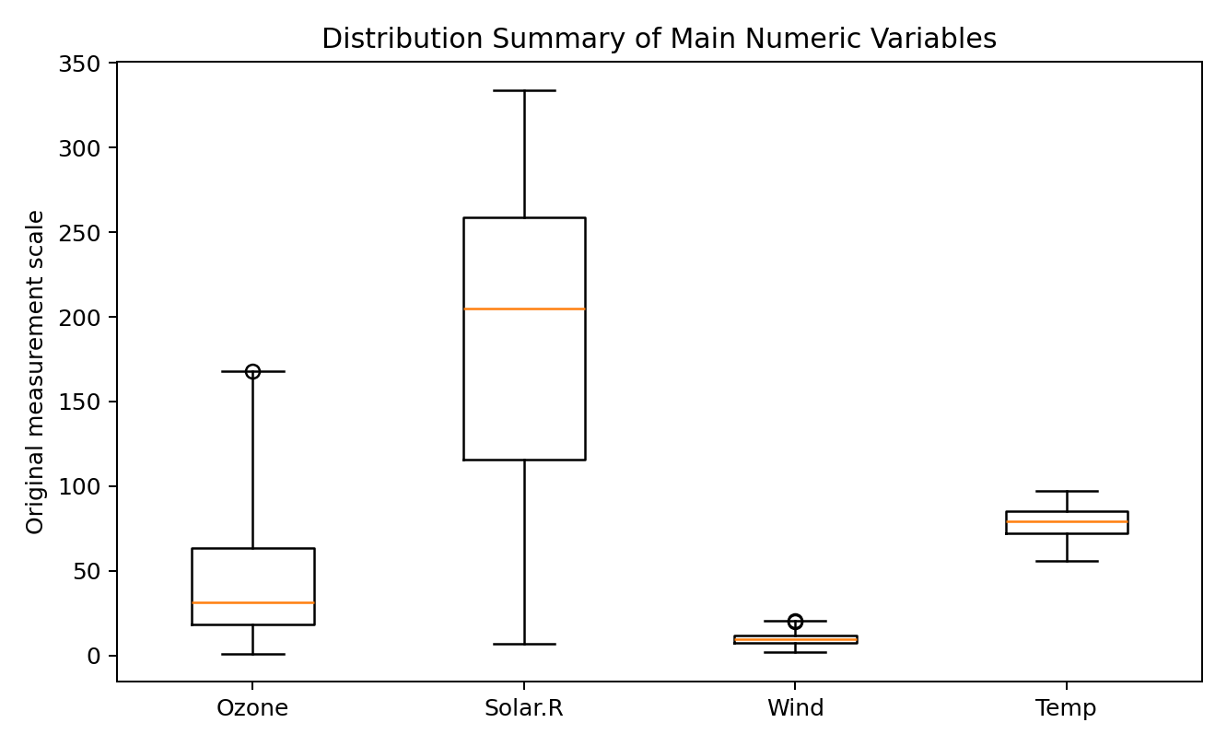
Figure 2. Distribution summary based on the documented five-number statistics.

7.2 R visualization code
# Histogram
hist(aq_clean$Ozone,
main = "Distribution of Ozone",
xlab = "Ozone (ppb)",
col = "lightblue")
# Boxplot by month
boxplot(Ozone ~ Month, data = aq_clean,
main = "Ozone by Month",
xlab = "Month",
ylab = "Ozone (ppb)")
# Scatterplot
plot(aq_clean$Temp, aq_clean$Ozone,
main = "Ozone vs Temperature",
xlab = "Temperature (°F)",
ylab = "Ozone (ppb)",
pch = 19)

8. Correlation Analysis
Pearson correlations are calculated using pairwise complete observations for the original numeric measurements. Pairwise handling allows each variable pair to use all available observations without discarding the entire dataset because another variable is missing.
cor(
airquality[, c("Ozone","Solar.R","Wind","Temp")],
use = "pairwise.complete.obs"
)
 | Ozone | Solar.R | Wind | Temp
Ozone | 1.000 | 0.348 | -0.602 | 0.698
Solar.R | 0.348 | 1.000 | -0.057 | 0.276
Wind | -0.602 | -0.057 | 1.000 | -0.458
Temp | 0.698 | 0.276 | -0.458 | 1.000
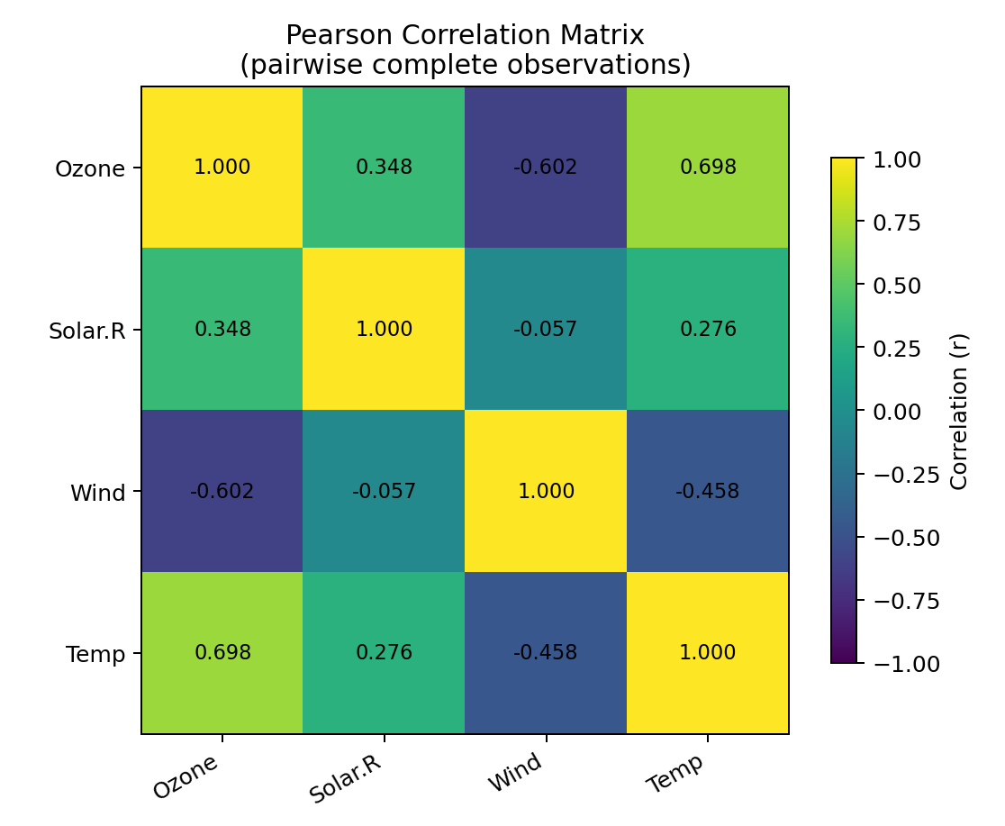
Figure 3. Pearson correlation matrix for the main numeric variables.
The strongest descriptive relationships are between Ozone and Temperature (r ≈ 0.70) and between Ozone and Wind (r ≈ −0.60). Solar.R and Ozone show a smaller positive relationship (r ≈ 0.35). Correlation describes association and should not be interpreted as proof of causation.

9. Outlier Assessment
The IQR rule identifies observations outside Q1 − 1.5×IQR and Q3 + 1.5×IQR as potential outliers. For Ozone, Q1 = 18 and Q3 = 63.25, giving an upper threshold of approximately 131.13 ppb. The maximum observed Ozone value is 168 ppb, so some high values are flagged. For Wind, Q1 = 7.4 and Q3 = 11.5, giving an upper threshold of approximately 17.65 mph; the maximum is 20.7 mph.
iqr_outliers <- function(x) {
q <- quantile(x, c(.25, .75), na.rm = TRUE)
iqr <- q[2] - q[1]
x[x < q[1] - 1.5*iqr | x > q[2] + 1.5*iqr]
}
iqr_outliers(airquality$Ozone)
iqr_outliers(airquality$Wind)
These observations are flagged rather than deleted. In an environmental dataset, extreme values can be substantively meaningful, so removal should require domain evidence or a documented measurement error.

10. Normalization and Categorical Encoding
Z-score standardization is prepared for the main continuous variables. Each standardized variable has approximately mean 0 and standard deviation 1, which places measurements on a comparable scale. The original variables are preserved.
aq_scaled <- aq_clean
num_vars <- c("Ozone","Solar.R","Wind","Temp")
aq_scaled[num_vars] <- lapply(
aq_scaled[num_vars],
function(x) as.numeric(scale(x))
)
# Month is categorical
aq_scaled$Month <- factor(aq_scaled$Month)
Categorical encoding is implemented through factor levels for Month. If a machine-learning model later requires dummy variables, R's model.matrix() can generate one-hot/dummy coding automatically.
month_dummies <- model.matrix(~ Month - 1, data = aq_scaled)
head(month_dummies)

11. Key Findings and Initial Insights
- Ozone has 37 missing observations, while Solar.R has 7; the other four variables contain no missing values.
- Ozone has a higher mean (42.13) than median (31.50), indicating a right-skewed distribution.
- Ozone and temperature have a strong positive descriptive correlation of about 0.70.
- Ozone and wind speed have a moderate-to-strong negative descriptive correlation of about −0.60.
- Solar radiation and ozone show a smaller positive correlation of about 0.35.
- Potential high-end outliers are visible in Ozone and Wind under the IQR rule; they are flagged rather than automatically removed.
- Month is converted to a factor so monthly comparisons are treated as categorical rather than as a linear numeric effect.
- Median imputation creates a complete analytical copy while preserving the original raw dataset for auditability.

12. Reproducible R Code
The following script is designed to reproduce the main Week 1 workflow. It uses only standard R functionality, so no external package installation is required.
# YuvaIntern - Week 1: Data Cleaning and Preliminary Analysis
# Dataset: New York Air Quality Measurements (R built-in airquality)
data("airquality")
aq <- airquality
# 1. Inspect
dim(aq)
str(aq)
summary(aq)
colSums(is.na(aq))
# 2. Keep raw data unchanged and create a cleaning copy
aq_clean <- aq
# 3. Median imputation for missing numeric values
aq_clean$Ozone[is.na(aq_clean$Ozone)] <-
median(aq_clean$Ozone, na.rm = TRUE)
aq_clean$Solar.R[is.na(aq_clean$Solar.R)] <-
median(aq_clean$Solar.R, na.rm = TRUE)
# 4. Encode Month as a categorical factor
aq_clean$Month <- factor(
aq_clean$Month,
levels = 5:9,
labels = c("May","June","July","August","September")
)
# 5. Duplicate and missing-value checks
sum(duplicated(aq_clean))
colSums(is.na(aq_clean))
# 6. Descriptive statistics
summary(aq_clean)
# 7. Correlation analysis on original numeric data
cor(
aq[, c("Ozone","Solar.R","Wind","Temp")],
use = "pairwise.complete.obs"
)
# 8. Outlier function using the IQR rule
iqr_outliers <- function(x) {
q <- quantile(x, c(.25, .75), na.rm = TRUE)
iqr <- q[2] - q[1]
x[x < q[1] - 1.5*iqr | x > q[2] + 1.5*iqr]
}
iqr_outliers(aq$Ozone)
iqr_outliers(aq$Wind)
# 9. Normalize numeric variables
aq_scaled <- aq_clean
num_vars <- c("Ozone","Solar.R","Wind","Temp")
aq_scaled[num_vars] <- lapply(
aq_scaled[num_vars],
function(x) as.numeric(scale(x))
)
# 10. Dummy variables for Month
month_dummies <- model.matrix(~ Month - 1, data = aq_scaled)
head(month_dummies)
# 11. Visualizations
hist(aq_clean$Ozone,
main = "Distribution of Ozone",
xlab = "Ozone (ppb)")
boxplot(Ozone ~ Month, data = aq_clean,
main = "Ozone by Month",
xlab = "Month",
ylab = "Ozone (ppb)")
plot(aq_clean$Temp, aq_clean$Ozone,
main = "Ozone vs Temperature",
xlab = "Temperature (F)",
ylab = "Ozone (ppb)",
pch = 19)
# Optional export
write.csv(aq_clean, "airquality_cleaned.csv", row.names = FALSE)

13. Limitations
- The dataset covers only May to September 1973 and one geographic setting, so it should not be treated as a current or globally representative air-quality dataset.
- Median imputation is a simple educational cleaning strategy; a production analysis could compare multiple imputation methods and assess sensitivity.
- Correlation measures association and does not establish causal effects.
- Outlier detection using the IQR rule is statistical screening, not proof that an observation is erroneous.
- The report is intended for preliminary analysis and data-cleaning practice rather than environmental risk assessment.

14. Conclusion
This Week 1 project demonstrates a reproducible data-cleaning and preliminary-analysis workflow in R. The selected dataset contains real missingness and a useful combination of environmental measurements and monthly categories. The workflow identifies data-quality issues, documents the treatment of missing values, flags potential outliers, converts Month to a categorical factor, standardizes numeric variables and performs descriptive and correlation-based exploratory analysis. The resulting cleaned dataset can be used as a starting point for more advanced modeling in later internship tasks.

15. References
- R Core Team. R datasets documentation: airquality — New York Air Quality Measurements. Official R documentation.
- Chambers, J. M., Cleveland, W. S., Kleiner, B., & Tukey, P. A. (1983). Graphical Methods for Data Analysis. Wadsworth & Brooks/Cole.
- CRAN / R Project documentation for the datasets package and the airquality dataset.
- Public CSV mirror: csvbase r-datasets/airquality (used only as an optional standalone-download reference).

End of Week 1 Report

