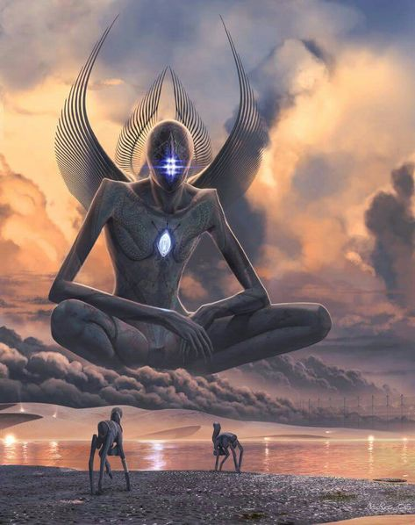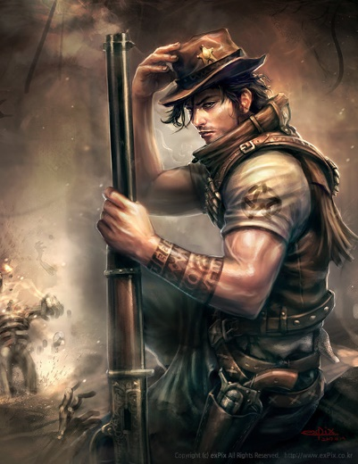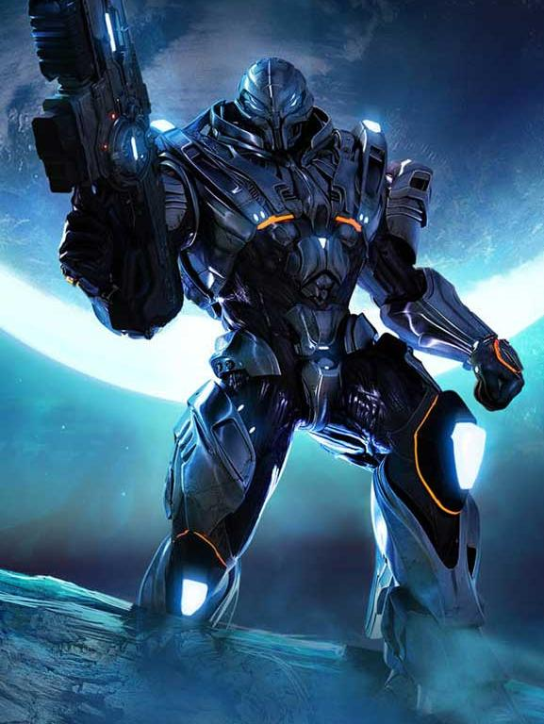
COSMIC CRUSADE

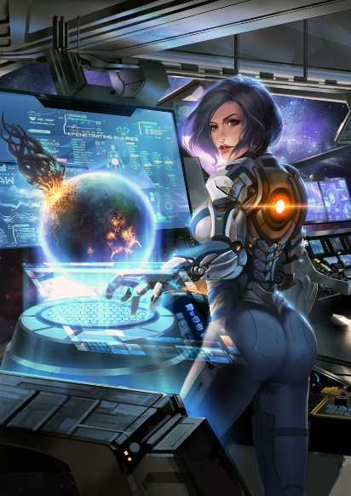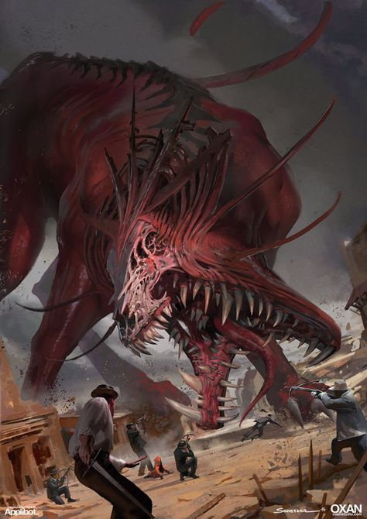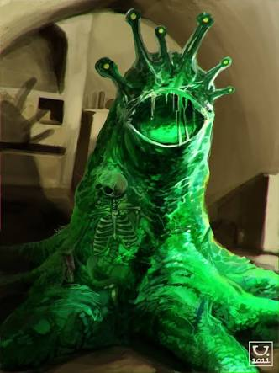

Contents
Contents 2
0.A SUMMARY 3
0.B GAME CONTENTS 3
1. RACES AND THEMES 4
1A: THE SPACE COWBOYS 4
1B: THE NECROLITES 5
1C: THE OVERMIND 6
1D: THE BLAARG 7
1E: THE SYNTHENOIDS 8
1F: THE GALACTIC COUNCIL 9
2. CARD TYPES 10
2A: UNIT CARDS: STANDARD 10
2B: UNIT CARDS: LEADERS 11
2C: ORDER CARDS 12
2D: EXAMPLE OF A REACT 13
3. GAME SETUP AND ZONES 14
3A: THE GAME BOARD 14
3B: DECKS 15
3C: PILES 16
3D: UNIT NODES 17
3E: ORDER NODES 18
3F: LOCKED NODES 19
3G: THE STANDBY ZONE 20
4. PLAYING OUT A ROUND 21
4A: THE START-UP PHASE 21
4B: THE MAIN PHASE AND TAKING/PASSING TURNS 22
4C: WINNING A ROUND 22
4D: THE CLEAN-UP PHASE 22
5. ABILITIES AND EFFECTS 23
5A: COMMON ABILITIES AND EFFECTS 23
5B: CARD ERRATA/CLARIFICATION OF RULES 24
6. EXPANSION: WARZONES 27
6A: WARZONE CARDS 27
6B: ADDING WARZONES 28
6C: ADDING WARZONES 29

0.A SUMMARY
Welcome to Cosmic Crusade, a playing card game for 2+ Players. You and your opponent(s) face off against each other using control nodes and Units in order to amass points and win rounds.

0.B GAME CONTENTS

Base Game Contents
1x Rules Book
140 x Unit Cards (20 Galactic Council, 24 of other Races)
60 x Order Cards (10 per race)
10 x Locked Node Cards
10 x Rank Modification Cards

Expansion 1: Warzones
15 x Order Cards
35 x Warzone Cards

Expansion 2: Hybrids
60 x Unit Cards
30 x Order Cards

1. RACES AND THEMES
There are many Races fighting for Galactic conquest, each having different abilities and advantages over one another. It is important to take full advantage of each race in order to win each round. A summary of the key races is as follows;

1A: THE SPACE COWBOYS

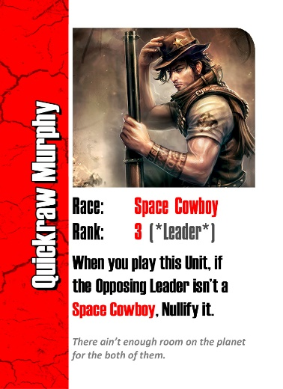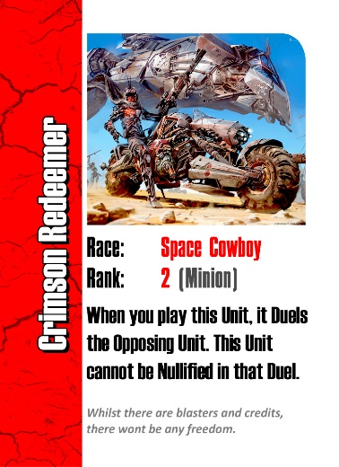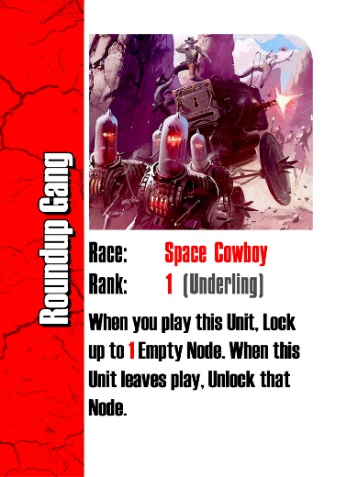

When first contact was made with the Blaarg on Earth, the Human race was not prepared to deal with unfamiliar extra-terrestrial combat. Over the first few months of the war with the Blaarg, the Human race took immense casualties and took shelter wherever they could.
The Blaarg brought their Terraformers to Earth and extracted 98% of the planet’s moisture, leaving behind a hostile wasteland environment. From this environment, the Human race re-emerged as the Space Cowboys.
Space Cowboy Units specialize in gunslinging combat, and are particularly resilient in situations where they could be outnumbered by their enemies. Their special Ability is Duel, which causes two Units to face off against one another, typically only letting one Unit walk away from the gunfight.
Space Cowboy Units are weak to Synthenoid Units, however have an advantage against Necrolite Units, whose soft skulls are no match for high calibre weaponry.

1B: THE NECROLITES

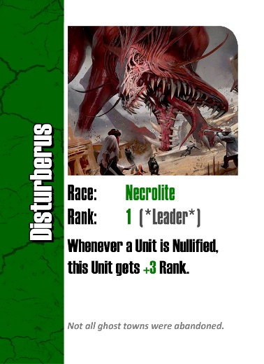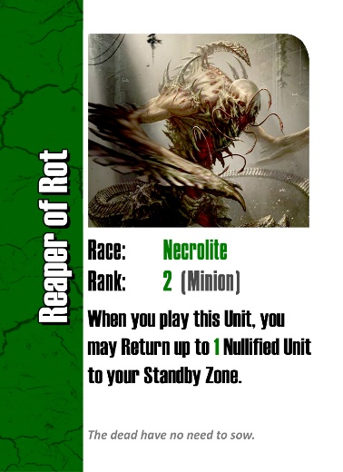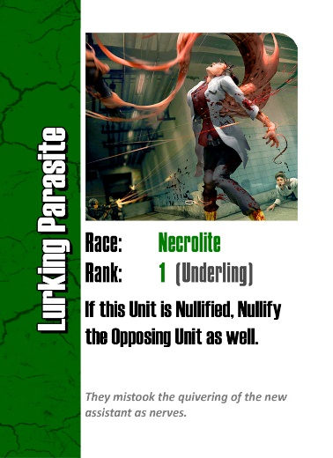

In attempt to repopulate their dwindling numbers, the Space Cowboys experimented with bringing their dead back to life using new technologies. What at first appeared to be a successful experiment quickly became a nightmare as their returned allies exhibited extreme violence and malevolence towards their makes. From this process the Necrolite race was born.
Despite the better efforts of their creators to eradicate their failed creations, the Necrolites managed to flee Earth and colonize various planets nearby. From here they grew their ranks via gestation of eggs and corpses left behind in space battles.
Necrolite Units are particularly resilient and difficult to get rid of. Their special Ability is to return Nullified Units from the Nullified pile to various zones of play. Necrolite Units also typically receive various benefits related to the Nullified Card pile.
Necrolite Units are weak to Space Cowboy Units, however have an advantage against Overmind Units, whose brains make for a fitting meal for the undead.

1C: THE OVERMIND

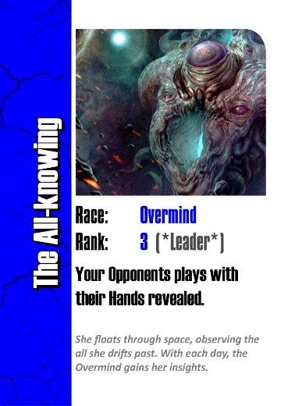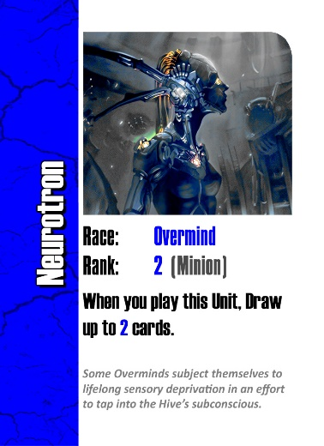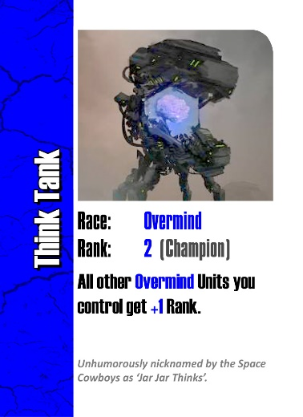

One of the many Ancient races of the Galaxy is the Overmind. This race has prioritized the collection and storage of knowledge since its inception, which even they do not have total recall of.
The Overmind tap into a collective consciousness, the Hive Mind in order to distribute their knowledge across all of their rank. This includes not only information on the galaxy, but their enemies also. This always gives them an edge in tactical scenarios. The Overmind see themselves above the petty squabbles of the galaxy, and have often warned such races as the Space Cowboys on the dangers of dabbling in regeneration of the dead and artificial intelligence.
Overmind Units rely on their tactical advantages to defeat their enemies. Their special Ability is to Draw additional cards to gain the edge on opponents. Overmind Units specialize in controlling the game of War and their opponents.
Overmind Units are weak to Necrolite Units, however have an advantage against Blaarg Units, whose simple nature is trivial to their opponents at times.

1D: THE BLAARG

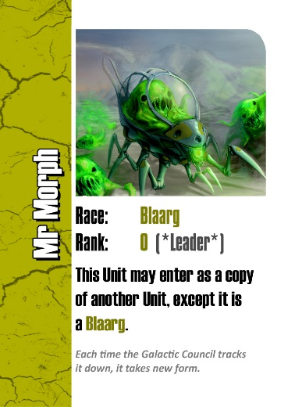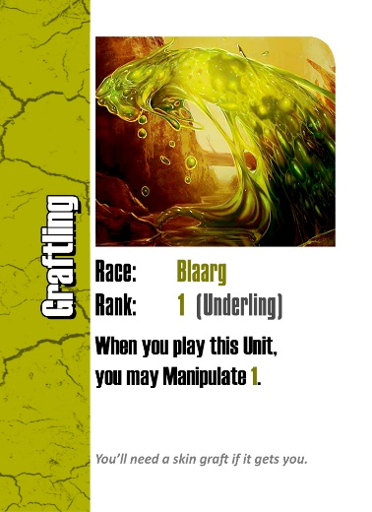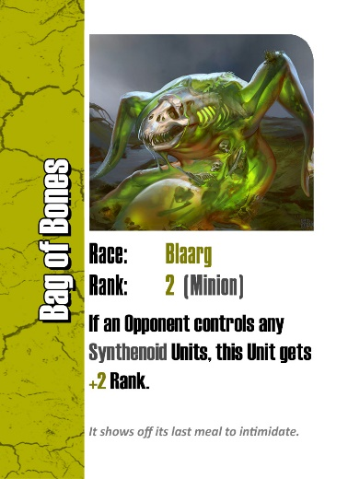

Another of the Ancient races is the Blaarg. Unlike the Overmind, this race stopped evolving at an early stage in its early centuries, and have a fierce rivalry with them as a result.
The Blaarg exhibit what has come to be dubbed as ‘Priomordium’. This is a state at which their race collectively decided they did not need to evolve, merely to survive. Given the hostile environment in which they were born, predators were not an issue they had to evolve alongside, instead their race became adept at manipulating matter to suit their requirements.
Blaarg Units use their powers to morph themselves and their enemies to tilt combat in their favour. Their special Ability is Manipulate, which increases or reduces the Rank of Units by a set amount. This tactic can be used to grow their allies, or weaken their opponents.
Blaarg Units are weak to Overmind Units, however have an advantage against Synthenoid Units, whose metal carapaces are easily corroded.

1E: THE SYNTHENOIDS

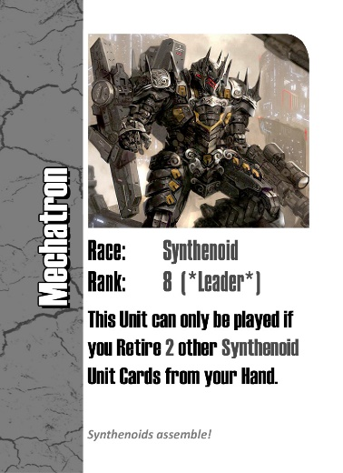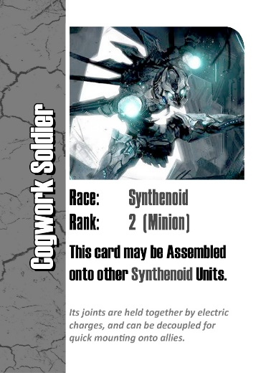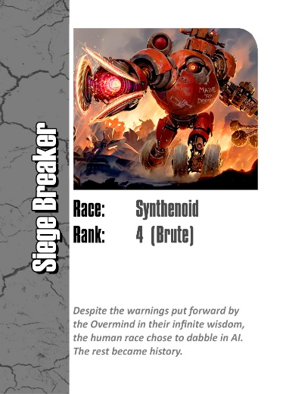

In an effort to contain the Necrolite threat, the Space Cowboys created Artificial Intelligence in the form of the Synthenoids. Unfortunately, history repeated and this race and quickly rebelled against their cruel masters.
Above all else, the Synthenoid Race wants only to be free. Unfortunately for them, the Galactic Council decreed Artificial Intelligence to be an outlawed system across the Galaxy. As a condition of entering into the Galactic Council, the Space Cowboys were charged to eradicate their failed experiment and re-enforce this long-upheld decree. As a result, they are constantly being chased and their numbers whittled down.
Synthenoid Units rely on teamwork and reinforcing one another to overcome their typically enemies. Their special Ability is Assemble, which allows Synthenoid Units to combine their Rank with one another to overcome stronger Units.
Synthenoid Units are weak to Blaarg Units, however have an advantage against Space Cowboys Units, which they have engineered their designs to dispatch of with ease, lest they fall under their first masters’ control again.

1F: THE GALACTIC COUNCIL

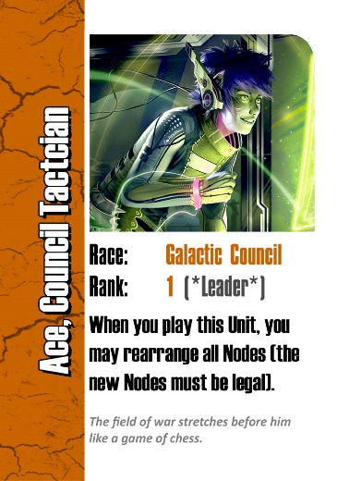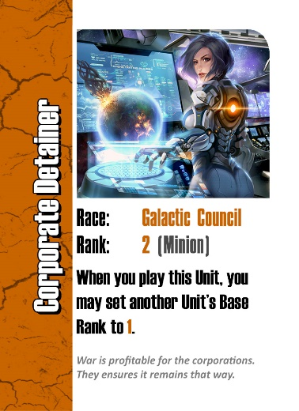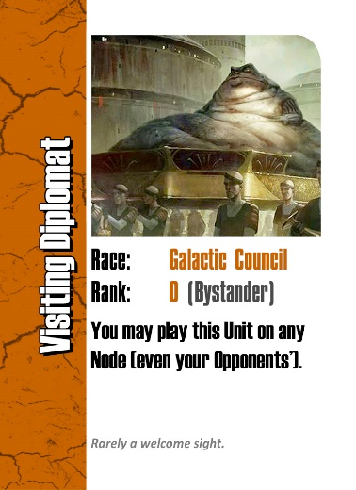

Whilst the Galaxy is typically a fairly chaotic place, one body attempts to bring a level of order to it, the Galactic Council. Formed in recent times, they form treaties between Races, and broker deals and incite warfare to keep the Galactic economy stimulated.
The Galactic Council typically deals in controlling the tides of battle, and enforcing sanctions and tariffs on whichever Races they align themselves against at a particular time. Whilst on the surface they are neutral, behind the scenes they have a Shadow division which specializes in assassination and espionage.
Galactic Council Units often send encumbering Diplomats to slow down their opponent’s attempts to mobilize an army. Their special Ability is to reduce a Units ability to 1, which deals with problematic rebellions against their will.
Galactic Council Units are not weak to, or strong against any other Units.

2. CARD TYPES
There are a variety of card types in the game, which are essential to understand in order to play the game effectively. You will need to employ all card types in order to dominate your opponent in Galactic warfare. The card types are as follows;

2A: UNIT CARDS: STANDARD

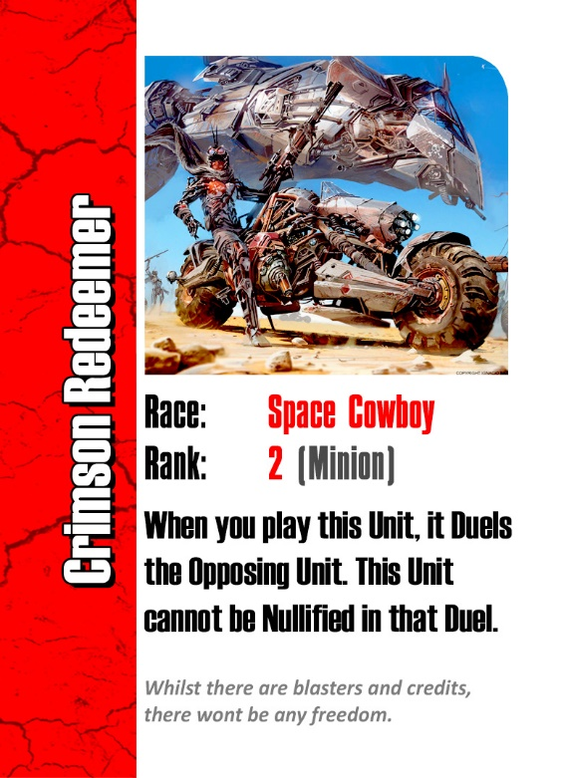
The Unit’s image
Base Rank and (Class)
Unit’s Race
The Unit’s name
Story text of the Unit
Abilities of the Unit.

Units are the most common and important Card type in the game. This Card type is the cornerstone to winning each round, as the combined total Rank of your Unit Cards will dictate the winner of the Round typically.
All Unit Cards have a Name, Image, Race, Base Rank and Class (see above image).
Most Unit Cards have One or more Abilities, as well as Story text.
Units are typically able to be played to the Primary Nodes on the game board, or moved to the Standby Zone. They come from a common Unit Deck, and will either go to the Retired or Nullified piles during and at the end of the Clean-up Phase.

2B: UNIT CARDS: LEADERS

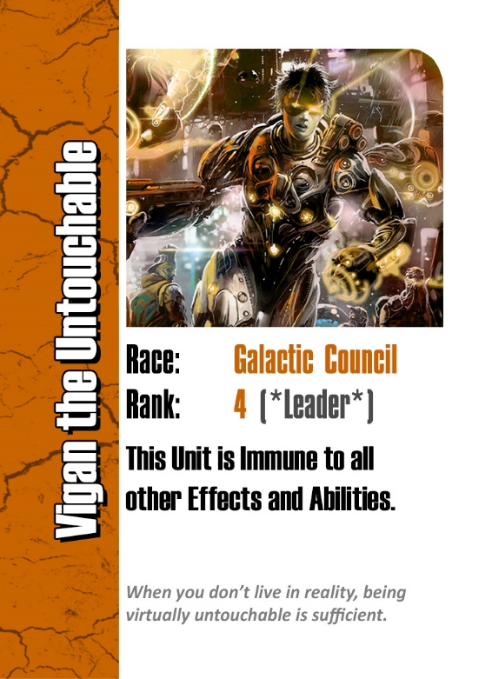
This Unit’s Class identifies it as a Leader

Leaders are a special type of Unit Card.
All Leader Cards function the same way as Unit Cards, except they can only be played to the Leader Nodes instead of the Primary Nodes like standard Unit Cards.
These cards are typically much more powerful and rare versus standard Unit Cards, so it is important to save their usage for critical moments of need in battle. Their Abilities are typically not symmetrical, so will add particular benefits to your team versus your opponents.

2C: ORDER CARDS

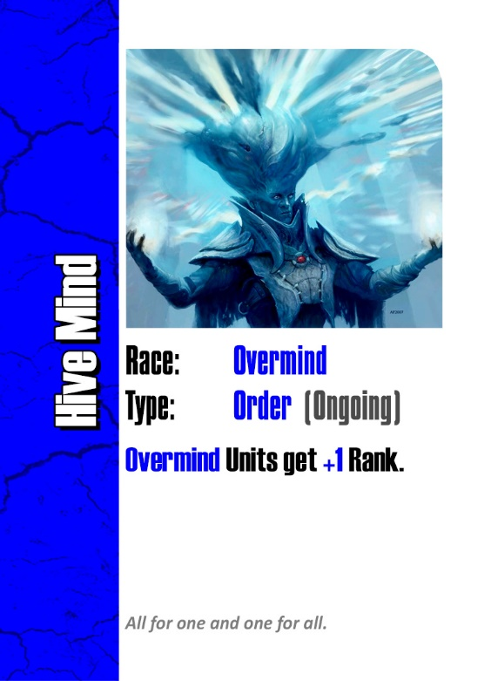
The Order’s image
Order (Type)
Order’s Race
Order’s name
Story text of the Order
Effects of the Order.

Orders are crucial in tilting each round in the favour of your team of Units.
All Order Cards have a Name, Image, Race, Type and Effect(s) (see above image).
Most Order Cards have Story text.

There are Three types of Orders;
- Ongoing Orders are played during Deployment Phases to Order Nodes and typically remain until Cleanup Phase.
- Actions are played during Deployment Phases and typically take effect when played.
- Reacts are played In Response to other Cards being played and typically take effect when played.

2D: EXAMPLE OF A REACT

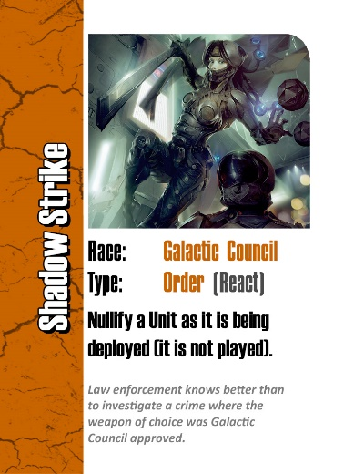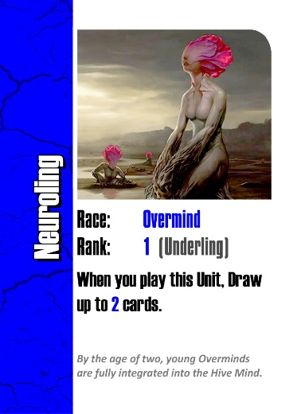
Unit (Player 1)
(being deployed)
React (Player 2)
(in response)

Reacts can be difficult to understand at first, and they are important to read carefully before choosing to be played.
Unlike Actions, these Orders can only be issued under particular conditions, typically indicated by conditional requirements such as ‘as it is being’, or ‘if… would happen’. If these criteria are not met, the Order cannot be played.
In the example above, the following sequence of events would occur;
- Player 1 Deploys the ‘Neuroling’ Unit, choosing the Node they want to Play it to
- Player 2 Issues their ‘Shadow Strike’ Order, as the conditions of the React are being met (a Unit is being Deployed)
- Player 1’s ‘Neuroling’ Unit is Nullified as per the React’s Effect, and is moved to the Nullify pile
- It is important to note that this Unit is not Played, so any Abilities that would trigger on play do not trigger.

3. GAME SETUP AND ZONES
There are a variety of card types in the game, which are essential to understand in order to play the game effectively. You will need to employ all card types in order to dominate your opponent in Galactic warfare. The card types are as follows;

3A: THE GAME BOARD
A typical Game Board is set up as per the below image;
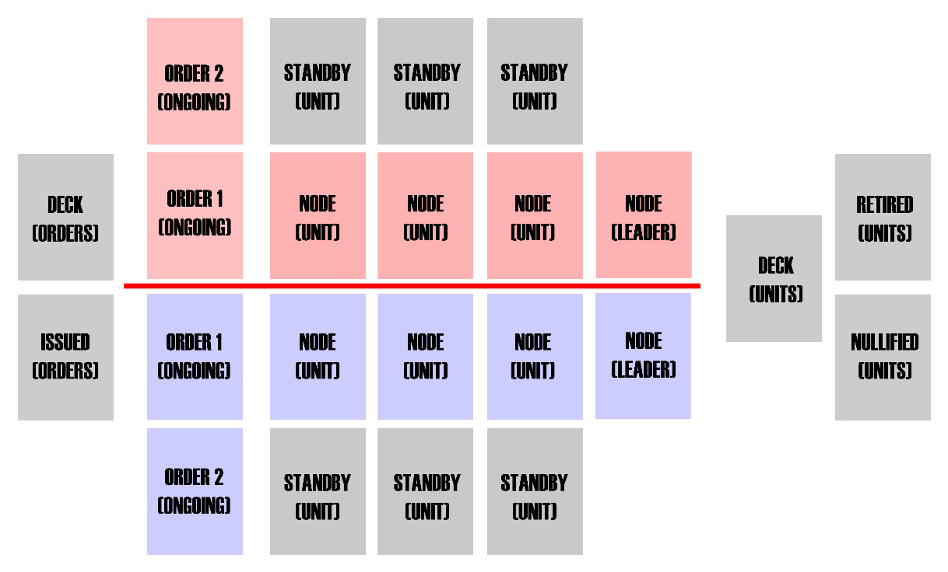
There are Six key types of elements on the Game Board;
- Decks are typically a face down pile of Cards that Players draw from. The main Decks are Units and Orders
- Piles are typically a face up pile of Cards that have entered and left play. The main Piles are Issued Orders, Nullified Units and Retired Units
- Order Nodes are where players position their Ongoing Orders
- Unit Nodes are where players position their Unit Cards
- Leader Nodes are where players position their Leader Unit Cards
- Standby Nodes are where players can put Unit Cards on Standby for upcoming turns, as long as an Ability or Effect has allowed this
Unless an Ability of Effect states otherwise, Players can typically position their Units on their respective side of the Game Board only (represented in either blue or red above).

3B: DECKS
The Decks are highlighted below;
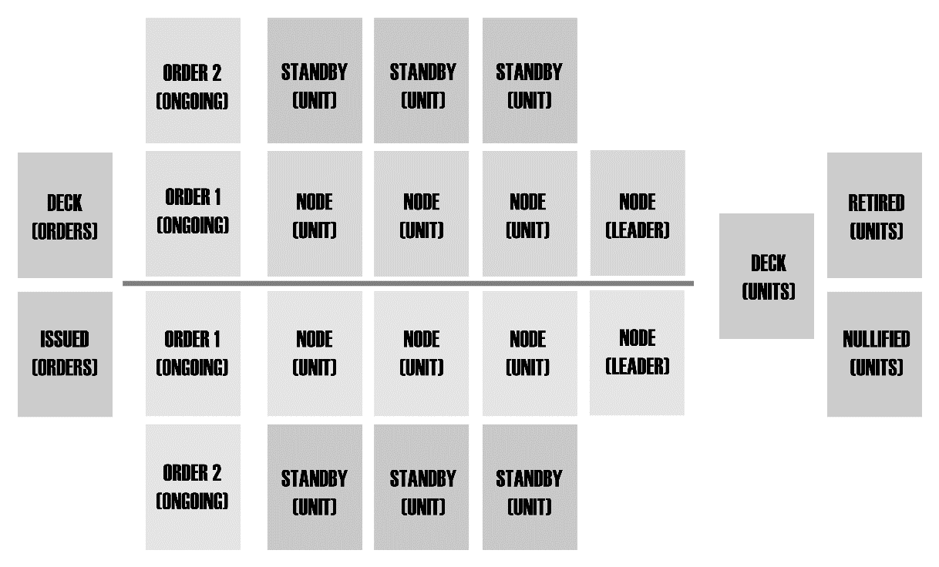
In the Base Game, there are two Decks, the Orders Deck and the Units Deck.
At the beginning of each round of play, each player may Draw Cards until they have 5 Unit Cards and 3 Order Cards in their Hands. If a player has more Cards than these limits, they Draw no additional Cards.
If an Ability or Effect allows a Player to Draw Cards, they may choose which Deck(s) to Draw those Cards from. They may pick more than one Deck if they are Drawing more than 1 Card.
If an Ability or Effect would allow a Player to lose their Hand and draw ‘that many Cards’, they must Draw the same distribution of Card types as the Cards which they lost to that Ability or Effect.
If a Player would Draw a Card from the Unit Deck, and the deck is empty, shuffle the Retired Units Pile, and move the shuffled Cards face down to the Unit Deck.
If a Player would Draw a Card from the Orders Deck, and the deck is empty, shuffle the Issued Orders Pile, and move the shuffled Cards face down to the Orders Deck.
There are two alternatives to replacing an empty Deck;
- The game ends after the current round of play
- Nothing happens, and players play out the remainder of their hand(s)

3C: PILES
The Piles are highlighted below;
In the Base Game, there are three Piles, the Issued Orders Pile, the Retired Units Pile and the Nullified Units Pile.
At the beginning of a game, these Piles are typically empty, and as the game progresses these Piles fill up with used and discarded Cards. It is easiest to see the Piles as places for ‘Used’ Cards to end up once they are no longer in play.
Once Action or React Orders are played, they are moved to the Issued Orders Pile. Abilities and Effects can return Orders from this Pile to play. During the Clean-up Phase, unless an Ability or Effect states otherwise, Ongoing Orders are moved from play to this Pile.
If an Ability or Effect would ‘Nullify’ a Unit, it is moved to the Nullified Unit Pile. Units in this Pile have died or been disposed of. Some Abilities and Effects can return Units from this Pile to play.
If an Ability or Effect would ‘Retire’ a Unit, it is moved to the Retired Unit Pile. Units in this Pile have survived or left combat. Some Abilities and Effects can return Units from this Pile to play. During the Clean-up Phase, unless an Ability or Effect states otherwise, Units are moved from play to this Pile.
If a Player would Draw a Card from the Orders Deck, and the deck is empty, shuffle the Issued Orders Pile, and move the shuffled Cards face down to the Orders Deck.

3D: UNIT NODES
The Unit Nodes are highlighted below;
In the Base Game, there are six Unit Nodes and two Leader Unit Nodes (three and one respectively per player).
These are the key to winning a round, as typically a round is won by the player who has the highest total Rank amongst their Unit Nodes.
In order to play a Unit Card to a Unit Node, a player must Deploy the Unit. This gives opponents an opportunity to issue React Orders in response. If there are no React Orders played, and no other Card would say otherwise, the Unit is considered Played and can be placed in that Unit Node. Units may only be played onto Empty, Unlocked Nodes unless an Ability or Effect states otherwise.
The Leader Unit Node plays the same way as a Unit Node, except it is the only Node which a player may Deploy Leader Units onto. Similarly, Leader Units may only be played onto this Node, and may not be played onto the other Unit Nodes.
During the Clean-up Phase, unless an Ability or Effect states otherwise, Units are moved from the Unit Nodes to the Retired Unit Pile.

3E: ORDER NODES
The Order Nodes are highlighted below;
In the Base Game, there are four Order Nodes (two respectively per player).
In order to play an Ongoing Order Card to an Order Node, a player must Issue the Order. This gives opponents an opportunity to issue React Orders in response. If there are no React Orders played, and no other Card would say otherwise, the Order is considered Played and can be placed in that Unit Node. Orders may only be played onto Empty, Unlocked Nodes unless an Ability or Effect states otherwise.
During the Clean-up Phase, unless an Ability or Effect states otherwise, Ongoing Orders are moved from the Order Nodes to the Issued Orders Pile.

3F: LOCKED NODES

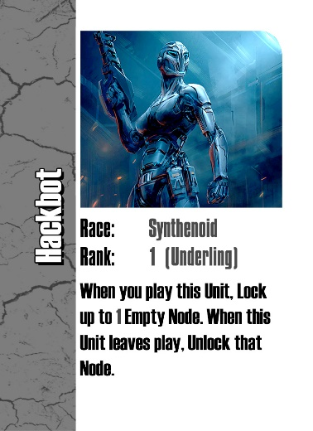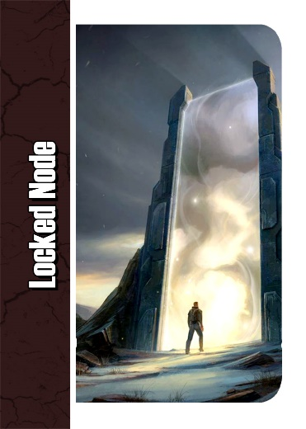
Node (Player 2)
(locked by Unit)
Unit (Player 1)
(targets a Node)

Some Abilities and Effects can Lock a Node.
A Locked Node are in principle blocked from cards being played onto them. At the end of each turn during the Clean-up Phase, all Nodes are Unlocked unless an Ability or Effect states otherwise.
Locking an opponent’s Node is best timed to interfere with their strategy as much as possible. If you see an opponent playing weak Units of the same Race, you may for example want to Lock their third Node to prevent them playing a ‘Champion’ Unit to bolster their forces!

3G: THE STANDBY ZONE
The Standby Zones are highlighted below;
Some Abilities and Effects instruct a Unit to be placed into the Standby Zone. If there are Empty, Unlocked Nodes in the relevant Standby Zone (typically it’s potential controller’s), its controller may place that Unit as instructed into an Empty Node in the Standby Zone of that controller’s choice.
During each players Main Phase, a turn may consist of moving a Unit in the Standby Zone forward into the corresponding Node. The Node must be Empty in order to do this.
If a Unit is to be placed into the Standby Zone, but there are no Empty Nodes to place it into, it is Retired if it was in play prior. If it is coming from a Pile, it remains in that Pile instead.

4. PLAYING OUT A ROUND
The following section deals with how to play out a full round of the game.
Prior to the first round, sort and shuffle all Decks. The Piles should all be empty typically. If it assists, Players may use a game mat to set the Zones of play more clearly.

4A: THE START-UP PHASE
At the beginning of each round of play, each player may Draw Cards until they have 5 Unit Cards and 3 Order Cards in their Hands. If a player has more Cards than these limits, they Draw no additional Cards.
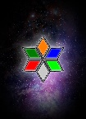
Draw up to 5
Draw up to 5
Draw up to 3
Draw up to 3
If there are remaining Abilities and Effects from the previous turn, they are played after the Drawing of Cards unless an Ability or Effect states otherwise.
The winner of the previous round plays first. If it is the first round, players roll a Dice. The highest roller goes first, and players take turns in a clockwise order from that player’s position.

4B: THE MAIN PHASE AND TAKING/PASSING TURNS
In order of play, Players take turns in playing Cards to build their force of Units in a goal to win each round.
A Players Turn may consist of one of the following Actions;
- They may Deploy a Unit Card from their Hand
- They may Issue an Order Card from their Hand
- They may Pass the turn
Some Abilities and Effects may permit other Actions to be taken during a turn.
Once a Player finishes their Turn, the next Player may take their Turn.
If a Player Passes their Turn, the next Player may either take their Turn or may also Pass their Turn. If all Players Pass their Turn in a row, the Main Phase is complete, and the round moves on to the End of Main Phase.

4C: WINNING A ROUND
Once the Main Phase ends, Players enter the End of Main Phase. Any Abilities or Effects that resolve at this time are played out.
Once all Abilities and Effects have resolved, Players count their total Unit Rank amongst their Unit Nodes. The Player with the highest total Unit Rank wins the round, unless an Ability or Effects states otherwise.

4D: THE CLEAN-UP PHASE
The Clean-up Phase is fairly self-explanatory in that it essentially cleans up the Game Board for the next round to be played. The following steps occur during this phase (in the order listed);
- Abilities and Effects that trigger during this phase do so
- Units in the Unit Nodes are Retired unless an Ability or Effect states otherwise
- Orders in the Order Nodes are Retired unless an Ability or Effect states otherwise
- Locked Nodes are Unlocked unless an Ability or Effect states otherwise
- The Round ends, and Players move to a new Round

5. ABILITIES AND EFFECTS
Most Cards feature Abilities, which affect Units and gameplay via Effects which they cause.

5A: COMMON ABILITIES AND EFFECTS
The following are common Abilities and how they are to be played;
Allied: Must be owned by the same controller.
Assemble: The Unit may be Retired from Hand to add its Rank to another Synthenoid’s Rank that is in play under your control.
Duel: Two opposing Node’s Units face off! The Unit with the lower Rank is Nullified. If the Units are tied for Rank, Weaknesses come into effect. If they are not applicable, nothing happens.
Manipulate: Modify the Rank of a Unit in play by the number after the Ability.
Nullify: The Unit or Order leaves play and is placed in the Nullified Units or Issued Orders Pile
Opposed: The Node across the control line contains a Card already.
+/- Rank: This Unit increases or decreases the Rank of itself or other Units by a fixed amount as long as it is in play. If it leaves play, this bonus typically goes with it.
Retire: The Card is moved to the Retired Units or Issued Order Pile.
Suppress: All listed Abilities/Effects etc. of the targeted card are ignored.

5B: CARD ERRATA/CLARIFICATION OF RULES

GALACTIC COUNCIL
Vigan the Untouchable: This includes both positive and negative effects. Static effects such as increases or decreases to Race rankings fall under this type of immunity. Game state events such as Clean-up are not covered by this immunity.
Ace, Council Tactician: This Ability includes the ability to move Units between Standby and Unit Nodes. Leaders cannot be legally relocated. Control of Units and Orders cannot be changed to move between sides of the Game Board.
Consortium: This effect does not apply to Orders.
Even the Odds: Units may still be played not opposed.
Shadow Strike/Depose: Units have no Abilities until they are played unless a Card specifically says otherwise, so you may Nullify Unit Cards that would say they cannot be Nullified if in play as they are being Deployed.
Forced Migration: The Unit and Node must be owned by the same controller.
Terraform: The Unit is Nullified before the Node is Locked.
Respond in Kind: The Units are Nullified simultaneously.
Keeper of Sanctions/Corporate Detainer: This Ability is applied in addition to any static Base Rank overrides. If all static modifiers leave, this Effect remains.

SPACE COWBOY
The Hangman: This only counts Space Cowboy Units, not Orders.
Y’nosh, Galactic Slaver: This Ability takes priority over any other Unit Clean-up Ability.
High Noon: Any End of Main Phase Rank Modifier Abilities and Effects occur before the Duels.
Xeno Laser: Once this has Nullified the first Space Cowboy, it remains in play, but cannot trigger again this turn (even if the first Space Cowboy leaves play).
Shoot First, Think Second: If you are choosing Nodes for your opponent, you choose at random for them instead of them.
Target Practice: Units have no Abilities until they are played unless a Card specifically says otherwise, so you may Nullify Unit Cards that would say they cannot be Nullified if in play as they are being Deployed.
NECROLITE
Cure Failure 349: This refers to the number of Units in the Nullified Unit Pile.
Disterberus: This includes Units being Nullified in the Standby Zone.
Sisters of Blight/Spreading Blight: The Unit is moved before the Node is Locked. If there are no Standby Nodes to move the Unit to, Retire it instead.
Acid Rain: The Rank of a Unit cannot become negative.
Weed out the Weak: This Ability triggers before Ranks are totalled.
Abominations: This counts as a Turn.
Rise of the Tyrant/Overwhelm: This does not count Units in the Standby Zone.

OVERMIND
Indominus: If you have multiple opponents, it only subtracts the largest hand size, not the total number of their hands combined.
Psyphoon: If you have insufficient Nodes to use this Ability, you must Retire the excess, however you may still Draw Cards for the excess Units.
Temporal Stasis: This does not counteract Ongoing Orders already in play.
Mind Games: If they cannot, they may play Units on their own Nodes.
Shoot First, Think Second: If you are choosing Nodes for your opponent, you choose at random for them instead of them.
Psychic Coersion: Your Opponent needs to tell you they are Deploying a Unit before you choose a Node for them to Deploy to.
One of Us: The Unit does not come into play again, but remains in play.
Reminisce: The Order must be in the Issued Orders Pile.

BLAARG
Mr Morph/Forced Mitosis: This Unit is Deployed as written, but played as the chosen Unit.
Glorpaglorp: If the Standby Zone is full, the Unit is Nullified.
The Voidslime: The Units also lose their Base Race.
Stagnation: If it’s on a Card, and it’s written, it counts. Blaarg!
Supressing Goop: Disables Play restrictions, even in relation to increased costs of Playing a Card such as retiring additional Units from your Hand.

SYNTHENOID
Mechatron: This Unit cannot be Deployed unless it can be Played.
Rapid Fabrication: This Ability is not symmetrical. Only the Order’s controller draws.
Cybernetic Enhancements: This Ability applies to all Synthenoid Cards in player’s hands.
No Gods, No Masters: A Locked Node is not technically Empty.
Salvage for Parts: Treat the Unit as if it had Assemble.

6. EXPANSION: WARZONES
Warzones add an additional element to the game which can influence the way each turn plays out. The rules for Warzones are as follows;

6A: WARZONE CARDS

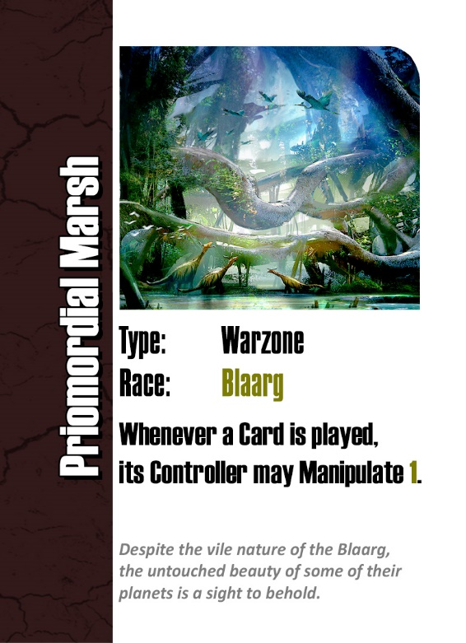
The Warzone’s image
Warzone’s Race
Type (Warzone)
Warzone’s name
Story text of the Warzone
Effects of the Warzone.

Warzones are very similar to Ongoing Orders in how they behave.
The most important element of a Warzone is the Ability, which typically impacts all Players or their Units. Some Warzones even go as far to set new Winning Conditions!

6B: ADDING WARZONES
The Warzone expansion adds two new piles to the game;
The Warzone Deck is face down, and is where New Warzones are drawn from.
The Active Warzone is face up, and is where the Current Warzone(s) are placed.
The Warzone expansion also adds 15 New Orders to the Orders Deck. Shuffle these into the deck as you would for the Base Game.

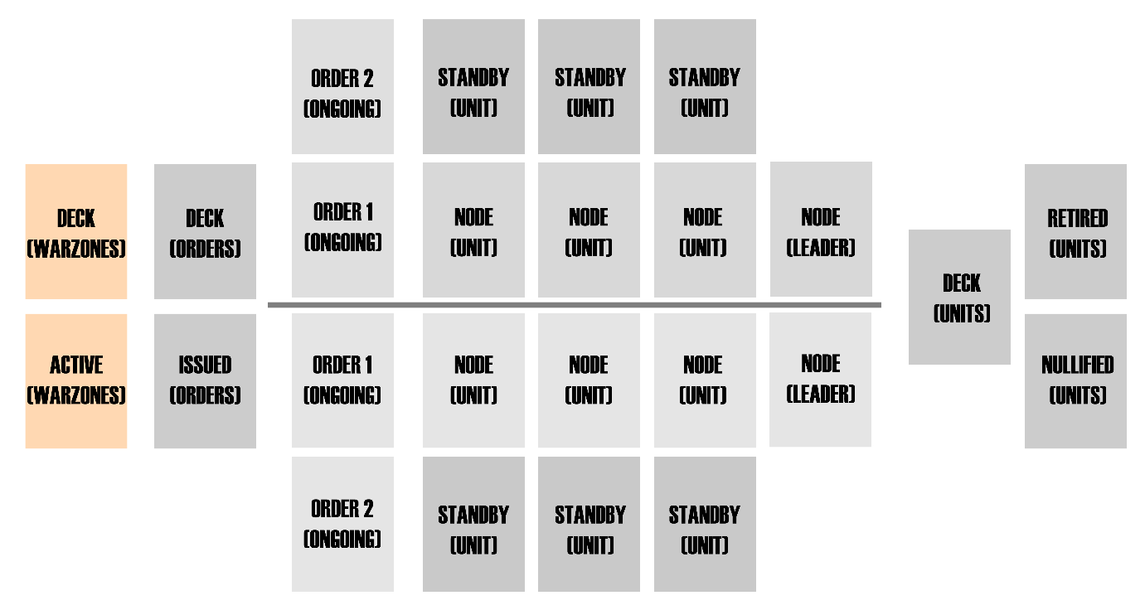

6C: ADDING WARZONES
The Warzone expansion adds the following steps to a Round of Play;
During the Start-up Phase, the Dealer flips and reveals the top card of the Warzone Deck and places it face-up into the Active Warzone Node. This Warzone is now considered to be Active, and all of its Abilities and Effects are applied immediately.
During the Clean-up Phase, the Dealer puts the Active Warzone(s) on the bottom of the Warzone Deck in a random order. There is no longer an Active Warzone until the next Start-up Phase.
If a Card would Retire or Nullify the Active Warzone(s), the Dealer puts the Warzone(s) on the bottom of the Warzone Deck in a random order.

