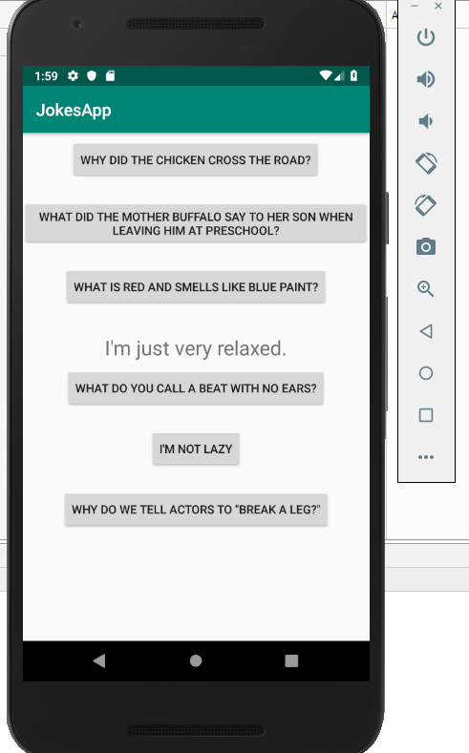

Part1: Jokes application working. Pressed “I’m not lazy” and the answer came up in the middle.

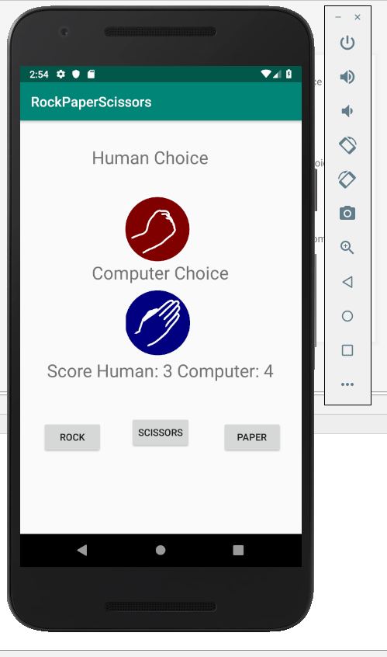

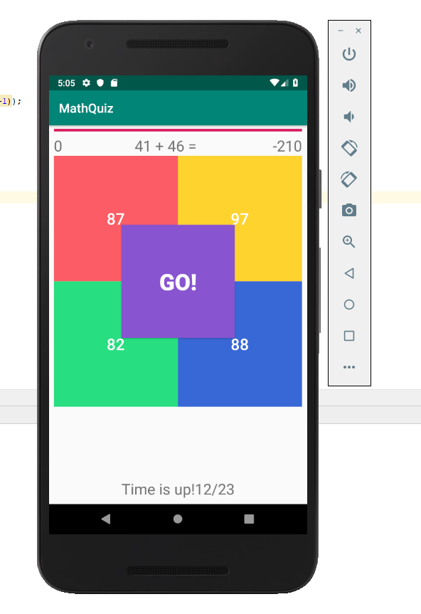Part2: Rock, Paper, Scissors application running and working. The pictures change accordingly and score is kept.

Part3: Quiz Application at the start. Ready for the user to press go to start the timer and questions to go.

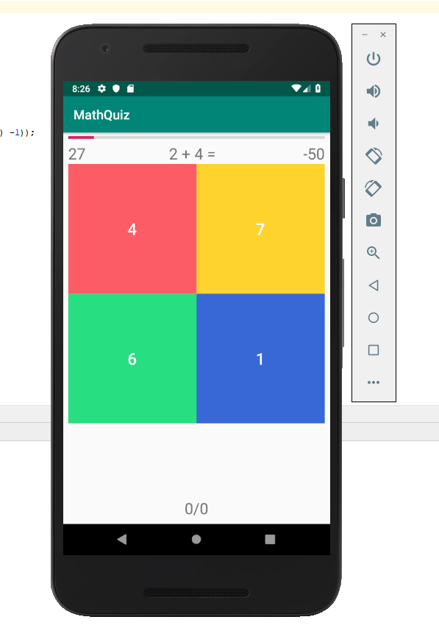

Going through the questions, it displays how many you got wrong and how many questions there were. The user’s score is at the top right and progress bar and timer works.