PROJECT 2: RUBY ON RAILS
https://github.com/ga-students/WDI_LA_15/blob/master/projects/project-2.md

##########################################################################
AQUARIUM COMPATABILITY APP
##########################################################################

PITCH
- An app that helps people plan their home aquariums based on what species are compatible with one another.
- Users can plan their aquarium by salt and fresh water
- By clicking on a species category, the app will filter compatible species from the database
- Users can save, update, share, and delete their arrangements

BONUS GOALS
- Integrate Wikipedia API for additional information about the different species
- Integrate Yelp API to find the nearest aquarium supply stores
- Users can automatically email saved stores to ask if they have a certain species in stock

DOWNSCALING
- A simplified version could focus on JUST freshwater or saltwater

RESOURCES
- Marine Compatibility Chart: http://www.liveaquaria.com/general/compatibility_chart.cfm
- Freshwater/Brackish Chart: http://www.liveaquaria.com/general/fwcompatibility_chart.cfm

MODELS
- Users
- Aquarium
- Stores
- Species

CONTROLLERS
- users_controller
- aquarium_controller
- store_controller
- species_controller

USER STORIES
https://www.pivotaltracker.com/n/projects/1320262
Example: As a <type of user>, I want <some goal> so that <some reason>.
- As an aquarium owner, I want to know what species I can keep together so that I can more effectively plan my aquarium.
- As an aquarium owner, I want to be able to save my virtual aquarium plan so that I can reference it when making purchases.
- As an aquarium owner, I would like to easily find stores that sell the species I'm looking for, so that I don't waste my time going to stores that don't have them in stock.
- As an aquarium owner, I want to know more information about individual species I am interested in so that I can more effectively prepare the right living conditions.
- As a store owner, I want to make myself easy to find so that customers can by from my store.
- As an aquarium owner, I want to be able to share my arrangements so that others can see my plan.
- As an aquarium owner, I want to know what kind of food a species eats so I can make better purchasing decisions.
- As an aquarium owner, I want to have access to images so I can visualize my setup.
- As a store owner, I want to be able to find users directly so I can more effectively cater to them.
- As aquarium owner, I want to know the general price range for certain species so I can budget accordingly.

DATA MODEL (TENTATIVE)
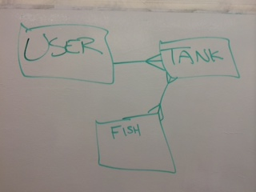
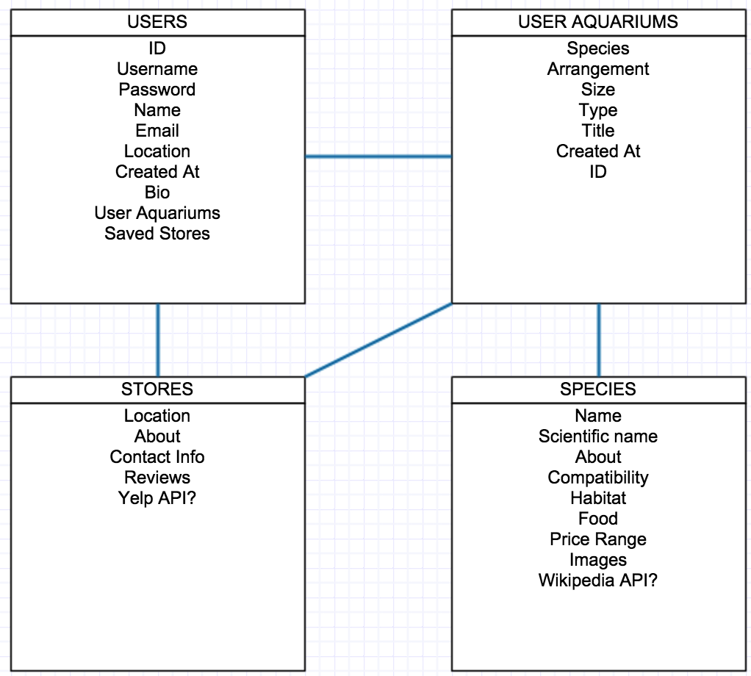

User
- name:string
- email:string
- about:text
- has_many :aquariums

Aquarium
- title:string
- description:text
- has_many :fish
- belongs_to :user

Fish
- name:string
- belongs_to :aquarium
- dwarf_angels:string
- large_angels:string
- anglers_frogs:string
- anthias:string
- basslets:string
- batfish:string
- blennies:string
- boxfish:string
- butterflies:string
- cardinals:string
- chromis:string
- clownfish:string
- damsels:string
- dartfish:string
- dragonets:string
- eels:string
- filefish:string
- foxface_rabbits:string
- gobies:string
- groupers:string
- grunts_sweetlips:string
- jawfish:string
- hawkfish:string
- hogfish:string
- lions_scorpions:string
- parrotfish:string
- pseudochromis:string
- puffers:string
- seahorse_pipefish:string
- sharks_rays:string
- squirrelfish:string
- tangs_surgeons:string
- triggerfish:string
- wrasse_reef_safe:string
- wrasse_fish_only:string
- live_corals:string
- invertebrates:string
- live_rock_sand:string

