指标测试
安徽旭能电力股份有限公司
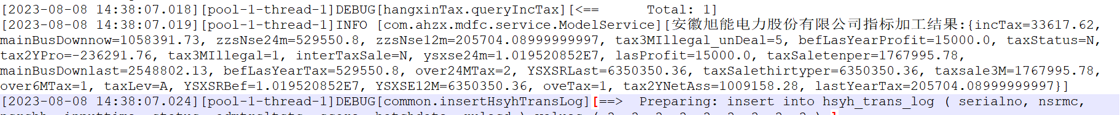
[安徽旭能电力股份有限公司指标加工结果:{incTax=33617.62, mainBusDownnow=1058391.73, zzsNse24m=529550.8, zzsNse12m=205704.08999999997, tax3MIllegal_unDeal=5, befLasYearProfit=15000.0, taxStatus=N, tax2YPro=-236291.76, tax3MIllegal=1, interTaxSale=N, ysxse24m=1.019520852E7, lasProfit=15000.0, taxSaletenper=1767995.78, mainBusDownlast=2548802.13, befLasYearTax=529550.8, over24MTax=2, YSXSRLast=6350350.36, taxSalethirtyper=6350350.36, taxsale3M=1767995.78, over6MTax=1, taxLev=A, YSXSRBef=1.019520852E7, YSXSE12M=6350350.36, oveTax=1, tax2YNetAss=1009158.28, lastYearTax=205704.08999999997}]

taxStatus
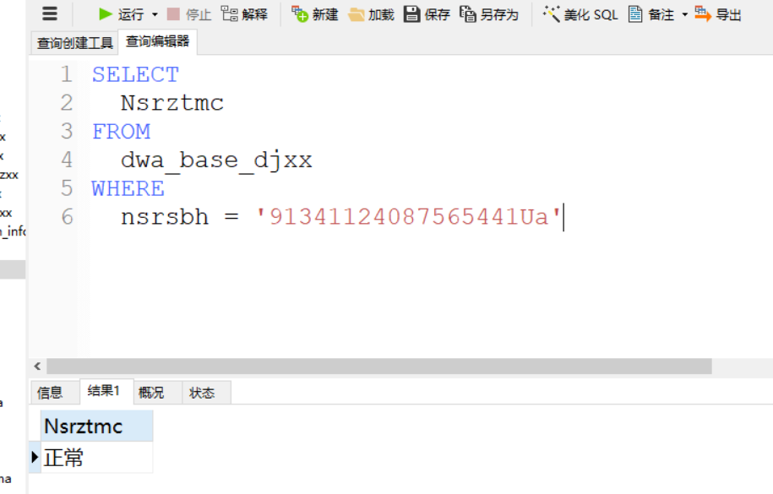

taxLev
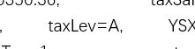
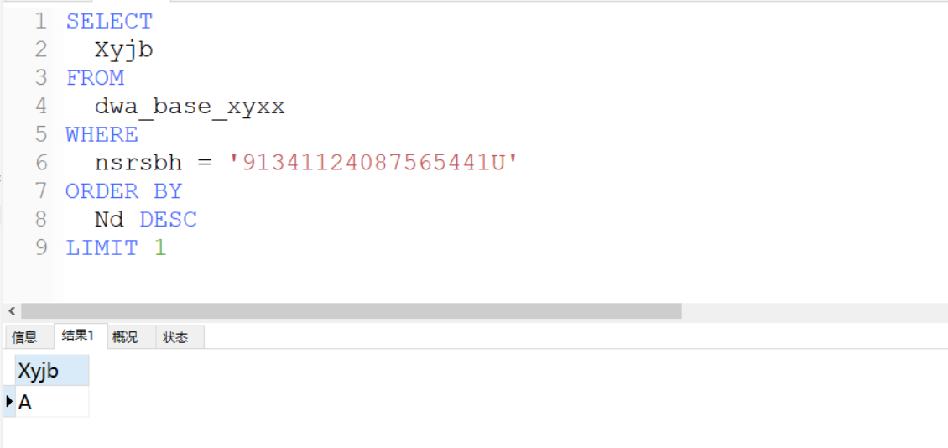
违法数据明细
SELECT
*
FROM
dwa_base_wfwzxx
WHERE
nsrsbh = '91341124087565441U'
AND Sswfsd_dm IN ('050202', '050204', '050204')
#AND DJRQ >= '2021-08-08'
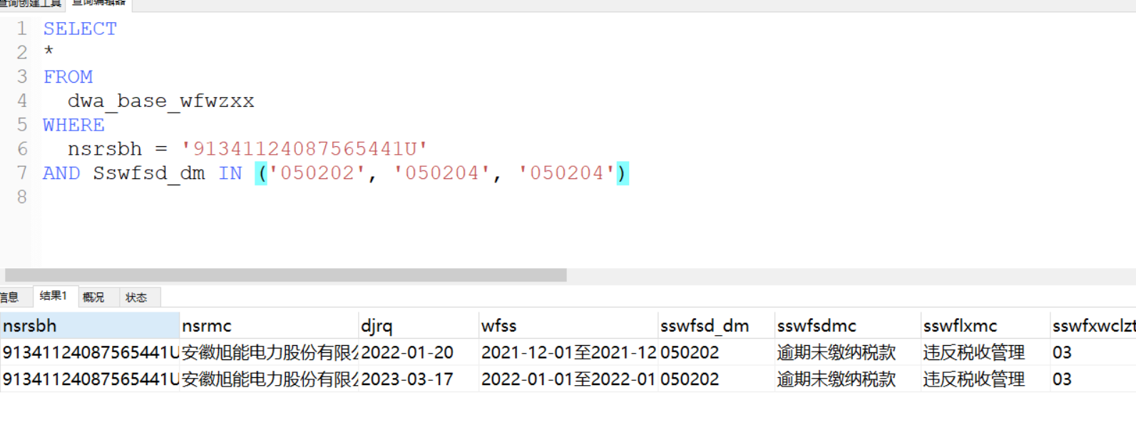

over24MTax
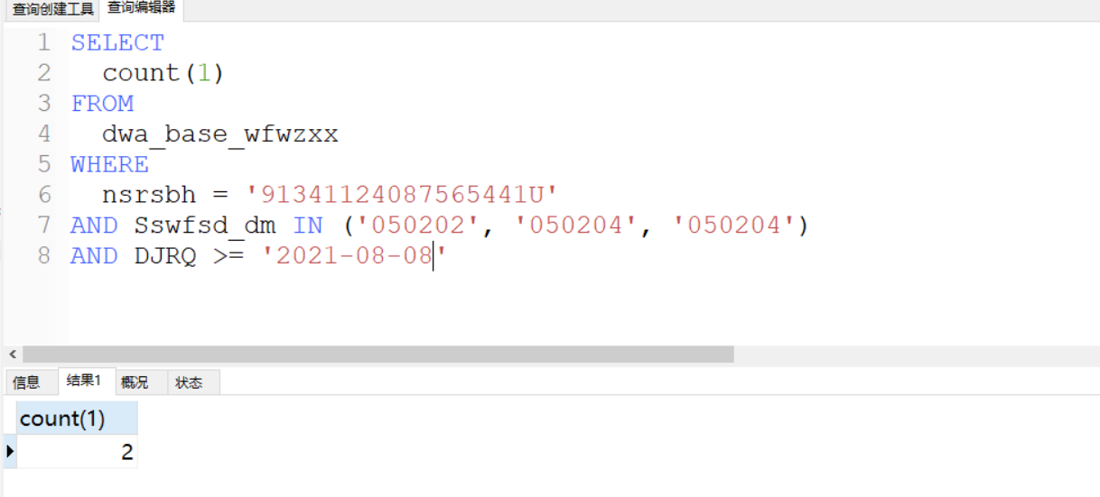

over6Mtax
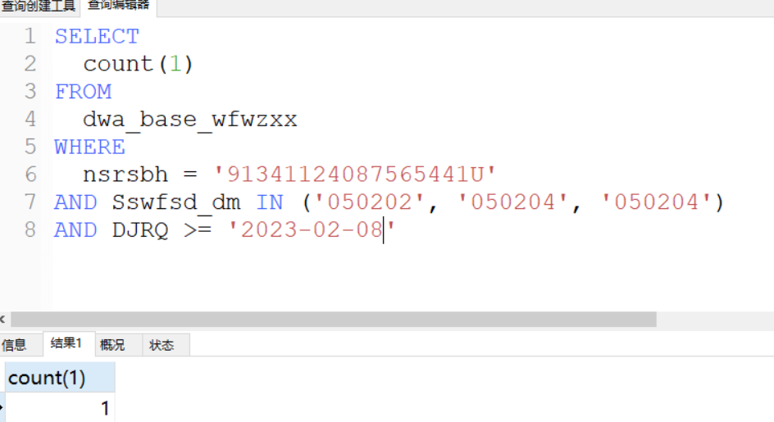

oveTax
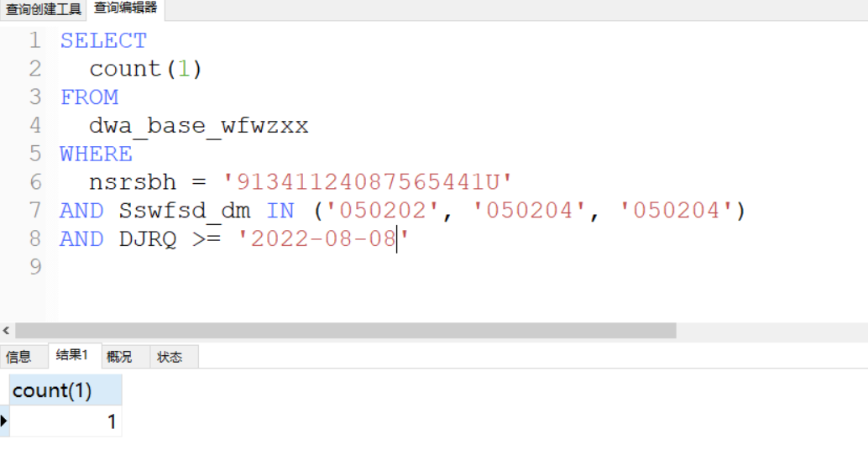

tax3MIllegal_unDeal
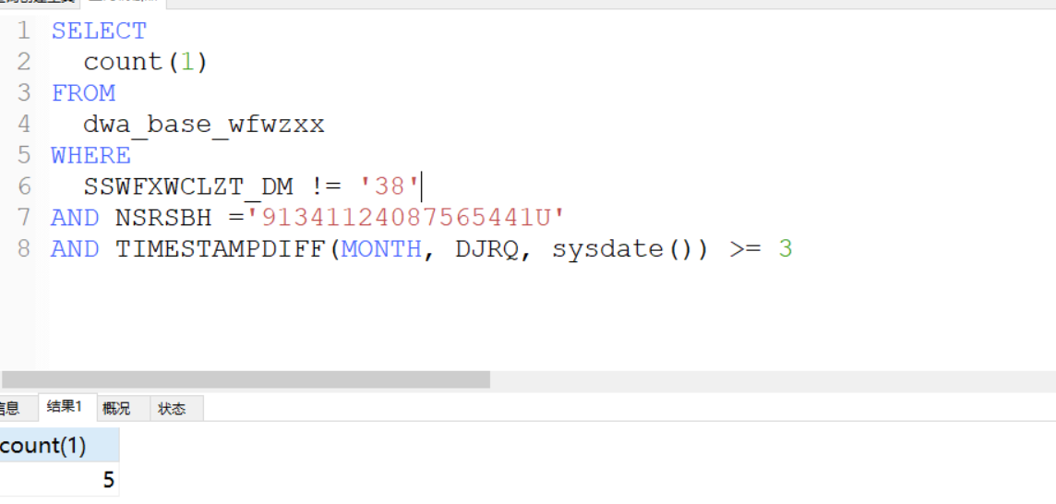

SELECT
count(1)
FROM
dwa_base_wfwzxx
WHERE
SSWFXWCLZT_DM != '38'
AND NSRSBH ='91341124087565441U'
AND TIMESTAMPDIFF(MONTH, DJRQ, sysdate()) >= 3

lasProfit
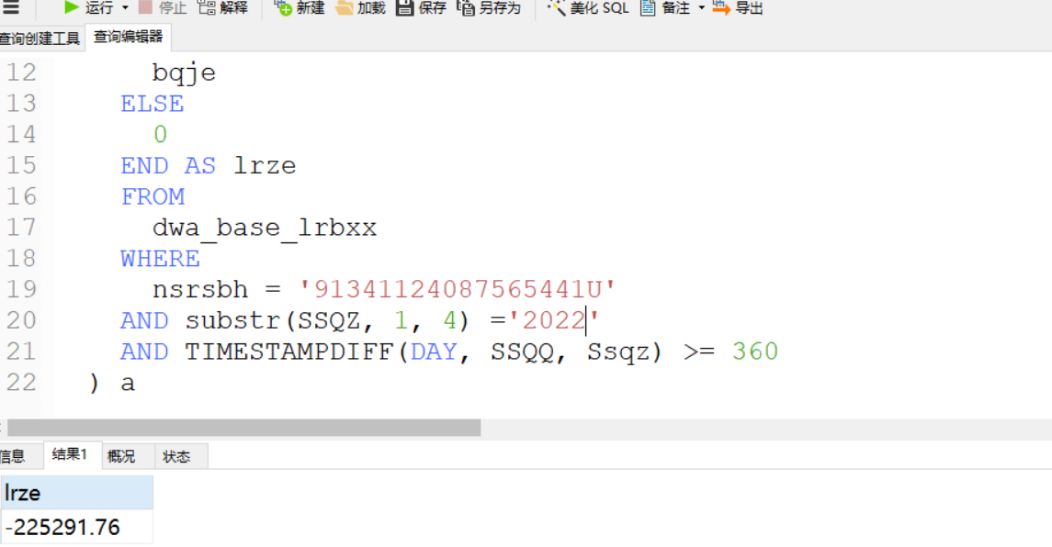
SELECT
ifnull(sum(lrze), 0) AS "lrze"
FROM
(
SELECT
CASE
WHEN kjzdzz_dm = '201' THEN
bys
WHEN kjzdzz_dm = '102' THEN
byje
WHEN kjzdzz_dm = '101' THEN
bqje
ELSE
0
END AS lrze
FROM
dwa_base_lrbxx
WHERE
nsrsbh = '91341124087565441U'
AND substr(SSQZ, 1, 4) ='2022'
AND TIMESTAMPDIFF(DAY, SSQQ, Ssqz) >= 360
) a

befLasYearProfit
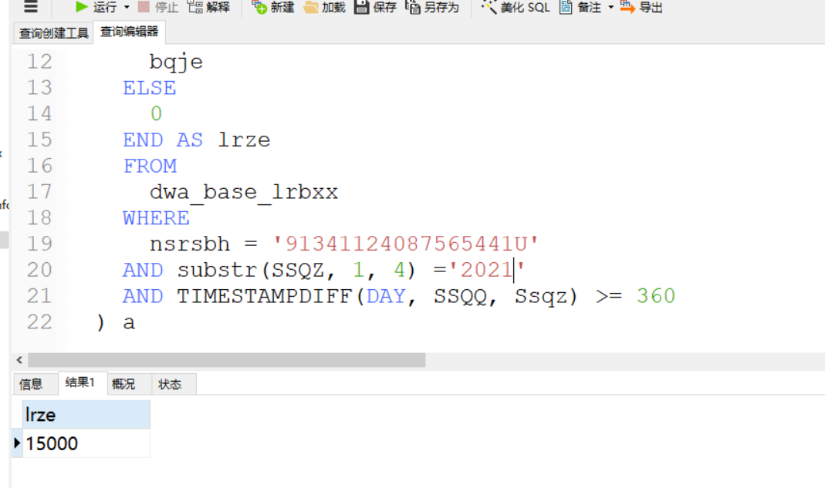
SELECT
ifnull(sum(lrze), 0) AS "lrze"
FROM
(
SELECT
CASE
WHEN kjzdzz_dm = '201' THEN
bys
WHEN kjzdzz_dm = '102' THEN
byje
WHEN kjzdzz_dm = '101' THEN
bqje
ELSE
0
END AS lrze
FROM
dwa_base_lrbxx
WHERE
nsrsbh = '91341124087565441U'
AND substr(SSQZ, 1, 4) ='2021'
AND TIMESTAMPDIFF(DAY, SSQQ, Ssqz) >= 360
) a

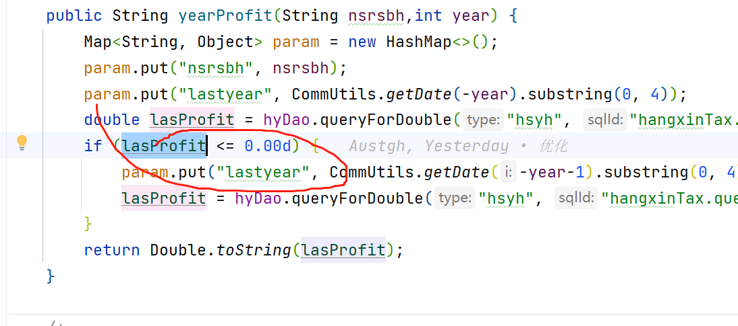
判断可能有问题

tax3Millegal
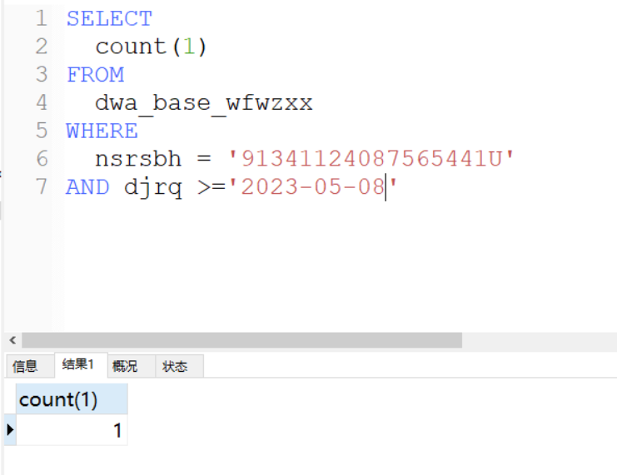
SELECT
count(1)
FROM
dwa_base_wfwzxx
WHERE
nsrsbh = '91341124087565441U'
AND djrq >='2023-05-08'
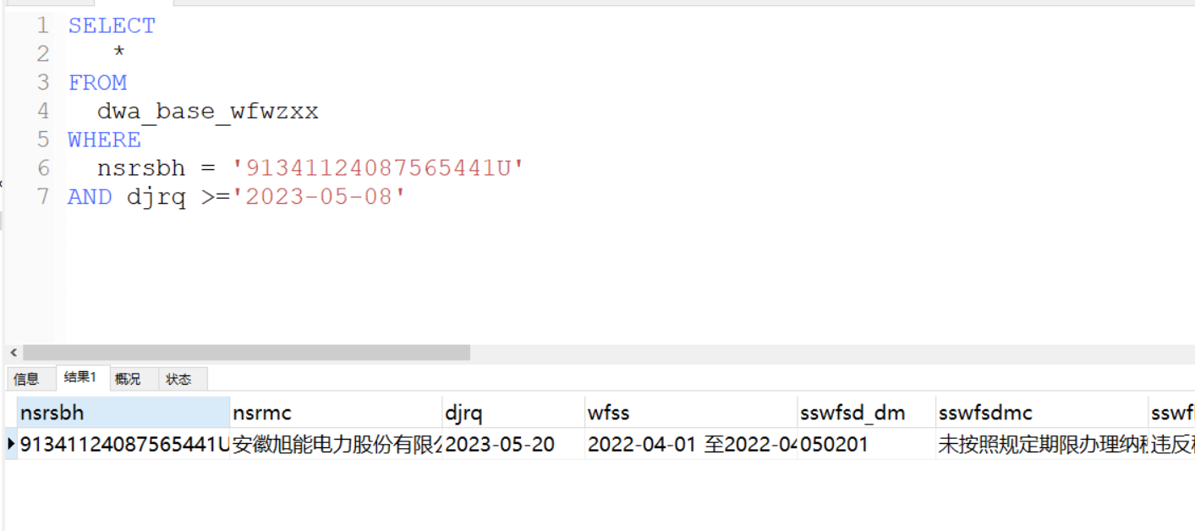

tax2YnetAss
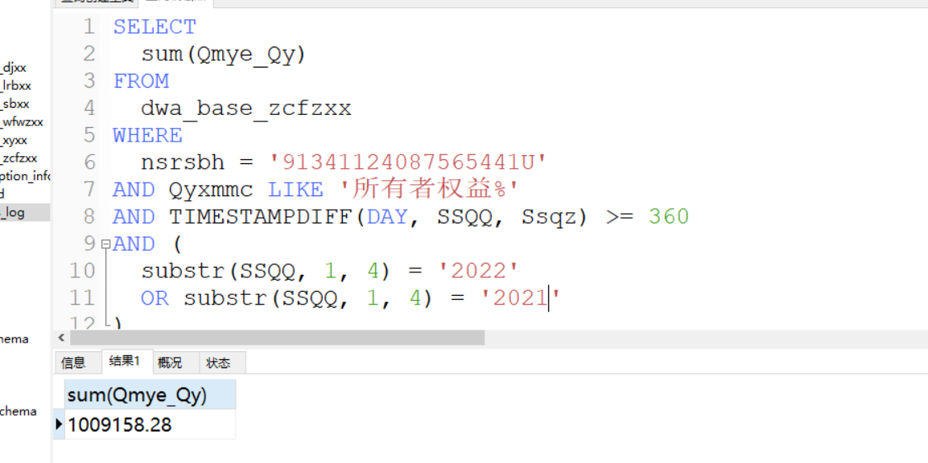
SELECT
sum(Qmye_Qy)
FROM
dwa_base_zcfzxx
WHERE
nsrsbh = '91341124087565441U'
AND Qyxmmc LIKE '所有者权益%'
AND TIMESTAMPDIFF(DAY, SSQQ, Ssqz) >= 360
AND (
substr(SSQQ, 1, 4) = '2022'
OR substr(SSQQ, 1, 4) = '2021'
)

tax2YPro
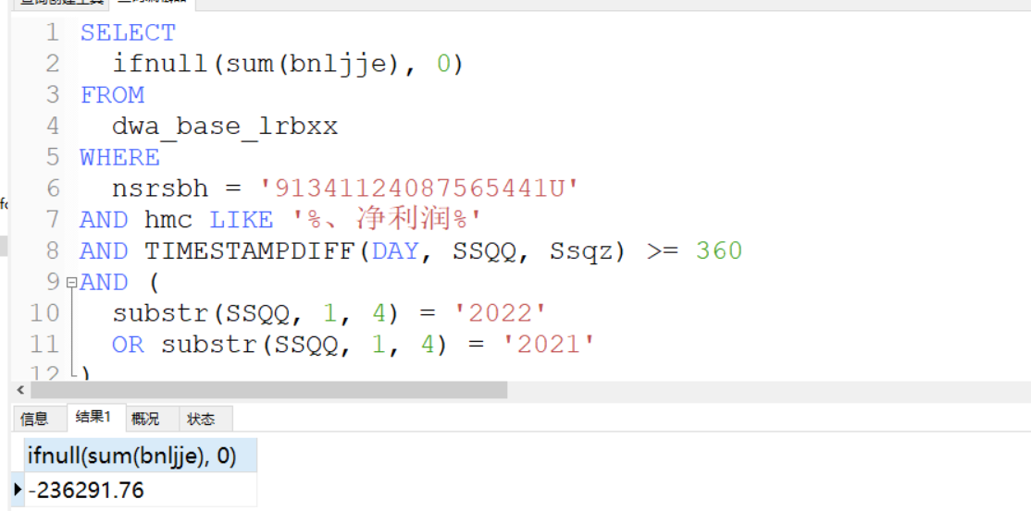
SELECT
ifnull(sum(bnljje), 0)
FROM
dwa_base_lrbxx
WHERE
nsrsbh = '91341124087565441U'
AND hmc LIKE '%、净利润%'
AND TIMESTAMPDIFF(DAY, SSQQ, Ssqz) >= 360
AND (
substr(SSQQ, 1, 4) = '2022'
OR substr(SSQQ, 1, 4) = '2021'
)

最近一笔增值税日期
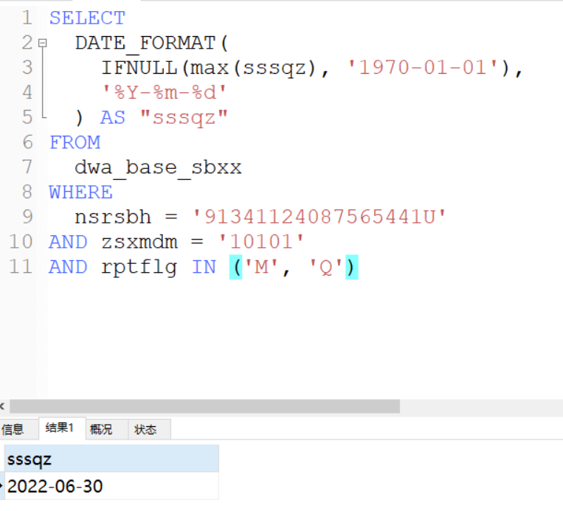 SELECT
DATE_FORMAT(
IFNULL(max(sssqz), '1970-01-01'),
'%Y-%m-%d'
) AS "sssqz"
FROM
dwa_base_sbxx
WHERE
nsrsbh = '91341124087565441U'
AND zsxmdm = '10101'
AND rptflg IN ('M', 'Q')

interTaxSale 这个逻辑处理有问题
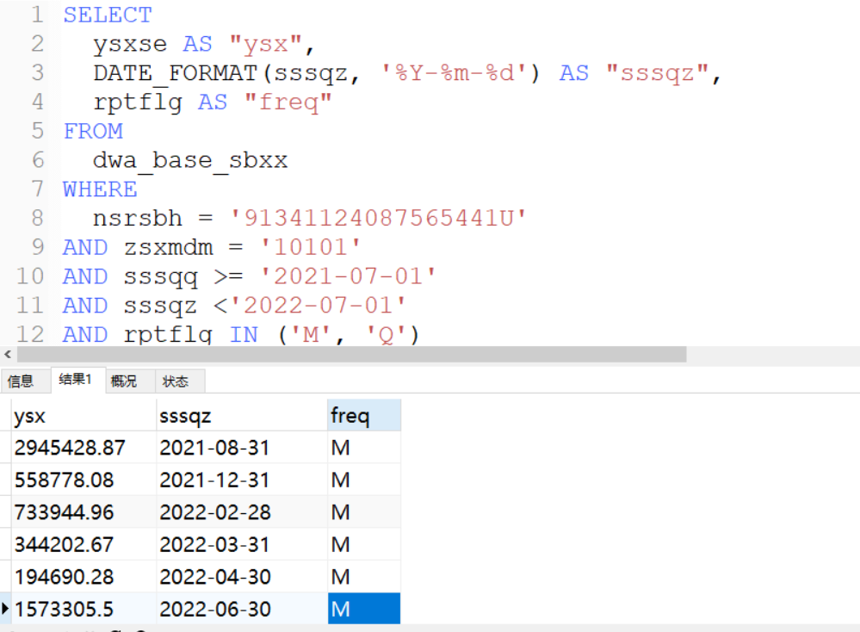
SELECT
ysxse AS "ysx",
DATE_FORMAT(sssqz, '%Y-%m-%d') AS "sssqz",
rptflg AS "freq"
FROM
dwa_base_sbxx
WHERE
nsrsbh = '91341124087565441U'
AND zsxmdm = '10101'
AND sssqq >= '2021-07-01'
AND sssqz <'2022-07-01'
AND rptflg IN ('M', 'Q')

mainBusDownnow
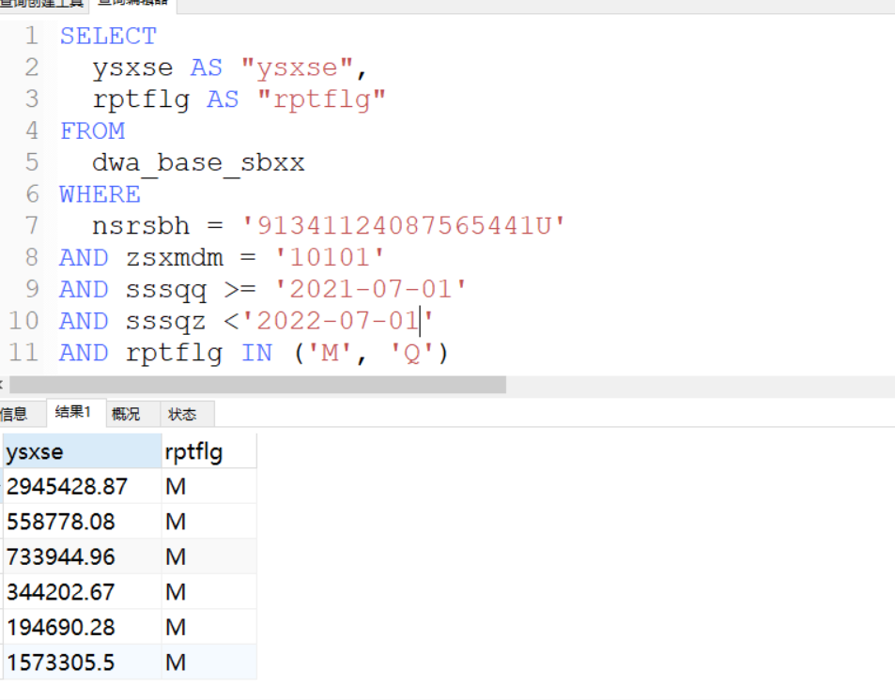
SELECT
ysxse AS "ysxse",
rptflg AS "rptflg"
FROM
dwa_base_sbxx
WHERE
nsrsbh = '91341124087565441U'
AND zsxmdm = '10101'
AND sssqq >= '2021-07-01'
AND sssqz <'2022-07-01'
AND rptflg IN ('M', 'Q')

mainBusDownlast
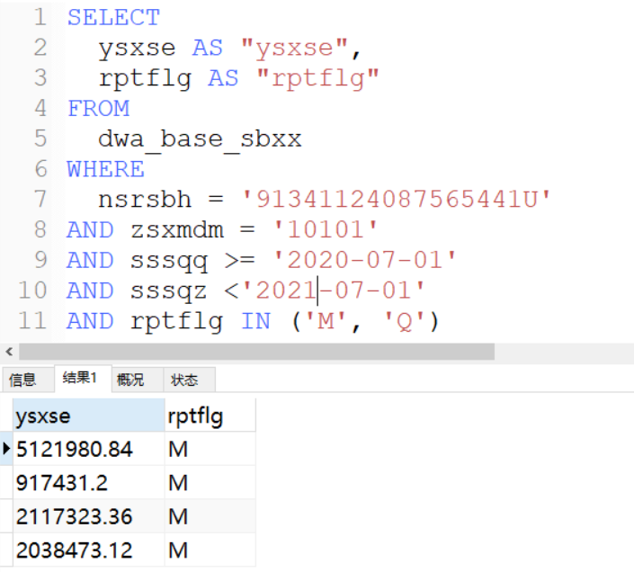
SELECT
ysxse AS "ysxse",
rptflg AS "rptflg"
FROM
dwa_base_sbxx
WHERE
nsrsbh = '91341124087565441U'
AND zsxmdm = '10101'
AND sssqq >= '2020-07-01'
AND sssqz <'2021-07-01'
AND rptflg IN ('M', 'Q')
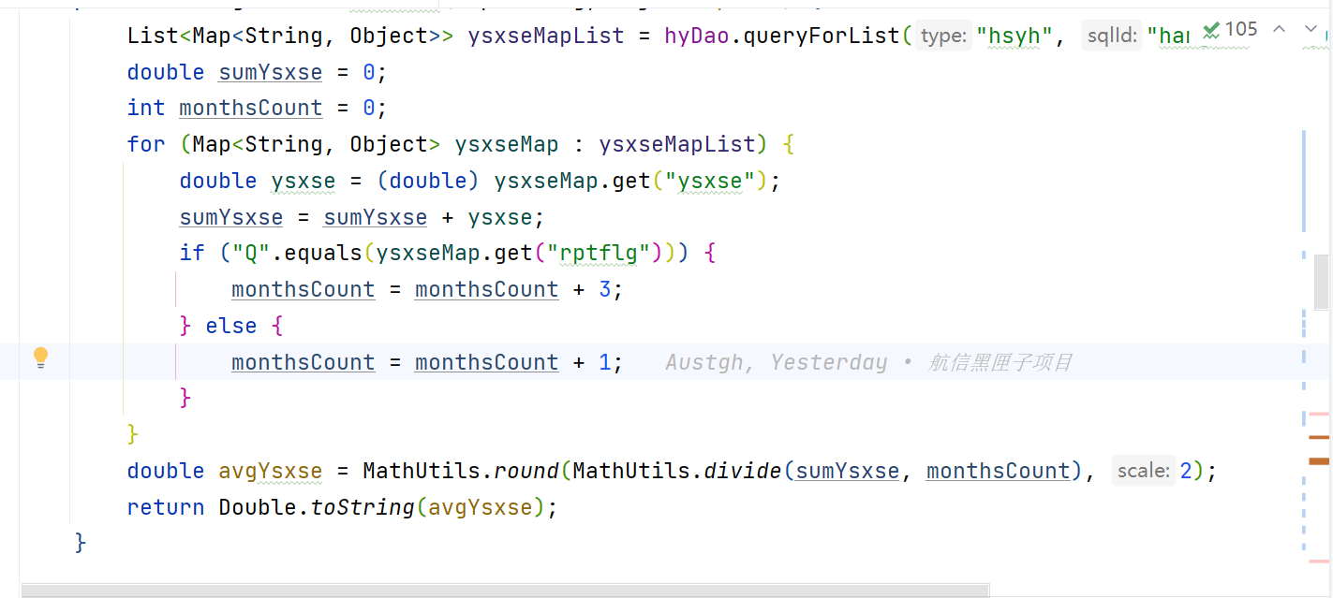
待定

lastYearTax
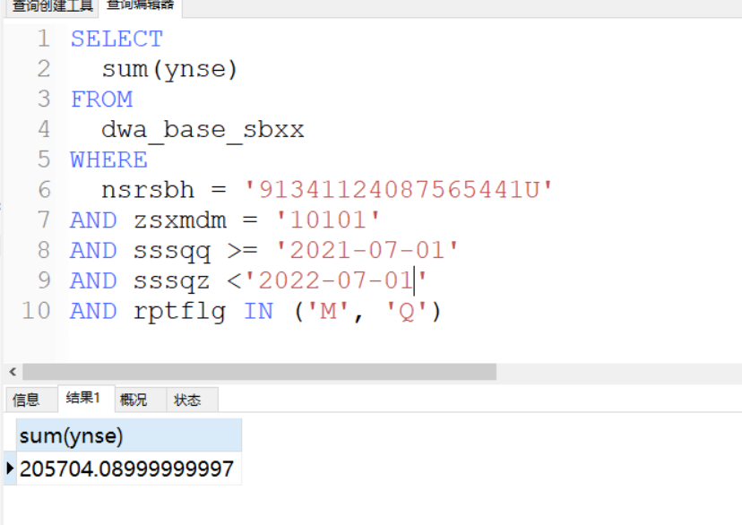
SELECT
sum(ynse)
FROM
dwa_base_sbxx
WHERE
nsrsbh = '91341124087565441U'
AND zsxmdm = '10101'
AND sssqq >= '2021-07-01'
AND sssqz <'2022-07-01'
AND rptflg IN ('M', 'Q')

befLasYearTax
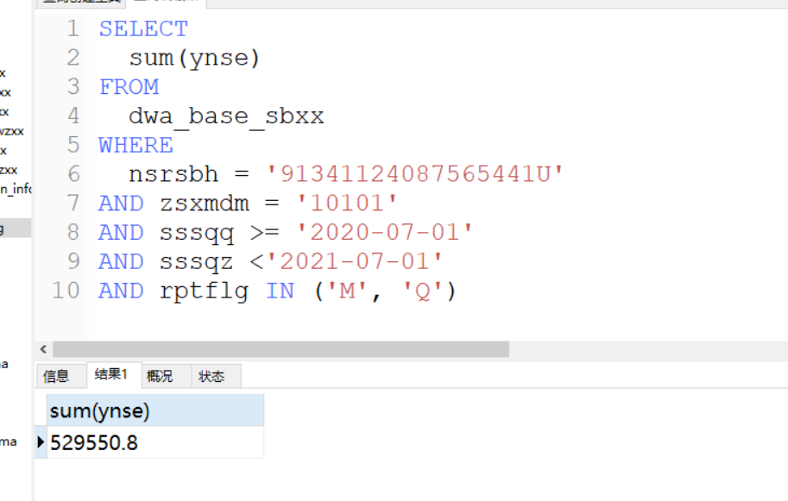
SELECT
sum(ynse)
FROM
dwa_base_sbxx
WHERE
nsrsbh = '91341124087565441U'
AND zsxmdm = '10101'
AND sssqq >= '2020-07-01'
AND sssqz <'2021-07-01'
AND rptflg IN ('M', 'Q')

YSXSRLast
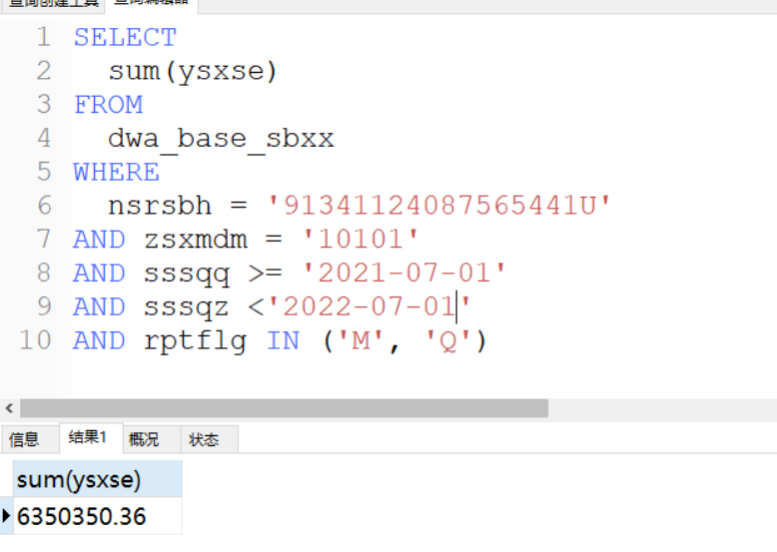
SELECT
sum(ysxse)
FROM
dwa_base_sbxx
WHERE
nsrsbh = '91341124087565441U'
AND zsxmdm = '10101'
AND sssqq >= '2021-07-01'
AND sssqz <'2022-07-01'
AND rptflg IN ('M', 'Q')

YSXSRBef
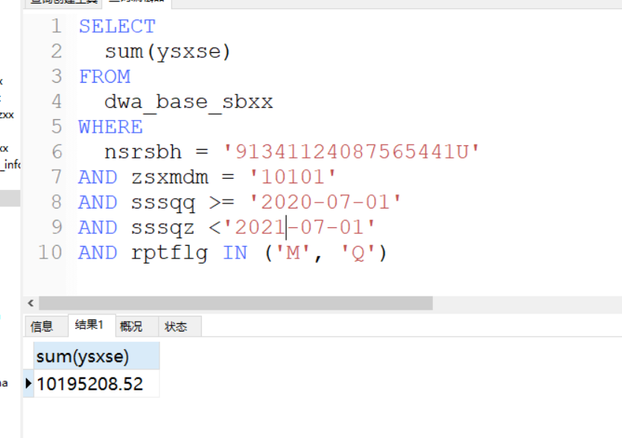
SELECT
sum(ysxse)
FROM
dwa_base_sbxx
WHERE
nsrsbh = '91341124087565441U'
AND zsxmdm = '10101'
AND sssqq >= '2020-07-01'
AND sssqz <'2021-07-01'
AND rptflg IN ('M', 'Q')

YSXSE12M
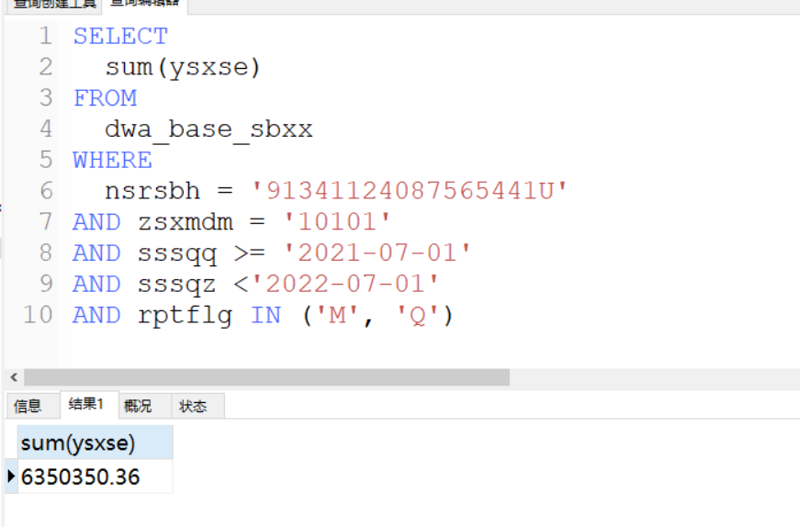
SELECT
sum(ysxse)
FROM
dwa_base_sbxx
WHERE
nsrsbh = '91341124087565441U'
AND zsxmdm = '10101'
AND sssqq >= '2021-07-01'
AND sssqz <'2022-07-01'
AND rptflg IN ('M', 'Q')

ysxse24m
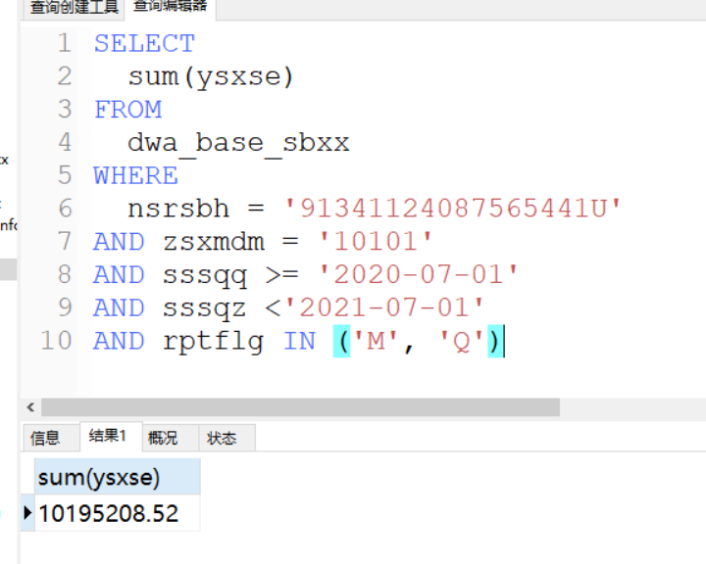

zzsNse12m
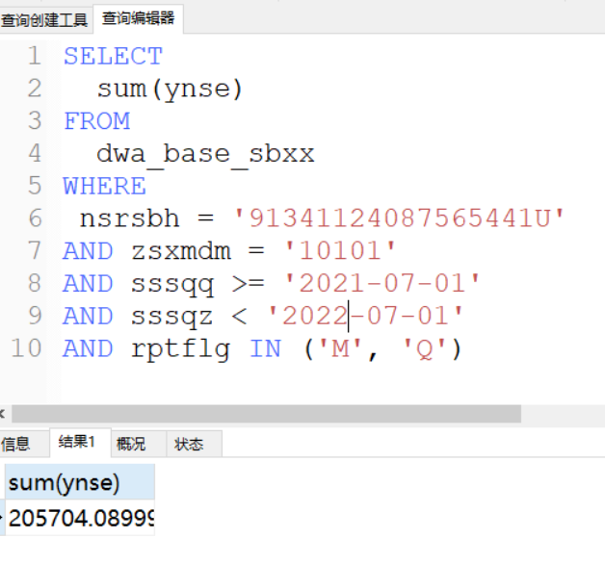
SELECT
sum(ynse)
FROM
dwa_base_sbxx
WHERE
nsrsbh = '91341124087565441U'
AND zsxmdm = '10101'
AND sssqq >= '2021-07-01'
AND sssqz < '2022-07-01'
AND rptflg IN ('M', 'Q')

zzsNse24m
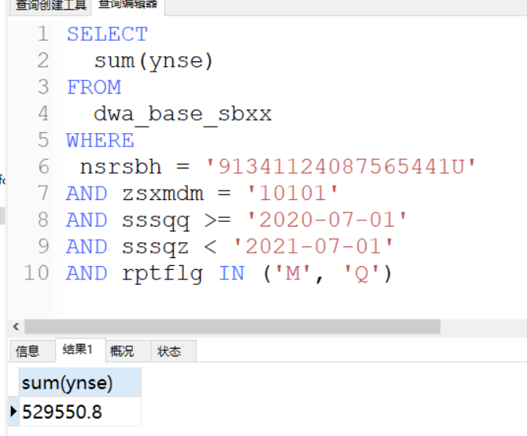
SELECT
sum(ynse)
FROM
dwa_base_sbxx
WHERE
nsrsbh = '91341124087565441U'
AND zsxmdm = '10101'
AND sssqq >= '2020-07-01'
AND sssqz < '2021-07-01'
AND rptflg IN ('M', 'Q')

taxSalethirtyper
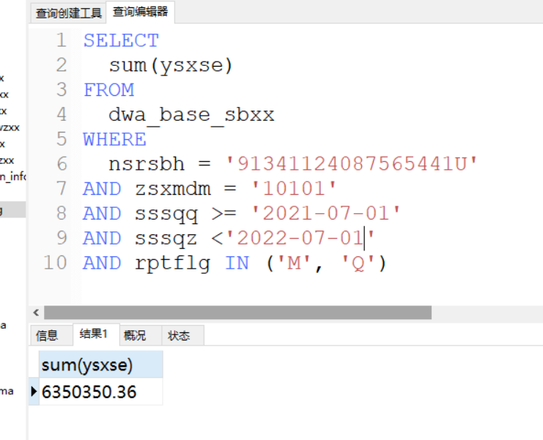
SELECT
sum(ysxse)
FROM
dwa_base_sbxx
WHERE
nsrsbh = '91341124087565441U'
AND zsxmdm = '10101'
AND sssqq >= '2021-07-01'
AND sssqz <'2022-07-01'
AND rptflg IN ('M', 'Q')

taxsale3M
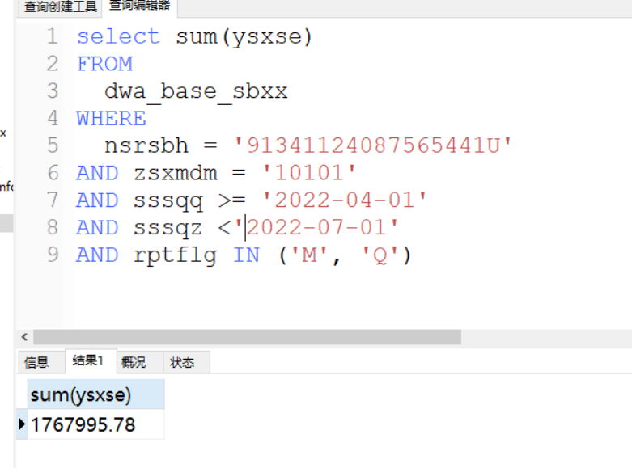
select sum(ysxse)
FROM
dwa_base_sbxx
WHERE
nsrsbh = '91341124087565441U'
AND zsxmdm = '10101'
AND sssqq >= '2022-04-01'
AND sssqz <'2022-07-01'
AND rptflg IN ('M', 'Q')

taxSaletenper
同taxsale3M逻辑一样

incTax
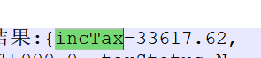

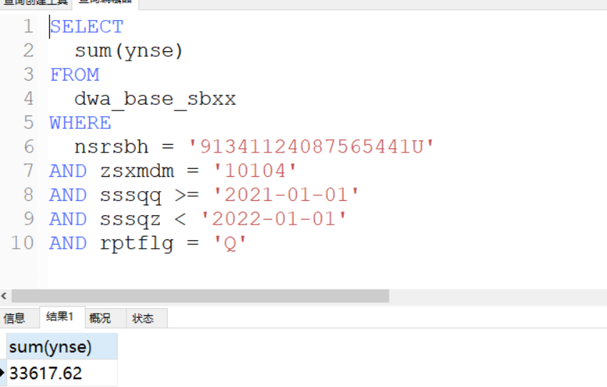
SELECT
sum(ynse)
FROM
dwa_base_sbxx
WHERE
nsrsbh = '91341124087565441U'
AND zsxmdm = '10104'
AND sssqq >= '2021-01-01'
AND sssqz < '2022-01-01'
AND rptflg = 'Q'

20251230
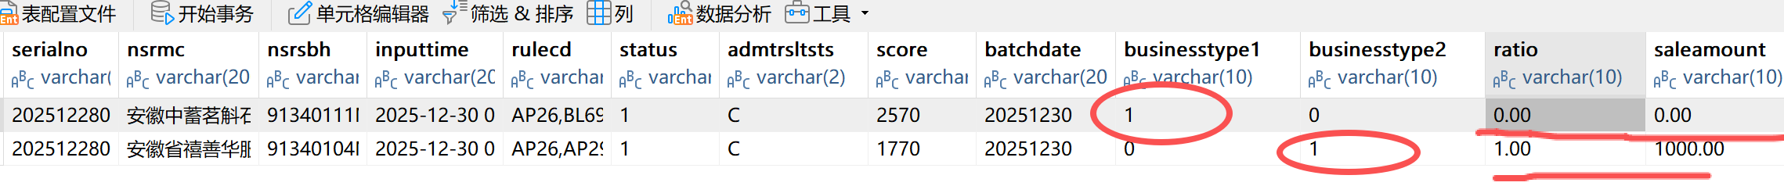
新增指标

growthRate

saleAmount

cancelTimes

cancelAmount

