# Spatial Optimization Workflow

Developer: Lance Watkins, Arizona State University

## Data and Input Layers

Data should be restricted to a given location using a shapefile for the jurisdiction of interest. The following input data and layers are needed to identify candidate locations.

**CDC Social Vulnerability Index (SVI):** The CDC Social Vulnerability Index (SVI) was downloaded from the CDC’s Agency for Toxic Substances and Disease Registry from [SVI Data and Documentation Download](https://www.atsdr.cdc.gov/placeandhealth/svi/data_documentation_download.html). **We recommend using the SVI for census tracts relative to the state, rather than to the national average.**

* Maricopa downloaded it then had to recalculate it so it was representative of only Maricopa County. Lance did this using R code, which he can share to process a similar layer for Pima. Alternatively, we can create a different vulnerability index. ** CONNECT TO SAM’S WORK to create a new exposure layer

**Current list of cooling centers: This data should ideally be point location and geo-referenced.**

**You may wish to restrict your list of cooling centers to those with air conditioning, or include both those with air conditioning and those that just offer water and shade (hydration stations).**

**Parcel data from jurisdiction: Often available from tax assessor or city/county government, the data includes parcel use codes and zoning including how parcels are currently used.**

**Street Network:** Often available from city/county governments, this data can be used to develop a street network, the process of which is detailed via an ESRI tutorial [Create a Network Dataset](https://pro.arcgis.com/en/pro-app/2.8/help/analysis/networks/how-to-create-a-usable-network-dataset.htm) but an amateur explanation can also be found on YouTube [How to make a Network Dataset in ArcGIS Pro](https://www.youtube.com/watch?v=gE1QnxxirQ8) by The Geomathematician.

**(Optional) Survey for vulnerable populations:** Point in Time survey of those experiencing homelessness was incorporated as additional demand locations in one of our counties. That survey is only representative of where those were experiencing homelessness lived for the day the survey was taken, in early 2022.

## Layer Development

Spatial optimization was accomplished using ArcGIS Pro 2.9.1, using the *Network Analyst* extension and the *Location-Allocation* option. Briefly, the Network Analyst extension allows for users to optimize the connections between entities. Here, we are geographically optimizing the location (*location -*allocation) of the candidate locations to reach maximum coverage of the demand locations (residential parcels). This tool requires three sets of input: (a) existing locations, (b) demand locations, and (c) candidate locations, which are then placed on a street network to select potential locations that meet the user set criteria optimally.

1. Existing Locations: are current cooling center locations
2. Demand Locations (Parcel data): Parcel data was processed by developing a categorization scheme for parcels by use type. Residences including fixed foundation residences and mobile homes were designated as demand locations. Finally, empty lots, recreation centers, common areas, and private drives were removed from the residential parcels as they do not house residents, marked as residential adjacent parcels. Some parcel data may not include mobile homes, so mobile home park data could supplement the parcel data.
3. Candidate Locations (Parcel data): This included three candidate location markers – public schools, assisted living centers including commercial nursing homes, hospitals, and places of worship. Religious institutions were included as “miscellaneous commercial” in the UseDesc attribute. Filtering to “miscellaneous commercial”, locations were further identified with a keyword search using the “Mail 1” attribute (the first line written when mailing an item to that location). Keywords used included: Church, Iglesia, Buddha, Islam, Jewish, Temple, Chapel, Evangelical, Methodist, Parish, and Catholic.
   1. In our tax assessor regional databases, this information was included in the description of parcel data fields including: PptDesc, SptDesc, and UseDesc attributes. These parcel use codes have three hierarchical layers of increasing/decreasing specificity – The broad “Ppt” description, the more specific “Spt” Description, and the close to exact “Use” Description.

## Pre-Processing

* 1. Add SVI and street network layers to ArcGIS. We used ArcGIS Pro 2.9.1.
  2. A screenshot of a computer

     Description automatically generated with medium confidenceLimit the analysis to the most highly vulnerable tracts via the CDC SVI. We used the top 25% as a cutoff for “highly vulnerable”
     1. In very large counties, you may need to do a smaller subset. For example, you could select 5 parcels from each tract that were highly vulnerable. See related Python code in order to determine this.

## Running the Optimization

1. Using the *Network Analyst* extension and the *Location-Allocation* option. In the **Analysis Tab**, select **Network Analysis**.
2. Graphical user interface, map

   Description automatically generatedThe function we will run is **Location Allocation.** Which creates a new layer to which ArcGIS Pro will allocate the locations.
3. Once the layer is created, new tools will popup:

* **Mode**: can be adjusted for pedestrian, car, etc.
* **Units**: dependent on the networks dataset.
* **Direction**: change to “**to facilities**”
* **Cut-Off**: this is an impendence, constrains the optimization to reasonable distances. Separate values for:
  + Residential: walking 5 miles (here feet so 26400). Set the largest one here in the main strip of commands
  + Point in time: 1 mile
  + Mobile: 3 miles
* Open Attribute Table, Create empty Field “Cutoff_v1_ft”, population field with value
* **Facilities**: This is how many facilities you want to have in the end: existing plus new. So if you want 10 new, and you have 15 existing , 15 old + 10 new = 25.
* **Type**: Type of problem. Select **Maximum Coverage**.

Below is the list of spatial optimization parameters that we used.

**Table**. Spatial Optimization User selected parameters.

|  |  |  |  |
| --- | --- | --- | --- |
| Parameter | Options/Definition | County 1 | County 2 |
| Mode | Can be adjusted for pedestrian, car, etc. | Not used | Not used |
| Units | Are dependent, defined by the imported network dataset | meters | Feet |
| Direction | The direction by which the locations will be identified, e.g., from the candidate out or from the residence to the candidate | “to facilities” | “to facilities” |
| Cut-Off | This is an impendence factor which constrains the optimization to reasonable distances. | Fixed foundation Residential – 8 km  Residential mobile homes – 5 km | * Residential: walking 5 miles (i.e., 26400 ft) * Point in time: 1 mile * Mobile Home: 3 miles |
| Facilities | The number of new facilities to end with: existing plus the desired number of new locations | 35 =  15 existing  20 new | 123 =  113 existing  10 new |
| Type | Type of problem being solved (e.g., minimize impedance, maximize coverage) | Maximize coverage | Maximize coverage |

1. **Import Existing Locations:** (set to Facility Type **Required**). & Make sure “**Append to Existing**” is always selected.
2. **Import Candidate Locations:** Add Candidate Sites (set to Facility Type **Candidate**). & Make sure “**Append to Existing**” is always selected.
3. **Import Demand Locations:** Using the same process as above but add Residential and Mobile home locations, with the option to include homeless, additional mobile home data, ans other datasets as needed.

*Note:* For the Cutoffs that aren’t the main, **change “Cutoff_Length**” to the variable in the Attribute table. Additionally, the output of the workflow does not include location attributes, so you may need to do a **spatial join** to the input data in order to have this information.

# Sample Output

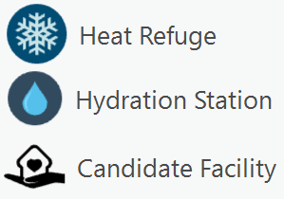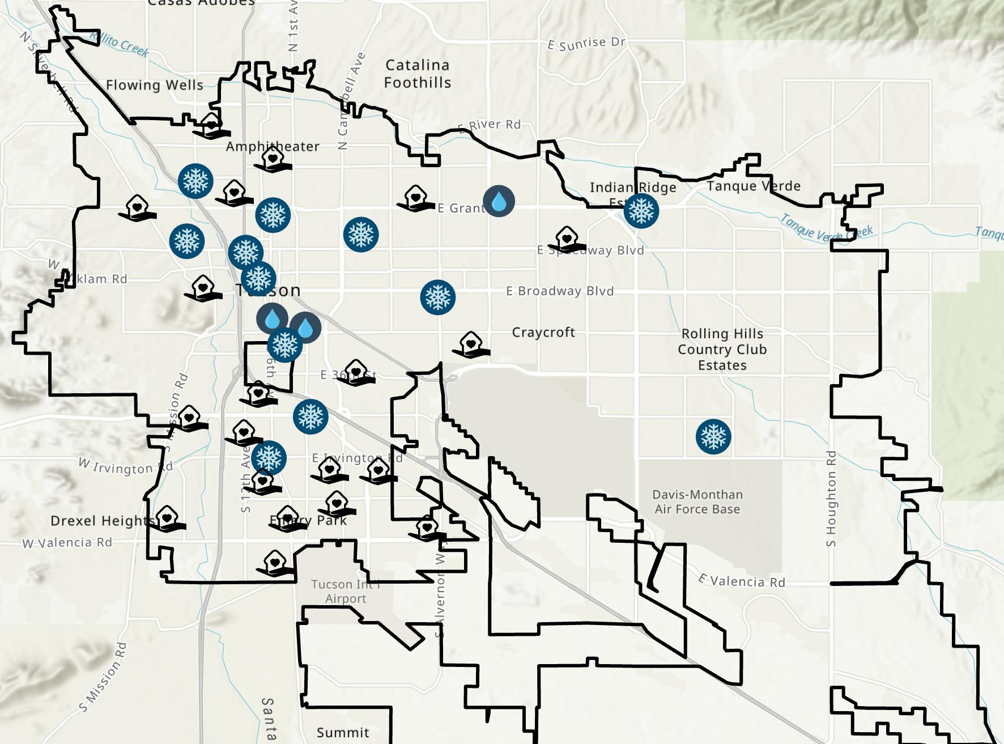Below is a figure of the sample candidate locations, mapped with current locations, for Pima County, AZ dependent on 2022 cooling center locations